ACADEMIC AND EMPL
OYABILITY SKILLS
BMSW4001
Assignment Title: ACE Practical Portfolio
Hafsa
Rajan
.
2110298
Lecturer. Sir
Soban
Sadiq

CONTENTS
- Introduction to academic and employability skills
- Examples of academic and employability skills
- Reasons for choosing career as marketing manager
- Pros and cons for a career as marketing manager
- Functions and skills of a marketing manager
- Personal SWOT analysis
- Personal development plan
- Conclusion
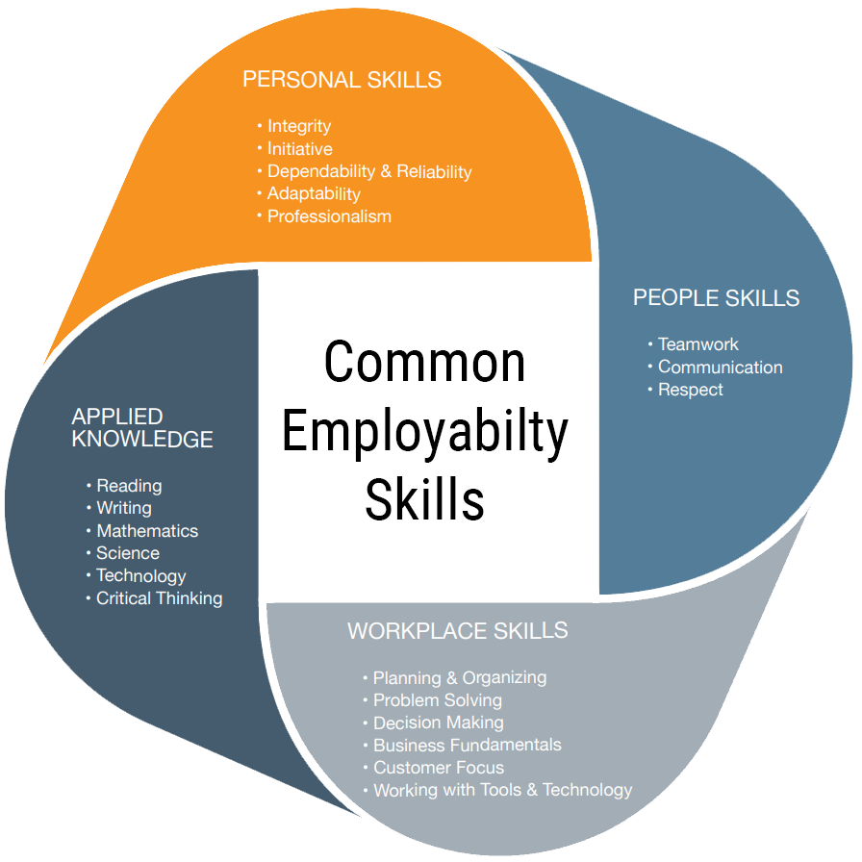
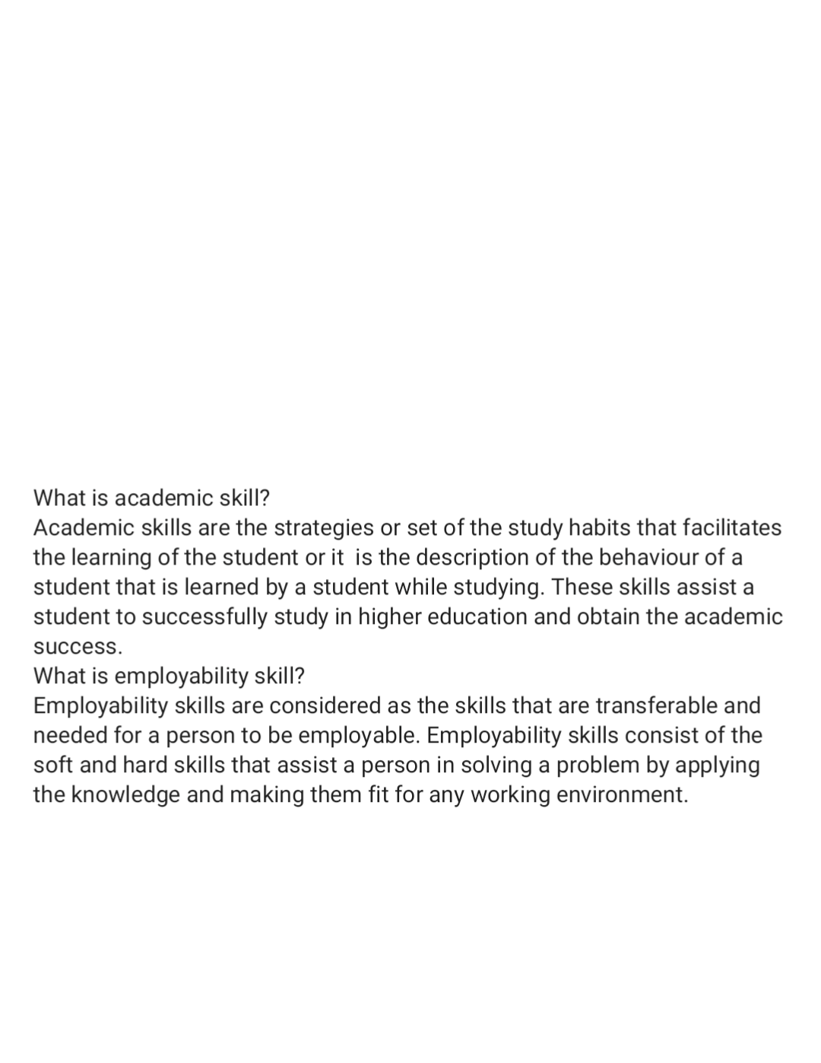
INTRODUCTION
What is academic skills?
▪
Learning strategies
▪
Collection of study habits
▪
Time management
What is employability skills?
▪
Transferable skills
▪
Applied knowledge
▪
Workplace skills
▪
Work place skills
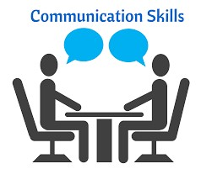

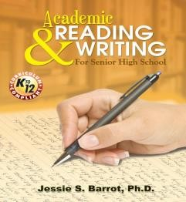






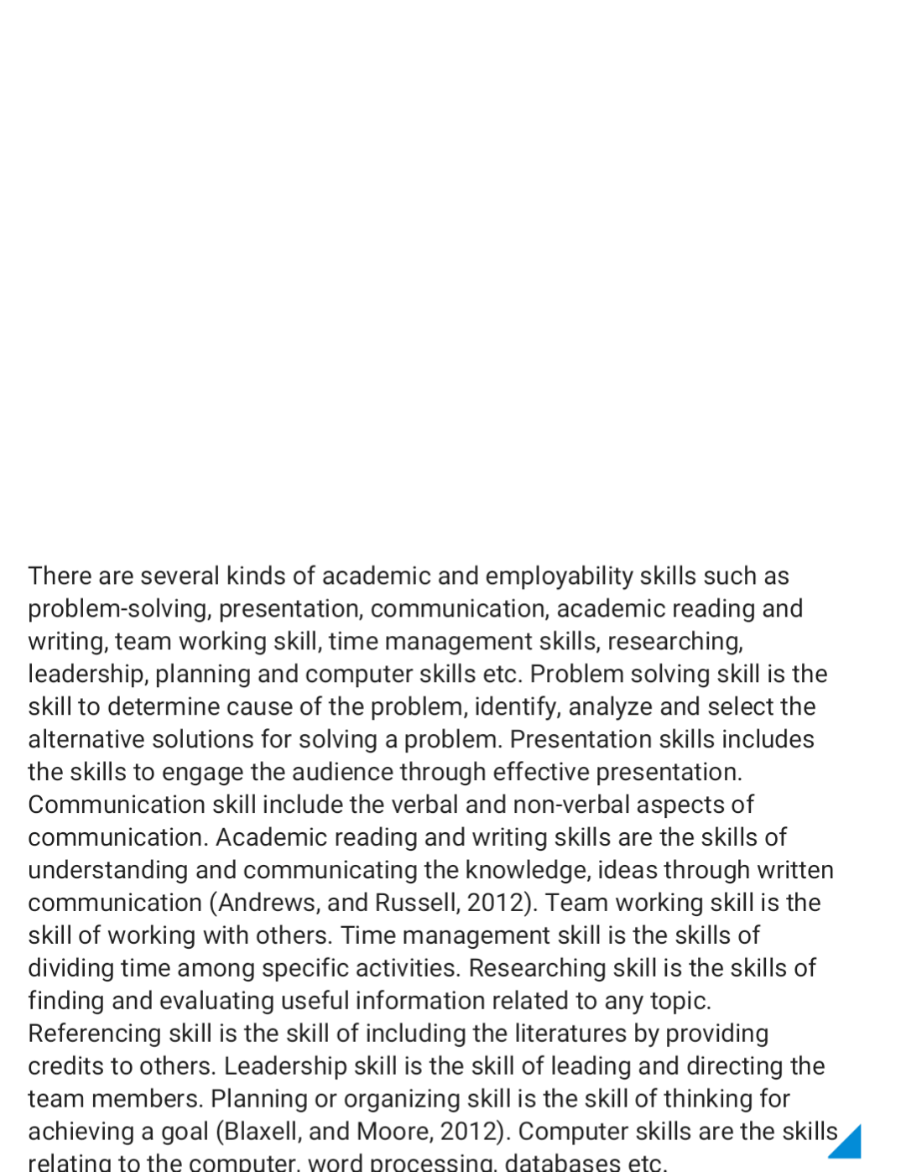
EXAMPLES OF ACADEMIC AND
EMPLOYABILITY SKILLS
Presentation &
Communication
Problem
-
solving
Academic reading
and writing
Team working
Time
management
Researching and
referencing
Leadership
Planning and
organizing
Technical or
computer skills





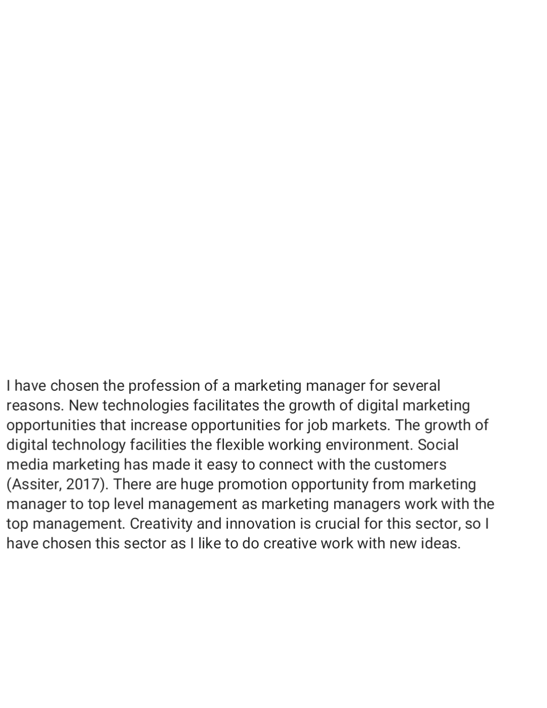
REASONS FOR CHOOSING CAREER AS
MARKETING MANAGER
Emerging new technologies
and growing job
-
market
1
Flexible working
environment
Social media marketing and
consumer interaction
Promotion opportunities
Creativity and innovation
2
3
4
5
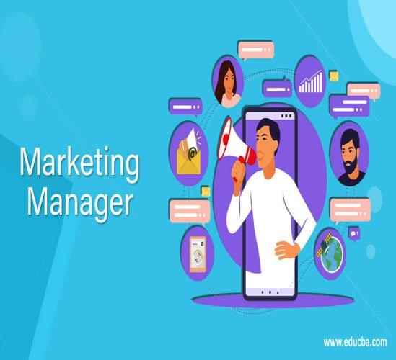




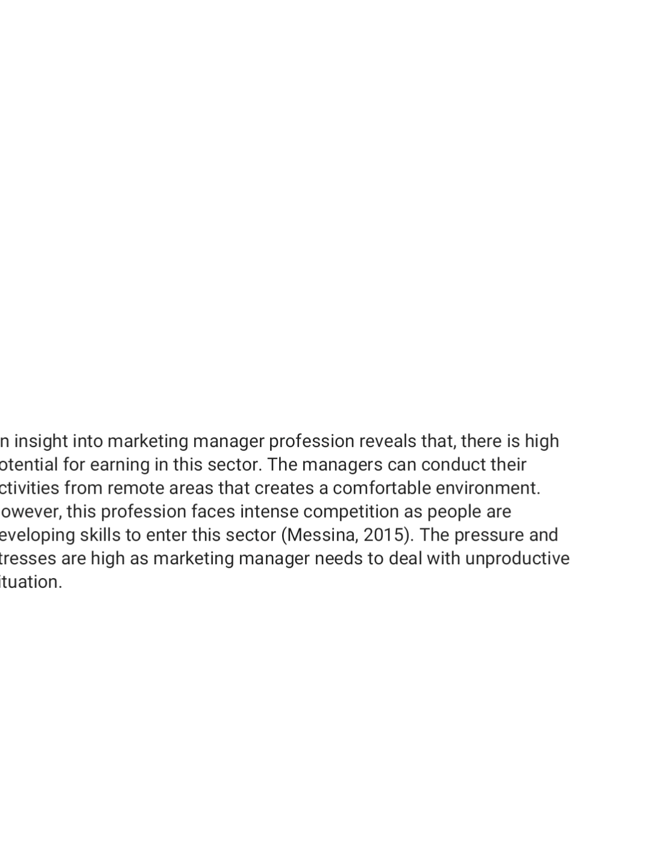
PROS AND CONS FOR A CAREER AS A
MARKETING MANAGER
High potential for earning
Intense competition and
stressful environment
3
Pressure for meeting the
deadlines
4
Comfortable environment and
virtually working opportunities
2
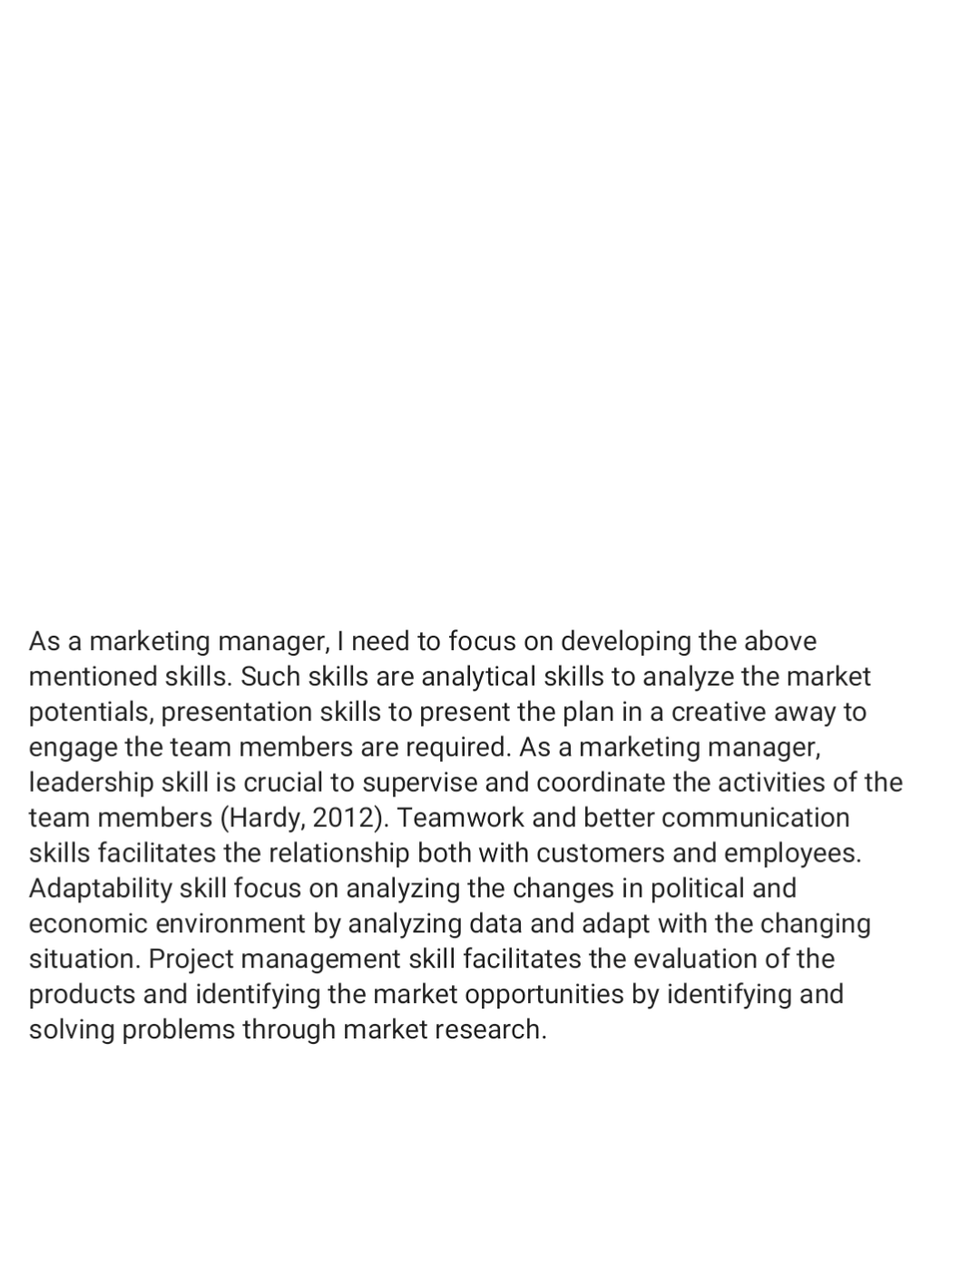
FUNCTIONS AND SKILL OF A
MARKETING MANAGER
Developing a
marketing plan
by analyzing
and evaluating
potential
markets
Analytical skill,
presentation and
creativity
Leadership, social,
teamwork and
communication skills
Adaptability,
analytics and data
analysis
Problem solving,
time management
and project
management skill
Supervising
and
coordinating
business
activities and
CRM activities
Researching on
the economic
and political
environment
Evaluating
products and
identifying new
business
opportunities




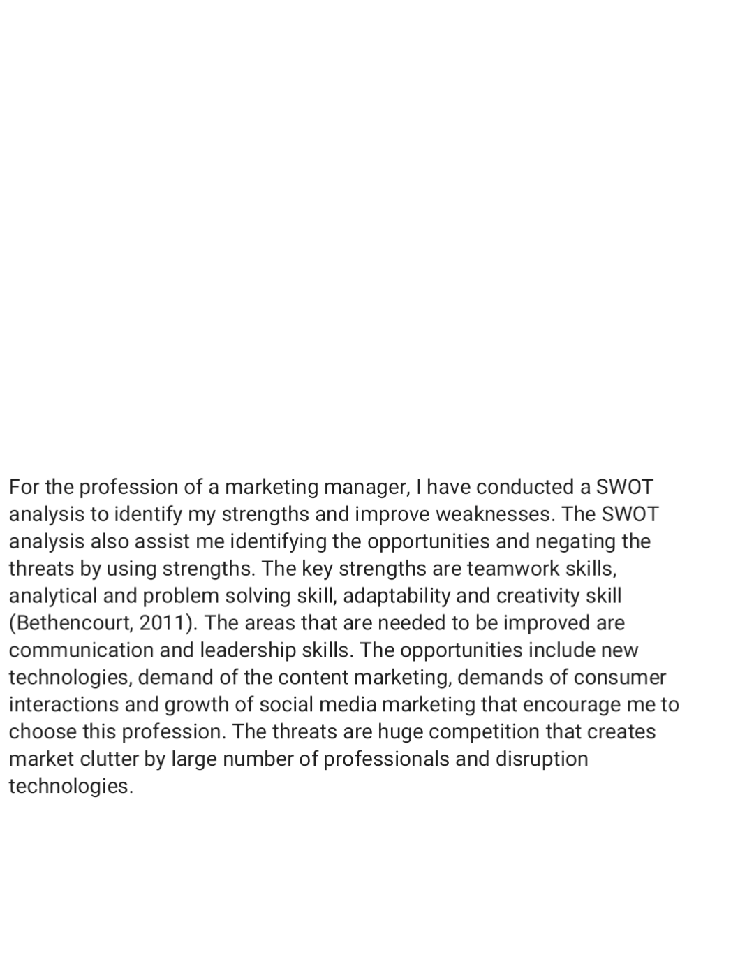
PERSONAL SWOT ANALYSIS FOR BEING
A MARKETING MANAGER
Strengths
Good teamwork skill
Analytical skill and problem
solving skill
Adaptability skill
Creativity
Weaknesses
Lack of good communication
skill
Lack of leadership skill
Opportunities
Emergence of new technology
and quality content
High earning opportunities
Growing consumer interaction
Social media marketing
Threats
Intense competition
Market clutter
Large number of marketing
professional
Changing technologies
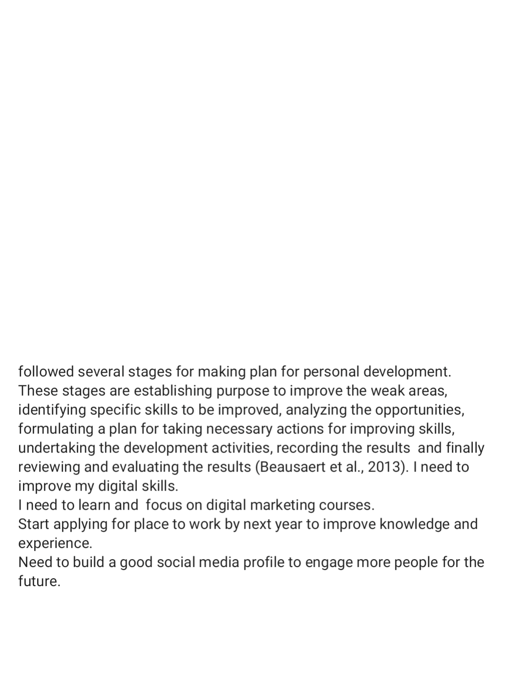
PERSONAL DEVELOPMENT PLAN
Establish
purpose
Identify
development
need
Analyze
development
opportunities
Formulation of
action plan
Undertaken
development
Recording
outcome
Reviewing and
evaluating
•
I need to improve my digital skills.
•
I need to learn and focus on digital marketing
courses.
•
Start applying for place to work by next year to
improve knowledge and experience.
•
Need to build a good social media profile to
engage more people for the future.

CONCLUSION
As a marketing
manager, for
promoting and
positioning a products
or brands, skills of
creativity,
communication and
presentation are key
areas to be improved
.
Attracting the
customers and
creating brand
awareness, social
media such as Face
book, Twitter ,
LinkedIn etc play a
key role
Content marketing
skill is require to be
developed for being
successful as a
marketing manager
REFERENCES
Beausaert, S., Segers, M., Fouarge, D. and Gijselaers, W., 2013. Effect of using a personal development plan on learning and development.Journal of Workplace Learning.
Bethencourt, P., 2011. Your Future: Start with your Personal Swot Analysis. In Success in Six Cups of Coffee (pp.129-154).Palgrave Macmillan,London.
Hardy,K.G.,2012 Marketing competencies for every manager.Business Quarterly,57(3),pp.51-53.
Messina, M.J., 2015. Recruiting a New Marketing Graduate: What Criteria are Important for Today’s Industrial Marketing Manager?. In Proceedings of the 1987 Academy of Marketing Science (AMS) Annual Conference (pp.515-515).Springer,Cham.
Assiter,A.,2017.Transferable skills in higher education.Routledge.
Andrews, G. and Russell, M., 2012. Employability skills development: strategy, evaluation and impact. Higher Education,Skills andWork-Based Learning.
Blaxell,R.and Moore,C.,2012.Connecting academic and employability skills and attributes.

