

UNIVERSITY OF WALES TRINITY SAINT DAVID
School of Engineering
The Marketing Mix
Student: GEORGIANA FLORINA CUNE
1805121
Logistics and Supply Chain Management
3 December 2018
INTRODUCTION TO MARKETING & CONSUMER BEHAVIOUR (M4X01278)

Table of contents

1. Introduction 1
2. Integrating the Marketing Mix 2
2.1. Product 2
2.2. Place 3
2.3. Price 3
2.4. Promotion 3
3. The customer perspective on the Marketing Mix 4
4. Conclusion 5

Abstract

All the marketing activities concentrate around the customer. Organizations are using the Marketing Mix notion, involving groups of strategic variables, in order to deliver value for customers and engage in customer relationships. The tools used by marketers from the seller’s point of view are referred as the four Ps: product, place, price, promotion. And from the customer’s perspective are referred as the four As: acceptability, accessibility, affordability and awareness.

Key words: Marketing Mix; Four Ps; Product, Place, Price, Promotion.

Introduction
The goal for all the organizations is to deliver value for customers and to engage in profitable customer relationships. One of the tools to provide this goal is the Marketing Mix. This concept is one of the most fundamental concepts in marketing. Armstrong et al. (2016) defines marketing mix as ‘a set of tactical marketing tools that the firm blends to produce the response it wants in the target market’ and it is also referred as the four Ps, which are the marketing mix elements: product, place, price and promotion (West et al. 2010). The 4Ps concept can be used by marketers to make decisions after a marketing analysis and take actions to provide the success of a product or service on the market.
Since it was firstly introduced in 1960 by Jerome McCarthy, the concept of Four Ps has been criticized by other marketers and added new Ps ‘…into the marketing scene in order to face up into a highly competitively changed environment’ (Nezakati et al. 2011, p.1158), but Armstrong et al. argue that ‘many activities that might appear to be left out of the marketing mix are included under one of the four Ps’ (Armstrong et al. 2016, p.83). In Figure 1 is presented the four Ps of the marketing mix and the marketing tools under each P (Armstrong et al. 2016).

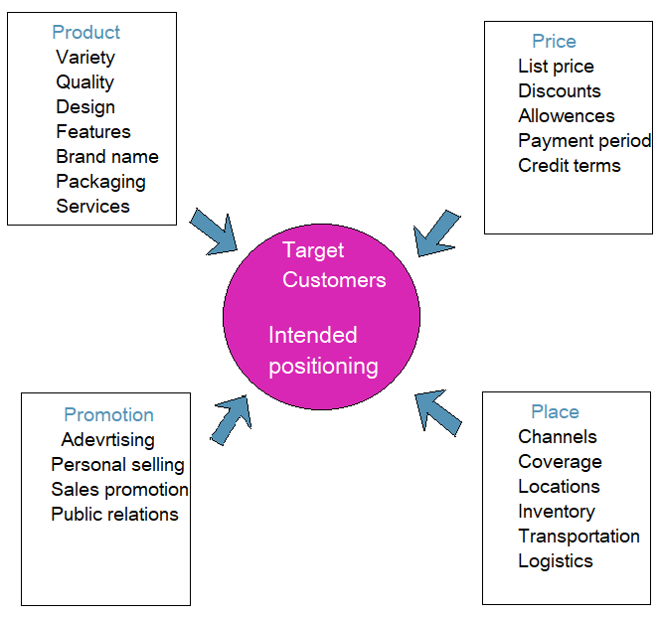
Figure 1. The 4 Ps of the Marketing Mix
Source: Armstrong et al. (2016).
Based on the marketing mix concept, this paper will evaluate the effective use of the four Ps by the Lidl company.

Integrating the Marketing Mix

2.1. Product
Product includes to ‘the goods-and-services combination the company offers to the target market’ (Armstrong et al. 2016, p.81). The budget supermarket Lidl offers a wide variety of products such as fruits and vegetables, fresh meat and fish, bakery, chilled, frozen, food cupboard, gluten-free, cleaning & household, baby products and sometimes clothing and electrical products for home. Lidl works closely with its suppliers, minimising the supply chain cost, and about two thirds of the products are sourced from local British suppliers (Lidl, 2018e).
Lidl’s product range are limited compared with other leading supermarkets in the UK, but nevertheless some of the products have been recognised prestigious awards in 2018 such as Fresh Produce Retailer of the Year (Retail Industry Awards, 2018), Christmas Retailer of the Year (Lidl, 2018a), Mother & Baby Silver Award in 2017 and other prestigious awards during the past years.
Although Lidl focuses on lowest prices for a variety of products, there may be a misconception on the quality of the products. The supermarket’s new strapline ‘Big on quality, Lidl on price’ is focusing to reinforce quality positioning through campaigns about the sources and local provenance of most of the products (Marketing Week, 2017).
Packaging is considered by marketers a step in the product decision (Armstrong et al. 2016, p.83) and as part of its sustainable movement, Lidl is committed to reduce plastic packaging of its own brand by 20% until 2022 (Lidl, 2018c). Another packing strategy for the company is to display the products in the packing they were dispatched, which is a practical and easy method for restocking the shelves and doesn’t require too much time. Figure 2 presents an example of shelf packaging for Lidl products (Lidl, 2018).
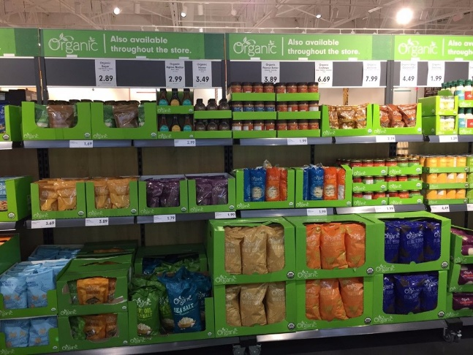
Figure 2. Products displayed on the Lidl shelves in the original shipment packaging
Source: Lidl (2018).

2.2. Place
Place refers to the activities within the company that ensure the product is available to target consumers (Armstrong et al., 2016, p.81). First opened in Germany in 1973, Lidl has expended ever since with more than 10,000 stores across twenty-nine countries in Europe, several in the United States (Lidl, 2018e) and own web shop in China (Retail Detail, 2017). In the UK, it operates over 700 stores across Wales, England and Scotland and twelve regional distribution centres (Lidl, 2018d). Lidl has established a number of Regional Distribution Centres (RDCs) in different regions of the UK to ensure that constant level of stock is maintained in the supermarkets in the area. Nezakati et al. states:
Place is replaced by convenience, with the rise of internet and hybrid model of purchasing, traditional definition of place is no longer relevant as convenience takes into account the ease to buy a product, find information about a product and several other considerations (Nezakati et al. 2011, p.1157). Although Lidl has over 700 stores across UK, it lags in the web business sector, which has grown and developed among other grocery markets. Lidl still adopts the traditional method of selling products on the store premises.

2.3. Price
The commercial success of the company when it first entered the UK food retail industry was because of the low prices it offered ((Dolgui and Proth, 2010). The company provides customer value by producing private label products which eliminates the need for middlemen, resulting in cost saving. Because the less choices of products, Lidl buys the products in bulk, allowing to get a volume discount. The discount reflects on the product prices.
Big on Quality, Lidl on Price strapline presented in Figure 3 reflects the discounter’s value (Lidl, 2018e). According to Lidl (2018e), the company is committed to provide quality products on low prices.
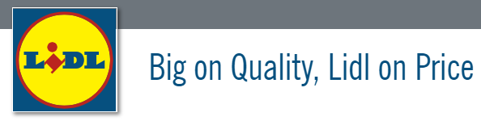
Figure 3. Lidl strapline
Source: Lidl (2018e).

2.4. Promotion
Promotion refers to information on the benefits of the product and determine the target customers to purchase the respective product (Armstrong et al. 2016, p.81). Lidl runs printed ads campaigns and media advertising on TV, radio, magazines and leaflets where the consumer can search for the newest offers.
Lidl released a campaign ‘Dream big with Lidl’ over the past three years to promote the grassroot initiative ‘FA Lidl Skills’ for children between 5 and 11-year-old to play football, creating 3 million opportunities. This advertising campaign featured football players Raheem Sterling, Gary Cahill and Kyle Walker (Campaign, 2018) as a form of celebrity enforcement to be associated with the Lidl’s brand image. Another celebrity association with the brand is Heidi Klum which has launched her budget clothing collection with the company since June 2018 (Daily Mail, 2018).
As many other organizations, the supermarket has developed an app - Lidl App for iPhone and Android where customers can browse through the latest offers in the leaflets, such as the ‘Weekly Offers’ and find information on the product prices and recipes (Lidl, 2018b).
One primary focus of the company’s social responsibility (CSR) is related to the environment and volunteer activities. The discounter adopts efficient and lean models to ensure sustainable supply chains and it works with recognised certification bodies such as UTZ Certified, RSPCA Assured, Fairtrade and MSC which commits the company to resource responsibly. Lidl is funding and supporting the National Society for the Prevention of Cruelty to Children (NSPCC) (Lidl, 2018).

The customer perspective on the Marketing Mix
The concept of Four As from the buyer’s perspective refer to acceptability, accessibility, affordability and awareness (Armstrong et al. 2016, p.81). The 4Ps focuses strictly on the ‘means’, while the 4As bring the (Nezakati et al., 2011). From the customer’s perspective, acceptability refers to product meeting the customer expectations; accessibility refers to the place and methods the customers can acquire the product; affordability refers to the amount the customer is willing and able to pay for the firm’s goods and services; awareness refers to the information the customer gets on the product’s features and reaches his mindset to buy and rebuy the products (Armstrong et al. 2016; Nezakati et al. 2011).
Acceptability for the customers of Lidl is continuously enhanced, as the company is always trying to improve their products by sourcing locally in order to deliver the expected value for its consumers.
Accessibility. As previously mentioned, Lidl has a large distribution of stores across the UK, where the customers may acquire the products without spending too much time travelling. However, one of the main drawbacks for the company is not offering the option for online shopping, a key strategy other competitor provide as the way of supply chain in the retail sector is progressing into the web business zone.
Affordability. Lidl entered the market using a low-price strategy, charging lower prices than other competitors in the food industry (Dolgui and Proth, 2010), making its cheap products available to all the consumers.
Awareness. The main way Lidl has reached to his customers is to promote the brand in TV commercials, social media and leaflets about the discounted products and the offers it provides. Customers are initially persuaded to try the products and eventually to repurchase them (Armstrong et al. 2016).

Conclusion
The concept of marketing mix is used by organizations to engage customers and provide greater value to them. The Marketing Mix accumulates different elements into four groups of variables: product, place, price and promotion referred as the Four Ps of the Marketing Mix. This concept is determined from the viewpoint of the company on the market. There is another approach on the Marketing Mix, from the perspective of the buyer and refers to acceptability, accessibility, affordability and awareness, defined as the Four As. The four As elements are not entirely connected to the concepts of the Four Ps, but they closely relate with each other - ‘product design influences acceptability, price affects affordability, place affects accessibility, and promotion influences awareness’ (Armstrong et al. 2016, p.84). The Lidl company focuses on engaging in customers relations by delivering inexpensive products available to all the customers. The variety of brands for the products is limited in the discounter store, but Lidl positioned itself on the market with lower prices than other supermarkets. Customers can find locally supplied products, from British farmers, household items, baby products, electrical and clothes. Those are products that satisfy the needs in day to day life of the customer. Accessibility reaches the customers by supplying the products in the Lidl store. The channels of distribution for the items Lidl sells are accessible to customers on the store premises, as Lidl haven’t yet entered the online business sector. The low-price strategy Lidl adopts is compensated by the big number of items it sells and own label products enables the company to eliminate the middlemen, excluding additional costs for the company. Every week the store offer discounts on its products, under the ‘Weekly Offers’ marketing strategy or ‘Pick of the week’. Lidl’s promotional activities are often based on TV advertising, Facebook, Instagram, Twitter, YouTube and other social media platforms. The company is also committed to adopt sustainable methods for the environment and support volunteer organization as part of the social responsibility to its customers.

References
Armstrong, G. et al. (2016) Marketing: An Introduction, Global Edition. 13th ed. Pearson Education Limited
Campaign (2018) Lidl ‘Dream big with Lidl’ by TBWA/London. Available at: https://www.campaignlive.co.uk/article/lidl-dream-big-lidl-tbwa-london/1465734 (Accessed 29th November 2018).
Daily Mail (2018) Heidi Klum unveils a festival range for Lidl starting from £2.49 and including some VERY convincing designer lookalikes – so can YOU tell which is which? Available at: https://www.dailymail.co.uk/femail/article-5828893/Heidi-Klum-launches-designer-inspired-festival-collection-Lidl-starting-just-2-49.html (Accessed 29th November 2018).
Dolgui, A. and Proth, J. M. (2010) Pricing strategies and models. Annual Reviews in Control, 34(1), pp. 101-110.
Khan, M.T., 2014. The concept of 'marketing mix' and its elements (a conceptual review paper). International journal of information, business and management, 6(2), p.95.
Lidl (2018a) Awards. Available at: https://www.lidl.co.uk/en/Awards-997.htm (Accessed 28th November 2018).
Lidl (2018b) Lidl App. Available at: https://www.lidl.co.uk/en/Lidl-App-923.htm (Accessed 30th November 2018).
Lidl (2018c) Packaging and plastic. Available at: https://www.lidl.co.uk/en/Packaging-and-plastic-12985.htm (Accessed 28th November 2018).
Lidl (2018d) Press Office. Available at: https://www.lidl.co.uk/en/Press-Office-13531.htm (Accessed 30th November 2018).
Lidl info (2018e) About Lidl. Available at: https://www.info.lidl/en-gb/index.html (Accessed 28th November 2018).
Marketing Week (2017) Lidl reveals ‘Big on quality, Lidl on price’ strapline. Available at: https://www.marketingweek.com/2017/01/03/lidl-reveals-new-big-quality-lidl-price-tagline/ (Accessed 30th November 2018).
Nezakati, H. et al. (2011) Exploring hierarchy situation of 4A marketing mix on Malaysia’s fast food restaurants. World Applied Sciences Journal, 15(8), pp.1157-1167.
Retail Detail (2017) Lidl launches Chinese web shop. Available at: ( https://www.retaildetail.eu/en/news/food/lidl-launches-chinese-web-shop (Accessed 29th November 2018).
Retail Industry Awards (2018) Retail Industry Awards winners. Available at: https://retailindustryawards.com/ria18/en/page/winners-2018 (Accessed 30th November 2018).
West, D. C. (2010) Strategic marketing: creating competitive advantage. 2nd ed. Oxford: Oxford: Oxford University Press.

