A Reflective Report on the Impact of the Masterclasses



MARCH 2018

MODULE NAME: Academic Skills
Project Name: Ysgol Crug Glas Tuckshop Project
Name: Heather jackson
Student Number: 1704024

Table of Contents

1. eXECUTIVE sUMMARY 1
2. Introduction 2
2.1 Report Remit 2
2.2 Brief background on your project 2
3. Models of reflection 3
3.1 Masterclass Sessions 4
3.2 Influence of Masterclasses on the Project 6
3.3 Influence of the masterclasses on personal learning & development 8
4. Conclusion 10
5. References 11

List of Figures
FIGURE 2-1 – Gibb’s (1998) Reflective Cycle https://www.kent.ac.uk/ 4

APPENDICES
APPENDIX A – Stifyn Parri notes
APPENDIX B – Ben Room Notes

eXECUTIVE sUMMARY

This is a management report to reflect upon and identify the skills and themes covered in the masterclasses at the Swansea Business School. The themes and skills will be further supported by relevant literature and models.
The project being reflected upon will be the Ysgol Crug Glas Tuckshop Project, where five students from the Swansea Business School worked with the students from Ysgol Crug Glas. Ysgol Grug Glas is a school in Swansea for children who suffer from complex and often multiple learning difficulties and disabilities. The team's aim was to raise awareness for Ysgol Crug Glas and their students within their local community.
A variety of reflective models will be discussed; However, this report will focus on Gibbs’ (1998) reflective cycle and the three staged models.
The main themes identified throughout the masterclasses included: Leadership, Motivation, Organisational skills, Self-awareness and, Confidence. These Themes are considered essential in both a successful academic and workplace environment. Inevitably these skills were applied throughout the project, overall improving the quality of the team’s performance.
The findings of the impact the masterclasses had on the project showed that the team needed to improve their communication skills as well as their time management skills. When looking at the personal learning and development section it was deemed essential to focus on SMART goals in the future to maintain motivated.
To conclude the themes identified in the masterclasses had a significant impact on both the project and on personal learning and development, these themes attributed towards the team’s success both together and individually. It is apparent that reflecting on both aspects of this report allowed a further understanding of the weaknesses of the team and individuals within the team. This allows for these weaknesses to be worked on before future projects.
The recommendations from this report include gaining a more comprehensive understanding of what motivates you and your team members. As well as working on effective communication methods.

Introduction

Report Remit

The remit of this report is to identify and reflect upon the skills and concepts highlighted and discussed by the masterclass speakers, concepts, and skills that are relevant to higher education. This will be presented in the form of a management report.
These skills and concepts will be better understood, using relevant literature to support that was discussed in the masterclasses. The skills that will be focused on include skills that support lifelong learning and can be transferred to different roles throughout life. These skills will have been used to help improve, impact and influence the way the project was implemented. It will also be looked at how the themes discussed in the masterclasses were influential on the student’s development and personal learning. It will also be included and reflected upon as to how the project could be improved and recommendations as to how future projects could be improved. Both an academic and practical understanding of these themes will be discussed including further research has been carried out. This will allow for the context in which these themes sit to be more broadly understood.

Brief background on your project

The project that this report will refer to is the Ysgol Crug Glas Tuckshop project; for this project, a group of four students worked with a disabled school in Swansea to raise awareness for the school and their students within their community. The students at Ysgol Crug Glas operate a tuckshop at their school, selling chocolate bars, sweets, and fizzy drinks. To raise awareness for students at the Ysgol Cryg Glas the group worked with the staff at the school to organise events where the students could set up their tuckshop starting at the Swansea Business Campus. The group also participated in a sponsored walk as part of their project.
To finish the project group attended a showcase event at unit nineteen on wind street where all of the different project groups were invited to showcase their project, organisation, and what they have achieved.

Models of reflection

This report will follow a model of reflection in order to adequately reflect on the experiences gained throughout the project. To do this its first important to evaluate the existing models, their limitations and decide which model is best suited to this report.
Coltman et al., (2008) state that most scholars use a reflective model, that these types of reflective models can be fundamental to theory building. Most models are staged models where an order is nominated as to how different aspects of the experience being reflected upon are considered.
Three staged models’, there are various three staged models. Borton (1970) and Driscoll (1994) both demonstrate and adopt this type of model. These models simplify the reflective process to: What?, So What?, and Now What? (Brown et al., 2015)
Multi-staged models break the stages of reflection down further, an example of this is Gibbs’s (1998) model the ‘Reflective Cycle’ that includes six stages: Description, Exploring Personal Feeling, Evaluation, Analysis, Conclusion, and Action Plan. Cottrell (2013) developed a core prompt-based model that is still popular with both professionals and academics. Cottrell’s (2013) model was designed to encourage questions that relate to a broader way of thinking, this is also further evident in Cottrell’s (2013) C.R.E.A.M strategy.
Kolb (1984) identified an experimental learning model that uses experiences as a fundamental tool for learning. This model reflects using: A Concrete Experience, Reflective Observation, Abstract Conceptualisation, and Active Experimentation.

This report will use multiple models but will focus on Gibbs’ reflective cycle to reflect on both the master classes and the project/project group, and the relationship between the two. A diagram for Gibbs’s reflective cycle can be found in figure 2-1. Gibbs’s (1998) model is a multi-stage model allowing an in-depth reflection on the project as a whole as well as how it can be improved upon in the future, this is evident in the action plan portion of the reflective cycle. Cottrell (2013) also identifies the criticality of reflection in order to improve in the future allowing mistakes to be understood and rectified or improved upon.

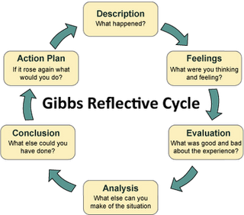
Figure 2-1 – Gibbs’ reflective Cycle

Masterclass Sessions

To allow the Swansea business school students to enhance their skills for the projects they were assigned to work on, they attended weekly master classes. These masterclasses were given by a variety of people, specialising in a variety of backgrounds, from entrepreneurs to entertainers. The main themes identified in these masterclasses included: Confidence, Motivation, Leadership, Self-awareness and Organisational skills. First, this section will identify what each of these themes are and then useing Gibbs’ (1998) reflective cycle will begin to reflect upon each.
Due to the limitations of this report, not all the masterclass speakers can be identified however the few that had the largest impact on the tuckshop project group will be identified. Starting with Stifyn Parri otherwise known as Mr. Producer, Stifyn Parri was confident and self-aware, he stood out to the team as he had the ability to display all the themes he talked about. Stifyn Parri is an entrepreneur in the entertainment industry (Parri, 2018). Parri (2017) highlighted the importance of the four C’s during his master class, the four C’s in this case including: Calm, Controlled, Clear, and Confident. This can be seen in Appendix A. All of the themes discussed in Parri’s (2017) masterclass related to confidence and its important role in becoming successful. Hogarth and Karelaia (2012) reinforce the importance of confidence within a business environment indication that confidence could be a key factor as to the success of an entrepreneur and their new business venture.
Parri (2017) stated some of the key factors of a good leader, continuing the importance of confidence within a leader. Parri (2017) also talked about the difference in status and how this can affect the way in which people perceive you, identifying the differences between a high low and medium status and when each could be deemed appropriate.
Mullins (2016, pg.620) defines leadership as “A relationship through which one person influences the behaviour or actions of other people.”. Northouse (2013) states the different types of leadership and how each type can impact upon the performance of a business in a different way. Both Kippenberger (2002) and Northouse (2013) support the idea that leadership is adaptable and not all situations, workplaces, or projects require the same style of leadership, success can be determined by the effectiveness of the leadership within an environment.
Martin and Fellenz (2010) use the definition “motivation refers to the set of internal forces that initiate, direct, and sustain deliberate behaviour”. Room (2017) states that individual motivation is key to a successful business, to help an individual feel motivated its essential for a said individual to understand their own goals. It is important to see the bigger picture to remain motivated (Room, 2017) this can be seen in Appendix B. Psychologists have identified two motivational theories, intrinsic, and extrinsic. Reiss (2012) identifies the differences between these two types of motivation theories. Defining intrinsic motivation as ‘‘doing something for its own sake,’’ for example a child playing a sport for no other reason than they want to and enjoy it. Reiss (2012) defines extrinsic motivation “the pursuit of an instrumental goal” using the same example as above when a child competes in a sport to win a title or championship. The difference between these types of motivation can be personal and each individual may not have the same response to both intrinsic and extrinsic factors. Pink (2010) encourages the idea that intrinsic and extrinsic motivation is beyond our generic reward and punishment system.
A theme that was clearly apparent throughout the masterclasses that can be found both in appendix A and appendix B is the concept of self-awareness. Eurich (2018) states that self-awareness is “being able to see yourself” and once an individual is able to do this the individual will become more creative, more confident, and make sounder decisions. Eurich (2018) also states that self-awareness is the difference between how others view us and we view ourselves. Parri (2017) touched on this during his talk, mentioning the importance of being genuine, understanding your own strengths and more importantly, your weaknesses will inevitably make you more successful.
The final theme to be discussed that stood out to the Ysgol Crug Glas project team was organisational skills, Jenkins (2017) mentioned the importance of organisation within her business, being organised and having good time management are crucial when delivering a product or service to a customer, regardless of the industry. Both Northouse (2013) and Martin and Fellenz (2010) consistently imply the importance of organisational skills throughout an organisation on all levels. However, this is deemed particularly important for effective leadership and management.
All of these themes when developed can be considered skills that are detrimental to the further development of an individual in any sphere. Whether academic or within the workplace. These skills can be transferred, this became evident in the early stages of the project where the team applied all of these skills to both the professional side of the project, and the personal academic side of the projects.

Influence of Masterclasses on the Project

This section will use Gibbs (1998) reflective cycle to reflect upon the direct impact the masterclasses had on the implementation of the Ysgo Crug Glas groups project. To make this easier to follow this section will be split into subheadings each heading representing a stage in the reflective Cycle.
Description
The group had to work with a disabled school in Swansea planning events for the school children to attend, as well as planning the teams own academic events such as the showcase at unit 19. The team was led by Heather, the team worked under a democratic leadership style, meaning that each member of the team had assigned roles and everyone’s input was considered in the decision-making process. These are all key traits of an organisation that adopts a democratic leadership style (Western, 2008) and (Mullins, 2016). Pettinger (2013) states the importance of suitable and strong leadership to any organisation, implying that bad or unsuitable leadership will result in delays and unsatisfied customers. Leadership styles such as the laissez-faire leadership allow the leader to take a back seat and let team members do what they think is best (Mullins 2016). After attending the masterclasses, it became apparent that it was essential for one member of the team to take more responsibility, this links with the concept and importance of confidence. It was important that each member of the team was confident and capable in their set role, for Heather this was leadership.
Exploring Personal Feeling
While the idea of being the team leader may have initially been daunting, after taking Parri’s (2017) four C’s into consideration there was a model to follow. While pushing the team to achieve their next goal it was important Heather remained calm, controlled, confident, and clear. This was stressful and testing at times its believed that the team as a whole were each confident and capable in the role assigned, its felt that this is due to their individual input into each role. This input allowed them to test themselves without having to work within their weakest skill set. As a whole this confidence and calmness that the team employed allowed them to efficiently work on tasks and organise events.
Evaluation
The overall leadership and confidence within the team was strong however there were some significant weaknesses, these weaknesses were within the communication of the team, this affected their organisational skills. While each member of the team was working well within their assigned roles it became apparent that the collaboration to make things run smoothly could have been improved upon. While the team were reasonably aware of most of their weaknesses, making them self-aware to an extent, it is felt that there was a lack of awareness to some of the weaknesses particularly in terms of the team as a whole.
Analysis
To analyse the situation as a whole is to consider the constraints put on the team, such as the team before this project having never worked together making everyone unaware of each other’s working styles and preferences. The masterclasses gave the team a common ground to work from when trying to improve certain aspects of the team and the project. This was evident at unit 19, the whole team had to present themselves in a way that no one had done before. Parri (2017) reinforces the importance of confidence and this confidence that the team had gained through his masterclass was evident at the unit 19 event. Understanding the underlying themes within the concept of confidence such as status allowed the team members to feel comfortable with situations like unit 19. Pink (2010) states that motivation goes beyond the normal reward and punishment system looking at intrinsic and extrinsic motivation, it was clear at the unit 19 event that the Ysgol Crug Glas Tuckshop team wanted to do well for themselves rather than the reward available. This was in intrinsic motivator for the team.
Conclusion
To conclude the reflection of the project its evident that the tasks required for the project were themselves simple, however, it was the organisational skills of the team themselves that were more complex. It is also very clear that the masterclasses positively influenced the team and helped them collaborate more efficiently with both each other and Ysgol Crug Glas.
Action Plan
For future projects similar to the Ysgol Crug Glas tuckshop project it would be considered essential to improve individuals time management skills and organisational skills. However, this must be done as a team. Setting stricter deadlines within the team may help this be achieved. It would also be essential for the team to improve their communication skills, communications skills are detrimental to the success of any team and their ability to work productively (Madrid, Totterdell and Niven, 2016).

Influence of the masterclasses on personal learning & development

This section will use a three-stage model of reflection to reflect upon the influence the masterclasses had on personal learning and development. To make this easier to follow this section will be split into subheadings each heading representing a stage in the reflective Cycle.
What?
While it is important to recognise how the masterclasses have directly impacted upon personal learning and development in terms of themes mentioned by both Parri (2017) and Jenkins (2017) such as organisational skills, and leadership skills. It is also key to acknowledge the effect attending these classes has indirectly had on personal learning and development. The masterclasses helped develop skills such as, making and storing notes, and Classifying and organising information. These classes helped identify weaknesses in making and storing notes, not only taking them but filling them appropriately. A practicall application of the leadership concept Parri (2017) thought was how Heather had to step into the team leader position for the Ysgol Crug Glas project team, Heather used the themes thought by Parri to try and maintain a calm and controlled leadership style. It was also essential for Heather to not appear undermining this was a theme Parri highlighted that was taken on board during Heathers time as team leader. Mullins (2016) highlights the importance of being a fair leader while still remaining in control, Heather attempted to follow these approaches to the best of her ability.
Room (2017) highlighted the importance of goal setting for individual success, that goals need to be specific to an individual. Achievable personal goals is an essential factor in remaining motivated (Room,2017). It was clear that through out this project there were both intrinsic and extrinsic factors to maintain motivation. Working within any social enterprise will allow personal satisfaction this being an intrinsic motivator, students also had an end gaol of passing assignments related to this project as well which would have been an extrinsic motivator. Room (2017) thought the concept that smaller goals leading to one larger long term goal keeps an individual motivated, during his masterclass. This concept really stood out on a personal development level.
So What?
Identifying and understanding weaknesses is crucial to both personal development and learning but also to enable an individual to have better self-awareness. Once these weaknesses are identified it allows them to be worked on and eventually rectified, practice makes perfect (Parri, 2017). Skills such as note-taking and organisation are essential to personal learning and development within academia, it is important to enhance these skills to the best of ability. These skills, as well as Leadership skills and their importance, are transferable into the workplace, these skills can be used anywhere from an interview to higher management positions. Heather enjoyed her time as team leader and as a result of this possition within the Ysgol Crug Glas project she is keen to explore her opportunities to enhance this skill and take it straight into the work place. Understanding weaknesses within yourself and striving to improve them is imperative, once these weaknesses are understood it is easier to maintain motivated. Ben rooms masterclass concept of motivation sparked further research into this theme and increased motivation levels. This helped intrinsic and extrinsic motivators to be understood on a personal level (Pink,2010).
Now What?
The importance of this stage is highlighted by Piscitelli (2009) who states that it is important to have both long and short-term goals, something to work towards but these goals must be measurable, he states there is a long way to go from getting an A in math class and becoming rich. These two goals are not measurable, bite-sized goals would need to be implemented along the way. The SMART goals model can be used to ensure goals; Specific, Measurable, Action, Receivable, and Timely. These words make up the SMART acronym, this is an effective method of ensuring goals are both achievable and heading towards the bigger picture, one step at a time (Gradeless,2003).
For future academic studies the SMART goal model will be applied, the weaknesses identified through the masterclasses will be focused on, aiming to slowly improve them step by step while working towards an end goal. Heather plans to work towards the goal of improving her leadership skills Heather has decided that industry-specific practice is essential to improve her leadership techniques to ready them for the workplace. An example of this would be to engage with projects in the future such as the Tuckshop project with Ysgol Crug Glas to work on leadership skills in a practical environment. Further research into motivation will be carried out to help improve the quality and understanding of work, maintaining motivated is essential for effective work (Reiss, 2012).

Conclusion

In conclusion, after reflecting on the masterclasses and both their impact on the Ysgol Crug Glas Tuckshop Project and personal learning and development, it is clear that the same themes had a major impact on both. Themes such as: leadership, organisational skills, communication skills, self-awareness, confidence, and, motivation. While some of these themes including, leadership and confidence were more prominent in regard to the team, and others including, self-awareness and motivation to personal development and learning. These themes being discussed allowed individuals and the team as a whole to identify their strengths and work on their weaknesses. Allowing further understanding of what motivates them as individuals and their ability to communicate.
The importance of a strong reflective structure has become apparent; While there are many different models, each with different stages it is important to understand the limitations of each. Having a structured method of reflation allows a more comprehensive overview of an experience.
It is important to acknowledge that there are more reflective models, and themes that were discussed in the masterclasses that may have impacted upon the project. However, due to the limitations of the report, it was not possible to look at them all. In the future, further research could be performed within both of these areas to allow a fuller understanding the impact the masterclasses had on both the project and personal learning and development.

References

Borton, T. (1970). Reach, touch, and teach. 1st ed. Toronto: McGraw-Hill.

Brown, B., Holt-Macey, S., Martin, B., Skau, K. and Vogt, E. (2015). Developing the reflective practitioner: what, so what, now what. Currents in Pharmacy Teaching and Learning, 7(5).

Coltman, T., Devinney, T., Midgley, D. and Venaik, S. (2008). Formative versus reflective measurement models: Two applications of formative measurement. Journal of Business Research, 61(12), pp.1250-1262.

Cottrell, S. (2013). The study skills handbook. 4th ed. Basingstoke, Hampshire: Palgrave Macmillan.

Driscoll, J. and Teh, B., 2001. The potential of reflective practice to develop individual orthopaedic nurse practitioners and their practice. Journal of Orthopaedic Nursing, 5(2), pp.95-103.

Gibbs, G. (2018). Learning by Doing: A Guide to Teaching and Learning Methods. 1st ed. London: FEU.

Gradeless, M. (2003). Smart goals. Dental Economics, 93(9), p.74.

Tasha Eurich (2018). What Self-Awareness Really Is (and How to Cultivate It). [online] Harvard Business Review. Available at: https://hbr.org/2018/01/what-self-awareness-really-is-and-how-to-cultivate-it [Accessed 9 Mar. 2018].

Hogarth, R. and Karelaia, N. (2012). Entrepreneurial Success and Failure: Confidence and Fallible Judgment. Organization Science, 23(6), pp.1733-1747.

Jenkins, K. (2017). Kates Brownies. Masterclass. 12 October 2017.

Kippenberger, T. (2002). Leadership styles. Oxford: Capstone Pub

Kolb, D. (2018). Experiential Learning: Experiences as the Source of Learning and Development. 1st ed. London: Prentice-Hall.

Martin, J. and Fellenz, M. (2010). Organizational Behaviour and Management. 4th ed. Andover: Cengage Learning EMEA.

Madrid, H., Totterdell, P. and Niven, K. (2016). Does Leader-affective Presence Influence Communication of Creative Ideas Within Work Teams?. Emotion, 16(6), pp.798-802.

Mullins, L. and Christy, G. (2016). Management and organisational behaviour. 11th ed. Harlow: Pearson Education Limited.

Northouse, P. (2013). Leadership. 6th ed. London: Sage Publications, Inc

Parri, S. (2018). HOMEPAGE | Stifyn Parri. [online] Mrproducer.co.uk. Available at: https://mrproducer.co.uk/homepage/ [Accessed 8 Mar. 2018].

Parri, S. (2017). Mr Producer. Masterclass. 12 October 2017.

Pettinger, R. (2013). Organizational Behaviour. Hoboken: Taylor and Francis.

Pink, D.H., (2010). Drive the surprising truth about what motivates us. Edinburgh: Canongate.

Piscitelli, S. (2009). Study Skills: Do I Really Need This Stuff?. 2nd ed. London: Pearson Education.

Reiss, S. (2012). Intrinsic and Extrinsic Motivatio. Teaching of Psychology, 39(2), pp.152-156.

Room, B. (2017). Strive to Achieve. Masterclass. 02 November 2017.

Western, S. (2008). Leadership A Critical Text. 1st ed. London: Sage Publications Ltd.

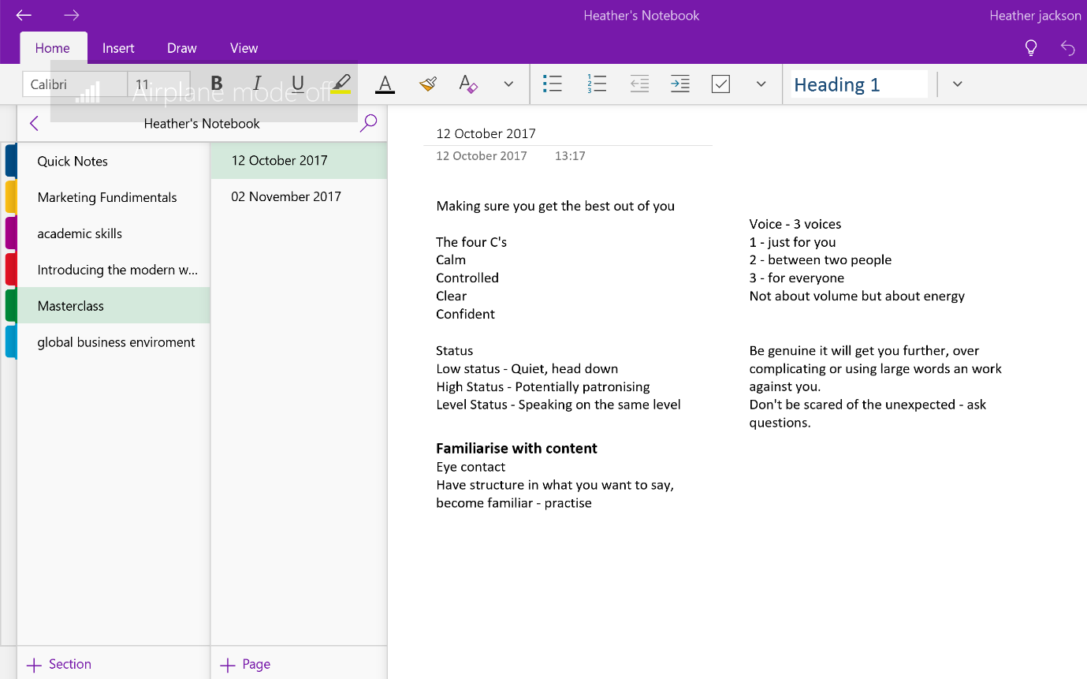
APPENDIX A

APPENDIX B


