Financial Management for Business Sustainability (BMSP4017)
Assessment 1: Mercedes-Benz Report



(Mercedes-Benz Logo, 2024)

Name: Iestyn Thomas 2404285
Lecturer: Navdeep Randhawa
Introduction
For this report I will be analysing the financial performance of German automotive company Mercedes-Benz during the years of 2022 and 2023 by examining their published financial statements and carrying out a ratio analysis. I will be providing reasons for why Mercedes may have performed better or worse than the previous year as well as make recommendations as to how the business could make financial improvements for the future and become more sustainable.
Mercedes-Benz have a rich history which began in 1886 when German entrepreneur Carl Benz built what is widely considered to be the first proper car (Ortiz, 2024). In 1926, Benz merged with rival Daimler to officially form Mercedes-Benz. Today, Mercedes-Benz are a car manufacturing phenomenon with a diverse product lineup that includes iconic models such as the S-Class and G-Wagon, alongside a growing range of electric vehicles (Charman, 2024). Headquartered in Stuttgart, Mercedes employ over 175,000 people and operate in 6 continents worldwide. (“Mercedes-Benz Group AG Company Description”, 2024).
Ratio Analysis and Reasons for Performance Changes
As seen by looking at the appendix, I have carried out a ratio analysis focusing on profitability, liquidity and efficiency by examining the official annual financial report of Mercedes-Benz. One metric that I used to analyse Mercedes-Benz is profitability performance was the gross profit margin ratio. This measures how efficient a company is at generating profit from its operations and shows how much of every £/€1 made in sales, remains as gross profit after deducting the cost of goods sold (Bloomenthal, 2024). In 2022 Mercedes had a gross profit margin of 22.68%, however this decreased slightly to 22.44% in 2023. The slight decline indicates that the cost of goods sold increased at a faster rate than the revenue. These increased costs seemed to have stemmed from higher supplier and production costs due to inflation which Mercedes-Benz were forced to pay in 2023. Also, despite a rise in revenue from €150.0 billion in 2022 to €153.2 billion in 2023, the focus on high-end and electric vehicles, which carries higher production expenses likely affected the COGS and therefore the overall gross profit margins. (“Mercedes profits hit by inflation, supply chain snags in 2023”, 2024; Kokemuller, n.d.; “Annual Report 2023”, 2024; “Sustainability Report 2023”, 2024).
The next profitability ratio I used to analyse Mercedes-Benz is financial performance was the mark-up ratio. Mark-up refers to the difference between the selling price of a good and its cost as a percentage. Similarly to the gross profit margin the mark-up ratio decreased marginally from 29.33% in 2022 to 28.93% in 2023, indicating a smaller margin between the selling price and the cost of goods in 2023 compared to 2022 (CFI Team, n.d.; “Annual Report 2023”, 2024). The decline in these profitability ratios from 2022 to 2023 can also be attributed to the increasingly rising raw materials costs in the automotive industry. Prices for raw materials have surged due to geopolitical tensions, supply chain disruptions, and inflation in recent years. This increase in costs has significantly impacted Mercedes-Benz is cost of goods sold, gross profit and therefore its mark-up ratio (Joyce, 2025).
To further analyse Mercedes-Benz is financial performance, I used the net profit margin ratio, which shows how much of each £/€1 of revenue is retained as net profit after all expenses, taxes, and costs get deducted (Murphy, 2024). Through ratio analysis I discovered that Mercedes-Benz is net profit margin has marginally decreased from 9.87% in 2022 to 9.48% in 2023 (“Annual Report 2023”, 2024). Typically, companies in the manufacturing industry have a net profit margin between 5-10%, therefore although Mercedes-Benz’s net profit margin receded slightly, the company remains within this range, indicating stable performance in this area. (“Net Profit Margin and Benchmark per Industry”, 2024).
The final profitability ratio I used was the return on capital employed ratio. ROCE shows the percentage of profits made from every £/€1 invested in the business (Hayes, 2024). Mercedes-Benz is ROCE decreased from 11.92% in 2022 to 10.89% in 2023, which indicates reduced efficiency in generating returns from the capital employed (“Annual Report 2023”, 2024). The decline to Mercedes-Benz is profitability ratios can be mainly attributed to higher supply chain, raw materials and production costs. (“Mercedes profits hit by inflation, supply chain snags in 2023, 2024”; Joyce, 2025).
Liquidity ratios assess a company’s ability to pay off its short-term liabilities by using existing assets (Tamplin, 2023). The two liquidity ratios I decided to use were the current and liquid capital ratio. The current ratio measures a company’s ability to pay short-term obligations by comparing its current assets to its current liabilities (Fernando, 2024). For automotive companies, a current ratio greater than one generally indicates a comfortable liquidity position (Smith, 2024). As shown in the appendix, by doing a ratio analysis I discovered that Mercedes-Benz is current ratio has improved from 1.16:1 in 2022 to 1.26:1 in 2023. This improvement indicates that Mercedes-Benz now have a stronger liquidity position and are now better equipped in 2023 to pay off their short-term obligations by using existing assets than they were in 2022. This improvement is likely due to a decline in current liabilities which declined from €88.4 billion in 2022 to €82.4 billion in 2023, which was aided by higher revenue and better cash flow management. (“Annual Report 2023”, 2024; Elkins, 2024).
Liquid capital ratio measures a company’s ability to cover its short-term liabilities using its most liquid assets, excluding inventory, which can be difficult to convert into cash quickly (Hayes, 2024). Typically, a ratio below 1 suggests that companies might struggle to cover its current liabilities. An ideal ratio is considered to be 1:1 (“Navigating Financial Health”, 2023). Although Mercedes-Benz is liquid capital ratio rose from 0.87:1 in 2022 to 0.93:1 in 2023, both figures are below 1 indicating that Mercedes might struggle slightly to cover its short-term obligations using its most liquid assets. However, the rise in the liquid capital ratio does show enhanced ability to meet short-term obligations using liquid assets, excluding inventory. Similarly to the current ratio the reduction in current liabilities is a contributing factor for the change, as a decrease in short-term debts has a positive impacted on the ratio (“Annual Report 2023”, 2024).
The final type of ratio analysis I decided to use to analyse Mercedes-Benz is financial report, were efficiency ratios. The efficiency ratio that I decided to use was inventory turnover, which is a measure of how efficiently a company’s inventory is managed. It measures the number of times a business sells and replaces its inventory over a specific time frame (Fernando, 2024). Through ratio analysis I discovered that Mercedes-Benz is inventory turnover increased from 74.08% in 2022 to 81.26% in 2023. The increase in inventory turnover demonstrates that Mercedes-Benz managed to sell and replace inventory more frequently in 2023. Reasons for this include improved inventory management and a higher demand for Mercedes-Benz produced vehicles, especially high-end and electric models, which is demonstrated in their sustainability report by the increase in electric vehicles sold in 2023 by Mercedes-Benz which is 401,943 vehicles compared to 333,490 vehicles sold in 2022. (“Sustainability Report 2023”, 2024; (Fernando, 2024; “Annual Report 2023”, 2024).

Recommendations for Improvements
Based on the information gathered from the ratio analysis and the reasons provided for performance changes, there are a wide variety of ways that Mercedes-Benz can improve their financial performance.
One way Mercedes-Benz could improve their financial performance and profitability ratios in particular is by focusing on cost optimisation. One of the main reasons for a decline in Mercedes-Benz is profitability ratios from 2022 to 2023 is the increase in costs of goods sold, which is likely driven by an increase in suppliers, raw material and production costs. Renegotiating lower supplier contracts for raw materials or searching for suppliers elsewhere is one of the ways Mercedes could reduce their costs and improve their financial performance. Additionally, Merecedes-Benz could partner with more eco-friendly suppliers to not only potentially negotiate cheaper deals for materials but also to operate in a more sustainable manner which can potentially attract customers who are keen on companies who act in a sustainable manner and lead to an increase in revenue. (Joyce, 2025; “Profitability ratios: what they are and how to use them”, 2022).
Although Mercedes-Benz improved their liquidity ratios, they only made minor improvements, leaving room for further gains. One way Mercedes can continue to lower their liquidity and improve their liquidity ratios is by selling non-essential assets. If there are underutilized assets or investments that are not critical to Mercedes is operations, selling these could free up cash to pay off liabilities (“13 Best Ways To Improve Your Liquidity Ratio”, n.d.)
Mercedes-Benz could also make further financial improvements by making electric vehicles their main focus. Despite already having a strong electric vehicle lineup, Mercedes-Benz have only scratched the surface of their potential in the EV market. While electric vehicle investments are costly in the short term, by accelerating the transition to electric vehicles Mercedes-Benz could capture a significant market share of this growing market, boosting long-term profitability and sustainability. Additionally, transitioning to predominantly electric vehicles could enhance Mercedes-Benz is brand image, help to attract environmentally conscious customers, ensure compliance with stricter emissions regulations, and avoid future cost surges such as EV suppliers and production cost. (“The Financial Benefits of UK Businesses Adopting Electric Vehicles (EVs)”, n.d.; Murphy, 2022).
Conclusion
To conclude, by analysing and conducting a ratio analysis on Mercedes-Benz is published annual financial report I have discovered valuable insights into Mercedes-Benz's financial performance. I discovered that while Mercedes-Benz suffered challenges with their profitability ratios, they made improvements in their liquidity and efficiency ratios between the years of 2022 and 2023. These results indicate an increase in costs, decrease in current liabilities and better inventory management. To make further financial improvements Mercedes-Benz should focus on cost optimisation, selling non-essential assets and prioritising electric vehicles.

Reference List

13 Best Ways To Improve Your Liquidity Ratio. (n.d.). Financial Magnets. Available at: https://www.financialmagnets.com/13-best-ways-to-improve-your-liquidity-ratio/
Annual Report 2023. (2024). Mercedes-Benz Group. Available at: https://group.mercedes-benz.com/documents/investors/reports/annual-report/mercedes-benz/mercedes-benz-annual-report-2023-incl-combined-management-report-mbg-ag.pdf
Bloomenthal, A. (2024). Gross Profit Margin: Formula and What It Tells You. Investopedia. Available at: https://www.investopedia.com/terms/g/gross_profit_margin.asp
CFI Team. (n.d.). Markup. CFI. Available at: https://corporatefinanceinstitute.com/resources/accounting/markup/
Charman, A. (2024). Everything you need to know about Mercedes-Benz. The Car Expert. Available at: https://www.thecarexpert.co.uk/everything-you-need-to-know-about-mercedes-benz/
Elkins, M. (2024). Mercedes-Benz preannounces strong free cash flow results for 2023. Investing.com. Available at: https://www.investing.com/news/stock-market-news/mercedesbenz-preannounces-strong-free-cash-flow-results-for-2023-432SI-3291329
Fernando, J. (2024). Current Ratio Explained With Formula and Examples. Investopedia. Available at: https://www.investopedia.com/terms/c/currentratio.asp
Fernando, J. (2024). Inventory Turnover Ratio: What It Is, How It Works, and Formula. Investopedia. Available at: https://www.investopedia.com/terms/i/inventoryturnover.asp
Hayes, A. (2024). Acid-Test Ratio: Definition, Formula, and Example. Investopedia. Available at: https://www.investopedia.com/terms/a/acidtest.asp
Hayes, A. (2024). Return on Capital Employed (ROCE): Ratio, Interpretation, and Example. Investopedia. Available at: https://www.investopedia.com/terms/r/roce.asp
Joyce, C. (2025). How Rising Raw Material Prices Are Affecting Mercedes-Benz Production Costs. The Car Guider. Available at: https://thecarguider.com/how-rising-raw-material-prices-are-affecting-mercedes-benz-production-costs/
Kokemuller, N. (n.d.). What Are the Causes of a Decrease in Gross Profit Margin?. Chron. Available at: https://smallbusiness.chron.com/causes-decrease-gross-profit-margin-80437.html
Mercedes profits hit by inflation, supply chain snags in 2023. (2024). Daily Finland. Available at: https://www.dailyfinland.fi/business/36488/Mercedes-profits-hit-by-inflation-supply-chain-snags-in-2023
Mercedes-Benz Group AG Company Description. (2024). Stock Analysis. Available at: https://stockanalysis.com/quote/fra/MBG/company/
Mercedes-Benz Logo. (2024). Logos World. Available at: https://logos-world.net/mercedes-benz-logo/
Murphy, C. (2022). Investing in Electric Vehicles and Green Transportation. Investopedia. Available at: https://www.investopedia.com/investing-in-electric-vehicles-and-green-transportation-5220604
Murphy, C.B. (2024). What Is Net Profit Margin? Formula and Examples. Investopedia. Available at: https://www.investopedia.com/terms/n/net_margin.asp
Navigating Financial Health: How to Calculate the Liquid Capital Ratio. (2023). Two Teachers. Available at: https://www.twoteachers.co.uk/post/navigating-financial-health-how-to-calculate-the-liquid-capital-ratio
Net Profit Margin and Benchmark per Industry. (2024). The Finance Weekly. Available at: https://www.thefinanceweekly.com/post/net-profit-margin-and-benchmark-per-industry
Ortiz, P. (2024). When Was Mercedes Founded? Origin, History, & FAQ. House Grail. Available at: https://housegrail.com/when-was-mercedes-founded/
Profitability ratios: what they are and how to use them. (2022). Quick Blogs Book. Available at: https://quickbooks.intuit.com/global/resources/budget-and-planning/profitability-ratios/?msockid=38838867965e632638b59b9597be6262
Smith, D. (2024). What Financial Ratios Are Crucial for Stakeholders Assessing an Auto Company’s Fiscal Wellness?. Accounting for Everyone. Available at: https://accountingforeveryone.com/what-financial-ratios-are-particularly-important-for-stakeholders-analyzing-the-financial-health-of-an-automotive-company/
Sustainability Report 2023. (2024). Mercedes-Benz Group. Available at: https://group.mercedes-benz.com/documents/sustainability/reports/mercedes-benz-sustainability-report-2023.pdf
Tamplin, T. (2023). Liquidity Ratio. Finance Strategists. Available at: https://www.financestrategists.com/wealth-management/accounting-ratios/liquidity-ratio/
The Financial Benefits of UK Businesses Adopting Electric Vehicles (EVs). (n.d.). Curve Accountancy. Available at: https://www.curveaccountancy.co.uk/post/the-financial-benefits-of-uk-businesses-adopting-electric-vehicles-evs
Appendix
Appendix 1
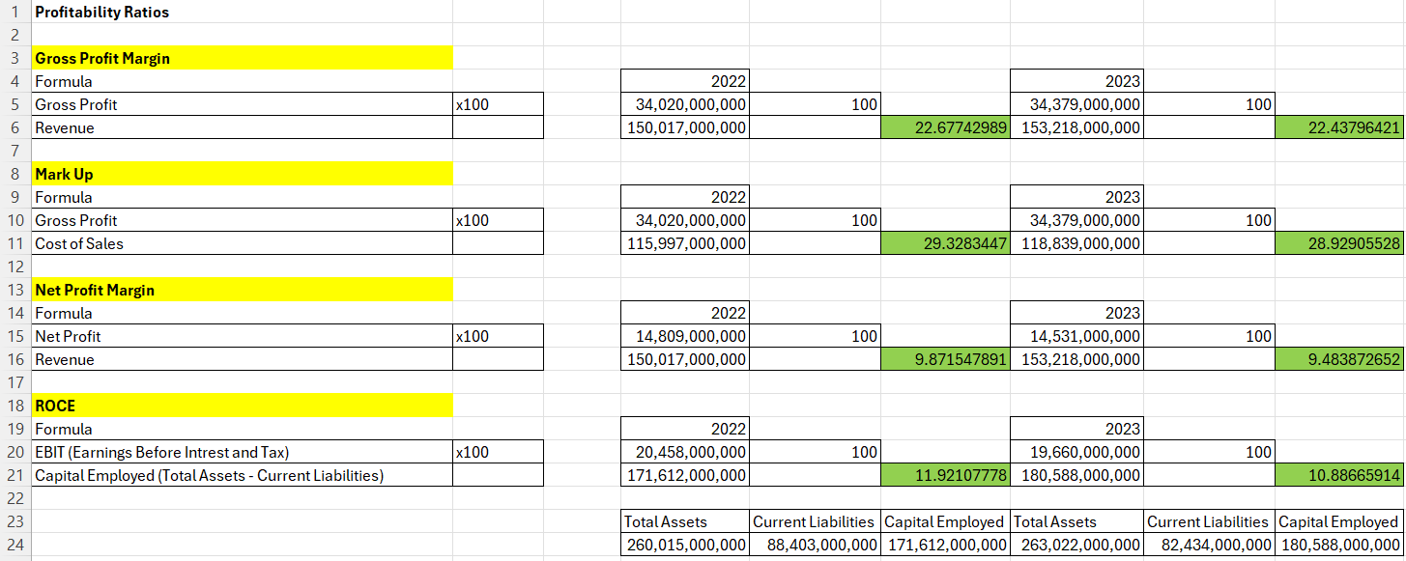
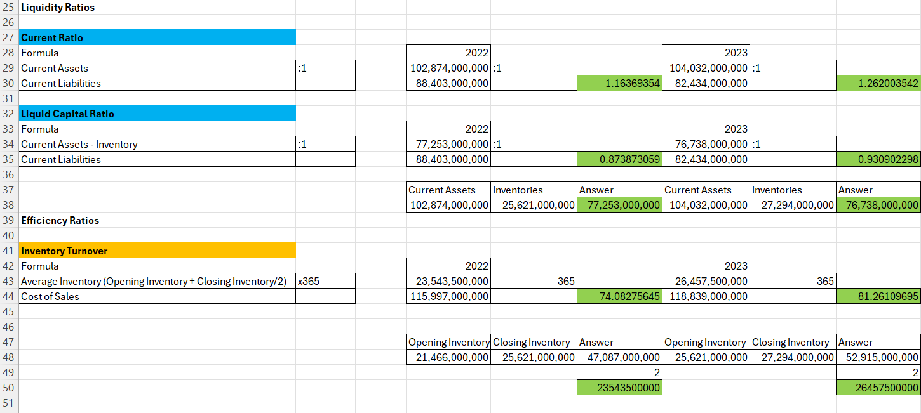

The first appendix shows the ratio analysis I made by examining Mercedes-Benz is official 2023 financial annual report. The analysis I conducted include profitability ratios such as the gross profit margin, mark-up, net profit margin and ROCE ratios, liquidity ratios such as the current and liquid capital ratios and efficiency ratios including inventory turnover. To help with calculating and structuring the formulas and the analysis I used Microsoft Excel.

