Managing People Assessment 2

Student Name: Nikolay Petkov
Student ID: 2011288
Module Code: LCBB5004

Table of Contents
Introduction 3
Employee Engagement 4
Drivers of Employee Engagement 5
Measuring Engagement Using Diagnostic Tools 6
Employee Value Proposition 7
Strategy to Raise Employee Engagement 9
Conclusion 10
Reference 11

Introduction
Organisations have changed over the last couple of years. Once, it was considered that production is the key to the success of the businesses. However, these days organisations are required to take care of different segments of the business to ensure a profitable operation. Human resource is considered one of the most important assets of the organisation after the integration of the value addition process. This report goes through how organisations can increase employee engagement, drivers of employee engagement. It evaluates different diagnostic tools used to measure engagement. Therefore, it prepares the employee value proposition and provides a strategy to raise employee engagement in the modern working environment.

Employee Engagement
Employee means the human resource who is responsible for carrying out work for any person or organisation and gets paid for that (Bratton and Gold, 2017). Employees are the core of an organisation. Without the efficient and productive effort of the employees, no business or organisation can become successful. Due to its importance, academicians have been working on how a company can use their employees’ efforts appropriately. Employee engagement is a concept of human resource management that measures or expresses the enthusiasm and dedication of a worker toward their work in any organisation. An employee who is engaged with his company always feels an attachment to the company and tries to contribute to the success of the company.
Good employee engagement shows the level of satisfaction among the employees about their jobs. If the employees are engaged with the company they will be motivated and perform higher than average. In most cases, such employees show their attachment to the goal of the company. They feel satisfied when they contribute to the achievement of the organisation. The concept of employee engagement has been introduced in the 1990s and organisations have been adopted the concept since the 2000s (Georgiades, 2015). Employee engagement directly impacts the company’s profit-making and overall financial situation.
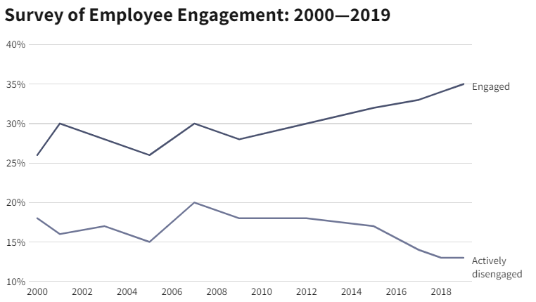
Figure: Worldwide Employee Engagement Survey (Bridger, 2014)
This graph shows the result of a survey where the employees expressed their engagement and actively disengagement. Therefore, it shows the portion of engaged employees is increasing over the last 20 years and the actively disengaged employees’ percentage has been decreasing implying that the companies are putting their effort to make the employees engaged with the company. It also implies that the companies are valuing employee engagement.
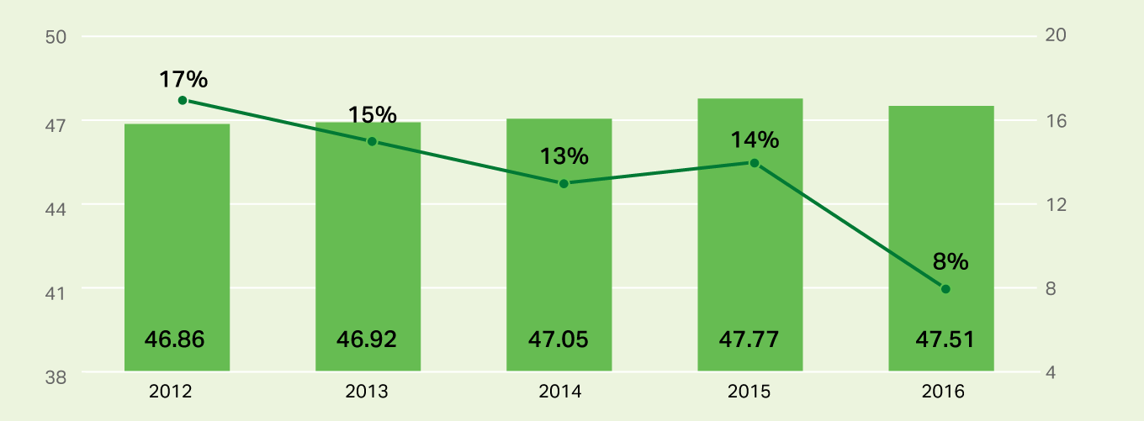
Figure: Employee Engagement Rate in the UK (Harter, 2020)
The graphs show another important piece of information and that is the employee engagement among the employees have been falling in the UK compared to other countries. It shows the percentage of the British employees who are engaged at their workplace has been as low as 8 per cent in the year 2016. This is high time the UK companies shall address the issues and make the employees engaged to the company.

Drivers of Employee Engagement
Companies are required to increase employee engagement to get maximum productivity and overall success in the industry (Hayton et al., 2021). Different drivers can impact employee engagement. Some of the drivers of employee engagement and how the companies shall capitalise on it has been explained below.
Learning and Performance: Nowadays the employees are careful about their career and play a contributing role in the organisation. Therefore, the companies need to provide learning opportunities to the employees. Furthermore, the employees want to grow in their careers and the companies are needed to offer growth and development opportunities to the employees. In some cases, the employees are not fully prepared for starting their job in a company. They shall be trained for the company before handing over the responsibilities. It will increase their confidence and the employees are more likely to perform better this way.
Wellbeing: Although the companies in the 20th century were focused on operation, they were never concerned about the employees. In most cases, the companies need labour employees which did not require any advanced skills. However, nowadays, there are so many fields of jobs and the employees have more advance and industry-specific skills. As a result, the companies cannot easily replace the employees. Therefore, the physical and mental health of the employees has become one of the most important drivers of employee engagement (Lee Whittington et al., 2017). Due to the pandemic, it has been the most important driver and the companies are responding to it by making the workplace covid safe or allowing the employees to work from home. If the employees are not physically and mentally unsound, the employees will not engage themselves with the company and eventually, the productivity will be impacted negatively.
Rewards and Benefits: The employees work for the companies to earn their living and maintain a standard lifestyle (Lussier and Hendon, 2012). On the other hand, everyone loves to receive rewards. The employees also feel good when they receive rewards for their work from the organisation. Similarly, the benefits they receive makes them positive toward the company. As a result, they feel attached to the companies and show more engagement.
Social Gatherings: Although it is important for companies to maintain a formal environment in the workplace, it is also important to create a social space where the employees can discuss among themselves and share knowledge. Although this has been difficult to be arranged since the pandemic has forced many companies’ employees to work from home. However, the collaboration among the employees creates connection, trust among themselves that raises the engagement.
Communication: Strategic communication is also a driver of employee engagement that allows the employees to see the bigger picture. It offers the employees motivation to work, they can connect themselves with the end goal and feel a part of the company. The company needs to make the employees feel them they are part of the company and if they do not about what is happening with the company they will feel detached from the company and the work engagement will get lowered (Manion, 2018).

Measuring Engagement Using Diagnostic Tools
Companies use different strategies to improve employee engagement that eventually helps to improve the company’s overall performance. However, it is also vital to measure employee engagement for the organisations. A low engagement will require the organisation to take actions that help improve the engagement. Here, some of the diagnostic tools have been stated that is handy for measuring the employee engagement of any organisation.
Employee Surveys: This is a survey that is conducted on the employees regarding their satisfaction and engagement in the company. In this survey, a set of questions are designed some of which can be generic questions and some can be company-specific questions. In most cases, the companies prefer to conduct the survey anonymously as many of the employees feel worried to share their opinion in the survey. They may not be able to share their true thoughts regarding the workplace if their identity is revealed. This is the most effective way of measuring employee engagement as it directly collects information from the employees (Marinescu, 2016).
HR Tools: In many cases, different companies have found out that their employees are not providing the real information in the surveys. As a result, the companies are using different periodic surveys using different software programs of HR. The modern HR tools can be used to collect more accurate data, stores those in one place and facilitate frequent conversations between the employees and the HR department (Lussier and Hendon, 2012).
Exit Interview:
Even if the company provides enough benefits to the employees, some employees change their jobs and shifts to other companies. Getting feedback from the employees who are quitting the job can provide an insight that no other cannot provide. This feedback can help the company to find areas that require improvement to ensure their employees are engaging properly and the performance of the company.

Employee Value Proposition
Employee Value Proposition is a set of benefits and opportunities provided by the companies to the employees for using their skills, experience and abilities to help the company to achieve their business goal (Lambru, 2012). The employee value proposition consists of the unique benefits that define the essence of the company for the employees.
The employee value proposition varies from company to company and there is no standard model of the employee value proposition. Companies try to design their value proposition for employees to make that different and unique compared to others. Attracting the best people for the companies is the purpose of the companies’ employee value proposition (Syed and Kramar, 2017).
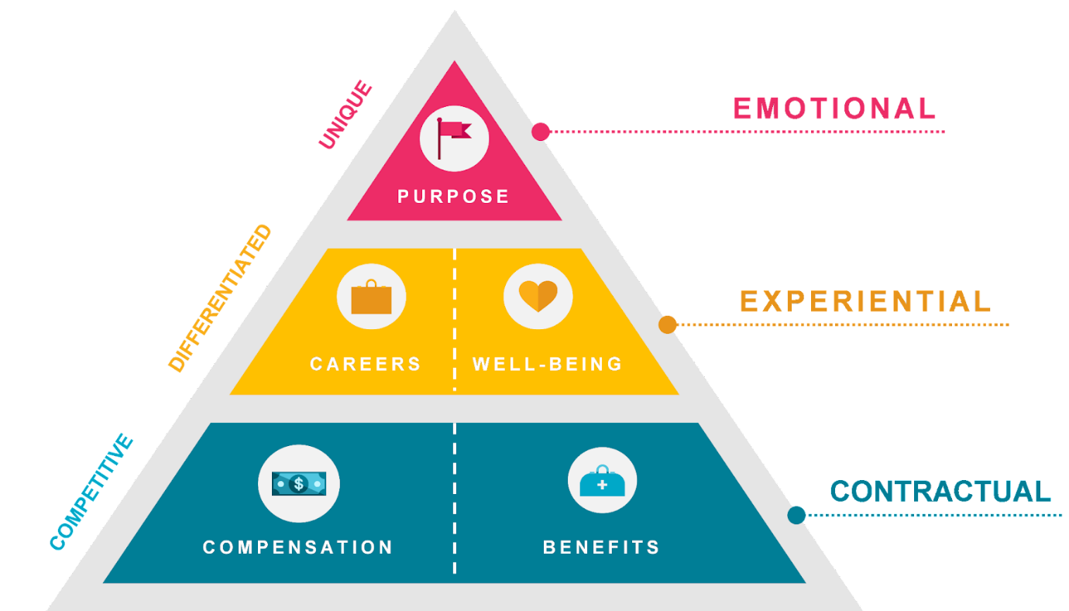
Figure: Constructing Employee Value Proposition (Brinknews, 2018)
The proposition can be divided into three specific and distinct areas that are contractual, experiential and emotional. These three will deal with three aspects of the employees’ lives. As for the contractual part, it includes the basic benefits and compensations that will be offered by the companies. The employees will be looking into this part initially. If the contractual gains are similar to other companies, they will look for the experiential part. In this part, the companies try to include career growth and opportunities for the employees along with well-being intentions. Companies shall design it in a way that provides better career growth for the interested candidates for the job. They will also demand a good working place. The company's intention toward the well-being of the employees shows whether a company considers the employee as their true asset or not (Tan et al., 2021).
Finally, on top of the model, there is the emotional part which is how well the company can connect with the employees. It is important to make the employees feel connected with the company. The employees who can avail both contractual and experiential offerings from any company always look for something where they can connect their emotions (Tan et al., 2021). For instance, an employee might be interested to work for improving the climate and he will more likely to choose a company for working which somehow contributes to the betterment of the world climate.

Strategy to Raise Employee Engagement
Employee engagement’s necessity has been proven in this report in the earlier sections. However, to raise employee engagement the companies need to prepare a strategy that addresses the company’s current engagement scenario and takes necessary steps as provided below.
Assess Current Situation: First of all the current situation of the company is required to be assessed. It has been mentioned that some actions have been taken such as letting the employees work from home, flexible working time, making the workplace covid safe etc. It shows that the company requires some actions that mainly work from home oriented. The Covid situation is needed to be assessed. Surveying, interviewing the employees using online tools can help to find out the mental condition of the employee. In the pandemic, mental breakdown is a big issue for individuals as many of the people experience difficult times. The workplace needed something that will help release mental stress (Hayton et al., 2021).
Improve the Lacking Areas: The company can start with online events that will help the employees to socialise among themselves. Moreover, some offline meet up can be arranged for the employees with proper caution that will help cheer the mental health of the employees. In this situation, the leaders of different departments shall be more empathetic (Syed and Kramar, 2017). The company can continuously communicate with the employees about the issues. Rewards and new benefits can help them to improve employee engagement as well.
Measure Success: Finally, it is also important to measure the change in employee engagement after the implementation of the employee engagement strategy by the company. It can be done by using surveys, interviews, HR tools etc. If the response is as expected, they shall continue following the strategy. Otherwise, they might change the strategy according to the assessment. The company might consider taking direct feedback from the employees on how they can make them satisfied in the new working situation, where everyone is facing new problems.

Conclusion
The customers' demand has increased and it requires skilled and efficient employees to meet their demand and achieve customer satisfaction. Employee engagement has been found as one of the most important factors to increase the productivity of the workplace. Companies are prioritising this matter to get the maximum output. There are different drivers on which employee engagement depends. The engagement of the employees are subject to be measured and proper actions are needed to be taken to increase it. The value proposition of the employees have been visualised and based on it a strategy has been provided to improve employee engagement.

Reference
Bratton, J. and Gold, J. (2017) Human resource management: Theory and practice. 2015th ed. Basingstoke, England: Macmillan Education.
Bridger, E. (2014) Employee Engagement. London, England: Kogan Page.
Brinknews (2018) BRINK – Conversations and Insights on Global Business. Available at: https://www.brinknews.com/curating-compelling-employee-value-proposition/ (Accessed: March 18, 2022).
Georgiades, S. (2015) Employee engagement in media management: Creativeness and organizational development. 2015th ed. Basel, Switzerland: Springer International Publishing.
Harter, J. (2020) 4 factors driving record-high employee engagement in U.s, Gallup. Available at: https://www.gallup.com/workplace/284180/factors-driving-record-high-employee-engagement.aspx (Accessed: March 18, 2022).
Hayton, J., Hornsby, J. S. and Kuratko, D. F. (2021) Human Resource Management: A Frontline Manager’s Perspective. London, England: Routledge.
Lambru, T. (2012) Employee value proposition and organizational commitment. LAP Lambert Academic Publishing.
Lee Whittington, J. et al. (2017) Enhancing employee engagement: An evidence-based approach. 1st ed. Cham, Switzerland: Springer International Publishing.
Lussier, R. N. and Hendon, J. R. (2012) Human resource management: Functions, applications, skill development. Thousand Oaks, CA: SAGE Publications.
Manion, J. J. (2018) The workforce engagement equation: A practitioner’s guide to creating and sustaining high performance. New York, NY: Productivity Press. doi: 10.1201/b12364.
Marinescu, A. P. (2016) The Discursive Dimension of Employee Engagement and Disengagement: Accounts of keeping and leaving jobs in present-day Bucharest organizations. Pieterlen, Switzerland: Peter Lang AG.
Syed, J. and Kramar, R. (2017) Human resource management: A global and critical perspective. 2nd ed. London, England: Macmillan Education.
Tan, K.-L., Lew, T.-Y. and Sim, A. K. S. (2021) “Effect of work engagement on meaningful work and psychological capital: perspectives from social workers in New Zealand,” Employee Relations, 43(3), pp. 807–826. doi: 10.1108/er-11-2019-0433.

