

Digital Transformation for Health and Care Professions
Master of Science

Academic Year | 2022 – 2023
Module I | Digital Technology in Health and Social Care
Module Code | BMDS 7006
Assignment | Programme improvement project
Student ID | 2219058
Submission date | 03 – March – 2023
Word Count

TABLE OF CONTENTS
1. TABLE OF CONTENTS 1
2. TABLE OF FIGURES 2
3. INTRODUCTION 3
4. METHODS 5
5. RESULTS 5
6. DISCUSSION 5
7. References 7

TABLE OF FIGURES
Figure 1: HL7 Diagram for allergies and intolerance model (Goss, et al., 2013). Allergy and intolerance model (adapted from HL7) 5
Figure 2: Pie chart depicting the percentage of the replies from the second item in the survey: 'The WCP AR software has all the functions and capabilities I would expect'. 7
Figure 3: Pie chart of percentage of replies to the question 'Overall, how satisfied or dissatisfied are you with the Adverse Reactions software in the Welsh Clinical Portal?' 8

INTRODUCTION
According to the World Allergy Organisation (WAO) the prevalence of allergy ranges from 10 to 40% in all the population, which means that allergies are a very common ailment (Pawankar, et al., 2013). The United Kingdom (UK) is among the most impacted countries with about 20% of its population affected by one or more allergic disorders (Levy, et al., 2004). Anaphylaxis is a life-threatening type of allergic reaction, with an annual incidence rate of 1.5 to 50 per 100,000 person-years (Yang, et al., 2017) of which approximately 1% is fatal. Hence, the recording of allergies and adverse reactions within the patient’s record is crucial.
In most countries, information on allergies and adverse reactions is stored in paper records and across multiple systems. Wales is not the exception, however, there is a vision whereby data pertaining to AR is stored in a central repository that enables that information to become available across all the health information technology (HIT) systems. This way, in the future, structured data will be made available to be accessed and contributed to through every system (Welsh Government, 2017).
Digital Health and Care Wales (DHCW) is part of the National Health Service (NHS) Wales and is in charge of delivering digital solutions that can transform health and care delivery. As part of its vision for a single record it has a portfolio that includes central repositories of information (documents, results, demographics, structured data) and portals to make that data accessible to clinicians anywhere in Wales. For example, the Welsh Clinical Portal (WCP) is the main point of contact for the clinician; at the same time, the WCP connects via Application Programming Interfaces (APIs) to the different repositories like the Clinical Data Repository (CDR), Welsh Care Records Service (WCRS) or Welsh Results Reports Service (WRRS) (Digital Health and Care Wales, 2023).
The ‘Adverse Reactions’ (AR) functionality was created in the WCP with the aim to be the display of the allergies and adverse reactions that have been stored in a central repository in the national CDR, and to be the place in the portal where clinicians can record new adverse reactions and allergies and write back/contribute to the central repository, in line with the vision described above. The CDR allows this data to be reused and retrieved by other systems that link to it, as this information is stored in a structured manner. The functionality is called Adverse Reactions because its intended use is not only to record allergies, but also intolerances and sensitivities as well (Sutton, 2020).
The focus for delivering the AR software was to design, develop and implement a minimal viable product (MVP) that can then be enhanced iteratively once live. This workstream was included in the Integrated Medium Term Plan (IMTP) for DHCW as early as 2016; however, due to COVID-19 response taking up the majority of resources, its release was postponed and it finally went live in late 2021 in the first health board (HB).
The data that is captured when the clinician records in the AR box is intended to be standardised via Systematized NOmenclature of MEDicine Clinical Terminology (SNOMED CT) code. This approach was adopted because SNOMED CT fulfils the desirable characteristics that a system to record adverse sensitivities requires, which includes the capacity to record ‘no known adverse reactions’; this negative finding is as equally as important to register as a positive one (Goss, et al., 2013). As well, Welsh Government (WG) endorsed the use of SNOMED CT for HIT in a Welsh Health Circular in 2015, which was in turn, adopted by DHCW as a data standard (Welsh Information Standards Board, 2018).

Facts about selected team!
The team

Delivering the adverse reactions capability, with the supporting technical architecture is the first step in unifying digital adverse reaction information for NHS Wales.

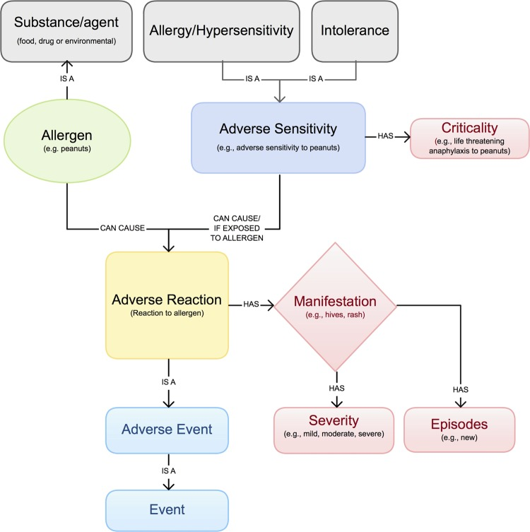
Figure 1: HL7 Diagram for allergies and intolerance model (Goss, et al., 2013). Allergy and intolerance model (adapted from HL7)

Demonstrate a systematic understanding and knowledge of the concepts, methods and technological components of a digital technology in a defined service context and evaluate critically its functionality, benefits and limitations
The scenario used in the coursework essay must involve a real software product that is in operational use.
Make sure that you follow the section structure given in the coursework brief and refer to the referencing guide provided for citations and the reference list (which should be the last section of your essay).
- Introduction section – brief coverage of any related published research.
Introduction section - facts about selected team/function/product

METHODS
A steady growth in development, implementation and use of HIT has been observed. These systems arise with the promise to solve issues like cost reduction, improving access to data and improving the safety in the care provided. However, adoption of HIT system is varied, with a wide percentage of failure. Different studies have tried to establish which are the factors that contribute to a successful implementation of a new system – several frameworks evaluate the adoption of HIT systems and the factors influencing it (Han, et al., 2020).
In order to assess the elements that influence the incorporation of a new system or feature within a system, and its use, the initial approach was to review existing frameworks in the literature which includes the systematic review by Han et al. (2020). Analysis of literature of characteristics that the HIT system should have to be fit

Benefits of FITT framework. Elements of FITT

To assess the fit as described by FITT framework
- Task: record allergies and adverse reactions
- Technology: Adverse reactions box in WCP, and storage in CDR.
- User: consultants, junior doctors, nurse specialists, pharmacists, and any other clinician with access to the WCP.

The AR project team, from which I form part as a patient safety manager, sent a survey to 55 clinicians that have been registered as using the system. This survey was a qualitative assessment of the software, with Likert-type questions and had a 64% response rate.
as part of the evaluation
Finally, Personal experience as patient safety manager using different systems and their recording of AR

RESULTS

Graphs from AR evaluation survey from Sutton – low engagement, only 55 persons, and the survey was only sent to clinicians who have used the system, so there is a bias in the fact that it does not capture the reasons why those who have not used the AR red box have not done so. It is the missing data that sometimes gives us more relevant information than the one we had in sight. For example, from a meeting with a pharmacist who is a user of the system, she prompted that junior clinicians may not have been properly trained regarding the functionality, hence this group tends to use it less frequently.
The first question in the survey was ‘How likely are you to recommend the WCP Adverse Reactions software to a colleague?’ followed by a Likert scale from 1 to 10 to reply. An interesting result was presented: 47% would be unlikely to recommend the software to colleagues and only 29% would promote its use.
In order for an organisation to be able to reap the benefits of an IT solution, there needs to be a clear understanding of the stakeholders involved, and their capacities. Government funding (costs, availability of resource to implement new technology), end-users, patients and tasks (Han, et al., 2020)
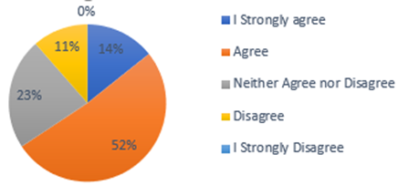
Figure 2: Pie chart depicting the percentage of the replies from the second item in the survey: 'The WCP AR software has all the functions and capabilities I would expect'.

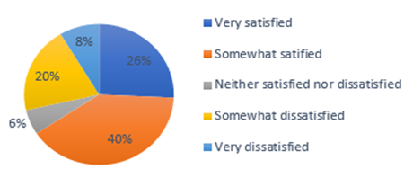
Figure 3: Pie chart of percentage of replies to the question 'Overall, how satisfied or dissatisfied are you with the Adverse Reactions software in the Welsh Clinical Portal?'

Contributions to the allergy record
The adverse reactions software has been designed to enable anyone with authority to use the WCP to access, contribute to and edit adverse reactions records. The software presents a full audit history trail of the adverse reaction record for transparency. During the project implementation, DHCW were asked to provide national guidance for recording adverse reactions in WCP and to specify who takes ownership or responsibility for maintaining the allergy record. A review of the allergy record confirms the following roles are the main contributors:

      - Pharmacists
      - Junior Doctors
      - Pharmacy Technicians

To encourage all WCP users to review and update the allergy record when interacting with the patient it is recommended that a short series of message of the days be displayed in WCP to prompt users to keep the record up to date.

DISCUSSION
One future scope to consider is the use of AR in clinical decision support (CDS). For example, alerts can be created to warn a clinician that a patient is allergic to a substance when doing a prescription. In Wales, the electronic prescribing and medicines administration (ePMA) programme has been established and soon, roll out of these systems will commence. AR will become more relevant in this use-case, and the benefit of collecting all the information in a central repository will be incorporated in this tool. However, care should be taken on the quality of the data that is stored and the types of alerts that are presented to the user, as it has been shown that override of these can be as high as 90% (Topaz, et al., 2017).
Other CDS in which AR can be incorporated are in the creation of order sets of medications, protocols, multipatient monitors and dashboards and relevant data summaries (Partnership for Health IT Patient Safety, 2019).

Seamless care – interoperability – not considered by FITT framework. Where HIT is developed and deployed as a silo, without taking into consideration de ecosystem of HIT that is in place across the health and care sectors, interoperability is harder to achieve, if not virtually impossible. The architecture that make each of these is difficult to integrate and manage (Han, et al., 2020)

“Seamless care” means coordination between services to ensure continuity: e.g. sufficient communication at a hospital discharge so that the right social care package is arranged and in place, or that the GP knows about any changes in medications. It could also cover comms/continuity within a service so that each team member knows where others are or which part of a care package/pathway is being provided by whom.
- Overall essay quality – logical flow, lucid writing, sound reasoning.
- Discussion section – reasoning about results and your inferences.

Your task in this assessment is to identify a software product that has been adopted to support a particular team or function. As part of this assessment, you will be required to explore the applicability of the implemented solution to the underlying task. You should critically analyse the benefits and limitations of the product, identifying key areas that pose challenges.

Welsh Government policy is to ensure an Open architecture and DHCW as the national digital organisation in NHS Wales is committed to ensuring an open data architecture to support health care and services across Wales. In essence this requires that Digital Health and Care Wales (DHCW) and other digital teams across NHS Wales provide APIs (Application Programming Interfaces) to open up health and care data to applications across Wales, subject to appropriate safeguards and governance.

Secure and robust APIs are needed to provide read and write access to patient information held in national and local repositories, in applications developed and maintained both within and outside of DHCW, including in Local Health Boards and by third party application developers. These must be provided within a robust governance framework ensuring compliance with patient safety, information governance and cyber security requirements
From SBAR DHCW API Delivery Team

REFERENCES
Digital Health and Care Wales, 2023. Digital Health and Care Wales Intranet. [Online]
Available at: https://nhswales365.sharepoint.com/sites/DHCW-Intranet
[Accessed 2 February 2023].
Goss, F. R. et al., 2013. Evaluating standard terminologies for encoding allergy information. Journal of the American Medical Informatics Association, September, 20(5), p. 969–979.
Han, L. et al., 2020. Factors Influencing the Adoption of Health Information Standards in Health Care Organizations: A Systematic Review Based on Best Fit Framework Synthesis. JMIR Medical Informatics, May, 8(5), p. e17334.
Levy, M. L. et al., 2004. Inadequacies in UK primary care allergy services: national survey of current provisions and perceptions of need. Clinical and experimental allergy, April, 34(4), pp. 518-9.
Partnership for Health IT Patient Safety, 2019. Safe practices for drug allergies - using CDS and health IT, Plymouth Meeting, Pennsylvania: ECRI Institute.
Pawankar, R. et al. eds., 2013. The WAO White Book on Allergy (Update 2013). Wisconsin: World Allergy Organization.
Sutton, N., 2020. Assurance quality plan: Adverse Reactions Service - Welsh Clinical Portal, Cardiff: Wales Informatics Assurance Group (WIAG).
Topaz, M., Goss, F. & Blumenthal, K., 2017. Towards improved drug allergy alerts: Multidisciplinary expertrecommendations. International Journal of Medical Informatics, Volume 97, pp. 353-355.
Welsh Government, 2017. Statement of Intent: Better use of health and care data for safe, effective care and efficient services, s.l.: Welsh Government.
Welsh Information Standards Board, 2018. SNOMED CT Maturity Matrix, s.l.: Digital Health and Care Wales.
Yang, M.-S.et al., 2017. True rise in anaphylaxis incidence: Epidemiologic study based on a national health insurance database. Medicine (Baltimore), February, 96(5), p. e5750.

ABBREVIATIONS
Abbreviation | Meaning
APIs | Application Programming Interfaces
AQP | Assurance Quality Plan
AR | Adverse Reactions
CDR | Clinical Data Repository
CDS | Clinical Decision Support
DHCW | Digital Health and Care Wales
FHIR | Fast Healthcare Interoperability Resources
HB | Health Board
HIT | Health Information Technology
IMTP | Integrated Medium Term Plan
IT | Information Technology
MVP | Minimum Viable Product
NHS | National Health Service
SNOMED CT | Systematized NOmenclature of MEDicine Clinical Terms
UK | United Kingdom
WAO | World Allergy Organisation
WCP | Welsh Clinical Portal
WCRS | Welsh Care Records Service
WG | Welsh Government
WIAG | Wales Informatics Assurance Group
WRRS | Welsh Results Reports Service

