Joseph Grigg
P145319
What makes a good flag design: Good?
(BA) Graphic Design
Donna Williams
Word count: 6,020

What makes a good flag design: Good?
Contents page
Introduction 3
Images for Introduction 5

Chapter One - The Relationship between Politics and Flags 6
- 1.1 History of National Flags 6
- 1.2 Flags of War 7
- 1.3 Social Politics 10
- 1.4 Nationalism 11
- Images for Chapter 1 15

Chapter Two – Geography 17
- 2.1 Flags using Geographic Symbolism 17
- 2.2 US State Flags 19
- 2.2 Neighbouring Countries 20
- 2.4 Changing Geography 20
- Images for Chapter 2 23

Chapter Three – Symbolism 25
- 3.1 Flag Shape and Construction 25
- 3.2 Using Symbolism in Flag Design 27
- 3.3 Colour Theory and Cultural Differences 28
- 3.4 Importance of Stars on Flags 31
- 3.5 Religious Symbolism on Flags 32
- Images for Chapter 3 34

Discussion 36
Images for discussion 38

Conclusion 39
Bibliography 40
References 40
Images 45
Introduction

Flags are pieces of cloth with printed or stitched designs on them in a variety of colours and designs. They are used to represent regions, and . They are not only used as geographical identifiers, flags have many other uses e.g. They are often used to convey information from a distance. For example: Life guards on beaches fly red and yellow flags to show where it is safe to swim, away from strong tidal currents (fig. 01) (In Cornwall, 2018). Flags are identifiers that people have been somewhere and/or accomplished a difficult task. Arctic and Antarctic explorers plant flags when they reach the north and south poles (fig. 02) (Bjaaland, 2011). Athletes are draped in flags when they win major sporting events (fig. 03) (Jamaica Observer, 2016). Mountain climbers proudly stand next to the summit next to their flag as a marker that they were there, and they were doing it representing their country (fig. 04) (Dvir, 2012). At motorsport races a number of flags are waved around the circuit to communicate to the driver as quickly as possible of events that may interfere with the race (fig. 05) (Thompson, M/Getty Images, 2016).

Flag design is very difficult as it needs to be simple, unique and well balanced. "Designing a great flag is very difficult, as you are trying to squeeze a whole nation into a small box." (Farrow, BBC. 2014). If you are representing a country or city, the flag needs to be a symbol that the people of that place can unite and connect with. If the flag is one that conveys information or is political then the flag needs to be very clear and distinctive. Not all flags have the same requirements, although many flags used are flown atop high flag poles and will be seen from large distances away. Flags do not only represent places or convey information sometimes they are used to represent a political party, movement, governing body or group of people. Some examples of non-geographical flags are the flag of the Nazi party during the Second World War UN (fig. 06) (Huss, W/Anonymous, 2017), LBGT community (fig. 07) (Guanaco, 2017) and the flag of ISIS (fig. 08) (Yo, 2015).

Images from Introduction
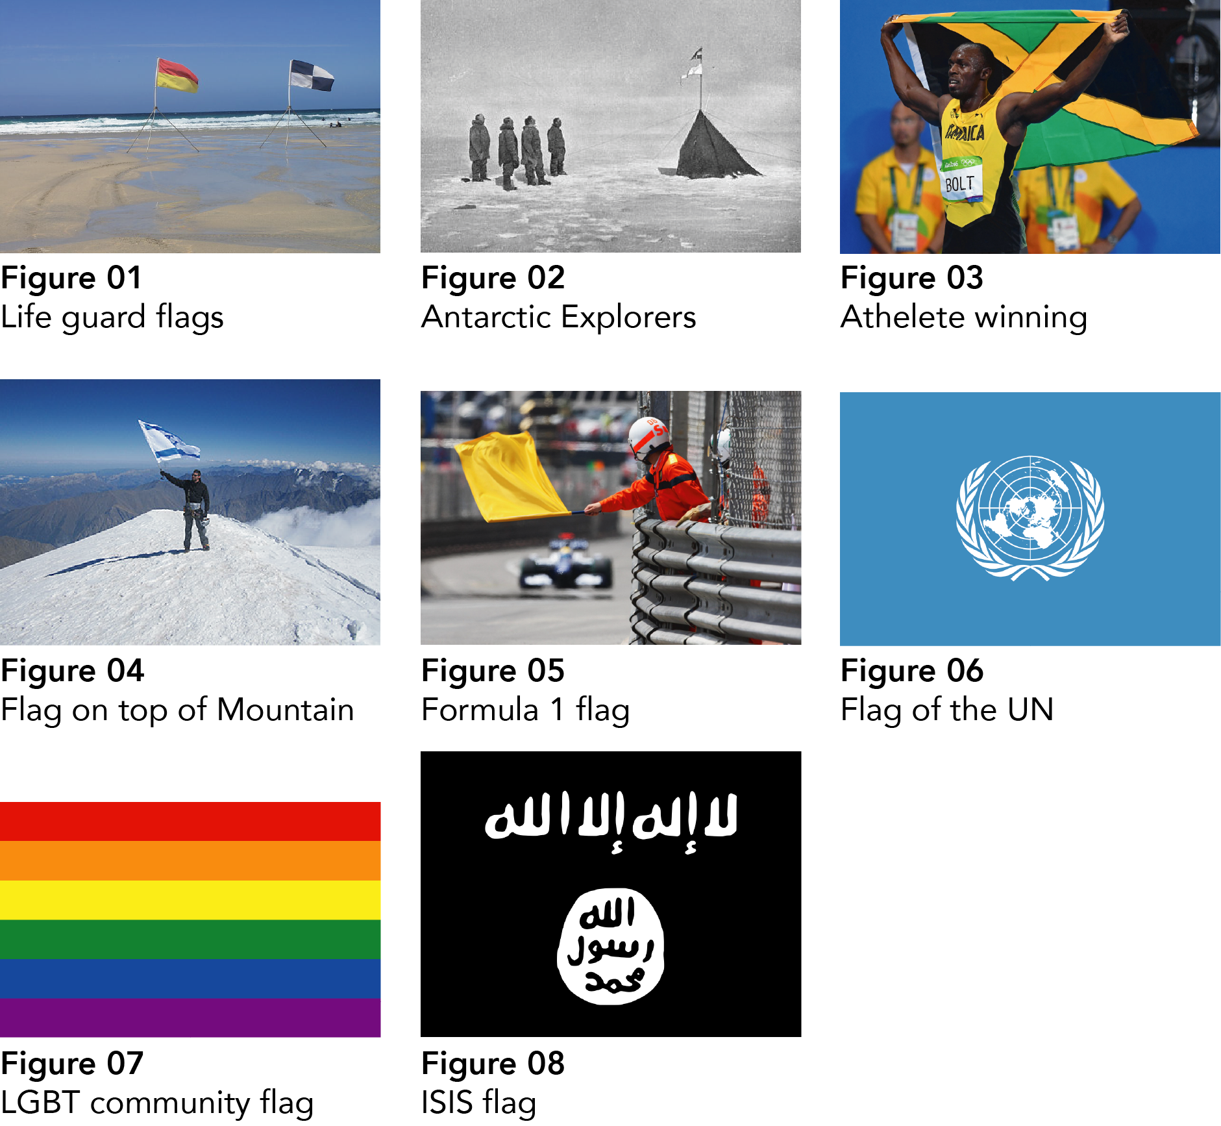

Chapter One - The Relationship between Politics and Flags

Politics and flags often go hand in hand. Without flags or banners people would have a difficult time communicating non-verbally. Communication is key to human survival, and it is what separates us from animals. It demonstrates how we have formed such complex societies. History is without a doubt messy and complicated, and flags have been there for the creation of new countries and the splitting apart of established regimes and constitutions. Flags are risen in celebration of political victories and have been used as propaganda tools by dictatorships.

1.1 History of Flags and National Flags

People have been communicating through symbols and physical objects for thousands of years. The earliest object that could be described as a flag that has been discovered is a metal flag found in the Shahdad region of Iran that dates back to 2400 BC (fig. 09) (The Circle of Ancient Iranian Studies (CAIS), 2007). The flag depicts a scene prevalent in the art from this region during the period; a man and woman facing each other with many animals and plants behind, showing the bounty of the area. The flag was discovered on its own so one can only speculate over its use and importance. “The flag has no parallels and its use is unknown” - (Andrew Lawler, 2011).

Before people spread all across the globe and when communication across long distances was difficult. Early humans used anything at their disposal to try to convey messages. From fire and smoke signals to mirrors and leafy branches humans have been ingenious in communicating over vast distances. (Connected Earth, n.d). Fire and smoke signals have been used for over a thousand years as they were first used in China 200 BC to communicate along the Great wall of China (Mashable, 2014). This form of communication was used for simple messages. When information needed to be communicated quickly, for example “On the battlefield flags and banners indicated when soldiers were to advance or retreat.” – (Johnson-Barker and Carpenter, 2015, p. 15). Banners used in war were designed to be easily recognisable, so soldiers would know what side others were on (fig. 10) (Pembroke, 2016).

1.2 Flags of War

During World War II, Germany was under Nazi control. In 1935 the flag was changed to the Nazi Flag (fig. 11) (Kookaburra, 2004) which Adolf Hitler designed himself. The flag was displayed across the country on official state buildings and on ships and planes. Hitler outlines the meaning of the design;

“The red expressed the social thought underlying the movement. White the national thought. And the swastika signified the mission allotted to us – the struggle for the victory of Aryan mankind.” (Marshall, 2017, p. 85-86).

Nazi Germany and more specifically, Hitler later completely re wrote the interpretation of the symbol. It was not originally a symbol of hated and segregation. The symbol has been used for hundreds of years in temples and in decorative designs across Asia (fig. 12) (zilupe, 2008), and to this day still used in India, where it is sometimes drawn on the bonnet of new cars as a symbol for luck (fig. 13) (dmarsh8758, 2013). It was adopted by Hitler and appointed new meanings. The swastika symbol has been tainted drastically in modern day western society. It is seen as a symbol of racism and hatred, and to wave a flag with a swastika on it is banned in many western countries, including Germany, which goes some way to show the remorse they feel for their countries’ past.

The Soviet Flag (fig. 14) (CCCP, 2018) depicts a yellow hammer and sickle on a red background, which represented the Industrial and Agricultural workers in the Communist country. In WW2 the Soviet Union suffered military deaths between 8.8 and 10.7 million (The National World War 2 Museum, n.d), this was in some part due to how intense the leadership was. If soldiers did not follow orders or they retreated, they would be shot. They also had more soldiers to throw into battles in an attempt to overwhelm the Germans. At the battle of Stalingrad over 2 million Russian soldiers died.

Historians often credit the Soviet Union with defeating the Nazis (Rozhnov, 2005), but inside the Soviet Union, communism was killing hundreds of thousands of people, through poor leadership and neglect. Many people in the western world are not as aware of the atrocities that communist regimes like the Soviet Union, and elsewhere across the world have committed. This is in stark contrast to the Nazis; the nature of their crimes is tangible and sickening. Therefore, in western society the swastika is seen with much more unease than the hammer and sickle. As Paul Hollander stated in a Washington post article;

“There is far more physical evidence and information about the Nazi mass murders, and Nazi methods of extermination were highly premeditated and repugnant, whereas many victims of communist systems died because of lethal living conditions in their places of detention. Most of the victims of communism were not killed by advanced industrial techniques.” (Hollander, 2009).

1.3 Social Politics

During the American Civil war 1861-65 the north fought under flags (fig. 15, 16) [2] Jacobolus, 2013) [3] (Jacobolus, 2013) which were early depictions of the stars and stripes that we all know today. The south fought under a number of different flags, chief among which was the confederate flag (fig. 17) (Miles, 2014). The northern states had outlawed slavery in 1805 and tried to bring freedom to the slave in the south. The south wanted to keep slaves as slavery was such an integral part of their economy. The Confederation of the Southern States lost the American Civil war, but to this day there still are people who fly the confederate flag.

The confederate flag was first used at a time where slavery was not seen as it is today by many people as immoral, evil and inhumane. For anyone who is unsure about how the Confederate flag is perceived in the modern day, in November 2015 a confederate flag rally was held outside Stone Mountain Park Police Station near Atlanta, Georgia. The rally was to “Keep the mountain “pure” to its Confederate roots and keeping a memorial to Martin Luther King Jr. off of it.” (Suggs, 2015) At the rally were a number of KKK members “offering salutes and wearing clothing featuring white supremacist slogans and KKK symbols” (Joyner, 2015). Joyner also goes on in his article to mention that some members of the KKK actually arranged the flag rally. This shows that the confederate flag is associated with an openly racist group and although you can’t then say all people who fly the flag are racist. It clearly has a strong negative connotation which unfortunately tarnishes the flag as a symbol for racial prejudices.

Several polls have been taken to obtain the American population’s view of the Confederate flag, and over the past 20 years the opinion has changed, although there still is a majority that see the confederate flag as ‘southern pride’ the percentage has reduced to 57% in 2015 down from 69% in 1992. The percentage of people who see the Confederate flag as a symbol of racism is up from 22% in 1992 to 33% in 2015. (CNN, 2015, p.4). It is unclear why these numbers have changed, but it could be due to the increasing number of controversial killings of young black men at the hands of the police and the racial tensions across the country. Maybe those who flew the confederate flag have been made more aware of how the flag is being interpreted by people outside of their community.

1.4 Nationalism

The American flag (fig. 18) (Dbenbenn, 2015) has 50 stars, each star representing one of the 50 states, and currently the 50 stars are neatly arranged on the flag in an appealing way. There has been talk in the past few years about areas receding from the union like Texas, and others joining, for example Puerto Rico and Washington D.C. This cannot happen without “Congressional approval” (Roos, n.d). Congressional approval may not be the only problem for a state to join America. Americans love their flag, it is flown across the country, houses, government buildings and shopping malls. The flag is displayed at embassies and military bases all around the world. In its current state the American flag is “The most recognisable, loved, hated, respected, feared, and admired flag in the world.” (Marshall, 2017). It was also the first flag to have been placed on another celestial body; the moon.

The origins of the design of the flag are unknown but the symbolism, representing every current state and the original 13 colonies, gives a sense of all-inclusiveness and pride in the history of the country. The fact that in schools across the country children every morning salute and Pledge their Allegiance to the flag, means from a young age every American connects to the flag and sees it as an embodiment of their home. The American flag is a good flag, in every sense of the word. Referring back to the book; Good Flag, Bad Flag. The flag follows all the rules aswell as creating an emotional connection to the people it represents. The flag is ever present in almost every major historical event; the rescue efforts by emergency services following the attack on the World Trade Centre in New York in 2001 (fig. 19) (Franklin, 2001), the moon landing in 1969 (fig. 20) (NASA/Armstrong, 2018) and the Raising the Flag Over Iwo Jima in Japan in 1945 (fig. 21) (Rosenthal, 2018).

The stakes are high for such an important flag. If a new state was added the flag would have to be changed. Brady Haran on the Hello Internet Podcast says:

“I think a lot of people in the United States would be reasonably indifferent to the idea of Puerto Rico becoming a state until you told them it would involve changing the flag. I think the fact that it will involve changing the flag is the biggest barrier to the people of the US letting Puerto Rico in [to the United States].” (Haran, 2015).

If another country was to join America, then the flag would have to change as it would affect the number of stars on the flag. There have been flags proposed for 51 stars up to 55 stars by several people but none of them are official yet (fig. 22). One 51-star flag design (fig. 23) (Andux, 2013) features the stars arranged in a circle, which would definitely be very different to the current flag but would be a historic reference to one of the first flags of The United States of America from 1776, the Betsy Ross (fig. 24)[1] (Jacobolus, 2015). The Betsy Ross was probably not actually designed or made by Betsy Ross herself, but the name has stuck and still is a popular flag for Americans.

The story of Betsy’s life was one of hard work and determination. She was widowed three times. Betsy Ross is an American Icon and she also played a role in “standing up for liberty and justice” (Moore, 2017). Liberty and justice are the American ideals and have been an integral part of the Pledge of Allegiance since the first pledge was written in 1892 “I pledge allegiance to my Flag and the Republic for which it stands one nation indivisible with liberty and justice for all.” (Streufert, 2005). No wonder why her flag is still popular to this day, as it is so intrinsically linked to America.
Images for Chapter 1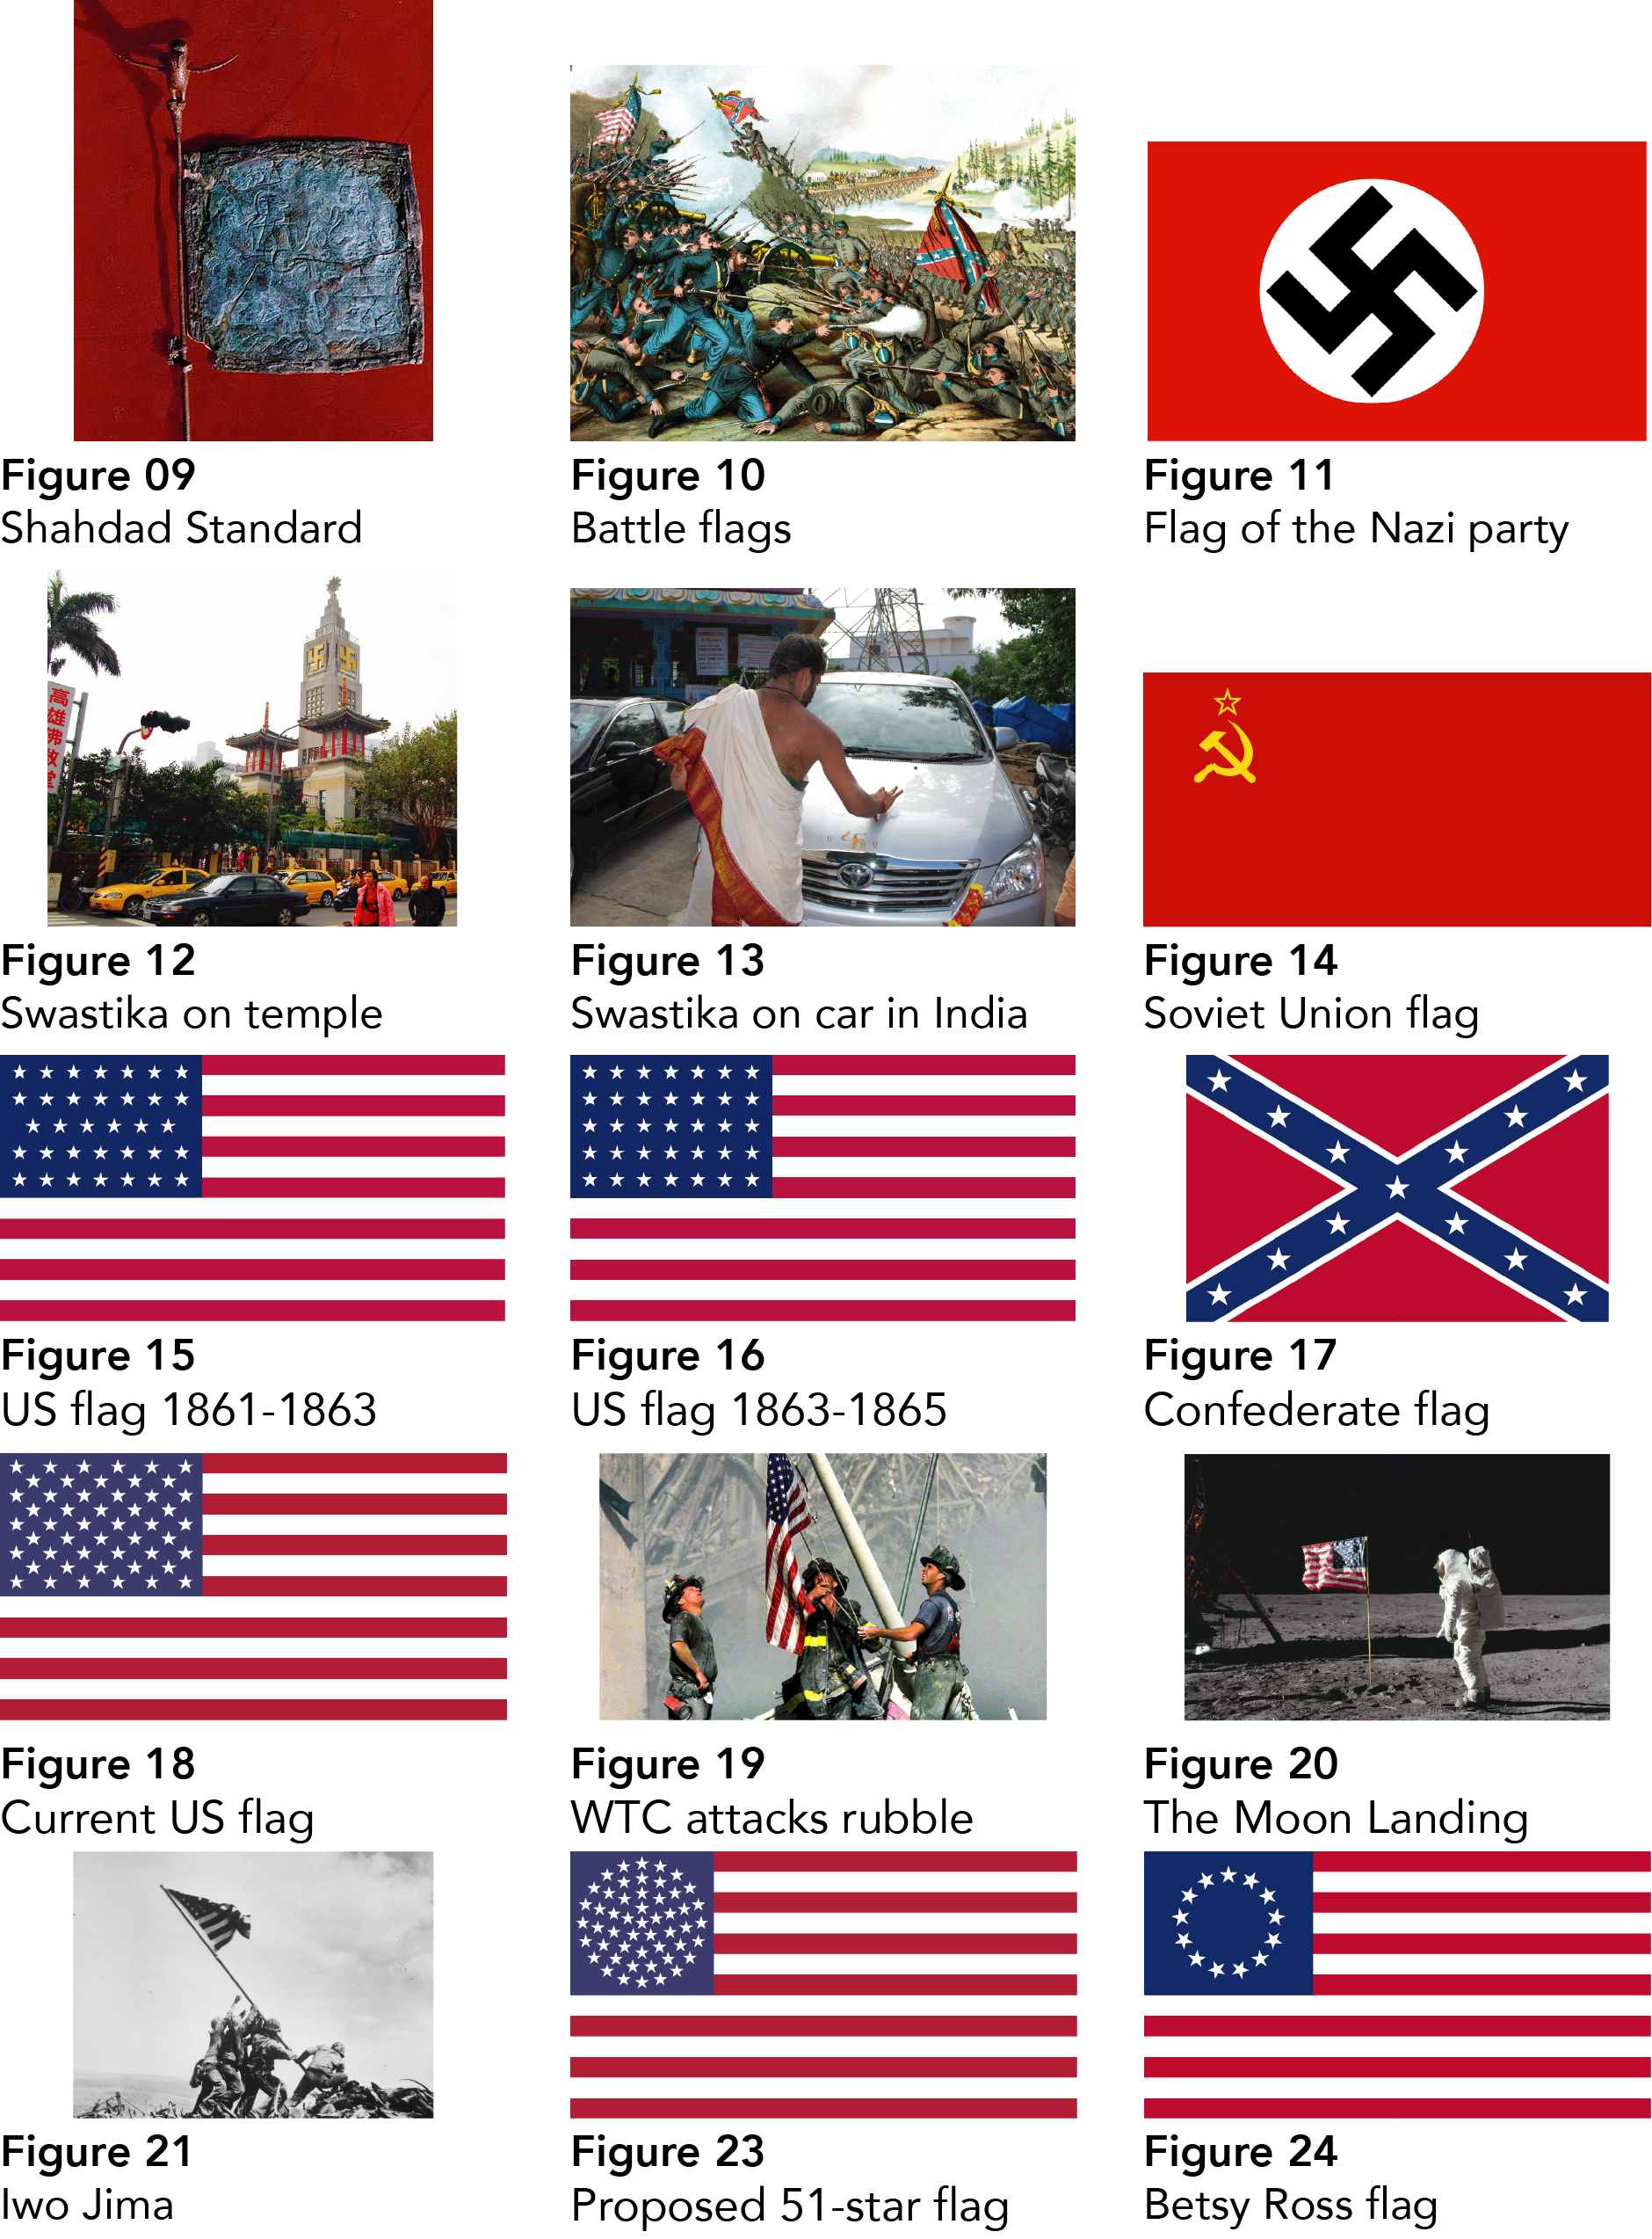
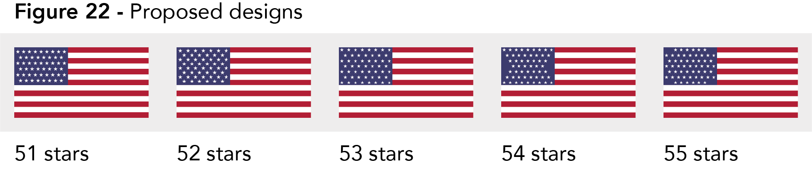

Chapter 2 - The Effect of Geography on Flags

The Geographical location of a country makes a large different to the history and politics. The location of a country doesn’t necessarily affect what the flag of the country will look like, but in some cases, the design can help identify where the county is. There are two countries which actually have the outline of their border on the flag, Kosovo (fig. 25) (Cradel, 2014) and Cyprus (fig. 26) (Vzb83, 2017).

2.1 Flags using Geographic Symbolism

Kosovo uses an outline of their country on their flag with 6 stars above, representing the six ethnic groups in the country. The Flag was adopted in 2008 when Kosovo declared its independence from Serbia. An international competition was held to appoint the new flag and the winner was the design we see today. It reflects the national pride and the use of the six stars for each ethnic group attempts to form a united country in the wake of the split from Serbia. On the other country’s flag, Cyprus the outline is accompanied by two olive branches. Olive trees are prevalent in Cyprus and is famous for the good quality oil that the olives produce. Olives are a key part of the Cypriot diet and cuisine. Having a symbol representing the quality of the country’s cuisine is important to the Cypriot people as they take pride in their food.

Flags that represent countries often take inspiration from their geographical location on earth for the design of their flag. There are a number of flags that use star constellations present in their night sky. One of the most creative way of using constellations is in the Brazilian flag (fig. 27) [2] (Anomie, 2011). The flag has 27 stars in 9 constellations, each star representing one of the Brazilian States and The Federal District. They chose constellations that contain the correct number of stars for their design. The state flag of Alaska (fig. 28) [1] (Zscout370, 2012) depicts Ursa major and the north star, Polaris. Polaris is also known as the North star. The star is very important and been used for thousands of years by explorers on land, ships and planes to navigate at night. The star is always in the same position in the night sky, in the northern hemisphere. New Zealand (fig. 29) [2] (Zscout370, 2015) and Australia (fig. 30) [1] (Anomie, 2011) both have the southern cross on them. Both flags are extremely similar and there is often confusion between them.

In 2015 it was announced that New Zealand would hold a national referendum for a redesign of the flag. There were 10,292 submissions which were shortlisted down to 40 by the Flag Consideration Panel (fig. 31). 20 out of the 40 featured the southern cross, and the finalist which went up against the existing flag also had the southern cross on it. When you look at the 40 shortlisted designs the most eye-catching design elements are those of the Koru, which is the shape of a fern which is native New Zealand unfurling. The southern cross has for many years been a symbol of New Zealand, along with many other southern countries, because the European settlers had never before seen the constellation in the night sky in their home countries and it is so prominent.

2.2 US State Flags

It is not only Countries that have flags, there are many counties and cities across the world that have flags. In America there are flags for every state, and for many American cities, albeit not very good ones according to C.G.P Grey. “I look at a page like this and, this is just a train wreck of awful, awful design.” (C.G.P. Grey, 2015.) Grey is referring to a page of the US state flags (fig. 32). They are mostly quite similar, with a few exceptions. Most of the flags, 24 out of 50 are plainly a shade of blue field with a seal somewhere on the design. Not all of the flags which have blue use the same colour blue, all the state seals are of different complexity and colours. There is no consistency for these flags. There have been some attempts to redesign the state flags to improve the consistency, as these flags are often seen flown together at government buildings, but no action has yet been taken to change the flags.

2.3 Neighbouring Countries

The Scandinavian countries of Sweden, Finland, Iceland, Norway, Denmark and the Faroe Islands all have very similarly designed flags. Sweden (fig. 33) (Stradivarius, 2014), Finland (fig. 34) (Koppehel, 2009) Iceland (fig. 35) (Dagur, A and Magasjukur2, 2017), Norway (fig. 36) [1] (Dbenbenn, 2016), Denmark (Fig. 37) (Madden, 2018) and the Faroe Islands (fig. 38) (Connell, J. (2015). The flags are all based upon the Danish flag (fig. 37), known as the Dannebrog, which is currently the oldest national flag in continual use. It has been used since the 13th century although it was not the country’s official flag until 1748. The flag uses the Nordic or Scandinavian cross, which is a symbol of Christianity. Many of the Scandinavian countries are Christian countries and so it is natural to have a Christian symbol on their flags. In Scandinavia all those countries had their own colours and flags for many centuries, but between 1821 and 1917, the Danish Dannebrog flag design spread across the countries as there were various unions involving Sweden, Denmark, Finland and Norway. These included royal marriages, wars between the Swedes and the Russians and as a result of the Napoleonic War.

2.4 Changing Geography

Korea is a peninsular which has a turbulent past and an uncertain future. The country was split into North Korea and South Korea after World War II. During World War II Korea was a Japanese colony and was used as agricultural land to provide food for Japan. The Russians and Americans had agreed that after the War they would separate Korea along the 38th parallel into two zones until such time that the two could be stabilised and re-join one another. “Of course, that did not happen. With the onset of the cold war the divide between them hardened.” (Lambert, 2018). The Russians installed a communist government in 1948 at the same time as a democratic government was elected in the South. The Korean war (1950-1953) was a tug of war between the two countries over the border that separated them. To this day the two countries are technically still at war as “the 1953 Korean War ended in a truce, not a treaty.” (Marshall, 2017).

Korea, as a united country before the colonisation from Japan, used the flag which now is the South Korean Flag (fig. 39) (Various, 2017). The symbolism behind the Flag is rather philosophical and is an important part of South Korean culture. As Korea was liberated from Japan and the south became a democratic republic, the flag remained. As for North Korea, they adopted a new flag, using the same colours as the southern flag but with a new composition and different meanings. On the flag which used to represent the whole of the Korean Peninsula, the red and blue represent positive and negative cosmic forces and the white was the traditional colour of the Korean people. These colours live on in the North Korean flag, although the meaning has changed.

The origins of the North Korean flag (fig. 40) [1] (SKopp, 2011) are not definitive. The original flag of Korea was suggested but as the Soviet Union were the rulers of North Korea at the time, they decided to use the flag of the Soviet Union. Sometime later the Soviet Union designed and appointed the flag we see today. The North Korean flag was created in a time when their communist dictatorship was just taking shape. So, the design and symbolism reflect the hopes for the new country. White is a traditional colour for Korean people and on the flag, it represented the “purity of the ideals of North Korea and national sovereignty.” Red symbolises the communist revolution and the blue stands for the “people’s desire for peace” [6] (FOTW Flags of The World, 2018).

Images for Chapter Two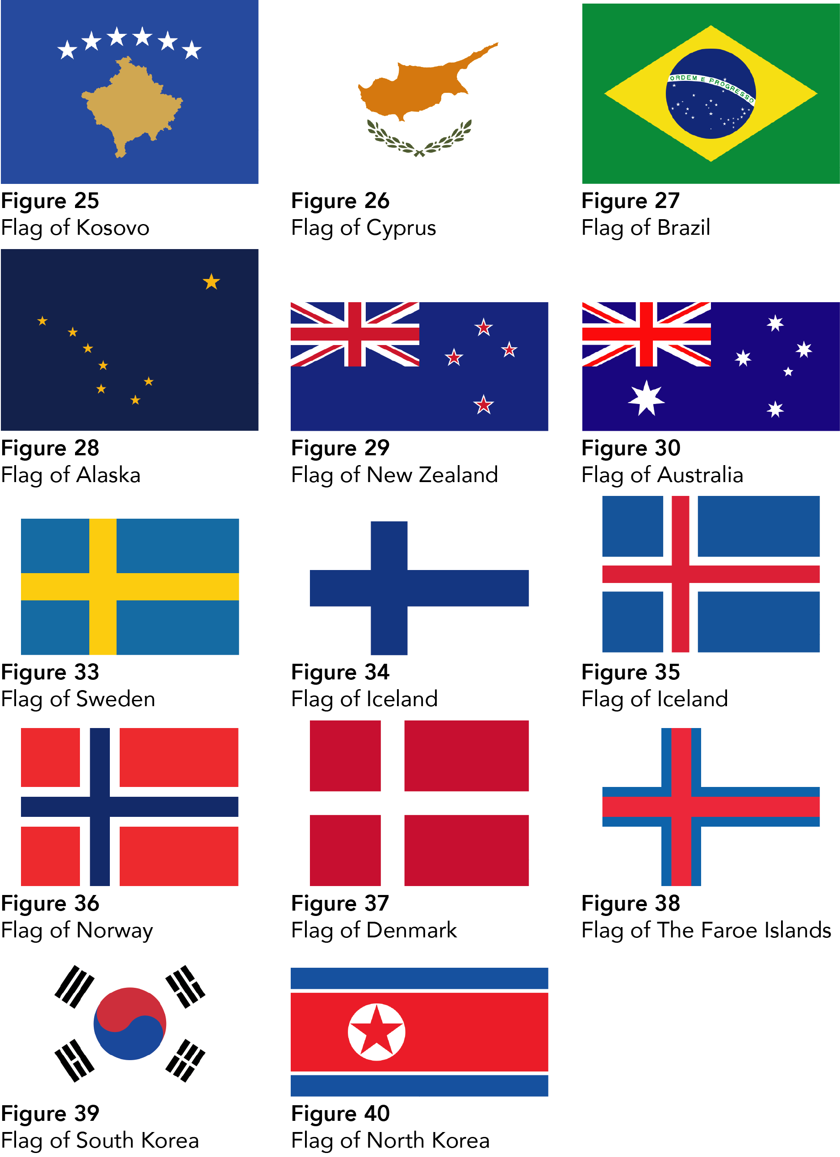

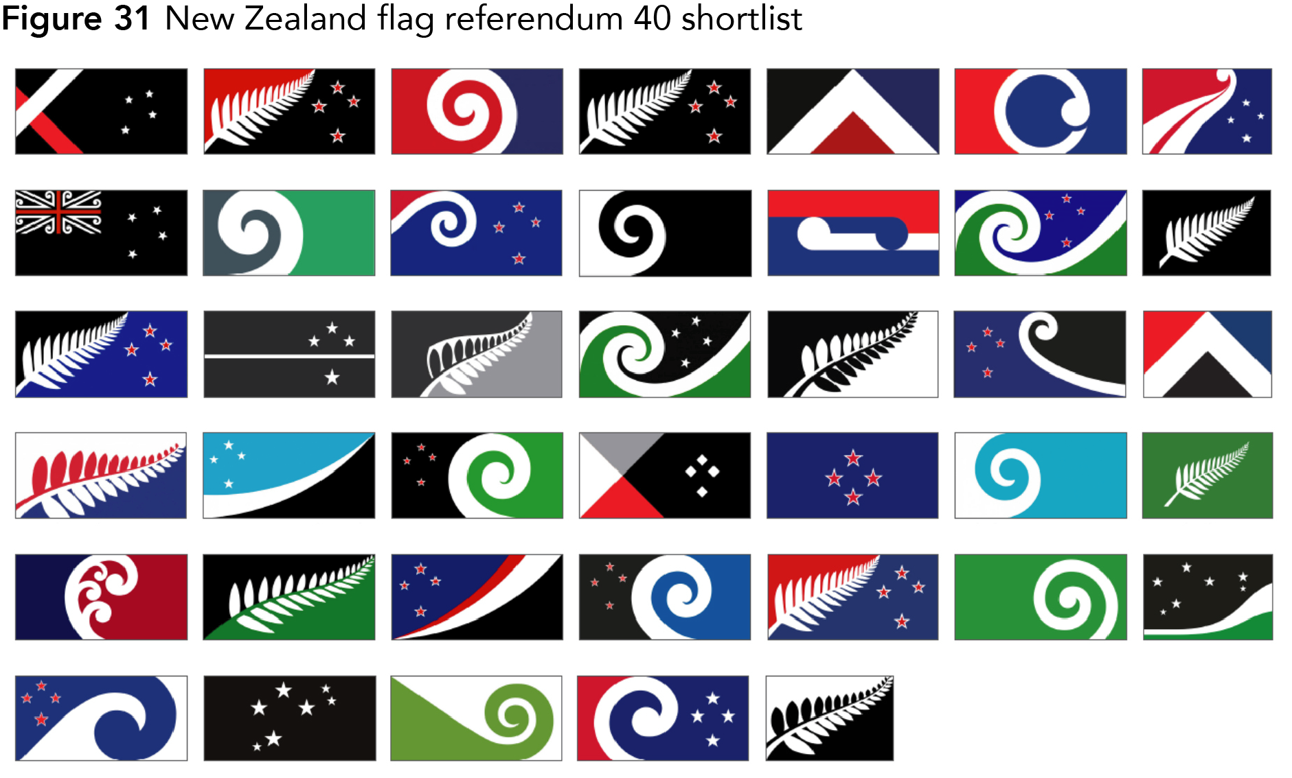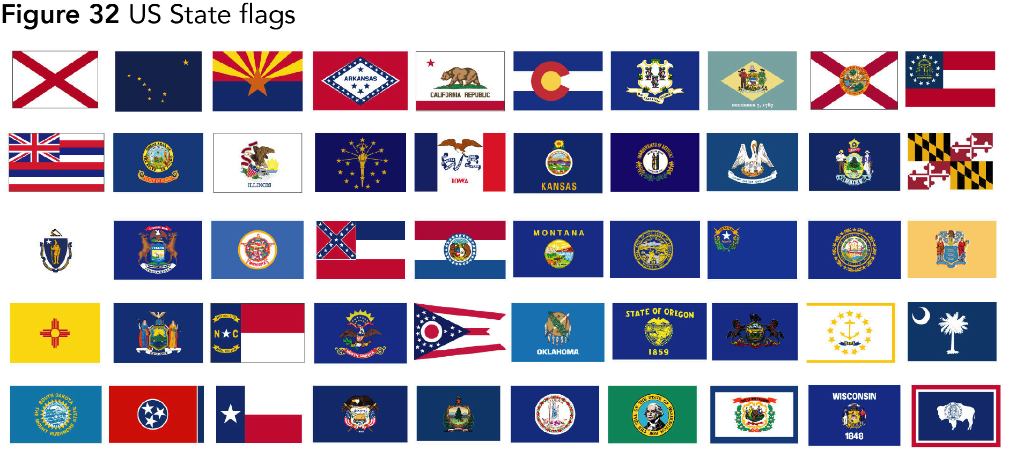

Chapter Three - Symbolism

Symbolism is ever-present in flag design. Colours are often used to symbolise certain historical or poignant events, for example on the South African Flag (fig. 41) (Brownell, 2013) the colours black, green and yellow are an ode to Nelson Mandela’s political party and the blue, red and white represent the European colonists. On many flags, red is used to represent the blood of fallen soldiers in wars and battles through the countries’ history. Colours mean different things across the world, for example in America red signifies hardiness & valour, but in China red corresponds with fire, and symbolizes good fortune and joy.

3.1 Flag Shape and Construction

There are only a very small number of national flags that do not have standard flag proportions. Every flag apart from one is a rectangle wider than it is tall. The most common flag proportion for national flags is 2:3, which 102 countries use, followed by 75 using 1:2 and 20 that use 3:5. (fig. 42) [4] (FOTW Flags of The World, 2013). There does not seem to be any strong reason as to the difference in flag ratios other than tradition or manufacture process. Flags of countries which used to be part of another’s empire often have the same flag proportions; “British flags have a 1:2 ratio, French flags are 2:3 and German flags are 3:5” [5] (FOTW Flags of The World, 2014).

The only national flag that is not a rectangle is that of Nepal (fig. 43) Pumbaa80, Achim1999, 2016). The Nepalese flag is often incorrectly shown (fig. 44) (Reddit, 2018), it is two triangles atop one another is often given an extra white portion on the right-hand side to make it into one of the standard flag ratios. This is incorrect. The flag’s shape is important as it represents the country’s two major religions; Hinduism and Buddhism. In a video by Australian film maker Brady Haran for his YouTube channel Numberphile (Numberphile. (2012). Haran and mathematician Dr James Grime dub the flag “The Most Mathematical Flag”. The construction of the design of the flag is precisely described in Article 5 of the Constitution of the Kingdom of Nepal. The way the construction is described is as mathematics used to be written and explained thousands of years ago, using simple geometric points and lines (fig. 45) (Myers, 2016) .The instructions for which do not require a measuring instrument:

“(A) Method of Making the Shape inside the Border
(1) On the lower portion of a crimson cloth draw a line AB of the required length from left to right.
(2) From A draw a line AC perpendicular to AB making AC equal to AB plus one third AB. From AC mark off D making line AD equal to line AB. Join BD.
(3) From BD mark off E making BE equal to AB.” (Nepalese Constitution, 1999, Schedule I, Article 5)

3.2 Using Symbolism in Flag Design

When designing a flag there are 5 basic principles that are outlined by the North American Vexillological Association and complied by Ted Kaye in his book Good Flag, Bad Flag. “Keep it simple; use meaningful symbolism; use 2-3 basic colours; no lettering or seals; be distinctive or be related.” (Kaye, 2006, p.3). A fantastic example of this last principle are the Scandinavian countries’ flags mentioned in the previous chapter. The simplicity principle state “The flag should be so simple that a child can draw it from memory…” (Kaye, 2006, p.3). There are a large number of flags which fall into this category. Many more flags however have little details which are important to the design of the flag, one of which is discussed in the next paragraph.

The South Korean flag (fig. 39) is a wonderful flag. At its centre there is a large blue and red yin and yang icon, derived from Chinese philosophy which explores the relationship between negative and positive forces in the natural world and how they are connected. In the case of the South Korean Flag the red represents the positive cosmic forces and the blue, the opposite negative cosmic forces. [1] (FOTW Flags of The World, 2012). Surrounding the yin and yang are 4 trigrams, which each have many meanings including celestial bodies, the 4 seasons, the 4 cardinal directions, north, east, south and west, virtues, family roles and natural elements. These meanings have cultural significance to the people of South Korea and having these represented on their flag, embodies the spirit of the people in the flag.

3.3 Colour theory and Cultural Differences

Colour is one of the main characteristics of flag design, in some cases it is the only distinguishing factor between a great number of flags. Many flags use the same or very similar layout. The horizontal and vertical tricolours originated from Europe in the 16th century. The Prinsenvlag ("Prince's flag") of The Netherlands had orange, white and blue horizontal stripes and is credited to be the first ‘modern flag’ (fig. 46) (IamExpat, n.d). The simplicity of its design and sharp contrast between the colours made it good at being recognisable at sea.

The colours were based on the livery (A special uniform worn by a servant, an official, or a member of a City Company) of William of Orange. The Dutch East India Company who were a very powerful Dutch trading company who protected The Netherlands’ trading in the Indian Ocean adopted the colours and design and then added their logo to the centre. (fig. 47) The orange colour gradually changed from to red. (fig. 48) [3] (Zscout370, 2010) Some believe that the change was due to the quality of the dye used on the flags. “The orange dye was particularly unstable and tended to turn red after a while”- (Bartram, G. et al, 2008, p.121). Others believe it was due to “the 1654 English-Dutch defence treaty, which prohibited any member of the House of Orange from becoming a Dutch head of state.” - (Holland.com, n.d). Either way, the orange colour has not disappeared from the Dutch people’s conscience. Orange is still the colour that represents the Dutch people at sporting events around the world, from football to the Olympics.

Flags which have three colours in equal proportions are known as tricolours. The term tricolour comes from the name of the French Flag, Tricolore, (fig. 49) [3] (Anomie, 2011) meaning three colours in French. The red and blue are the colours of Paris and white the colour of the Royal House of Bourbon. The colours also represent the “ideals of the 1780 French Revolution: liberty, equality and fraternity.” - (Johnson-Barker and Carpenter, 2015, p. 15).
Figure 50 | World | Africa | America | Asia | Europe | Oceania
Red | 74 | 75 | 66 | 81 | 74 | 64
White | 71 | 55 | 74 | 84 | 72 | 86
Blue | 50 | 40 | 69 | 35 | 53 | 79
Yellow | 43 | 58 | 51 | 28 | 30 | 50
Green | 42 | 79 | 29 | 42 | 19 | 14
Black | 22 | 32 | 26 | 23 | 11 | 14
Orange | 5 | 6 | 0 | 7 | 4 | 7
Other | 5 | 4 | 6 | 5 | 8 | 0

The colours red white and blue are the most frequently used across the whole world. [2] (FOTW Flags of The World, 2012). Just red, white and blue appear on 30 national flags most notably those of America, United Kingdom, France, Russia, and Australia. These three colours are the most used colours on national flag, red appears on 74% of national flags, second is white, only slightly lower with 71% and the third most common is blue at 50% of flags. Figure. 50 shows the percentage of flags that each colour appears in each continent (North and South America have been accumulated for this study).

3.4 Importance of Stars on Flags

Many flags across the world incorporate stars and the number of points can indicate a number of different meanings (Star polygons in art and culture, En.wikipedia.org, 2018). For example, the flag of Malaysia (fig. 51) [3] (SKopp and Zscout370, 2013) has 14 equal stripes, which symbolises the equal status between the states and a 14-pointed star representing the unity between the 13 states and the federal government. Nauru (fig. 52) [4] (SKopp, 2012), a small island nation in the pacific has a 12-pointed star, which is a reflection of the island’s original 12 tribes dating back thousands of years and is an important identifying factor for the peoples of the island. “When a child is born, he/she will inherit their tribe from their mother's side. Clothing for each tribe is different which helps identify each individual.” (Government of the Republic of Nauru, 2018). This keeps the tradition of the country going, although they may not live exactly as their ancestors did, they are still the same people with the same values.

The city of Chicago has four 6 pointed stars on their flag (fig. 53) (-xfi-, 2014) and each one represents both a significant point in the history of the city or key parts of the culture of the city. The 6 points on each star represent other aspects of the city. The people of Chicago are extremely proud of their flag and it can be seen everywhere. A tattoo parlour in Chicago was receiving so many requests for the iconic flag, that the owner, Nick Colella decided to create a decorative poster (fig. 54) (Nick Colella,2016) breaking down the symbolism in the flag. The city has many bragging rights mentioned on the flag, from the nick name ‘Urbs in horto’ which is Latin for ‘City in a Garden’ was used by the initial settlers in Chicago, in the 1830s Chicago was “’little more than a swampy outpost” (Wilkin, K, 2017). In an article in DNAinfo Joe Ward states:

“Colella said the reason for the flag's popularity as a tattoo is twofold: It has a simple, "dominant" design and is a visible stand-in for the city. Tattoos depicting hometowns all are popular even when the place doesn't have an iconic symbol.” (Ward, 2016)

3.5 Religious symbolism on Flags

Stars on flags represent a huge number of different things, ranging from bragging rights, in the case of the City of Chicago, to a constellation seen in the night sky. The meaning behind a star can also often be religious. The 5-pointed star, often known as the golden five-pointed star because of its uniform nature, is often used alongside a crescent. This was originally a symbol of the Ottoman Empire and then by popular extension, the Islamic world. The crescent and star appear on many Islamic countries’ flags, e.g. Turkey (fig. 55) (Benbennick, 2012), Pakistan (fig. 56) [4] (Zscout370, 2012) and Azerbaijan (fig. 57) [2] (SKopp, 2015). Often the composition of the crescent and the star changes depending on the country, some countries rotate the icon or change the size, some even have different number of stars on them to represent different parts of their histories or locations.

The star of David, which comprises two regular triangles laid over one another rotated at 180 degrees, is a symbol of Judaism and appears on the Flag of Israel (fig. 58) (The Provisional Council of State Proclamation of the Flag of the State of Israel, 2010), a Jewish Country in the Middle East. During the second world war, the Nazis forced all Jewish people living in Germany to wear various forms of the star of David as way of identifying them, and then taking them away to concentration camps. This was later turned around as Jewish American soldiers wore the star as a symbol of defiance against Nazi antisemitism.

Images for Chapter 3
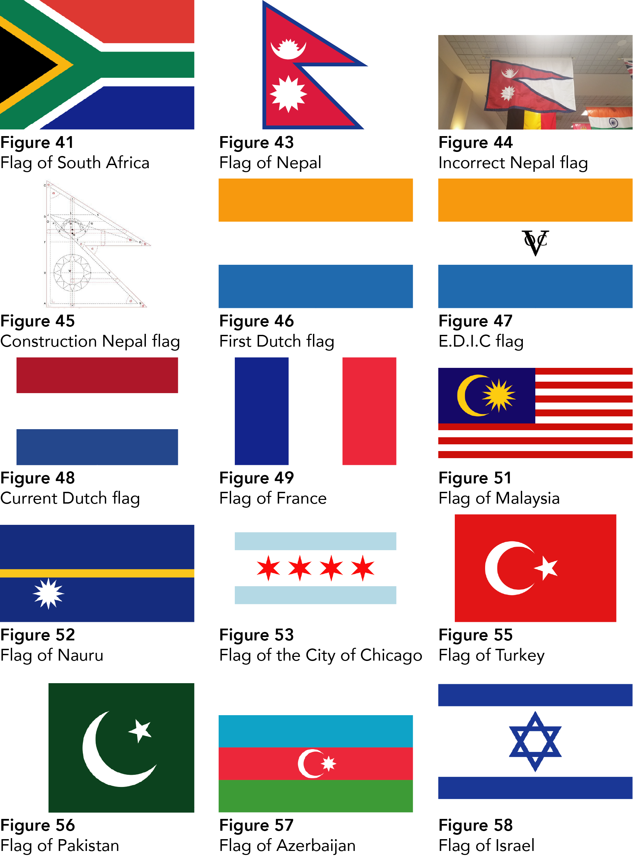
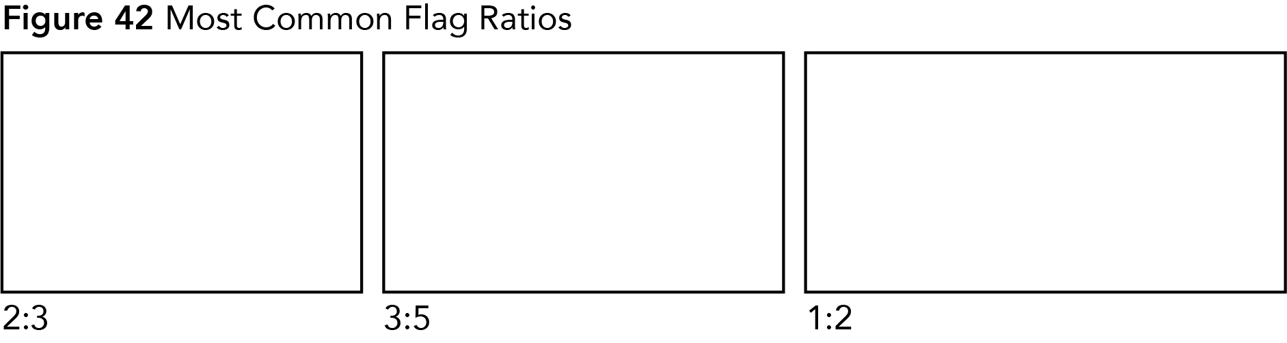
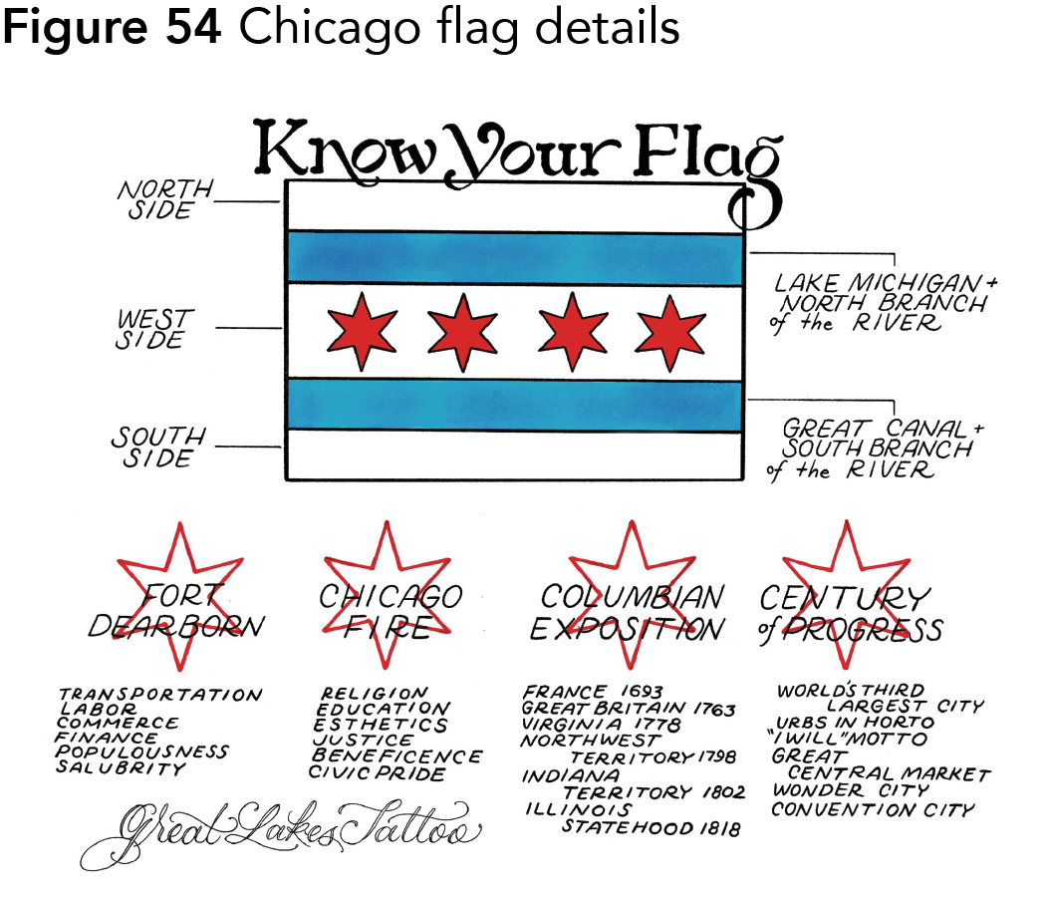

Discussion

A flag’s purpose is not only to represent the country, place or organisation but to unite the people it represents. Taking this into account, flags of war such as the Nazi flag were extremely successful. The Nazi flag ensured that the Nazi party had many loyal followers and a clear goal for the country, through strong and imposing symbolism and colours. In the book Good Flag, Bad Flag, the North American Vexillological Association discuss five basic principles for flag design which I mentioned in a previous paragraph.

A couple of the ‘rules’ could be tweaked, limiting the colours on a flag could prevent flags with more complex colours such as South Africa (fig. 41) from existing, although it incorporates so much symbolism in the flag. Similarly, simplicity is an important role of course, but the idea that a child should draw it from memory is a grey area. If all flag designers abided by this rule flags like Wales (fig. 59) (Jakobs, 2018), Albania (fig. 60) [3] (Dbenbenn et. al, 2017), Hong Kong (fig. 61) (Ho, 2011) and Nepal (fig. 43) would not exist. They have simple concepts at the heart of the designs but the execution of them is complex. Of course, there will always be exceptions to rules like these.

A key part of designing a good flag is ensuring that the identity of the country is embodied by the flag. Americans treat their flag as though it physically is America, and as a result it is one of the most loved flags in the world. This makes the design good. “Don’t allow a committee to design a flag. Instead, empower individuals to design flags, and use a committee to select among them” (Kaye, 2006, p.14). This quote embodies the sentiment perfectly. When a flag needs to be designed for a country, place or organisation, ultimately the people responsible for the decisions are those that the flag will represent. If the people love their flag, then the flag is fulfilling its purpose. This is what good design is all about.

Images for Discussion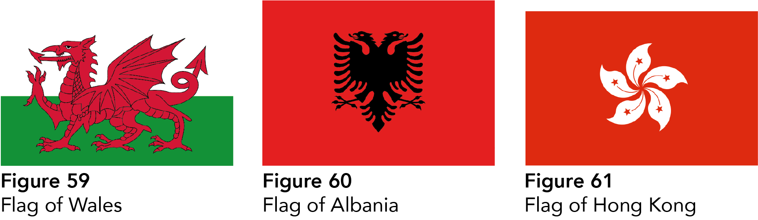

Conclusion

In conclusion, there are many factors that go into the design of a good flag. Through this dissertation I have developed a deeper understanding of flag design, and the factors at play. First of all, the design needs to be well balanced and organised. The use of a correct colour palette including complementary and contrasting. Finally, relevant symbolism is critical, through the use of unique design elements or colours that are appropriate to the country, place or organisation. This ensures a strong connection with the people the flag represents.

Bibliography:

Marshall, T. (2017) Worth Dying For: The Power and Politics of Flags. London: Elliot and Thompson.

Kaye, T. (2006) Good Flag, Bad Flag. Trenton, NJ: North American Vexillological Association.

Johnson-Barker, B. and Carpenter, C. (2015). The complete guide to flags of the world. East Petersburg: IMM Lifestyle Books.

Cooper, J. (1995). An illustrated encyclopaedia of traditional symbols. Thames and Hudson Ltd.

Bartram, G. et al. (2008). Complete flags of the world. London: Dorling Kindersley.

References:

[1] BBC (2014). How are national flags designed? Available at:
https://www.bbc.co.uk/newsround/26530974
(Accessed: 19th October 2018)

[2] BBC (2018). Who were the Vikings? Available at:
https://www.bbc.com/bitesize/articles/zcpf34j
(Accessed: 6th November 2018)

Connected Earth (n.d). Line of sight communications. Available at:
http://www.connected-earth.com/Journeys/Introducingcommunications/Thesoundbarrier/Lineofsightcommunications/index.htm
(Accessed: 6th November 2018)

Cabinet Office and Office of the Secretary of State for Wales (2018). Devolution settlement: Wales. Available at:
https://www.gov.uk/guidance/devolution-settlement-wales
(Accessed: 7th December 2018)

Chicago Public Library (2018). Chicago Facts. Available at: https://www.chipublib.org/chicago-facts/
(Accessed: 30th September 2018).

CNN (2015). ORC Poll 6, Confederate Flag. Available at: http://i2.cdn.turner.com/cnn/2015/images/07/01/confederate.flag.pdf
(Accessed: 27th September 2018).

[1] FOTW Flags of The World. (2018). History of the South Korean Flag.
Available at:
https://www.crwflags.com/fotw/flags/kr_hist.html
(Accessed: 1st October 2018).

[2] FOTW Flags of The World (2012). Statistics on flag colors. Available at:
https://www.crwflags.com/fotw/flags/xf-csts.html
(Accessed: 7th November 2018)

[3] FOTW Flags of The World (2011). Colors of Flags. Available at:
https://www.crwflags.com/fotw/flags/xf-colx.html
(Accessed: 7th November 2018)

[4] FOTW Flags of The World (2013). Flag Sizes (Comparative). Available at:
https://www.crwflags.com/fotw/flags/xf-size.html
(Accessed: 20th November 2018)

[5] FOTW Flags of The World (2013). Ratios of Flags. Available at:
https://www.crwflags.com/fotw/flags/xf-rati.html
(Accessed: 20th November 2018)

[6] FOTW Flags of The World (2018). Democratic People’s Republic of Korea Available at:
https://www.crwflags.com/fotw/flags/kp.html
(Accessed: 22nd November 2018)

Formula One World Championship Limited (2018). Flags. Available at:
https://www.formula1.com/en/championship/inside-f1/understanding-f1-racing/Flags.html
(Accessed: 19th October 2018)

Government of the Republic of Nauru (2018). Tribes of Nauru. Available at: http://www.naurugov.nr/about-nauru/nauruans%27-stories/tribes-of-nauru.aspx
(Accessed: 29th September 2018).

Haran, B (2015). H.I. #16: The Worst Topic for a Podcast. [video] Available at:
https://www.youtube.com/watch?v=UM29TL35ZIw&t=3204s
(Accessed: 10th September 2018)

Hollander, P (2009). Remembering communism. Available at:
http://www.washingtonpost.com/wp-dyn/content/article/2009/11/01/AR2009110101702.html
(Accessed: 6th December 2018)

Holland.com. (n.d) The Dutch flag. Available at:
https://www.holland.com/global/tourism/information/the-dutch-flag.htm
(Accessed:10th October 2018)

[1] Johnson, B (n.d). The Red Dragon of Wales. Available at:
https://www.historic-uk.com/HistoryUK/HistoryofWales/The-Red-Dragon-of-Wales/
(Accessed: 6th November 2018)

[2] Johnson, B (n.d). The English Invasion of Wales. Available at:
https://www.historic-uk.com/HistoryUK/HistoryofWales/The-English-conquest-of-Wales/
(Accessed: 6th November 2018)

Joyner, C. (2015) Klan presence obvious at Confederate flag rally. Available at:
https://www.myajc.com/news/public-affairs/klan-presence-obvious-confederate-flag-rally/3J25Ys4kZBKDYczt2CtBBJ/
(Accessed: 3rd December 2018)

Lambert, T. (2018) A Brief History of Korea. Available at:
http://www.localhistories.org/korea.html
(Accessed: 21st November 2018)

Lawler, A. (2011). The World in Between. Available at:
https://archive.archaeology.org/1111/features/dasht-e_lut_iran_shahr-i-sokta-shahad_tepe_yaha.html
(Accessed: 5th November 2018).

Mashable (2014).: From smoke signals to smartphones The evolution of communication. Available at:
https://mashable.com/2014/12/05/evolution-of-communication-brandspeak/?europe=true
(Accessed: 6th November 2018)

Moore, M (2017). Betsy Ross: An American Icon. Available at:
http://american-exceptionalism.org/an-american-icon/
(Accessed: 7th December 2018)

Nepal - Constitution National Flag
https://web.archive.org/web/20060805190104/http://www.supremecourt.gov.np:80/main.php?d=lawmaterial&f=constitution_schedule_i
(Accessed: 20th November 2018)

New Zealand Herald (2015). Forty flags, and only one with a Union Jack - so which one is best? Available at:
https://www.nzherald.co.nz/nz/news/article.cfm?c_id=1&objectid=11495030
(Accessed: 24th October 2018)

Numberphile (2012). The Most Mathematical Flag - Numberphile. [video]
Available at:
https://www.youtube.com/watch?v=f2Gne3UHKHs
(Accessed: 20th November 2018)

Rohac, D (2013). Why is Communist Iconography Still Cool? Available at:
https://theumlaut.com/why-is-communist-iconography-still-cool-5b32ba818ec
(Accessed: 6th December 2018)

Roos, D (n.d). How do new states become part of the U.S.? Available at:
https://people.howstuffworks.com/new-state-in-us.htm
(Accessed: 6th December 2018)

Rozhnov , K. (2005) Who won World War II? Available at:
http://news.bbc.co.uk/1/hi/world/europe/4508901.stm
(Accessed: 3rd December 2018)

Snyder, T. (2011) Hitler vs. Stalin: Who Was Worse? Available at:
https://www.nybooks.com/daily/2011/01/27/hitler-vs-stalin-who-was-worse/
(Accessed: 3rd December 2018)

Streufert, D (2005). The Original Pledge of Allegiance. Available at:
http://www.usflag.org/history/pledgeofallegiance.html
(Accessed: 7th December 2018)

Suggs, E. (2015) Pro-Confederate Flag rally underway at Stone Mountain.
Available at:
https://www.myajc.com/news/local/pro-confederate-flag-rally-underway-stone-mountain/t30X6J5kjWr0hcksG0MwVK/
(Accessed: 3rd December 2018)

Tharoor, I. (2015) VE Day 70th anniversary: We should never forget - the Soviets won World War II in Europe. Available at:
https://www.independent.co.uk/news/world/europe/ve-day-70th-anniversary-we-should-never-forget-the-soviets-won-world-war-ii-in-europe-10239369.html
(Accessed: 3rd December 2018)

The Circle of Ancient Iranian Studies (2007). Iran’s Most Ancient Standard Goes on Display in National Museum. Available at:
http://www.cais-soas.com/News/2007/May2007/14-05-iran.htm
(Accessed: 10th October 2018)

The National World War 2 Museum. New Orleans (n.d) Research Starters: Worldwide Deaths in World War II. Available at:
https://www.nationalww2museum.org/students-teachers/student-resources/research-starters/research-starters-worldwide-deaths-world-war
(Accessed: 3rd December 2018)

The Norwegian Directorate of Integration and Diversity (IMDi) (2018). The Norwegian History, Some important facts in the Norwegian History. Available at: http://www.nyinorge.no/en/Ny-i-Norge-velg-sprak/New-in-Norway/Useful-information/Facts-about-Norway1/The-Norwegian-History/
(Accessed: 29th September).

Ward, J. (2016). Have A Chicago Flag Tattoo? One Parlour Is Asking You To 'Know Your Flag'. Available at:
https://www.dnainfo.com/chicago/20160128/west-town/have-chicago-flag-tattoo-one-parlor-is-asking-you-know-your-flag/
(Accessed: 10th September 2018)

Welsh Government (2012). Wales and Argentina. Available at:
https://web.archive.org/web/20121016085052/http://www.wales.com/en/content/cms/English/International_Links/Wales_and_the_World/wales_argentina/wales_argentina.aspx
(Accessed: 6th November 2018)

Wilkin, K (2017). Chicago: the city in a garden. Available at:
https://www.theweek.co.uk/89073/chicago-the-city-in-a-garden
(Accessed: 30th September 2018).

Images:

Andux. (2013) US 51-star alternate flag. [image] Available at:
https://commons.wikimedia.org/wiki/File:US_51-star_alternate_flag.svg
(Accessed: 9th December 2018)

[1] Anomie. (2011) Flag of Australia. [image] Available at:
https://en.wikipedia.org/wiki/File:Flag_of_Australia.svg
(Accessed: 9th December 2018)

[2] Anomie. (2011) Flag of France. [image] Available at:
https://en.wikipedia.org/wiki/File:Flag_of_France.svg
(Accessed: 9th December 2018)

Bjaaland, O. (2011) At the South Pole, December 1911. [image] Available at:
https://en.wikipedia.org/wiki/File:At_the_South_Pole,_December_1911.jpg
(Accessed: 9th December 2018)

Benbennick, D. (2012) Flag of Turkey. [image] Available at:
https://commons.wikimedia.org/wiki/File:Flag_of_Turkey.svg
(Accessed: 9th December 2018)

Brownell, F. (2013) Flag of South Africa. [image] Available at:
https://commons.wikimedia.org/wiki/File:Flag_of_South_Africa.svg
(Accessed: 9th December 2018)

CCCP. (2018) Fag of the USSR. [image] Available at:
https://commons.wikimedia.org/wiki/File:Flag_of_the_Soviet_Union.svg
(Accessed: 9th December 2018)

Connell, J. (2015) Flag of the Faroe Islands. [image] Available at:
https://commons.wikimedia.org/wiki/File:Flag_of_the_Faroe_Islands.svg
(Accessed: 9th December 2018)

Dagur, A and Magasjukur2. (2017) Flag of Iceland [image] Available at:
https://commons.wikimedia.org/wiki/File:Flag_of_Iceland.svg
(Accessed: 9th December 2018)

[1] Dbenbenn. (2016) Flag of Norway. [image] Available at:
https://commons.wikimedia.org/wiki/File:Flag_of_Norway.svg
(Accessed: 9th December 2018)

[2] Dbenbenn et al. (2015) Flag of the United States. [image] Available at:
https://upload.wikimedia.org/wikipedia/en/thumb/a/a4/Flag_of_the_United_States.svg/1235px-Flag_of_the_United_States.svg.png
(Accessed: 9th December 2018)

[3] Dbenbenn et. al. (2017) Flag of Albania. [image] Available at:
https://commons.wikimedia.org/wiki/File:Flag_of_Albania.svg
(Accessed: 9th December 2018)

[1] dmarsh8758. (2008) Swastika Svastika Buddhist auspiciousness symbol in Taiwan. [image] Available at:
https://commons.wikimedia.org/wiki/File:Swastika_Svastika_Buddhist_auspiciousness_symbol_in_Taiwan.jpg
(Accessed: 9th December 2018)

[2] dmarsh8758. (2013) Purjari applying om symbol to car. [image] Available at:
https://namastefromhyderabad.wordpress.com/2013/07/14/the-blessed-mini-van/
(Accessed: 9th December 2018)

Dvir, N. (2012) Israeli hero places national flag on Georgian mountaintop. [image] Available at:
https://www.ynetnews.com/articles/0,7340,L-4283395,00.html
(Accessed: 9th December 2018)

Franklin, T. E. (2001) Ground Zero Spirit. [image] Available at:
http://www.christianparley.com/blog-parley/2014/9/11/the-story-behind-thomas-e-franklins-firefighters-raising-the-flag-photo
(Accessed: 9th December 2018)

Guanaco. (2017) LGBT Flag. [image] Available at:
https://commons.wikimedia.org/wiki/File:Gay_flag.svg
(Accessed: 9th December 2018)

Ho, T. (2011) Flag of Hong Kong. [image] Available at:
https://commons.wikimedia.org/wiki/File:Flag_of_Hong_Kong.svg
(Accessed: 9th December 2018)

Huss, W/Anonymous. (2017) Flag of The United Nations. [image] Available at:
https://commons.wikimedia.org/wiki/File:Flag_of_the_United_Nations.svg
(Accessed: 9th December 2018)

In Cornwall. (2018) Lifeguard flags on beach. [image] Available at:
http://incornwall.info/beaches/beaches-with-rnli-lifeguards/
(Accessed: 9th December 2018)

[1] Jacobolus. (2015) Flag of the United States (1777-1795). [image] Available at:
https://commons.wikimedia.org/wiki/File:Flag_of_the_United_States_(1777-1795).svg
(Accessed: 9th December 2018)

[2] Jacobolus. (2013) Flag of the United States (1861-1863). [image] Available at:
https://en.wikipedia.org/wiki/File:Flag_of_the_United_States_(1861-1863).svg
(Accessed: 9th December 2018)

[3] Jacobolus. (2013) Flag of the United States (1863-1865). [image] Available at:
https://en.wikipedia.org/wiki/File:Flag_of_the_United_States_(1863-1865).svg
(Accessed: 9th December 2018)

Jakobs, T. (2018) Flag of Wales. [image] Available at:
https://commons.wikimedia.org/wiki/File:Flag_of_Wales_(1959–present).svg
(Accessed: 9th December 2018)

Jamaica Observer. (2016) Bolt wins third consecutive Olympic 200m title. [image] Available at:
http://www.jamaicaobserver.com/news/-ReadySetRio--Bolt-wins-third-consecutive-Olympic-200m-title?profile=&template=PrinterVersion
(Accessed: 9th December 2018)

Kookaburra. (2004) Flag of the NSDAP. [image] Available at:
https://commons.wikimedia.org/wiki/File:Flag_of_the_NSDAP_(1920–1945).svg
(Accessed: 9th December 2018)

Koppehel, S. (2009) Flag of Finland. [image] Available at:
https://commons.wikimedia.org/wiki/File:Flag_of_Finland.svg
(Accessed: 9th December 2018)

Madden. (2018) Flag of Denmark. [image] Available at:
https://commons.wikimedia.org/wiki/File:Flag_of_Denmark.svg
(Accessed: 9th December 2018)

Miles, W. P. (2014) Confederate Rebel Flag. [image] Available at:
https://commons.wikimedia.org/wiki/File:Confederate_Rebel_Flag.svg
(Accessed: 9th December 2018)

Myers, J. (2016) The flag of Nepal drawn using analytic geometry. [image]
Available at:
https://www.mathworks.com/matlabcentral/fileexchange/58956-flag-of-nepal
(Accessed: 9th December 2018)

NASA/Neil A. Armstrong. (2018) Buzz salutes the U.S. Flag. [image] Available at:
https://commons.wikimedia.org/wiki/File:Buzz_salutes_the_U.S._Flag.jpg
(Accessed: 9th December 2018)

Nick Colella. (2016) Chicago Flag Print. [image] Available at:
https://store.greatlakestattoo.com/collections/prints/products/chicago-flag-print
(Accessed: 9th December 2018)

Pembroke. (2016) US Civil War. [image] Available at:
http://thepandorasociety.com/medicine-macabre-the-generals-leg/
(Accessed: 9th December 2018)

Pumbaa80, Achim1999. (2016) Flag of Nepal. [image] Available at:
https://commons.wikimedia.org/wiki/File:Flag_of_Nepal.svg
(Accessed: 9th December 2018)

Reddit. (2018) Displayed prominently in my University's Student Union [image] Available at:
https://www.reddit.com/r/BadNepaliFlags/comments/9cf5je/displayed_prominently_in_my_universitys_student/
(Accessed: 9th December 2018)

Rosenthal, J. (2018) The Flag Raising on Iwo Jima. [image] Available at:
https://commons.wikimedia.org/wiki/File:Raising_the_Flag_on_Iwo_Jima_by_Joe_Rosenthal.jpg
(Accessed: 9th December 2018)

[1] SKopp. (2011) Flag of North Korea. [image] Available at:
https://commons.wikimedia.org/wiki/File:Flag_of_North_Korea.svg
(Accessed: 9th December 2018)

[2] SKopp. (2015) Flag of Azerbaijan. [image] Available at:
https://commons.wikimedia.org/wiki/File:Flag_of_Azerbaijan.svg
(Accessed: 9th December 2018)

[3] SKopp and Zscout370. (2013) Flag of Malaysia. [image] Available at:
https://commons.wikimedia.org/wiki/File:Flag_of_Malaysia.svg
(Accessed: 9th December 2018)

[4] SKopp (2012) Flag of Nauru. [image] Available at:
https://commons.wikimedia.org/wiki/File:Flag_of_Nauru.svg
(Accessed: 9th December 2018)

[5] SKopp et al. (2015) Flag of Azerbaijan. [image] Available at:
https://commons.wikimedia.org/wiki/File:Flag_of_Azerbaijan.svg
(Accessed: 9th December 2018)

Stradivarius. (2014) Flag of Sweden. [image] Available at:
https://en.wikipedia.org/wiki/File:Flag_of_Sweden.svg
(Accessed: 9th December 2018)

The Circle of Ancient Iranian Studies (CAIS). (2007) Shahdad Standard. [image] Available at:
http://www.cais-soas.com/CAIS/Images2/Pre-Median/Shahdad_Standard.jpg
(Accessed: 9th December 2018)

The Provisional Council of State Proclamation of the Flag of the State of Israel. (2010) Flag of Israel. [image] Available at:
https://commons.wikimedia.org/wiki/File:Flag_of_Israel.svg
(Accessed: 9th December 2018)

Thompson, M/Getty Images. (2016) What do the F1 flags mean? [image]
Available at:
https://www.redbull.com/au-en/f1-flag-infographic
(Accessed: 9th December 2018)

Various. (2017) Flag of South Korea. [image]
Available at:
https://commons.wikimedia.org/wiki/File:Flag_of_South_Korea.svg
(Accessed: 9th December 2018)

-xfi-. (2014) Flag of Chicago, Illinois. [image] Available at:
https://commons.wikimedia.org/wiki/File:Flag_of_Chicago,_Illinois.svg
(Accessed: 9th December 2018)

Yo. (2015) AQMI Flag asymmetric. [image] Available at:
https://commons.wikimedia.org/wiki/File:AQMI_Flag_asymmetric.svg
(Accessed: 9th December 2018)

[1] Zscout370, Jass, H. (2015) Flag of New Zealand. [image] Available at:
https://commons.wikimedia.org/wiki/File:Flag_of_New_Zealand.svg
(Accessed: 9th December 2018)

[2] Zscout370. (2012) Flag of Pakistan. [image] Available at:
https://commons.wikimedia.org/wiki/File:Flag_of_Pakistan.svg
(Accessed: 9th December 2018)

