Task 1: Locating Sources
Identify and locate three different sources (a report, a journal article, and a website) related to the question
“What employability skills do business graduates need to succeed in the modern workplace?”
Show how you used keywords, search terms, and Boolean operators to find them, and explain how you know which type of source each one is and why it is appropriate for the research question.

Source Type & Why It Is Appropriate | URL/DOI | What search engine did you use? Google/Online Library/Library AI Assistant | Keywords/Boolean Operators Used
website | https://globalbanking.ac.uk/blog/what-skills-do-employers-expect-from-business-graduates-in-2026/ | Google | Skills  or
journal | DOI: 10.22004/ag.econ.156423 | library | Skills  and

Task 2: Evaluating Information (CRAAP Test)
Your colleague has forwarded you a source from a peer reviewed journal, and they are not sure whether it is appropriate to use and has asked for your help. Your task is to evaluate the source by using the CRAAP Test to assess its appropriateness.
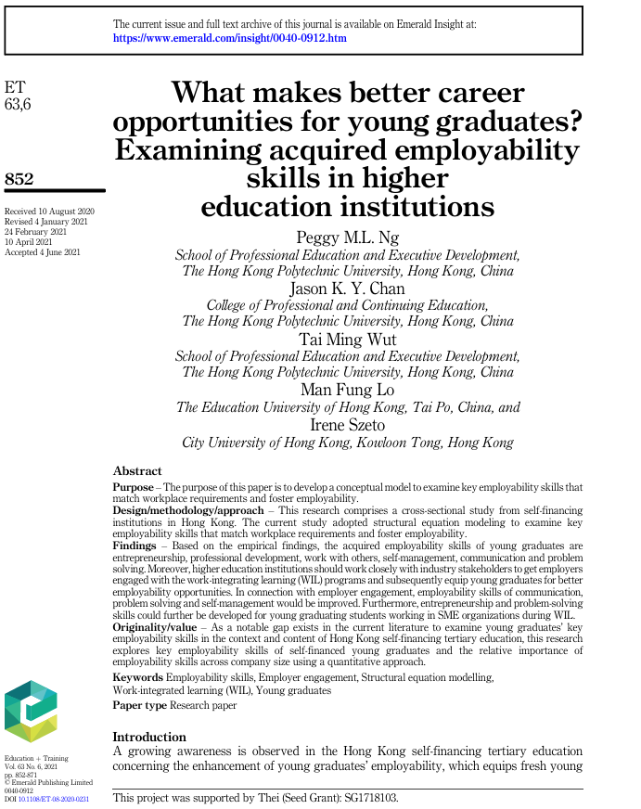

CRAAP Test
Currency | Received: 10th august 2020  Reviewed: 4th january 2021  Accepted: 4th june 2021
Relevance

Authority | All authors professionals
Accuracy | Non bias
Purpose | Examine key employability skills

Task 3: Source Analysis
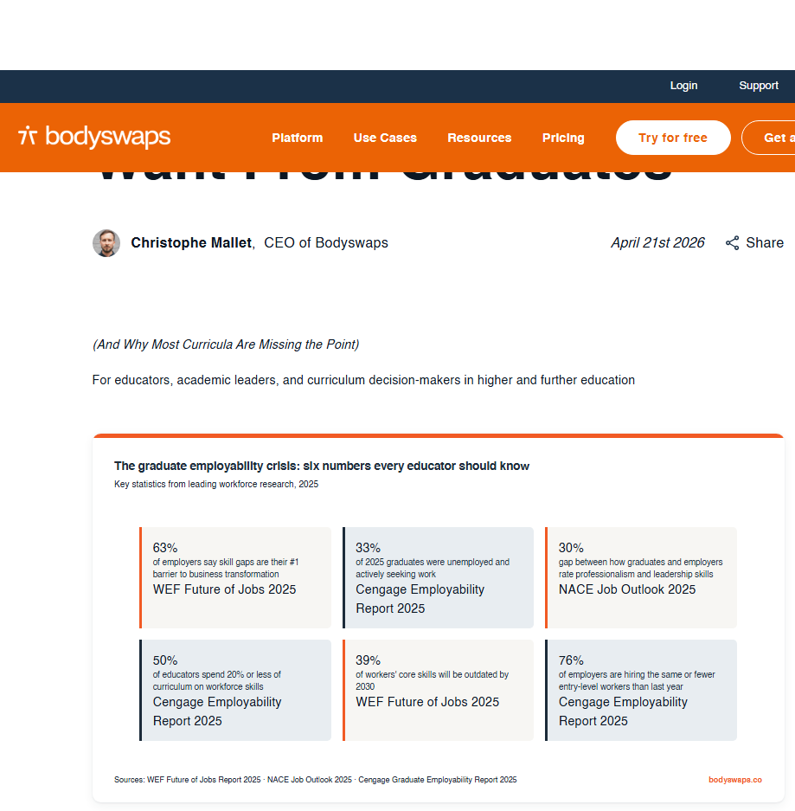
Your manager has provided you with a short extract from a source and has asked you to analyse the source by Identifying one strength, one weakness, and providing a brief explanation of the strength and weakness identified.

.

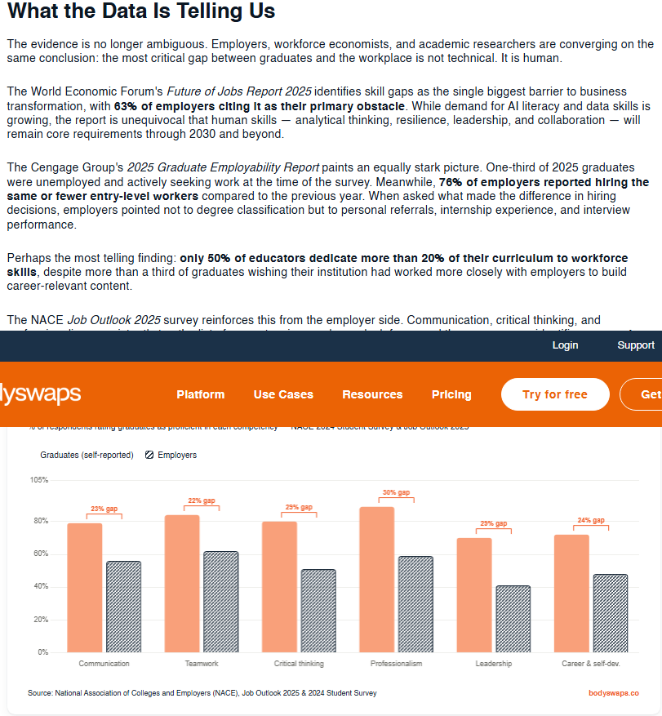

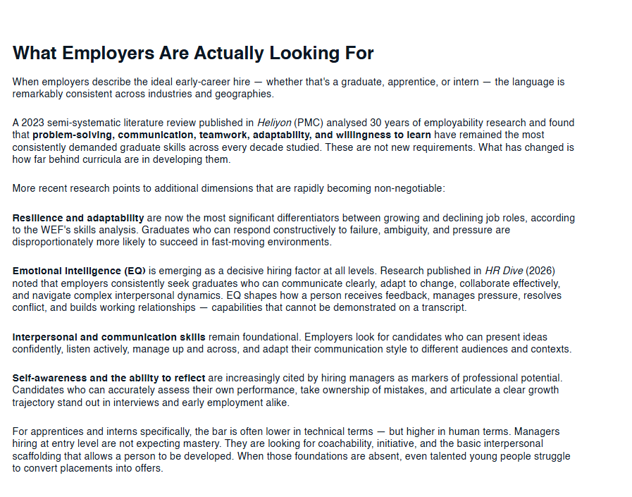

Please click the link, if you wish to read the article online.
What Employers Actually Want From Graduates

Strength of the Source:
Recently published (21st april 2026) which tells me its recent data.

Weakness of the Source:
The CEO has written which makes me think it is bias.
The percentage statistics are all dated 2025 when this report was written 2026 which is a long time for numbers to change.

