
Web & Mobile Technology

^{[1]}
School of Applied Computing | Assignment Title:  1 Javascript/JQuery-enabled Website | Code: ACCA 5031
Module:
Data Security and Compliance

Student:  Theresa Darzins  No 1909721 | Programme: Computing Portfolio  BSc/HND Computing | Lecturer: Gaynor Thomas  Date: 10th December 2021

Contents
1.0 INTRODUCTION 1
1.1 Report structure 1
1.2 Aims 1
1.3 Objectives 1
2.0 SCREENSHOTS HIGHLIGHTING JAVASCRIPT CONTENT 2
2.1 Index Page 2
2.2 Recipe Links 3
2.3 Restaurant Booking 4
2.4 Free E Book and Gold/Silver Card 6
2.5 Feed Back Form 7
2.6 Quiz 8
2.7 Learn Farsi 10
2.8 Horse Riding 12
2.9 Contact Page 13
3.0 CODE, COMPONENTS, AND THE APPROACH TAKEN AND WHY 14
3.1 The Code Used – Overview 14
3.2 The Components 16
3.3 The Approach Taken and Why 17
4.0 CONCLUSION 18
4.1 How I would extend the code in future/take different approach 18
5.0 REFERENCES 19

Table 2-1 Contents of Website 2
Table 3-1 Overview of Code Used 14
Table 3-3 The Components Used 16

Figure 2-1 Main Home Page 2
Figure 2-2 Recipe Links Page 3
Figure 2-3 Restaurant Booking Page 4
Figure 2-4 Free E Book and Gold/Silver Card Page 6
Figure 2-5 Feed Back Form Page 7
Figure 2-6 Quiz About Iran Page 8
Figure 2-7 Quiz About Iran Page with Colour Change 9
Figure 2-8 Learn Farsi Page 10
Figure 2-9 Learn Farsi with Colour Change Page 11
Figure 2-10 Horse Riding Page 12
Figure 2-11 Contact Page 13

INTRODUCTION

1.1 Report structure

Sections:

    - Introduction
    - Task
    - The Code, Components, Approach Taken and Why
    - Conclusion
    - References

Aims

Show how Data Web and Mobile Technology work.

Objectives

Show an understanding of key points regarding:
- Javascript
- JQuery

Give overview of:

- different ways to achieve similar results

SCREENSHOTS HIGHLIGHTING JAVASCRIPT CONTENT
Table 2-1 Contents of Website
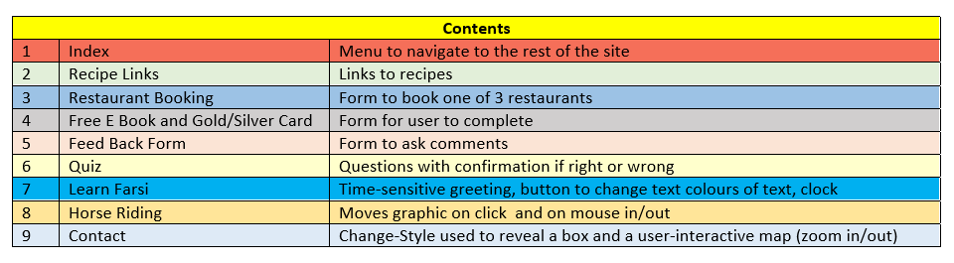

Index Page
Figure 2-1 Main Home Page
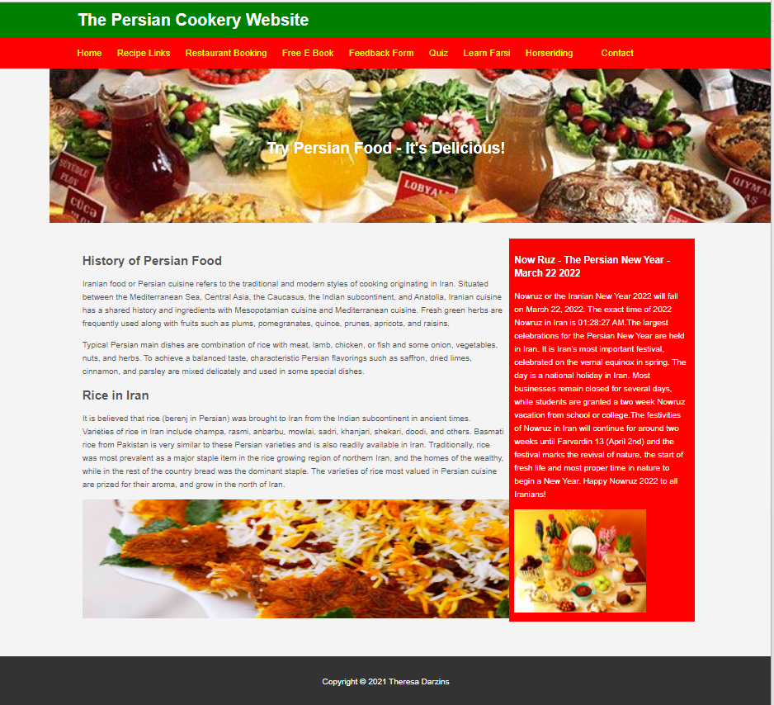
- Navigation Panel
- Side Panel
- Linked to CSS1

Recipe Links
Figure 2-2 Recipe Links Page
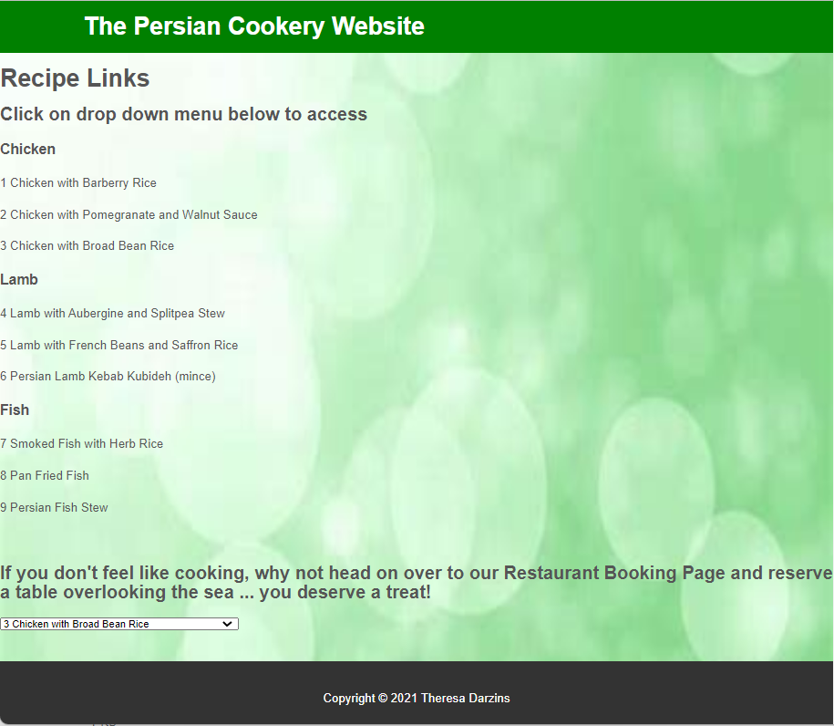
- Drop-down menu navigating to each of the 9 recipes on click.

Restaurant Booking
Figure 2-3 Restaurant Booking Page
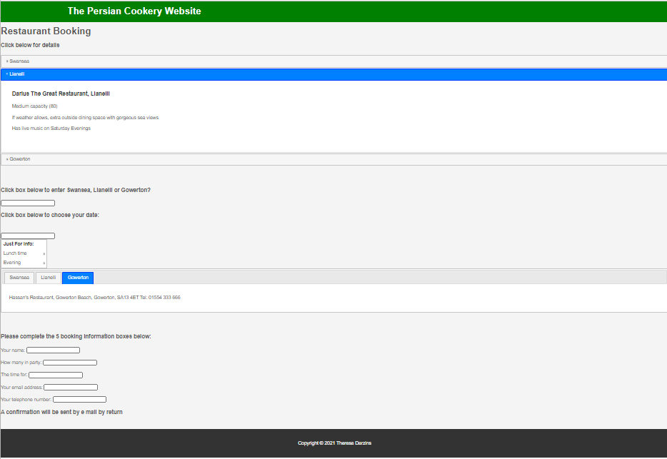
- Linked to . js file which controls:

- Colours of banner and tabs
- Towns to help user auto complete
- 3 Restaurant Tabs
- Calendar graphic

- The 3 blue bars, on click, titled with towns:
- Swansea
- Llanelli
- Gowerton
Reveals:
- Size of restaurant
- Special features

- Box entry for town name auto fills on entry of first few letters

- Calendar pop-up.

- Information box on click reveals times of Lunch and Dinner and hours children welcome

- The 3 blue Tabs titled with town names on click revealing:
- Restaurant Name
- Address
- Telephone No.

- Form boxes for:
- Name
- No. of People
- Time
- E Mail address
- Tel No

Free E Book and Gold/Silver Card
Figure 2-4 Free E Book and Gold/Silver Card Page
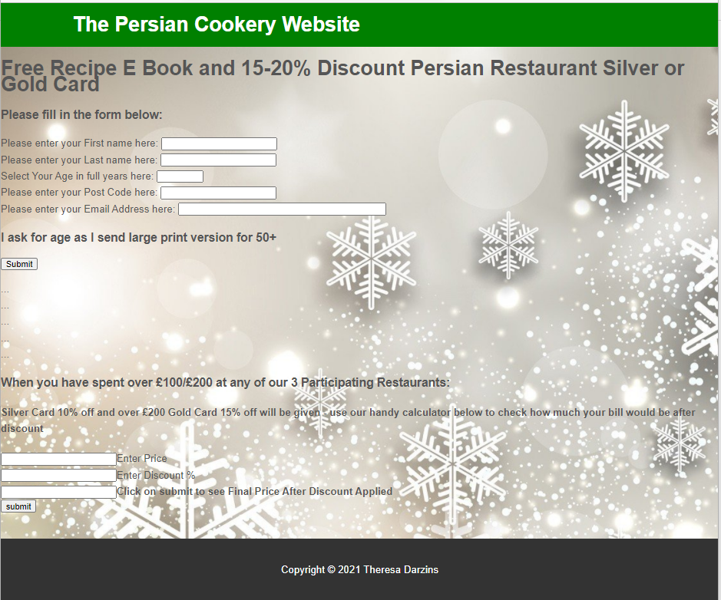
- Background changes in summer or wintertime
- User to enter details with validation
- Calculator for final cost of meal after discount

Feed Back Form
Figure 2-5 Feed Back Form Page
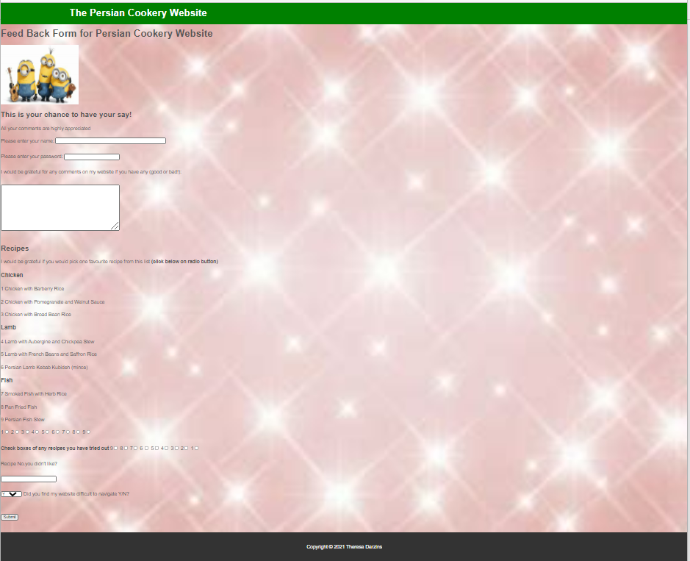
- Form name, password (won’t let you leave without filling in)
- Comments Box
- Radio buttons
- Tick boxes
- Box asking website navigation difficult or not Y/N and submit button

Quiz
Figure 2-6 Quiz About Iran Page
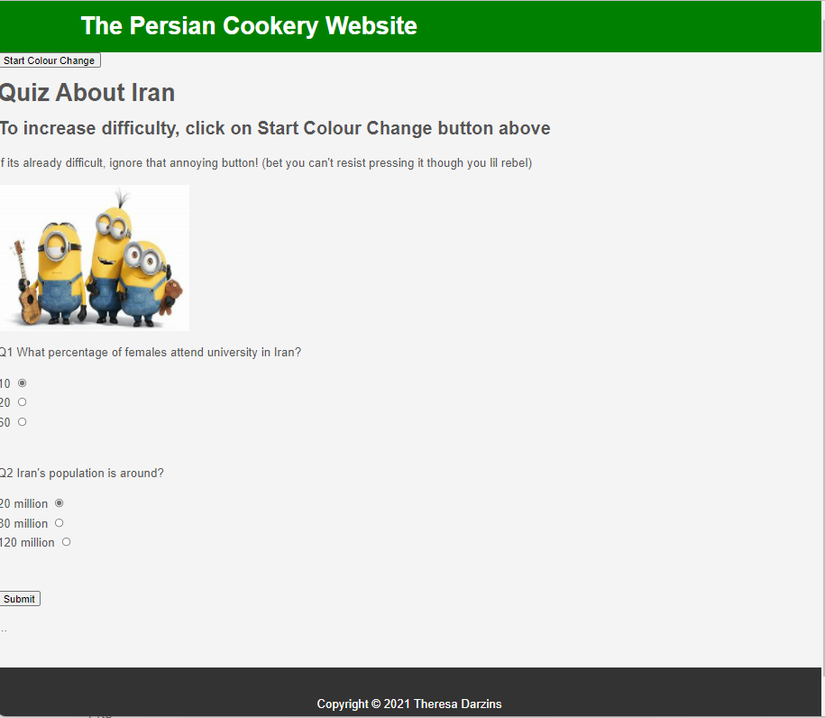

Figure 2-7 Quiz About Iran Page with Colour Change
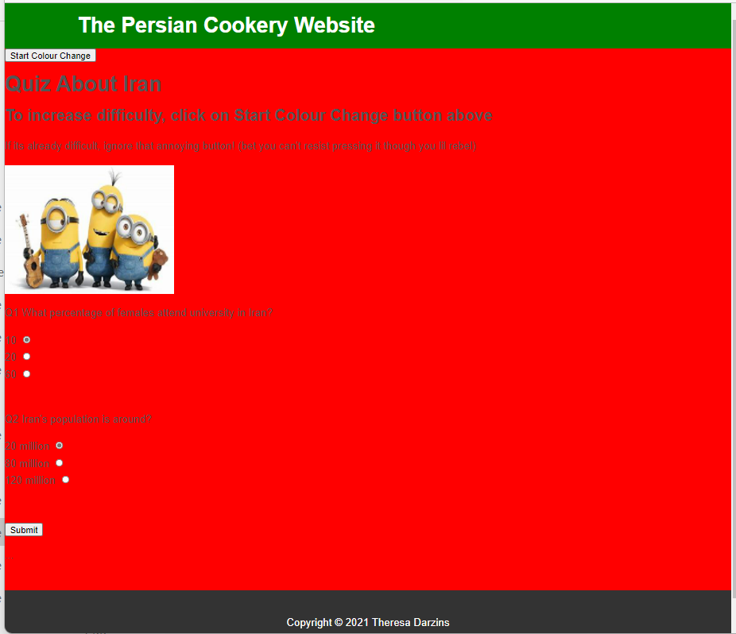
- Radio buttons for Q1 and Q2
- Confirmation answers right/wrong
- Random Colour Changes button.

Learn Farsi
Figure 2-8 Learn Farsi Page

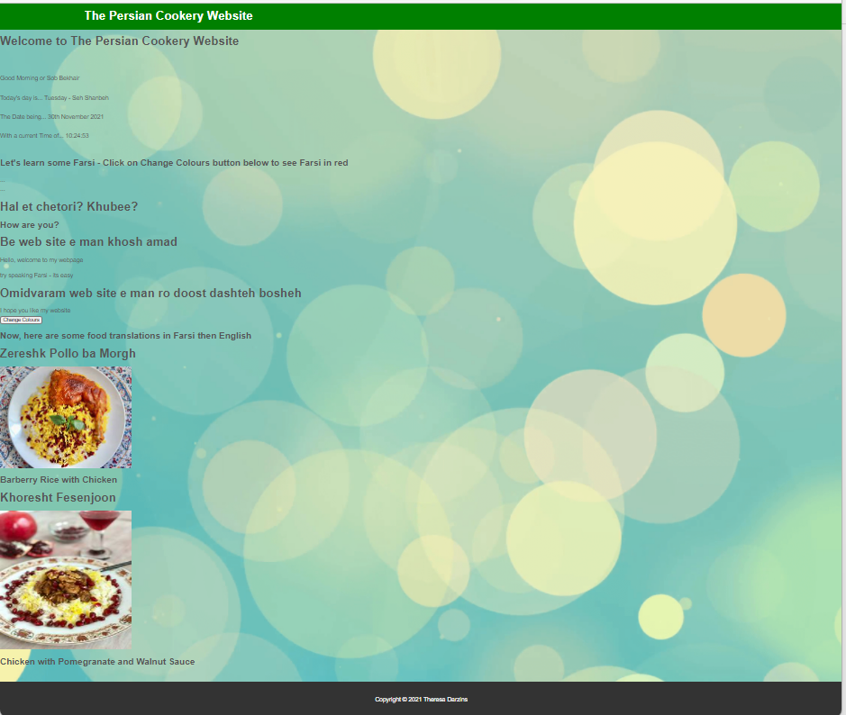

Figure 2-9 Learn Farsi with Colour Change Page
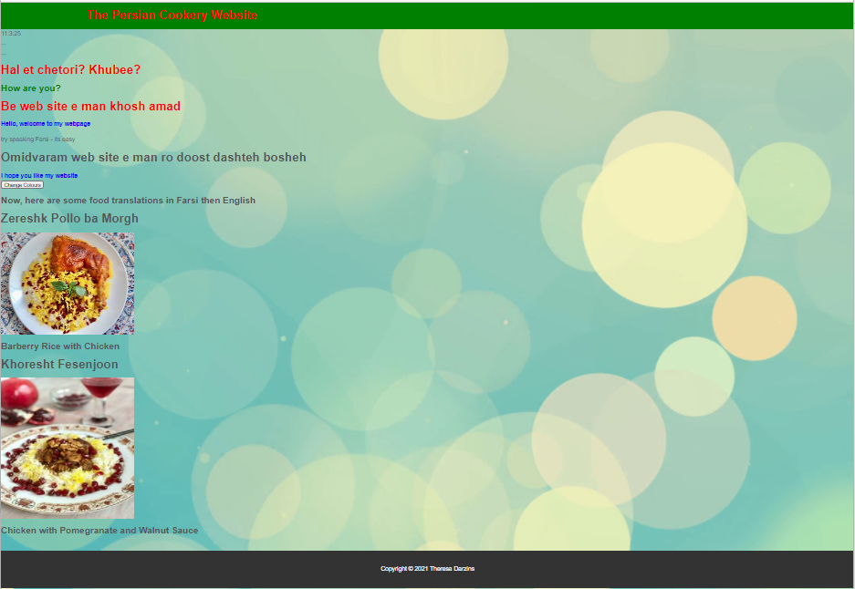
- Greeting according to time of day in English and Farsi
- Current day, date, and time notification
- Button to change text colours
- Time clock starts at top of page after clicking Button to change text colours

Horse Riding
Figure 2-10 Horse Riding Page

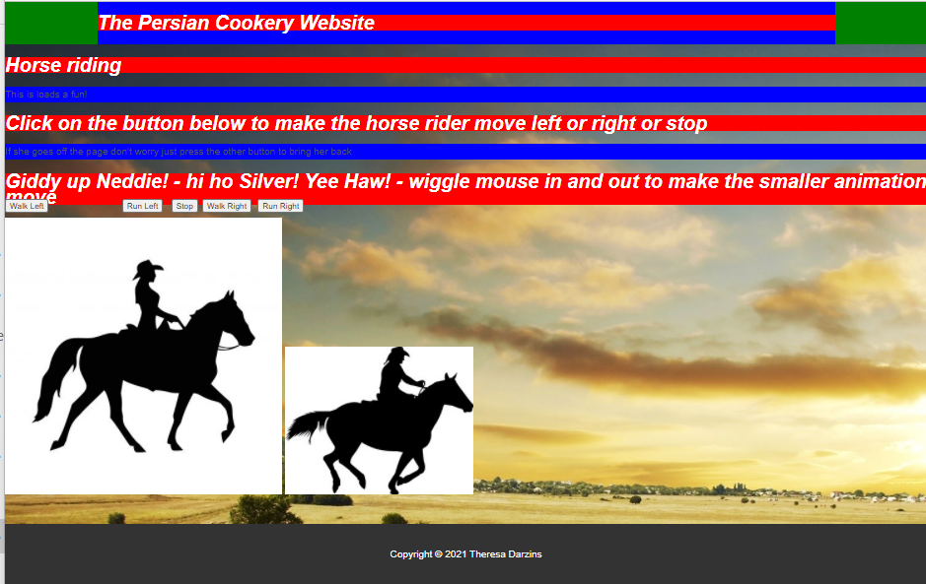
- Linked to js file to show colours
- Buttons to move horse
- On mouse in/out

Contact Page
Figure 2-11 Contact Page
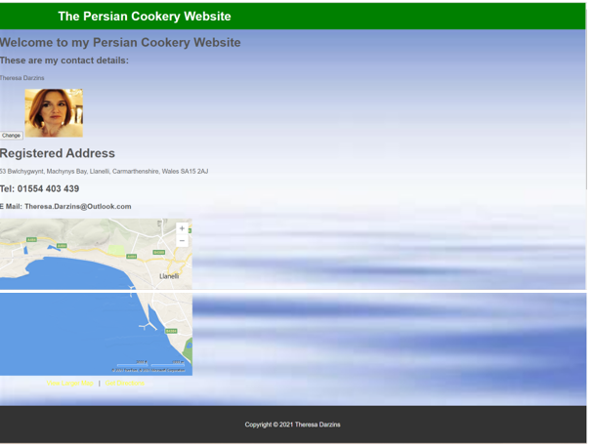
- Change style button reveals hidden object
- Map location zooms in and out

CODE, COMPONENTS, AND THE APPROACH TAKEN AND WHY

The Code Used – Overview
Table 3-1 Overview of Code Used
Section | Page Names | Overview
1 | Index | Menu to navigate to the rest of site
- header id
- footer id
2 | Recipe Links | Links to recipes
- function () – navigate to – onChange
- if , else if and else
- footer id
3 | *Restaurant Booking | Form to book one of 3 restaurants
- stylesheet – jquery ui
- label for, input type, href, ul id, div id
- script src
 | js | - $(page ready)  - Var  - $().autocomplete, datepicker, css, menu, tabs  - $(document).tooltip
4 | Free E Book Gold/Silver Card | Form for user to complete, and a Calculation Box % Discount (validated)
- function() – checkit, calculate
- getElementById, themessage.innerHTML=
- var
- input
5 | Feed Back Form | Form to ask comments, pick favourite recipe, etc.
- background-image
- img src=
- input type=”…”, radio, checkbox
- text area cols=, rows=
- required (for name and password), maxlength
6 | Quiz | Questions with confirmation if right or wrong with colour change button
- var timer, setInterval
- function showrandom() new Array()
- randNo, mybody.style.backgroundColor
- function() checkquiz
- getElementById, if,else
- input type= radio
7 | Learn Farsi | Time-sensitive greeting, button to change text colours of text, clock
- function OnLoad managedates(), new Array, switch, break
- showdate.innerHTML
- function changeit()
- getElementByTagName
- getElementByClassName
- function show clock(), timer=setInterval
8 | *Horse Riding | Moves graphic on click of buttons and on mouse in/out
- background-image, background-repeat:no repeat:
- Var timer function(), left, right, stop
- Var Image(), change image()
- Div class “..”
- Preload images
- this
 | js | - $(pageready)  - $”…”.css
9 | Contact | Change-Style to reveal a box and a user-interactive map (zoom in/out)
- meta charset CSS1 stylesheet
- onClick () change style
- img src=
- dirMapLink target

The Components

Table 3-3 The Components Used
Section | Page Names | Component Used
1 | Index | Home page with a Menu to navigate to the rest of the site
 |  | - Links to CSS1
2 | Recipe Links | Links to recipes to choose from
 |  | - Function navigate to
3 | *Restaurant Booking | Form to book one of 3 restaurants
- Links to js file Stylesheet jquery ui
- Sections, village, datepicker, restauranttabs
- Prompts user entries
4 | Free E Book Gold/Silver Card | Form for user to complete, and a Calculation Box % Discount (validated)
- Get Element by ID
- Function change background (summer/Winter)
- Function check it (user details)
- Function calculate %
- On click to see final price after discount
5 | Feed Back Form | Form to ask comments, pick favourite recipe, etc.
- Form will not let you leave without name and password
- Input radio buttons
- Input checkbox
- Input Y/N
6 | Quiz | Questions with confirmation if right or wrong with colour change button
- Function show random (array colours)
- Function starttimer
- Function checkquiz
7 | Learn Farsi | Time-sensitive greeting, button to change text colours of text, clock
- Function managedates
- Function showclock
- Function startclock
- Function changeit
8 | *Horse Riding | Moves graphic on click of buttons and mouse in/out
- Links to js File
- Function pageready (for background colours)
- Moves images on mouse in and out
- Preloads images
- Uses this
9 | Contact | Change-Style to reveal a box and a user-interactive map (zoom in/out)
- CSS File
- Function change style
 | * | Js file

The Approach Taken and Why

Tackled in stages:
Phase 1 - Research
- Brainstorm theme
- Draw boxes of how each page will look
- Research materials listing references
- List titles for different pages
Phase 2 - Input
- Start with Index (home page)
- Add pages, commenting as go
- Test
Phase 3 - Polish
- Draw up Report in Word
  - Insert Screenshots
  - List Components
  - Insert References
  - Proofread and wordcount

CONCLUSION

How I would extend the code in future/take different approach

- Use Themeroller to give:
      - conformity
      - style
      - interactive features

    - Link to countdown to Now Ruz (Iranian New Year)
    - Links (to horse racing in Iran) Nourouzabad
    - Link to tourist board

WORD COUNT
Total Words | 1017
Minus Tables and Figures | 97
TOTAL NET WORDS | 920

5.0 REFERENCES

[1] Web & Mobile Technology Images - Bing images [Accessed 11 Nov 2021]
 | Page Names | Summary Description References for the Website
1 | Index (Home) | The home page with a Menu to navigate to the rest of the site
1 | Main pic | panoramic picture iranian cookery - Bing
2 | Text | History of Iranian Food & Cuisine (enjoyvisit.com)
3 | Text box | Nowruz 1401: Persian New Year 2022 Date & Time (dayfinders.com)
4 | Rice pic | All About Rice in Iran: History, Cultivation and Traditional Iranian Rice-Based Foods – SURFIRAN
5 | Sofret pic | 471174891_880308350.jpg (3826×2867) (wp-cpr.s3.amazonaws.com)
2 | Recipe Links | Links to recipes to choose from
6 | 1 | Zereshk Polo ba Morgh | Persian Barberry Rice with Chicken recipe - PersianGood
7 | 2 | Fesenjan (Persian Pomegranate Chicken) Recipe (simplyrecipes.com)
8 | 3 | (1) New Message! (epersianfood.com)
9 | 4 | Khoresht Gheymeh Bademjan Recipe | EpersianFood
10 | 5 | Persian kebab kubideh with rice (Chelow kebab) Recipe by Rozina Dinaa - Cookpad
11 | 6 | bild-067.jpg (2256×1496) (wordpress.com)
12 | 7 | Turmeric & Saffron: Mahi - Fish (Fried, Smoked or Baked) Persian New Year's Day Lunch/Dinner (turmericsaffron.blogspot.com)
13 | 8 | Turmeric & Saffron: Mahi - Fish (Fried, Smoked or Baked) Persian New Year's Day Lunch/Dinner (turmericsaffron.blogspot.com)
14 | 9 | Persian fish stew recipe | delicious. magazine (deliciousmagazine.co.uk)
3 | Restaurant Booking | Form to book one of 3 restaurants
4 | Free E Book and Gold/Silver Card | Form for user to complete, and a Calculation Box % Discount
15 | Grey | Soft Background winter theme Patterns - Bing images
16 | Blue | wallpaper summer background soft repeating patten - Bing images
5 | Feed Back Form | Pop ups and Form to ask comments, pick favourite recipe, ask least favourite etc.
17 | Minions | Minions-Dancing-image-minions-wallpaper.jpg (1920×1200) (wallpaperheart.com)
18 | Pink Sparkles | Beautiful Pink Sparkles Background Vector Art & Graphics | freevector.com
6 | Quiz | Questions with confirmation if right or wrong with colour change button
19 |  | Iran Quizzes Online, Trivia, Questions & Answers - ProProfs Quizzes
7 | Learn Farsi | Time-sensitive greeting, button to change text colours of text, clock
20 | Barberry Rice | zereshk polo ba morgh - Bing images
21 | Pomegranate and Walnuts | khoresh fesenjoon - Bing images
22 |  | Download this awesome wallpaper - Wallpaper Cave
8 | Horse Riding | Moves graphic on click of buttons
23 | Pics | Race Horse Silhouette - Bing
24 |  | Race Horse Silhouette - Bing
25 |  | Race Horse Silhouette - Bing
26 |  | Race Horse Silhouette - Bing
26 |  | Texas Photography Western Landscape Southwestern Prints | Etsy
9 | Contact | Change-Style used to reveal a box and a user-interactive map (zoom in/out)
27 |  | background soft jpeg - Bing images

