Discuss how you would plan and design a project management process for the workplace

Name: Georgia Sweet
Student ID Number: 2134239
Module Title: Managing Work-based Projects
Module Code: BMPF7018
Word Count: 2473

My Workplace
My workplace is a large county council that provides Transport, Planning, Environment and Education services to the public, under the direction of elected county councillors. Approximately 178,000 people live in the county and are supported by the council. I work in Digital Transformation, a team within the ICT department. In my role as a Project Officer, I manage and support ICT related projects across all council services. Although all of my projects have an ICT component to them, they vary greatly from supporting hybrid working, rolling out multi-factor authentication, transitioning to cloud applications and supporting the ICT network connectivity for council sites and visitor centres. There are many different project management methodologies, all with their pros and cons. A project process used to manage a Digital Transformation project within my team may not meet the requirements of a project carried out in another department. For that reason, I want to focus the design of my project management process to suit Digital Transformation projects, but my hope is that it can be adjusted to suit other departments across the authority.

Current Practice
The Authority have developed a corporate approach to managing projects that is heavily influenced by the PRINCE2 methodology. The project management toolkit is intended to be used in the knowledge that there’s no ‘one size fits all’ approach, but that a core set of principles always apply. The toolkit is designed to provide guidance to everyone that is involved in a project, to clarify roles and responsibilities and provide structure for the planning, delivery and closure of projects.
In my two-year experience working for the Authority, I haven’t seen the project management toolkit being used in practice. It is a very detailed, lengthy process which includes a considerable amount of documentation. Because of this, I believe staff find the toolkit overwhelming, and inaccessible and as a result it’s rarely applied. In addition to this, many of the projects run in the Authority are managed by staff who don’t have project management experience, so they are either not aware of the project management toolkit or they don’t have the specialist experience needed to apply the process to the management of their projects. Projects are usually managed on an ad hoc basis without clear structure or process. Because the toolkit is often not applied, there is an increased risk that projects will not be thoroughly planned, monitored and controlled, and therefore a higher risk of project objectives not being fulfilled.

Current Issues
One of the issues of managing projects in an ad hoc way is that there’s no consistency or structure in the way projects are managed from individual to individual. Everyone has their own management style and therefore plan and deliver projects in their own way. This can result in huge variances in terms of project success and the quality of project outcomes.
Departments often work to their own priorities and objectives in a very siloed way so there is very little knowledge sharing and collaboration across the authority. This means there aren’t many opportunities for ‘lessons learned’ and sometimes there’s very similar, if not identical, projects running across two departments that each are unaware of. If we had more collaboration and knowledge sharing across the Authority, I think we could really harness staff expertise and experience to drive future projects.
Resource is a real issue in the Authority. I’ve worked on a few projects where there is real enthusiasm and drive at the beginning of the project, but this gradually reduces throughout the duration of the project until a point is reached where the stakeholders aren’t responding, or the project has to come to a complete stop. I think the reason for this is that departmental resources are under a huge strain, often being expected to deliver the project while also fulfilling their normal operational roles.
IT resource is also very limited. Departments often go straight to ICT staff to ask for resource which means that they are encumbered with work that hasn’t been approved and isn’t on their work program. There are only so many hours in the day and for our developers, most of those hours are likely already accounted for. That's why it can be so disruptive when ad hoc projects or requests get pushed onto the team. They’re left in a position where you have to make time up out of nowhere.
Communication and governance of projects can be very poor. On the projects I have worked on there has been very little in the way of project documentation or clear project plans or schedules. Meetings are held to discuss the project and what needs to be delivered but detailed discussions regarding the tasks involved to deliver the project rarely take place and are not documented. This relies on stakeholders and resources working in a very isolated way, managing the tasks they think need to be completed to the best of their knowledge or experience. As a result, lead times, risks and changes are often overlooked. Communication is usually managed via email, which does serve a purpose however in my experience it can limit consistent communication and often involves lots of document attachments. Multiple document versions, attached to emails, can be difficult to locate and when saved locally, inhibit collaboration.
Unfortunately, project closure is non-existent which means that project teams often continue to support projects long term rather than reverting back to a business-as-usual model. Because of this, there is further strain on our resource because their time is not freed up to move on to other projects and priorities.
Microsoft Project (MS) is recommended in the Authorities toolkit as a resource to support projects, but staff don’t actually have access to MS Project as it’s not included in our enterprise agreement. For this reason, I’d like to build my Project Management process using MS applications that we do have access to.

My Project Management Process
Having summarised the Authorities current project management process and some of the issues we experience with managing projects I’d like to design my own project management process in such a way that those issues are addressed. My aim is to design a project management process which is accessible and simple to follow. It will allow those with or without project management experience to plan and deliver projects while following a clear and universal structure.
In my own project management process, I wanted to maintain the project stages that are detailed in the Authorities project management toolkit and so many other project management methodologies. The reason for this is that I think it gives the project team a clear and visual structure to follow when delivering a project. Even though we work on a variety of different project types and sizes, I think these four stages can be adapted and scaled to suit all projects.
Figure 2 The four stages of my project management process. Developing an idea, developing the project, delivering the project and reviewing and closing the project. Monitoring and control spanning the duration of the entire project.

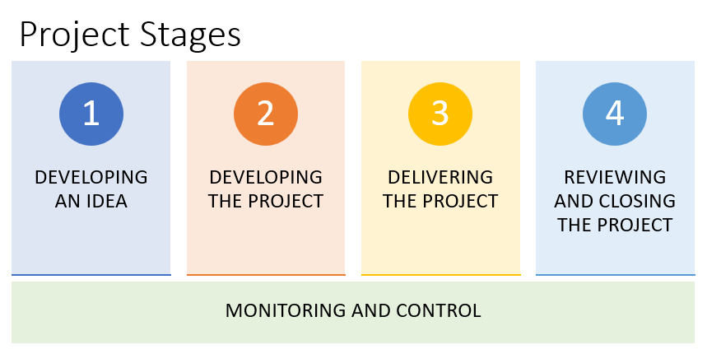
Developing an Idea
An Expression of Interest (EOI) process is something that we’ve recently implemented in our department which I wanted to include in my project management process because it’s working really effectively. It can be viewed as a business case for requesting ICT resource or Digital Transformation funding. It gives justification of the requested work or project and helps the service to prioritise the work required by the requesting department. The Expression of Interest form is online and available to all staff so anyone in the authority can put forward their ideas for service improvement. The form is accessible, easy to fill out and doesn’t require a huge amount of detail, therefore staff aren’t intimidated by or deterred from filling it out. It allows us as a Digital Transformation team to quantify incoming work which in turn allows us to evaluate priorities against our available resources.
I mentioned that one of the issues with our current process is that we have limited ICT resource available to support projects. I think the EOI process has really helped to support our ICT staff because it stops staff members going directly to ICT resource to request work. If a department want ICT resource, they must submit an EOI, there is no other route.

Figure 3 An extract of the Expression of Interest form.
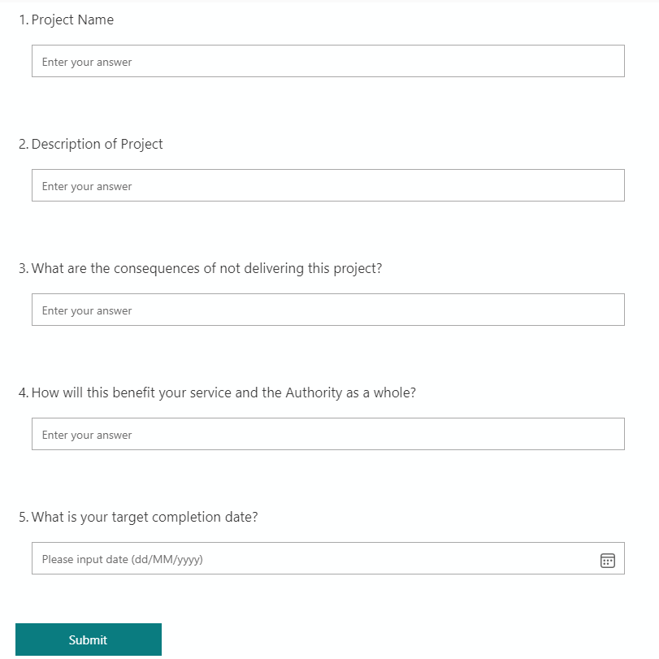
The first stage of my project management process is developing an idea and a large part of this is the Expression of Interest form but also the engagement meeting that follows on from that. After the EOI is submitted, it’s passed on to our Digital Transformation team who meet to discuss EOIs on a weekly basis. This gives us the opportunity to look at the EOI in more detail, share knowledge about other similar projects we’ve worked on, identify if there’s already a system or project in place that can meet their needs and evaluate whether or not we have the ICT resource available to support the project. A Project Officer is assigned the EOI and will organise an engagement meeting with all relevant stakeholders. This is where the EOI will be discussed in more detail. If the project is approved a single line of communication is used to ensure that all stakeholders are informed about the project. At this point a Microsoft Teams Channel is set up for the project which all stakeholders have access to.
Figure 4 Diagram of idea development process
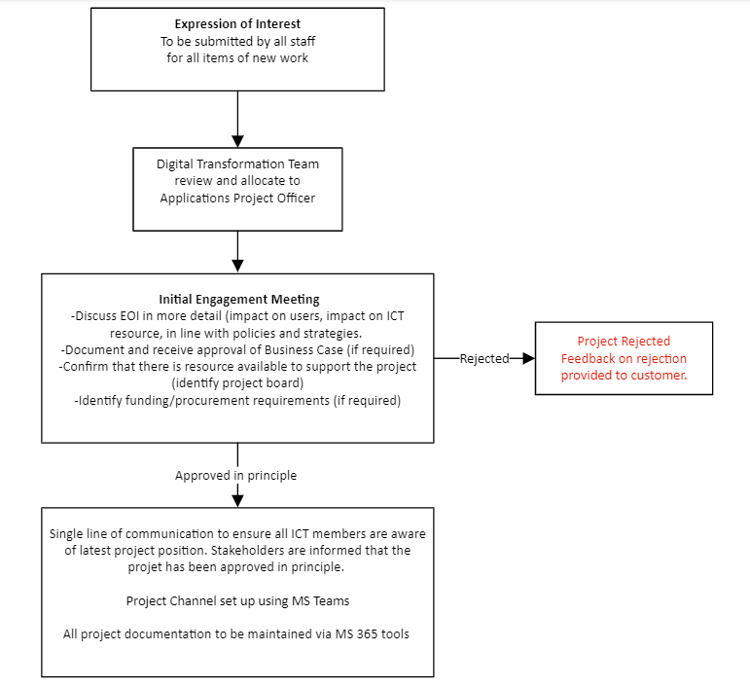
Confirming that there is available resource within the requesting department to support the project and setting up a project governance team is a crucial part of the EOI process. Many of our stakeholders are under huge resource pressures and are required to deliver projects on top of their daily tasks. This is why I’d like to implement the Six Sigma approach where 1% of workforce are committed as ‘black belts’. “Once trained properly, these individuals work only on black belt projects. In this regard, they are strictly overhead and contribute nothing directly to the everyday operations” (Keller, 2011, p. 20). My project management process would include ‘Project Teams’ located in each department who would take ownership of all departmental projects while not being required to fulfil other roles or tasks.

Developing the Project
All project documentation would be held digitally within a Microsoft Teams Channel with easy, accessible document templates available at the beginning of each project. Included in this would be a Business Case template in a MS Forms format that all stakeholders would have access to via the project Teams Channel. The use of a Business Case is heavily influenced by the Prince2 methodology which states that “a project should be driven by a Business Case” and that “a viable Business Case should be proved before a project is allowed to start and its continued justification should be confirmed at all major decision points throughout the project” (Managing Successful Projects with PRINCE2, 2017, p. 7).
For project planning and scheduling I’d like utilise Tasks within Teams. It allows project tasks to be scheduled in a Kanban view. Multiple tasks can be added, assigned to individuals and comments and notes can be added against tasks which the project team are notified of. This again allows for collaboration across all stakeholders, it’s visual and it can be upscaled to reflect project size and complexity.

Figure 5 Extract of Microsoft Tasks illustrating how it can be used for project scheduling
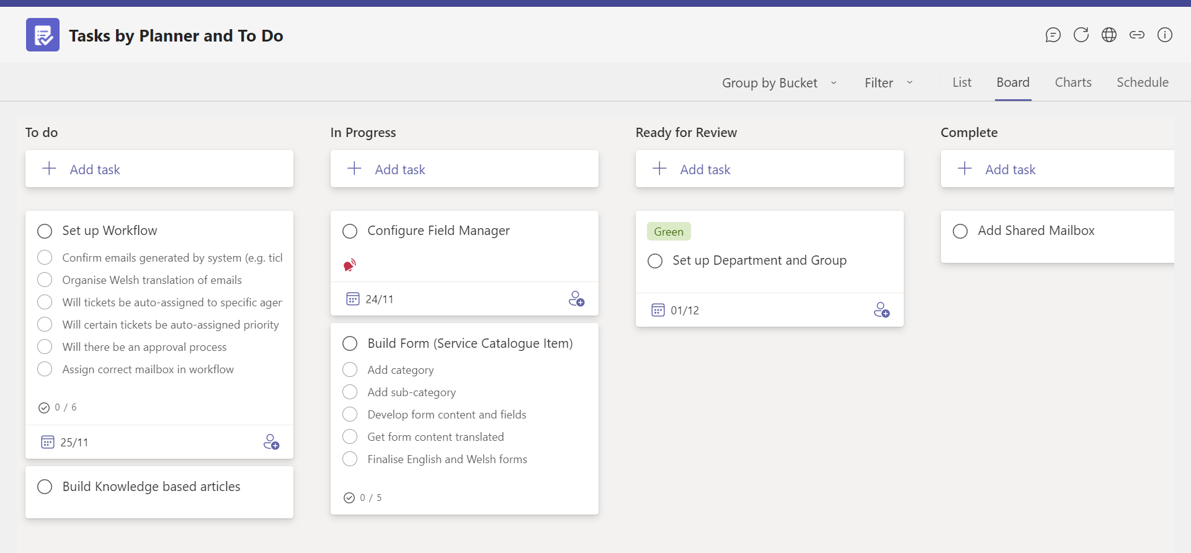
Delivering the Project
I want to managing stakeholder engagement through daily SCRUM meetings which would also be held on Teams. Morris and Carroll state that ‘Daily Scrums result in improved communications and remove the need for other meetings. They identify and deal with obstacles to development, promote speedy decision making, and increase the Development Team’s product knowledge’ (Morris and Carroll, 2015, p. 38). I think this would really improve communication and knowledge sharing, encourage lessons learned and project discussion.
I wanted to move away from the PRINCE method of projects being output oriented rather than work oriented so where possible I’d like an agile (iterative) approach to be adopted during project delivery.
“The agile approach to projects starts out with the expectation that the requirements (or features) will evolve and change during the course of the project. What is fixed and agreed between the project team and the customer is the resources that will be used and the time that will be taken by the project team to deliver as much as possible of the prioritized features the customer wants” (Morris and Carroll, 2015, p. 8).
I believe this approach would also allow for better, more creative output from our software developers because they’d be given the freedom to think innovatively using their experience and expert knowledge to deliver an outcome.

Monitoring Risks and Changes
Another tool that we’re not utilising in the Authority is Microsoft Lists. In a similar way to Tasks, it allows risks to be rag rated, assigned to specific staff and comments added against specific items. These are date and time stamped so there’s a continual log of communication and history.
Figure 6 Extract of Microsoft Lists illustrating how it can be used for risk and change management
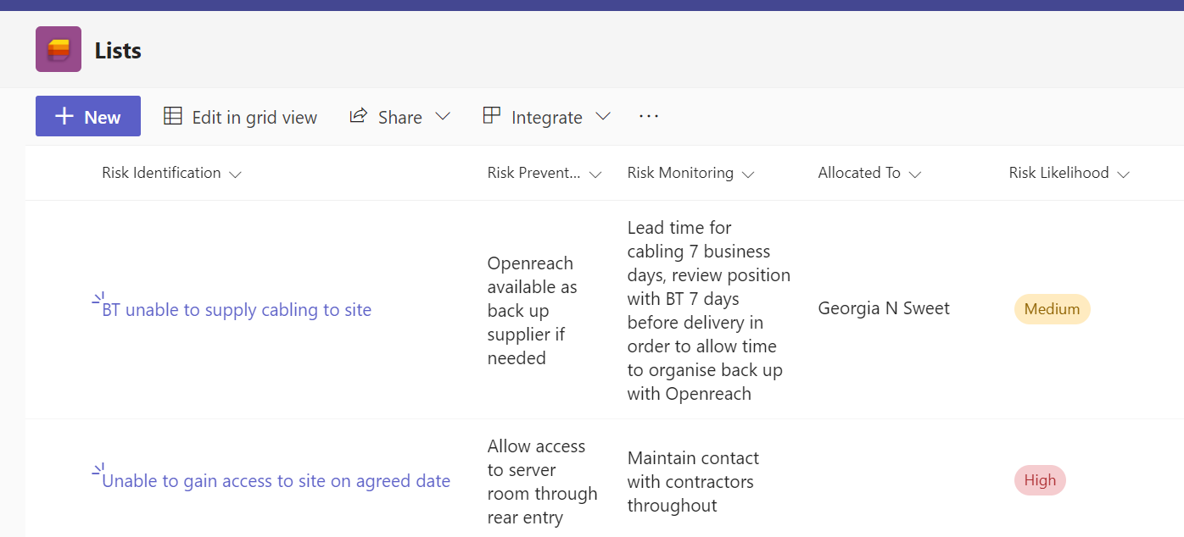

Project Review and Close
At present, project review and close does not exist and hasn’t been a part of any of the projects I’ve worked on. This is one of the main issues we have with resource. If we don’t have project closure, our resources aren’t available to move on to other projects.
I want to implement a process by which the Project Board confirm that the project has come to an end. In that meeting the project will be reviewed to capture the benefits, successes, lessons learned and other relevant experiences. I think this stage is so crucial for informing future projects. At this stage the project team prepare for handover. Operational or procedural instructions and any ongoing issues/risks are transferred to the operating team or service area. From there, the project team is released.

Conclusion
Reviewing and scrutinising my Authorities current project management process has given me the opportunity to provide suggestions for improvements. For each issue I’ve identified in my introductory paragraph I have attempted to suggest new ways of working that will address the pressures and difficulties we experience when managing projects. Our biggest failure is that we don’t acknowledge and harness the experience and expertise of our staff. Their continued engagement and support is crucial to the successful delivery of projects which is why I’ve tried to include as much knowledge sharing, and collaboration as possible in my own process. Where possible, I’ve recognised and maintained processes that are working well within our Authority, such as the EOI process. In other areas, I’ve used industry best practice to influence my process. All project management methodologies have their own strengths and unique characteristics, and my aim was to utilise the most suitable and appropriate elements of each. By combining these project management methodologies, I believe I’ve been able to develop a process which meets the needs of my workplace that can be adjusted and scaled to suit a variety of different projects.
References
Keller, P. (2011) Six Sigma Demystified. 2nd edn. New York: McGraw-Hill Professional
Managing Successful Projects with PRINCE2 (2017) Norwich: The Stationery Office Ltd
Morris, D. and Carroll, J. (2015) Agile Project Management. Reading: In Easy Steps

