Assignment on Digital Skills and Research Methods

Mohammed Shahadat Hussain
1712830

Contents
Introduction 3
Literature Review 3
Research Methodology 5
Qualitative and Quantitative Research 5
Primary and Secondary Research 5
Data Sources 6
Data Collection Method 6
Data Analysis Method 7
Ethical considerations 8
Discussions over digital market research methods 8
Conclusion 9
References 9

Introduction
Digital skills are being promoted as one of the most sought out employability skills that employers are searching for in their potential employees these days. The employment opportunities are ever competitive with introduction of consecutive technological innovations implemented in workplace to increase efficiency and speed of deliverance of work in the workplace setting (Sheldrake, 2011). As a marketing manager for the Brainlabs, I will present a discussion over the research methodologies, ethical considerations and effective data interpretations techniques used for organizational researches in this report. Brainlabs is a reputable online marketing agency that is helping the advertisement of product of their customer companies. Hence, they are conducting organizational research on digital marketing techniques that can appeal the most for the individual consumers of the products from the companies. And the importance of the required digital skills for effectuating the research project will be also discussed for their employability value.
The title for the research discussed here is-
“Evaluating the digital marketing impacts on sales of products of advertising companies in Brainlabs”

Literature Review
In the olden days, business only referred to exchange of goods and resources. However, the practice has changed and in the present business world, the exchange of goods is as important as building a lasting and trusting relationship with customers. The marketing functions of businesses helps initiate the first gesture of bonding to the business towards the customer and then helps continue bringing back the customer overtime and ensures sustainable development for the business organization.
Hence, essentially according to Kotler (2007), marketing is the process for exchanging needed products and services between business and customer of the business and then continuing service to the satisfied customers. Therefore, it is evident that marketing is not only to advertise products but also continuing the effort for a longer time to bring in valuable and loyal customers who provide security to the business. This is also supported by Jobber (2010) who claims that the archaic thought about marketing is no good and needs redefinition which must include the efforts to engage customers for a longer time period in the business of companies.
To effectuate the marketing operation in business, there needs to be concentration on several aspects which can be defined by standard formulas. This is called the marketing mix. According to Ivy (2008), marketing mix helps gain the desired results from company performance over target consumer groups and the components to be considered for this are the components for marketing mix. There are 7P’s and 4P’s of marketing mix. While 7P’s of marketing refer to all internalized factors for marketing influence, external factors are considered for 4P’s of marketing.
The 4P’s are- Product, price, promotion and place. These are main influential factors of marketing. As Baker and Hart (2008) describes, the company doing the marketing needs a supplier who will provide the product and set a price to gain profit with promotional activities to introduce the product to potential customers and selected and suitable places where products will be served.
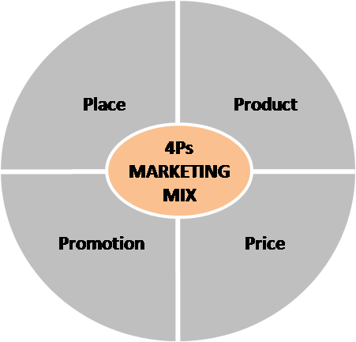
Figure: 4P’s of Marketing Mix
According to Martin (2014), marketing mix is necessary to capitalize on the marketing strategy that aims to successfully sell the products while still being satisfactory for the customers to be retained for the next time product will be served.
For present day promotion of product to customers, it is essential to utilize the digital channels that the customers are more associated with these days. That way, it can reach a bigger audience and appeal to an increased customer base. So, Ahmad (2013) advices that digital skills can help increase workplace efficiency. Also, this lead to believe that acquiring such relevant digital skills that helps effectuating digital marketing campaign of product and services of companies bring in increased employability value for the employees. However, Mitrovic (2010) suggests to put the digital skills of employees presented as their employability skills in relevant needs as he suggest that having a lot of digital skills does not buy into success but having relevant skills does. Thus, Vries’s (2012) suggestion for HR managers to seek employability skill such as digital skills is extremely important.

Research Methodology
The methodology for research enables the validation of analyzed data and helps make reliable conclusion after complete analysis of collected data. Furthermore, the technique for collecting, selecting and analyzing relevant data also falls under the supervision of research methodologies. Hence, it is extremely important to choose the best suited research methodology for a particular research topic.

Qualitative and Quantitative Research
Qualitative research is a subjective approach for research where explanations over trends, opinions and feelings of people around the subject matter is assessed in an unstructured or semi-structured method (Taylor, 2016). Most qualitative research is done in order to construct a hypothesis as basis for quantitative research over the same topic. Qualitative research can be done through discussions, focus group, observations, etc.
Quantitative research on the contrary is an objective approach to a research topic that needs conclusive remarks. These researches are done through converting collected data into numeric values and by statistical approach to present the data (Stemmler, 2015). Quantitative research can be done through surveys, polls, one on one interviews, longitudinal studies and observations, etc.
This particular research over digital marketing of products can be effectuated using quantitative research using survey questionnaire from customers of the product of the company, while qualitative research can be helpful to direct the questionnaire.

Primary and Secondary Research
Primary research is first hand research first started for a particular ongoing research. The purpose of primary research is to find specifics of a research topic from a controlled setting of the research population. In primary research raw data is collected by researchers themselves for the first time and so is costly to conduct through interviews or surveys (Edmonds, 2017).
Consequently, secondary research is the research over already done research data form a new perspective. Hence, these researches use already analyzed data from other primary data to inform the secondary research prospects. Since, the data analyzed here are from previous survey reports, papers and articles from text sources and the internet, it is effectively desk research incurring lesser cost than primary research.
This research topic to evaluate digital marketing strategies for advertising company products is best realized and done if both primary and secondary research is used for analyzing data and coming to conclusion. While secondary research informs the researchers of underlying assumptions influencing the topic, primary research evaluates realistic concerns of the topic.

Data Sources
For primary research. Data sources can include people related to the research topic and organization as well as direct reports and publications form the research organization containing relevant data. However, for secondary data, data source includes books, newspaper articles, national statistical data, journals and papers as well as previous similar research reports (Creswell, 2009). For the purpose of evaluating marketing applications for advertising company product in this research, a primary and quantitative research will be followed which can be informed through secondary research of journal papers and books. Also, a survey questionnaire is to be distributed among company customers to make effective analysis of the marketing strategy used for advertising product of the company by Brainlabs. The customers of the company are all called the population of research project, while selected individuals made responsible for providing answers in the research are sample group.
This research will be utilizing 50 customers answers form a carefully designed questionnaire to finally conclude decisively on the research matter. Although an interview can be done as well, it is not conducted due to time constraints and random selection of customers of the business helps eliminate any inclined and biased views while effectuating collected results within shorter resource and time limit.

Data Collection Method
Data collection method for numeric data has to be better structured and research have to conducted with extreme are at the risks of misjudgment of the entire analysis, based on only few mistakes. On the other hand, explanatory data such as secondary data collection method needs comprehensive research of library data and so on (Hancock, 2017). This research over marketing of company products advertisement in digital domain needs to use a primary and quantitative approach for collecting data as its main approach, while a concise secondary analysis can help illuminate the way.
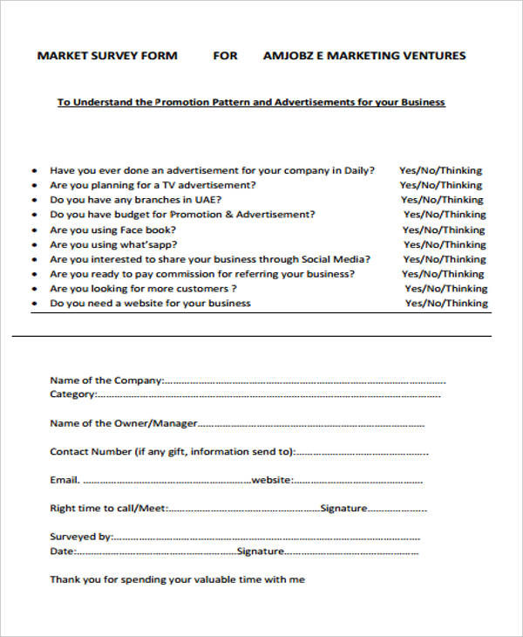
Figure: A Sample marketing research questionnaire

Data Analysis Method
The collected data for the research can be analyzed through various methods. These methods are selected solely based on the nature of data and requirements for research topic and objectives achievement. For qualitative and secondary data, the bets data analysis method is textual analysis where explanatory previous researches are to be analyzed suing the researchers own understanding over similar topic and assumptions made base on available data (Mligo, 2016).
On the other hand, quantitative and primary research data is best analyzed pursuing SPSS, Microsoft Excel, Microsoft Words analysis tools, etc. In such situations, collected data are converted to numerical counterparts and mathematical models and put into display using statistical tools such as charts, diagrams and tabulated formats.

Ethical considerations
Ethical considerations are of extreme importance in case of a research project whether social or business research project. This research project aims to evaluate digital marketing of company products to customers through survey questionnaires and so requires following certain ethical considerations to increase its reliability and acceptance. The following ethical considerations ware adhered to in this research:
- All materials used in the research is used with prior permission from the owners of the materials. For example, all books and journal articles were used in accordance to copyright law imposed on these materials. In case of special circumstances, permission was collected before using information form the material.
- The survey questionnaire were kept confidential and accessible only for the researchers who promised to destroy the main papers after recording the data in a tabulated format for analysis.
- The data collected for the research are protected with data protection act so as not to use those for business related purposes, but only for academic purpose of this particular project.

Discussions over digital market research methods
As a marketing manager for Brainlabs, it is essential to understand the various research methodologies in order to apply them properly for various market researches done by the organization to effectuate their marketing and advertising campaigns. Thus, knowing and being able to weight among available research methodologies and the digital skills that effectuate research in a digital environment is considered to improve on efficiency in workplace and by having the digital skills required to make it effective employability potential of employees can be fully realized in the organization (Brown, 2008). Efficiency is achieved as the market research can be faster and accurate with less resource required compared to traditional system and this is due to improved employability of employees imbued with digital skills.
The research needs decisive answers to posed research questions as it needs close relations to collected data and objective. Hence, direct data of the research is most effective in bringing out the exact answers for research questions. However, some literature source reviews cannot hurt since they can pave the way for designing the best questionnaire effectively, contributing to the research reporting. As every research has constraints such as resource constraints and time limitations, we used a Gantt chart and Work Breakdown Structure to accommodate for all subtasks for the research. Questionnaires help answer all relevant questions and helps articulate conclusive remarks over research questions. Resource management and using digital technology and relevant skills to operate the technology is a valuable employability skill for employees in the marketing department as it increases workplace efficiency greatly by being appropriate and timely. Also, being able to operate effectively means research data can be handled in workplace research properly.

Conclusion
If impacts of digital marketing and advertising of products seems to have a positive implication, the Brainlabs can effectively increase and improve their current marketing strategies to accommodate the prospective field. The marketing approaches for advertising company products needs to be deliberately planned to build trusting relations between company and consumers apart from effectuating increased sales for a single time. To effectively market products of the company, the marketing operations associates needs to understand the various strategy available and choose among them the best alternative to use for marketing (Newlands, 2011). Hence, market research is useful and as digital media is increasingly popular. It can be used for effective data collection and digital technologies may also help handling the large volume of data in order to ethically and efficiently research the data. Additionally, digital skills for effectively using these tools increases employability aspects for the employees and helps effective work in workplaces for marketing operations.

References
Brown, D. and Hayes, N. (2008). Influencer marketing. Amsterdam: Elsevier/Butterworth-Heinemann.
Creswell, J. W. (2009). Research design: Qualitative, quantitative, and mixed methods approaches (3rd ed ed.). Thousand Oaks: Sage Publications.
Edmonds, W. A., & Kennedy, T. D. (2017). An applied guide to research designs: Quantitative, qualitative, and mixed methods. Thousand Oaks, California: SAGE.
Hancock, D. R., &Algozzine, R. (2017). Doing case study research: A practical guide for beginning researchers. New York, NY: Teachers College Press.
Jobber, D. (2010). Principles and practice of marketing. London: McGraw-Hill.
Mligo, E. S. (2016). Introduction to research methods and report writing: A practical guide for students and researchers in social sciences and the humanities. Eugene, Oregon: Resource Publications.
Newlands, Murray (2011) Online marketing: a user’s manual. Chichester: John Wiley
Sheldrake, P. (2011) The business of influence: reframing marketing and PR for the digital age (electronic resource). Chichester: John Wiley. Available at: http://site.ebrary.com/lib/roehampton/Doc?id=10510365
Stemmler, M., Eye, A. v., &Wiedermann, W. (2015). Dependent data in social sciences research: Forms, issues, and methods of analysis. London: Springer.
Taylor, S. J., Bogdan, R., &DeVault, M. L. (2016). Introduction to qualitative research methods: A guidebook and resource. Hoboken, New Jersey: Wiley.

