Chloe Tozer 2502353
Marketing Report
Niche Marketing & social media BMTH4014
Chris Wilkin
Word Count:
Date Submitted:

Contents Pages
1.Introduction………………………………………………………….5
2. main body…………………………………………………………….6
3. situational analysis……………………………………………….6
3.1. company………………………………………………………………6
3.2. customers……………………………………………………………6
3.3. competitors………………………………………………………….6
3.4. collaborators………………………………………………………...6
3.5. climate………………………………………………………………...7
4. Objectives……………………………………………………………7
4.1 smart target…………………………………………………………...7
5. strategy………………………………………………………………...7
5.1. marketing mix………………………………………………………...7
5.1.1. product……………………………………………………………...7
5.1.2. price………………………………………………………………….7
5.1.3. place…………………………………………………………………8
5.1.4. promotion………………………………………………………….8
5.1.5. people……………………………………………………………….8
5.1.6. process……………………………………………………………...8
6. tactics…………………………………………………………………8
6.1 communications mix………………………………………………9
6.1.1. paid advertising………………………………………………….9
6.1.2. sales promotion………………………………………………….9
6.1.3. public relations…………………………………………………...9
6.1.4. direct marketing………………………………………………….9
6.1.5. personal selling…………………………………………………...9
7. action………………………………………………………………….9
8. control…………………………………………………………………9
9. conclusion…………………………………………………………..10
10. appendices…………………………………………………………11
10.1. appendix 1(swot analysis)………………………………………11
10.2. appendix 2(similar web)…………………………………12
10.3. appendix 3(sparktoro)……………………………………...14
10.4. appendix 4(perceptual positioning graph)…………….14
10.5. appendix 5(PESTLE analysis)………………………………...15
10.6. appendix 6(customer profile 1)………………………………16
10.7. appendix 7(customer profile 2)……………………………….17
10.8. appendix 8(customer profile 3)………………………………….17
10.9. appendix 9(Ansoff matrix)…………………………………………...18
10.10. appendix 10(Instagram or facebook post)……………………18
10.11. appendix 11(gannt chart)………………………………………….19
11. reference list……………………………………………………………20

AI Declaration
I confirm that I have not used any AI tools in the research and creation of this assignment. I confirm that I have not presented any AI generated materials as my own work. I confirm I have copies of my drafts, notes, and other resources I used, which I may be asked to provide in evidence.
Introduction
This report covers the current marketing for Swansea Arena house party using SOSTAC for the framework, including audience profile, competitive markets and promotional strategies. The promotional strategies are studied using RACE (reach, act, convert, engage) It examines how the Arena has built its brand, engaged new customers and ongoing customers and looked into the opportunities and growth available. This has been done using the 4 p’s (product, place, price, promotion) This report offers recommendations in order to enhance customer experience and evaluate the cultural and economic factors the arena provides. The customers and products will be evaluated through Ansoff’s Matrix theory.

Situational Analysis
Company
See (appendix 1) for a SWOT analysis.

Customers
(appendix 2) shows that the Swansea Arena website had a total of 102,381 visits 52.14% being bounce rate visits meaning the customers did not mean to click on the website. The month of the highest visits is August. The top three alternative websites visited are ‘Ocean Colour Scene’ ‘Sustainability Events in Wales’ and ‘John Bishop tour’. The top branded link destination is ATG tickets which is what the Arena uses for tickets. (appendix 3) shows the top three social medias used are ‘YouTube’ ‘Facebook’ and ‘Reddit’ Which can be analysed as the customers being aged between 20-30. See (appendix 6, 7 and 8) for customer profiles on the Swansea Arena House party.

Competitors
See (appendix 3) for a perceptual positioning graph on the competitors for the Swansea Arena house party. From the graph student nights and local nightclubs are the most competition that the Arena have as they are priced at a low cost and “consumers will favour products that are available and highly affordable” (Kotler, 2024, p.33) as well as having a good atmosphere. They also compete due to them all being strongly student-based events. Themed nightlife events and small venue gigs are less competitive as they are pricier however they do also have a good atmosphere. These are also one-off events rather than just an average night out. Small venue gigs are a big competitor as they have the same type of music meaning they attract a similar crowd to this event.

Collaborators
Music Venue Trust is the main collaborator for the event aiming to raise money in order to support grassroots music venues in 2024 they “saw £10,000 raised for Music Venue Trust” Nation Cymru (2024). “Students from University of Wales Trinity Saint David are playing a pivotal role in the creative process” Hurley (2023) these students are also collaborating with the Arena to ensure a successful event and also to allow the students to have experience within the tourism industry. The house party also collaborates with afterparty venues such as Elysium, Hippos and Bunkhouse. Some of the stakeholders of the event would be the staff at the Arena(management, events, marketing, technical, operations and finance teams), construction workers who have jobs at the Arena, public transport would be affected as they would be making less profit, the surrounding community(Swansea council and emergency services) would be affected, local shops, the performers and customers, the suppliers(security firms, bar, catering, equipment suppliers and ticketing partners) along with ticketmaster and ATG tickets.

Climate
See (appendix 5) for a PESTLE review on the event.

Objectives
SMART Target
To increase customer satisfaction by improving the experience for attendees. This can be measured using a survey. It can be achieved with strong production, ensuring there are quicker queues, and a good lineup, this will ensure customer loyalty. This feedback will be collected the day after the event.

Strategy
Ansoff’s matrix (appendix 9) is the theory of using existing customers and new or existing products with new customers. “The concept of the new consumer is now considered as a topic of research in marketing to better understand consumer behaviour” (Frochot, 2013 p.10). If using existing products and customers, then this would be market penetration (making the most out of what you have) however for this event the best suited option would be the same product as it is a successful event but reaching newer audiences. The market being targeted is (appendix 6) students and young adults.

Marketing Mix
Product
“The product covers the complete experience from the time he leaves home to the time
he returns to it” (Middleton, Fyall, Morgan, 2009, p.120) the product would be the event itself.
Basic products: a good atmosphere, with nightlife experience and social interaction.
Augmented product: VIP areas, exclusive bars, photobooths, merch, multiple stages and DJs, lighting, audio effects.
Perceived product: fun, memorable night out, with club-style environment but on a bigger scale.

Price
The tickets are £10, by keeping this price low if competitive markets raise their prices, then customers may choose this product over theirs. Student discounts will be available in order to capture more students as it’s a student-based area. Nearer to the event increasing the price may be a benefit for more profit. There will also be add-ons available such as VIP seating including the FSG lounge at £35 which includes “a complimentary welcome drink of choice, as well as your chosen package of charcuterie board, featuring fresh, artisanal Welsh cheeses and sliced meats, nibbles and drinks for your stay with us” Swansea Arena(2025)

Place
The event is held in the Swansea Arena which can be considered easily accessible in the day however after 23:00 there is no transportation out of Swansea making this location fairly difficult to get home. There are hotels in the surrounding area for those who might want an overnight stay. There are also a number of car parks available around the arena with disabled spaces.

Promotion
Promotion would be done using social media due to the target market(appendix 6) having the age range of teens to 20s the platforms used would primarily be Instagram and Facebook. There will also be a website available to purchase tickets. For an event like these public relations such as News reports would be too costly and not effective. Direct marketing would be a good strategy to use for existing customers with some sort of discount for returning customers - 10% off VIP package.

People
Staff are a large part of this event ensuring good customer experience. Bar staff, ushers, supervisors, performers, box office and technical crew. All these staff are needed for a smooth flow of service and to create a memorable experience.

Process
Online ticket purchasing will be in place for efficiency with immediate digital confirmation, this also ensures a smooth and quick entry process. There will be security checks in place for safety, these will be firm but customer-friendly checks. There will also be accessible support available.

Tactics
As this event is focusing on bringing in new customers using the RACE (reach,act,convert and engage) framework it will be focusing on converting the customers. It involves trying to encourage people to purchase tickets. This will be done through a call-to-action button on the social media post such as a price and a buy now button. This post will be catered to target market one (appendix 6) which are teens to 20s as people tend to copy what other people do (herd mentality) so if a large number of people have been converted others should follow. After analysing spark Toro(appendix3) the social media used to advertise this event will be Facebook and Instagram stories.

Communications Mix
Paid advertising
This plays a vital role for reaching an audience and letting people know about the event. This is done using tv/radio adverts or social media adverts. For this event and the age range an ad on Facebook and Instagram would be more suitable and also more cost effective.
Sales Promotions
This helps to convert sales so would be beneficial for this event. It includes discounts and limited time offer. For this event, earlybird tickets, students’ discounts and VIP upgrades would be available.
Public Relations
This is about reputation management, encouraging people to talk about the event. This can be through newspapers, press releases, radio stations etc. This would not be suitable for this event as it would be too unrealistic and costly.
Direct marketing
This involves emails or text messages directly sent to previous attenders. This would be an effective method for this event to encourage existing customers to return to the event with a VIP upgrade or discount on VIP.
Personal selling
This involves somebody face to face trying to sell you tickets to the event. This would also not be a suitable option for this event.

Action
See (appendix 11) for a gannt chart of the communication plan for this event. It is mainly focused on social media and student-based communications as the target market is students and young adults. The main focus dates are from March to January as the event is in February. Instagram is going to be the main form of social media as it is more popular to the target audience whereas tik Tok audience is too young. The best time to post on social media to increase ticket sales is a year before as the sooner people know about the event the more time they have to plan for it. Some advertising is not worth it such as TV as it is too pricey and wouldn’t be very beneficial due to the target audience mainly using apps like Netflix rather than TV.

Control
The communications for this event will be measured mostly using social media interactions as well as new customers and click rates. This is due to the main communication being social media to cater to the target market. This will measure the success of the event and also how many people roughly will be attending.

Conclusion
Overall, this event is targeted towards students and young adults who are currently studying or early employed. It is going to be marketed mainly using social media to cater towards the target market.

Appendices
Appendix 1(SWOT analysis)
Strengths | Weaknesses | Opportunities | Threats
Supports local artists allowing them to “raise aspirations and rant these emerging stars the recognition they truly deserve” Swansea Arena (2025) | Limited marketing resources due to budget. | The event could start a loyalty scheme for the house party. | In competition with other venues, festivals and clubs (especially if they are hosting more well-known artists)
Engages the community through creative stalls and workshops showing its “dedication to the local community through the spirit of cultural place-making, while highlighting the outstanding talent that Swansea, as well as Wales more widely, has to offer” Music Venue Trust (2025) | Inconsistency in quality due to the artists only recently starting their career. | The event could create merchandise for the House Party. | Due to the tickets being cheap and the event relying on charity donations if costs rise then this might be a downfall in the long term.
The event supports Music Venue Trust aiming to raise “£20,000” Swansea Arena (2025) to preserve grassroots music venues. | Transport issues due to no late-night transport available into or out of Swansea.  “Transport is a huge priority as currently, in Swansea and Southwest Wales, most transport links East currently finish before 23:00” Sundae(2024) meaning attendees either have to miss the final hour of the event or drive. | The event could take advantage of the size of the arena to grow the event in the upcoming years with more bands and genres. | There are risks of logistical failures, licensing issues, crowd management problems, safety and licencing especially since there are multiple stages.
A diverse lineup supporting local artists with a variety of music. | The event depends on student population due to it being in a student-based city. | Could look for collaboration with local businesses, sponsors and media. | Due to the concert not being high-profile people may not spend money on them especially during times of economic strain.

Appendix 2(similar web)
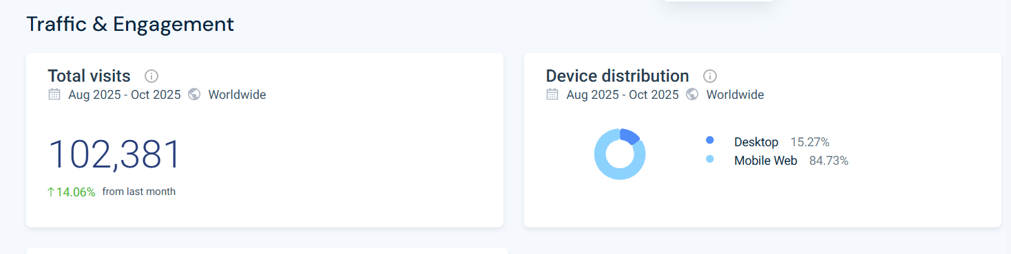

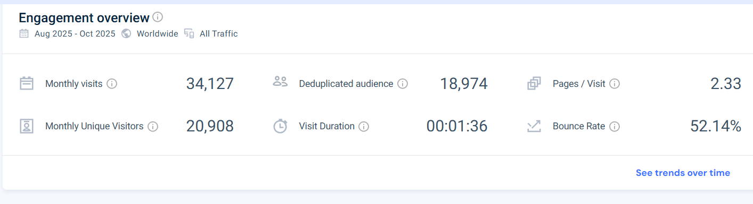
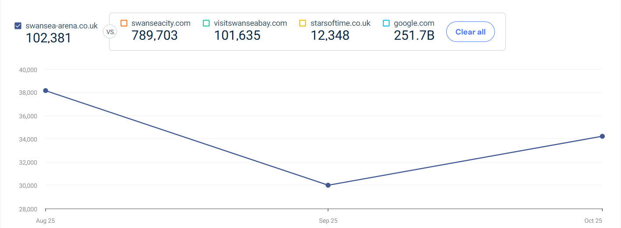
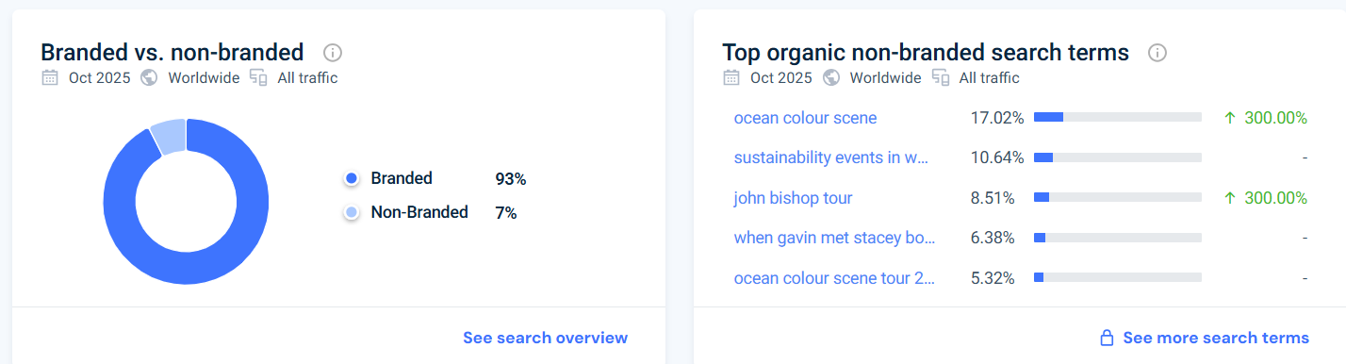
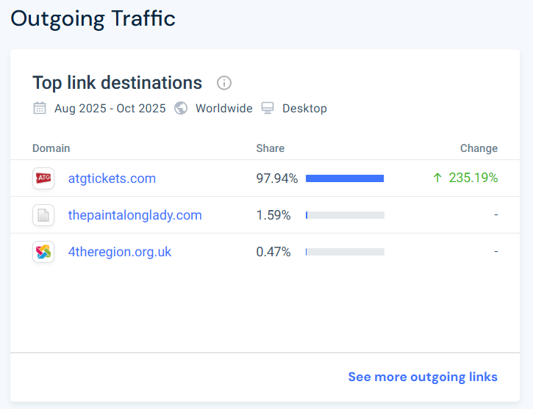

Appendix 3 (Sparktoro)
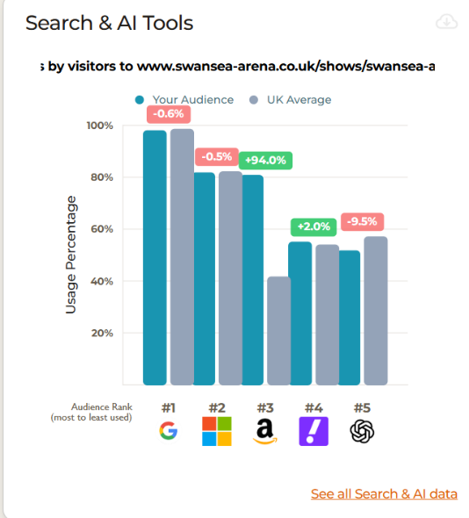
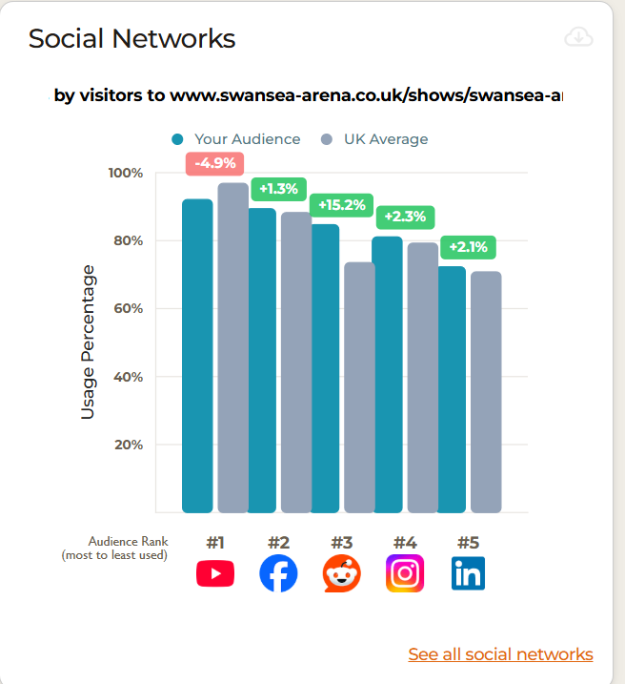
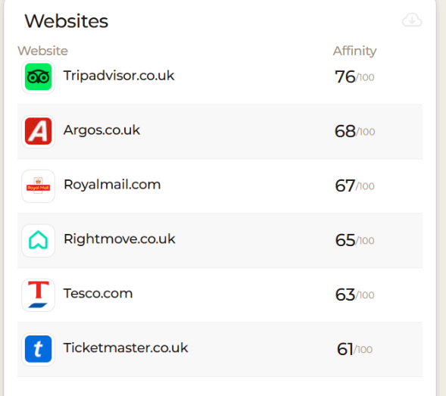

Appendix 4(perceptual positioning graph)
Affordable
Small venue gigs
Themed nightlife events
Student nights
Local nightclubs
Good atmosphere
Laid back atmosphere
Expensive
Appendix 5(PESTLE analysis)
Political | There are a variety of political factors that have an effect on the Swansea Arena House Party including support from the Swansea council which can provide help with policies, event permissions and promotional backing. “Supporting the work of Music Venue Trust is more important now than ever, with the recent Government budget cuts placing hundreds of grassroots music venues at risk of closure” as cited in BuisnessNewsWales (2025) the House Party event raises funds to support local grassroot music venues to limit the risk of closure. The event also has to comply with the licensing laws in place for the event as well as the mandatory safety inspections. Available to this event is funding and grants which support events that encourage tourism. Finally a political factor that would also benefit this event would be the new public transport plan which is being developed by the Swansea Council from 2026/27 “the schemes are being proposed after extensive public consultation and will be subject to Welsh Government approval and funding” Gregory(2025), these plans are going to make the event more accessible with bus links being added as well as more parking, walking and cycling routes, trains, taxis and buses around Swansea.
Economic | Cost of living could be considered an economic impact for the house party however the events ticket prices are very affordable supporting this issue and allowing more of the public to attend during this crisis. However, this crisis may impact the how much alcohol is purchased along with how many VIP packages are purchased. This event can also boost sales massively in hotels due to there being no transport outside of Swansea following the event. It may also boost sales in taxis due to this issue. The “disposable income has decreased in the last five years” Nicholls (2025) events are struggling to balance the rising costs with the stricter budgets of their clients. Finally, this will also impact the operational costs of this event including staff, security, energy costs, production equipment and artist fees.
Social | The house party attracts a lot of younger audiences due to its catchy name, therefore Swansea having a large student population this will benefit this event massively. This event also has positive community relationships therefore the event needs to be careful with late night noise levels as it may have an impact on the local attitudes. Finally, this event has a diverse lineup including Welsh artists, DJS and themes.
Technological | The Swansea Arena House Party support technology within tourism through many factors, one being that their tickets are accessible online. “when it comes to purchasing event tickets, buying them online offers a multitude of benefits that can make your life easier” Inviteusevents(2024) as it will save time, allow accessibility to deal, make them easier to manage and also avoid disappointment for sold out events. The Swansea Arena is cashless only accepting contactless payments for things like merchandise and drinks. Finally, the Arena also has advance technology like its LED facade, lighting and production capabilities.
Legal | One of the legal factors affecting this event linked to the online ticket system would be the data protection over the details of the ticket holder. Health and safety laws are also in place for crowd control, fire safety and emergency plans, this means all staff need to be trained in these areas. Some of the practices put into place are bag searches at the door, CCTV, safeguarding procedures, accessible features and ticket scanning. “Working together with local and national authorities, security measures at the Arena are under constant review to ensure that they remain effective and proportionate” Swansea Arena(2025). Finally, there are also licensing laws in place for things like alcohol, performance rights, noise control and curfew regulations.
Environmental | Sustainability within event is a big factor for environmental impacts. The arena was an issue when being constructed as it used “6,135 cubic metres of concrete of different strengths” Youle (2022) due to the pandemic this meant that no low-carbon concrete was accessible. However, the council have applied solar panels on its roof to provide some of the electricity needed. Although this is in place the arena still has high energy use effecting the carbon footprint. The arena does have recycling points, less plastic and sustainable merchandise to support sustainability. Finally, another factor effecting the environment would be the travel to the arena as there is little public transport a lot of people are travelling by car meaning transport emissions are higher.

Appendix 6(customer profile 1)
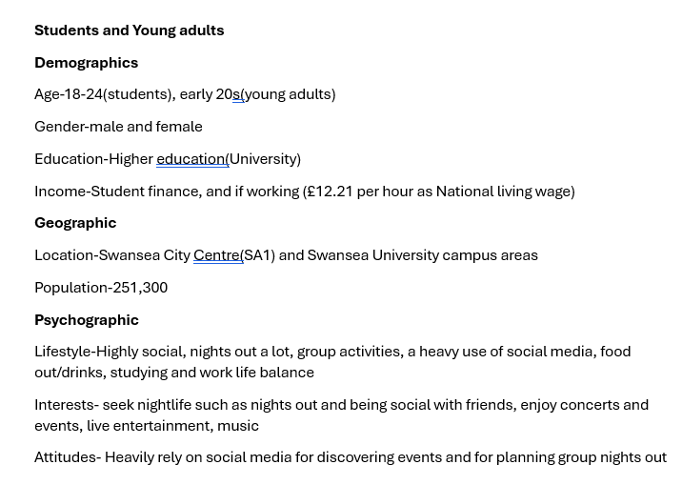

Appendix 7(customer profile 2)
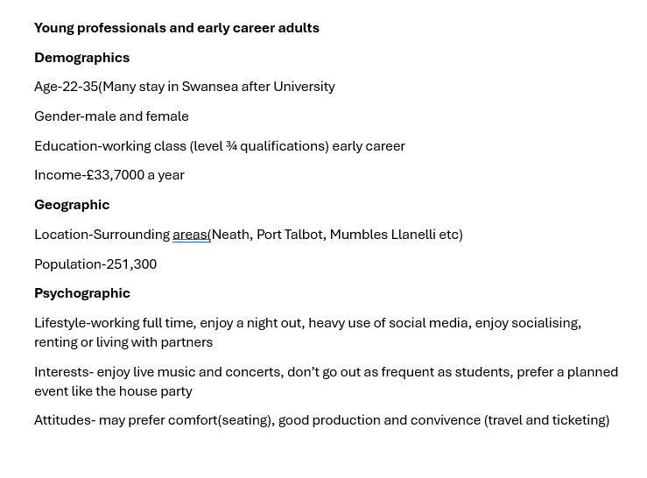
Appendix 8(customer profile 3)
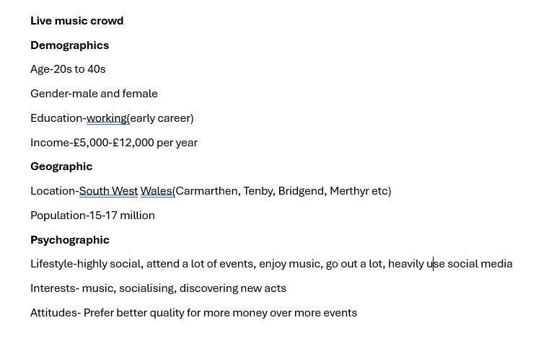

Appendix 9(Ansoff matrix)
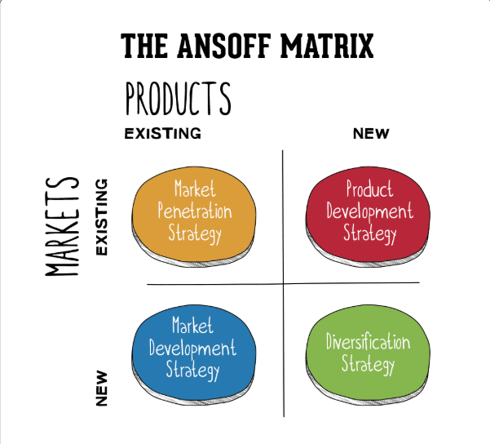

Appendix 10(Instagram and Facebook post)
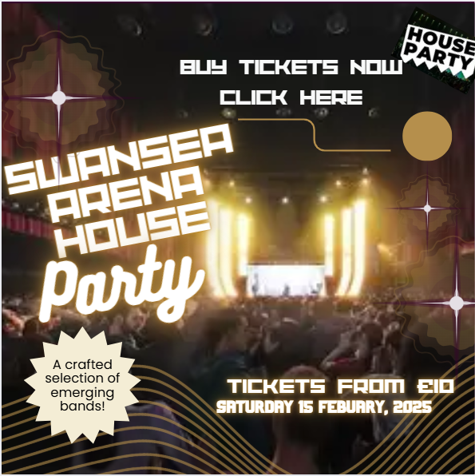

Appendix 11 gannt chart marketing report.xlsx
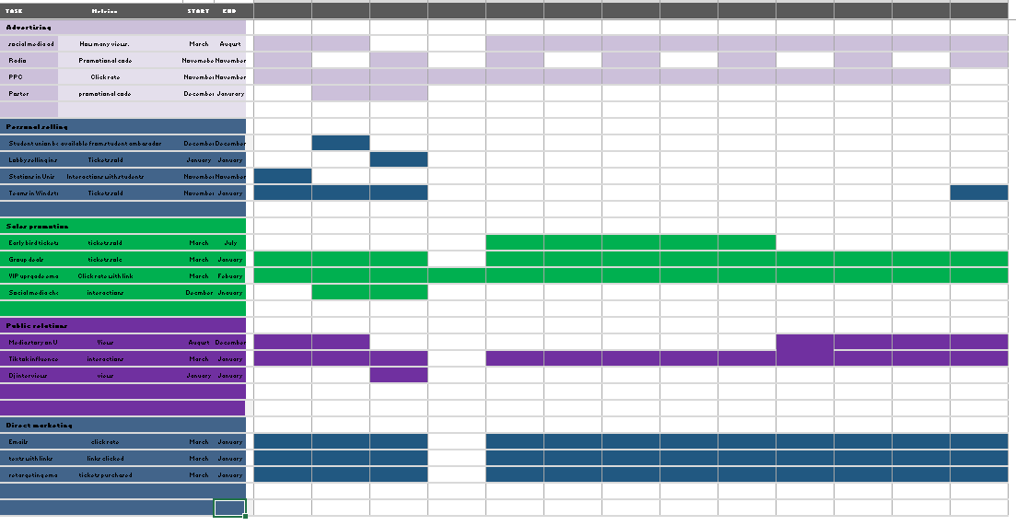

Reference List
BuisnessNewsWales(2025) Swansea Arena’s 2025 Big House Party to Support the Region’s Grassroots Music Venues
Available at: Swansea Arena’s 2025 Big House Party to Support the Region’s Grassroots Music Venues (accessed:09.12.2025)

Frochot, I (2013) Marketing and Designing the Tourist Experience Oxford: Goodfellow Publishers

Gregory, R(2025) Swansea set to Approve Regional Transport Plans
Available at: Swansea set to approve regional transport plans (accessed:09.12.2025)

Evans-Hurley, K(2023) The Swansea arena House party: Uniting for Music with Music Venue Trust
Available at: THE SWANSEA ARENA HOUSE PARTY: UNITING FOR MUSIC WITH MUSIC VENUE TRUST | Swansea Standard (accessed:07.12.2025)

Inviteuseevents(2024) The Benefits of Buying Event Tickets Online
Available at: The Benefits of Buying Event Tickets Online - Helping You Create Your Own Fun With Friends (accessed:09.12.2025)

Kotler, P (2024) Principle of Marketing (nineteenth edt) Harlow, Essex: Pearson

Middleton, V, Fyall, A, Morgan, M (2009) Marketing in Travel and Tourism (fourth edition) Oxforf:Butterworth-Heinemann

Music Venue Trust (2025) The Swansea Arena House Party: Uniting for Music with Music Venue Trust
Available at: The Swansea Arena House Party: Uniting For Music With Music Venue Trust (accessed:02.12.2025)

Nation Cymru(2024) Artists Confirmed for Swansea Arena’s 2025 House Party
Available at: Artists confirmed for Swansea Arena's 2025 House Party (accessed:07.12.2025)

Nicholls, H (2025) Crisis Breeds Creativity: How Event Agencies are Adapted to Cost-of-living Pressures
Available at: How event agencies are adapted to cost-of-living pressures (accessed:09.12.2025)

Similarweb
Available at: Digital Suite (accessed:07.12.2025)

Sparktoro
Available at: Overview - SparkToro (accessed:07.12.2025)

Sundae(2024) Swansea Arena House Party: The Fight to Save Grassroots Venues
Available at: Swansea Arena House Party: The Fight to Save Grassroots Venues - Sundae Communications (Accessed:07.12.2025)

Swansea Arena (2025) The Swansea Arena House Party
Available at: Swansea Arena | The Swansea Arena House Party (accessed:02.12.2025)

Youle, R (2022) Questions raised about the Carbon Footprint of ned Swansea Arena
Available at: Questions raised about the carbon footprint of new Swansea arena | Wales Online (accessed:09.12.2025)

