BSC Health and Social Care
Introduction to Physiology
BMHP5003_BIRM
Individual Academic Poster
Tutor: Mumtaz Goolam

Sanara Begum Akbar 1713889

Sanara Akbar (1713889)

Cardiovascular system
The main function is to pump blood around the body

The body needs blood to transport oxygen to the cells and carbon dioxide to the lungs. The blood helps the body regulate its temperature and hydration levels and also helps the body fight off infections, disease and injuries.
The heart has a fibrous covering called the pericardium which holds the heart in place and gives it the capability to move/beat
Vessels to the head, neck and arms
Aorta
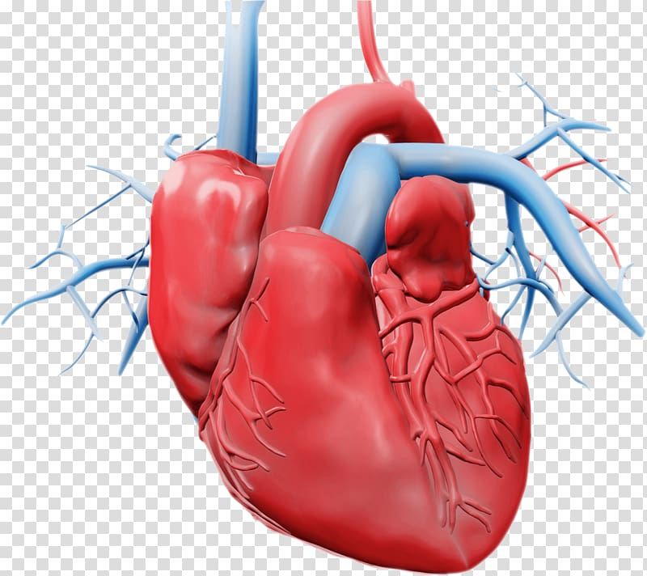
Right Atrium
(1)
The outer wall is cardiac muscle
Right Ventricle
Superior Vena Cava
Left Ventricle
Left atrium
Pulmonary Artery

The cardiovascular system (CVS) acts as a transport network for the body. There are three main components which are the heart, blood vessels and blood. The heart pumps the blood around the body, the blood vessels are the routes which transport the blood and the blood contains all the oxygen and nutrients which the body needs and waste which has to be removed. The heart is a muscle and is roughly the size of a fist and is situated between the lungs in the middle (slight left) of the chest cavity.
The CVS works in synergy with the respiratory system to supply the body with oxygen. The respiratory system takes in oxygen from the air we breathe and creates gaseous exchange that exchanges it in the blood stream which then goes to through the heart to be pumped around the body. The used blood is deoxygenated which is then pumped back to the lungs to be converted to oxygen. This is done as the cardiovascular system maintains blood flow to all parts of the body ensuring survival. Veins transport used blood which is low in oxygen (as its been taken out) back to the heart. The blood is high in carbon dioxide as the body has removed it back into the blood. Ensuring Normal Homeostasis. (Chloe, A 2020).

All the veins drain into the superior and inferior vena cava which drain into the right atrium which pumps blood into the right ventricle which pumps the blood into the pulmonary trunk. It then passes through the pulmonary arteries and into the lungs. The lungs transform oxygen that we breathe in and get rid of the carbon dioxide which is breathed out. Blood is rich in oxygen which the body uses. The lungs drain the blood into the left atrium that pumps blood to the left ventricles which flows to the aorta it is then distributed throughout the body through the arteries. The oxygenated blood is used to help the body function properly and then the blood is returned through the veins to the heart to repeat the process.

Cardiovascular circulation

Refers to the double pump system.

The pulmonary circuit transports blood from the right side of the heart to the lungs and then back to the heart.

The systematic circuit transports blood from the left part of the heart to the head and body then moves it to the right side of the heart to continue the cycle.
(Waugh & Gant 2014)

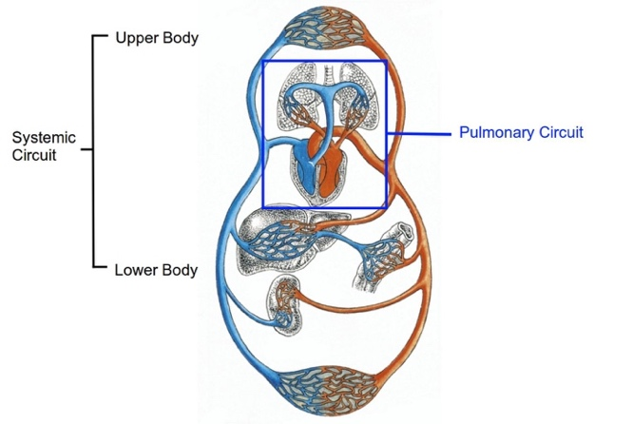
(2)

There are three types of blood vessels Arteries, Veins and Capillaries
Arteries have a thick outer wall and smaller inner tubes. They carry blood away from the heart
Veins have thinner outer walls and a large inner tube. They carry blood towards the heart and have valves to prevent backflow
Capillaries are very thin/small and are found in muscles and lungs. They exchange gasses from blood vessels. They are the smallest blood vessels in the human body. (Waugh & Gant 2014)
Two other blood vessels
Arterioles are smaller branches of arteries that attach to the capillaries and arteries.
Venules are smaller branches of veins that attach to the capillaries and veins

Blood Vessels
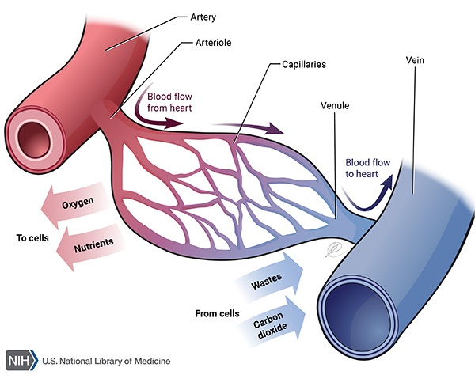
(3)

Blood

On average the human body has around 4-5 litres of blood, it helps maintain homeostasis by transporting substances throughout the body including waste, gases and nutrients. Blood is made up of liquid plasma, red/white blood cells and platelets.
Red Blood Cells make up 45% of blood volume and are the most common they are responsible for transporting oxygen in the blood through the haemoglobin (red pigment).
White blood cells (Leukocytes) are vital to the support of the body’s immune system they contain enzymes which neutralise bacteria and help protect against parasites and also contain killer T cells which fight off viral infections and create antibodies.
Platelets are small cells which helps with clotting and the formation of scabs from cuts and wounds.
Plasma is non-cellular it makes up 55% of the volume of blood which contains all the proteins, water (90%) and dissolved substances. The proteins within the plasma include anti-bodies (part of the immune system) which bind with foreign pathogens that infect the body. Other substances in the plasma include nutrients, glucose, oxygen, electrolytes, nutrients and cellular waste products. The plasma transports these substances as they move throughout the body.

As part of growing older changes happen to the CVS. Our heart rate slows down because the time between heart beats increases. There’s a decrease in the amount of blood being pumped decreases (in women more than men) and our blood pressure drops (postural hypertension). (Melvin & Cheitlin 2007).

The CVS can stop working efficiently if serious health conditions and diseases are not maintained. If CVS fails firstly blood flow will stop and muscles will not get the blood that is vital in survival as the nutrients, glucose and oxygen which is inside the blood cells will not be converted to energy and if the cells do not get blood they will cease to exist.
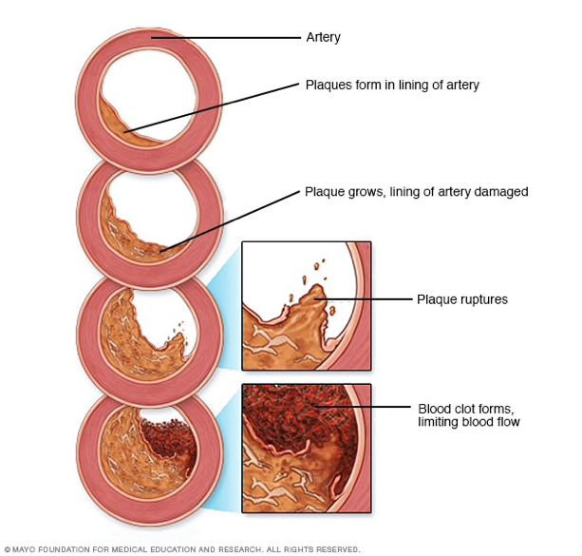
(4)
Coronary Artery Disease

Develops when blood vessels that provide the heart with blood gets damaged/diseased by deposits of plaque (cholesterol containing deposits) these cause inflammation in the coronary arteries which prevents oxygen and nutrients from getting to the heart as they make the arteries quite narrow. Especially when your exercising for example the heart will be working harder and will need blood to pump freely. If you don’t get yourself diagnosed and treated early enough you will suffer from chest pains (angina) which is tightness in the chest, Shortness of breath or feel extreme tired all the time. And finally, a heart attack which is the result of complete blockage of the coronary artery.

Risk factors include Age, Sex, family history, pre-existing conditions, poor diet, poor health, obesity and stress

Prevention is key
Lifestyle habits need adjusting like exercising staying physical, maintaining a healthy diet, managing/reducing stress levels, quitting smoking and controlling pre-existing conditions like diabetes and high blood pressure/cholesterol.

(Mayo clinic 2020) (4)

References

- Bailey, R (2019). Circulatory System: Pulmonary and Systemic Circuits. Available at :> https://www.thoughtco.com/circulatory-system-pulmonary-and-systemic-circuits-3999090. (Accessed online Thursday 22nd October 2020). (2)
- Buckberg, G.Nanda, N. Nguyen, C. Kocica, M (2018). What Is the Heart? Anatomy, Function, Pathophysiology, and Misconceptions. Journal of cardiovascular development and disease, 5(2), 33. Available at:>https://doi.org/10.3390/jcdd5020033. (Accessed online 19th October 2020).

Chloe, A (2020). How Does the Cardiovascular System Work With the Respiratory System? Available at:> https://www.livestrong.com/article/18606-cardiovascular-system-work-respiratory-system/. (Accessed online: 16th October 2020).
- Evan. Stefan, V. Mandira, P. (2017). What are the smallest blood vessels in the human body? Available at:>https://socratic.org/questions/5a1bfa4eb72cff5a20dec185. (Accessed online Thursday 22nd October 2020).
- Heart Circulatory system heart amour transparent background PNG clipart. Available at:>https://www.hiclipart.com/free-transparent-background-png-clipart-fkeuw. (Accessed online: 23rd October 2020). (1)
- James and Jones (2020). Anatomy and Physiology of the Cardiovascular System. Available at:> http://samples.jbpub.com/9781449652609/99069_ch05_6101.pdf. (Accessed online 19th October 2020).
- Jarvis S, Saman S (2018) Cardiac system 1: anatomy and physiology. Nursing Times[online]; 114: 2, 34-37. Available at:> https://www.nursingtimes.net/clinical-archive/cardiovascular-clinical-archive/cardiac-system-1-anatomy-and-physiology-29-01-2018/. (Accessed online 19th October 2020). (3)
- Klabunde, R (2012). Cardiovascular Physiology Concepts), which was published in its second edition by Lippincott Williams & Wilkins (2012).
- Mayo Clinic (2020). Coronary Artery Disease. Available at:>
https://www.mayoclinic.org/diseases-conditions/coronary-artery-disease/symptoms-causes/syc-20350613. (Accessed online: 2nd November 2020). (4).

Melvin, D. Cheitlin, MD. (2007). Cardiovascular Physiology—Changes With Aging. Available at:> https://onlinelibrary.wiley.com/doi/abs/10.1111/j.1076-7460.2003.01751.x. (Accessed online Thursday 22nd October 2020)
- NIDA. 2020. Cardiovascular Effects. Available at:> https://www.drugabuse.gov/drug-topics/health-consequences-drug-misuse/cardiovascular-effects on 2020, October 12. (Accessed online 23rd October 2020).
- Rudenko, M. Voronova, O. Zernov, V. Mamberger, K. Makedonsky, D. Rudenko, S. Kolmakov,S (2012). Control of Cardiovascular System, The Cardiovascular System - Physiology, Diagnostics and Clinical Implications, David C. Gaze, Intech Open, DOI: 10.5772/36259. Available at:> https://www.intechopen.com/books/the-cardiovascular-system-physiology-diagnostics-and-clinical-implications/control-of-the-cardiovascular-system. (Accessed online: 23rd October 2020).
- Stefanovska, A (1999) Physics of the human cardiovascular system, Contemporary Physics, 40:1,31-55, DOI: 10.1080/001075199181693. (Accessed online: 23rd October 2020).

Taylor,T. Curreli, S. (2020). Cardiovascular System. Available at:>
https://www.innerbody.com/image/cardov.html. (Accessed online 23rd October 2020).

Ward, J (2019). Introduction to the cardiovascular system. Kings college London, UK. Available at:> https://hstalks-com.ezproxy.uwtsd.ac.uk/upload/content/talk/handouts/4061.pdf. (Accessed online October 22nd 2020).
- Waugh, A & Gant, A (2014). Ross and Wilson Anatomy and Physiology in Health and Illness. (12th ed). Publisher: Elsevier Ltd. P9.

