Appendices
Transcript 1
Researcher
My first question to you would be what does well-being mean?
Child A
Well-being is means being nice to people and being kind and making them happy.
Researcher
OK, so how would you feel your wellbeing affects your learning?
Child A
My well-being affects my learning because when I became very kind, I could focus on my learning better, but when I’m not kind I can't focus because I've been all thinking about the things I did wrong.
Researcher
Do you think your teachers make sure your well-being is taken care of?
Child A
Yeah.
Researcher
Can I ask you to expand? How do you think they do this?
Child A
They always keep an eye on us (pupils), to see is we’re okay and we have emotion coaches like me to check in on our friends.
Researcher
Can you tell me a bit more about your emotion coaching?
Child A
Well, with the emotion coaching we may try to make people feel better if someone's kind of sad. And we try to get them to open up their feelings. We also have a lot of places like the regulation stations. We can go there and just give them like something activities that make them focus and forget about their sorrows.
Researcher
Brilliant. Sounds like a very important job. Are you aware of anything you do regularly? This could be daily, weekly within your classroom that focuses on well-being?
Child A
We used to do a game where it's like other people actually act different feeling and the emotion coaches try to find the feeling and try to understand it, talk to them and make them feel better.
Researcher
Oh wow, that sounds really good. Do you think that everyone gets the same opportunities in the classroom?
Child A
Yeah, we just always tried to make everyone feel equal. No one is standing out.
Researcher
Perfect. Brilliant. How do you support your own well-being?
Child A
Actually, I had a friend who was very nice and that time I wasn't very nice. So I was like, how are you so happy? And she was like it's because I'm very kind and I feel better when I'm kind, so I started being kind. That's how important well-being is and why we’ve got to support everyone’s well-being.
Researcher
Do you know who you would speak to about your well-being?
Child A
Within school, my teacher, I would say. Has improved my well-being.
Researcher
What if you felt like your well-being wasn't very good. Who do you think you'd speak to?
Child A
I think I would talk to Miss Taylor. (The wellbeing officer)
Researcher
Perfect. So, do you get the opportunity to speak about your own well-being to teachers and other staff in school?
Child A
Yeah, we get to talk about everything and well-being is one part of it.
Researcher
Brilliant. Do you think you get to talk about these sort of things more, less or the same as before? I know you've come from a different school. Do you think that's it's different?
Child A
Yeah, it’s different because in my old school was in India.
Researcher
It's a big change then.
Child A
And we didn't have this stuff. It's very different. Yeah.
Researcher
How do you think this school has helped you with that big change? Because that's a big change coming from India, isn't it?
Child A
Yeah, because this could have helped me by teaching me that if you're wellbeing is good and you’re kind, you know, people like will like you more. I never want people to hate me so I started working on my wellbeing.
Researcher
Perfect. So do you think that your environment or your surroundings like these displays and all the rainbows and the bright colours, do you think it has an impact on your well-being? And if so how does it affect?
Child A
Yeah, it actually makes our life feel brighter. Like in this room we make it as much as fun as we can cause so people when they’re sad they could do a lot of stuff and make themselves happy. There’s a place for them to lay down there and make them feel better with those. (Blankets) To to make their life better, yeah.
Researcher
Thank you so much and I'll let you get back to class.

Transcript 2: Group interview
Researcher
My first question is what does well-being mean to you?
Child B
I think a good meaning is that like your emotions or something.
Child C
Yeah, that's what I think.
Researcher
Are you happy with that? (Child D nods) OK, so how do you feel your well-being affects your learning?
Child C
I think it affects us loads so if we're sad or something, or if we're feeling something, it does affect our life sometimes. I could get distracted sometimes. Like if I'm thinking of something that happened but not really.
Researcher
Do you guys agree? Disagree. Yeah. OK, so do you. Do you think your teachers make sure your well-being is taken care of? If so how?
Child B
Yeah.
Child C
Like if you're sad or something, they would always like see if you wanted to have a chat with them or if you just wanted to have some time in the regulation station or if you wanted to write, what's wrong down a piece of paper, you would be able to do that.
Researcher
Ohh that's lovely. So are you aware of anything you do regularly so it could be daily? It could be during the week, within your classroom that focuses on your well-being.
Child B
We do usually sit around in a circle and do like a check in every Monday to see how our weekend was. But yeah. Yeah, sometimes.
Child C
If we're not doing anything and miss wants to have a little check and she'll make sure so she'll just ask. Everybody sit right here and then I'll say like ‘Dw i’n hapus’ or ‘Dw i’n dryst’. And if, like they say, ‘Dw i’n dryst’miss, will say, ‘Do you want to come and have a chat?’
Child B
Or she will have a chat with us. (Points to the emotion coach)
Child C
With me. Or do you want to go to the regulation station? And then usually people say yes because they really like the regulation station cause like it keeps you calm.
Researcher
Lovely. Do you think that everyone gets the same opportunities within the classroom to talk about things like this?
Child B
Yeah
Child C
Yeah
Child D
Yeah.
Researcher
So what do you do to support your own well-being? Could be anything. It could be drawing, painting a picture, going horse riding. Go for a walk, could be playing football.
Child D
I think taking my dogs for a walk.
Researcher
Lovely. If you could tell your teachers one thing that you'd like them to do to support your well-being. What would you like them to know? It could be something that you do already or that you'd like to do more often, if that helps.
Child C
I think for everybody it would be tracking, like sometimes we do the check in see how people are on a Monday, we should maybe do it on a Wednesday or Thursday too, to make sure.
Researcher
Yeah, sounds good. So do you know who you would speak to about your well-being in?
Child B
School.
Child C
Family and Miss Taylor. Like, if you have anger issues she can help with that.
Child B
She like do a session with you and will try to get all your anger out of you so you don't like, hit out on anyone.
Child C
And like she would make like putty and slime for people to like. Punch and stuff.
Child B
One time she did it, she bought a pumpkin for Halloween, and they all wrote on it, I'm kind.
Child C
You always make stuff with people, and if we've not had a very good time in school, she won't share that. She'll just say, do you want to come and make something with me in my room so you could do that.
Child B
Yeah. Do you know the thrive? Room by ours.
Researcher
Yes
Child D
It’s got lots of fun stuff to do with Miss Taylor then.
Researcher
Okay. Do you often get the opportunity to speak about your well-being with teachers and other staff in school?
Child C
Yeah, I think so.
Researcher
You've said a lot about that. So do you feel that your environment, so the things that could be displays like how your classroom set out, do you think that helps your well-being or whether it affects it at all?
Child B
What like the poster? Like, don't stop until you're proud or something, or cause one of the posters that was in the school last year. Not sure where.
Child C
Yeah. And then. One, they said you would be fun. It's like, really got this. Like, people like are ashamed of yourself because, like, I feel like that's really good to have in the school because I know some people, like don't really feel grateful, but like.
Researcher
Very good. Thank you for answering my questions girls.

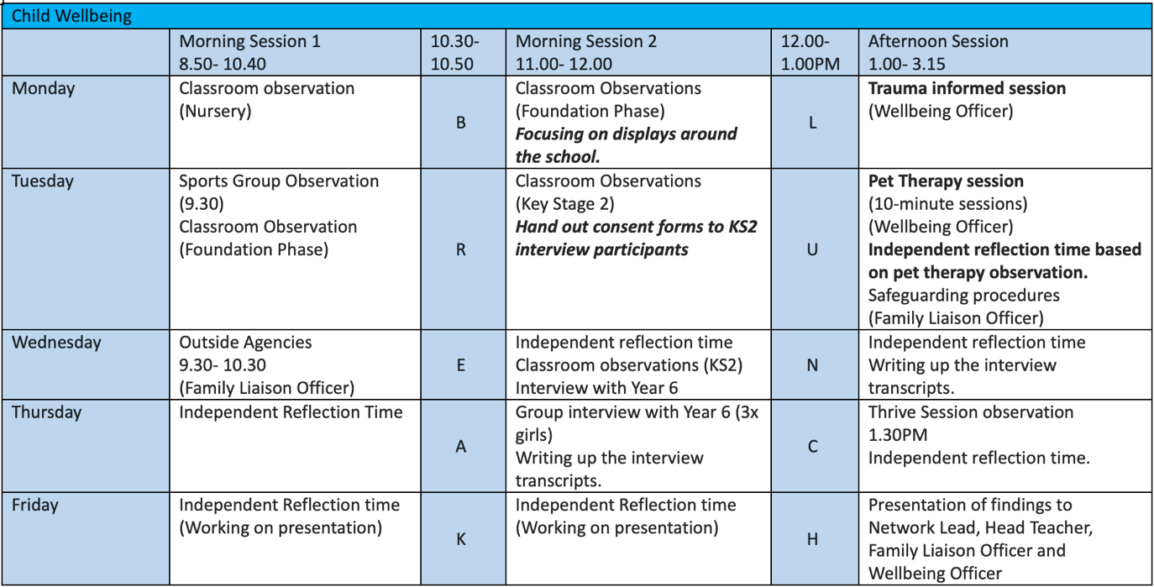
Observation Schedule

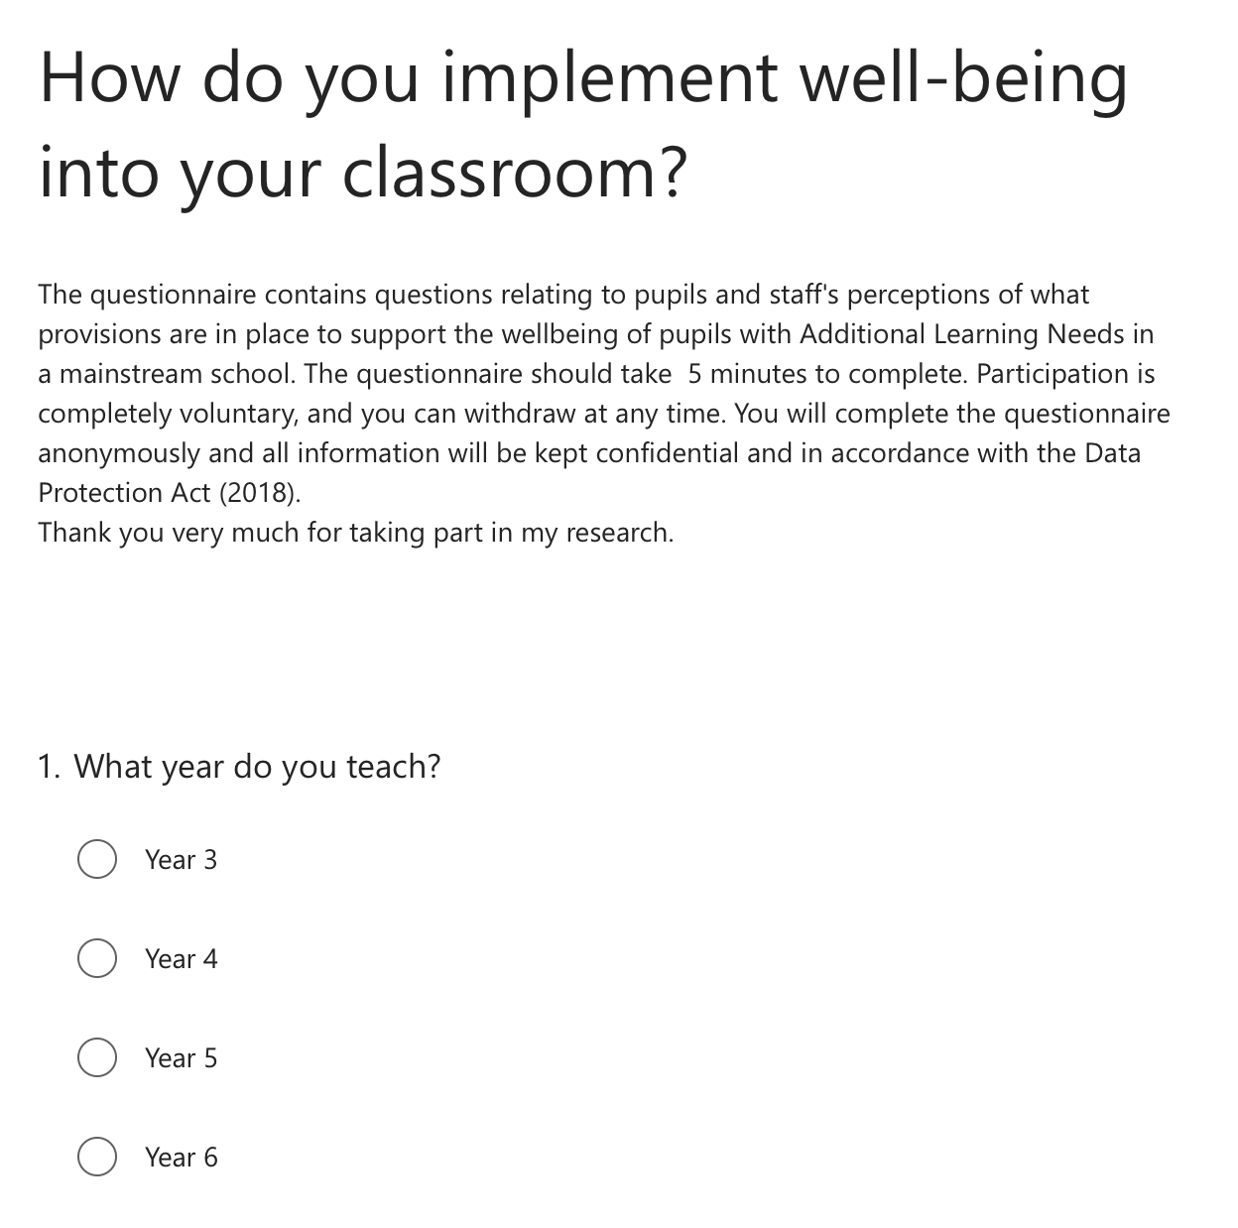
Example of Teacher Questionnaire

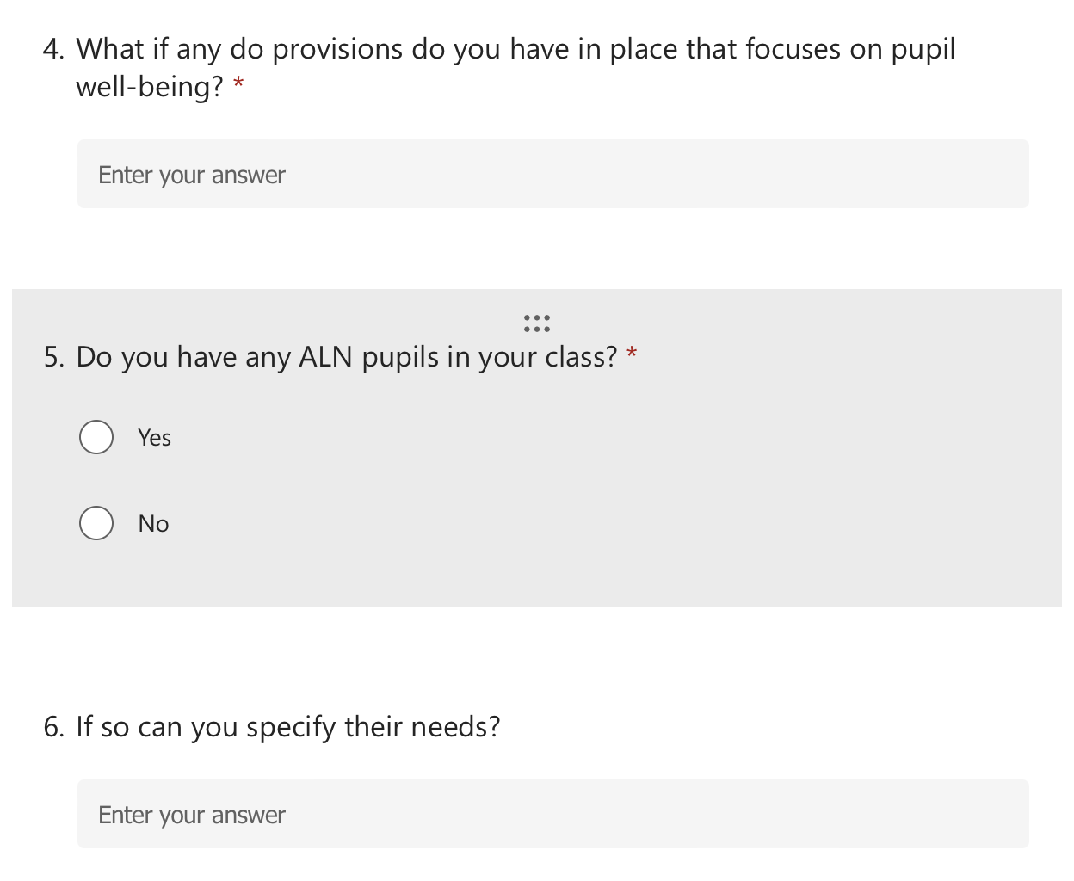
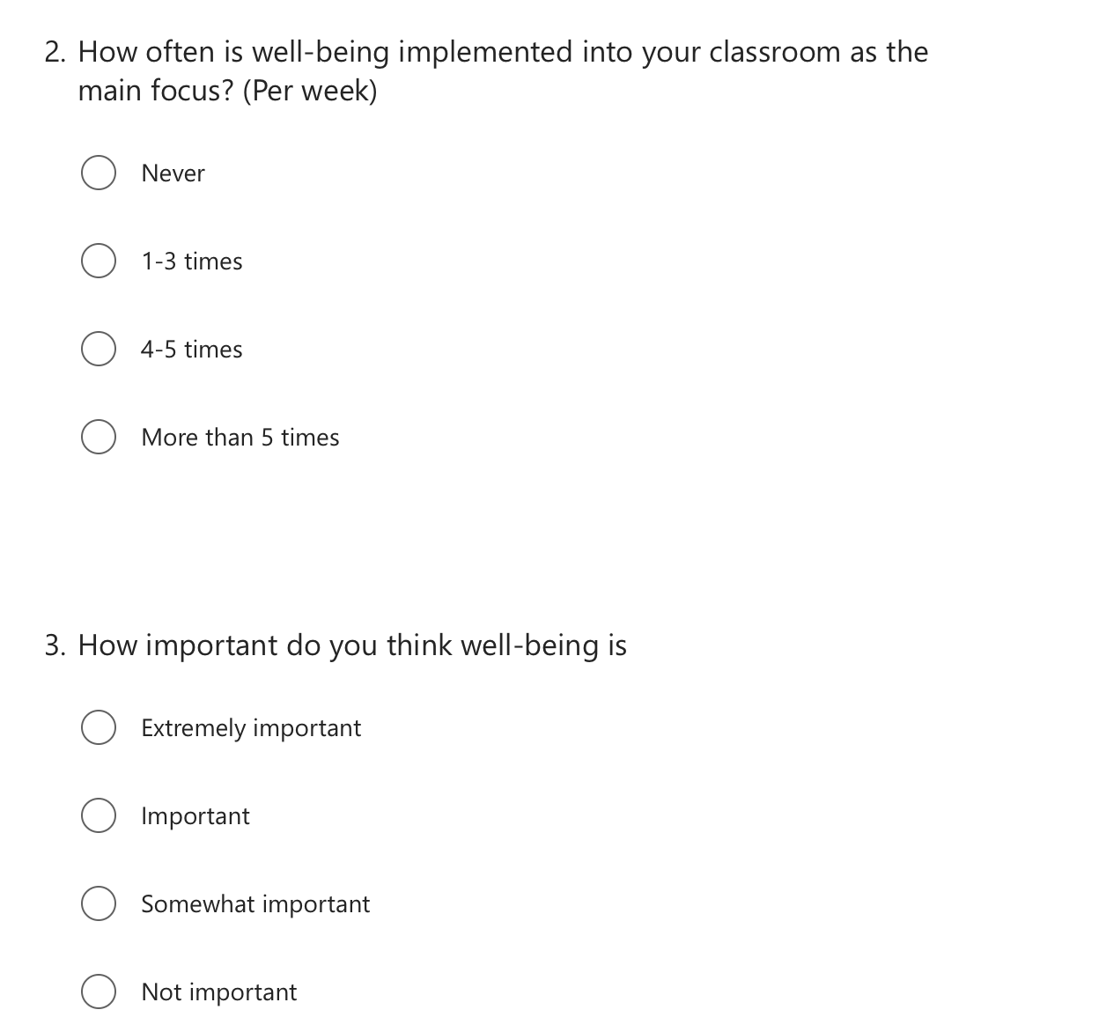
In

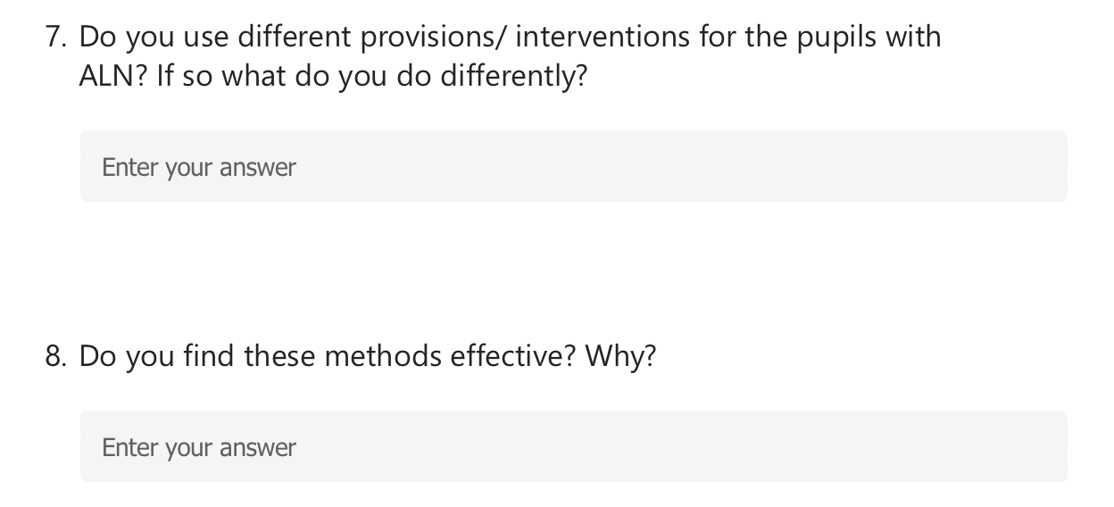
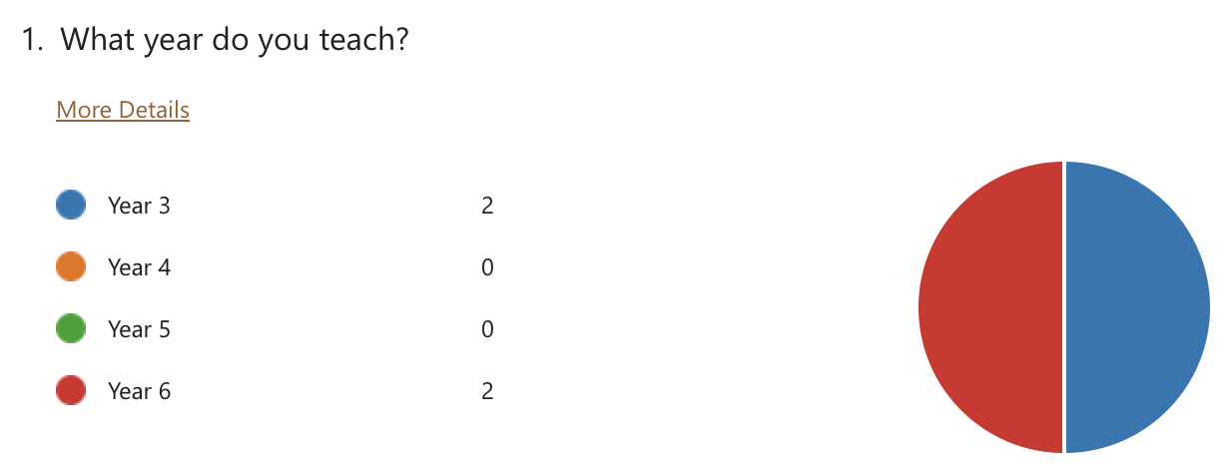
Questionnaire Responses

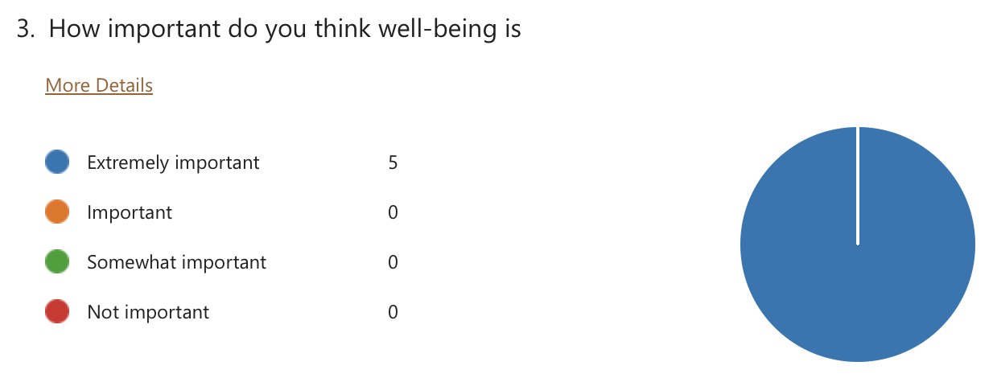
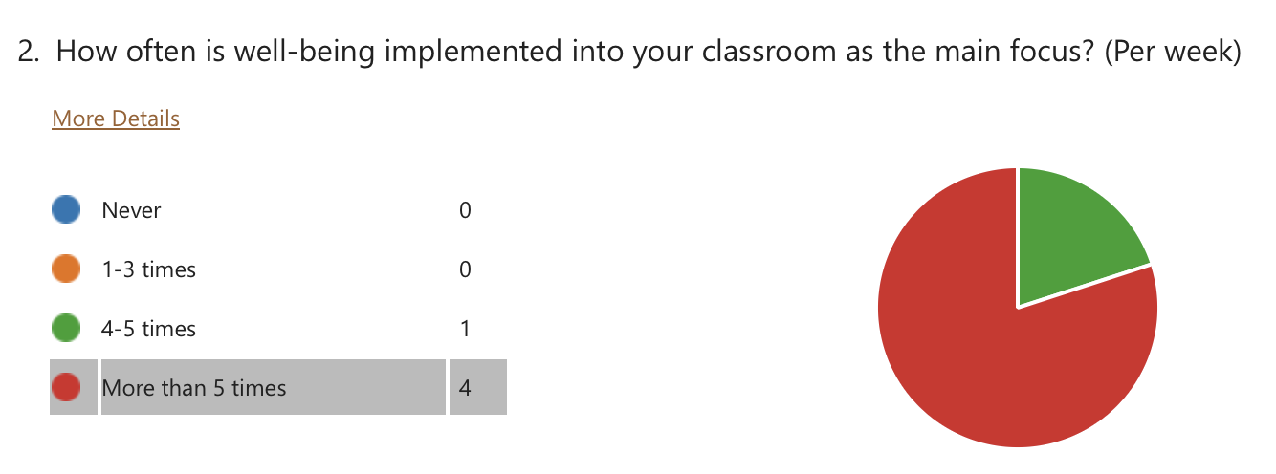
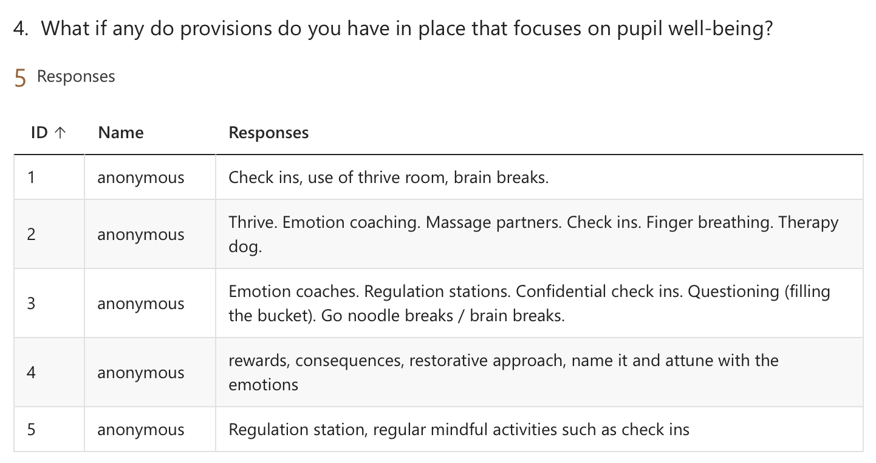
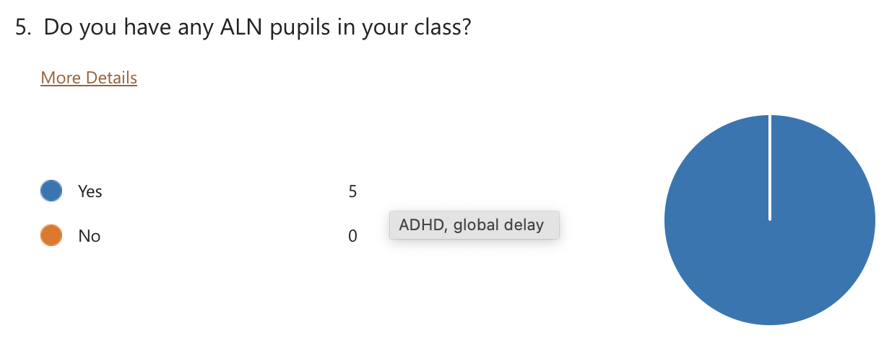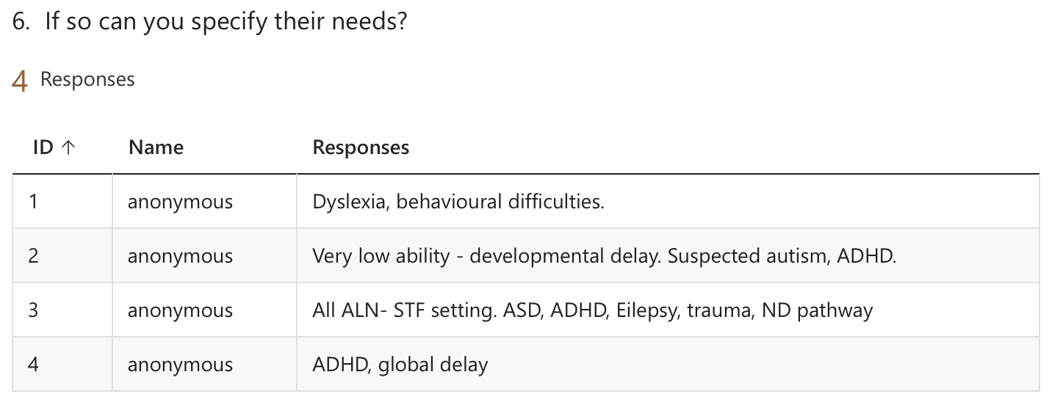
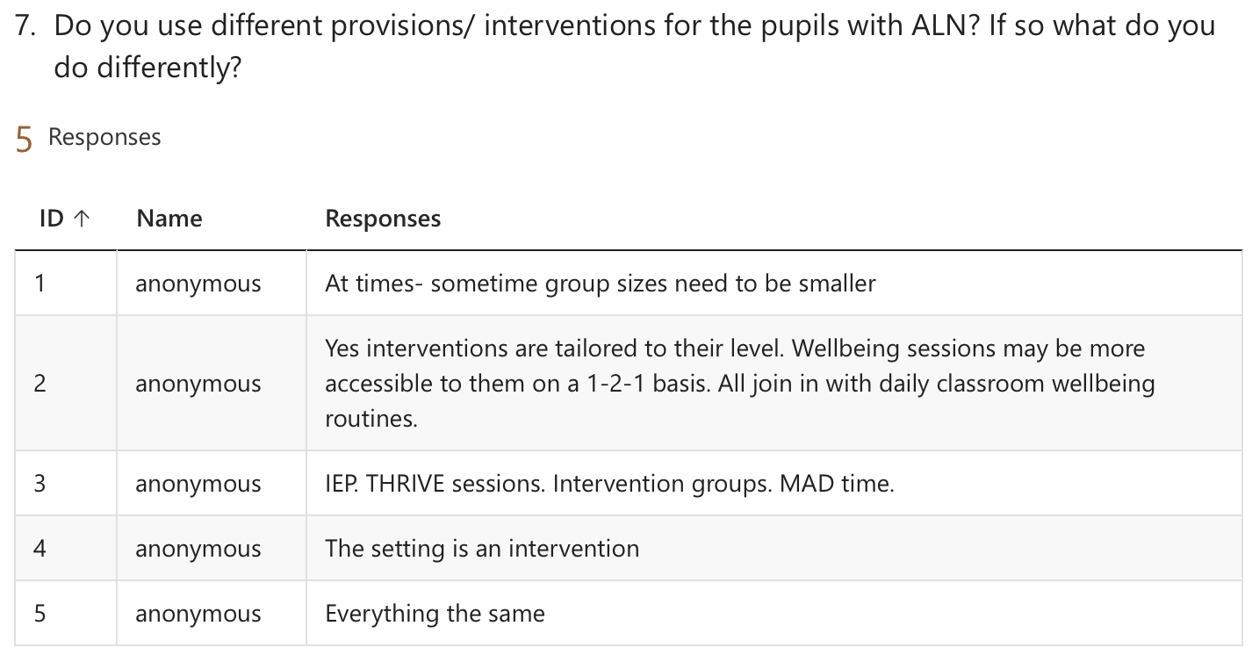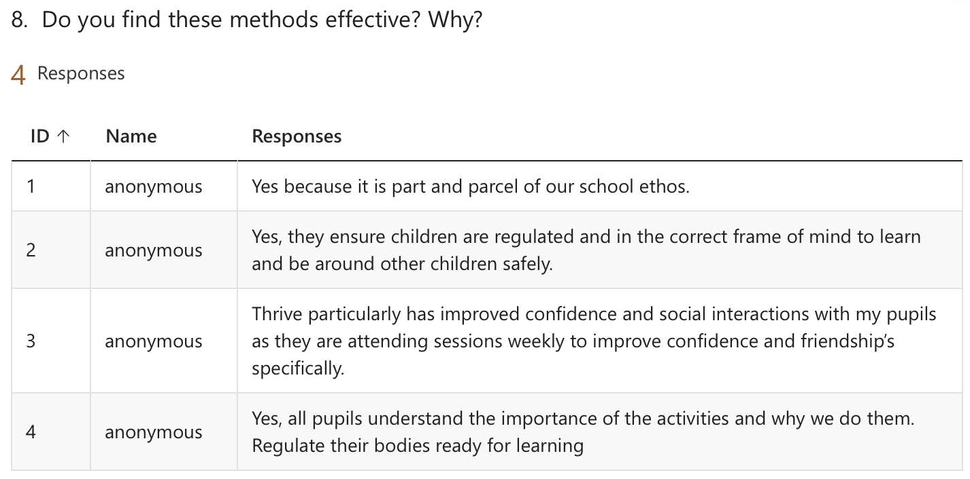



CONSENT FORM

PROJECT TITLE: Pupils’ wellbeing within the classroom

Name of Researcher: Leia Lewis

Please initial box

1.I confirm that I have read and understand the information sheet dated 28/11/23 for the above study.

2. I understand that my child’s participation is voluntary and that I am free to withdraw my child from the study at any time, without giving any reason.

3. I understand that my child can choose to withdraw at any time, without giving a reason.

4. I understand that the information given by my child will be used in a university assignment.

5. I understand that my child’s name will not appear at any time.

6. I agree for my child to take part in the above study.

_____________________ _____________________________ __________
Child’s name Parent signature Date

When completed, please return to your class teacher by the 29th of November.
Thank you.

Letter to parents/ guardians

INFORMATION sheet

PROJECT TITLE: Pupils’ wellbeing within the classroom

FOR PARTICIPANTS IN KEY STAGES 2

Dear Parent / Guardian,

My name is Leia Lewis and I am studying for a BAEd qualification at Yr Athrofa, University of Wales Trinity Saint David. I am currently a student teacher within Cadle and am teaching in your child’s class.

I would like to invite your child to participate in my research project. The title of the project is ‘What are pupils and staff’s perceptions of what provisions are in place to support the wellbeing of pupils within the classroom?’ I aim to conduct research that will give me a deeper understanding of how wellbeing is implemented into the pupils’ day. Through your child’s participation, I hope to ascertain a better understanding as to what support children find beneficial.

The research will include a combination of questionnaires, interviews and focus groups. With both the interviews and focus groups being audio recorded for the purpose of transcription and all recordings will be disposed of after use.

All names will be kept strictly confidential and will only be known by myself. Your child’s participation in this study is completely voluntary so you or your child can withdraw from the study at any stage. Your child will also be asked to give their assent before the beginning of the study.

After careful and precise analysis of the data obtained from the lesson observation and group interview, I would be happy to provide you with a copy of the findings at your request. The results of the research will be discussed in a university assignment that will contribute to my BAED course. The results of this study will be stored in a password protected encrypted file and all raw data will be destroyed once the assessment has been marked.

I thank you in advance for your time. If any questions do arise, feel free to contact me at your convenience.

Yours sincerely,

Leia Lewis
Ethics form
APPLICATION FOR ETHICAL APPROVAL

RESEARCH STUDENTS
This form is to be completed by the student within SIX months for full-time students and TWELVE months for part time students, after the commencement of the research degree or following progression to Part Two of your course.

Once complete, submit this form via the MyTSD Doctoral College Portal at (https://mytsd.uwtsd.ac.uk).

This document is also available in Welsh.

RESEARCH STAFF ONLY
All communications relating to this application during its processing must be in writing and emailed to pgresearch@uwtsd.ac.uk , with the title ‘Ethical Approval’ followed by your name.

STUDENTS ON UNDERGRADUATE OR TAUGHT MASTERS PROGRAMMES should submit this form (and receive the outcome) via systems explained to you by the supervisor/module leader.

In order for research to result in benefit and minimise risk of harm, it must be conducted ethically. A researcher may not be covered by the University’s insurance if ethical approval has not been obtained prior to commencement.

The University follows the OECD Frascati manual definition of research activity: “creative work undertaken on a systematic basis in order to increase the stock of knowledge, including knowledge of man, culture and society, and the use of this stock of knowledge to devise new applications”. As such this covers activities undertaken by members of staff, postgraduate research students, and both taught postgraduate and undergraduate students working on dissertations/projects.

The individual undertaking the research activity is known as the “principal researcher”.

Ethical approval is not required for routine audits, performance reviews, quality assurance studies, testing within normal educational requirements, and literary or artistic criticism.

Please read the notes for guidance before completing ALL sections of the form.

This form must be completed and approved prior to undertaking any research activity. Please see Checklist for details of process for different categories of application.

SECTION A: About You (Principal Researcher)
1 | Full Name: |  | Leia Minnie Lewis
2 | Tick all boxes that apply: |  | Member of staff: | ☐ | Honorary research fellow: | ☐
 | Undergraduate Student | ☒ | Taught Postgraduate Student | ☐ | Postgraduate Research Student | ☐

3 | Institute/Academic Discipline/Centre: | Initial Teacher Education, Yr Athrofa
4 | Campus: | Carmarthen
5 | E-mail address: | 2100447@student.uwtsd.ac.uk
6 | Contact Telephone Number: | 07828598945
 | For students:
7 | Student Number: | 2100447
8 | Programme of Study: | BA Primary Education with QTS
9 | Director of Studies/Supervisor: | Julia Holloway

SECTION B: Approval for Research Activity
1 | Has the research activity received approval in principle?  (please check the Guidance Notes as to the appropriate approval process for different levels of research by different categories of individual) |  | YES | ☐ | NO | ☐
 |  |  |  |  | Date
2 | If Yes, please indicate source of approval (and date where known): Approval in principle must be obtained from the relevant source prior to seeking ethical approval | Research Degrees Committee |  | ☒ | 16/11/23
2 |  | Institute Research Committee |  | ☐
2 |  | Other (write in) ECAD6010 Jo Bamsey (Lecturer) |  | ☒ | 16/11/23

SECTION C: Internal and External Ethical Guidance Materials
 | Please list the core ethical guidance documents that have been referred to during the completion of this form (including any discipline-specific codes of research ethics, location-specific codes of research ethics, and also any specific ethical guidance relating to the proposed methodology). Please tick to confirm that your research proposal adheres to these codes and guidelines. You may add rows to this table if needed.
1 | UWTSD Research Ethics & Integrity Code of Practice | ☒
2 | UWTSD Research Data Management Policy | ☒
3 | Code of Professional Conduct and Practice for Registrants with the Education Workforce Council (EWC)  BERA Guidelines (2018)  GDPR (2018)  UNCRC (2012) | ☒

SECTION D: External Collaborative Research Activity
If there are external collaborators then you should gain consent from the contact persons to share their personal data with the university. If there are no external collaborators then leave this section blank and continue to section E.
1 | Institution
2 | Contact person name
3 | Contact person e-mail address
4 | Is your research externally funded? |  | YES | ☐ | NO |  | ☒
5 | Are you in receipt of a KESS scholarship? |  | YES | ☐ | NO |  | ☐
6 | Are you specifically employed to undertake this research in either a paid or voluntary capacity? | Voluntary | YES | ☐ | NO | ☐
7 |  | Employed | YES | ☐ | NO | ☐
8 | Is the research being undertaken within an existing UWTSD Athrofa Professional Learning Partnership (APLP)? | If YES then the permission question below does not need to be answered. | YES | ☐ | NO |  | ☐
9 | Has permission to undertake the research has been provided by the partner organisation? | (If YES attach copy)  If NO the application cannot continue | YES | ☐ | NO |  | ☐

Where research activity is carried out in collaboration with an external organisation
10 | Does this organisation have its own ethics approval system? | YES | ☐ | NO | ☐
 | If Yes, please attach a copy of any final approval (or interim approval) from the organisation (this may be a copy of an email if appropriate).

SECTION E: Details of Research Activity
1 | Indicative title: | What are pupils and staff’s perceptions of what provisions are in place to support the wellbeing of pupils with ALN in a mainstream classroom?
2 | Proposed start date: | 27/11/23 | Proposed end date: | 1/12/23
Introduction to the Research (maximum 300 words per section)
Ensure that you write for a Non-Specialist Audience when outlining your response to the points below:
- Purpose of Research Activity
- Proposed Research Question
- Aims of Research Activity
- Objectives of Research Activity
Demonstrate, briefly, how Existing Research has informed the proposed activity and explain
- What the research activity will add to the body of knowledge
- How it addresses an area of importance.
3 | Purpose of Research Activity  The purpose of research assignment is to develop a better understanding of perceptions of both the staff and the pupils when discussing the provisions in place in order to support pupils with ALN in a mainstream classroom.
4 | Research Question  What are pupils and staff’s perceptions of what provisions are in place to support the wellbeing of pupils with ALN in a mainstream classroom?
5 | Aims of Research Activity  - To explore what provisions have been put in place to support the wellbeing of pupils with ALN.  - To explore pupils and staff’s perceptions of the chosen provision.  - To explore what wellbeing means to the pupils and staff in the school.
6 | Objectives of Research Activity  - To explore different provisions.  - To determine the different provisions used within the classroom.  - To determine the effects of the provision on pupil with ALN with wellbeing.  - To explore other provisions that may be beneficial.  - Determine pupils’ understanding of what wellbeing is and how does it affect them.  - Determine how often teacher’s implement wellbeing into their classroom.
Proposed methods (maximum 600 words)
Provide a brief summary of all the methods that may be used in the research activity, making it clear what specific techniques may be used. If methods other than those listed in this section are deemed appropriate later, additional ethical approval for those methods will be needed. You do not need to justify the methods here but should instead describe how you intend to collect the data necessary for you to complete your project.
7 | I will be adopting a mosaic approach to ensure I gather a wider range of data to provide me with a more definite result. I will also be using semi-structured interviews as this will allow me to provide the interviewees with prompts with the ability to re-word any questions and provide any clarifications to ensure proper understanding. Whilst conducting these interviews I will also be observing the participants to ensure I take into consideration body language and the way the participants react to other peoples responses. In addition to this I will be using questionnaires to allow the participants to anonymously respond.
Location of research activity
Identify all locations where research activity will take place.
8 | In a quiet classroom in a local primary school.
Research activity outside of the UK
If research activity will take place overseas, you are responsible for ensuring that local ethical considerations are complied with and that the relevant permissions are sought. Specify any local guidelines (e.g. from local professional associations/learned societies/universities) that exist and whether these involve any ethical stipulations beyond those usual in the UK (provide details of any licenses or permissions required). Also specify whether there are any specific ethical issues raised by the local context in which the research activity is taking place, for example, particular cultural and/or legal sensitivities or vulnerabilities of participants. If you live in the country where you will do the research then please state this.
9 | N/A

10 | Use of documentation not in the public domain: Are any documents NOT publicly available? | NO | ☒
10 |  | YES | ☐
11 | If Yes, please provide details here of how you will gain access to specific documentation that is not in the public domain and that this is in accordance with the current data protection law of the country in question and that of England and Wales.
 | Does your research relate to one or more of the seven aims of the Well-being of Future Generations (Wales) Act 2015? | YES | NO
12 | A prosperous Wales | ☐ | ☒
13 | A resilient Wales | ☒ | ☐
14 | A healthier Wales | ☒ | ☐
15 | A more equal Wales | ☐ | ☒
16 | A Wales of cohesive communities | ☐ | ☒
17 | A Wales of vibrant culture and thriving Welsh language | ☐ | ☒
18 | A globally responsible Wales | ☐ | ☒
19 | If YES to any of the above, please give details:
The focus of my research will be to investigate perceptions of wellbeing within the classroom.

(this box should expand as you type)

SECTION F: Scope of Research Activity
 | Will the research activity include: | YES | NO
1 | Use of a questionnaire or similar research instrument? | ☒ | ☐
2 | Use of interviews? | ☒ | ☐
3 | Use of focus groups? | ☒ | ☐
4 | Use of participant diaries? | ☐ | ☒
5 | Use of video or audio recording? | ☒ | ☐
6 | Use of computer-generated log files? | ☐ | ☒
7 | Participant observation with their knowledge? | ☒ | ☐
8 | Participant observation without their knowledge? | ☐ | ☒
9 | Access to personal or confidential information without the participants’ specific consent? | ☐ | ☒
10 | Administration of any questions, test stimuli, presentation that may be experienced as physically, mentally or emotionally harmful / offensive? | ☐ | ☒
11 | Performance of any acts which may cause embarrassment or affect self-esteem? | ☐ | ☒
12 | Investigation of participants involved in illegal activities? | ☐ | ☒
13 | Use of procedures that involve deception? | ☐ | ☒
14 | Administration of any substance, agent or placebo? | ☐ | ☒
15 | Working with live vertebrate animals? | ☐ | ☒
16 | Procedures that may have a negative impact on the environment? | ☐ | ☒
17 | Other primary data collection methods. Please indicate the type of data collection method(s) below. | ☐ | ☒
 | Details of any other primary data collection method:  (this box should expand as you type) | ☐ | ☒
If NO to every question, then the research activity is (ethically) low risk and may be exempt from some of the following sections (please refer to Guidance Notes).

If YES to any question, then no research activity should be undertaken until full ethical approval has been obtained.

SECTION G: Intended Participants
If there are no participants then do not complete this section, but go directly to section H.

 | Who are the intended participants: | YES | NO
1 | Students or staff at the University? | ☐ | ☒
2 | Adults (over the age of 18 and competent to give consent)? | ☒ | ☐
3 | Vulnerable adults? | ☐ | ☒
4 | Children and Young People under the age of 18? (Consent from Parent, Carer or Guardian will be required) | ☒ | ☐
5 | Prisoners? | ☐ | ☒
6 | Young offenders? | ☐ | ☒
7 | Those who could be considered to have a particularly dependent relationship with the investigator or a gatekeeper? | ☐ | ☒
8 | People engaged in illegal activities? | ☐ | ☒
9 | Others. Please indicate the participants below, and specifically any group who may be unable to give consent. | ☐ | ☒
 | Details of any other participant groups:  (this box should expand as you type) | ☐ | ☒

Participant numbers and source
Provide an estimate of the expected number of participants. How will you identify participants and how will they be recruited?
10 | How many participants are expected? | Maximum of 32 participants
11 | Who will the participants be? | Teachers, Teaching Assistants and Pupils
12 | How will you identify the participants? | I will be using teachers and pupils from KS2 that have suspected or diagnosed ALN.  (this box should expand as you type)

 | Information for participants: | YES | NO | N/A
13 | Will you describe the main research procedures to participants in advance, so that they are informed about what to expect? | ☒ | ☐ | ☐
14 | Will you tell participants that their participation is voluntary? | ☒ | ☐ | ☐
15 | Will you obtain written consent for participation? | ☒ | ☐ | ☐
16 | Will you explain to participants that refusal to participate in the research will not affect their treatment or education (if relevant)? | ☒ | ☐ | ☐
17 | If the research is observational, will you ask participants for their consent to being observed? | ☒ | ☐ | ☐
18 | Will you tell participants that they may withdraw from the research at any time and for any reason? | ☒ | ☐ | ☐
19 | With questionnaires, will you give participants the option of omitting questions they do not want to answer? | ☒ | ☐ | ☐
20 | Will you tell participants that their data will be treated with full confidentiality and that, if published, it will not be identifiable as theirs? | ☒ | ☐ | ☐
21 | Will you debrief participants at the end of their participation, in a way appropriate to the type of research undertaken? | ☒ | ☐ | ☐
22 | If NO to any of above questions, please give an explanation
 | (this box should expand as you type)

 | Information for participants: | YES | NO | N/A
24 | Will participants be paid? | ☐ | ☒ | ☐
25 | Is specialist electrical or other equipment to be used with participants? | ☐ | ☒ | ☐
26 | Are there any financial or other interests to the investigator or University arising from this study? | ☐ | ☒ | ☐
27 | Will the research activity involve deliberately misleading participants in any way, or the partial or full concealment of the specific study aims? | ☐ | ☒ | ☐
28 | If YES to any question, please provide full details
 | (this box should expand as you type)

SECTION H: Anticipated Risks

Outline any anticipated risks that may adversely affect any of the participants, the researchers and/or the University, and the steps that will be taken to address them.

If you have completed a full risk assessment (for example as required by a laboratory, or external research collaborator) you may append that to this form.
1 | Full risk assessment completed and appended? |  | Yes | ☐
1 |  |  | No | ☐
2 | Risks to participants  For example: sector-specific health & safety, emotional distress, financial disclosure, physical harm, transfer of personal data, sensitive organisational information
 | Risk to participants:  Causing any unintentional embarrassment and emotional stress. | How you will mitigate the risk to participants:  I will allow the participant to withdraw at any point.  I will also ensure to explain thoroughly what the research entails.
3 | If research activity may include sensitive, embarrassing or upsetting topics (e.g. sexual activity, drug use) or issues likely to disclose information requiring further action (e.g. criminal activity), give details of the procedures to deal with these issues, including any support/advice (e.g. helpline numbers) to be offered to participants. Note that where applicable, consent procedures should make it clear that if something potentially or actually illegal is discovered in the course of a project, it may need to be disclosed to the proper authorities
 | Research will involve links to well-being thus I will ensure any questions asked to children will be vetted by the teacher.
4 | Risks to the investigator  For example: personal health & safety, physical harm, emotional distress, risk of accusation of harm/impropriety, conflict of interest
 | Risk to the investigator:  - Risk of accusation of fabrication or falsification of data.  - Possibility of being accused of favouritism by pupils who are not part of the focus group.  - Possible conflict, possible bias when recording data due to the teacher’s relationship with the pupils.  - Investigator may not feel comfortable questioning staff responses.  - Investigator may struggle to keep the interview on track | How you will mitigate the risk to the investigator:  I will follow the UWTSD and BERA ethical guidelines when conducting primary research in a school.  I will ensure to conduct the interviews in an open area such as the corridor with unlocked doors and a CCTV camera.  I will treat all pupils equally and show no preferential treatment.
5 | University/institutional risks  For example: adverse publicity, financial loss, data protection
 | Risk to the University:  Not behaving in a way that could impact the relationship between school and university. – As a representative of the university I must ensure to conduct myself in a professional manner so as not to risk the link between the school and the university.  The need to maintain the reputation of the university. | How you will mitigate the risk to the University:  I will behave in a professional manner, at all times. I will also collect my data on a password protected file and all data will be confidential and anonymous.
6 | Environmental risks  For example: accidental spillage of pollutants, damage to local ecosystems
 | Risk to the environment:  N/A  (this box should expand as you type) | How you will mitigate the risk to environment:  N/A  (this box should expand as you type)

 | Disclosure and Barring Service
 | If the research activity involves children or vulnerable adults, a Disclosure and Barring Service (DBS) certificate must be obtained before any contact with such participants. | YES | NO | N/A
7 | Does your research require you to hold a current DBS Certificate? | ☒ | ☐ | ☐
8 | If YES, please give the certificate number. If the certificate number is not available please write “Pending”; in this case any ethical approval will be subject to providing the appropriate certificate number.

SECTION I: Feedback, Consent and Confidentiality

1 | Feedback  What de-briefing and feedback will be provided to participants, how will this be done and when?
 | Presentation demonstrating findings to the adult participants and arrange a time to share findings with the pupils.
2 | Informed consent  Describe the arrangements to inform potential participants, before providing consent, of what is involved in participating. Describe the arrangements for participants to provide full consent before data collection begins. If gaining consent in this way is inappropriate, explain how consent will be obtained and recorded in accordance with prevailing data protection legislation.
A letter of consent will be sent to the school to distribute to the parents of the children stating that only the children that return their consent letters will be allowed to participant in accordance to the BERA Guidelines (2018)

(this box should expand as you type)
3 | Confidentiality / Anonymity  Set out how anonymity of participants and confidentiality will be ensured in any outputs. If anonymity is not being offered, explain why this is the case.
 | Confidentiality will be preferred over anonymity for the purpose of triangulating data. Only the researcher will have access to the data and all relevant safeguards will be applied. The school’s name will be anonymised using BERA (2018). Pseudonyms will be used to protect the identity of the child.

SECTION J: Data Protection and Storage

 | Does the research activity involve personal data (as defined by the General Data Protection Regulation 2016 “GDPR” and the Data Protection Act 2018 “DPA”)? | YES | NO
1 | “Personal data” means any information relating to an identified or identifiable natural person (‘data subject’). An identifiable natural person is one who can be identified, directly or indirectly, in particular by reference to an identifier such as a name, an identification number, location data, an online identifier or to one or more factors specific to the physical, physiological, genetic, mental, economic, cultural or social identity of that natural person. Any video or audio recordings of participants is considered to be personal data. | YES
 | If YES, provide a description of the data and explain why this data needs to be collected:
2 | I will be looking to interview children with ALN.  (this box should expand as you type)
 | Does it involve special category data (as defined by the GDPR)? | YES | NO
3 | “Special category data” means sensitive personal data consisting of information as to the data subjects’ –  (a) racial or ethnic origin,  (b) political opinions,  (c ) religious beliefs or other beliefs of a similar nature,  (d) membership of a trade union (within the meaning of the Trade Union and Labour Relations (Consolidation) Act 1992),  (e) physical or mental health or condition,  (f) sexual life,  (g) genetics,  (h) biometric data (as used for ID purposes), |  | NO
 | If YES, provide a description of the special category data and explain why this data needs to be collected:
4 | (this box should expand as you type)

 | Will data from the research activity (collected data, drafts of the thesis, or materials for publication) be stored in any of the following ways? | YES | NO
5 | Manual files (i.e. in paper form)? | ☒ | ☐
6 | University computers? | ☐ | ☒
7 | Private company computers? | ☐ | ☒
8 | Home or other personal computers? | ☐ | ☒
9 | Laptop computers/ CDs/ Portable disk-drives/ memory sticks? | ☒ | ☐
10 | “Cloud” storage or websites? | ☐ | ☒
11 | Other – specify: | ☐ | ☒
12 | For all stored data, explain the measures in place to ensure the security of the data collected, data confidentiality, including details of backup procedures, password protection, encryption, anonymisation and pseudonymisation:
I will ensure to put any paper copies of data in a locked cupboard and any digital files will be saved directly onto my laptop using encrypted files.

(this box should expand as you type)

 | Data Protection
 | Will the research activity involve any of the following activities: | YES | NO
13 | Electronic transfer of data in any form? | ☐ | ☒
14 | Sharing of data with others at the University outside of the immediate research team? | ☐ | ☒
15 | Sharing of data with other organisations? | ☐ | ☒
16 | Export of data outside the UK or importing of data from outside the UK? | ☐ | ☒
17 | Use of personal addresses, postcodes, faxes, emails or telephone numbers? | ☐ | ☒
18 | Publication of data that might allow identification of individuals? | ☐ | ☒
19 | Use of data management system? | ☐ | ☒
20 | Data archiving? | ☐ | ☒
21 | If YES to any question, please provide full details, explaining how this will be conducted in accordance with the GDPR and Data Protection Act (2018) (and any international equivalents, where appropriate):
 | (this box should expand as you type)
22 | List all who will have access to the data generated by the research activity:
 | The Researcher.
23 | List who will have control of, and act as custodian(s) for, data generated by the research activity:
 | The Researcher.
24 | Give details of data storage arrangements, including security measures in place to protect the data, where data will be stored, how long for, and in what form. Will data be archived – if so how and if not why not.
 | I will ensure to put any paper copies of data in a locked cupboard and any digital files will be saved directly onto my laptop using encrypted files.
25 | Please indicate if your data will be stored in the UWTSD Research Data Repository (see https://researchdata.uwtsd.ac.uk/ ). If so please explain. (Most relevant to academic staff)
 | N/A
26 | Confirm that you have read the UWTSD guidance on data management (see https://www.uwtsd.ac.uk/library/research-data-management/) | YES | ☒
27 | Confirm that you are aware that you need to keep all data until after your research has completed or the end of your funding | YES | ☒

SECTION K: Declaration
The information which I have provided is correct and complete to the best of my knowledge. I have attempted to identify any risks and issues related to the research activity and acknowledge my obligations and the rights of the participants.

In submitting this application I hereby confirm that I undertake to ensure that the above named research activity will meet the University’s Research Ethics and Integrity Code of Practice which is published on the website: https://www.uwtsd.ac.uk/research/research-ethics/
1 | Signature of applicant: | L. M . Lewis | Date:  16/11/23

For STUDENT Submissions:
2 | Director of Studies/Supervisor: | Jo Bamsey | Date:  16/11/23
3 | Signature: | JMB | Date:  16/11/23

For STAFF Submissions:
4 | Academic Director/ Assistant Dean: |  | Date:
5 | Signature: |  | Date:

Checklist: Please complete the checklist below to ensure that you have completed the form according to the guidelines and attached any required documentation:
☒ | I have read the guidance notes supplied before completing the form.
☒ | I have completed ALL RELEVANT sections of the form in full.
☐ | I confirm that the research activity has received approval in principle
☒ | I have attached a copy of final/interim approval from external organisation (where appropriate)
☒ | I have attached a full risk assessment (where appropriate) ONLY TICK IF YOU HAVE ATTACHED A FULL RISK ASSESSMENT
☒ | I understand that it is my responsibility to ensure that the above named research activity will meet the University’s Research Ethics and Integrity Code of Practice.
☒ | I understand that before commencing data collection all documents aimed at respondents (including information sheets, consent forms, questionnaires, interview schedules etc.) must be confirmed by the DoS/Supervisor, module tutor or Academic Director.

RESEARCH STUDENTS ONLY
Once complete, submit this form via the MyTSD Doctoral College Portal at (https://mytsd.uwtsd.ac.uk).

RESEARCH STAFF ONLY
All communications relating to this application during its processing must be in writing and emailed to pgresearch@uwtsd.ac.uk , with the title ‘Ethical Approval’ followed by your name.

STUDENTS ON UNDERGRADUATE OR TAUGHT MASTERS PROGRAMMES should submit this form (and receive the outcome) via systems explained to you by the supervisor/module leader.

