

A Critical Analysis of Coca-Cola’s corporate social responsibility, and the impact on consumer buying behaviour.
Name: Chloe Ferraro
Student ID: 1802459
School: UWTSD Swansea
Degree: Business Management
Due Date: 12th May 2021
Word Count: 8,669

Impact of Coronavirus (Covid-19)
In light of the continuing impact of the global pandemic, it is important to include a statement at the start of the dissertation which outlines the effects that Covid-19 has had on the research that has been undertaken towards an undergraduate degree.
The University of Wales Trinity Saint David recognised that the Covid-19 pandemic, and consequent closures of the campus (18th March 2020) and national and international lockdowns, has directly or indirectly impacted the work of many undergraduate researchers. All research data collection was designed to utilise digital data collection.
This statement has been included to aid the reader's awareness, for now, and in the future. Therefore, it is important to declare that the academic standards and quality for the award remain unchanged and this statement is not evidencing a lack of original research or quality.

Declaration

This work has not previously been accepted in substance for any degree and is not being concurrently submitted in candidature for any degree.
Signed: Date: 06/05/2021
STATEMENT ONE
This dissertation is being submitted in partial fulfilment of the requirements for the degree of BA.
Signed: Date: 06/05/21
STATEMENT TWO
This dissertation is the result of my own independent work/ investigation, except where otherwise stated.
Signed: Date: 06/05/21
STATEMENT THREE
I hereby give consent for my dissertation, if accepted, to be available for photocopying and for interlibrary loan, and for the title and summary to be made available to outside organisations.
Signed: Date: 06/05/21
STATEMENT FOUR
I hereby give consent for my dissertation, if accepted, to be available on the university’s IT system to those who have consent to use the system.
Signed: Date: 06/05/21

Acknowledgments

I would like to thank the dissertation supervisor, Dr. Caroline Jawad for her continued support and kindness throughout the process of this dissertation, and the past two years.
I would also like to thank my family, partner, manager, and work colleagues for their continued support and thoughtfulness throughout my three years at university, especially this last year.

Abstract

The concern for corporate social responsibility (CSR) and sustainability practices of an organisation is rising, particularly in consumers. Whilst many organisations claim to implement CSR and sustainable practices, it is often unclear as to why they are doing it, whether it is for-profit purposes from external pressures from their stakeholders or for their own morale. Although research has suggested that CSR and sustainability influence a consumer's buying behaviour, this research project has identified that there is very little research concerning consumer buying behaviour and CSR. Therefore, this research project has aimed to examine general consumers of Coca-Cola to identify whether their CSR and sustainability practices influence their buying behaviour. An online questionnaire was distributed through social media channels to the researcher’s friends and family, so they could voluntarily participate. The questionnaire collected 100 participants, where 49% were male and 48% were female, 54% of those participants were in the age group of 18-24, 18% were in the age group 25-34 and 19% were 35-44. The other 9% of participants were in the other age groups the researcher provided. The data was analysed using cross-tabulation tables which allowed for further analysis using Pearsons chi-squares. Demographic questions were analysed using bar charts. The results provided showed high p-values which means that there were no statistical relationships found despite the researcher's findings in chapter two. It was found that there were no statistical relationships between age and gender and shopping sustainably. However, it was identified that there was a relationship between gender and understanding the meaning of CSR. Despite chapter two identifying that females are more likely to know about the phenomenon, this research found that both males and females equally knew about CSR. The most significant finding was the relationship between CSR and buying sustainably. Therefore, suggesting that CSR and sustainability can affect a consumer's buying behaviour. Chapter five discussed the main findings of the research project, limitations, and achievements, recommendations as well as room for future research on CSR, sustainability, and consumer buying behaviour.

Table of contents

Declaration 3
Acknowledgments 4
Abstract 5
Table of contents 6
List of Figures 8
List of Tables 9
List of Abbreviations 10
7. Appendices 10
1. Chapter One: Introduction 1
1.1. Introduction 1
1.2. Rationale 1
1.3. Background 1
1.4. Aims and objectives 3
1.4.1. Aims 3
1.4.2. Objectives 3
1.5. Research Structure 3
1.6. Conclusion 4
2. Chapter Two: Literature Review 5
2.1. Introduction 5
2.2. Consumer buying behaviour 5
2.3. Corporate Social Responsibility and Sustainability 6
2.4. Sustainability and Coca-Cola 8
2.5. Conclusion 9
3. Chapter Three: Methodology 10
3.1. Introduction 10
3.2. Research Onion 10
3.3. Philosophy 11
3.4. Research Approaches 11
3.5. Strategy 12
3.6. Choice 12
3.7. Time management 12
3.8. Data collection 12
3.9. Questionnaire Design and literature review matrix 13
3.10. Pilot Study 14
3.11. Sample 14
3.12. Reliability and Validity 15
3.13. Limitations 15
3.14. Ethical considerations 15
3.15. Chapter conclusion 16
4. Chapter Four: Analysis 16
4.1 Introduction 16
4.2 Data analysis 17
4.3 Demographics 17
4.4. Chi-square analysis 18
4.4.1. Chi-square analysis on demographics associations 18
4.4.2 General chi-square analysis 23
4.5 Main findings 25
4.5 Conclusion 26
5. Chapter Five: Conclusions and Recommendations 27
5.1 Introduction 27
5.2 Main findings 27
5.3 Limitations 27
5.4 Achievements 28
5.5. Further Research 28
5.6 Recommendations 29
5.7 Conclusions 29
6. References 30
7. Appendices 39

List of Figures

Figure 3.1. The Research Onion (Saunders et al., 2009)
Figure 4.1. Gender of Participants
Figure 4.2. Age of Participants
Figure 4.3. Relationships between gender of participants and buying sustainably.
Figure 4.4. Relationship between gender of participants and the meaning of CSR.
Figure 4.5. Relationship between participants age and buying sustainably.
Figure 4.6. Relationship between participants age and the effects of price on buying sustainably.
Figure 4.7. Relationship between participants age and the meaning of Consumer buying behaviour.
Figure 4.8. Relationship between the meaning of CSR and buying sustainably.
Figure 4.9. Relationship between the considerations of Coca-Cola sustainability and future effects of purchasing.

List of Tables

Table 3.1. Literature review matrix.
Table 4.1. Cross-tabulation of participants gender and buying sustainably.
Table 4.2. Cross-tabulation of participants gender and the understanding of CSR.
Table 4.3. Cross-tabulation of participants age and buying sustainably.
Table 4.4. Cross-tabulation of participants age and the effects price has on buying sustainably.
Table 4.5. Cross-tabulation of participants age and the meaning of consumer buying behaviour.
Table 4.6. Cross-tabulation of the meaning of CSR and buying sustainably.
Table 4.7. Cross-tabulation of the considerations of Coca-Colas sustainability and the effects of future purchasing.

List of Abbreviations

Covid-19: Coronavirus
CSR: Corporate Social Responsibility
SPSS: Statistical Package for the Social Sciences

7. Appendices

  - Questionnaire
  - Ethics form

Chapter One: Introduction

Introduction
This chapter aims to provide a background and rationale for this dissertation, along with the aims and objections.
This dissertation aims to study consumers' buying behaviour concerning an organisations sustainability, with a particular focus on Corporate Social Responsibility (CSR) and beverage giant Coca-Cola.

Rationale
The food and drink industry is the largest manufacturing sector in the UK, contributing to over £28.2 billion to its’ economy and has provided approximately 400,000 jobs to the community (FDF,2020). Soft drinks account for the largest quantity in the industry, with the idea of drinks on the go, this being carbonated drinks dominated by big brand Coca-Cola (Ashurst, 2016).
Despite contributing jobs and money to the economy, the food and drinks industry is increasingly under a lot of social pressure to perform sustainably in regards to sensitive products such as; unhealthy products, products that contribute to a lot of waste. For instance; water waste and plastic pollution, (Rudawska, 2019). Therefore, increasing emphasis on environmental concerns is putting pressure on organisations to account for their sustainable performance as more and more consumers are aware of their green purchasing and the sustainable practices of a business (McDonals and Oates, 2006). According to Galbreth and Ghosh (2012), consumer buying behaviour is usually influenced by their level of concern for sustainability and their general awareness regarding the sustainability within a business.
This dissertation will evaluate Coca-Cola and its’ CSR and sustainability practices and to further understand if consumers' buying behaviour is dependent on an organisation's sustainability practices.

Background
Corporate social responsibility (CSR) and environmental sustainability is something that has been long practiced by most organisations, often to contribute to the well-being of society and the environment (Rangan et al., 2015). Many theories and models have been produced influenced by the sustainability and CSR phenomenon. One theory used to measure responsibility is Hegel's theory of responsibility (2015). The theorist believes that responsibility can be defined by characteristics of humanity, used as an essential nature to individuals and organisations, whereas Bowen (1953) defines the key themes of CSR to be the obligation of a business to obey the laws, make the right decisions and follow the rules as desired by society.
According to Vilanovs et al. (2009), CSR is an important aspect for any organisation; therefore different approaches have been used over the years. For instance; Milton Friedman (1970) who according to Schwartz and Saiia (2012), best represents narrow CSR; argues that organisations only exist to make a profit whilst obeying the law.
Conversely, philosopher Edward Freeman (1984) believes that an organisation aims to meet the needs of the stakeholders, as they are the organisation's main moneymakers. Therefore, he developed his stakeholder theory of business ethics. This theory aims to account for the different stakeholders of the business such as employees, suppliers, local communities, etc (Stakeholder Theory, 2018).
This theory is the solution to dealing with the external environment in a form of a map. This map allows the organisation to understand and gain a better insight into who will be affected overall based on a decision made by the business.
According to the Coca-Cola website (2017), sustainability is covered over several topics, including women, societal duties to communities, human and workplace rights, human health, and sustainable agriculture. For instance; Coca-cola began its partnership with the Red Cross in 1917, which remains strong to this day, and even expressed its concerns with human health where it produced its first diet drinks before the early growth of the diet soft drink segment. This later led to the launch of the nutritional project aimed to find a solution to the protein gap facing the poor around the world, designed to provide protein-rich beverages for consumers (The Coca-Cola Company, 2017).
Although Coca-Cola seems to be doing the most with its sustainable practices, the ethical consumer (1989) argues that Coca-Cola has several ethical issues including violations of using overturned Suharto editorship to prevent workers’ rights to organise. The organisation then had issues regarding their packaging in terms of Animal rights and environmental issues. This is because, Coca-Cola products contained small traces of fish gelatine (Ethical Consumer, 2020).
The most sustainable covered topic the organisation looks to improve is their water usages and packaging, which this project will be focusing on. According to the organisation, they are always trying to improve their sustainable endeavours, thus including their plastic and water usage. Coca-Cola had created its 2020 vision, which is primarily concerned with their water and plastic usage (The Coca-Company, 2020). According to the company, water is the main ingredient in all their products, therefore Coca-Cola unveils their water stewardship framework in which focuses on regenerating water back to the environment, aiming to enhance the community water resilience (The Coca-Cola Company, 2021). Similarly, Coca-Cola has a mission to work towards a world without waste in which challenges packaging waste and climate change. According to the company, the main goal of this initiative is to make 100% of their packaging recyclable globally by 2025 and use at least 30% recycled material in their packaging by 2030 (The Coca-Cola Company, 2020).
However, despite their efforts, the brand was put under attack and blamed for high diabetes and obesity rates in a small Mexican town for the reason that more than 300,000 gallons of water a day is being extracted by the Coca-Cola factory situated on the edge of town (Lopez and Jacobs, 2018).
However, according to Petter (2020) Coca-Cola recently unveiled that they will not stop selling drinks in single-use plastic bottles as it alienates customers and reduces sales. According to the head of sustainability of the organisation, consumers like buying the product in plastic bottles as they are lightweight and resealable therefore, they will continue to selling single-use plastic until they move to recycled materials.

Aims and objectives
This dissertation aims to critically evaluate consumer buying behaviours and whether it is affected by the sustainability and CSR practices of an organisation, particularly focusing on Coca-Cola.

Aims
To explore the general public and general consumers of Coca-Cola buying behaviour and whether it is affected by the sustainability and CSR initiatives of a business.

Objectives
“To analyse extensive academic literature on the current understanding of CSR, sustainability and consumer buying behaviour. “
“To provide a questionnaire to general consumers of Coca-Cola to identify whether CSR and sustainability affect a consumers buying behaviour. “
“To analyse the data collected to explore general consumers of Coca-cola to identify whether CSR and sustainability affect a consumers buying behaviour. “

Research Structure
To meet the objectives of this research project, it will consist of five chapters. Chapter one includes the introduction to the research, chapter two provides an extensive literature review, chapter three includes an insight into the methodology going to be used to analyse the data, chapter four provides the collection and analysis of the data collected, and finally, chapter five concludes the project with a set of recommendations.
Chapter one has introduced the research by providing a brief background into the research, the rationalisation for conducting the research, and the aims and objectives for this research.
Chapter two provides an extensive literature review, looking at CSR and sustainability, Coca-Cola, and the effects on consumer buying behaviour. Conducting a literature review helps to provide the researcher with a better understanding of CSR and consumer buying behaviour as well as gaps in the research. This allows the researcher to create a questionnaire based on this research, to collect the data.
Chapter three looks at the methodology, allowing the researcher to identify the appropriate methods used in this research. After the researcher has identified a suitable method, then the data can be collected and analysed in the next chapter.
Chapter four analyses the data collected, through the methods as discussed in the previous chapter. The researcher will use statistical analysis using IBM SPSS software. Then, the researcher will present and discuss the findings of the project.
Chapter five will discuss and review the aims and objectives of this research project. This chapter will then discuss the main findings and the limitations to this research project, and then make a set of recommendations.

Conclusion
Chapter one has provided an introduction to this research project. This chapter has successfully outlined the aims and objectives, as well as outlined how consumer buying behaviour may be affected by the sustainability practices of an organisation. The next chapter will provide an extensive literature review, in line with the information discussed in chapter one.

Chapter Two: Literature Review

2.1. Introduction
The purpose of this chapter is to review current academic literature surrounding Coca-Colas CSR practices, particularly focusing on consumer buying behaviour. This chapter will aim to complete the first objective of this dissertation:
“To critically analyse academic literature on CSR practices, sustainable Coca-Cola and consumer buying behaviour”.
This literature review is made up of sources acquired from Google Scholar and the University of Wales Trinity Saint David’s online library. The sources include primary research in the topic area as well as books and academic journals.

2.2. Consumer buying behaviour
Ramya and Ali (2016) define consumer buying behaviour to be the selection, purchase, and consumption of goods or services for the satisfaction of the consumer’s desires. This behaviour is influenced by several factors, such as; cultural factors, social factors, personal factors, and psychological factors (Thangasamy and Patikar, 2014). Seo et al. (2016) identified that consumers have demanded more sustainable products, which Emerich (2000) calls LOHAS (Lifestyle of Health and Sustainability) the new breed of consumers, concerned with human rights, fair trade, the environment, sustainable practices as well as personal development. According to Picha and Navratil (2019), these kinds of consumers are set to revolutionise the consumption market. This is because, consumers are not just concerned with price and quality, other factors mainly concerning economical and social factors which influence their behaviour or buying behaviour. This could be because, sustainability and CSR have been a growing area of research (Pomering and Dolnicer, 2009), particularly within the consumption industry, since this market has such big impacts on the environment (Hartmann, 2011). As a result of this, businesses are competing to gain a competitive advantage because of increased environmental concerns and revolutionising their brand image to stand out (Kwarteng et al., 2016).
However, according to Kervyn et al. (2012), customers perceive businesses the same way they perceive people, in an emotional sense. For instance; this basis entirely relies on how the consumer perceives, feels, and behaves towards the brand (e.g. brand loyalty). This is called brand perception. Therefore consumers are more likely to purchase the products from businesses projecting a positive image, in regards to their reputation. This aims to promote consumer loyalty and commitment towards the company (Min et al., 2012).
According to Young et al. (2010), 30% of UK consumers are very concerned with sustainability and the environmental issues of a business but struggle to make green purchases when they have a good relationship with the business. However, factors such as demographic issues, culture, brand strength, lifestyle, and lack of information can make a consumer buy, opposed to the greener option, resulting in organisations increasingly concerned with their stakeholders, consumers, investors, and employees on whether they will embrace the mix of change, in terms of performing more sustainably, therefore the debate on whether demographic variables like gender and age can indicate whether a person will support the organisations CSR conduct (Jones et al., 2017). For instance, female consumers are more likely to care about environmental consumption than males (Luchs and Mooradian, 2012) and females tend to demonstrate a bigger concern for environmental issues such as; global warming and recycling (Chen, 2011). Despite the pressure of changing their performance, Coca-cola heavily revolutionised their giving back to the environment scheme. This involved reports fully explaining their future schemes to their consumers to resolve their sustainability problem, therefore implying they are facing increasing external pressure to perform more sustainably. For instance; the brand unveils its’ 2030 water security strategy, in which the framework focuses on regenerating water used to improve watershed health and enhance community water resilience (The Coca-Cola Company, 2021). As well as this, Coca-cola also made commitments to make 100% of their packaging recyclable globally by 2025 as well as try to use at least 50% recycled materials in their packaging by 2030, despite their bottles being made from 100% of recycled plastic in Sweden (The Coca-Cola Company, 2020). According to James (2014), these reports have increasingly been published by organisations over the past few decades to help consumers identify their sustainable practices.
Similarly, Tians et al. (2011) study showed that demographics such as age also had an impact on CSR buying behaviour. The study found that the middle class (40-55) were more likely to react positively to CSR initiatives and buy sustainable products whereas younger participants within the ages of 18-24 with a low income do not typically intake CSR in their daily consumptions; this is mainly because of affordability. This is because; sustainable products are generally produced more expensive which adds to the perception that businesses only do it for financial gain (Sachdeva and Zhao, 2020). However, organisations are increasingly recognising that environmental sustainability is a necessity and a social requirement, therefore requires investments that may never be recovered despite being an important element in their competitive advantage (Bista, 2019). Despite this, recent research suggests that most consumers and green purchasing are influenced by elevating their public reputation (Griskevicius et al., 2010) and, driven by status-seeking (Moser, 2015). Nevertheless, organisations are still under increasing pressure to perform sustainably and responsibly by these stakeholders despite the affecting demographics to preserve natural resources for future generations (Alsmadi, 2007).

2.3. Corporate Social Responsibility and Sustainability
There is no one definition of CSR, however, Bowen (1953) defines CSR as the obligation of a business to practise policies and obey laws, make the right decisions and follow the actions as desired by society. However, it was determined that a new definition of CSR was to be decided in 2011, that CSR is a way for businesses to take responsibility for its actions in the environment as well as aim to impact society (TCSR Strategy, 2011) whereas Crane et al. (2013) view the responsibility of CSR as the regard of protecting the environment and being sustainable. For the sake of this project, the researcher will be using Cranes et al., (2013) definition of CSR and sustainability. With the increasing global media platforms such as Youtube and Twitter, allowing for such transparency to consumers, organisations cannot hide their sustainable practises or lack of (Aagaard, 2016). Therefore, organisations are increasingly pressured to perform sustainably as well as improve their corporate social responsibility influenced by external pressure in addition to financial added value (Maas and Reniers, 2014), thus models and external analysis are used to incorporate sustainable practices (Bian et al., 2016).
A model that can be used is the CSR concept ‘The triple bottom line’, also known as the three pillars developed by John Elkington in 1994, originally developed as an accounting tool (2004). The model states that businesses should contribute to the three pillars of CSR; social, environmental, and economic which according to Ksiezak and Fishbach (2017), if the company contributes to all three aspects of the concept, then can it be called sustainable. This dissertation will mostly focus on the environmental side of the pillar. The pillar focuses on environmental sustainability, which according to Bista (2019) is rather important as the earth’s environmental resources are being consumed at a rate in which can bring consequences such as scarcity problems. This pillar allows for an organisation to view and respond to these problems. Coca-Cola has adopted this pillar in their consumer report, aimed to advertise their water scarcity solution with their water stewardship plan. As well as this, Coca-Cola introduced their 2020 vision strategy aimed to alleviate many social, environmental, and economic problems, like stated before; their water stewardship, recyclable plastic usage (Masud et al., 2019).
There are many benefits of implementing CSR practices in business. Good CSR engagement according to Freeman (1994) suggests that good relationships can be formed or strengthened amongst the different stakeholder groups. Kao et al. (2018) highlight that stronger relationships can increase financial performance, in particular, consumers due to the higher marketing opportunities available. According to (Chaklader and Gautam, 2013) attention has turned to the social and environmental issues of an organisation over the past few years, therefore it is emphasised that relationships with their stakeholders are the main driver of an organisations success or failure, therefore, organisations have stepped up their CSR efforts to maintain their reputations and external stakeholder relationships. For example, Coca-cola developed its 2020 vision that addressed six different areas; people, planet, profit, partners, portfolio, and productivity, which provides a ten-year road map to remain the leading business in the beverage industry and achieve sustainable growth (Coca-cola annual report, 2009). According to the company, this ten-year roadmap declares the purpose as a company to create value and make a difference, and in an environmental sense, be responsible and maintain sustainable communities (Coca-Cola Journey, 2020).
Many CSR models have been developed over the years; however, a widely adopted theory of CSR is Freeman’s Stakeholder Theory (1984). Freeman detailed this theory of organisational management which aims to account for the numerous constituencies that have been affected by business stakeholders, such as; employees, suppliers, local communities, consumers, etc (Stakeholder Theory, 2018). The theorist states that there are definite flaws within CSR, for instance; an organisation often relied on profits, and performing sustainably often requires a strain on these profits (Freeman, 2013).
This theory is the approach to dealing with the external environment, which identifies the business’ stakeholders. The map allows for the organisation to identify what groups and individuals will be affected by the accomplishments and failures of the business (Freeman, 1984). Due to this, some businesses are adopting the SLO (Social License to Operate) model as part of their CSR strategy. This strategy is only gained through the broad acceptance of the activities by society or the local community. This, therefore, allows the business to automatically think about sustainable development expectations of the local communities (Wilburn and Wilburn, 2011). For instance; a lack of social license to operate shut down Coca-colas plants in Kerala, India due to the lack of drinking water available during a drought (Asmus, 2009).
According to Haseeb et al. (2019), sustainable business performance is vital for success in a competitive environment, therefore sustainable performance through everyday actions is considered to maximise consumer value. Due to this, stakeholders of the business tend to push organisations to strengthen their CSR initiatives, especially consumers with a strong relationship with the business (Marais, 2012). Therefore, businesses will restyle their strategy and structure to fully embrace CSR as a key element of their core business (Freeman, 1984), whereas Friedman (1970) argues that the role of a business is to perform within its’ shareholders desires, to make as much money as possible whilst conforming to the basic rules of society.
While there is no one definition of CSR, it mainly applies to serving people, its’ communities, and society, however from a business standpoint; CSR is a way to maximize firms resources whilst being the leading consumer choice (Chaklader and Gautam, 2013). Therefore, businesses will adopt sustainable development plans in order to not only boost productivity and competitive advantage but also gain the attention of suitable stakeholders influenced by CSR initiatives (Bateh et al., 2014).

2.4. Sustainability and Coca-Cola

According to Walsh and Dowding (2012), Coca-Cola’s viability is entirely linked to the availability of freshwater for its beverages, being the main ingredient. Therefore, water stewardship is at the top of their sustainability strategy, aiming to return the water the business has used, entirely to nature and local communities. This is because, water resources are increasingly being used from agriculture and industrial use for beverages, thus depleting local aquifers, disrupted ecosystems, and destroyed natural habitats globally. For example; Coca-Cola received backlash from locals in India, Kaladera after a huge investment in a water plant. The locals argued that problems arose since the Coca-cola plant was commissioned, therefore, in response, the organisation gave a patient hearing to all stakeholders including the local villagers to help engagement. With this plan, Coca-Cola adopted CSR measures to help build sustainability (Chaklader and Gautam, 2013).
Often businesses that have a large supply chain, who operates globally, are frequently vulnerable to natural disasters such as climate change and water scarcity despite being the biggest contributors to environmental damage (Sadhi and Son, 2009). Supply chains and more modern food value chains often require natural resources worldwide causing environmental and social implication (Toussaint et al., 2021), yet according to Carr and Pearson (1999), most businesses are concerned with the impact on financial performance rather than the environmental impact, thus promoting scarcity amendments in local communities. Amending scarcity in cities due to business operations is heavily linked to sustainable purposes. For those living under conditions of scarcity, the costs of consuming water as such seem overwhelming, especially if it is the only choice they have got (Sachdeva and Zhao, 2020). According to the water resource group (2009), water requirements will be 40% greater globally by 2030 which is one-third of the world’s population, and Coca-Colas value chain is heavily contributing towards this(Walsh and Dowding,2012).
As stated before, food value chains contribute to environmental complications due to natural requirements being required (Toussaint et al., 2021). According to Walsh and Dowding (2012), most of Coca-Cola ingredients contain water as well as agricultural raw materials such as sugar cane and corn (corn syrup), which is a highly water-intensive process. This is then boiled down to a liquid form using water at very high heat. Finally, Coca-cola transports raw materials using oil-based gasoline fuel which uses over 1851 gallons of water for just one barrel of crude oil as well as contribute heavily towards Greenhouse emissions (Environmental Protection Agency, 2010) therefore manufacturers are already seeing an increase in price in certain locations (Reich-Wesier and Dornfeld, 2009).
Despite this, Coca-Cola seems to take on a Freemans (1984) approach to CSR, despite their heavy contributions to greenhouse emissions. This is because; the organisation contributes to decreasing their impact on the environment, not just for their profit purposes but for the local communities they operate in (The Coca-Cola Company, 2020).

2.5. Conclusion

This chapter achieved the first objective:
“To critically analyse academic literature on CSR practices, sustainable Coca-Cola and consumer buying behaviour”.
The literature review revealed that more and more consumers are concerned with CSR practices, especially with regards to the environment, therefore companies are implementing CSR initiatives in their everyday practices, whether it be their ethical morale, or in line with increasing profits ( Ramya and Ali, 2016). This chapter has identified a gap in the literature, concerning a lack of knowledge and understanding concerning consumer buying behaviour and sustainability.
The next chapter will identify the appropriate research methods to address the findings in this chapter.

Chapter Three: Methodology

Introduction

The previous chapter achieved the first objective, to conduct an extensive literature review on the implementation of CSR practices and consumer buying behaviour. There is a lack of evidence on how and why a consumer's buying behaviour could be influenced by an organisation's CSR and sustainability initiatives. This therefore could explain an organisation's CSR practices.
This chapter will help to achieve the second objective:
“To carry out questionnaires of general consumers of Coca-Cola to further understand whether CSR practices affect consumer buying behaviour.”
To achieve this objective, Saunders et al. (2016) research onion will be used to help the considerations of reliability, validity, limitations, and ethical issues.

Research Onion

There is no one definition of research, however,DePoy and Gitlin (2015) define research to be the professional responsibility that aims to develop and advance the understanding of a subject, using already existing knowledge. Research can be classified into primary and secondary research (Stewart et al., 1993), which for the sake of this project, primary research will be conducted, which is the primary tool used to further understand individuals or groups opinions and rhetoric actions, conducted through interviews, questionnaires and focus groups (Gaillet and Eble, 2015).
The research onion was developed by Saunders et al. (2009) which aimed to summarise research using the several layers which will effectively help the researcher to explain why or how a phenomenon is happening. For this model to be effective, each layer of the model must be chosen.

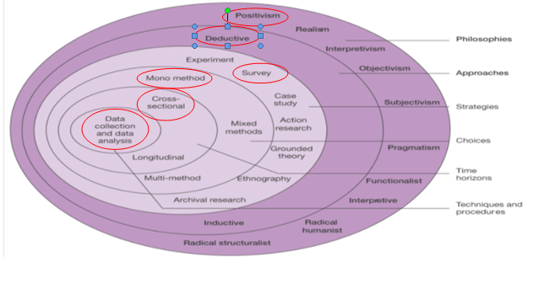
Figure 3.1. The Research Onion (Saunders et al., 2009).

Philosophy

As described by Partington (2002), philosophy is concerned with establishing, regulating, and improving the methods of knowledge by the fields of intellectual endeavour, which according to Scotland (2012) philosophy can take on different fields of beliefs. This research will take on a positivism view, which is associated with the idea of social science (Bryant, 1985), which Saunders et al. (2009) describe the role of positivism to be the data collection and interpretation which leads to the analysis of data and statistical collection. Therefore, knowledge is objective and quantifiable.
This research will be using surveys for the nature of the project, therefore positivist researchers use this to help clearly understand the analysis of data from sampling, questionnaires, etc (Pham, 2018). Positivism limits the researcher to only data collection and interpretation in an objective way, therefore implying that findings are usually quantifiable and or observable. For that reason, positivism studies entirely depend on quantifiable observations which lead to statistical analysis (Business Research Methodology, 2020).

Research Approaches

The second layer of the onion is the different research approaches which according to Collis and Hussey (2014), there are two types of research approaches, deductive and inductive.
This research will be using a deductive approach; this is due to the research being based on consumer buying behaviour concerning Coca-Cola’s CSR approach. Deductive reasoning according to Hyde (2000) commences with concepts, used to try and identify whether these generalisations apply to specific instances, therefore reasoning deductively means-testing these theories. For instance research on the consumer buying behaviour phenomena was conducted by early economists over 300 years ago, examining the basis of consumer buying decisions and the different factors affecting these decisions. Therefore, different theories such as the ‘Utility Theory’ suggest that consumers make choices based on expected outcomes as well as the consumption activities beyond purchasing (Bray, 2008).

Strategy

There is little no consensus on what a method can be defined as, however; Chu and Ke (2017) define it as different kinds of techniques used to gather and analyse data. This research uses questionnaires to collect social views to provide a consensus on consumer buying behaviour concerning a business’s CSR practices. Kotler (2012) defines questionnaires to be best suited for descriptive research as well as being the appropriate choice for standardised results to be compared (Saunders et al., 2009). This is because; questionnaires often obtain faster response rates, as well as increased accuracy as participants, can enter their own information (Mol, 2017). Therefore, allowing the researcher to further understand how and why individuals think and act in general or for example; how they react to CSR (Nardi, 2018).
The questionnaires were created online using Google Forms using a personal account. The link was provided to participants to access the forms, distributed online using various social media platforms, such as; Facebook, Linkedin, as well as via email to voluntary participants. Once the participants have followed the link, they were prompted to read a brief overview of what the project is about as well as security details. These security details inform participants on how their responses will be stored as well as the researchers' contact details, should they prefer to discuss any aspect of the project.

Choice

Saunders et al. (2009) research onion display the different choices a researcher can choose, for the sake of this project the mono-method will be used with is the use of one method either being quantitative or qualitative (Molina-Azorin and Font, 2016). As stated before, the positivism approach used for this project depends on quantifiable observations which leads to statistical analysis. This project is using the quantitative method; this is because questionnaires are the most efficient method to achieve a large number of responses as well as provide rich data to help explain a phenomenon (Humble, 2020). However, questionnaires are often considered to have their limitations in terms of understanding the context of some of the answers provided compared with the validity of interviews (Schellings, 2011).

Time management

For this project, cross-sectional research is best suited as it is the research being conducted over a short space of time to better understand a phenomenon such as consumer buying behaviour (Levin, 2006). However, Lindell and Whitney (2001, p.1) describe using cross-sectional studies for attitude-behaviour relationships are often “vulnerable to the inflation of correlations by common method variance”.

Data collection

Data collection is the range of techniques and approaches that a researcher might use in research projects in order the better understand a phenomenon (Sapsford and Jupp, 1996). The approach used for this project is primary research including a questionnaire, allowing for the researcher to obtain relevant information from specific questions (Hox and Boeije, 2005). However, often missing data from questionnaires may complicate both implementations as well as the interpretation of the questions (Ginkel and Kroonenberg, 2014).

Questionnaire Design and literature review matrix

The use of a questionnaire is used for many different data-gathering functions, therefore, further considerations for the design of the questionnaire to make the questions easy to understand to get the best possible results (Brace, 2018). For the sake of this, research project the researcher mostly included closed-ended questions, this was because, it allowed for the responses to be coded clearly which meant that it gave the researcher a clearer view of the findings (Ghauri et al., 2020). Some of the open-ended questions that allowed the participants to give their take on the question were created into a word cloud. A copy of the questionnaire can be found in the appendix.
As the previous chapter identified a lack of literature supporting consumer buying behaviour and some aspects of organisation CSR initiatives. Therefore, a literature review matrix was conducted which allowed the researcher to ask the questions which was lacking in the literature review. This is shown in the table below.

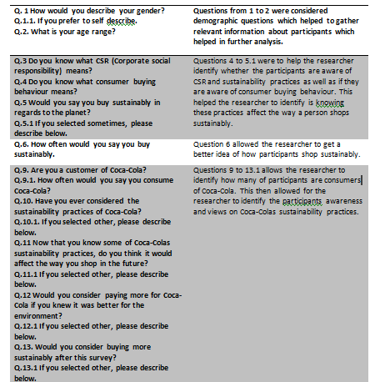
Table 3.1. Literature review matrix.

Pilot Study

Connelly (2008) describes a pilot study to be the data collection, intended to influence study, which according to Leon et al., (2011) a pilot study can help strengthen the competencies and skills required for the research project to be conducted accurately. Establishes the validity of research based on other expert’s knowledge allowing testing the method (Kim, 2010). In this project, the researcher uses a convenience sample in order to further understand the questionnaire questions as well as, allowing for the questions to be edited if necessary.

Sample

Due to the large population, a smaller sample is required to send out the questionnaires as it best represents the wider population to help increase the validity of the findings represented in the questionnaire (Collis and Hussey, 2013). The target audience of this project is regular consumers of Coca-Cola as well as the general public. Therefore, the questionnaire was sent out on social media platforms where the researcher knows the location of participants. For example; Llanelli, Swansea, and Carmarthenshire. The sample size the researcher aimed for was a minimum of 100 respondents, to collect the reliable amount of data, this is because Pearson and Mundfrom (2010) suggest that for the statistical analysis to be valid and reliable, it is a minimum requirement to have 100 responses. Therefore, the researcher will be using a convenient sample due to collecting a large amount of data from a large variety of people.
A mono-method was utilised within the projects. Saunders et al., (2007), the mono-method is an approach researchers use when implementing the use of one approach when analysing statistical data, for instance; sending out the questionnaires through social media in regards to convenience sampling.

Reliability and Validity

According to Roberts and Priest (2006), reliability and validity in research is the method of demonstrating the thoroughness of research processes as well as how trustworthy the research findings are, therefore the research must be valid and reliable in order to be helpful. A pilot study might be introduced into research as it increased reliability and validity. Questionnaires are considered to be a valid and reliable form of collecting research (Akinci and Saunders, 2015), therefore the more reliable the questionnaire the higher the correlation between the results (Greco et al., 1987), Therefore, using a questionnaire increases your validity, as validity is the quality and confidentiality.
To gain efficient and reliable responses, the researcher encouraged honest responses from its audience by emphasising its anonymity. As the target audience was broad, it allowed for the broader responses as well as characteristics of the target audience.

Limitations

Referring back to the literature review, it was found there was a correlation between the gender gap between females and males who demonstrate a bigger concern for buying sustainably as well as concerns for environmental issues (Chen, 2011). Therefore, the questionnaire allowed the researcher to fully understand demographic characteristics and their relationship to CSR and consumer buying behaviour.
However, most often questionnaires can take up a lot of time, as it is a lot of effort to create a good questionnaire that collects data that answers the questions you want to be answered but also gains enough attraction to ensure sufficient response rates (Rowley, 2014).

Ethical considerations

Ethical considerations refer to a method, a perspective, or a procedure in which a person or a business decides to act (Gajjar, 2013). Whereas in terms of research, Saunders et al.,(2009) describe ethical considerations to be the sustainability of researching in regards to society, for instance; how data is stored and participants' response use. Ethics in research is important, as a lack of ethical behaviour can be listed as a form of plagiarism or misconduct in research (Celikdemir, 2019).
This research project was conducted in line with UWTSD ethical standards. To achieve approval, an ethics approval form was sent out (see appendix). In order to maintain ethical standards throughout this research, anonymity, confidentiality, and security of data were met continuously. For instance; all data was stored securely on a password-protected laptop only used by the researcher. The questionnaire was posted on social media platforms for participants over the age of 18 could voluntarily partake.

Chapter conclusion

This chapter has successfully helped achieve the second objective:
“To carry out questionnaires of general consumers of Coca-Cola to further understand whether CSR practices affect consumer buying behaviour.”
This chapter has identified the appropriate research methods needed to conduct this research project. Not only has it justified the researcher’s choice in method but this chapter has also helped form a suitable form in data collection; a questionnaire. The next chapter will analyse and discuss the collected data.

Chapter Four: Analysis

4.1 Introduction

The last chapter identified the methods and the methodology of this research. Chapter four will analyse and present the data collected through questionnaires. This chapter aims to achieve the third objective of the project:
“To analyse the data collected to explore general consumers of Coca-cola to identify whether CSR and sustainability affect a consumers buying behaviour.”
One hundred participants responded to the questionnaire through social media websites to conclude whether Coca-Cola's sustainability practices affect consumer buying behaviour.

4.2 Data analysis

According to Morton et al., (2014) data analysis involves the transformation of collected data to help the researcher understand patterns, which is often helpful towards providing representations of the findings in the data. The data in this research was analysed using IBM SPSS statistics, a software package. The tests that were run were a combination of bar charts, cross-tabulation, and Pearson’s chi-square tests. In order to input the data into SPSS, scale-like codes were necessary. For example; gender questions include codes such as Males, with a code of 1, females with a code of 2, non-binary with a code of 3, etc. These codes were continued with other scale responses, which helps with identifying data.
The main analysis method which was used in this research was cross-tabulations which led to the further use of Pearsons Chi-square tests. This chi-square test is typically used when the researcher is after a more categorical and raw data set of variables (Berkman and Reise, 2011). The use of a chi-square is to identify the p-value, which allows the researcher to identify the probability of there being a link between the two sets of data (Rumsey, 2007). If the p-value is less than 0.05, then the researcher can conclude that there is a relationship between the data inputted.

4.3 Demographics

Demographics are characteristics associated with age, sex, race, and ethnicity, etc (Murdock et al., 2015). Referring back to the literature review, the researcher wanted to find out whether gender and age have a relationship with how a person shops sustainably and whether it affects their consumer buying behaviour. The questionnaire also aimed to find out specifically whether gender has a relationship when asked about the meaning of CSR and sustainability.
The questionnaire received a total of 100 respondents, all of which were aged 18 or over who all participated voluntarily. The questionnaire was sent out via online platforms, e.g. social media and emails, completed by family and friends. Of the total 100 participants, 48% were females, 49% were males and 3% had responded that they would prefer not to say, as shown in the figure below.

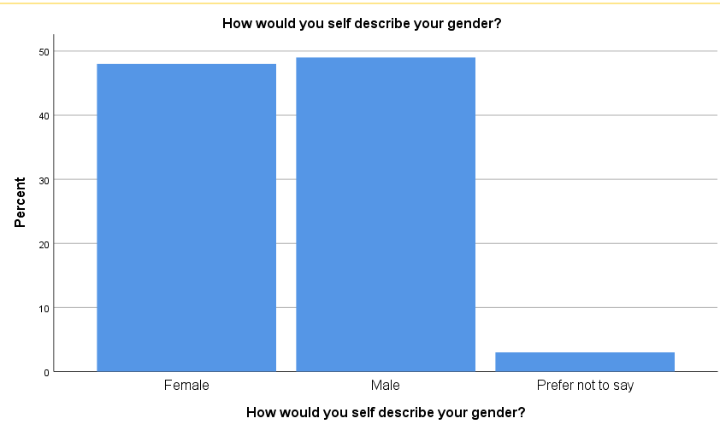
Figure 4.1. Gender of participants.
The figure below represents the ages of the 100 participants. This question was sub-grouped into seven age brackets, ranging from 18-24 to 65 or older, and a choice for the participants to select if they prefer not to say. The results from the graph show that the most popular age group was between the ages of 18-24, which could reflect that the researcher has more friends between this age group as the questionnaire was posted on social media platforms.

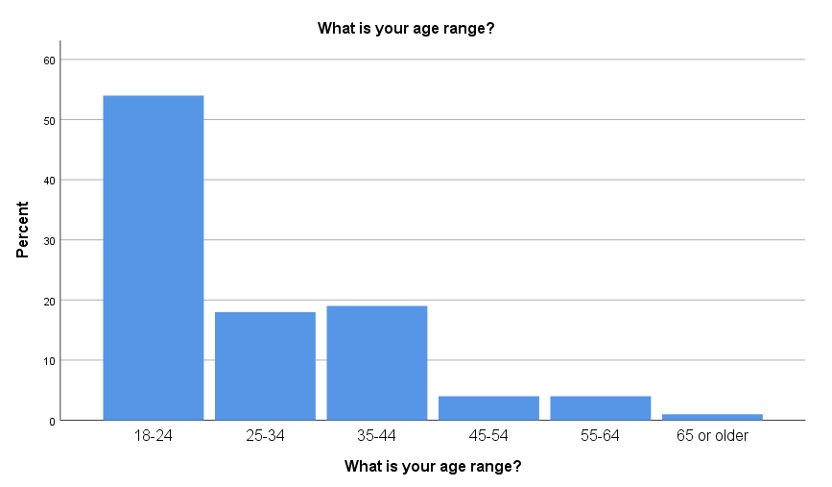
Figure 4.2. Age of participants.

4.4. Chi-square analysis

4.4.1. Chi-square analysis on demographics associations

To examine the results shown between statistical associations between the data, chi-squares were produced. The first chi-square that was produced was the analysis between the gender of participants and whether they shop sustainably. The reason this chi-square was produced was because of the findings produced in chapter twos’ literature review. It was concluded that females tend to shop more sustainably than men. However, the finding represents the p-value as 0.77 which is above 0.05 values; therefore there is no significant relationship between the data inputted.

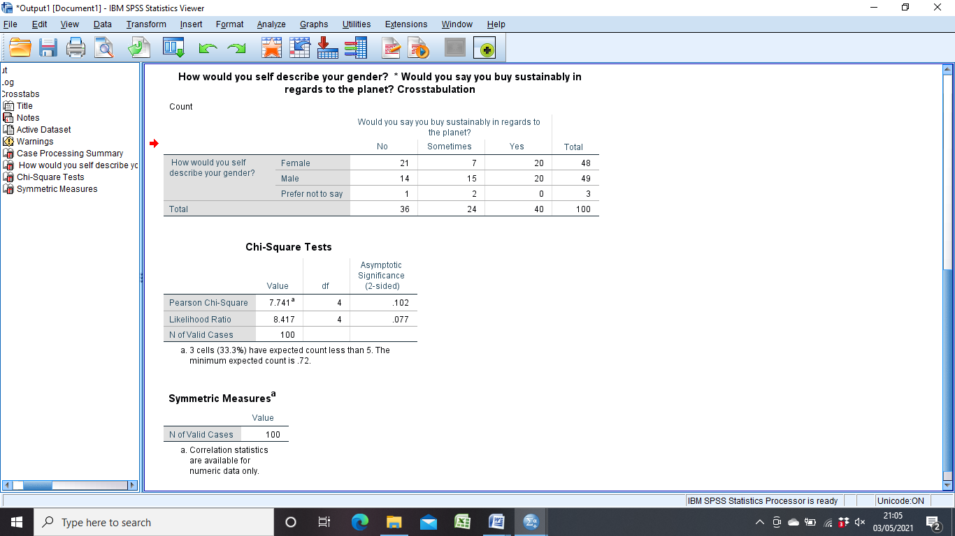
Table 4.1 Cross-tabulation of participants gender and sustainable purchasing

Figure 4.3. Relationships between Gender and sustainable purchasing.

The next chi-square analysis that was conducted was to analyse the relationship between the participant’s gender and whether they understood the meaning of CSR prior to completing the questionnaire. 22% of female participants answered yes to the question and 25% answered no, whereas 22% of males answered yes and 19% answered no to the question. Therefore, the chi-square as shown in Figure 4.4 represents a p-value of 0.020, which according to the 0.05 p-value rule, represents a relationship between the data.

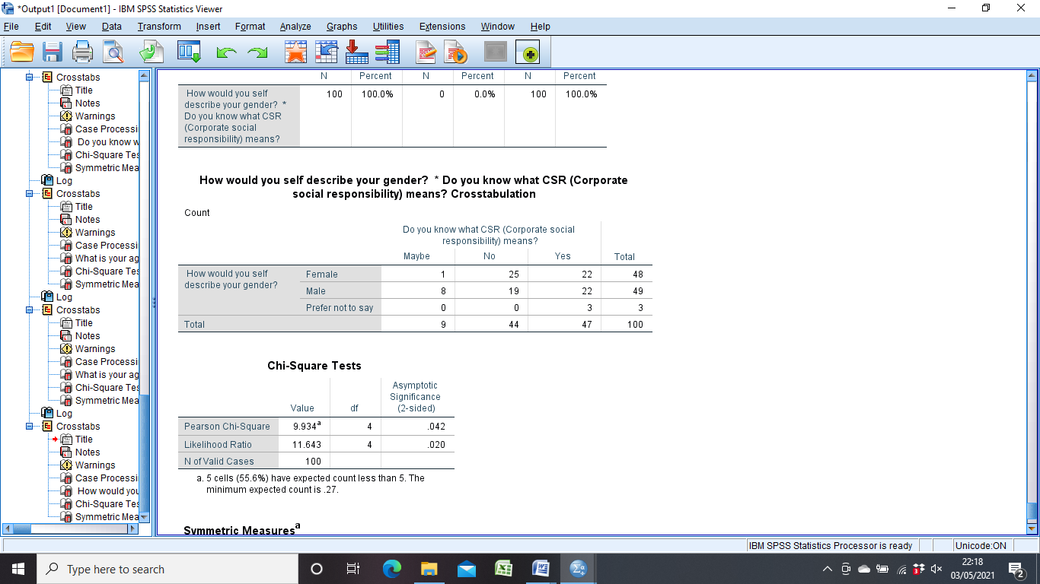
Table 4.2. Cross-tabulation of participants' gender and the understanding of CSR.

Figure 4.4. Relationship between Gender and the understanding of CSR.

The third chi-square which was conducted, evaluated participants' age and whether they buy sustainably. This is in line with the findings from chapter two’s literature review which found that older generations tend to buy more sustainably as they typically have more money than the younger generation (Jones et al., 2017). However, the cross-tabulation that was performed allowed the researcher to see that the 18-24 age bracket had a 19% yes answer rate to shopping sustainably along with an 8% yes answer rate in the 35-44 range. This is comparable with the 45-54 age bracket who answered 2% yes. This is shown below in table 4.3.
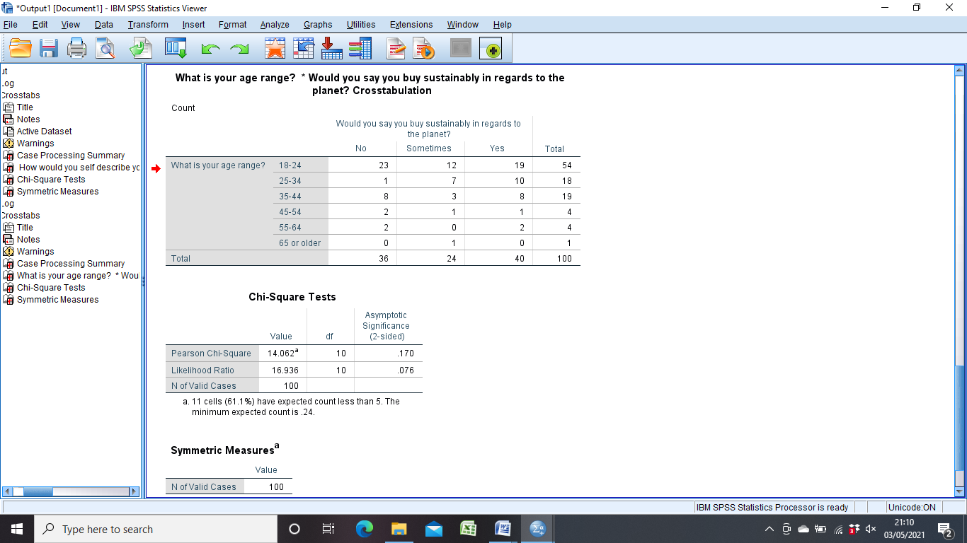
Table 4.3. Cross-tabulation of participants' age and whether they buy sustainably.
This cross-tabulation table allowed for further analysis using the chi-square as shown below in figure 4.6. the P-value presented is 0.076 which is higher than 0.05. Therefore, there is no relationship between the two data inputted.
Figure 4.5. Relationship between age of participants and sustainable purchasing.

After this, the researcher wanted to find out the relationship between the participant's age and whether they believe the price affects how consumer shops sustainably. According to the cross-tabulation table, 47% of participants within the age group of 18-24 answered yes along with 19% of participants within the age group of 35-44 answered yes. Whereas, 4% of participants in the 55-64 age group answered yes. This relates back to the previous cross-tabulation table which presents that the younger age group bought more sustainably than the older age brackets.
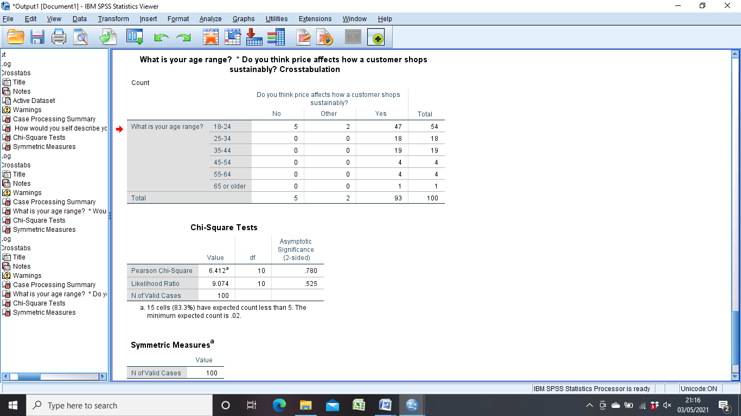
Table 4.4. Cross-tabulation of participants' age and the effects of price on buying sustainably.
This allowed the researcher to perform the chi-square analysis which showed the p-value to be 0.525 which is higher than the p-value of 0.05. Therefore, there is no significant relationship between the two data sets.

Figure 4.6. Relationship between participants age and the effects of price on buying sustainably.

The next chi-square which was completed was the analysis of participant’s age range and whether they knew the meaning of consumer buying behaviour. The cross-tabulation table presents 30% of participants in the age group of 18-24 answered yes to knowing what consumer buying behaviour means whereas the older age bracket, such as 45-54; only 2% answered yes.

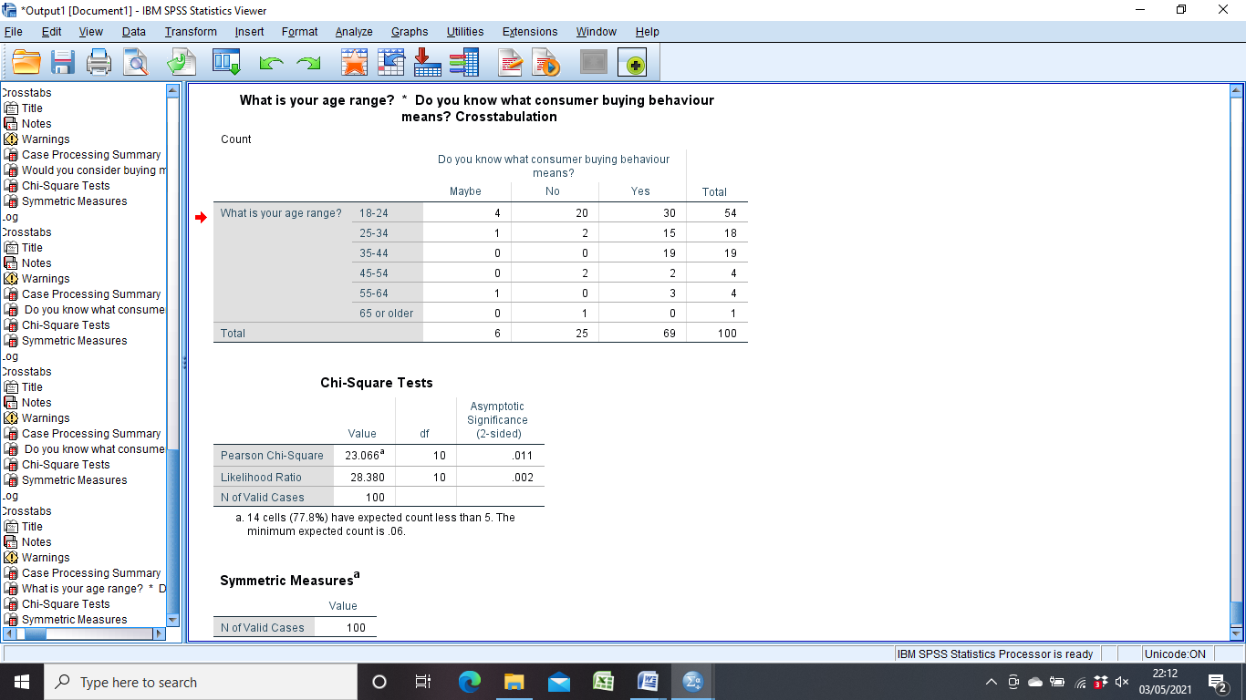
Table. 4.5. Cross-tabulation of participants' age and the meaning of consumer buying behaviour.
The cross-tabulation allowed for further analysis using a chi-square, as shown below in figure 4.10.The chi-square presents the p-value as 0.002 for this analysis which is lower than 0.05, therefore it is a significant relationship between the data inputted.
Figure 4.7. Relationship between participant’s age and the meaning of consumer buying behaviour.

4.4.2 General chi-square analysis

Referring back to chapter two’s literature review, it was found that if a person knows about sustainability and CSR initiatives, then they are more likely to buy sustainably (Picha and Navratil, 2019). According to the cross-tabulation table shown below in table 4.6, 18% of participants who answered yes to knowing the meaning of CSR are more likely to buy sustainably, whereas 22% of those who didn’t know what CSR is, do not buy sustainably.
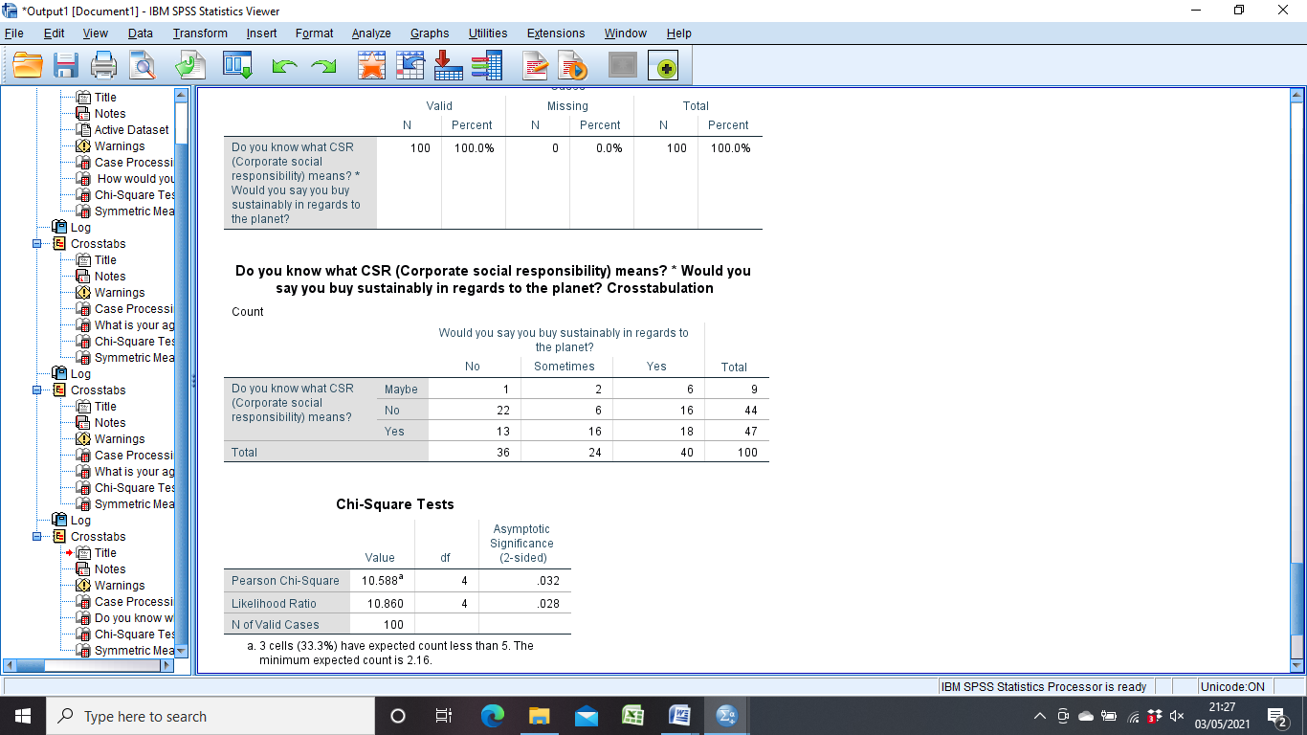
Table 4.6. Cross-tabulation of the meaning of CSR and sustainable purchasing.

The cross-tabulation table allowed for the chi-square analysis as shown below in figure 4.8, which shows a p-value of 0.28 presenting a relationship between the data.

Figure 4.8. Relationship between the meaning of CSR and sustainable purchasing.
The last analysis which was conducted was between the two questions that ask participants whether they have ever considered the sustainability practices of Coca-Cola and whether it would affect the way the shop in the future. The cross-tabulation table as shown below in figure 4.13 presents that those who selected yes in the first question, 8% of participants selected yes in whether it would affect the way they shop in the future. However, 58% of participants who selected no in considering sustainability practices of Coca-cola selected yes in how it would affect the way they shop in the future.
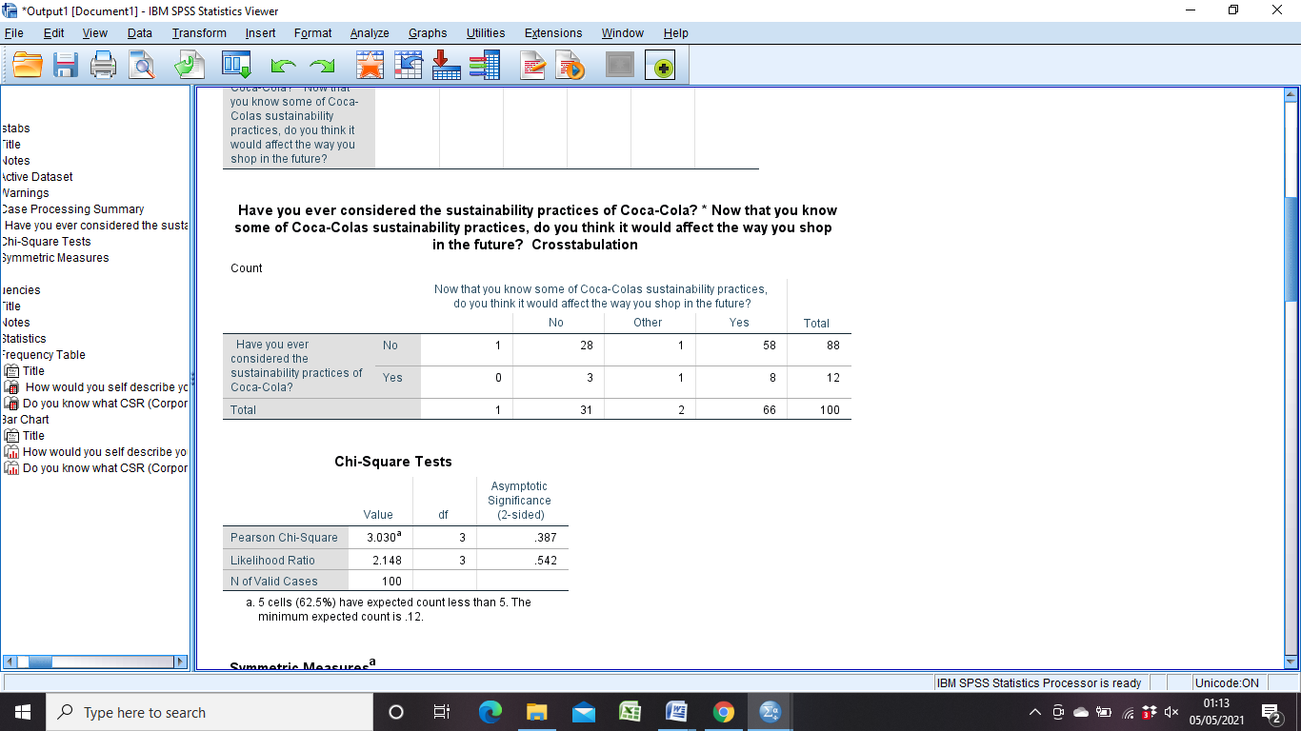
Table 4.7. Cross-tabulation of the considerations of Coca-Colas's sustainability and future effects of purchasing.
This cross-tabulation allows for the chi-square analysis shown below in figure 4.14, which showed the p-value to be 0.542 which is higher than 0.05. Therefore, there is no significant relationship between the two sets of data.
Figure 4.9. Relationship between the considerations of Coca-Cola’s sustainability and the future effects of purchasing.

4.5 Main findings

The main findings of this chapter are as follows:
- There were no statistical relationships between gender and buying sustainably and age and buying sustainably despite the findings in chapter two.
- There was however, a statistical relationship between participants’ age and knowing the meaning of consumer buying behaviour as well as gender and knowing the meaning of CSR.
- Finally, the researcher identified that there was a statistical relationship between knowing the meaning of CSR and participants sustainable shopping. Thus suggesting that CSR and sustainability can influence a consumers buying behaviour.

4.5 Conclusion

This chapter achieved the third objective:
“To analyse the data collected to explore general consumers of Coca-cola to identify whether CSR and sustainability affect a consumers buying behaviour.”
In conclusion, the study briefly aligns with previous research suggesting that a consumer’s awareness of CSR and sustainable practices influence their behaviour and purchasing habits. The analysis also supported the research found in chapter two, regarding participants' age and gender and their awareness of CSR and sustainable practices. However, the research suggested that the older generation has a higher level of awareness, and this research found that it was the younger generation who are more aware of the phenomenon.
Despite this, the other analysis which was conducted found that there were no statistical relationships between the other data inputted. This was because, the p-values in the chi-squares conducted had a high p-value over 0.05, therefore meaning there is no relationship. According to Anezakis et al. (2018), high p-values indicate that the evidence is not strong enough to obtain results that are not statistically significant, despite the evidence found in chapter two. However, high p-values mean that it helps prevent the researcher to jump to costly conclusions. As well as this, high p-values allow for the opportunity for further research.

5. Chapter Five: Conclusions and Recommendations

5.1 Introduction

The previous chapter analysed and discussed the collected data from this research project and successfully achieved the last objective. This chapter will discuss the main findings of the research project, the overall limitations the researcher faced during this project, the researcher's achievements, and finally a set of suitable recommendations.

5.2 Main findings

The main findings concluded that consumers are more likely to shop sustainably if they are aware of CSR and sustainability in general and the organisation's practices. To be more specific, it was found that those in the younger age group seemed to be more aware of CSR and sustainability practices of an organisation, than the older age groups. The younger age groups were also more likely to buy more sustainably, despite what the research in chapter two found. Similarly, it was found that females were more likely to buy sustainably in line with whether they knew what the phenomenon means, however, the analysed data in the previous chapter found that males and females were roughly tied when it came to shopping sustainably and knowing what CSR meant, despite what the research found.
However, it was found in the previous chapter that there was a significant statistical relationship between the participant’s age and the meaning of consumer buying behaviour, in line with chapter two's findings. The newer generation is described as the new breed of consumers in which they are more aware of how an organisation's CSR and sustainable practices affect how they purchase (Ramya and Ali, 2016). The analysis shows a statistical relationship between the two data sets.

5.3 Limitations

One limitation that most impacted this research project was Covid-19. This impacted the data collection part of the study. This is because the researcher originally planned to conduct interviews with the general public about consumer buying behaviour and their awareness of CSR and sustainability practices. This, therefore, meant that questionnaires had to be posted online which gave the researcher another problem.
Chapter two looked at demographic aspects particularly age and gender. This may have influenced the results and the 18-24 age group was the highest when the researcher needed a mix of the younger generation and the older generation. This suggested that the researcher had more friends in that age group, comprised by posting the questionnaire on social media.
Another limitation was the time restriction the researcher had. This project was conducted as an Undergraduate dissertation; therefore the researcher had to work around other obligations in order to ensure work was meeting time frames. In particular, the researcher had problems with the questionnaire, as there was not a lot of time to hit the ideal sample size despite just hitting minimum requirements.
The last limitation that the researcher came across was the reliability of the answers. For example; participants may have given answers that they thought were morally right to give rather than their truthful answers. For example; question five asked if they think they shopped sustainably. Participants may have given socially desirable questions rather than truthful ones, despite the responses remaining completely anonymous.

5.4 Achievements

One of the main achievements of this research project was that it achieved all three objectives.
Chapter two achieved the first objective:
“To analyse extensive literature on the current understanding of CSR, sustainability and Consumer buying behaviour.”
This chapter was completed by conducting an in-depth literature review, focusing on previous research in terms of CSR, sustainability, and consumer buying behaviour.
Chapter three achieved the second objective:
“To provide a questionnaire to general consumers of Coca-Cola to identify whether CSR and sustainability affect a consumers buying behaviour.”
This objective was achieved by utilising Saunders et al. (2016) research onion. This allowed the researcher to summarise several methods and pick out which fits best for the research project. This questionnaire was developed in line with the literature review.
Finally, chapter four achieved the last objective:
“To analyse the data collected to explore general consumers of Coca-Cola to identify whether CSR and sustainability affect a consumers buying behaviour.”
Finally, this chapter achieved this objective by inputting the collected data and inputting it into IBM SPSS. This gave the researcher several descriptive statistics to choose from which helped with the analysis.

5.5. Further Research

This research would benefit from using a mixed-methods approach for future research. This is because, it would allow for the researcher to collect questionnaires as well as conduct in person interviews. This would provide the researcher with a deeper and richer understanding than this research gave. This could potentially help give a deeper set of recommendations in regards to CSR and sustainability.

5.6 Recommendations

The following recommendations are being made in general and towards Coca-Cola.
Following on from the research, organisations need to stress their own CSR and sustainable practices to the public as more and more consumers are aware of the phenomenon.
To match the awareness, organisations should care about how they perform for the well-being of the environment they operate in but also their brand image. This is because; consumers perceive the organisation the way they act. This is not only morally right but is also beneficial to the organisations profits.
However; Coca-Cola should worry less about the profits they would lose out on switching from plastic to plastic-free bottles. This is because; research has shown that Coca-Cola consumers are more concerned with plastic waste than how their product is packaged, as referred by in chapter one.

5.7 Conclusions

This research project aimed to explore CSR and sustainability initiatives, as well as general consumers of Coca-Colas, take on whether consumer buying behaviour is affected by these initiatives. This project has successfully met this aim. This research project has successfully met the objectives set out to achieve this aim. These objectives were achieved through the previous chapters.
Chapter one introduced the research and rationalised the project as well as set out aims and objectives. Chapter two looked at available literature on CSR, sustainability, and consumer buying behaviour, this helped to create a questionnaire for data collection. Chapter three identified different methods for the researcher to use, to help carry out the analysis. Chapter four analysed the collected data and explored the different views collected whilst referring back to chapter two. Finally, chapter five discussed the main findings, limitations of the project, achievements and made a suitable set of recommendations. This research has highlighted CSR and sustainability as a whole and how it affects a consumers buying behaviour.

6. References

2030 Water resource group. (2009) Charting our water future. McKinsey & Co.
Aagaard, A. (2016) Sustainable Business: Integrating CSR in Business and Functions. River Publishers Series in Multi-Business Model Innovation, Technologies and Sustainable Business: Stylus Publishing LLC.
Akinic, C., and Saunders, M. N. (2015) Using questionnaire surveys for within organisation HRD research. Handbook of research methods on human resource development. Edward Elgar Publishing.
Alsmadi, S. (2007) Green marketing and the concern over the environment: Measuring environmental consciousness of Jordanian consumers. Journal of promotion management, 13(3-4).
Alznauer, M. (2015) Hegel’s Theory of Responsibility. Cambridge University Press.
Asmus, P. (2009) When it comes to water, can corporations and community really coexist? Available at: http://peaceandjustice.org/article.php/20090820081745528. (Assessed 13th March 2021).
Bateh, J., Heaton, C., Arbogast, G. W., and Broadbent, A. (2014) Defining Sustainability in the Business Setting. Jounral of Sustainability Management, 1(1).
Bista, S. (2019) Sustainability in Business: A critique of environmental sustainability practices in Coca-Cola & Unilever. Metropolia: University of Applied Sciences. Available at: https://www.theseus.fi/bitstream/handle/10024/263797/Sustainability%20in%20Business%20upload%20version%20.pdf?sequence=2(Assessed 13th March 2021)
Bowen, H. (1953) Social responsibilities of the Business man. University of Iowa Press.
Brace, I. (2018) Questionnaire Design: How to plan. Structure and write survey material for effective market research. 4th ed. Kogan page publishers.
Bray, J. P (2008) Consumer behaviour theory: approaches and models. Discussion paper. [PDF] Available at: http://eprints.bournemouth.ac.uk/10107/1/Consumer_Behaviour_Theory_-_Approaches_&_Models.pdf (Assessed 10th March 2021).
Bryant, C. G. A. (1985) Positivism in Social Theory and Research: Contemporary Social Theory. Macmillan International Higher Education.
Business Research Methodology. (2020) Positivism Research Philosophy. Business Research Methodology. Available at: https://research-methodology.net/research-philosophy/positivism/#:~:text=In%20positivism%20studies%20the%20role,interpretation%20in%20an%20objective%20way.&text=Researchers%20warn%20that%20%E2%80%9Cif%20you,research%20can%20be%20purely%20objective. (Assessed 10th March 2021).
Carr, A., and Pearson. (1999) Strategically managed buyer- supplier relationships and performance outcomes. Journal of operations management, 17(5).
Celikdemir, D. Z. (2019) Ethics in Research and Teaching: Ethics for Academics. Higher Education and he Evolution of Management, Applied Sciences, and Engineering Curricula. [PDF] Available at: https://www.igi-global.com/chapter/ethics-in-research-and-teaching/223034 (Assessed 11th March 2021).
Chaklader, B., and Gautam, N. (2013) Efficient water management through public-private partnership Model: An experiment in CSR by Coca-Cola India. Vikalpa, 38(4).
Chaklader, B., and Gautam, N. (2013) Public-private partnership model: An experiment in CSR by Coca-cola India. Vikapla, 38(4).
Chen, M. (2011) The gender gap in food choice motives as determinants of consumers’ attitudes towards GM foods in Taiwan. British food journal, 113(6).
Chu, H., and Ke, Q. (2017) Research methods: What’s in the name? Library and Information Science Research, 39(4).
Coca-Cola Journey. (2020) Mission, Vision & Values. Available at: https://www.coca-cola.com.sg/our-company/mission-vision-values(Assessed 12th March 2021).
Collis, J., and Hussey, R. (2013) Business research: A practical guide for undergraduate and postgraduate students. England: Palgrave Macmillan Higher Education.
Connelly, L. M. (2008) Pilot studies. Medsurg Nursing, 17(6).
Crane, A., Matten, D., and Spence, L.J. (2013) Corporate social responsibility in a global context. Corporate Social Responsibility: Readings and cases in a global context. 2nd ed.
DePoy, E. and Gitlin, L., 2015. Introduction To Research: Understanding And Applying Multiple Strategies. 5th ed. Elsevier Health Sciences.
Elkington, J. (1994) Enter the triple bottom line. Routledge.
Elkington, J. (2004) Enter the triple bottom line. Routledge.
Emerich, M. (2000) LOHAS means business. Natural Business Communications. Available at: https://monicaemerich.com/downloads/lohas_means_business.pdf(Assessed 5th February 2021).
Environmental Protection Agency. (2010) Emission Facts: Average Carbon Dioxide Emissions Resulting from Gasoline and Diesel Fuel 2010. Available from:https://www.epa.gov/otaq/climate/420f05001.htm(Assessed 6th February 2021)
Freeman, E. (2013) Business is about purpose. Ted Talk. Available at: https://www.youtube.com/watch?v=7dugfwJthBY (Assessed 5th February 2021)
Freeman, E. 2010. Strategic Management: A Stakeholder Approach. Cambridge University Press.
Freeman, E. 2010. Strategic Management: A Stakeholder Approach. Cambridge University Press.
Freeman, E. 2018. ‘Stakeholder Theory. Available at: http://stakeholdertheory.org/about/ (Assessed 20 November 2020)
Freeman, E. 2018. ‘Stakeholder Theory. Available at: http://stakeholdertheory.org/about/(Assessed 6th February 2021)
Freeman, R. E. (1984) Strategic management: A stakeholder approach. Boston: Pitman.
Friedman, M. (1970) Money and income: Comment on Tobin. Quarterly journal of Economics, 84.
Friedman, M., (1970), The social responsibility of business is to increase it's profits. The New York Times, [online] Available at: https://graphics8.nytimes.com/packages/pdf/business/miltonfriedman1970.pdf [Accessed 11 April 2020].
Gaillet, L., and Eble, M. (2015) Primary Research and Writing: People, Places and Spaces. Routledge.
Gajjar, N. 2013, ‘Ethical Consideration in Research’, International Journal for Research in Education,Vol .2, Issue no. 7. [online]Available at:www.raijmr.com/ijre/wp-content/uploads/2017/11/IJRE_2013_vol02_issue_07_02.pdf [Assessed 10th March 2021].
Ginkel, J. V., and Kroonenberg, P. M. (2014) Missing data in principal component analysis of questionnaire data: a comparison of methods. Journal of Statistical Computation and Stimulation, 84(11).
Griskevicius, V., Tybur, J. B., and Van den Bergh, B. (2010) Going green to be seen: Status, reputation, and conspicuous conservation. Journal of personality and social psychology, 98(3).
Hartmann, M. (2011) Corporate Social responsibility in the food sector. European Review of Agriculture Economics, 38(3).
Haseeb, M., Hussain, H. I., Kot, S., Androiceanu, A., and Jermsittiparsert, K. (2019) Role of Social and Technological Challenges in Achieving a Sustainable Competitive Advantage and Sustainable Business Performance. Sustainability, 11(14).
Hox, J. J., and Boeje, H. R. (2005) Data collection, primary versus secondary. Utrecht University.
Humble, S. (2020) Quantitative Analysis of Questionnaires: Techniques to Explore Structures and Relationships. Routledge.
Hyde, K. F. (2000) Recognising deductive processes in qualitative research. Qualititative Market Research, 3(2).
Ian, J., Li, K. W., and Guo, X. (2016) A strategic analysis of incorporating CSR into managerial incentive design. Transportation Research Part E: Logistics and Transportation Review, 86(1).
IBM 2020, Why SPSS Statistics. Available at :<https://www.ibm.com/uk-en/products/spss-statistics (Assessed 10th March 2021).
James, M. (2014) The Benefits of Sustainability and Integrated Reporting: An investigation of Acconting Majors Perceptions. Available at: https://www.questia.com/library/jounral/1G1-397579856/the-benefits-of-sustainability-and-integrated-reporting. (Assessed 12th February 2021)
Jones, R. J., Reilly, T. M., Cox, M. Z., and Cole, B. M. (2017) Gender makes a difference: Investigating Consumer Purchasing behaviour and attitudes toward corporate social responsibility policies. Corporate Social Responsibility and Environmental management, 24(2).
Kao, E. H., Yeh, C. C., Wang, L. H., and Fung, H. G. (2018) The relationship between CSR and performance: Evidence in China. Pacific-Basin Finance Journal, 51(1).
Kervyn, N., Fiske, S. T., and Malone, C. (2012) Brands as intentional agents framework: How perceived intentions and ability can map brand perception. Journal of Consumer Psychology, 22(2).
Kim, Y. (2010) The pilot study in Qualitative Inquiry: Identifying issues and learning lessons for culturally competent research. Qualitative Social Work, 10(2).
Kotler, P. (2012) Kotler on marketing. Simon and Schuster.
Ksiezak, P., and Fischbach, B. (2017) Triple Bottom Line: The Pillars of CSR. Journal of Corporate Responsibility and Leadership, 4(3).
Kwarteng. A., Dadzie, S., and Famiyeh, S. (2016) Sustainability and competitive advantage from a developing economy. Journal of Global Responsibility, 7(1).
Leon, A. C., Davis, L., and Kraemer, H. C. (2011) The role and interpretation of pilot studies in clinical research. Journal of Psychiatric Research, 45(5).
Levin, K. A. (2006) Study designIII: Cross-sectional studies. Evidence-based dentistry, 7(1).
Lindell, M. K., and Whitney, D. J. (2001) Accounting for Common Method Variance in Cross-Sectional Research Designs. Journal of Applied Psychology, 86(1).
Luchd, M. G., and Moordadian, T.A (2012) Sex, personality, and sustainable consumer behaviour: Elucidating the gender effect. Journal of consumer policy, 35.
Maas, S., and Reniers, G. (2014) Development of a CSR model for practice: connecting five inherent areas of sustainable business. Journal of Cleaner Production, 64(1).
Marais, M. (2012) CEO theatrical strategies for corporate social responsibility. Society and Business Review, 7(3).
Masud, A. K., Rashid, H. U., Khan, T., Bae, S. M., and Kim, J. D. (2019) Organisational strategy and Corporate social responsibility: The mediating Effect of Triple Bottom Line. Occupational Safety and Health, 16(22).
McDonald, S., and Oates, C. J. (2006) Sustainability: Consumer Perceptions and Marketing Strategies. Business Strategy and the Environment, 15(1).
Min, C. M., Ai, Y. J., Choo, A. C. P., Wah, W. P., and Yang, T. C. (2012) A study of the effect of corporate social responsibility (CSR) towards consumer buying behaviour. Faculty Business Law: Multimedia University. Available at:https://www.researchgate.net/profile/Jian-Yeow/publication/249649009_A_Study_Of_The_Effect_of_Corporate_Social_Responsibility_CSR_towards_Consumer_Buying_Behaviour/links/0deec51e6309eec140000000/A-Study-Of-The-Effect-of-Corporate-Social-Responsibility-CSR-towards-Consumer-Buying-Behaviour.pdf(Assessed 11th February 2021)
Mol, C. V. (2017) Improving web survey efficiency: the impact of an extra reminder and reminder content on web survey response. International Journal of Social Research Methodology, 20(4).
Molina- Azorin. J. F., and Font, X. (2016) Mixed methods in sustainable tourism research: an analysis of prevalence, designs and application in JOST. Journal of Sustainable Tourism, 24(4).
Moser, A. K. (2015) Thinking green, buying green? Drivers of pro-environmental purchasing behaviour. Journal of Consumer Marketing, 32(3).
Nardi, P. M. (2018) Doing Survey Research: A Guide to Quantitative Methods. 4th ed. Routledge.
Partington, D. (2002) Essential Skills for Management Research . Business and economics: SAGE.
Pearson, R. H., and Mundfrom, D. J. (2010) Recommended sample size for conducting exploratory factors analysis on dichotomous data. Journal of modern applied statistical methods, 9(2).
Petter, O. (2020) Coca-Cola refuses to scrap plastic bottles in fear of reduced sales. Independent. Available at: https://www.independent.co.uk/life-style/food-and-drink/coca-cola-plastic-bottles-sustainability-single-use-a9296036.html (Assessed 5th April 2021).
Pham, L. T. M. (2018) Qualitative approach to research: A review of advantages and disadvantages of three paradigms: positivism, interpretive and critical inquiry. The University of Adelaide. Available at: https://www.researchgate.net/profile/Lan-Pham- 3/publication/324486854_A_Review_of_key_paradigms_positivism_interpretivism_and_critical_inquiry/links/5acffa880f7e9b18965cd52f/A-Review-of-key-paradigms-positivism-interpretivism-and-critical-inquiry.pdf (Assessed 10th March 2021).
Picha, K., and Navratil, J. (2019) The factors of Lifestyle of Health and Sustainability influencing pro-environmental buying behaviour. Journal of cleaner production, 234(1).
Pomering, A., and Dolnicar, S. (2009) Assessing the Prerequisite of Successful CSR implementation: Are consumers aware of CSR initiatives? Journal of business ethics, 1(1).
Ramya. N., and Ali, M. S. A. (2016) Factors affecting consumer buying behaviour. International Journal of Applied Research, 2(10).
Rangan, K. V., Chase, L., and Karim, S. (2015) The truth about CSR. Harvard Business Review. Available at:https://hbr.org/2015/01/the-truth-about-csr (Assessed 15th April 2021).
Reich-Weiser, C., and Dornfeld, D.A. (2009) A discussion of greenhouse gas emission tradeoffs and water scarcity within the supply chain. Journal of manufacturing systems, 28(1).
Roberts, P., and Priest, H. (2006) Reliability and validity in research. Nursing standard, 20(44).
Rowley, J. (2014) Designing and using research questionnaires. Management Research review, 37(3).
Rudawska, E. (2019) Sustainable marketing strategy in food and drink industry: a comparative analysis of B2B and B2C SMEs operating in Europe. Journal of Business & Industrial Marketing, 34(4).
Sachdeva, S., and Zhao, J. (2020) Distinct impacts of financial scarcity and natural resource scarcity on sustainable choices and motivations. Journal of Consumer Behaviour.
Sadhi, M., and Son, B. (2009) Supply-chain partnership performance. Logistics and Transportation review, 45(6).
Sapsford, R., and Jupp, V. (1996) Data collection and analysis. SAGE.
Saunders, M., Lewis, P., an Thornhill, A. (2009) Research methods for business students. England: Pearson Education Limited.
Saunders, M., Lewis, P., and Thornhill, A. (2007) Research methods for business students. 8th ed. Pearson Eductaion: Harlow.
Saunders, M., Lewis, P., and Thornhill, A. (2016) Research methods for business students. 7th ed. Nueva York: Pearson Education.
Schellings, G. (2011) Applying learning strategy questionnaires: problems and possibilities. Metacognition learning, 6(91).
Schwartz, M. and Saiia, D., 2012. Should firms go 'Beyond Profits' ? Milton Friedman Versus Broad CSR. Business and society review, 117(1).
Scotland, J. (2012) Exploring the philosophical underpinnings of research: Relating ontology and epistemology to the methodology and methods of the scientific, interpretive, and critical research paradigms. English language teaching, 5(9).
Seo, S., Ahn, H., Jeong, J., and Moon, J. (2016) Consumers Attitude towards Sustainable Food Products: Ingredients vs Packaging. Journal of Sustainable Food Waste Management and Utilization. 8(10).
Stewart, D. KAmins, M., and Kamins, M. (1993) ‘Secondary Research: Information Sources and Methods. 4th ed. SAGE.
TCSR Strategy. (2011) Corporate social responsibility. Richemont Annual Report and Accounts.
Thangasamy, E., and Patikar, G. (2014) Factors Influencing Consumer Buying Behaviour: A Case Study. Global Journal of Management and Business Research: E-marketing, 14(5).
The Coca-Cola company. (2009) Annual Review. Available at: https://www.coca-colacompany.com/ourcompany/ar/pdf/2009_annual_review.pdf%3e(Assessed 13th March 2021)
The Coca-Cola Company. (2020) Coca-Cola labels in Sweden issue call to action in support of a circular economy. The Coca-Cola Company. Available at:https://www.coca-colacompany.com/news/new-coca-cola-labels-support-circular-economy(Assessed 9th March 2021).
The Coca-Cola Company. (2020) Coca-Cola labels in Sweden issue call to action in support of a circular economy. The Coca-Cola Company. Available at:https://www.coca-colacompany.com/news/new-coca-cola-labels-support-circular-economy(Assessed 13th March 2021).
The Coca-Cola Company. (2021). Coca-Cola Unveils 2030 Water Security Strategy. The Coca-Cola Company. Available at: https://www.coca-colacompany.com/news/2030-water-security-strategy(Assessed 13th March 2021).
Tian, Z., Wang, R., and Yang, W. (2011) Consumer Responses to Corporate Social Responsibility (CSR) in China. Journal of Business Ethics.
Toussaint, M., Cabanelas, P., and Gonzales-Alvarado, T, (2021) What about consumer choice? The influence of social sustainability on consumers purchasing behaviour in the Food Value Chain. European Research on Management and Business Economics, 27(1).
Vilanova, M., Lozano, J. M., and Arenas. (2009) Exploring the Nature of the Relationship between CSR and Competitiveness. Journal of Business Ethics, 87(1).
Walsh, H., and Dowding, T.J. (2012) Sustainability and the Coca-Cola company: the global water crisis and Coca-Cola’s business case for water stewardship. International Journal of Business insights and Transformation, 4(3).
Wilburn, K.M., and Wilburn, R. (2011) Achieving social license to operate using stakeholder theory. Jounral of international business ethics, 4(2).
Young, W., Hwang, K., McDonalds, S., and Oates, C. J. (2010) Sustainable consumption: Green Consumer behaviour when purchasing products. InterScience Wiley, 18(1).

7. Appendices

7.1. Questionnaire

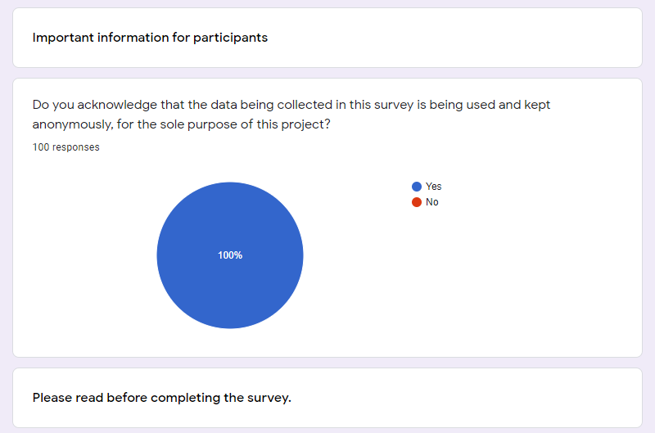
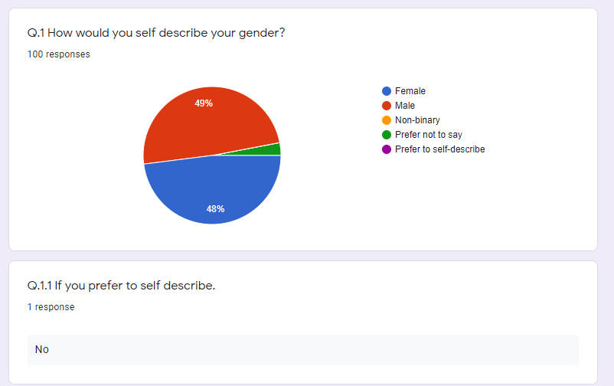

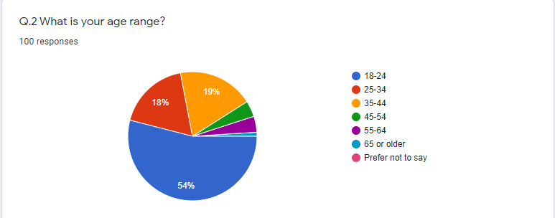

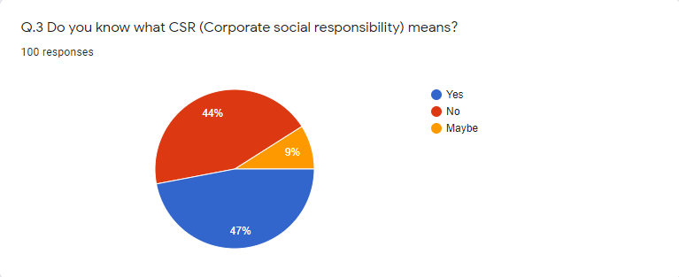

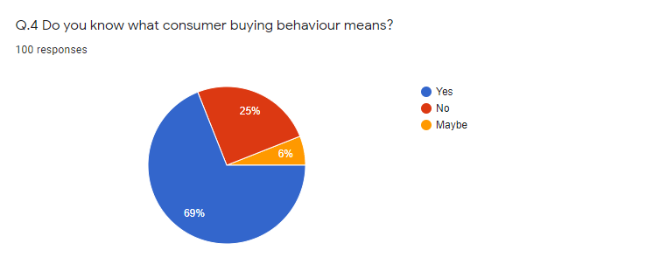
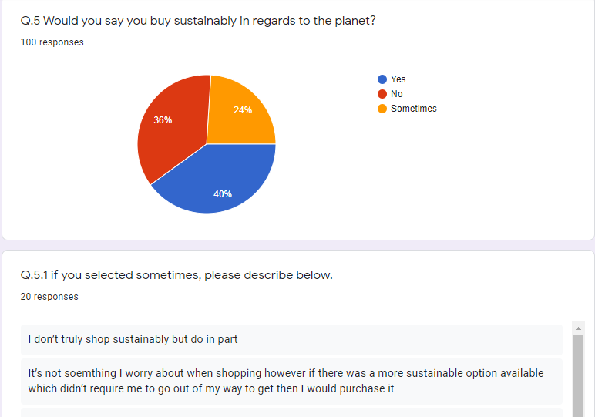

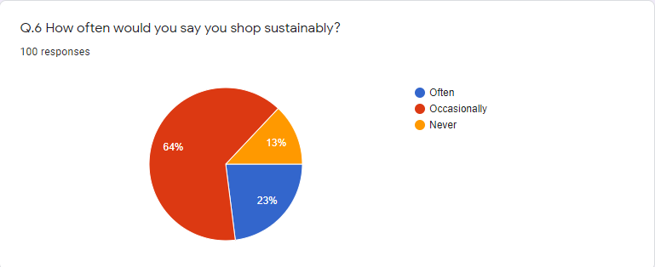

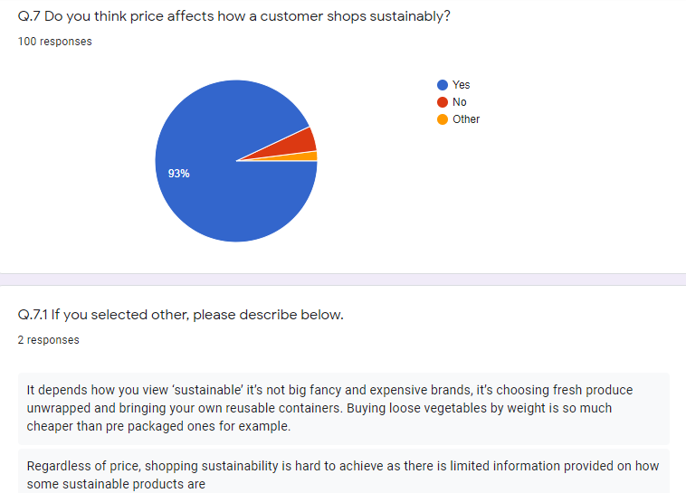

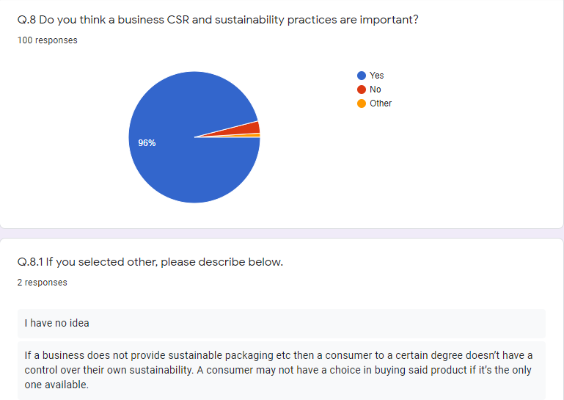

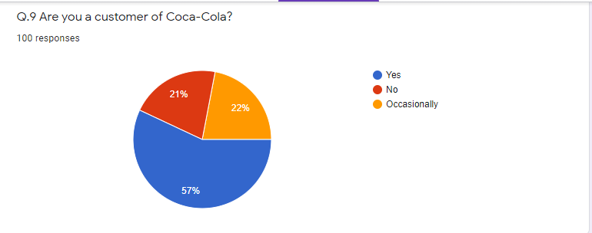

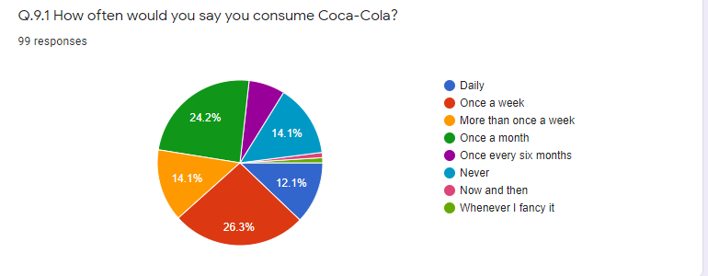
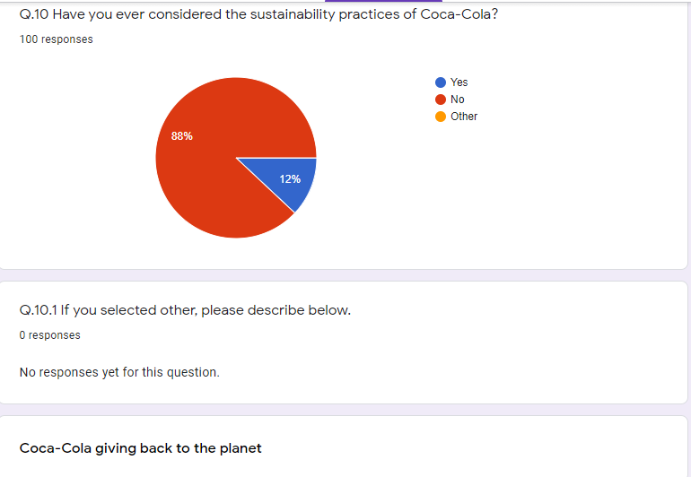

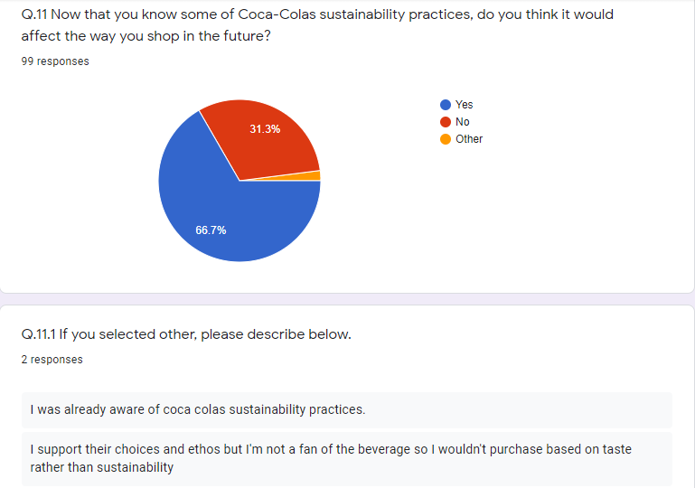

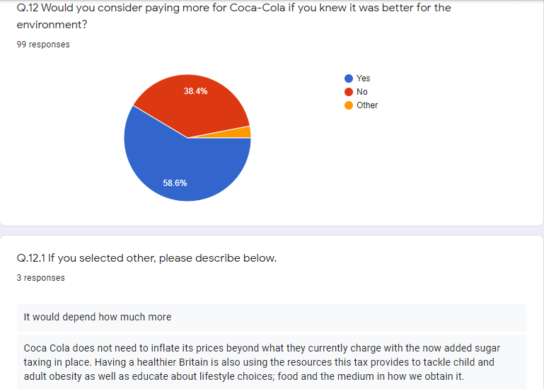

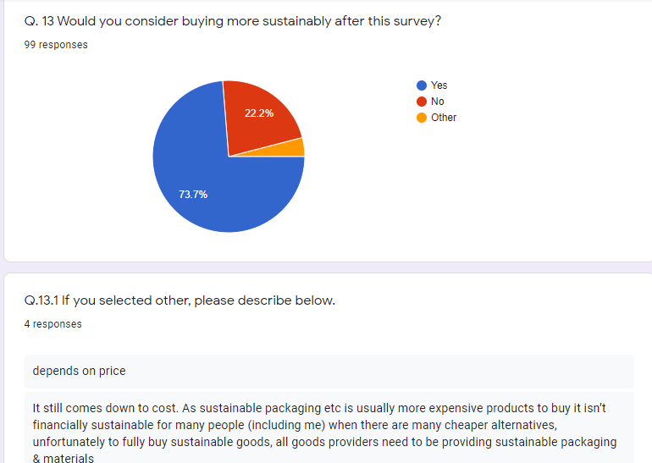

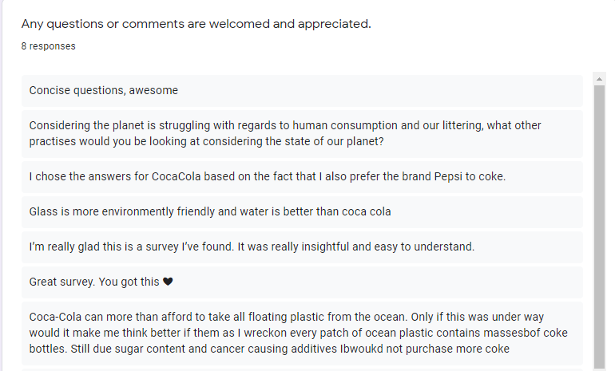

7.2. Ethics form


