

Neurodiversity and the Police: An investigation into the support and guidance neurodiverse officers receive within the South Wales Police. Does the police force demonstrate inclusion regarding neurodiverse officers & provide adequate training?
Sian Davies
Student Number: 2236980
BSc (Hons) Professional Policing Practice: 06/10/2025

Word Count: 7,857

Acknowledgments
I would like to thank my supervisor Deepak Patel for his support, time and guidance throughout this project and my work supervisor Russell O’Rourke for being the biggest support.
I would like to thank my children who have allowed me the time to work on my degree throughout the last three years and have shown nothing but patience, I am forever grateful.

Declaration
This work has not previously been accepted in substance for any degree and is not being concurrently submitted in candidature for any degree.
Signed: Sian Davies - 2236980
Date: 06/10/2025

Statement 1:
This dissertation is being submitted in partial fulfilment of the requirements for the degree of BSc Policing and Criminology.
Signed: Sian Davies - 2236980
Date: 06/10/2025

Statement 2:
This dissertation is the result of my own independent work/investigation, except where otherwise stated. Other sources are acknowledged by footnotes giving explicit references. A bibliography is appended.
Signed: Sian Davies - 2236980
Date: 06/10/2025

Statement 3:
I hereby give consent for my dissertation, if accepted, to be available for photocopying and for interlibrary loan, and for the title and summary to be made available to outside organisations.
Signed: Sian Davies - 2236980
Date: 06/10/2025
Statement 4:
I hereby give consent for my dissertation, if accepted, to be available on the university’s IT system to those who have consent to use the system.
Signed: Sian Davies - 2236980
Date: 06/10/2025

Abstract
The aim of this dissertation is to investigate the support and guidance that officers with neurodiverse needs receive within South Wales Police.
The researcher has carried out a critical analysis of the existing data held within South Wales Police regarding neurodiversity.

The researcher has utilised existing academic literature and current statistics to assist with the investigation and conduct a survey. The survey provided questions to serving members of South Wales Police regarding their experiences with Neurodiversity within the workplace.

The findings of the project identified individual’s opinions on the support and guidance that they receive within the force. Questions relating to the training and the support received were identified by the researcher.

Table of Contents
Chapter One: Introduction 8
1.1 Background 8
1.2 Research Rationale 10
1.3 Summary of Research Objectives: 11
1.4 Structure 12
1.5 Conclusion 14
Chapter Two: Literature Review 15
2.1 Introduction 15
2.2 What is Neurodiversity? 15
2.2.1 The neurodiversity movement 16
2.2.2 The Equality Act 2010 17
2.3 Neurodiversity and employment 18
2.4 Diversity statistics for Police Officers in the UK 19
2.5 The current support in place for neurodiverse police officers within South Wales Police. 20
2.6 Career advancement in South Wales Police for neurodiverse officers 21
2.7 The benefits of a neurodiverse workforce. 22
2.8 The disadvantages of a neurodiverse workforce. 24
2.9 Conclusion 24
Chapter Three: Methodology 26
3.1 Introduction 26
3.2 The Research Onion 27
3.3 Research Approach 27
3.4 Research Strategy 29
3.5 Time Horizon 29
3.6 Data Collection 29
3.7 Limitations 30
3.8 Ethical Issues 30
3.9 Conclusion 30
Chapter Four: Data Analysis 31
4.1 Introduction 31
4.2 Data Analysis 31
4.3 Statistics 31
4.4 Officers perception of neurodiversity in policing 32
4.5 Job progression within South Wales Police 33
4.6 Neurodiversity training within South Wales Police 33
4.7 The Support Police Officers are provided surrounding neurodiversity 34
4.8 Additional comments 35
4.9 Conclusion 35
Chapter Five: Findings and Conclusion 36
5.1 Introduction 36
5.2 Main Findings 36
5.4 Limitations 39
5.5 Further Research 40
5.6 The achievement of Objectives 41
5.7 Self Reflection 42
5.8 Conclusion 43
Bibliography: 44
Appendices 48
Appendix 1: The Research Onion by M. Saunders 48
Appendix 2: Copy of Questionnaire 49
Appendix 3: The Ethics Form 52
Appendix 4: Questionnaire Answers 66

Chapter One: Introduction

This chapter aims to provide a broad overview of the support and guidance provided, surrounding neurodiversity and the police service, specifically South Wales Police (SWP). Moreover, the chapter aims to explore the terminology ‘Neurodiverse’ by undertaking research into what neurodiversity entails.
Chapter one examines the support mechanisms implemented by South Wales Police, to promote the well-being and professional development of the staff in the orginasation.
This chapter introduces and outlines the three central objectives that guide this research. These objectives serve not only as the foundation for the study’s structure but also as key focal points for the analysis and discussion presented in subsequent chapters.

1.1 Background

The term ‘Neurodiverse’ has been significantly developed in recent years, despite having been conversed; the concept of studies in sociology, education, medicine, and psychology is ambiguous (Kamada, 2024). Neurodiversity is the neurological functioning of the brain which is known to affect many individuals. According to the Home Office, statistics display that, “Around 1 in 7 of the UK population is neurodivergent” (Government, 2021). Research will explore the figures and statistics on how many of the 1 in 7 neurodiverse people are in the South Wales Police force. Research defines neurodiversity as an umbrella term that encompasses dyspraxia, dyslexia, attention deficit disorder, dyscalculia, autism spectrum and Tourette’s syndrome; despite the term’s ambiguity (Clouder, 2020).

Research displays that people fall into one of two categories of the umbrella term – Neurotypical and neurodivergent. An individual with standard or usual brain processing behaviours is referred to as neurotypical. Individuals whose brains develop or function differently than what has been considered as typical are referred to be neurodivergent (Office, 2024).
The research undertaken in this project relates to the support that police officers partake whilst being neurodiverse within the police force. It also explores the career progression of neurodiverse officers and whether they experience detriments or benefits in contrast to neuro typical officers. It aims to explore the gap in studies regarding neurodiversity within the police force. The necessity for the understanding of neurodiversity is essential, as mental health, race, gender and disability are widely discussed and supported within the police force, whereas neurodiversity is not well researched.
Surveys into new recruits joining the UK police forces in 2022 were undertaken to gather information regarding whether the new recruits recognised themselves having a disability. The results of the findings display that, “12% of new recruits reported having a disability, compared to 8% in 2021” (Office, 2023). The term ‘disability’ referred to having any illness that impacts day to day abilities with the inclusion of the term neurodiversity.

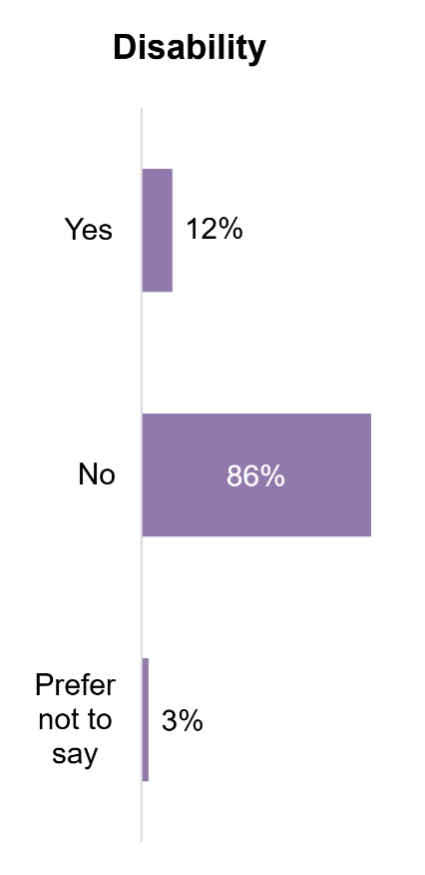
Figure 1.1 - Charts showing disability, sexual orientation and religion of new recruits (Source: (Office, 2023)).

South Wales Police currently have a network called the Neurodiversity Staff Support Network (ND SSN). The network acts as a point of support for neurodiverse colleagues (Police, 2025). Upon researching the statistics for neurodiverse police officers within South Wales Police, Human Resources (HR) have confirmed that information is not currently asked of individuals. There are currently no resources documented on South Wales Police systems surrounding this matter and there are no reports to offer statistics.

1.2 Research Rationale

The researcher’s rationale behind this topic has become apparent due to the ever increasing diverse and complex communities that the police force serves. As stated in the Policing Vision 2025, “Policing must embed legitimacy, trust and confidence, underpinned by the Code of Ethics” (Council, 2025). Moreover, neurodiversity has become more apparent in recent years as research has developed. To serve a diverse community, it is critical that the police force seek to show understanding of neurodiversity and display transparency within the force. The employment of neurodiverse police officers displays a united front, better understandings and inclusion of the neurodiverse community.
Over recent years, research into mental health has become evident, whereas there appears to be a gap in research surrounding neurodiversity. The aim of this dissertation is to investigate beyond the programmed statistic of police officers in South Wales Police who have identified themselves as neurodiverse. The dissertation seeks to explore the outcomes of individual officers who perceive themselves as neurodiverse but are currently undiagnosed and have not shared their perceptions which have become part of the statistic.
Research will be acquired to explore the effects of neurodiversity in policing and the experiences of people within the police force who are neurodiverse.

1.3 Summary of Research Objectives:

The aim of this study is to determine the statistics around neurodiversity within South Wales Police. It includes the support available for neurodiverse officers and the experiences of neurodiversity of people who are employed by South Wales Police.
Questionnaires to collect data will display the findings and support the research for this project.

- Objective 1: To identify the support available to police officers and police staff who are neurodiverse

- Objective 2: To identify the research method most suitable to gather data surrounding police officer’s views on Neurodiversity in the workplace.

- Objective 3: To collect and analysis data from Police officers and staff within South Wales Police regarding Neurodiversity

1.4 Structure

The project is structured into five chapters to ensure that each objective is accomplished.

Chapter one has researched the term ‘Neurodiversity’ and outlined meaning of it by utilising current academic literature. Current statistics are outlined for new recruits who reported to having a disability. Chapter one includes research that displays statistics for serving members of South Wales Police which have been identified as not being held on their systems. The four research objectives for this dissertation have been summarised in chapter one alongside the structure of the study.

Chapter two is the literature review; this section investigates research surrounding neurodiversity and the typical behaviours associated with various neurodiverse traits.
This chapter identifies the Neurodiversity Movement which seeks to empower neurodiverse individuals (May, 2025) and the Equality Act 2010. Both pieces of legislation are in place to uphold the rights of neurodiverse individuals.

Chapter three displays the research into the topic of Neurodiversity by undertaking surveys and exploring the statistics. This chapter concludes objective two. The framework for this project is based on the Research Onion developed by Saunder and the research approach is outlined. The time horizons, limitations and ethical issues are discussed in chapter three.

Chapter four will seek to analyse the data concluded in the methodology and concludes objective three. This chapter provides percentages of the data collected from the survey and the perceptions of serving police officers. The support that officers receive is outlined as well as the training that is provided surrounding neurodiversity.

Chapter five concludes the findings of the dissertation. The main findings of the dissertation are concluded, and recommendations are made to South Wales Police from the researcher. The achievements of the objectives are outlined in chapter five alongside further research which has been undertaken and any limitations that have been identified. The researcher has provided self-reflection in chapter five and the study is concluded.

1.5 Conclusion

The first chapter has outlined the objectives of the topic – neurodiversity. It has stated the definition of neurodiverse, albeit its vagueness and has identified the core aim of the project.
It has identified the recent findings of the low statistics from new recruits that identify as disabled and the aims and objectives behind the dissertation have been outlined.

Chapter Two: Literature Review

2.1 Introduction

The purpose of this chapter is to critically analyse current research available on the topic, which seeks to identify the support and guidance that police officers with neurodiversity receive. The chapter aims to highlight the void in the studies surrounding neurodiversity and the police force and to identify research which is up to date and aligned with current practices.
This chapter will review the legislation already in place to support officers in the force and consider if the legislation provides adequate support and guidance.
This chapter investigates the first objective of the dissertation which is:
- Objective 1: To identify the support available to police officers and police staff who are neurodiverse.

The key literature in the review has been scoped from secondary sources which have been obtained from the University of Wales Trinity Saint David’s (UWTSD) library which has been accessed online and google scholar. The sources obtained for the literature review are recommended academic resources and are obtained from academic journal articles, books and government reports.

2.2 What is Neurodiversity?

The term neurodiversity refers to the neurocognitive functioning of an individual (Chown, 2021), which is regarded substantially different from what is regarded as ‘normal’ by society.
Attention Deficit Disorders, Autism, Dyslexia and Dyspraxia are neurological conditions (Bewley, 2016) that fall under the umbrella term of neurodiversity. Individuals with these characteristics, especially with Autism (ASD), usually present as exhibiting difficulty with communication and social skills and repetitive behaviours (Morrison, 2024). Furthermore, neurodiversity can be associated with negative effects such as depression, burn out and post-traumatic stress disorder (PTSD) (Dijk, 2025). There seems to be no set guidelines for what neurodivergent conditions fall into the boundaries of neurodiversity, it is unclear the precise characteristics that fall under the terminology. However, there is discussion surrounding what neurodiversity entails and how we can perceive what is ‘normal’ cognitive behaviour and what is not.

2.2.1 The Neurodiversity Movement

Disorders such as autism, ADHD, dyslexia and other neurological variances should not be perceived as deficiencies but rather as a natural part of the human experience (Swanepoel, 2024). Nevertheless, legal protections and rights for neurodiverse people, especially in the areas of employment, education and healthcare, have been implemented as a result of this increased awareness.
Ensuring that neurodiverse people receive equitable treatment and equal opportunity, is largely dependent on neurodiverse legislation. The legislation refers to laws created to safeguard and assist people with neurological problems.
E. Finke (2025) states that, The Neurodiversity movement which was founded in the early 1990’s, which aimed to prioritise research into neurodiversity and focused on reshaping narratives about autism. However, S. Kapp states that the “Term ‘neurodiversity’ originates from the autism rights movement in 1998, from Judy Singer” (Kapp, 2020). There appears to be some confusion surrounding the formulation of neurodiversity as research does not seem to outline a set time or date for the findings of the term. Rebeca Bayeh states that journalist Harvey Blume first used the term neurodiversity in print in the late 1900s (Bayeh, 2022). Given that the term neurodiversity has only come to light in the last 30 years, the research surrounding it appears vague. The vagueness of the key meaning of neurodiversity causes implications for researchers as it creates non- factual figures for research.

The Neurodiversity Movement seeks to empower individuals to value their differences and demand more ethical behaviour and acceptance within society (May, 2025).
Kapp states that the criteria for the eligibility for the Neurodiversity movement remains unclear and studies of the movement display that participants are uncomfortable about posing limits (Kapp, 2020). The limits for the term ‘Neurodiverse’ are not structured guidelines but is established from the umbrella term stated by Clouder (2020), in the beginning of this paper where ADHD, Autism and Dyslexia are included. Nobuo Masataka states that this may include other categories such as learning disabilities, which widens the gap for research into neurodiverse and neurotypical individuals. Masataka further highlights the importance of biodiversity, cultural diversity and brain diversity and states that neurological development is a normal human difference (Masataka, 2017). Despite Kapp highlighting the unclear eligibility for neurodiversity guidelines, The World Health Organization (WHO) recognise neurodiversity as a disability. An individual with a disability may be recognised as being limited in their activities or having difficulty carrying out a task or action with a participation requirement (Miranda‐Ojeda, 2025).

2.2.2 The Equality Act 2010

The Equality Act 2010 is a piece of legislation with the purpose of protecting individuals against discrimination. The act seeks to protect individuals with protected characteristics such as –
- Age
- Disability
- Gender reassignment
- Marriage and civil partnership
- Race (Wadham, 2010)
This legal framework protects individuals in day-to-day life in addition to whilst in their place of work. The term ‘Neurodiversity’ falls under the disability category.

2.3 Neurodiversity and employment

Whilst there is a Neurodiverse movement in place to protect individuals, neurodiverse people still confront major obstacles, for example; Autistic adults face multiple barriers to accessing and retaining employments (Morris, 2025), resulting in significant rates of underemployment amongst the neurodiverse community. Cynthia May states that even when qualified, neurotypical individuals are more likely to be hired than candidates with autism spectrum disorder (ASD) (May, 2025). Jantje Schuurmans solidifies May’s theory of underemployment amongst the neurodiverse community by stating that the “Employment rate for individuals on the spectrum is significantly lower than for persons without disabilities” (Schuurmans, 2024). However, Krzeminska states that “The last decade has seen a remarkable opening of new job opportunities for people who are neurodiverse” (Krzeminska, 2019).

To mitigate the publics negative perception of neurodiversity, research is required to encourage recognition of neurodiversity among employers and employees, which may effectively counter pathologizing views of neurodivergent adults and foster inclusive employment for neurodiverse adults (Morris, 2025). In January 2025, The UK Government launched a panel – founded by Professor Amanda Kirby, as part of the Governments Plan for Change, as recent figures demonstrate that the employment rate for disabled people is 54.7%, however, the employment rate for disabled people with autism is 31%, highlighting the gap (Government, 2025).
The National Autistic Society 2016 have undertaken a survey which highlights a significant employment gap, with 77% of autistic people want to work however, the employment rates for autistic individuals are low (Ashworth, 2025). Dawn Moore has stated that, 29% of adults with autism are currently employed but her figures differ from the National Autistic Society’s figures as she provides a higher figure of 99% of young autistic people expressing a desire to work (Moore, 2023). These figures may be dependent on the timelines of the specific research.

A significant change needs to be implemented to mitigate employment gaps and enforce equal opportunities for those with Neurodivergent mindsets. To ensure that individuals with neurodiverse thinking have equitable opportunities, more studies are required to bridge the gap. The Equality Act 2010 can enforce inclusion and can guarantee that appropriate adjustments are provided at work; enabling individuals to flourish professionally and share their special skills.

2.4 Diversity statistics for Police Officers in the UK

Statistics into the percentage of neurodiverse police officers in South Wales Police is unknown. Unfortunately, a search into neurodiversity and the police revealed no related results.
Human Resources (HR) in South Wales Police have stated that no such data of neurodiversity amongst officers is known. As this information is unknown, research has been conducted as part of this chapter to collect any known data regarding neurodiverse Police Officers in the UK.

The UK Government states that the data collection regarding diversity and protected characteristics amongst UK officers, is self-reported to HR, however, the systems are not up to date and data is not currently complete (Government, 2022). This data demonstrates the gap in statistics and the need for additional research to assist neurodiverse individuals. The outcomes of this study reveal the lack of emerging evidence regarding police officers and neurodiversity. There is little to clarify specific reasons for high levels of non-disclosure rates for neurodiversity in the police force, resulting in a lack of understanding as to why officers would wish to share this information.
Miranda – Ojeda Rual states that neurodivergent individuals may ‘mask’ their neurodiverse traits, this is due to the belief that their neurodivergent behaviours are not understood or accepted. Masking demands both cognitive and emotional exertion which have been linked to stress, depression and anxiety (Miranda‐Ojeda, 2025).

2.5 The current support in place for neurodiverse police officers within South Wales Police.

A qualitative approach study into police education undertaken by Michael Mathura, displayed a need for ‘pedagogical change’ due to the ‘one size fits all’ approach. The pedagogical change refers to transitioning from traditional methods which may be outdated more collaborative method, inclusive of all. This approach presented as counterproductive for individuals as each had different learning styles and needs (Mathura, 2024). Mathura’s study displays the need for increased adaptability in the workplace to assist officers, not only in the recruitment process but also to support each individual to their own working needs.
South Wales Police demonstrate that they recognise neurodiversity within the police force regularly participating in raising awareness. Material relevant to Neurodiversity support is found on the policing website along with support networks, inclusion days and reasonable adjustments. Links to advocates and contact details are displayed for members of the organisation.
The Neurodiversity Staff Support Network (ND SSN) has been formed within South Wales Police to raise awareness of neurodiversity. The network is tailored to the force and is aimed at individuals who either have neurodiverse needs themselves or for colleagues who may care for neurodiverse individuals in their family. Regular meetings are held for the network and support is provided for anyone within South Wales Police.

2.6 Career advancement in South Wales Police for neurodiverse officers

In November 2021, South Wales Police conducted a survey into Neurodiversity in the police force, where 321 responses were received. 85% of the respondents stated that promotion and development within in the force was most often seen as a disadvantage for individuals with neurodiversity (Police, 2021). This statistic highlights the significant need for strengthened opportunities for career progression within the force and the need for an inclusive workforce, which recognises neurodiverse leadership. Furthermore, 44% of respondents, expressed that they believe neurodiverse conditions are a disadvantaged in the force (Police, 2021). The figures display that there is a disadvantage for neurodiverse individuals across the force with career progression being the most disadvantaged.
Neurominority refers to the group representation of individuals who share a type of neurodiversity. A study into the representation in leadership positions within South Wales Police explore the risks surrounding the lack of neurominority representation in leadership positions. The report states that the lack of awareness can hinder cohesive collaboration and awareness of a neurominority strengths they can offer (Bird, 2024).
Neurodiverse officers who inspire to progress in their careers may benefit from a transparent leadership. Leaders who are neurodiverse and share this information with others help create a diverse and cohesive organisation that is built on trust and credibility (Jiang, 2017). The goal of managing diversity is to foster a more positive atmosphere where everyone is valued, regardless of personal facts (Ratten, 2025).

2.7 The benefits of a neurodiverse workforce.

The concept of neurodiversity requires the understanding that it is part of the natural variation of human neurocognition. Organizations need to harness the potential of a neurodiverse workforce and identify ways to adapt to altered needs (Brinzea, 2019).
The police force serves a diverse community, it is imperative to uphold a united front to demonstration that officers recognise and respect equality and inclusion. This is also the case when recruiting individuals with neurodiverse needs. Neurodiverse individuals are “Uniquely skilled individuals” (Whelpley, 2021) who often think differently and approach issues from unique angles. This diversity can lead to innovative solutions in investigations and crisis management. Neurodivergent individuals excel at recognition and memory recall which are key skills in analysing evidence, these skills would be beneficial to all roles in the police force but particularly major Crime, CID (Criminal Investigation Dept) and intelligence where their ability to hyperfocus can ensure meticulous evidence collection.

Employer Assistance and Resource Network (EARN), state that due to their detailed knowledge, persistence and reliability, neurodiverse teams are more effective than those without neurodiverse representation (Ortiz, 2020). Moreover, Ortiz states that “Research identifies a consumer preference for doing business with organizations that employ people of all abilities” (Ortiz, 2020). This highlights the importance for a neurodiverse representation within the police force and the preference of a neurodiverse organisation for the public that the police serve.

A neurodiverse police force can assist with bridging the gap with neurodiverse communities, and can foster organisational creativity, enhancing the social and economic well-being of the communities that the police serve (Moore, 2023). Officers who understand the neurodivergence are better equipped to manage individuals in crisis, reducing escalations and displaying empathy. It is paramount to destigmatizing neurodiversity and encourage individuals to display their strengths within the condition (Hunt, 2024), not just in the police force, but in all walks of life.

2.8 The disadvantages of a neurodiverse workforce.

A neurodiverse police force has many benefits, but there can also be challenges that individuals employed by the organisation may encounter, by addressing these issues in the first instance may mitigate any potential disadvantages they may experience.
Neurodivergent individuals may face challenges whilst undertaking daily tasks, as they may experience difficulties with maths, reading or writing or suffer anxiety or chronic fatigue (Mahony, 2024). Police officers partake in writing, reading and communicating with the public daily and often carry a high workload. It is likely that a neurotypical individual would experience pressure from these elements and must maintain resilience, therefore, these factors may increase a neurodivergent individual’s stress and anxiety levels and lead to depression.
Stian Orm states that there is little knowledge of the link between anxiety and depression for neurodiverse individuals however people with neurodiversity do experience these symptoms (Orm, 2025). Furthermore, neurodiverse individuals may experience social interaction difficulties which may be misunderstood or misinterpreted.

2.9 Conclusion

This chapter has attained the objectives of point one - To identify the support available to police officers and staff and to understand the gap in research.
To conclude, the literature review highlights the clear gap in studies surrounding neurodiversity within the police force. It is apparent that no data is held for neurodiverse police officers or staff within South Wales Police, it is down to the individual to report any neurodiverse needs at their own discretion. Research has found that high levels of non-disclosure rates for neurodiversity may be due to fear of discrimination and neurodiverse individuals may ‘mask’ their diverse needs to avoid this. Furthermore, primary data collected from previous surveys within South Wales Police establishes that 85% of the respondents have stated that they feel that career progression for neurodiverse individuals is a disadvantage.
Statistics obtained from the UK Government have displayed that the current systems are not up to date regarding diversity and protected characteristics within the UK police force. This displays, not only a gap in research within South Wales Police, but the entire UK police force.

The next chapter of this dissertation explores the research methodology to garner primary research data into the gaps that have been identified in this literature review.

Chapter Three: Methodology

3.1 Introduction

The literature review chapter of the dissertation completed objective one by analysing the current literature that is available surrounding neurodiversity and neurodiversity within the police force. This chapter of the dissertation seeks to achieve objective two which is:
- Objective 2: To identify the research method most suitable to gather data surrounding police officer’s views on Neurodiversity in the workplace.

Research is the activity of data collection, with the purpose of identifying social trends (Mogalakwe, 2006), and is an important part in academic or professional duty which is defined as a structured investigation for discovering knowledge (Bahodirovich, 2025). Objective two of this dissertation seeks to collect primary data from serving police officers, primary data is an approach which collects first hand data from an individual (Taherdoost, 2021). Secondary data is scoped from studies which are published in articles such as journals and books (Mazhar, 2021).
Quantitative and qualitative research are designs which are applied whilst collecting data. Quantitative research focuses on numerical data and is structured by establishing patterns and trends (Dehalwar, 2023). Quantitative research aims to test hypotheses and is beneficial for obtaining large data and statistics in a timely manner, it is often the preferred method for participants due to the uncomplicated and straightforward method.
Qualitative data refers to data which is often gathered through interviews (Pilcher, 2023), or questionnaires utilizing open ended questions. Qualitative data is more in depth and focuses on understanding the ‘How’ and ‘Why’ of the research rather than the statistics.

3.2 The Research Onion

The Research Onion is a framework developed by Saunders et al, 2016, to help formulate an effective and transparent methodology (Abdelhakim, 2021). The framework will structure the research undertaken for this dissertation.

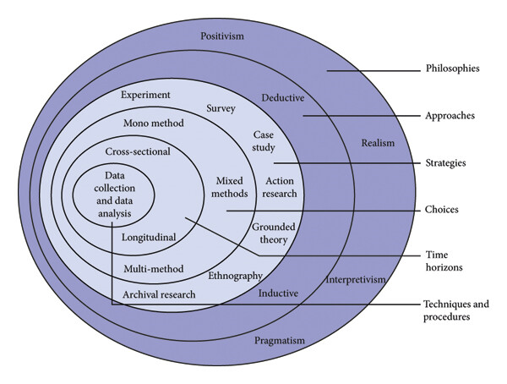
Figure 1. Research onion model (Saunders et al., 2016)

The Research Onion resembles an onions layer, when peeled back, they resemble a different aspect of the model. The core of the Research Onion is the data collection and data analysis which meets the main objective of this dissertation.

3.3 Research Approach

As displayed in 3.1, Figure 1 - The Research Onion model, demonstrates the sections required to fulfil the objectives of research. The strategies undertaken for this dissertation, seek the collection of primary data which are outlined in detail in 3.4 – The Research strategy. The research approach is split into two categories – Deductive and Inductive.
The deductive approach starts with a theory, the implications of the theory are then tested with the data (Usman, 2021) received from the study. The inductive approach is the opposite of the deductive approach. As stated by Usman 2021, it starts with a collection of observations, then looks for patterns in the data in attempt to create a hypothesis to explain the patterns.
The approach that will be utilised for this dissertation will be in the form of questionnaire. The questionnaires will be multiple choice questions which distributed to serving members of South Wales Police. Upon completion of the questionnaires, patterns in the data will be studied and analysed.

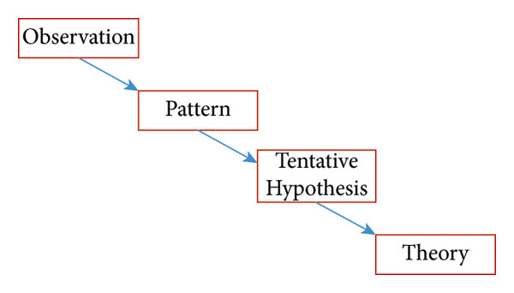

Figure 2. The Inductive approach (Source Usman 2021)

The Inductive approach will be applied for this dissertation. The initial observations of the study present the lack of discussion surrounding neurodiversity within South Wales Police. The study seeks to identify any patterns, evidence the hypothesis and obtain a theory in the findings of the surveys.

3.4 Research Strategy

The research strategy for this project is to obtain quantitative research data from primary sources via a survey or questionnaire. The research method that will be used will be a questionnaire with simple check box answers, this is due to time restraints as police officers have limited spare time during their tour of duty. The project aims to collect a quantity of data from serving police officers, the data will be obtained by seeking permission from officers with South Wales Police who are willing to participate.

3.5 Time Horizon

The Research Onion framework presents two-time horizons – Cross sectional and longitudinal. The cross-sectional time horizon captures a momentary picture of a specific group at one time (Mphale, 2024), this best suit the projects time scale as it seeks to obtain this information in a particular time.

3.6 Data Collection

The collection of data represents the key findings of any research project (Bryman, 2016), the collection of data for this project will be in the form of quantitative questionnaires. The interviews will be structured through Microsoft forms, in the format of a questionnaire with tick boxes. The questions will be structured to suit the projects intentions, the participants will be able to select one or multiple boxes to complete the questionnaire. Data collection in the Research Onion framework seeks to identify techniques and procedures.

3.7 Limitations

The limitations to this dissertation are minor, aside from time constrictions due to officers’ high workloads, the sample population for the project may not be large enough to obtain valid reflection to the data. The questionnaire has been set out in a simplistic manner which is straightforward to navigate, therefore, making it more appealing for individuals to participate. The collection of data in the form of a quantitative study is best suited to this project, as it is timely and simple for officers to complete.

3.8 Ethical Issues

Prior to the commence of data collection for this project, an ethics form has been completed to ensure that the project was commenced in an ethical manner. The project was approved by the university ethics committee. Prior to the questionnaire aspect of this project, participants are informed that they may withdraw their consent at any time and that their identity would remain anonymous throughout.

3.9 Conclusion

This chapter of the project has concluded the methodology, it has outlined the methods that will be utilised for the questionnaire process. It has highlighted objective two and has explained the research methodology employed. The next chapter of the dissertation seeks to analyse the data that has been collected as part of this project and examine whether Neurodiversity has a positive or negative effect on policing.

Chapter Four: Data Analysis

4.1 Introduction

The aim of this chapter is to outline objective three which is to:
- Objective 3: To collect and analysis data from Police officers and staff within South Wales Police regarding Neurodiversity
The chapter analyses the data that has been obtained by primary research by the means of a quantitative study. The online questionnaire had 61 respondents who shared their views on Neurodiversity in policing.

4.2 Data Analysis

The collection of data is obtained by repeating observations to acquire information (Mertens, 2017), the data for this project was collected via Microsoft forms, which is a “Valuable tool for quick formative assessments” (Panchbudhe, 2024). The survey was structured in the form of a questionnaire which was designed to be time efficient and simple for users to complete, it was easy to navigate and took users on average, three minutes to complete.

4.3 Statistics

The survey was shared on South Wales Police’s internet site, which is known as BOB, BOB is accessible to each member of the South Wales Police Force, therefore, the target audience for the survey was met. All 61 participants gave their permission to use their feedback in the questionnaire as part of the data collection for the survey. The participants were informed before taking part, that all information collected was confidential and anonymous to the survey organiser. This information was provided in Question 1 of the survey when consent was sought.

Question 2 of the study asked the participant their length of service, 33% of the users had more than 20 years’ service within South Wales Police, 21% had 10-20 years’ service, 20% had 5-10 years’ service and 26% of users had less than 5 years’ service.

4.4 Officers perception of neurodiversity in policing

Question 3 studied the percentage of participants who identified as Neurodiverse, 31% stated that they identified as being Neurodiverse, 10% stated that they were unsure if they were Neurodiverse or not and 59% of the users stated that they did not identify as Neurodiverse.
This figure displays that 41% of the participants were either Neurodiverse or they were unsure if they had neurodiverse traits, this figure exceeds the hypothesis for Neurodiverse officers and is higher than what the researcher perceived.
These statistics display the need for the UK Government to hold the relevant data surrounding Neurodiverse Police officers, due to the number of officers identifying as neurodiverse, improved support could be implemented within the force.
As stated in Chapter 2.4 of the literature review; Protected characteristics amongst UK officers are self-reported to HR and the systems and data are not currently complete (Government, 2022). The collection of such data by the UK Government would offer an improved network of support for diverse Police officers.

4.5 Job progression within South Wales Police

The analysis of the 61 respondents when asked about job progression within South Wales Police, displayed that 15% believed that disclosing Neurodiversity would prevent job progression. Respondents were provided with a multiple-choice answer where they could select one or more answer for this question. The highest statistic displayed that 32% believed that Mental Health would be a negative factor for job progression, followed by 18% believing that disability would impede progression.
Respondents were asked about the disclosure of Neurodiversity, mental health and disability upon joining South Wales Police, a staggering 84% stated that they disclosed none of these factors upon joining. 8% of respondents stated that they disclosed mental health upon joining South Wales Police and 5% disclosed Neurodiversity.
These statistics highlight the low disclosure rates for Police officers who join South Wales Police, and strengthen the statement made by Miranda Ojeda Rual in chapter 2.4 of the literature review; Neurodivergent individuals may ‘mask’ neurodiverse traits in fear of not being ‘accepted’ (Miranda‐Ojeda, 2025).

4.6 Neurodiversity training within South Wales Police

When participants of the survey were asked whether they felt that there was adequate training for Neurodiverse officers within South Wales Police, 43% believed that there was adequate training, 30% were not sure and 28% stated that no, there was not enough support.
Respondents were also asked if they felt that there was adequate training when dealing with Neurodiverse members of the public, 61% selected ‘No’, 23% were not sure and 16% selected ‘Yes’.
A further question was raised to the respondents by asking if they felt confident whilst dealing with Neurodiverse members of the public; 53% stated that they were ‘Somewhat confident’, 35% selected ‘Very confident’ and 10% selected ‘Not very confident’.
The statistics highlight a lack of confidence when dealing with neurodiverse members of the public. This displays the gap for extra training required surrounding neurodiverse members of the public and how to best support an individual’s neurodiverse needs.

4.7 The Support Police Officers are provided surrounding neurodiversity

As identified in the literature review, South Wales Police have formed the Neurodiversity Network, 79% of respondents stated that they are not part of the network and 21% form part of it. Furthermore, respondents were asked about training that they have received within their role, specific to neurodiversity. 66% of respondents stated that they had not received any training and 34% stated that they had.
Question 12 asked if respondents would like to see extra support surrounding neurodiversity, whether that be in terms of how to best assist members of the public, supporting a neurodiverse colleague or support for themselves. 80% of respondents stated that they would like to see extra support provided, 20% stated that they would not use extra support.

Due to the confidentiality of the questionnaire, the data collected is anonymously sourced. However, conclusions sought from data surrounding the support police officers are provided; the figures align. The 21% of respondent’s that stated they are part of the Neurodiverse Network may form the 20% of respondent’s that stated they would not use extra support.

4.8 Additional comments
The questionnaire had a final box for respondents to add any comments in addition to the questionnaire. To summarise the responses, the anonymous feedback from two respondents stated that neurodiversity can be seen as an advantage and a disadvantage within the police force. A further response was that ‘Appropriate custody experiences for neurodiverse detainees should be considered’. Five respondents stated that further training is needed for officers and training on how to approach individuals with neurodiversity when they need assistance would be beneficial.

4.9 Conclusion

This chapter of research has collected the data and analysed the results.
Most of the respondents to the questionnaire stated that they would like to see extra support and training surrounding neurodiversity. Nearly half of the respondents stated that they were neurodiverse or believed that they fell under the category; these figures exceeded the researcher’s hypothesis.
To conclude, the completion of self-reported characteristics by the UK Government would create an improved support network to individuals who identify as Neurodiverse.
This chapter has successfully analysed the data that has been retrieved from the questionnaire and the individuals’ responses. The final chapter of this project seeks to provide recommendations and to conclude the project.

Chapter Five: Findings and Conclusion

5.1 Introduction

This final chapter will discuss the main findings and conclude the project.
The previous chapters of the dissertation have directed the research for the project and emphasised the meaning of the term ‘Neurodiverse’ and its discrepancies.
The early chapters revealed the absence of current statistics for neurodiversity in employment within the police force. The research approach implemented the ‘Research onion’ which has provided the structure for the project, which allowed the project to attain its objectives.
The previous chapter presented the statistics for neurodiversity in South Wales Police, quantitative questionnaires concluded the primary data that was collected.
This chapter seeks to conclude the project and identify any limitations and recommendations that could provide potential future academic research.

5.2 Main Findings

As a result of the research conducted in this dissertation, there have been multiple main findings. Out of the 61 participants who are employed by South Wales Police, that took part in the questionnaire; 41% of the respondents stated that they either have or may have neurodiverse needs. This figure provides real time statistics, due to this research that is currently not held in South Wales Police data base.
In addition to this figure, only 5% disclosed neurodiversity upon joining the force and 79% of respondents are not part of South Wales Police’s Neurodiversity Network. These figures display that a small minority of individuals disclosed a neurodivergent condition, and a significant majority of respondents are not involved in the internal support that is offered by South Wales Police. The fear of stigma or discrimination may prevent neurodivergent individuals from disclosing such information. Strengthening of the Neurodiversity network may assist in promoting the network across all departments in South Wales Police.

80% of respondents stated they would like extra support surrounding neurodiversity, whether that being assisting members of the public, supporting a colleague or support for themselves. One participant from the questionnaire stated that neurodiversity training is required for the whole department. Further training being implemented on Neurodiversity could be key for providing the extra support that is being requested by the participants of the survey.
The 61 respondent’s that participated in the questionnaire, is a fraction of the number of employees that South Wales Police hold. This figure presented a limitation for the dissertation, as the low percentage of participants presented a small figure in comparison. There is scope for further research to be undertaken on Neurodiversity in South Wales Police, if questionnaires surrounding the topic became mandatory but confidential, there would be more scope to obtain accurate information.

The lack of statistics held by Human Resources within South Wales Police may present as an issue for future surveys, as it appears that officers are hesitant to disclose such information.
This research supports Cynthia May’s hypothesis, as outlined in section 2.3 of the literature review, which suggests that neurotypical individuals are more likely to be hired than their neurodiverse counterparts (May, 2025). This perception may contribute to the reluctance of neurodiverse professionals to disclose their condition, stemming from concerns about potential discrimination and adverse impacts on their employment opportunities.

5.3 Recommendations

As a result of this dissertation, recommendations have been identified in relation to neurodiversity in the workplace within South Wales police. The first recommendation would be to share the findings of the study with Human Resources within South Wales Police and highlight the importance of holding relevant training sessions for staff within the organisation. Training regarding Neurodiversity would be beneficial supporting staff when dealing with Neurodiverse members of the public. The statistics obtained from the quantitative study identified that 80% of the respondents would like to see extra support surrounding neurodiversity for officers. This support included how to best assist themselves and neurodiverse members of the public as well as colleagues. The training could include how to recognise neurodiversity and how a neurodiverse person may present when dealing with incidents. As identified in the literature review in chapter two, a neurodiverse individual usually presents as exhibiting difficulty with communication and social skills and repetitive behaviours (Morrison, 2024). These difficulties may present as barriers when taking statements or witness accounts, therefore, it is imperative that such barriers can be broken down with implemented training.

The second recommendation would advise all members of the organisation to join South Wales Police Neurodiverse Network. This would highlight Neurodiversity and spread awareness of the conditions that Neurodiverse individuals hold, resulting in an improved understanding of neurodiverse needs. Neurodiverse staff within South Wales Police may feel more comfortable about disclosing neurodiverse needs if it is more openly spoken about and accepted.

Finally, it can be recommended for Human Resources within South Wales Police to obtain information from members of the force regarding Neurodiversity. This information could be scoped by obtaining information of each individual on an anonymous basis. The anonymity of the information would negate any fear of repercussion or discrimination to the individual.
Furthermore, this information could be asked on a voluntary basis. It would be beneficial for South Wales Police to obtain information of the Neurodiverse needs of their force, whether it would be only a small percentage of officers who choose to disclose this information or not.

5.4 Limitations

Limitations for this dissertation have been identified. The perception of ‘Neurodiversity’ may differ from each individual and a person’s understanding of Neurodiversity may differ from the next. One individual may perceive Neurodiversity as Autism, ADHD and ADD; whereas a person who is educated on the term may define this as the umbrella term - dyspraxia, dyslexia, attention deficit disorder, dyscalculia, autism spectrum and Tourette’s syndrome (Clouder, 2020).
A second limitation of the study is due to quantitative method, therefore, only neurodiversity, disability and mental health were discussed. The researcher did not query the individual’s perception of the term neurodiversity or gather perceptions from participants in the form of free form text, due to the quantitative method being used and a closed form of questioning. Additional comments were provided at the end of the survey, however, only nine respondents completed this section.

The final limitation identifies the number of individuals that the questionnaire reached. The study was shared on South Wales Police’s BOB website, with 61 participants. The researcher is aware that 61 respondents is a good figure to obtain information and statistics from, however, if more individuals responded, the statistics received would provide a clearer figure. This in turn would provide a better understanding of the needs with the force.

5.5 Further Research

Further research that this dissertation and the researcher recommends being conducted, which would be beneficial, would be to extend and enhance upon the topic of neurodiversity within the police force. As stated in the recommendations, studies to collect data from members of the organisation would assist in solidifying figures for neurodiversity across the force. A mandatory study which is kept anonymous would present real time figures for South Wales Police surrounding neurodiversity. A further study would help determine the exact figures for neurodiversity, however this study would need to be conducted by Human Resources on behalf of the force.
Identifying neurodiverse individuals within the organisation would result in improved support and awareness for an individual’s neurodiverse needs. Furthermore, improved support for all police officers would increase the awareness of neurodiverse individuals within the community.

5.6 The achievement of Objectives

This study set out to achieve three objectives.
- Objective 1: To identify the support available to police officers and police staff who are neurodiverse.
Objective one was accomplished with an extensive literature review. The literature review critically analysed the support that neurodiverse officers receive. Objective one assisted in identifying a gap in South Wales Police’s neurodiversity statistics; currently there are no up to date statistics for neurodiversity in the force. However, it was identified that South Wales Police does support neurodiverse officers and staff. Research shows that the Neurodiversity Staff Support Network, offers support to individuals in the organisation.

- Objective 2: To identify the research method most suitable to gather data surrounding police officer’s views on Neurodiversity in the workplace.
This objective was completed with the support of the research onion. An inductive research approach was identified alongside a quantitative study to collect views on neurodiversity in the workplace. A quantitative study was developed by the researcher, the study was shared with members of South Wales Police via an online survey by utilising Microsoft Forms.

- Objective 3: To collect and analysis data from Police officers and staff within South Wales Police regarding Neurodiversity
This objective analysed the data from the study. It collected perceptions into neurodiversity and individuals’ views on the training and support that is received from South Wales Police.
Objective three also looked at job progression for neurodiverse members of the organisation. This objective revealed that 15% of the respondents to the survey stated that disclosing neurodiversity would prevent job progression. And 84% of the respondents did not disclose any neurodiverse needs, mental health or disability.

5.7 Self Reflection

Due to the researcher’s personal interest and previous experience in Neurodiversity, the topic for this dissertation was scoped to obtain statistics and insights into neurodiverse individuals in South Wales Police. The study identified statistics held by Human Resources and then compared them with current statistics utilising a quantitative study.
The hypothesis for the study displayed that the statistics were higher than expected for the quantity of staff within the organisation who identified as neurodiverse, whether diagnosed professionally or self-diagnosed.
The researcher intends on sharing the data collected with HR, in the hope that further training and support can be offered to individuals surrounding neurodiversity.
This dissertation has taught the researcher how to thoroughly research a topic and to utilise the research to create strong foundations to academic literature.

5.8 Conclusion

This dissertation has successfully achieved the objectives, and the research aims of the study.
The study has provided the researcher with current key statistics into neurodiversity and highlighted the issues involved with the non-disclosure of neurodiverse needs, mental health and disability within South Wales Police.

The lack of current statistics into neurodiversity in South Wales Police has revealed substantial gaps in literature which have been outlined in this dissertation. The study has highlighted the importance of information sharing between Human Resources and individuals within the organisation, to maintain current figures.

This dissertation has answered the question: “Does the police force demonstrate inclusion regarding neurodiverse officers and provide adequate training?”. Whilst South Wales Police do demonstrate inclusion for neurodiverse officers, there is scope to implement further training and support to members of the organisation, whether they are neurodiverse or neurotypical.
Further training surrounding neurodiversity for officers, would raise awareness of a neurodiverse individuals needs, resulting in a better understanding. Whilst South Wales Police do implement neurodiverse training to officers, it is apparent that the training is not mandatory. 80% of the respondents to the survey would like to see further training for neurodiversity.

To conclude, the findings of this project highlight the importance of implementing further training programmes for members of South Wales Police to enchance their understanding of neurodiversity. Such initiatives would not only strengthern the organisations internal capacity but also improve the quality of service delivered to the diverse communities it serves.
By equipping member of the organsation with the tools to reconise and appropriately respond to varied needs, will ensure that interactions with neurodivergent individuals in the community and workplace are handled with greater sensitivity, empathy and effectiveness. This in turn will contribute to the building of trust and legitimacy between colleagues and members of the public.

Bibliography:

- Abdelhakim, A. S., 2021. Adopted research designs by tourisn and hospitality. International Journal of Tourism and Hospitality Management, 4(2), p. 27.

- Ashworth, M. C., 2025. Tracking the long-term outcomes of a supported employment internship programme for autistic adults without a learning disability. Neurodiversity, 1(1).

- Bahodirovich, K., 2025. Description of types of research. Journal of Marine technology and environment, 1(3), pp. 269-277.

- Bayeh, R., 2022. Neurodiversity, Intersectionality and Distress: A Quantitative Survey on the Experiences of , Canada: Rebeca Beyah.

- Bewley, H., 2016. Neurodiversity at work. National Institute of Soical and Economic Research , 1(1), pp. 1-68.

- Bird, J., 2024. Police Promotion and Progression Assessments, South Wales : s.n.

- Brinzea, V.-M., 2019. ENCOURAGING NEURODIVERSITY IN THE EVOLVING WORKFORCE – THE NEXT FRONTIER TO A DIVERSE WORKPLACE. Economic Sciences, 18(3), pp. 13-25.

- Bryman, A., 2016. Social Research Methods. 5th ed. Oxford: Oxford University Press.

- Chown, N., 2021. Neurodiversity. Encyclopedia of Autism Spectrum Disorders, 1(1), pp. 3134-3135.

- Clouder, L., 2020. Neurodiversity in higher education:. Higher Education , 80(4), pp. 757-778.

- Council, N. P. C., 2025. Policing Vision 2025. [Online]
Available at: https://www.npcc.police.uk/SysSiteAssets/media/downloads/publications/policing-vision/policing-vision-2025.pdf
[Accessed 3rd Febuary 2025].

- Dehalwar, K., 2023. Exploring the Distinctions between Quantitative and Qualitative Research Methods. Think India Journal , 27(1), p. 9.

- Dijk, J. v., 2025. In support of neurodiverse participatory sensemaking. Language Sciences, 110(1), p. 101717.

- Finke, E., 2025. Neurodiversity and double empathy: can empathy disconnects be mitigated to support autistic belonging?. Disability and Society, 40(3), pp. 727-750.

- Government, 2021. Recognising Neurodiversity in the Workforce. [Online]
Available at: https://www.governmentevents.co.uk/recognising-neurodiversity-in-the-workforce/
[Accessed 14th January 2025].

- Government, U., 2022. Introduction and changes to data collection on diversity, London: UK Governemnt.

- Government, U., 2025. Employment prospects for neurodiverse people set to be boosted with launch of new expert panel, London: UK Government .

- Hunt, A. D., 2024. Changing perspectives on autism: Overlapping contributions of evolutionary psychiatry and the neurodiversity movement. Autism research, 17(3), pp. 459-466.

- Jiang, H., 2017. Creating an Engaged Workforce: The Impact of Authentic Leadership, Transparent Organizational Communication, and Work-Life Enrichment. Communication research, 44(2), pp. 225-243.

- Kamada, T., 2024. What is Neurodiversity?: A Review of Concepts and Theoretical Perspectives in Management Studies. The Academic Association for Organizational Science, August.pp. 30-44.

- Kapp, S., 2020. Autistic Community and the Neurodiversity Movement : Stories from the Frontline. 1st ed. ed. Singapore : Springer Nature.

- Krzeminska, A., 2019. The advantages and challenges of neurodiversity employment in organizations. Journal of management & organization, 25(4).

- Mahony, C., 2024. NEURODIVERSITY, Cape Town : Creative Commons Attribution.

- Masataka, N., 2017. Implications of the idea of neurodiversity for understanding the origins of developmental disorders. Physics of life reviews , 20(1), pp. 85-108.

- Mathura, M., 2024. INCLUSIVE EDUCATION FOR NEURODIVERSE STUDENT POLICE OFFICERS IN THE UNITED KINGDOM. European Journal of Educational Studies , 11(12).

- May, C., 2025. How Long Does it Last? The Enduring Benefits of Neurodiversity Training and Diagnostic Disclosure on Hiring Outcomes for Adults with ASD. Journal of autism and developmental disorders,, 27(1), p. 14.

- May, J., 2025. Neurodiversity with Nuance. Neuroethics, 18(30), p. 14.
- Mazhar, S. A., 2021. Methods of Data Collection: A Fundamental. Journal of Integrated Community Health, 10(1), pp. 6-10.

- Mertens, W., 2017. Quantitative Data Analysis. Switzerland: Springer International Publishing.
- Miranda‐Ojeda, R., 2025. The Neurodiversity Framework in Medicine: On the Spectrum. 85(1), p. 8.

- Mogalakwe, M., 2006. The Use of Documentary Research Methods in Social Research. African Sociological Review, 10(1), pp. 221-230.

- Moore, D., 2023. Why employing neurodivergent workers is key to building a better future. Opinion, 1(3022), p. 15.
- Morrison, C., 2024. Daily living skill support for autistic people through a neurodiversity-affirming practice lens. Australian Occupational Therapy Journal, 72(2), p. 12.

- Morris, R., 2025. Autistic-inclusive employment: A qualitative interpretive meta-synthesis. The British journal of social work, 26(1).

- Mphale, O., 2024. Understanding IoT Adoption in Botswana’s SMEs: A Research Onion Approach. Journal of Information Systems and Informatics, 6(4), p. 23.

- Office, H., 2023. Police Uplift Programme New Recruits Onboarding Survey 2022 - Report. [Online]
Available at: https://www.gov.uk/government/publications/police-uplift-programme-new-recruits-onboarding-survey-2022/police-uplift-programme-new-recruits-onboarding-survey-2022-report
[Accessed 3rd Febuary 2025].

- Office, H., 2024. Neurodiversity - Member guidence. [Online]
Available at: https://assets.publishing.service.gov.uk/media/6731edff5364e7efcec41917/Neurodiversity_guidance_2024_-_External_version.pdf
[Accessed 3rd Febuary 2025].

- Orm, S., 2025. Anxiety Symptoms Predict Subsequent Depressive Symptoms in Neurodivergent Youth: A 10-Year Longitudinal Study. Research on child and adolescent psychopathology, 53(3), pp. 429-441.

- Ortiz, L., 2020. Business and professional communication quarterly. Reframing Neurodiversity as Competitive Advantage: Opportunities, Challenges, and Resources for Business and Professional Communication Educators, 83(3), pp. 261-284.

- Panchbudhe, S., 2024. Efficacy of Google Form–based MCQ tests for formative assessment in medical biochemistry education. Journal of Education and Health Promotion, 13(1), p. 92.

- Pilcher, N., 2023. Qualitative' and 'quantitative' methods and approaches across subject fields: implications for research values, assumptions, and practices. Quality & Quantity, 58(1), p. 2357–2387.

- Police, S. W., 2021. Neurodiversity Survey Findings, South Wales: South Wales Police .

- Police, S. W., 2025. Staff associations. [Online]
Available at: https://www.south-wales.police.uk/police-forces/south-wales-police/areas/careers/careers/equality-diversity-and-inclusion-recruitment/staff-associations/
[Accessed 17th January 2025].

- Ratten, V., 2025. Neurodiversity and inclusive social value management practices. Journal of management & organization, 31(1), pp. 298-306.
- Schuurmans, J., 2024. Exploring autistic employment and retention realities: A qualitative study among 12 Dutch organisations. Neurodiversity, 9(2), p. 26.

- Swanepoel, A., 2024. ADHD and ASD are Normal Biological Variations as part of Human Evolution and are not “Disorders”. Clinical Neuropsychiatry - Journal of treatment evaluation , 21(6), p. 4.

- Taherdoost, H., 2021. Data Collection Methods and Tools for Research; A Step-by-Step Guide to Choose Data Collection Technique for Academic and Business Research Projects.

- International Journal of Academic Research in Management, 10(1), pp. 10-38.
- Usman, M., 2021. Research Onion for Smart IoT-Enabled Mobile Applications. Scientific Programming , 1(1), p. 9.

- Wadham, J., 2010. Blackstone's guide to the Equality Act. 1st ed. Oxford: Oxford university press.

- Whelpley, C. E., 2021. Autism at work: How internal and external factors influence employee outcomes and firm performance. Journal of general management, 46(3), pp. 210-219.

Appendices

Appendix 1: The Research Onion by M. Saunders

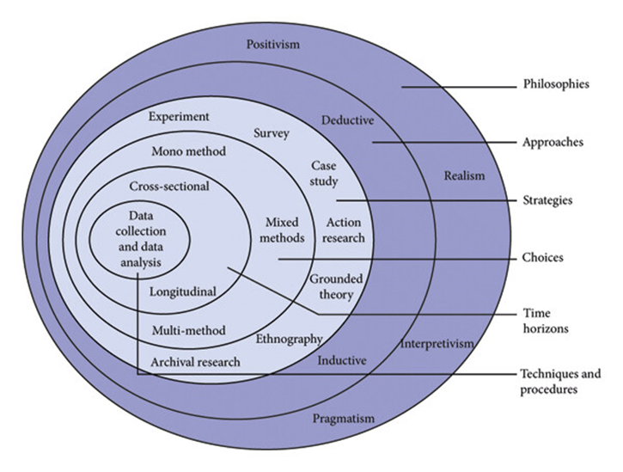

Appendix 2: Copy of Questionnaire

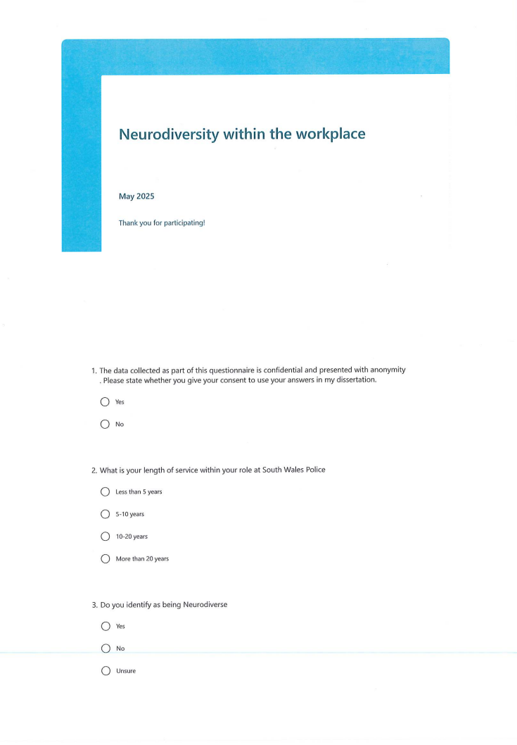
A
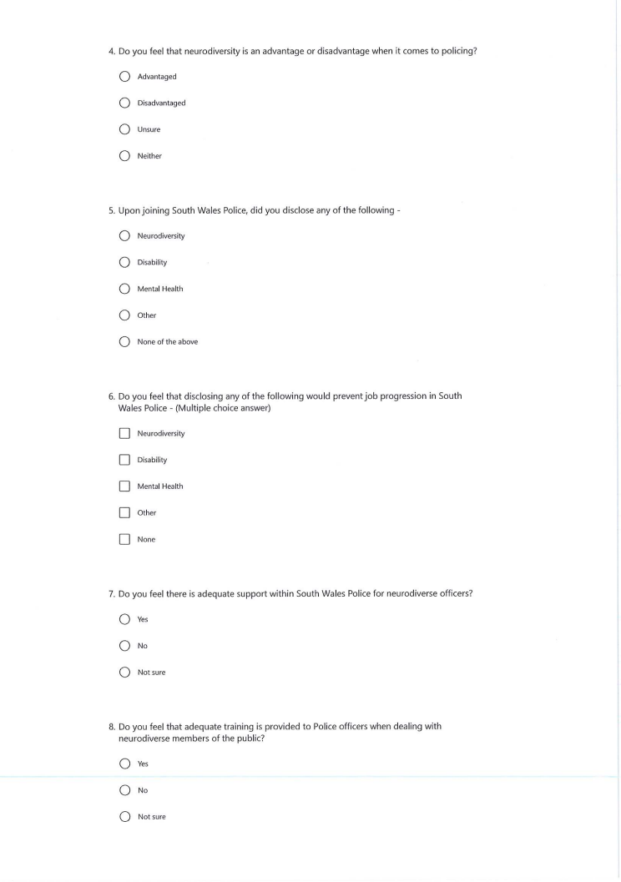
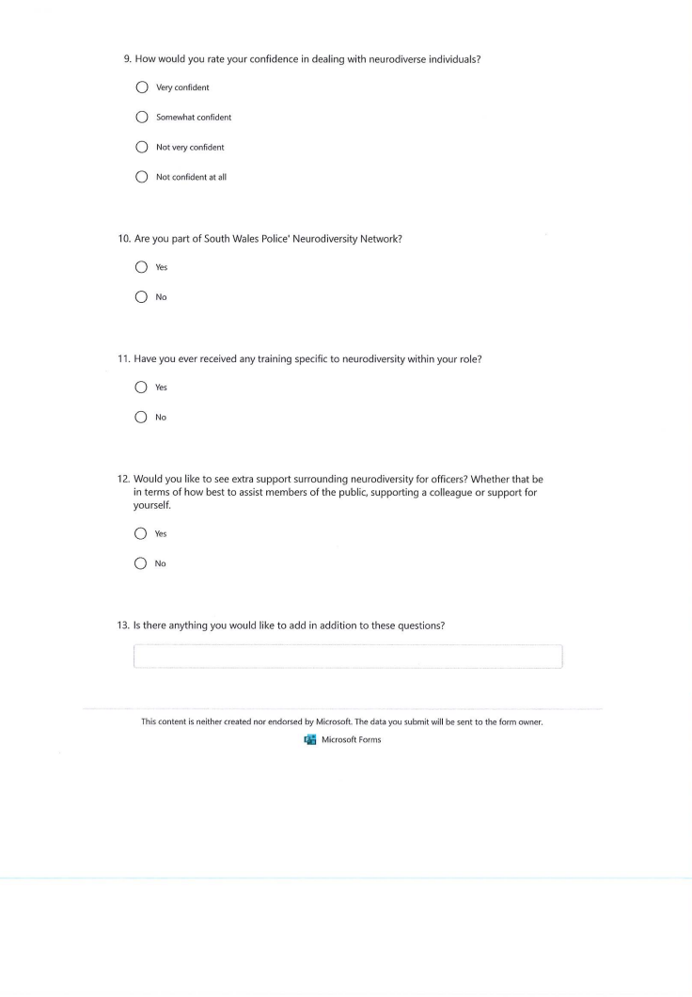

Appendix 3: The Ethics Form

APPLICATION FOR ETHICAL APPROVAL

RESEARCH STUDENTS
This form is to be completed by the student within SIX months for full-time students and TWELVE months for part time students, after the commencement of the research degree or following progression to Part Two of your course.

Once complete, submit this form via the MyTSD Doctoral College Portal at (https://mytsd.uwtsd.ac.uk).

This document is also available in Welsh.

RESEARCH STAFF ONLY
All communications relating to this application during its processing must be in writing and emailed to pgresearch@uwtsd.ac.uk , with the title ‘Ethical Approval’ followed by your name.

STUDENTS ON UNDERGRADUATE OR TAUGHT MASTERS PROGRAMMES should submit this form (and receive the outcome) via systems explained to you by the supervisor/module leader.

In order for research to result in benefit and minimise risk of harm, it must be conducted ethically. A researcher may not be covered by the University’s insurance if ethical approval has not been obtained prior to commencement.

The University follows the OECD Frascati manual definition of research activity: “creative work undertaken on a systematic basis in order to increase the stock of knowledge, including knowledge of man, culture and society, and the use of this stock of knowledge to devise new applications”. As such this covers activities undertaken by members of staff, postgraduate research students, and both taught postgraduate and undergraduate students working on dissertations/projects.

The individual undertaking the research activity is known as the “principal researcher”.

Ethical approval is not required for routine audits, performance reviews, quality assurance studies, testing within normal educational requirements, and literary or artistic criticism.

Please read the notes for guidance before completing ALL sections of the form.

This form must be completed and approved prior to undertaking any research activity. Please see Checklist for details of process for different categories of application.

SECTION A: About You (Principal Researcher)
1 | Full Name: |  | Sian Davies
2 | Tick all boxes that apply: |  | Member of staff: | ☐ | Honorary research fellow: | ☐
 | Undergraduate Student | ☒ | Taught Postgraduate Student | ☐ | Postgraduate Research Student | ☐

3 | Institute/Academic Discipline/Centre: | IMH
4 | Campus: | Swansea
5 | E-mail address: | 2236980@student.uwtsd.ac.uk
6 | Contact Telephone Number: | Not needed
 | For students:
7 | Student Number: | 2236980
8 | Programme of Study: | BSc (HONS) Professional Policing Degree
9 | Director of Studies/Supervisor: | Jane Davies

SECTION B: Approval for Research Activity
1 | Has the research activity received approval in principle?  (please check the Guidance Notes as to the appropriate approval process for different levels of research by different categories of individual) |  | YES | ☒ | NO | ☐
 |  |  |  |  | Date
2 | If Yes, please indicate source of approval (and date where known): Approval in principle must be obtained from the relevant source prior to seeking ethical approval | Research Degrees Committee |  | ☐
2 |  | Institute Research Committee |  | ☐
2 |  | Other (write in) |  | ☒ | Jane Davies – 03/02/2025

SECTION C: Internal and External Ethical Guidance Materials
 | Please list the core ethical guidance documents that have been referred to during the completion of this form (including any discipline-specific codes of research ethics, location-specific codes of research ethics, and also any specific ethical guidance relating to the proposed methodology). Please tick to confirm that your research proposal adheres to these codes and guidelines. You may add rows to this table if needed.
1 | UWTSD Research Ethics & Integrity Code of Practice | ☒
2 | UWTSD Research Data Management Policy | ☒
3 | [List any other relevant documents here] | ☐

SECTION D: External Collaborative Research Activity
If there are external collaborators then you should gain consent from the contact persons to share their personal data with the university. If there are no external collaborators then leave this section blank and continue to section E.
1 | Institution
2 | Contact person name
3 | Contact person e-mail address
4 | Is your research externally funded? |  | YES | ☐ | NO |  | ☐
5 | Are you in receipt of a KESS scholarship? |  | YES | ☐ | NO |  | ☐
6 | Are you specifically employed to undertake this research in either a paid or voluntary capacity? | Voluntary | YES | ☐ | NO | ☐
7 |  | Employed | YES | ☐ | NO | ☐
8 | Is the research being undertaken within an existing UWTSD Athrofa Professional Learning Partnership (APLP)? | If YES then the permission question below does not need to be answered. | YES | ☐ | NO |  | ☐
9 | Has permission to undertake the research has been provided by the partner organisation? | (If YES attach copy)  If NO the application cannot continue | YES | ☐ | NO |  | ☒

Where research activity is carried out in collaboration with an external organisation
10 | Does this organisation have its own ethics approval system? | YES | ☐ | NO | ☐
 | If Yes, please attach a copy of any final approval (or interim approval) from the organisation (this may be a copy of an email if appropriate).

SECTION E: Details of Research Activity
1 | Indicative title: | Neurodiversity and the Police: A critical evaluation into the support and guidance neurodiverse officers receive within the South Wales Police. Does the police force demonstrate inclusion regarding neurodiverse officers?
2 | Proposed start date: | 03/02/2025 | Proposed end date: | 06/10/2025
Introduction to the Research (maximum 300 words per section)
Ensure that you write for a Non-Specialist Audience when outlining your response to the points below:
- Purpose of Research Activity
- Proposed Research Question
- Aims of Research Activity
- Objectives of Research Activity
Demonstrate, briefly, how Existing Research has informed the proposed activity and explain
- What the research activity will add to the body of knowledge
- How it addresses an area of importance.
3 | Purpose of Research Activity –  The purpose of this research activity is to explore neurodiversity within the police force.  It explores the topic and its definitions and to summarise the findings. The police force in the UK, seeks to demonstrate inclusion and to serve the complex and diverse communities to the highest standard. There is a gap in research regarding the topic of neurodiversity within the police force. The dissertation seeks to explore the true statistic of neurodiverse police officers and to establish what support they receive within the force and to cover the grey area surrounding neurodiverse police officers. The dissertation aims to shed light on the topic by highlighting it and demonstrating inclusion and transparency.
4 | Research Question – Neurodiversity and the Police: A critical evaluation into the support and guidance neurodiverse officers receive within the South Wales Police. Does the police force demonstrate inclusion regarding neurodiverse officers?
5 | Aims of Research Activity –  The aim of the research activity is to collaborate with officers and to discover findings on neurodiversity within the force. The dissertation seeks to carry out questionnaires to serving officers to acquire quantitative analysis.
6 | Objectives of Research Activity –  - Objective 1: To collect and analyse data from police officers and staff within South Wales Police that identify as being neurodiverse verses the statistics for the general public  - Objective 2: To critically examine the effects, whether positive or negative, of neurodiversity in policing.  - Objective 3: To identify the support available to police officers and staff and to understand the gap in research.
Proposed methods (maximum 600 words)
Provide a brief summary of all the methods that may be used in the research activity, making it clear what specific techniques may be used. If methods other than those listed in this section are deemed appropriate later, additional ethical approval for those methods will be needed. You do not need to justify the methods here, but should instead describe how you intend to collect the data necessary for you to complete your project.
7 | The data for this dissertation will be collected through means of questionnaires within the South Wales police force. The questionnaires will cover the rank, age range and time in service of serving officers and whether they consider themselves to be neurodiverse or not.  It aims to explore whether a formal diagnosis has been acquired, the type of neurodiversity they may have and the personal experiences that officer may have of being in South Wales Police.
Location of research activity
Identify all locations where research activity will take place.
8 | South Wales Police – South Wales, UK.
Research activity outside of the UK
If research activity will take place overseas, you are responsible for ensuring that local ethical considerations are complied with and that the relevant permissions are sought. Specify any local guidelines (e.g. from local professional associations/learned societies/universities) that exist and whether these involve any ethical stipulations beyond those usual in the UK (provide details of any licenses or permissions required). Also specify whether there are any specific ethical issues raised by the local context in which the research activity is taking place, for example, particular cultural and/or legal sensitivities or vulnerabilities of participants. If you live in the country where you will do the research then please state this.
9 | (this box should expand as you type)

10 | Use of documentation not in the public domain: Are any documents NOT publicly available? | NO | ☒
10 |  | YES | ☐
11 | If Yes, please provide details here of how you will gain access to specific documentation that is not in the public domain and that this is in accordance with the current data protection law of the country in question and that of England and Wales.

 | Does your research relate to one or more of the seven aims of the Well-being of Future Generations (Wales) Act 2015? | YES | NO
12 | A prosperous Wales | ☐ | ☒
13 | A resilient Wales | ☐ | ☒
14 | A healthier Wales | ☐ | ☒
15 | A more equal Wales | ☒ | ☐
16 | A Wales of cohesive communities | ☒ | ☐
17 | A Wales of vibrant culture and thriving Welsh language | ☐ | ☒
18 | A globally responsible Wales | ☐ | ☒
19 | If YES to any of the above, please give details:
A more equal Wales – To enable people to fulfil their potential no matter what their circumstances. Supporting inclusion for a neurodiverse community.

A Wales of cohesive communities – A goal which is well – connected. Supporting the inclusion of all walks of life and to unite as one, regardless of protected characteristics.

SECTION F: Scope of Research Activity
 | Will the research activity include: | YES | NO
1 | Use of a questionnaire or similar research instrument? | ☒ | ☐
2 | Use of interviews? | ☐ | ☒
3 | Use of focus groups? | ☐ | ☒
4 | Use of participant diaries? | ☐ | ☒
5 | Use of video or audio recording? | ☐ | ☒
6 | Use of computer-generated log files? | ☐ | ☒
7 | Participant observation with their knowledge? | ☐ | ☒
8 | Participant observation without their knowledge? | ☐ | ☒
9 | Access to personal or confidential information without the participants’ specific consent? | ☐ | ☒
10 | Administration of any questions, test stimuli, presentation that may be experienced as physically, mentally or emotionally harmful / offensive? | ☐ | ☒
11 | Performance of any acts which may cause embarrassment or affect self-esteem? | ☐ | ☒
12 | Investigation of participants involved in illegal activities? | ☐ | ☒
13 | Use of procedures that involve deception? | ☐ | ☒
14 | Administration of any substance, agent or placebo? | ☐ | ☒
15 | Working with live vertebrate animals? | ☐ | ☒
16 | Procedures that may have a negative impact on the environment? | ☐ | ☒
17 | Other primary data collection methods. Please indicate the type of data collection method(s) below. | ☐ | ☐
 | Details of any other primary data collection method: | ☐ | ☐
If NO to every question, then the research activity is (ethically) low risk and may be exempt from some of the following sections (please refer to Guidance Notes).

If YES to any question, then no research activity should be undertaken until full ethical approval has been obtained.

SECTION G: Intended Participants
If there are no participants then do not complete this section, but go directly to section H.

 | Who are the intended participants: | YES | NO
1 | Students or staff at the University? | ☐ | ☒
2 | Adults (over the age of 18 and competent to give consent)? | ☒ | ☐
3 | Vulnerable adults? | ☐ | ☒
4 | Children and Young People under the age of 18? (Consent from Parent, Carer or Guardian will be required) | ☐ | ☒
5 | Prisoners? | ☐ | ☒
6 | Young offenders? | ☐ | ☒
7 | Those who could be considered to have a particularly dependent relationship with the investigator or a gatekeeper? | ☐ | ☒
8 | People engaged in illegal activities? | ☐ | ☒
9 | Others. Please indicate the participants below, and specifically any group who may be unable to give consent. | ☐ | ☐
 | Details of any other participant groups: | ☐ | ☐

Participant numbers and source
Provide an estimate of the expected number of participants. How will you identify participants and how will they be recruited?
10 | How many participants are expected? | There are an estimated 20 - 25 participants expected for the questionnaires.
11 | Who will the participants be? | All participants will be employed by South Wales Police and are current serving Police Officers.
12 | How will you identify the participants? | Though word of mouth and the willingness to take part in the questionnaires. If the willing number of participants is low, then the questionnaire will be posted on BOB which is a online system for members of South Wales Police.

 | Information for participants: | YES | NO | N/A
13 | Will you describe the main research procedures to participants in advance, so that they are informed about what to expect? | ☒ | ☐ | ☐
14 | Will you tell participants that their participation is voluntary? | ☒ | ☐ | ☐
15 | Will you obtain written consent for participation? | ☐ | ☒ | ☐
16 | Will you explain to participants that refusal to participate in the research will not affect their treatment or education (if relevant)? | ☒ | ☐ | ☐
17 | If the research is observational, will you ask participants for their consent to being observed? | ☐ | ☐ | ☒
18 | Will you tell participants that they may withdraw from the research at any time and for any reason? | ☒ | ☐ | ☐
19 | With questionnaires, will you give participants the option of omitting questions they do not want to answer? | ☒ | ☐ | ☐
20 | Will you tell participants that their data will be treated with full confidentiality and that, if published, it will not be identifiable as theirs? | ☒ | ☐ | ☐
21 | Will you debrief participants at the end of their participation, in a way appropriate to the type of research undertaken? | ☒ | ☐ | ☐
22 | If NO to any of above questions, please give an explanation
 | Point 15 – Written consent will not be needed as the questionnaires are voluntary.

 | Information for participants: | YES | NO | N/A
24 | Will participants be paid? | ☐ | ☒ | ☐
25 | Is specialist electrical or other equipment to be used with participants? | ☐ | ☒ | ☐
26 | Are there any financial or other interests to the investigator or University arising from this study? | ☐ | ☒ | ☐
27 | Will the research activity involve deliberately misleading participants in any way, or the partial or full concealment of the specific study aims? | ☐ | ☒ | ☐
28 | If YES to any question, please provide full details

SECTION H: Anticipated Risks

Outline any anticipated risks that may adversely affect any of the participants, the researchers and/or the University, and the steps that will be taken to address them.

If you have completed a full risk assessment (for example as required by a laboratory, or external research collaborator) you may append that to this form.
1 | Full risk assessment completed and appended? |  | Yes | ☐
1 |  |  | No | ☒
2 | Risks to participants  For example: sector-specific health & safety, emotional distress, financial disclosure, physical harm, transfer of personal data, sensitive organisational information
 | Risk to participants:  No risks identified. | How you will mitigate the risk to participants:
3 | If research activity may include sensitive, embarrassing or upsetting topics (e.g. sexual activity, drug use) or issues likely to disclose information requiring further action (e.g. criminal activity), give details of the procedures to deal with these issues, including any support/advice (e.g. helpline numbers) to be offered to participants. Note that where applicable, consent procedures should make it clear that if something potentially or actually illegal is discovered in the course of a project, it may need to be disclosed to the proper authorities
4 | Risks to the investigator  For example: personal health & safety, physical harm, emotional distress, risk of accusation of harm/impropriety, conflict of interest
 | Risk to the investigator: No risks to the investigator. | How you will mitigate the risk to the investigator:
5 | University/institutional risks  For example: adverse publicity, financial loss, data protection
 | Risk to the University: No risks to the university. | How you will mitigate the risk to the University:
6 | Environmental risks  For example: accidental spillage of pollutants, damage to local ecosystems
 | Risk to the environment: No risks to the environment. | How you will mitigate the risk to environment:

 | Disclosure and Barring Service
 | If the research activity involves children or vulnerable adults, a Disclosure and Barring Service (DBS) certificate must be obtained before any contact with such participants. | YES | NO | N/A
7 | Does your research require you to hold a current DBS Certificate? | ☐ | ☐ | ☒
8 | If YES, please give the certificate number. If the certificate number is not available, please write “Pending”; in this case any ethical approval will be subject to providing the appropriate certificate number.

SECTION I: Feedback, Consent and Confidentiality

1 | Feedback  What de-briefing and feedback will be provided to participants, how will this be done and when?
 | The participant will be able to ask for feedback regarding the findings of the questionnaire. Alternatively, they may request to view the final dissertation once it is marked.
2 | Informed consent  Describe the arrangements to inform potential participants, before providing consent, of what is involved in participating. Describe the arrangements for participants to provide full consent before data collection begins. If gaining consent in this way is inappropriate, explain how consent will be obtained and recorded in accordance with prevailing data protection legislation.
 | The participants will be made aware that the questionnaire is confidential and voluntary. No written consent will be needed.
3 | Confidentiality / Anonymity  Set out how anonymity of participants and confidentiality will be ensured in any outputs. If anonymity is not being offered, explain why this is the case.
 | The participants will be made aware of the anonymity of the questionnaire

SECTION J: Data Protection and Storage

 | Does the research activity involve personal data (as defined by the General Data Protection Regulation 2016 “GDPR” and the Data Protection Act 2018 “DPA”)? | YES | NO
1 | “Personal data” means any information relating to an identified or identifiable natural person (‘data subject’). An identifiable natural person is one who can be identified, directly or indirectly, in particular by reference to an identifier such as a name, an identification number, location data, an online identifier or to one or more factors specific to the physical, physiological, genetic, mental, economic, cultural or social identity of that natural person. Any video or audio recordings of participants is considered to be personal data. | ☐ | 
 | If YES, provide a description of the data and explain why this data needs to be collected:
2
 | Does it involve special category data (as defined by the GDPR)? | YES | NO
3 | “Special category data” means sensitive personal data consisting of information as to the data subjects’ –  (a) racial or ethnic origin,  (b) political opinions,  (c ) religious beliefs or other beliefs of a similar nature,  (d) membership of a trade union (within the meaning of the Trade Union and Labour Relations (Consolidation) Act 1992),  (e) physical or mental health or condition,  (f) sexual life,  (g) genetics,  (h) biometric data (as used for ID purposes), | ☐
 | If YES, provide a description of the special category data and explain why this data needs to be collected:
4

 | Will data from the research activity (collected data, drafts of the thesis, or materials for publication) be stored in any of the following ways? | YES | NO
5 | Manual files (i.e. in paper form)? | ☒ | ☐
6 | University computers? | ☐ | ☒
7 | Private company computers? | ☒ | ☐
8 | Home or other personal computers? | ☐ | ☒
9 | Laptop computers/ CDs/ Portable disk-drives/ memory sticks? | ☒ | ☐
10 | “Cloud” storage or websites? | ☐ | ☒
11 | Other – specify: | ☐ | ☒
12 | For all stored data, explain the measures in place to ensure the security of the data collected, data confidentiality, including details of backup procedures, password protection, encryption, anonymisation and pseudonymisation:
 | N/A

 | Data Protection
 | Will the research activity involve any of the following activities: | YES | NO
13 | Electronic transfer of data in any form? | ☒ | ☒
14 | Sharing of data with others at the University outside of the immediate research team? | ☐ | ☒
15 | Sharing of data with other organisations? | ☐ | ☒
16 | Export of data outside the UK or importing of data from outside the UK? | ☐ | ☒
17 | Use of personal addresses, postcodes, faxes, emails or telephone numbers? | ☐ | ☒
18 | Publication of data that might allow identification of individuals? | ☐ | ☒
19 | Use of data management system? | ☐ | ☒
20 | Data archiving? | ☐ | ☒
21 | If YES to any question, please provide full details, explaining how this will be conducted in accordance with the GDPR and Data Protection Act (2018) (and any international equivalents, where appropriate):
22 | List all who will have access to the data generated by the research activity:
23 | List who will have control of, and act as custodian(s) for, data generated by the research activity:
24 | Give details of data storage arrangements, including security measures in place to protect the data, where data will be stored, how long for, and in what form. Will data be archived – if so how and if not why not.
25 | Please indicate if your data will be stored in the UWTSD Research Data Repository (see https://researchdata.uwtsd.ac.uk/ ). If so please explain. (Most relevant to academic staff)
26 | Confirm that you have read the UWTSD guidance on data management (see https://www.uwtsd.ac.uk/library/research-data-management/) | YES | ☒
27 | Confirm that you are aware that you need to keep all data until after your research has completed or the end of your funding | YES | ☒

SECTION K: Declaration
The information which I have provided is correct and complete to the best of my knowledge. I have attempted to identify any risks and issues related to the research activity and acknowledge my obligations and the rights of the participants.

In submitting this application I hereby confirm that I undertake to ensure that the above named research activity will meet the University’s Research Ethics and Integrity Code of Practice which is published on the website: https://www.uwtsd.ac.uk/research/research-ethics/
1 | Signature of applicant: | S.Davies | Date: 03/02/2025

For STUDENT Submissions:
2 | Director of Studies/Supervisor: |  | Date:
3 | Signature: |  | Date:

For STAFF Submissions:
4 | Academic Director/ Assistant Dean: |  | Date:
5 | Signature: |  | Date:

Checklist: Please complete the checklist below to ensure that you have completed the form according to the guidelines and attached any required documentation:
☒ | I have read the guidance notes supplied before completing the form.
☒ | I have completed ALL RELEVANT sections of the form in full.
☒ | I confirm that the research activity has received approval in principle
☐ | I have attached a copy of final/interim approval from external organisation (where appropriate)
☐ | I have attached a full risk assessment (where appropriate) ONLY TICK IF YOU HAVE ATTACHED A FULL RISK ASSESSMENT
☒ | I understand that it is my responsibility to ensure that the above named research activity will meet the University’s Research Ethics and Integrity Code of Practice.
☒ | I understand that before commencing data collection all documents aimed at respondents (including information sheets, consent forms, questionnaires, interview schedules etc.) must be confirmed by the DoS/Supervisor, module tutor or Academic Director.

RESEARCH STUDENTS ONLY
Once complete, submit this form via the MyTSD Doctoral College Portal at (https://mytsd.uwtsd.ac.uk).

RESEARCH STAFF ONLY
All communications relating to this application during its processing must be in writing and emailed to pgresearch@uwtsd.ac.uk , with the title ‘Ethical Approval’ followed by your name.

STUDENTS ON UNDERGRADUATE OR TAUGHT MASTERS PROGRAMMES should submit this form (and receive the outcome) via systems explained to you by the supervisor/module leader.

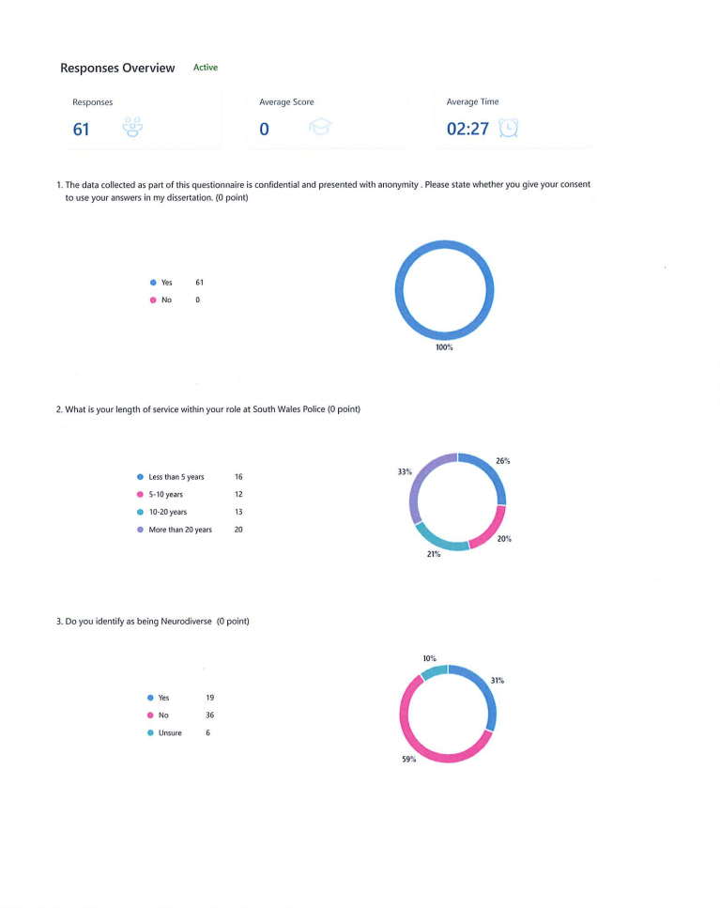
Appendix 4: Questionnaire Answers
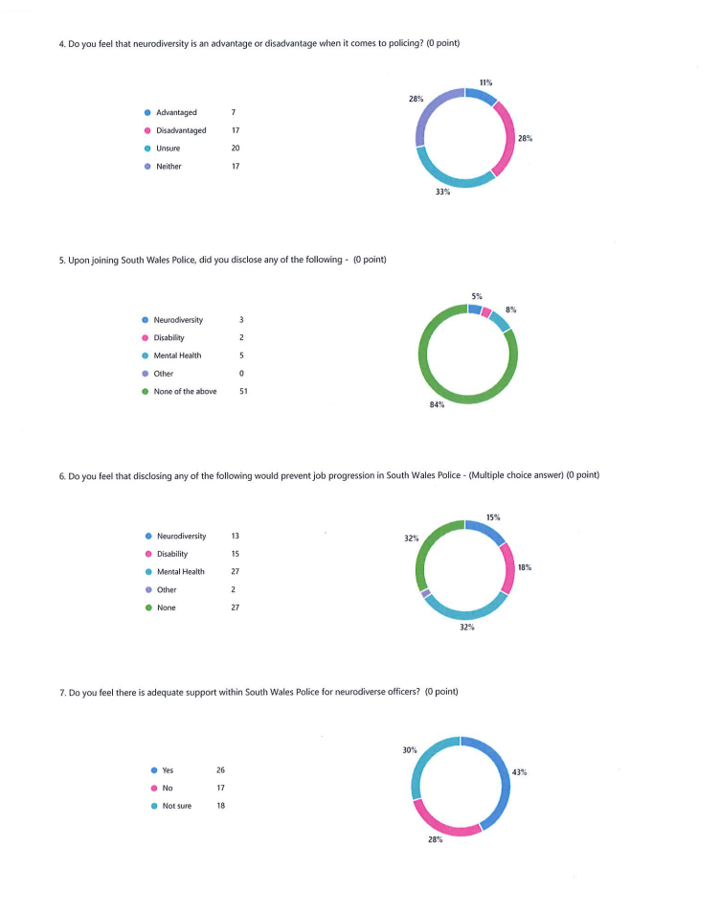
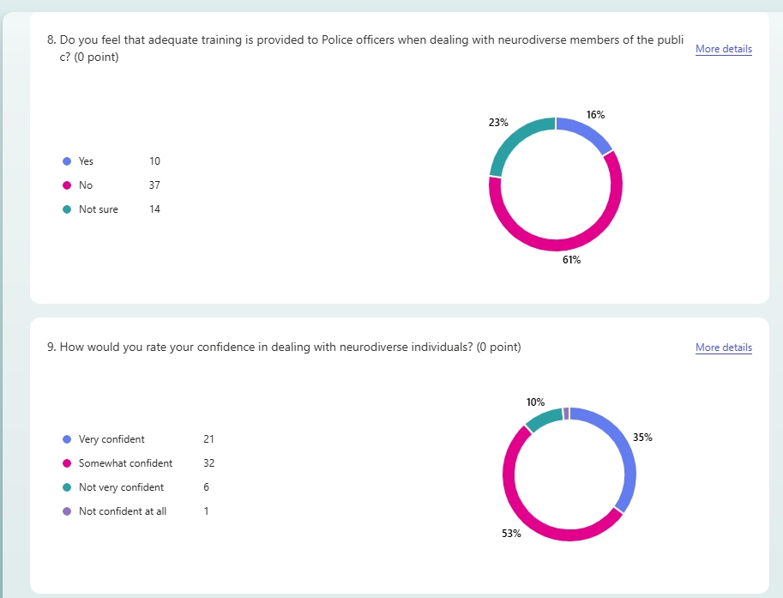
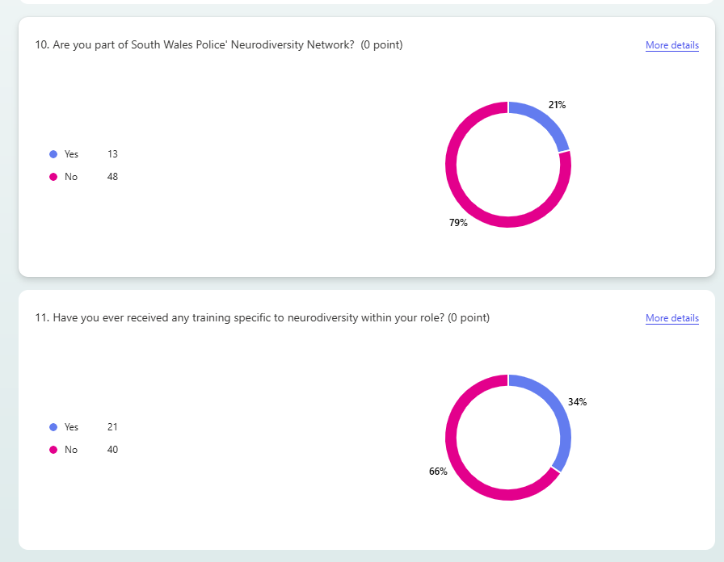
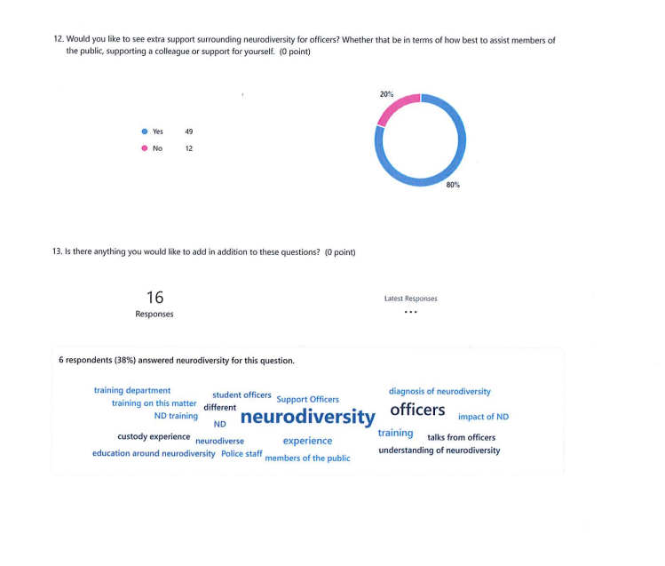

7.5 – Appendix 5 – Responses to Question 13

A person’s experience seems to be very dependent on their team/SGT.

I think that neurodiversity can be both a disadvantage and an advantage. It allows people to think different and see things different. It also allows officers to understand those people in public that are neurodiverse which can be a benefit.

Having a family member who is neurodiverse, I have an understanding already on the matter and the communication styles best suited to interacting with those showing signs. However, I feel strongly that training on this matter should form an element of policing, both for student officers and those already in the organisation. Inputs and talks from officers who have experience/diagnosis of neurodiversity, such as C.Supt Attwell is a very very good first step in achieving this.

More education around neurodiversity required within the Police

Regarding question 4 - Neurodiversity is both an Advantage and a Disadvantage

No

No

Further consideration should be given to providing an appropriate custody experience for neurodiverse detainees in our custody units.

Who do you mean by officers? It’s not just "officers" that deal with members of the public. e.g.] PCSOs, Sector Support Officers, Detectives, Front desk staff & Control Room operators. Some of these roles are Police staff. I’m sure all would benefit from additional ND training rather than just focusing on 'Officers'??

No

No

Training is required for the whole of the training department in how to approach officers with neurodiversity and how the impact of ND is different for all individuals. Training should be provided as to how to best communicate with someone with ND as struggles with understanding unclear information and directions can be extremely difficult for someone with ND

More understanding of neurodiversity and what officers could do in certain scenarios to deal with episodes.

No

No

