
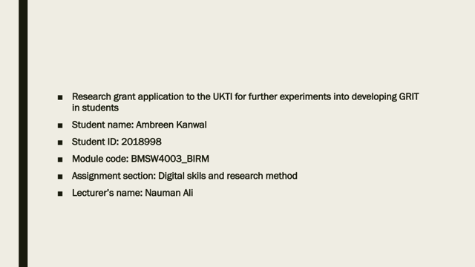

Introduction: My name is Ambreen Kanwal and I am enrolled as student at university of Wales Trinity St. David.
What is grit? Angela Duckworth a 27 year old assessed about factors that causes students to be successful. She observed her students and saw there was a pattern in students who were more successful. She came up with the term “grit” present in those students. Grit is demonstration of remaining on your goals and pushing through every hurdle there is. Grit is being eagerness to through every consequences to achieve progressed stage. These observations in her students were authentic as she researched more about it later on. Grit is assessed by Angela’s grit scale which prompts that people with more grittiness are more likely to be successful.

https://angeladuckworth.com/grit-scale/

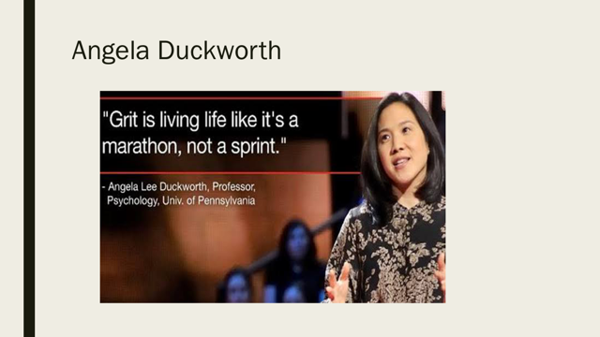

Angela Duckworth is a 52 years old who is CEO and inventor of character lab. It is a non profit institution which works on research on children to make them more triumphant. At the age of 27 years, many students were explored by her in terms of research to measure success in them. Being a teacher, her interactions with students were more and she had the exposure and freedom to observe and make assumptions. After all the calculations and research, she invented grit. Grit became a significant tool that can measure perseverance and progress in anyone not just academic students.
At TED, She conveyed a lecture about grit which became one of the most viewed lectures. In that lecture, she delivered and told people about being gritty and how it helps you get successful and achieve your goals. She explained sense of competency and thrive arises by grit. Duckworth then wrote many books on grit and one of the book that was released in 2016 named “The power of passion and perseverance” got good amount of significance and fame among students and professors.
The scale which measures grit consists of ten questions. Each question needs to be answered honestly as it comprises of a scale from 0-5. The number 5 on scale represents very much likely and 0 represents not likely at all. Each question’s requirement should be met accordingly with honest opinion about yourself. In the end, after solving each questions, you get the result about how gritty you are. Angela Duckworth completed degree in psychology and neurobiology in university of Pennsylvania. She was expert at studying human brain and their grittiness. If we apply CRAAP test on her TED video

Currency: It refers to timeliness of the information provided in the video. It explains if the information being provided was up to date. Its publication date. The Angela’s video passes currency as it met all requirements.

Relevance: Relevance in CRAAP framework is how much information is important. Angela’s Duckworth provided significant information at appropriate level.

Authority: Authority refers to the source of information, if its authentic or not. Information needs proper referencing and sourcing. Duckworth’s video meet all credentials of being accurate and authentic.

Accuracy: Accuracy of the CRAAP explains that information is reliable and truthful. Angele’s video follows accuracy and information being said is accurate, researched and reviewed.

Purpose: Purpose explains the reason behind existence of the information. It is very necessary that information being existed is purposeful. Angel’s information had a great purpose of increasing grit in students

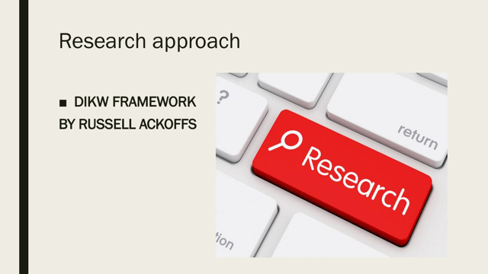

A research is described as studying a topic and carefully evaluating it, analysing it with problem-solving skills, critical thinking and decision-making approach. Research explains, decides, and does prediction of the content. Research can be inductive and deductive. Research can be done through different methods whether its surveys, interviews, surfing etc. In this report, I have used DIKW framework presented by Russell Ackoff who was an American theorist. Every section of this framework will be applied on the research of grittiness in my classmates.

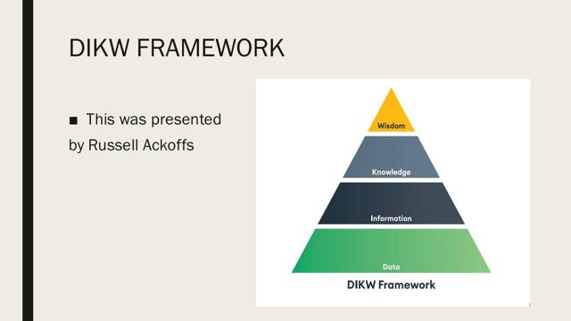

Now we will use DIKW framework in our research to measure grittiness in students.
DIKW is the hierarchy in the form of pyramid. It consists of four elements and represents the relationship between them such as data, information, knowledge, wisdom. This framework was introduced by American theorist, Russell Ackoff in 1989. Each element of his framework explains the hierarchal relationship and progression of data to information and then into knowledge and wisdom. Ackoff’s work passes the CRAAP test showing that data is accurate, reliable and relevant

Data: It is the first step of the procedure. It is present in raw form and consist of simplest content. To make it more relevant, It needs to go through series of changes and progression.

Information: This is second element of the pyramid. This is cleaned version of the data that was presented initially. In this the purpose is built and analysed according to the data

Knowledge: Knowledge is when you start asking question as “how”. Its very important to find the the application of information you have analysed in the previous step. Knowledge allows connection between primary and secondary data that makes thing more clearer.

Wisdom: It is at the last stage of DIKW framework, it is the knowledge that we acquired and too apply it in action. It is actually use of knowledge for future and making a purposeful approach towards knowledge.

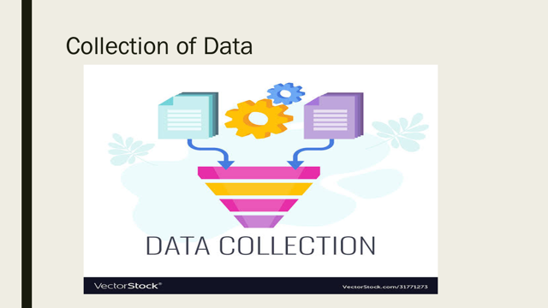

Data is in the form of raw material that needs to be translated, analysed for processing. The collected content in the data is at initial stage of its processing, means its concise and needs analysation and study. During this research, collection of data was done through means of microsoft forms survey. The questionnaire I added in forms consisted of 10 questions which was actually questions of Angela’s Duckworth scale of measuring grit. My class fellows then solved the survey. The responses i got from the survey was analysed and evaluated by me. I compared each response and each grit score of the students with highest academic level of grit presented in UK comparison chart of grittiness.
The result was formulated consisting of two things, final grit score students after comparison with UK chart.
In next part of presentation, copy of microsoft form is shown. The video link to Angela’s Duckworth video is:


This is the data that was collected through microsoft forms. According to GDPR principles followed all over Europe. Data collected in any form does not need to be breached and consent should be taken if data is being shown to other people. The protection of the data is must.

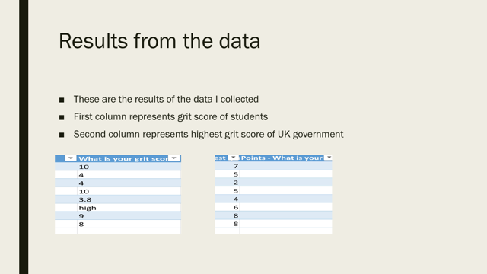
My conducted result is shown above. This was achieved by analysing the data and transferring it into information by obtaining a graph.
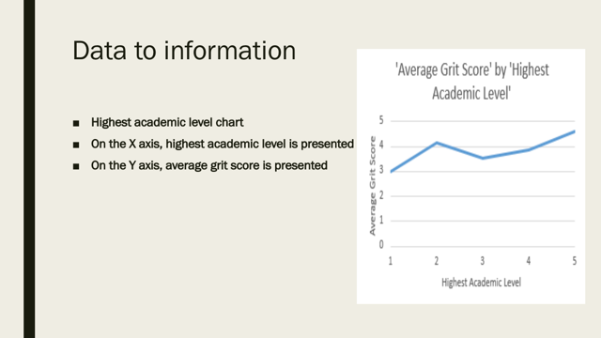

This graph was formulated through the data i collected. During collection of data, I got eight responses from my class fellows after completion of the survey. As data is in raw form and needs analysing and processing, I made sure my data was completely free of errors while converting it into information. According to the DIKW framework by Ackoff, the same thing has been established about the data that it needs cleaning so error full information is prevented. Data is always at initial stage and consists of raw facts.
Next stage of the Ackoff’s framework is obtaining information from the data. So if its cleaned competently, raw facts and figures will presented easier to understand.
Now Ackoff’s next step of the framework requires you to convert it into knowledge. The graph that was formulated to see the progression of my data which needed to be compared with UK academic chart. I presented both entries using Microsoft Excel and formed a spreadsheet. The results of the formulated graph showed a high curve referring to grittiness in students. This curve proved the hypothesis presented by Angela Duckworth; Students having high score of grit are more competent than students with low score. The grittiness is directly proportional with high academic level.
Rusell Ackoff explained in his third step, when research is obtaining knowledge from the the information. Two types of information is evaluated together that is primary and secondary information.
My collection of data is said to be “primary” and the secondary information i have chosen to analyse with the primary is university’s 2021 results.

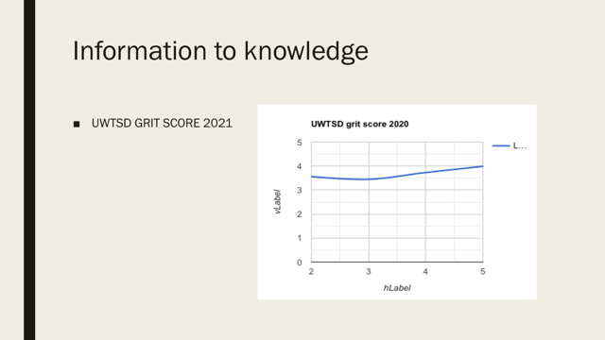
The primary data of UWTSD collected by me by conducting a survey with my classmates will be compared with secondary dats of my choice for the research. The obtained results after comparison is that curve of the graph is getting higher. Both graphs i formulated during this research showed same series of behaviour. That points to Angela Duckworth’s direct relationship between grittiness and highest academic level as well. The curve of my graph elevating from bottom to higher stage relates to Angela’s theory.
As my data collection was small, i still got the same results. If this is done with more participants, behaviour of the result will be similar even UWTSD 2021 sample was at much bigger level than mine. The sample used by Angela Duckworth was of large quantity consisting of 3000 responders. Big datas contains more errors but due to dishonesty of few people. Even due to this consequences, the same pattern was seen. Angela’s research is still continued as she asked people, how can we produce more grittiness
In the next part, I will share conversation of this knowledge to wisdom
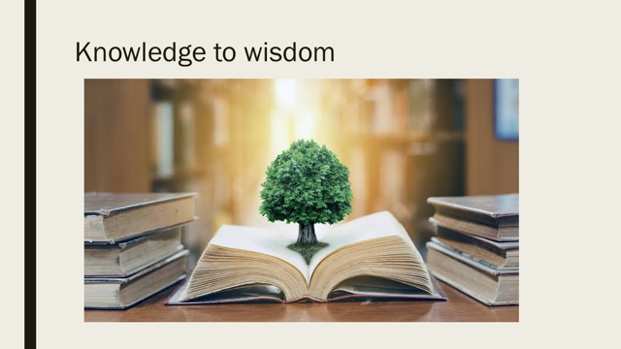

This is last progression of the initiation dats that we converted into information. We look primary and secondary information to transfer into knowledge. Now the last stage requires changing of knowledge into wisdom. Our knowledge converts into wisdom when we associate our judgement and perspective with the said knowledge. The wisdom part is obtain when use our knowledge and spend it in good way and for purposeful venture. Knowledge never finishes and if you get wise with it, it proves to be useful. The TED talk video of Angela Duckworth has millions of views and it proves her observation about this trait thats making people show perseverance is grit. The major question arise by people when they see the video is how to be develop grittiness in ourselves in order to get successful.
According to my perspective, having a mindset that is designed to thrive and grow. Generally people think successful people have more IQ and highest grades but its the mindset that helps you complete marathon of life. You need to keep putting efforts to thrive for better. A mindset which never deviates its focus from the success and being more gritty helps the success process.


