

UNIVERSITY OF WALES: TRINITY SAINT DAVID PRIFYSGOL CYMRU:
Y DRINDOD DEWI SANT

London Campus/ Weekend Study

BA Leadership and Management skills for the Workplace

Coaching and Mentoring Skills in the Workplace/BMSW 6105

Lecturer name: Nishi Ramsurrun

Student ID: 2121081

Executive Summary
This report highlights my placement experience at Company FREA, a leader in the fashion and home décor industry renowned for its innovation, sustainability, and customer-centric approach. Based in Bulgaria, with operations in Plovdiv and Sofia, FREA excels in providing trendsetting fashion and functional home décor, coupled with visually engaging in-store displays to deliver a seamless shopping experience.
During my placement in the Sales Consultant and In-Store Display Department, I gained hands-on experience in customer engagement, merchandising, and sales. This opportunity aligned with my career interests in sales and marketing, allowing me to contribute to FREA’s mission of delivering exceptional service while advancing my professional skills.
A key focus of this report is the workplace challenge I faced regarding my manager’s resistance to staff suggestions for in-store display changes. By leveraging the ERA Model (Experience, Reflection, Action), I systematically addressed the issue through coaching and mentoring sessions. The coaching sessions provided actionable strategies to navigate immediate challenges, such as employing assertive communication and data-supported proposals. Mentoring offered broader insights into fostering effective collaboration and understanding the manager’s perspective.
Through this dual approach, I developed key professional skills, including active listening, empathy, and adaptability. Reflecting on the experience revealed the importance of aligning solutions with organizational goals and building mutual trust to achieve positive outcomes.
Additionally, the report incorporates the GROW Model as a structured framework to guide goal setting and action planning, enhancing the coaching and mentoring process. Key skills such as feedback delivery, problem-solving, and fostering motivation were emphasized, aligning personal growth with FREA’s standards of excellence.
Ultimately, this placement experience at Company FREA has been pivotal in equipping me with the tools to address workplace challenges constructively. It underscored the value of adaptability, patience, and proactive communication in driving innovation and collaboration. These lessons will serve as a foundation for future professional endeavours in dynamic and customer-focused environments.

Table of Contents
Executive Summary 2
Company FREA Overview 3
My Link to Company FREA 3
Coaching and Mentoring Advantages 3
The Top 10 Coaching and Mentoring skills 5
The GROW Model 7
Benefits of the GROW Model 9
Coaching and Mentoring session 9
Reflection 10
Action 10
Final Reflection Using ERA 11
Conclusion 12
Reference: 13

Company FREA Overview
Company FREA is a dynamic and innovative leader in the fashion and home décor industry, known for its commitment to quality, sustainability, customer-centric approach, innovation. With a strong presence in Bulgaria, Plovdiv, and Sofia the capital cities in the country, FREA specializes in trendsetting fashion and services, and functional home decor. The company prides itself on creating a seamless shopping experience for its customers by combining exceptional service with visually captivating in-store displays that reflect the latest trends and customer preferences.
During my placement, I worked in the Sales Consultant and In-Store Display Department at Company FREA, a well-established brand in the fashion industry. This department plays a dual role in ensuring exceptional customer experiences through personalized sales consultations and creating visually appealing in-store displays to enhance product visibility and drive sales. My role within the department allowed me to gain hands-on experience in customer engagement, merchandising, and contributing to the company's overarching goal of providing a seamless and inspiring shopping experience.

My Link to Company FREA
I joined Company FREA during my placement as part of my professional development in my career interest, in sales and marketing. The opportunity to work in the Sales Consultant and In-Store Display Department allowed me to contribute to specific aspects of the job, like, enhancing customer engagement, optimizing product presentation, and driving sales. while gaining valuable insights into the company's innovative approach to company focus retail excellence, and customer satisfaction. This experience provided a unique opportunity to align my personal and professional growth with FREA's mission to deliver, exceptional service.

Coaching and Mentoring Advantages
Coaching
Coaching is a structured, short-term process focused on improving specific skills, performance, or achieving defined goals. It typically involves a coach who provides guidance, feedback, and strategies to help the individual (coachee) develop in a particular area.(Vistage International UK,2024).

Advantages of Coaching:
- Targeted Skill Development:
  - Focuses on specific areas for improvement, such as leadership, communication, or technical skills.
- Enhanced Performance:
  - Helps individuals achieve measurable results by setting clear objectives and tracking progress.
- Increased Self-Awareness:
  - Encourages individuals to reflect on their strengths and areas for growth, fostering personal and professional development.
- Boosted Confidence:
  - Regular feedback and support help build self-esteem and readiness to tackle challenges.
- Flexible and Adaptable:
  - Can be tailored to the coachee’s unique needs, whether for career development or overcoming workplace challenges. (Vistage International UK,2024).
Mentoring
Mentoring is a long-term relationship in which a more experienced individual (mentor) provides guidance, advice, and support to a less experienced individual (mentee) to help them navigate their personal or professional growth. (PushFar,2024).

Advantages of Mentoring:
- Knowledge and Experience Sharing:
  - Mentees benefit from the mentor’s insights, lessons learned, and expertise.
- Career Development:
  - Mentors help mentees identify career paths, set goals, and build networks for long-term success.
- Support and Encouragement:
  - Provides a safe space for discussing challenges and receiving encouragement.
- Improved Decision-Making:
  - Mentees gain valuable advice that helps them make informed choices in their careers or personal growth.
- Mutual Learning:
  - Both mentor and mentee can learn from each other, enhancing their skills and perspectives. (PushFar,2024).

Focus: Coaching is skill-oriented and short-term, while mentoring is relationship-based and long-term.
Approach: Coaching is more structured and performance-driven; mentoring is more holistic, focusing on overall development.
By combining the benefits of coaching and mentoring, organizations and individuals can create a well-rounded approach to personal and professional. (PushFar,2024).

The Top 10 Coaching and Mentoring skills
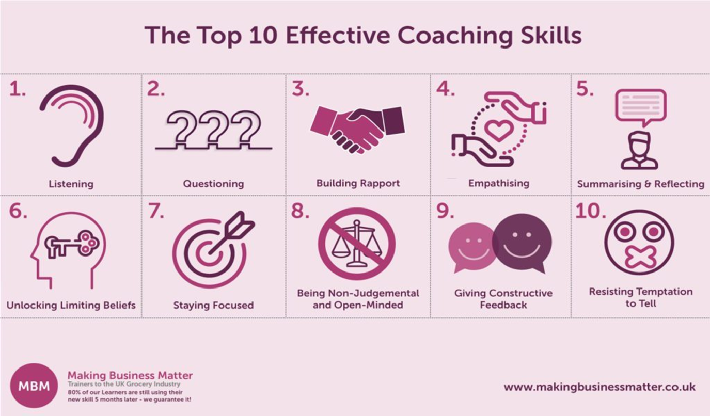
Figure 1 Coaching Skills Ultimate Guide with a Focus on Coaching Techniques: (Darren, A. Smith,2024).

1. Active Listening
Active listening involves fully focusing on the speaker, understanding their message, and responding thoughtfully without interrupting. It includes paying attention to verbal and non-verbal cues such as tone and body language.
This skill is fundamental for building trust, fostering open communication, and ensuring that the coachee or mentee feels heard and valued. (Starr, Julie, 2021).

2. Empathy
Empathy is the ability to understand and share the feelings of another person. Coaches and mentors use empathy to connect with their coachees or mentees on a deeper level.
Empathy creates a supportive environment where individuals feel comfortable discussing challenges and exploring solutions. (Goleman, Daniel, 1995).

3. Questioning
Effective questioning involves asking open-ended and thought-provoking questions that help individuals reflect, identify solutions, and make informed decisions.
Encourages self-discovery, critical thinking, and active problem-solving. (Whitmore, John, 2017).

4. Patience
Patience allows the mentor or coach to give the individual time to process information, learn, and grow without rushing them.
Fosters a positive and stress-free environment, helping individuals develop at their own pace. (Starr, Julie,2014).

5. Feedback (Constructive and Positive)
Feedback involves giving clear, actionable suggestions and highlighting strengths. Constructive feedback focuses on areas for improvement, while positive feedback reinforces good practices.
Promotes continuous improvement, boosts confidence, and aligns actions with goals. (Downey, Myles, (2003).

6. Goal Setting
Coaches and mentors help individuals set SMART goals (Specific, Measurable, Achievable, Relevant, and Time-bound) to provide a clear sense of direction.
Provides a framework for measuring progress and celebrating milestones, ensuring motivation and focus. (Locke, Edwin A., & Latham, Gary P. n.d.).

7. Adaptability
Being adaptable means adjusting your coaching or mentoring approach to suit the individual’s needs, personality, and learning style.
Ensures relevance and effectiveness in guiding diverse individuals with unique challenges and goals. (Clutterbuck, David, 2014).

8. Building Trust
Trust is established by maintaining confidentiality, being reliable, and showing genuine interest in the individual’s success.
A strong foundation of trust encourages open dialogue, vulnerability, and deeper engagement. (Covey, Stephen M.R.,2006).

9. Problem Solving
Coaches and mentors assist individuals in identifying challenges, analysing situations, and developing practical solutions.
Equips coachees or mentees with tools to tackle future challenges independently, fostering resilience and confidence. (Whitmore, John, 2017).

10. Encouragement and Motivation
Providing consistent encouragement helps individuals stay motivated and committed, especially during setbacks or challenges
Boosts morale, builds self-esteem, and keeps individuals focused on their long-term goals. (Williams, Patrick, & Menendez, Diane S.,2015).
Coaching and mentoring are about fostering personal and professional growth, and these skills ensure that individuals receive the guidance, support, and encouragement they need to thrive. Effective coaching and mentoring skills create an environment where the individual feels valued, understood, and empowered to make lasting changes, achieve goals, and reach their full potential. Together, these skills help to establish strong relationships that support growth, learning, and success. (Leadership, People skills,2024).

The GROW Model
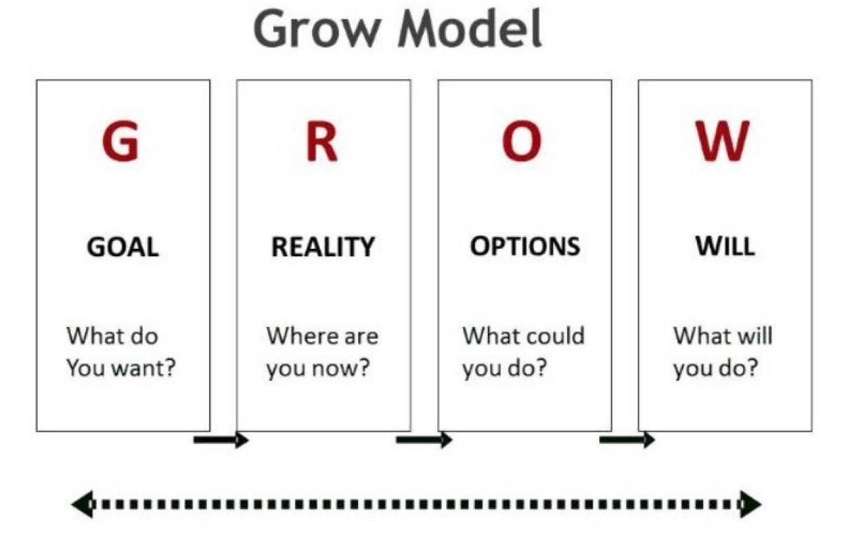
Figure 2 The Grow Model: (Imperial,2024).
The GROW Model is a structured framework used in coaching to guide individuals toward achieving their goals effectively. It consists of four key stages: Goal, Reality, Options, and Way Forward. This model provides a clear and actionable approach to coaching conversations, enabling individuals to identify objectives, evaluate their current situation, explore potential solutions, and commit to concrete actions. (Wilson, Cindy,2020)

1. Goal
The first stage focuses on defining the desired outcome. The goal must be clear, specific, and measurable, ensuring it provides a clear direction for the coaching process.
The Purpose is to Establish a well-defined goal allows the individual to understand what they want to achieve and sets the tone for the session. (Wilson, Cindy,2020)

2. Reality
This stage involves examining the individual’s current situation and identifying the gap between where they are now and where they want to be. It includes exploring challenges, barriers, and any progress made so far.
Understanding the reality provides a foundation for identifying actionable steps by highlighting areas that need improvement. . (Wilson, Cindy,2020)

3. Options
In this stage, the coach and the individual brainstorm potential strategies or solutions to address challenges and move closer to the goal. These options should be practical and relevant to the situation.
Exploring multiple options encourages creativity and critical thinking, allowing the individual to identify the best path forward. . (Wilson, Cindy,2020)

4. Way Forward
The final stage focuses on creating an actionable plan. This includes selecting the most suitable options, defining specific steps, and setting timelines. It also involves committing to accountability measures to ensure follow-through.
The Way Forward ensures the coaching session concludes with a clear, actionable outcome, providing the individual with a roadmap to achieve their goal. . (Wilson, Cindy,2020)

Benefits of the GROW Model
- Clarity: It simplifies complex goals into manageable steps.
- Focus: Ensures coaching sessions remain purpose-driven and productive.
- Empowerment: Encourages individuals to find their own solutions, fostering independence.
- Accountability: The Way Forward stage ensures follow-through and measurable outcomes.
The GROW Model is an effective coaching framework that supports personal and professional development by fostering structured and meaningful conversations. Its focus on actionable outcomes makes it a powerful tool for guiding individuals in achieving their objectives, addressing challenges, and building confidence in their abilities. (Parsloe, Eric, & Leedham, Monika,2016)

Coaching and Mentoring session
Reflection is a critical process that allows individuals to analyse their experiences, draw meaningful insights, and improve future actions. For this report, I will be using the ERA Model—Experience, Reflection, and Action—to structure my analysis of a workplace challenge and the subsequent coaching and mentoring sessions I participated in to address the issue.
The ERA Model is a practical framework for reflective practice:
- Experience involves describing the events or situations in detail, focusing on what occurred, who was involved, and the context.
- Reflection focuses on analysing the experience critically, identifying what went well, what could have been improved, and the emotions and assumptions involved.
- Action entails outlining the steps for future improvement based on the insights gained during reflection. (Robinson, J.2022).
By applying this model, I aim to systematically explore the workplace issue I faced with my manager, the strategies discussed in my coaching and mentoring sessions, and how I can use these insights to improve my professional practice moving forward.
Experience/Scenario
I was facing an issue at work because my manager wasn’t open to staff suggestions for changing in-store displays, even when those suggestions could potentially improve customer experience and sales. This led to frustration among the team and a lack of motivation.
  - First Coaching Session:
In the first session with my coach, I explained the problem and my feelings about the manager’s resistance. My coach helped me identify the underlying issues and encouraged me to explore how I could approach the situation constructively. We discussed strategies like using assertive communication and presenting ideas with evidence of their benefits.
  - Second Mentoring Session (Two Weeks Later):
In the mentoring session, I shared the outcomes of the strategies I had tried. My mentor provided feedback on how to refine my approach and shared their own experiences dealing with similar challenges in the workplace.
- Key Events:
  - During the coaching session, I realized I often avoided discussing my ideas directly with the manager because I feared conflict.
  - By the time of the mentoring session, I had tried presenting an idea using sales data to support its value, but the manager still dismissed it, which left me feeling demoralized.

Reflection

The coaching session helped me gain clarity about the problem and identify practical strategies to address it.
In the mentoring session, I received valuable insights and encouragement to persevere despite setbacks.
- What could have been improved?
  - In the first session, I felt I didn’t express my emotional frustration fully, which might have limited the coach’s understanding of how deeply the issue was affecting me.
  - In the mentoring session, I realized I hadn’t reflected enough on how I delivered my suggestions to the manager. My approach may have seemed too focused on the solution without considering her perspective.
- How did I feel?
  - During the coaching session, I felt hopeful and empowered to try new strategies.
  - After the mentoring session, I felt supported but also recognized the need to be more patient and adaptable in dealing with my manager.
- What assumptions influenced me?
  - I assumed that presenting data alone would convince my manager, without fully considering her reasons for resisting change (e.g., concerns about store branding or past failures with similar ideas).

Action
- What will I do differently?
  - Before approaching my manager again, I will seek to understand her concerns and priorities better by asking open-ended questions like, “What are your main goals for the in-store displays?”
  - I will adapt my communication style to emphasize collaboration and demonstrate how the team’s ideas align with her objectives.
  - I’ll also involve other team members in brainstorming to present a united and thoughtful proposal.
- How will I improve my skills?
  - I’ll work on active listening and empathy to build a better rapport with my manager.
  - I’ll practice framing suggestions in a way that addresses potential objections and highlights mutual benefits.

Final Reflection Using ERA
Reflecting through the ERA Model has helped me break down this challenging workplace issue systematically. The coaching session gave me tools to address the problem, while the mentoring session provided guidance on long-term relationship-building with my manager. By integrating their feedback and focusing on understanding my manager’s perspective, I feel better prepared to navigate this situation constructively.
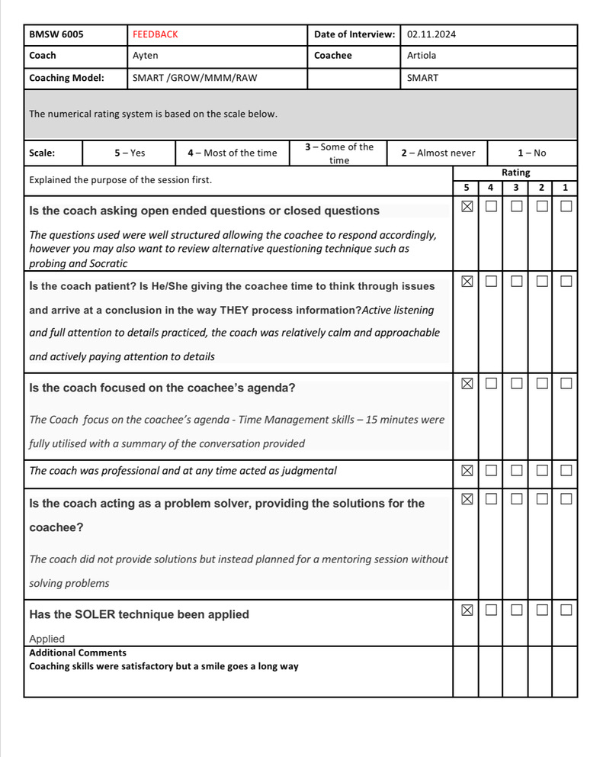

Conclusion
In summary, my experience at Company FREA during my placement provided invaluable insights into the dynamics of sales consultancy and in-store display management within a leading fashion and home décor organization. By applying the ERA Model to reflect on the workplace challenge with my manager, I gained a deeper understanding of how coaching, and mentoring can enhance professional development and problem-solving capabilities.
The coaching sessions enabled me to develop actionable strategies for addressing immediate workplace concerns, while the mentoring sessions provided broader guidance for building effective communication and fostering collaboration with my manager. This dual approach helped me identify key areas for personal growth, such as improving empathy, active listening, and framing solutions in alignment with others' perspectives.
Ultimately, the reflective process reinforced the importance of adaptability, patience, and proactive engagement in overcoming workplace challenges. The skills and lessons learned from this experience have not only contributed to my personal and professional development but have also aligned with FREA’s mission to deliver exceptional service and innovation. This reflection serves as a foundation for future endeavours, equipping me with the tools to navigate complex workplace dynamics and drive positive outcomes effectively.

Reference:

Clutterbuck, D., 2014. Everyone Needs a Mentor: Fostering Talent in Your Organisation. 5th ed. London: Chartered Institute of Personnel and Development.
Clutterbuck, D., 2014. Everyone Needs a Mentor. 5th ed. London: Chartered Institute of Personnel and Development.

Covey, S.M.R., 2006. The Speed of Trust: The One Thing That Changes Everything. New York: Free Press.
CrowJack, 2022. ERA Cycle: Self-Introspection and Improvement. [online] Available at: https://crowjack.com/blog/strategy/reflection-models/era-cycle [Accessed 2nd December 2024].
Dale Carnegie, 2024. 10 Skills Every Mentor Needs. [online] Available at: https://www.dalecarnegie.co.uk/10-skills-every-mentor-needs/ [Accessed 5 December 2024].

Downey, M., 2003. Effective Coaching: Lessons from the Coach's Coach. London: Texere Publishing.

Imperial College London, 2024. The GROW Model. [online] Available at: https://www.imperial.ac.uk/personal-tutors-guide/developing-students/coaching/the-grow-model/ [Accessed 4th December 2024].

International Coaching Federation, n.d. Home. [online] Available at: https://www.coachfederation.org [Accessed 5 December 2024].

Locke, E.A. and Latham, G.P., 1990. A Theory of Goal Setting and Task Performance. Englewood Cliffs, NJ: Prentice Hall.

Making Business Matter, 2024. Coaching Skills Ultimate Guide: Focus on Coaching Techniques. [online] Available at: https://www.makingbusinessmatter.co.uk/coaching-skills-ultimate-guide/ [Accessed 1st December 2024].

Parsloe, E. and Leedham, M., 2016. Coaching and Mentoring: Practical Techniques for Developing Learning and Performance. London: Kogan Page.
Starr, J., 2021. The Coaching Manual. 5th ed. London: Pearson.
Whitmore, J., 2017. Coaching for Performance: The Principles and Practice of Coaching and Leadership. 5th ed. London: Nicholas Brealey Publishing.
Whitmore, J., 2017. Coaching for Performance. 5th ed. London: Nicholas Brealey Publishing.

Williams, P. and Menendez, D.S., 2015. Becoming a Professional Life Coach: Lessons from the Institute of Life Coach Training. 2nd ed. New York: W.W. Norton & Company.

Wilson, C., 2020. Best Practices in Coaching and Mentoring. [online] Available at: <URL> [Accessed 5 December 2024].

