BMSW4001
Academic and Employability Skills
Janice Sewell
2009071

Contents

- Introduction ………………………………… 2

- Reflection Model …………………………... 3-4

- Time Management …………………………... 5

- Referencing ………………………………....... 6

- Analytical and Critical Thinking …………… 7

- Conclusion …………………………………..... 8

- References …………………………………….. 9

- Introduction

In my report I will be discussing my chosen model of reflection, I will also show my understanding within this reflective cycle throughout my report. I will apply the reflection model to my 3 chosen topics which I have covered during the academic term as well as reflecting on how useful these topics have been to me as a whole. I will be showing my understanding of what I knew before I started my studies on each topic and the knowledge that I have learnt throughout my studies to help me execute my academic and employability skills.

- Reflection Model

Gibbs reflective cycle

In 1988, Professor Graham Gibbs created the Gibbs reflection cycle which is used to help individuals reflect on their learning from their own personal experiences. Gibbs reflection model is one of the most famous cyclical models of reflection leading individuals through six stages exploring an experience: description, feelings, evaluation, analysis, conclusion and action plan, University of Edinburgh, (2020). Once an individual has been through an experience of their own, Gibb’s six-step model should help to identify their overall strengths, the areas that they will need to develop and possible actions they can take on board to improve their professional or academic skills.

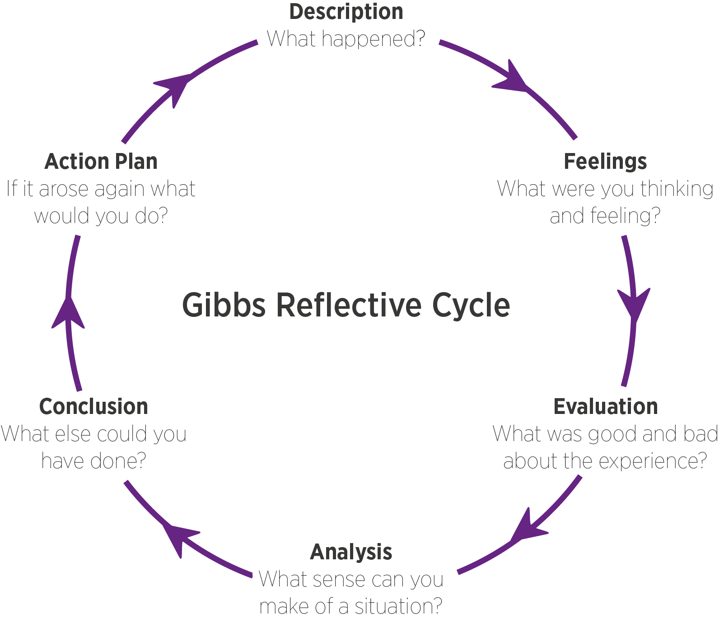

Step 1 in the Gibbs cycle is the description of my experience; A good way to establish my experience is to ask myself questions about what actually happened. The questions that I will ask myself can include,
- When and where did the event take place?
- What happened in the situation?
- What input did I have in this situation?
- Was there anyone else involved, if yes what did they do?
- What did the situation result to?

Step 2 in the Gibbs cycle involve my feelings; this includes thinking about all the thoughts i had or what I felt throughout my experience. Questions that can help to determine my thoughts and feelings in this stage include,
- How I was feeling before the event took place?
- What were my feelings during the time of the situation?
- Did my beliefs, values and emotions play a big impact on the situation at the time?
- What were my thoughts on how others felt during the situation?
- How did I feel after my experience?
- How do I feel about the experience now?

Step 3 in the Gibbs cycle is when I evaluate how the situation went by looking at the positive as well as the negative points. I would determine this by asking myself questions such as,
- What went well with my experience?
- What went bad with my experience?
- What were my thoughts on the situation afterwards?

Step 4 in the Gibbs cycle is the analysis stage, this is where I weigh up why the situation happened the way it did. I would carry out some research to understand behavioural patterns and the outcomes within certain situations to gain a better understanding. Questions I would ask myself would include,
- Why did things go well or why did they go bad?
- Could I have responded to the situation differently?
- Is there anything that I could have done to help better to improve things?

Step 5 in the Gibbs cycle is the conclusion stage, in this stage I would summarise my situation within my experience. I will identify all the changes that need to be made for future reference. The questions that I would ask myself to complete this stage would include,
- What I have discovered in this stage?
- What have I learnt in the situation that I was in?
- Is there anything the I could’ve done better?
- Is there anything that I could of or should have done differently?
- Are there any particular skills I would need to handle a situation like this better?

Step 6 in the Gibbs cycle is my action plan, this stage summarises everything that I need to know so that I can take the relevant actions needed for the next time; I would ask myself,
- How and where can I use my new knowledge and experience?
- How will I adapt my actions or improve my skills?
- If the same thing happened again, what would I do differently?

- Time Management

Before I started my academic studies, my understanding of what time management meant was, prioritising my tasks to achieve any goals that I had set myself. This could have included me delegating a task to someone else to get the task done or planning my day-to-day routine efficiently to get what I needed to get done in a timely manner. Although I had the concept of what time management was, my lectures helped me to have a better and more thorough understanding of what time management really is. An extensive and more accurate meaning of time management is, the process of organising and planning how to divide your time between specific activities, MindTools, (2019).

Within this time, I have learnt different skills which has helped me to manage my time, as well as building up my organisational skills. I have learnt the importance of keeping a weekly calendar to manage my day-to-day routine from Monday to Sunday with identifiable times, this included the days I carry out my tasks and the times they will be carried out and completed. Logged in the calendar were my general day to day tasks such as work, lecturers, study time, house chores, family time, other tasks or commitments may have included appointments or important events; the calendar was a very resourceful way which helped me to monitor what needed to be done and by when. The Einsenhower method has helped me to identify the importance of my activities, this helps me to prioritise each activity by relevance, these tasks will be grouped by important and non-important, urgent and non-urgent, this is a good way to identify what needs to be done first, as it is urgent and important, what needed to be rescheduled for another time, as it was not urgent but it was important, what needed to be delegated to someone else, as it was urgent but not important and what needed to be completely eliminated, as it was not important and not urgent.

Having these skills has helped me with my studies, my job role, as well as my day-to-day family life. It has enabled me to become more proactive and efficient; within my job role it has helped me to have a better professional reputation which has helped my employers to delegate more tasks to me as I have built a better trust and reliability of being able to get the job done, this has enabled me to be recognised for opportunities and more advanced career goals. Academically, I have been able to manage my lectures and studying, while managing my home life efficiently, these skills have enabled me to submit my assignments in a timely manner and not miss any deadlines so that I can still have a positive path to success, I have been able to do this by demonstrating the skills that I have learnt throughout this time. Having time management skills takes a weight off your shoulders as things become less hassle which reduces stress.

- Referencing

Referencing is when you carry out research from a specific source, upon your findings, you must acknowledge when you have used someone else's work. This avoids plagiarism by making it clear on which piece of work is yours and which piece of work is someone else's. Referencing plays a major part in my academic journey, it prevents me from plagiarising which can have serious consequences, it also helps with the structure of my work which keeps it of a high standard to university expectations.

in week 3 of my lectures, we began the topic of references, we discussed the topic as a class and then were given a video to watch about references. A task was set where I had to complete references pertaining to the type of source that it was drawn from and some brief information about the source. I could not remember the last time I had ever been in a situation where I needed to use referencing before as I had been out of education for a very long time. I felt a little embarrassed as after class I still did not quite understand it; my understanding was still a bit vague. Each source, for example website references and a journal references, just to name a few, had different types of formats, we also needed to do citation references, which is used to acknowledge the work or ideas of other. They are place next to the text that you have paraphrased or quoted, enabling the reader to differentiate between your writing and other peoples work, Victoria University, (2015) as well as full references. In the end I handed my task in half done rather than having a full go at all of the questions because of my lack of understanding. Upon speaking to my classmates, I had realised that I was not the only one that felt nervous about the task that had been set, this made me feel a little bit more at ease as I realised it was only homework to possibly get feedback on, it was being marked so that we could show our understanding as well as reflect on our mistakes and improve on them. This was to help us prepare for when our definite assignments came along. I feel that I made the nerves get the best of me when really what I should have done was ask for help as I needed it, or let my tutor know that I did not fully understand. In future if anything like this was to happen again in any type of situation, I will not let my feelings get the best of me and ask for the help that I need.

- Analytical and Critical Thinking Skills

Critical thinking refers to the mental process of cautiously gauging details to find out the best way to interpret it to come up with the right judgment. Analytical thinking refers to the mental process of breaking down comprehensive or complex ideas into basic or fundamental principles, Critical Thinking Secrets, (2019) Upon writing my assignment I would need to carry out research, I will break down the pieces of information I have gathered, I will analyse and evaluate the relevant information that I need to draw up a conclusion; this method will help me to structure my work.
In my job role as a healthcare assistant analytical and critical thinking will help me to analyse my staff and servicer user effectively to know what each individual is capable of doing and not doing. For example, when administering medication, I have two service users that usually refuse medication. Service user A is capable of making decisions on his own, service user B is not cable of making decisions on her own. After use my analytical and critical thinking it has helped me to come to the conclusion of how to administer medication to both service users accordingly, but in different ways.
With service user A, he needs to be interacted with by conversating with him about things he likes, such as the Newspapers and politics; this helps to encourage servicer user A and builds up rapport and trust with him which enable him to take his medication. Service user B likes to be sung to and likes to listen to music so that she can sing and dance. We prompt servicer user B and let her know that she will be getting medication now, how much and what the names of her medication are.

- Conclusion

The steps in the Gibbs cycle are aimed to be used as a lifelong process for individuals to use to reflect on the experiences that occur throughout our lives. This can occur during our work life, academic life or even our day-to-day home lives. The model is very easy to understand and use when reflecting on your own experiences, it is quick and efficient especially for individuals that are new to reflecting their experiences, it allows me to learn over time based on the experiences that I have been through and it gives me a more of a balance and better judgement of what I need to do in the future. There are some disadvantages with the Gibbs cycle, it may be difficult for some individuals to open up about their feelings and many people do find it very difficult to point out their weaknesses, so this may not be efficient for individuals who find this difficult to do. It may also work better if someone else is coaching you and guiding you through this type of reflective process, it may be considered to be quite biased as this model only has the input of the individual that is reflecting.

- References

Critical thinking secrets (2019) Critical Thinking Vs Analytical Thinking, Available at:
https://criticalthinkingsecrets.com/critical-thinking-vs-analytical-thinking/ (Accessed: 03rd January 2021)

Expert program management, (2019) Gibbs reflective cycle, Available at: https://expertprogrammanagement.com/2019/05/gibbs-reflective-cycle/ (Accessed: 03rd January 2021)

Koz, (2020), The ultimate list:58 time management techniques and our top 10 picks (with mind map), Available at: https://www.spica.com/blog/time-management-techniques (Accessed: 3rd January 2021)

MindTools, (2019), What is time management, Available at: https://www.mindtools.com/pages/article/newHTE_00.htm (Accessed:3rd January 2021)

University of Cumbria, (2020), Gibbs’ reflective cycle, Available at: https://my.cumbria.ac.uk/media/MyCumbria/Documents/ReflectiveCycleGibbs.pdf (Accessed:30th December 2020)

University of Edinburgh, (2011) Reflection and reflective writing, Available at: https://www.clinicaleducator.org/index.php/en-gb/resource/735?partner_site_tried=1 (Accessed:3rd January 2021)

University of Edinburgh, (2020) Gibbs’ reflective cycle, Available at: https://www.ed.ac.uk/reflection/reflectors-toolkit/reflecting-on-experience/gibbs-reflective-cycle (Accessed: 1st January 2021)

Victoria University, (2015), Harvard referencing: sample in text references, Available at: https://libraryguides.vu.edu.au/harvard/sample-in-text-references#:~:text=In%2Dtext%20references%20or%20citations,included%20in%20a%20reference%20list. (Accessed:30th December 2020)

