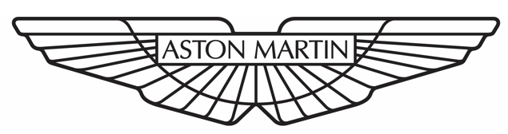


Manufacturing Systems Engineering

ACMA5010 – Stress Analysis and Dynamics

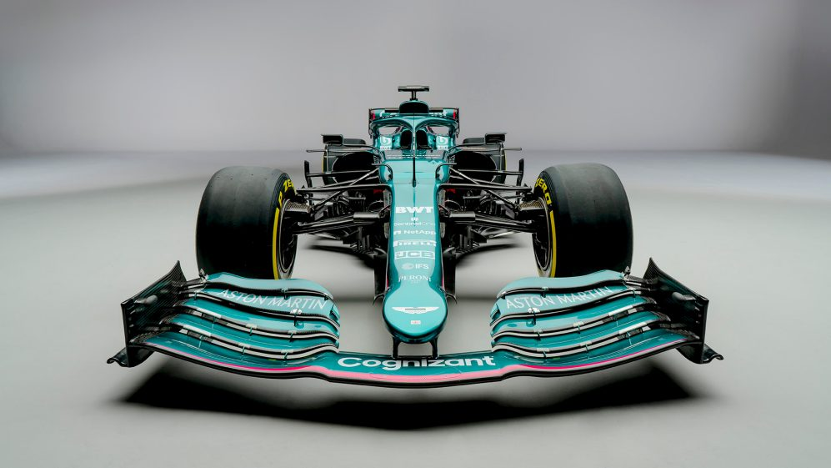

Name: Chris Beddoe
Date: 6th July 2022

Table of Contents
Introduction 2
History of front wings in motorsport 3
Manufacturing processes and materials 4
Wing dimensions and downforce 5
Beam loading calculations 6
Conclusion 10
Bibliography 11

Introduction

The following report aims to explore the principles and methodology of slope and deflection of beams theory. The theory, and its principles, are used identify minimum outside diameter of a support structure for the front wing of an automotive racing vehicle entering a new race series. The given specifications for the beam are that the
deflection at the end of the wing must be limited to 10mm and the material used is to be steel with a young’s modulus of 210GPa.
The history, development and types of front wing are discussed, and a glimpse into the past, present and future of front wings is explored. Innovation in the overall design, materials and manufacturing processes is discussed, and how these have driven the evolution of front wing design over time.
To analyse this theory, certain assumptions are made with regards to dimensions of, and conditions acting upon the front wing. These assumptions are explored and justified, with analysis and recommendations being made upon these assumptions.
Finally, various testing methods that could be used for a real-life prototype of the wing structure are scrutinised with an explanation of how results would be interpreted.

History of front wings in motorsport


The front wing made its first appearance in Formula One at the Monaco Grand Prix in1968 (Oggioni, 2019). It made its maiden appearance fitted to Graham Hill’s Lotus, and its continuous evolution and innovation has been seen in Formula One ever since. Front wings have evolved over time, starting from this basic single element (figure 1), to the multi-finned front wing designs we see in Formula One today.
Figure 1 - Graham Hills' 1968 Lotus (Oggioni 2019)
Considering the very first Formula One Grand Prix was completely devoid of any mechanisms for downforce, since its introduction, downforce-producing wings and other downforce creating bodywork features are now considered synonymous with almost all single-seater racing. Throughout its history, both the overall design of these wings has changed along with the materials and processes used to produce them. In the 1950s the bodywork of Formula One cars mainly consisted of Aluminium sheeting, with Steel tubular chassis frames (Autosport, 2020). Since then, material innovation has led to the introduction of alternative materials and alloys with lower density and a higher Youngs modulus of the Steel and Aluminium traditionally used. Materials such as Carbon fibre, Kevlar and Titanium are some of the materials that now fit this new age profile.
A better understanding of downforce, and the science surrounding it, has led to more innovative and complex downforce design structures. Today, a huge amount of resource is spent by racing teams exploring and optimising downforce. According to Marchesin et al (2018), downforce is regarded as such an important feature in formula one, that “mechanical systems designs are often compromised in order to improve aerodynamic performance”. This is because correct levels of downforce can highly improve braking, cornering and other characteristics such as acceleration performance of competition racing vehicles.

Manufacturing processes and materials

Just like the aerodynamic design of racing cars, the materials used and manufacturing processes available, have also been innovatively transformed. Lighter frames made from materials, such as simple Aluminium and Steel structures, are a thing of the past. With the introduction of additive manufacturing and new materials such as Carbon fibre reinforced plastics (CRFP), newer, lighter designs are available for all engineers, not only engineers within racing teams. Instead of simple Aluminium tubes or beams, additive manufacturing has paved the way for direct metal laser sintering (DMLS) and rapid manufacturing (RM). According to Hopkinson (2006), the design freedoms offered by Rapid Manufacturing are enormous, with processes capable of creating detailed and ultra-complex geometries. Hopkinson (2006) also states that “In the short life of layer additive manufacturing technologies the processes have outstripped the capabilities of CAD, in many cases the bottleneck in producing parts is their design, while making them is the easy part. Prior to the advent of these technologies, has mankind ever been in the situation where visualising and designing a product is actually harder than making it?”. An example of which would be how Formula One chassis are made today. All about aluminium (2015) points out that a modern Formula One chassis is a composite of an Aluminium honeycomb structure that is between six and 15mm thick, and sandwiched by Carbon skins on either side. This Aluminium honeycomb pattern and Carbon outer means that teams can ensure that the chassis is very stiff, tough, and as light as 50 kilograms. The all about aluminium (2015) article also states that, along with Aluminium and Carbon fibre, Formula One engineers rely on a multitude of other materials. Quoting former head of engine and electronics at Ferrari, Luca Marmorini, as stating that Ferarri “uses more than 100 different alloys. Typically, Aluminium, Titanium, Copper, Cobalt, Tungsten are used. There is a standard to ensure quality and reliability, [and] that is the aerospace standard, but a lot of materials are developed with some suppliers and Ferrari often develop their own standards. Typically, if you have to mention a standard, it is aerospace standard."

Additive manufacturing and RM can also benefit the design and development of racing vehicle aerodynamics. As mentioned above, highly details and ultra-complex designs can be laser sintered paving the way for highly detailed scaled down designs to also be produced. These scaled down parts, being highly accurate, can be used by development teams for testing, thus also scaling down the requirement of the test equipment, in turn, saving on costs. The downside of this is that investment in direct metal laser sintering equipment can be expensive. According to Gregoric (2019), a professional level DMLS machine can cost between $50,000 and $1,000,000. Converted to British pounds this means a cost of between £43,000 and £846,000 depending on the size of machine required. Gregoric (2019) also states that the metal powder itself can cost anywhere between $300 and $600 per kilogram. Again, converted to British Pounds meaning the metal powder can cost between £260 and £518 per kilogram. There are companies that offer DMLS services as an alternative to investing in equipment. This may suit some racing teams running with lower budgets.

Wing dimensions and downforce

As Formula One is the current gold standard of motorsport, the dimensions of the vehicle to enter the new race series will reference the current specified dimensions of a 2022 Formula One vehicle. FIA technical regulations (2022), present that “With the exception of the tyres and the wheel covers defined in Article 3.13.7, no part of the car may lie outboard of Y=1000mm”. Anderson (2022), translates this as “The front wing assembly, including the endplates, runs to the full width of the car, 1000mm each side of the centreline”. Figure 2, below, is an illustration of the 2022 Formula One wing dimensions also referenced by Anderson (2022).
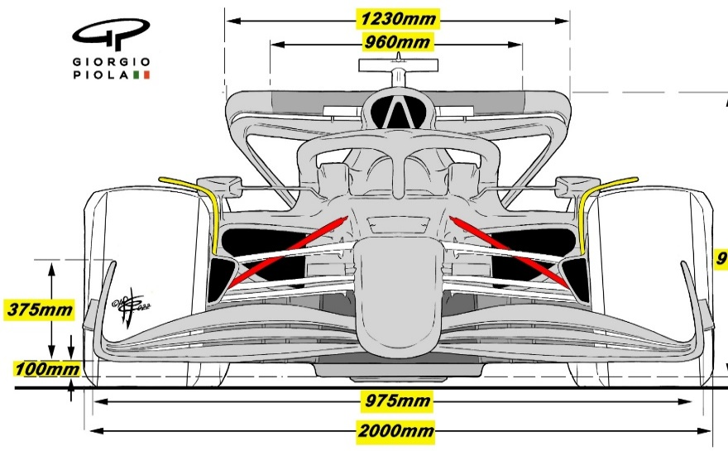

Figure 2 - Formula 1 2022 wing dimensions (Autosport, 2022)
The objective of this report is to specify the minimum dimensions of the tubular support of a single front wing. Therefore, based on the above information, it would be justified to make the first assumption that that the length of the tubular wing support structure will be one meter in length.
To resolve how much downforce the front wing structure with endure, FIA Technical Regulations (2022) state that the minimum weight permitted is 798kg. According to Howson (2021), a Formula One front wing can produce up to 5G in downforce, with the front wing alone contributing up to twenty five percent of this downforce This would translate to around 3990 kilograms maximum downforce produced by all the downforce creating structures on the vehicle. Howson (2021) also states that front wings can produce up to twenty five percent of this downforce, which leads to the second assumption. With the total front wing downforce creation being twenty five percent, one half of the wing would produce up to 12.5 percent of the 3990kgs total 5G of downforce. This leads to the second assumption, that the wing structure would need to support up to 498kgs. This is confirmed by McLaren Formula One team (2022) that state that their front wing weighs 10kgs, and can produce up to 100 times its own weight in downforce, resulting in total downforce of around 1000kgs.

Beam loading calculations

Before carrying out accurate beam loading calculations, the type of loading on the beam must be determined. To establish this, an understanding of the aerodynamic forces acting upon the beam need to be derived. The design of the wing will determine the way forces will act upon it in any given condition. These forces can vary, be very complex and non-uniformed. An example of which can be seen below in figure 3.
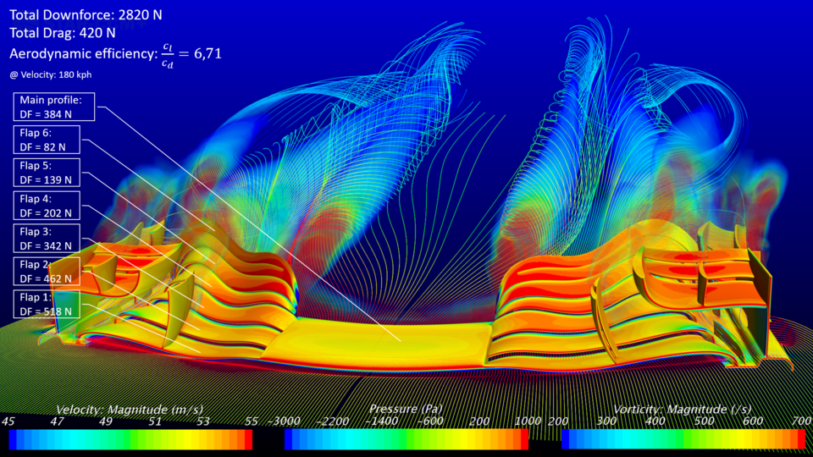
Figure 3 – CAD image of forces acting upon Formula One front wing (https://grabcad.com/library/formula-1-front-wing-2018-design-cfd-simulation-1)

There are also various other external factors, such as the flatness of the race track surface or ‘porpoising’ that has been seen in the Formula One 2022 season. With these factors in mind, beam loading calculations can be derived. In this scenario, the wing support structure is to be ‘fixed at one end in all six axes of movement’, meaning, a cantilever beam configuration. The two types of loading potentially acting on the given cantilever beam, could either be concentrated point load, or a uniformly distributed loading (UDL). As there is no design or prototype for the front wing, the final assumption required to carry out the beam loading calculations would be that the downforce is a uniformly distributed load across the cantilever beam fixed at one end. The equation for this is stated by Hearn (1997) and shown in figure 4 below.
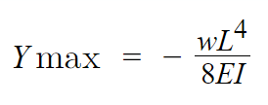
Figure 4 - Direct integration method for UDL cantilever beam
Given the design specifications state that that maximum deflection (Ymax) is to be 10mm and the Youngs modulus of (E) is 210GPA. The beam structure is to be tubular with a wall thickness of 2mm. A length has been assumed (L) as 1m, and the downforce (W) has been assumed at 498Kg. The only unknown in the equation is the second moment of area (I). The second moment of area is given in units of meters to power of 4 (m⁴). To derive the second moment of area the equation must be rearranged to: -
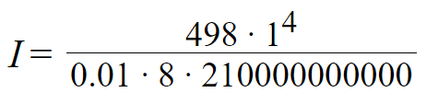
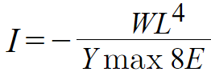
Figure 5 - Direct integration method transposed for I
Figure 6 - Values added to direct integration formula

or

The derived equation would result in an answer that, for a maximum deflection at end of the beam to be no more than 10mm, the minimum second moment of area of our beam must be: -
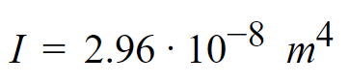
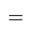
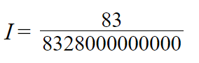
Figure 7 - Result as a fraction
Figure 8 – Minimum second moment of area result as a decimal

With the minimum second moment of area calculated, the second moment of area must now be resolved for the tubular structure of the beam with a 2mm wall thickness. The formula to calculate second moment of area is also noted by (Hearn, 1997) and is as follows: -
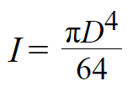
Figure 9 – Second moment of area equation for a cylinder
As the beam structure is deemed to be a hollow tube, with a wall thickness of 2mm, it would require calculations of both the outer diameter of the tube, minus the second moment of area of the inner diameter of the tube. An example is shown below for a tube with an outer diameter of 5mm (D) and an inner diameter (d) of 1mm: -
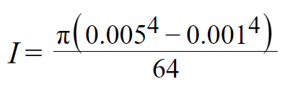
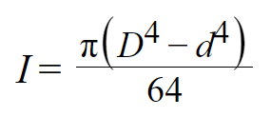
Figure 11 – Values added to equation
Figure 10 – Second moment of area equation adjusted for a tube structure

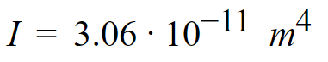
Figure 12 – Second moment of area for tube with outer diameter of 5mm

The result of which is far below the minimum second moment area required for a Ymax of 10mm. For ease, a spreadsheet was created, using the above formula, which highlights the minimum outside diameter (figure 8) required for a maximum deflection of 10mm.

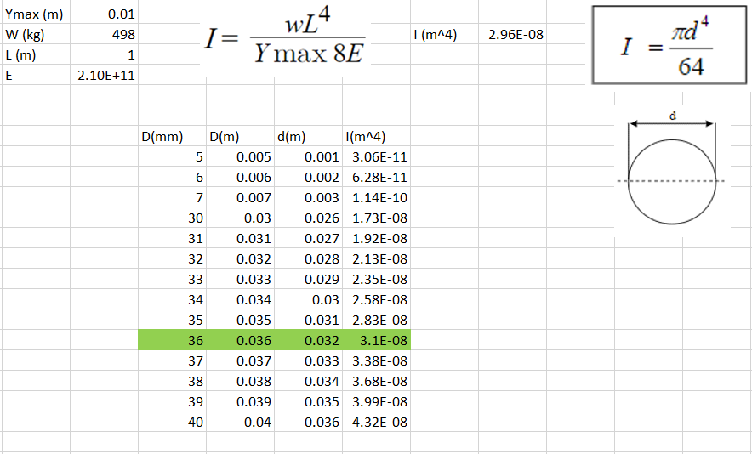
Figure 13 – Spreadsheet highlighting minimum spec tube with outer diameter that would conform to specification

With a minimum outside diameter of 36mm now specified, the next step would be to ascertain the options available to source the materials and ensure the vehicle conforms to specification with regards to wing deflection. The most accessible tube would be a standard size already stocked by a supplier. To establish the availability and cost, various stockists were consulted and off the shelf specifications, closest to the required outer diameter, were gathered and shown in figure14, below.

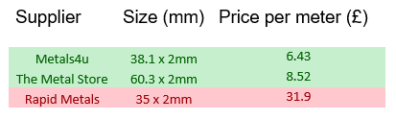
Figure 14 - Suppliers stock and prices checked

Figure 14 presents that 36mm x 2mm tube does not appear to be a standard size stocked by suppliers. Due to this, it would be recommended that the 38.1mm x 2mm tube supplied by Metals4u should be used if the project is low budget and if time is of the essence. Although Rapid Metals can supply a tube closer to the specified 36mm tube, the 35mm tube would be too flexible and therefore has been highlighted in red. If the budget for the team is much larger, and there are time constraints, then custom tube could be sourced and ordered. Custom tube would be much more expensive and take longer to source, but the advantage of the custom sourced tube would be that weight would be kept to a minimum. If budgets are tight then the standard, very cheap tube from Metals4u would suffice, but being larger than the specified minimum diameter required, extra weight would be added to the vehicle possibly resulting in a slower vehicle.

Conclusion

Although a minimum specification of tube was derived, there are limitations to these calculations. Firstly, to use the direct integration method, it had to be assumed that the downforce loading on the front wing was uniformed. This will almost certainly not be the case and will vary from wing to wing, depending on its design and set up. There are more accurate, but more expensive methods, that could be used. Techniques such as CAD modelling (figure 3, page 5), or the use of real life simulation equipment such as a wind tunnel. The alternatives are expensive, with the estimated Formula One wind tunnel costing teams between £50,000,000 and £80,000,000 to build. Alternatively, there are companies offering to hire out their wind tunnels and undertake the aerodynamic analysis for racing teams. Some of the services offered by Aero Performance Engineering, England, range from £100,000 for one-day hire, testing and results, to £38,000,000 for a year of hire, testing and analysis. As discussed above in ‘manufacturing processes and materials’, accurate scale models can now also be produced which may reduce the cost for teams on lower budgets. Finite Element Analysis (FEA) is another form of CAD modelling. An example of such software would be Solidworks. According to English (2019) “Finite Element Analysis or FEA is the simulation of a physical phenomenon using a numerical mathematic technique referred to as the Finite Element Method, or FEM. This process is at the core of mechanical engineering, as well as a variety of other disciplines. It also is one of the key principles used in the development of simulation software. Engineers can use FEM to reduce the number of physical prototypes and run virtual experiments to optimize their designs”. Using this information, it would be fair to suggest that FEA could be used when designing and analysing the deflection of a front wing. As stated by English (2019), FEA could also reduce the number of prototypes required for testing which in turn would save on time and costs. To use FEA there is an initial investment required for the software, and experienced engineer resource would also be required, again, adding to cost.
Lastly, one of the crudest forms of testing could something as simple as placing a 498kg UDL on different 1m tubes of 2mm thickness and simply measuring the deflection at the end until a tube is found with less than 10mm deflection. This method, although simple, could turn out to be quite impractical. It would not be easy to find a 498kg UDL to place on a piece of tubing, and lifting equipment would also need to be used.
Based on the above costing and practicality information, the direct integration method does give engineers some idea of the tube dimensions required to meet the specification stated, without incurring the very high costs derived. Due to this, and complexity of more accurate methods, it would be fair to state that the direct integration method used should be considered as a reasonable approach for deriving the tube dimensions required for the specification.

Bibliography

Oggioni, T. (2019) ‘Aerodynamics of Formula One Front Wing and its Evolution’ [Online], Available: https://www.linkedin.com/pulse/aerodynamics-formula-one-front-wing-its-evolution-thomas-oggioni/, Accessed 2022, July, 19th.

Autosport (2020) ‘F1’s 70th Anniversary: How have F1 cars changed since 1950’ [Online] Available: https://www.autosport.com/f1/news/f1s-70th-anniversary-how-have-f1-cars-changed-since-1950-4980423/4980423/. Accessed 2022, July, 20th.

Marchesin, F., Barbosa, R., Gadola, M. and Chindamo, D. (2018) ‘High downforce race car vertical dynamics: aerodynamic index’ [Peer reviewed article], Vehicle system dynamics, 2018, Vol.56 (8), p.1269-1288, Taylor and Francis Journals.

FIA Technical Regulations (2022), [Online, pdf], Available: https://www.fia.com/sites/default/files/2022_formula_1_technical_regulations_-_iss_3_-_2021-02-19.pdf, Accessed 2022, July, 20th.

Anderson, G (2022) ‘HOW F1 FRONT WINGS ARE CHANGING FOR 2022’ [Online], Available: https://the-race.com/formula-1/gary-anderson-how-f1-front-wings-are-changing-for-2022/#:~:text=The%20front%20wing%20must%20sit,down%20from%20five%20last%20year. Accessed 2022, July, 21st.

Autosport (2022) ‘The design trends to watch in the 2022 F1 car launches’ [Online], Available: https://www.autosport.com/f1/news/the-design-trends-to-watch-in-the-2022-f1-car-launches/7960589/. Accessed 2022, July, 21st.

Howson, G (2021), F1 Chronicle, ‘How Do Formula 1 Cars Generate Downforce?’, [Online], Available: https://f1chronicle.com/how-do-formula-1-cars-generate-downforce-f1-tech/#:~:text=Good%20grip%20on%20the%20racing%20track%20is%20equally%20important%20as,much%20as%205G%20down%20force. Accessed 2022, July, 22nd.

Hearn, E. J., (1997). Mechanics of Materials Volume 1 : An Introduction to the Mechanics of Elastic and Plastic Deformation of Solids and Structural Materials. s.l.:Butterworth-Heinemann.
Hopkinson, N. (2006). Rapid manufacturing an industrial revolution for the digital age. s.l.:Wiley-Blackwell.

All About Aluminium. Aluminium at the Heart of Formula One. Available at:
https://www.aluminiumleader.com. Accessed 2022, August, 31st.

Greguric, L. (2019). How much does a metal 3D printer cost?. Available at: https://all3dp.com/2/how-much-does-a-metal-3d-printer-cost/. Accessed 2022, September 2nd.

English, T. (2019). What Is Finite Element Analysis and How Does It Work?. Available at: https://interestingengineering.com/science/what-is-finite-element-analysis-and-how-does-it-work/. Accessed 2022, September, 2nd.

