LISTENING SKILLS FOR PROJECT MANAGERS: TARGETED COACH TRAINING TO ENHANCE LISTENING SKILLS FOR BETTER PROJECT OUTCOMES.

By

Laura Kingdon

Work Based Learning Project BMPF7010

MA Coaching and Mentoring

The Wales Academy for
Professional Practice and Applied Research

University of Wales Trinity St Davids

CONTENTS

Project Proposal 4
Introduction 10
Methods 13
Research Paradigm 13
Ontology and Epistemology 13
Mixed methods 13
Methodology 15
Participants 15
Survey 15
Interviews 16
Analysis 17
Ethical Considerations 18
Insider Research 18
Data Protection 18
Ethics 19
Literature Review 20
Findings 27
Surveys 28
Participant Demographics 28
Self-assessed listening skills 31
Impact of gender on listening behaviour 34
Listening Tools 35
Accepting feedback 36
Interviews 39
Question 1: How would you define good listening? 39
Question 2: How do you recognise poor listening in yourself? 40
Question 3: What prevents good listening? 41
Question 4: How do you ensure you listen effectively? 43
Themes in the Findings 47
Theme 1: Listening definition 48
Theme 2: Listener Tools 48
Theme 3: Listener Attributes 51
Conclusion 55
Learning Outcomes 55
Reflection on the research 57
Future recommendations 58
References 59
Appendix A: Ethical Approval Form 64
Appendix B: Manager Approval 80
Appendix C: Survey Questions 81
Appendix D: Interview Responses 82
Appendix E: Presentation Slides 85

Project Proposal

Research Title: Listening skills for project managers: targeted coach training to enhance listening skills for better project outcomes.

CONTEXT

Project management involves the organisation, delegation and oversight of tasks to achieve specific objectives. While project managers receive formal training to acquire technical skills for planning, controlling, and measuring project delivery (Axelos, 2017), they are also expected to demonstrate soft skills such as problem-solving, communication, and conflict management (Bost, 2018). Listening, as identified by the researcher, stands out as a critical soft skill for project managers, affecting various aspects of a project, including understanding the project scope, reflecting on situations, ensuring clear goal comprehension, managing conflicts, and building relationships with stakeholders.

Badurussaman & Khoiry (2021) discovered that project managers often prioritise technical skills due to their tangible and measurable nature, while Thompson & Cox (2017) underscored the importance of coaching for project managers as a remedy for the lack of development opportunities. Coaching fosters informal learning and guided reflection, supporting project managers in their career growth. Chelagat et al. (2019) also emphasise coaching as a means to enhance team performance through reflection and dialogue, both of which necessitate strong listening skills. Moreover, coaching tools can effectively be integrated throughout the project lifecycle to foster collaboration and boost project team performance (Thompson & Cox, 2017).

Organisation
The researcher operates a business that provides contracting services as a project manager, change consultant, and coach. They initially undertook project management training in 2000 and began practicing as a project manager in 2006. Subsequently, the researcher delved into coach training in 2012, incorporating this skill set into their line management and project management responsibilities. In 2018, they formalised their coaching skillset by offering private coaching services.

Situation
Presently, the researcher has several contract arrangements in place, including the delivery of project management services to the health sector in Wales. Within this organisation, there is a team of project managers who could potentially serve as research participants. Additionally, the researcher is an active member of the Association for Project Managers (APM), the Project Management Institute (PMI) and various communities of practice, providing access to a broad network of project managers who also represent potential research participants.

JUSTIFICATION

BBC News (2020) reported on numerous high-profile projects that experienced significant overspending, potentially negating the anticipated benefits of their implementation. While these issues cannot be attributed to a single cause, the APM (2021) identified interpersonal skills as a significant influence on project outcomes, with listening ranking among the top three.

The Project Management Body of Knowledge (PMI) has been criticised for its excessive focus on technical skills at the expense of vital soft skills (Gillard, 2017). Buvik and Rolfsen (2015) established correlations between trust, collaboration, and project success. As a project manager, the researcher acknowledges that listening enables them to proactively build high levels of trust with team members, thereby increasing team engagement and commitment to their project-related responsibilities. Developing listening skills, according to the researcher, can establish a culture of collaboration within the project team and enhance the likelihood of project success.

Despite the existing research on interpersonal skills in project management, there is a noticeable gap in specific research on the importance of listening skills in project management.

In summary, there are three compelling reasons for undertaking this research project:
- Listening skills are essential for project managers.
- Project management training typically lacks a focus on listening skill development.
- Targeted coaching can effectively enhance listening skills.

INTENDED IMPACT

What is the intended impact of this project?
Conducting this research project will enable the researcher to:
- Develop a training program aimed at improving project managers' listening skills through a coaching approach.
- Provide support for a business case advocating for coach training for project managers within their workplace.

What could be the broader implications of this project within the context?
The broader implications of this project may encompass:
- Publication of the research findings in project management or coaching journals to underscore the importance of developing listening skills in project management and the methods to achieve this through coach training.
- Elevated recognition of listening skills within the project management community, potentially resulting in modifications to certification programs to include coach training for enhancing listening skills.
- Stimulating further research on the development of interpersonal skills in project managers through coach training.

OUTLINED INTENTION

Intention Summary
The research aims to:
- Explore the experiences and perceptions of project managers in leading project teams and their prioritisation of technical versus soft skills.
- Critically evaluate how project managers perceive their listening skills and the steps they have taken to enhance them.
- Understand how project managers perceive the value and effectiveness of coaching and coach training in improving their listening skills.
- Identify and analyse different coaching approaches that enhance listening skills.

The researcher adopts an interpretivist epistemological stance, preferring qualitative research methods that allow in-depth exploration of the subjective experiences, perspectives, and interpretations of project managers. However, they also recognise the value of quantitative data for gathering objective and generalisable results. As a result, the researcher will employ a predominantly subjective ontological approach through a question-driven mixed-methods research design, incorporating semi-structured interviews, a survey of the project management population, and the use of categorised data.

The research process will follow a two-part sequential explanatory mixed-methods design. Commencing with an online survey to collect quantitative data, a sampling strategy will be used to obtain input from various sources, maximising participant diversity. Subsequently, following the analysis of the quantitative data, the second phase will involve interviews. These interviews will be transcribed, and the data categorised using a thematic analysis approach.

PROPOSED METHODS

Participants
The study's participants will be project managers. Participants will be invited to take part in the survey and interview using a cluster sampling approach, leveraging several project management communities, including the Association of Project Managers, Project Management Institute, and a group of project managers within the researcher’s workplace. These participants encompass individuals within the researcher's network and project managers employed in the researcher’s organisation.

Analysis
Survey: The outcomes of the survey's outcome measure questions for each scale value will be computed as percentages. These statistics will be used for initial descriptive analysis and to inform the interview design.

Interviews: Responses to open-ended questions will initially be analysed, using constant comparative method, leading to the coding of data to identify categories and themes, also referred to as thematic analysis (Thomas, 2023).

A triangulation approach will be adopted to analyse the data, potentially allowing the researcher to draw inferential conclusions (O’leary, 2017). The data will also facilitate the evaluation of existing project management training and the development of listening skills.

Expected Timeline

2023/24 | Sept | Oct | Nov | Dec | Jan | Feb | Mar | Apr
Ethics
Form

Literature
Review
Project
Proposal
Introduction
Research
Design
Conduct  Research |  | Survey |  | Interviews
Analysis of Findings
Conclusion

Submission
Presentation
Figure 1 Research project timeline

ETHICS AND INSIDER RESEARCH

As an insider researcher in project management, the researcher possesses a unique and first hand perspective in the field. This insider position offers valuable insights and enhances the credibility of the research findings (Berkovic, 2020). The researcher is part of various networks of project managers, providing access to data and participants. They also have direct access to project-related information, stakeholders, and project teams due to their role as a project manager.

Nevertheless, the researcher acknowledges the potential challenges and ethical considerations associated with insider research (O’leary, 2017). Maintaining objectivity and avoiding bias during data collection and analysis is of paramount importance. Transparent disclosure of their roles as a researcher, project manager, and coach is critical to uphold research integrity.

Moreover, the management of potential conflicts of interest is essential. As the owner of a business offering project management and coaching services, the researcher may have vested interests in the research findings. Addressing these potential biases is crucial to preserve research credibility and validity.

In summary, conducting insider research in project management as a project manager and coach presents unique opportunities and challenges. It allows for a deep understanding of the field and the potential to provide valuable insights (Bridges, 2017). However, this role demands careful consideration of ethical issues, potential biases, and the management of relationships and conflicts of interest.

EXPECTED LEARNING OUTCOMES

The researcher seeks to achieve the following learning outcomes:
- Evaluate existing project management training approaches for their incorporation of targeted listening skills development;
- Determine whether project managers recognise the importance of listening skills and actively seek to develop their listening skills;
- Measure the listening proficiency of project managers and pinpoint specific areas for improvement;
- Ascertain whether there is a demand for coaching tools training to enhance listening skills among project managers.

Introduction

Project management is a complex and multi-faceted professional field that requires a combination of technical and interpersonal skills. Technical skills refer to the knowledge and expertise in specific project management tools, techniques, and methodologies, while interpersonal skills encompass communication abilities and emotionally intelligent behaviour. While both types of skills are important for project success, literature suggests that project management training tends to focus on technical skills (Badurussaman and Khoiry, 2021).


Figure 2 Examples of project management accreditation bodies

In contrast, coach training is a field that places equal importance on technical and interpersonal skills, with listening being arguably the most critical skill for a coach to possess (Jones and Wallace, 2005). Coaching is a discipline that supports individuals or groups to undertake reflective inquiry to access internal resources that, when applied, can resolve the presented problem.

Despite the extensive research on interpersonal skills in organisational management, the researcher has identified a noticeable gap in both research related to the importance of listening skills in project management and the use of coach training to develop listening skills in project managers. The researcher wishes to address this gap by focusing their research activity in this area.

The planned research will involve:

- A literature review to understand:
  - Why listening is an important skill for project managers;
  - Whether current project management training approaches meet the need for listening skills development;
  - Which coaching tools enhance listening skills.
- A mixed methods research, sequential explanatory approach. This will comprise of:
  - A survey of project managers to capture quantitative data relating to project manager demographics, experience and a self-assessment of listening skill capability;
  - Semi-structured interviews designed to capture the experiences of project managers and how they perceive listening as a valued professional skill.

Data will be stored and analysed to identify qualitative themes and quantitative evidence that might provide an indication as to whether enhancing listening skills in project managers would provide a tangible benefit to organisations, as a result of improved project outcomes.

Outcomes from the research could potentially raise awareness, in organisations, that project managers need to consider the improvement of interpersonal skills alongside training in technical project management methodologies. This may suggest that further research is required to investigate the measurable impact of enhanced interpersonal skills in project management professionals.

The researcher runs a private business offering coaching and project management services to the health and social care sector in Wales. They also work as a programme manager leading groups of project managers to digital transformation projects in the Welsh health service. The researcher is a member of international, national and local project manager networks and works closely with other project managers within the workplace. They also run a project management community of practice for project managers. As a result, the researcher has access to potential research participants.

As an insider researcher, the researcher recognises their privileged position in relation to having access to project managers to participate in the research. They are also aware that their perspective may be biased, particularly as they are both a practicing project manager and coach, meaning their objectivity may be compromised. The researcher endeavours to maintain impartiality throughout the research project, through transparency with participants and an awareness of potential biases that can be used for reflection, throughout the lifetime of the project.

The researcher seeks to achieve the following learning outcomes:
- Identify the project lifecycle stages where listening is most crucial;
- Evaluate existing project management training approaches for their incorporation of targeted listening skills development;
- Measure the listening proficiency of project managers and pinpoint specific areas for improvement;
- Ascertain whether there is a need for coaching tools training to enhance listening skills among project managers.

Methods

Research Paradigm

Ontology and Epistemology

The researcher adopts an interpretivist epistemological stance, preferring qualitative research methods that allow in-depth exploration of the subjective experiences, perspectives, and interpretations of project managers. The term interpretive research is often used synonymously with qualitative research, but the two concepts are different. Interpretive research is a research paradigm or set of common beliefs and agreements shared between scientists about how problems should be understood and addressed (Kuhn, 1970).
Interpretivists believe that reality happens through an individual’s experience of the social constructions in the world around them (ontology), including language, consciousness, instruments and shared meanings (Myers, 2008). As the researcher does not believe that everything can be measured this has led them to a requirement for an alternative ontology. Taking an interpretivist approach will enable the researcher to critically analyse and evaluate two research aims:
- Explore the experiences and perceptions of project managers in leading project teams and their prioritisation of listening skills;
- Understand how project managers perceive the value and effectiveness of coaching and coach training in improving their listening skills.

The researcher aims to explore how individual project managers interpret the same objective reality “listening to others in a project environment” in different ways, and therefore present with different actions (Rhemenyi et al., 2003). This contrasts with a post positivist approach (Thomas, 2023), which generally considers the reflections and personal stories of participants to be unacceptable as research because they are neither scientific nor objective.
The researcher does not approach their research with any hypotheses (Christensen, L.B., 2011) because their interpretivist epistemological approach means that they see social reality as inextricably linked with an individual’s social settings.

Mixed methods

The researcher recognises the value of quantitative data for gathering objective and generalisable results. Babones, S. (2016, p1) describes how an interpretivist epistemological stance could be applied to both qualitative and quantitative research, through, “integration of measurement and modelling into a more holistic process of discovery”. As a result, the researcher will employ a predominantly subjective ontological approach through a question-driven mixed-methods research design, incorporating semi-structured interviews, a survey of the project management population, and the use of categorised data. The researcher will be able to identify project managers with similar characteristics, such as age, gender or project management approach and explore how their listening behaviour aligns or differs from others. This will enable the researcher to achieve their third research aim, “Critically evaluate how project managers perceive their listening skills and the steps they have taken to enhance them”.

The researcher plans to initially explore the data inductively, utilising a grounded theory approach (Corbin and Strauss, 1997) and therefore has no predetermined themes or theory in mind. To generate grounded theory, the research process will follow a two-part sequential explanatory mixed-methods design. This will commence with an online survey to collect quantitative data. A sampling strategy will be used to obtain input from various sources, including the researcher’s workplace network, social media and professional bodies, thus maximising participant diversity.

Following the analysis of the quantitative data, the second phase will involve the collection of qualitative data. There are a range of techniques interpretivists use to collate qualitative data (Myers, 2008). The researcher adopts the most frequently used of these, interviews. The interviews will be conducted virtually, using video conferencing technology. The researcher has chosen not to use face-to-face interviews, focus groups or observation. This was primarily due to limitations in time and the practicalities of meeting with geographically dispersed research participants.

The questions to be used in interviews will derive from identified themes emerging from the quantitative data. These interviews will be transcribed, and the data categorised to validate the quantitative data and provide depth to the research.

Methodology

Participants

The study's participants will be project managers. Participants will be invited to take part in the survey using a cluster sampling approach, leveraging several project management communities, including the Association of Project Managers, the researcher’s LinkedIn network, and a group of project managers within the researcher’s workplace. These participants encompass individuals within the researcher's network and project managers employed in the researcher’s organisation.
The researcher aims to attract participants from a variety of sources to increase levels of population diversity. However, this approach has its limitations due to the researcher being an insider researcher. The researcher joined a project management professional body (Association of Project Management) because it is aligned to their own professional, project management approach. Similarly, the workplace and social media networks from which survey participants will be sampled have been chosen, by the researcher, due to their own subjective experiences, perspectives, and interpretations of being a project manager. This means that there may be unintended bias before data collection or analysis has begun. It is, therefore, imperative that the researcher is transparent throughout the research activity to ensure confidence in the research findings. The actions taken to maintain objectivity, transparency and the management of conflicts of interest are explored in detail in section 3, Ethics and Insider Research.

Survey

The survey will consist of 16 questions (appendix C); predominantly quantitative questions, with some questions of a qualitative nature, which will enable the participant to expand their answers further.

The survey will be created using Google Forms. The introductory page of the form will begin with an introduction to the researcher, the reasons behind the research, contact information for the researcher, a declaration of interest and information relating to how data supplied by the participants would be managed.

The survey will consist of three types of questions:
- Demographic information about the participant, including age range and gender.
- Project management experience, workplace environment and level of responsibility.
- An evaluation of listening ability, developed by adapting an existing data-gathering instrument.

Following the survey, the researcher will express gratitude to the participants and remind them of their right to withdraw. They will provide contact information for further inquiries and a link to a contact form for participants willing to partake in interviews. This contact form will not be linked to the anonymous survey.

The survey is estimated to take about 15 minutes to complete. The survey will be piloted with the researcher’s close colleagues and refined using feedback before implementation to ensure accuracy, quality and accessibility for participants.

Interviews

Interviews will be conducted, by the researcher, with project managers. The interviews aim to capture qualitative data from five participants regarding project management training, project managers' views on continuous professional development, and their coaching experiences. The choice of interview participants will depend on the survey findings. Selection criteria will be based on the submission of the contact form, following the participants completion of the survey, providing the participants contact information and a request to be included in the interview stage of the research. The researcher will not be able to connect participant contact information to the completed surveys. The researcher is aiming to interview a minimum of five participants. Should that number not be achieved through the contact form, the researcher will publish a request on social media (LinkedIn).

Before the interviews begin, the researcher will send an introductory email detailing the purpose of the research and the researcher’s declaration of interest and potential biases.

During the interview, the researcher will take an informal approach by opening the interview by thanking the participant and engaging them in “small talk” to help build rapport and put the participant at ease. The participants will be reminded of their right to withdraw and thanked for their participation. The reasons for the research and the researcher’s interest in the research will be re-iterated. The researcher will ask participants if they would like to receive information on the research outcomes, in which case their email addresses will be retained for six months after the research concludes.

Interviews will be conducted via Microsoft Teams, lasting an estimated 20 minutes. The length of the interview may differ in length depending on the participant’s answers and the direction the interview takes. The researcher is taking a semi-structured approach to interviews, meaning the questions may shift to follow the natural flow of the participant’s dialogue. The researcher may divert from the plan should an interesting tangent arise that is related to the area of research.
The researcher will record and transcribe the interviews and securely store the information online for further analysis.

Analysis

The outcomes of the survey questions (quantitative data) will be computed as percentages. These statistics will be used for initial descriptive analysis. Demographic variables, including gender, age, or professional experience will be used to further interrogate quantitative data, using tools including pivot tables and graphs. Using Microsoft Excel will enable a triangulation approach to be adopted to analyse the quantitative data, potentially allowing the researcher to draw inferential conclusions (O’leary, 2021). Findings from the survey will be used to inform the interview design.
Responses to open-ended questions (qualitative data) will initially be analysed, using constant comparative method, leading to the coding of data to identify categories and themes, also referred to as thematic analysis (Naeem et al., 2023). An open-coding approach will be used to code the data. Following the initial cycle of analysis, these themes may highlight the need for further inquiry with interview participants. The researcher considered using a QDA (Qualitative Data Analysis) software application but has chosen a manual approach due to their inexperience in the field and a desire to experience the induction reasoning approach first hand. This approach, often referred to as grounded theory (Corbin and Strauss, 2015), will involve iterations of data collection and constant comparative analysis.

Ethical Considerations

Insider Research

As an insider researcher in project management, the researcher possesses a unique and firsthand perspective in the field. This insider position offers valuable insights and enhances the credibility of the research findings (Asselin, 2003). The researcher is part of various networks of project managers, providing access to data and participants. They also have direct access to project-related information, stakeholders, and project teams due to their role as a project manager.

The researcher acknowledges the potential challenges and ethical considerations associated with insider research. The researcher understands that maintaining objectivity and avoiding bias during data collection and analysis is of paramount importance. Transparent disclosure of their roles as a researcher, project manager, and coach is critical to uphold research integrity. As the owner of a business offering project management and coaching services, the researcher may have vested interests in the research findings. Addressing these potential biases is crucial to preserve research credibility and validity.

The researcher will therefore include a statement within the survey introduction and at the start of all interviews disclosing their roles and interest in the research.

Data Protection

All participant contact information and related documentation will be securely stored in a cloud-based electronic filing system called Microsoft OneDrive accessible only to the researcher. Quantitative data will remain in the cloud and will be interrogated using Microsoft Excel, a cloud-based software application.

The researcher will not make handwritten notes during the interviews but will rely on making notes in Microsoft OneNote. The transcripts generated from interviews and video recordings will also be stored in the cloud. The scripts will not contain identifiable information and participants will be labelled using a code (P1, P2, etc). The scripts will be printed to enable manual analysis, using highlighter pens and sticky notes to identify themes, codes and insights within the qualitative data.

Printed documentation will be stored securely in the researcher’s office. All data (electronic and physical) will be destroyed upon completion of the research.

Ethics

The researcher endeavours to avoid assuming to fully understand the experiences of their participants (other project managers), recognising that individual experiences, personalities, and situations lead to unique perspectives, as per the researcher’s interpretivist epistemological approach. For the qualitative data collection, the researcher will ask open questions and refrain from offering opinion. This will help maintain impartiality throughout the interview process, ensuring that questions remain unbiased and do not guide participants toward specific conclusions.

Literature Review

Listening is a cognitive process that involves actively attending to, hearing, understanding, and remembering auditory stimuli (Thomas and Levine, 1994). This engagement in the listening process extends beyond hearing to encompass comprehension and retention of information, incorporating both verbal and non-verbal cues (Vandergrift, 2004). Research indicates that listening can also incorporate visual cues, particularly in audiovisual settings, underscoring its multi-faceted nature (Aryadoust and Luo, 2022). Listening is not an act of passively receiving information but an active mental operation aimed at resolving comprehension challenges (Aryadoust and Luo, 2022). Moreover, listening is a critical skill with significant implications for interpersonal communication, decision-making, and learning processes (Gilakjani and Ahmadi, 2011). Effective listening entails not only processing auditory input but also actively engaging with the speaker, interpreting verbal and non-verbal signals, and responding appropriately (Watson and Barker, 1984). In essence, listening is an active cognitive process that involves attending to, understanding, and retaining auditory stimuli, encompassing verbal and non-verbal cues. This skill is indispensable for successful communication, learning, and decision-making.

The importance of listening as a crucial soft skill for project managers has been extensively discussed in the literature. Jahromi et al. (2016) emphasises the significance of listening in enabling project managers to understand the needs and concerns of team members and stakeholders, thereby facilitating informed decision-making and appropriate actions. This aligns with the findings of Roebuck et al. (2016), who state that managers who prioritise listening are perceived to be more effective in their communication, contributing to their overall managerial success. Effective listening not only builds trust and creates a positive work environment but also fosters better collaboration among project team members and stakeholders.

Moradi et al. (2020) highlight the importance of effective listening skills for project managers involved in collaborative delivery methods, particularly in construction projects. The authors emphasise that by listening to various stakeholders, project managers can better meet their needs and perspectives, ultimately increasing the likelihood of project success. This underscores the critical role of listening in facilitating successful project outcomes.

The relationship between listening skills and managerial effectiveness in decision-making is further supported by the research of Alexander et al. (1992). Their findings demonstrate that effective listening enables project managers to accurately understand and interpret information, leading to informed task prioritisation and effective communication of those decisions to team members and stakeholders.

Additionally, Zulkiffli and Latiffi (2019) emphasize the vital role of project managers in possessing effective leadership skills, with effective listening being a key aspect of leadership. By understanding the goals, concerns, and expectations of stakeholders through effective listening, project managers can align their actions to lead the project towards its defined goals.

The literature consistently underscores the essential role of listening as a skill for project managers. Effective listening fosters collaboration, supports well-informed decision-making, enables the understanding of diverse perspectives, and facilitates the alignment of project actions with the criteria for project success.

In the workplace it has been found that employees who report a high-quality listening experience enjoy benefits including increased levels of job satisfaction, generally positive organisational culture, trust and loyalty to the organisation (Flynn, Valikoski and Grau, 2008).

The Project Management Institute (PMI) defines a project as a sequence of tasks that when completed attain a specific outcome. Projects range in size with short timeframes, low risk and little cost to project spanning several years, having complex and far-reaching impacts and requiring substantial financial investment (PMI, 2021). A project manager is responsible for guiding a project from initiation to completion, with project managers demonstrating and developing skills through natural ability, reflective experiential learning and formal training.

Accreditation to demonstrate attainment of project management standards can be achieved through a range of learning establishments, with project managers able to achieve chartered status if desired, through the Association of Project Management (APM).

Project management training often focuses on technical aspects, leaving the "soft" or interpersonal skills in the background (Gillard, 2017). Gillard’s research emphasises the need to address the "how to" elements of communication, including listening, rather than the current focus on the tools and techniques commonly used to manage a project. To understand the full extent to which project management training focuses on technical project management skills rather than the interpersonal skills required to be an effective project manager the researcher chose to review the three most popular project management methodologies, PRINCE2, Agile and PMBoK (Pabian, 2021) to assess each the methodologies approach to address the “how to” elements of listening.

The PRINCE2 handbook (Axelos, 2017) refers to communication as a required competency of a project manager but the verb “listen” is not used throughout the entire handbook. The chapter on engagement and communications focusses on the requirement of a project manager to effectively transmit a message rather than actively receive one. However, the manual does recommend that the project manager endeavours to “establish feedback channels” and “capture lessons” (p.152). The PRINCE2 handbook (Axelos, 2017) was the most technical of the three project management methodology guides. It included the least information about the importance of interpersonal skills in a project manager and no mention was made to the importance of listening.

The Project Management Book of Knowledge (PMBoK) (Project Management Institute, 2021) states that the 12 Principles of Project Management include two principles that require the project manager to be a competent listener; “Create a collaborative team environment” and “Effectively engage with stakeholders”. These competencies both require effective listening skills (Roebuck et al., 2016). There was more emphasis on developing relationships as a project manager in the PMBoK Guide than there was in the PRINCE2 manual.

The AgilePM Handbook contained the most material relating to the importance of competencies related to our requiring effective listening skills. Principle 7 of the handbook states that, “poor communication is often cited as the biggest single cause of project failure” (page 73). Emphasis is made on the engagement of stakeholders through facilitated workshops, however, in this project management approach relationships with stakeholders would be the domain of other team members and not necessarily the project manager.

In summary, the literature relating to the three most popular project management methodologies offer little guidance on the “how to” of effective communication, and there was no guidance on the “how to” of listening. The literature reviewed, supports Gillard’s (2017) research finding that project management professional development focuses on technical rather than interpersonal skills.

The researcher identified that this gap partly exists due to the assumption from project management accreditation and training organisations that the development of interpersonal skills will be addressed through new project managers being exposed to positive role models, experience of relationship management and additional workplace training. However, the opportunities for junior members of staff to spend time with more experienced project managers has reduced as a result of the increase in remote working over the last twenty years. This shift was rapidly accelerated in 2020 following restrictions put in place to manage the spread of the Covid-19 virus meaning that team members interacted exclusively through a virtual medium. Van Zoomen et al (2021) found that employees were required to adapt quickly to this independent working approach, so junior employees had to learn how to act with more autonomy and more seasoned professionals had to learn how to manage and build relationships in a whole new way with little organisational guidance.

Although coaching is not a regulated profession, the consensus is that coach training is essential to develop a well-rounded skill set. In fact, to work within the established and emerging fields of coaching of sports coaching (Wagner, 2023) and coaching psychology (Moin et al, 2023) attainment of specific learning and subsequent accreditation, is required for most roles. The Chartered Institute for Professional Development (CIPD) said that coaching is one competent technical experts develop better interpersonal skills (CIPD, 2023).

There is no single, specific coaching protocol. Coach training comprises of a range of theories with corresponding methodologies that when applied result in a coaching practice (Smith et. al., 2023). Most coach training include methodologies a coach can apply to improve listening skills. Examples of these include active listening and clean language questioning.

The International Coach Federation (ICF) recognises listening as a fundamental coaching skill (Baron and Morin, 2009) and promotes active listening as a tool to develop this skill. This is supported by various studies that emphasise the importance of active listening skills in coaching, along with other related skills such as questioning, observation, and analytical skills (Ellinger et al., 2008; Chong et al., 2016; Matsuo, 2020). Active listening was also considered a core competency in positive psychological coaching, to identify strengths that the client may not be aware of (Zyl and Rothmann, 2021). Herd (2015), cited questioning and active listening skills as core coaching skills, essential for promoting reflection and facilitating learning.

The Clean Language listening technique is used as a method to elicit metaphors and explore the way individuals experience various aspects of their lives (Linder-Pelz and Lawley, 2015). The practice involves using a set of simple patterns to ask neutral questions to limit the bias that may exist in the speaker. This approach allows the individual's own words and expressions to be used to explore their thoughts and experiences without imposing the coach's or interviewer's assumptions or interpretations (Linder-Pelz and Lawley, 2015). Clean questioning is being increasingly utilised in research settings as it emphasizes the use of neutral and open-ended questions without imposing the questioner’s own interpretations or biases (Cairns-Lee et al., 2022). This demonstrates that tools initially developed for a therapeutic coaching practice could be transferable to other domains, such as project management.

Developing skills as a flexible listener mean that individuals don’t simply reply on the words spoken and develop the ability to observe non-verbal cues to understand that individuals don’t only communicate verbally (Nompo, 2021). Individuals who pay attention to creating the optimal circumstances for listening to take place, considering the context of the exchange and the levels of trust or rapport, build strong relationships and deep connections to others.

Literature exists that identifies effective communication, including active listening, is crucial in health coaching, where coaches use key procedures for action planning and visualisation exercises to help patients set goals for health improvement (Caldwell et al., 2013). Additionally, research has indicated that coach selection should be based on the ability to actively listen, establish trust, employ powerful questioning, and focus on designing actions, ultimately leading to positive outcomes (Gray et al., 2011).

In terms of project management, empirical studies have shown that coaching protocols, particularly those emphasising active listening and think aloud listening, are more effective than traditional and other listening approaches in identifying usability problems within software development projects (Bruun and Stage, 2015).

There is some evidence in the literature that coaching is increasingly being recognised as a way for project managers to develop the soft skills required to effectively lead and manage project teams (Thompson and Cox, 2017).The ability to coach has also been identified as helping project managers understand the strengths and weaknesses of team members, identify areas for improvement, and provide support to enhance their performance (AbuJbara and Worley, 2018). The same literature suggests that by adopting a coaching approach, project managers can empower their team members, promote learning and growth, and ultimately contribute to project success.

Coaching can also provide much‐needed guidance, support, and experience to the project manager (Darrell and Baccarini, 2010). Ramazani (2014) also concluded that receiving coaching has a role in continuous project manager development. The respondents of the study saw 'strong coaching' programs as critical to achieving a more "multifaceted and systematic approach" to project manager development.

There was minimal literature directly considering the effects of coach training on the development of effective listening skills in project managers but Zuo et al. (2018), found that coaching helps project managers to communicate clearly, listen actively, and adapt their communication style to different situations and audiences. Additionally, a study by Ballesteros-Sánchez and Rodríguez-Rivero (2019) found that coaching significantly improved team performance by enhancing communication, collaboration, and problem-solving skills.

It is evident from the literature that listening is a key skill for project managers and that limited attention is currently paid to developing listening skills within the most popular project management methodologies used by project managers. The research showed that the training coaches undertake usually includes the development of specific techniques and tools to improve listening ability within the coach. The literature therefore gives weight to the idea that training project managers in the elements of coach training specifically designed to improve listening ability would improve listening skills within the project managers, ultimately leading to better project outcomes.

Findings

Multiple stages were used to analyse the research in order to identify and evaluate meaningful findings.

Stage one involved the collection of data. This was stored and analysed using Microsoft Excel initially using a descriptive approach followed by variable segmentation analysis. This enabled the researcher to manually generate an initial set of descriptive codes.

Stage two involved interviews with six research participants; the researcher generated an initial set of codes to inform the questions asked during these interviews.

Stage three involved the transcription and storage of the interviews. The researcher wished to experience the qualitative data analysis process firsthand, they therefore undertook the coding manually instead of using a Qualitative Data Analysis (QDA) software application. The researcher used memo writing techniques to record the code, it’s properties and the relevant quote from the transcript. Participants were identified with a number 1 to 6. A line-by-line analytical approach was used to analyse the interview transcripts. This enabled the researcher to build a comprehensive set of codes that were then used to create themes.

Stage four sought extra qualitative date from interview participants through the identification of an emerging theme found during the coding process. As a result of the identification of this emerging theme the six interview participants were asked to complete a VARK (Fleming, 2001) questionnaire and return their scores to the researcher. The researcher analysed the VARK questionnaire outcomes and evaluated the impact this had on the findings.

Stage five involved the identification and further analysis of the key themes enabling the researcher to evaluate the findings and this contribution to the existing body of research.

Surveys

The survey was published in September 2023 and received 41 responses before being closed in December 2023. The researcher promoted the survey on the social media site LinkedIn and through the Association of Project Management.

Participant Demographics

61% of survey participants were women and 39% men. 65% of survey participants were line managers and this did not significantly deviate based on gender.
60% of women who participated in the survey had undertaken some coach training, whereas only 50% of men said they had. Of those who had undertaken some coach training, only 3% had undertaken an accredited coaching qualification. All participants had undertaken accredited project management training.

Figure 3. Gender of survey participants by age

 | Mean | Median | Mode | Range
Women | 35-44 | 35-44 | 35-44 | 25-34 to 60-65
Men | 40-45 | 35-44 | 35-44 | 18-24 to 66+
Table 1 Average age range by gender
The average (mean) age of survey participants was 40-45, the majority (34%) of women who responded to the survey were between the ages of 35 and 44. Survey participants who were men, were found from the lowest age range of 18-25 to the highest age range of 66 years and over, whereas women surveyed were only found in the 25-34 year old aged range up to the 60-65 year old age range. This suggest that mean have longer project management careers this suggests that women tend to not remain in the profession for as long a period as men.

Figure 2 Number of years of experience by gender
The graph in Table 4 shows that the majority (22%) of women had between the 6 and 10 years of project management experience.
 | Mean | Median | Mode | Standard Deviation
Women | 10.0 | 8 | 5 | 6.2
Men | 13.4 | 10 | 10 | 10.4
Combined | 11.4 | 9.5 | 5 | 8.2
Table 2 Average years experience by gender
The average number of years project management experience in women was 10 years and in men 13.4 years.
There was a noticeable drop in the number of women, who were project managers over the age of 44. This was not replicated in men. This “skills leakage” is a known phenomenon in project management (Legault and Chasserio, 2012), which sees an average ratio of 3:1 of men to women within the industry. This gender disparity increases with seniority.
Project management can be a challenging career choice. A project manager is required to manage competing priorities, balancing budgets, ensuring quality outcomes and managing resource in order to meet deadlines, leadership expectations and the needs of stakeholders. The stakes of project management delivery is particularly high within the health sector. Services operate 24/7 for 365 days per year and mistakes can have a detrimental impact of patient wellbeing. This makes it even more important that the project managers working in the health sector have not only the technical skills they need to effectively manage project but also have refined interpersonal skills that enable them to be diplomats, leaders and negotiators.
With this demand for high quality project managers in mind it is worrying that several industry sources have cited concerns about the skills leakage and lack of new project managers joining the industry. ESI International (ESI International, 2015) warned of a “looming skills crisis” and the Project Management Institute (PMI, 2017) said that the world will need 88 million project professionals by 2027, which is 25 million more than it currently has.
A wide variety of project management methodologies exist and training courses to learn project management technical skills are plentiful, however a study by The Association of Talent Development (2019) found that the main causes of skills gaps were related to a lack of resilience (leading to individual’s changing career from project management), a lack of skills development and low levels of organisational acceptance to develop more flexible project management approaches requiring enhanced interpersonal skillsets, like agile methodologies.
12% more women than men took a hybrid approach to project management. The hybrid approach of combining agile and waterfall methodologies (also referred to as Wagile) is a more recent development in the world of project management. It has become popular within digital transformation change initiatives within the public sector due to its use of waterfall project management techniques to govern and control a project, while using agile to “do the work” through small chunks of iterative progression. Agile requires project team members to communicate regularly (i.e. daily stand ups) and be self-organising, which requires the ability to negotiate and compromise. Strong interpersonal skills, including the ability to listen is key to a successful implementation of the hybrid approach.
The “skills leakage” may be due to the lack of development in less experienced project managers in people management and interpersonal skills. The “people-related” challenges faced in projects can have a significant impact on the confidence levels and emotional resilience of a project manager, leading to burn out. Developing these skills may not only improve project outcomes but also prevent project managers from leaving roles due to pressure and lost confidence in their own ability.

Self-assessed listening skills

Survey participants were presented with a list of poor listening behaviours (appendix A) and asked to choose the behaviours they recognised in themselves.

Figure 5 Percentage of poor listening behaviours by gender
None of the male participants identified more than 6 poor listening behaviours, whereas 8% of women identified more than 6 poor listening behaviours. It is not understood whether this is because women have more poor listening behaviours or because they are more aware and willing to share that they recognised more poor listening behaviours in themselves.
Those that identified with six or more poor listening behaviours had more than five years’ experience as a project manager. The age range with the highest number of identified poor listening behaviours was 50-55. This may indicate that awareness of behaviour and the desire to do something about it peaks during this age range. Meaning that individuals have an increased sense of awareness and can identify more poor behaviour traits in themselves. Conversely, it may also indicate that the number of poor listening behaviours increase during this age range.
Survey participants were asked to rate their listening ability on a Likert scale of 1 to 7, where 1 was very poor and 7 was excellent. 44% of survey participants assessed themselves as above average listeners, 44% assessed themselves as being good listeners and 12% assessed themselves as being excellent listeners. The researcher initially planned to use a Likert scale with 5 options. A shorter scale may have been more user friendly but using the slightly longer scale has highlighted that, even with more options, that all survey participants rated themselves as above average listeners.
Figure 6 shows that the average rating for women was 6 (good) and the average for men was 5 (above average). More women than men rated themselves as excellent listeners.
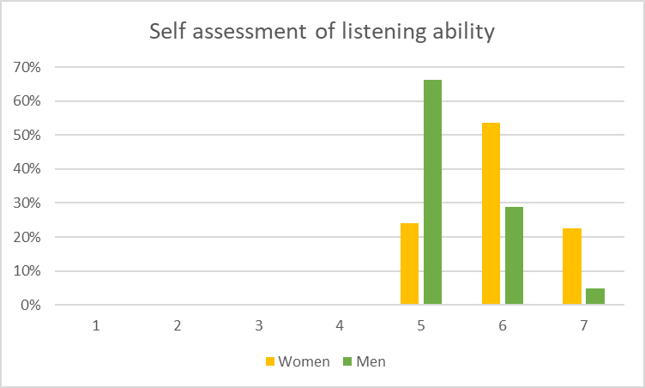
Figure 6 Survey participant listening self assessment
It was surprising to find that although 100% of individuals identified themselves as above average, good and excellent listeners, 80% of these listeners recognised at least one poor listening behaviour. This would suggest that survey participants had a tendency to over-estimate their listening ability. The researcher identified this statistical outcome as a potential demonstration of the Dunning-Kruger effect (Kruger, J, Dunning, D. et al, 2013). This demonstrates a cognitive bias with individuals believe they are more capable than they actually are. In fact, further studies into the Dunning-Kruger effect have shown that individuals with lower skills are more likely to overestimate their abilities compared to those who are more skilled (Teo et al., 2022).
The researcher concedes that they did not define listening or how the survey ratings applied within a real-world project management situation at the outset of the surveys and interviews. As a result, how the survey participant rated themselves is based on their subjective beliefs and experiences. The researcher considered how they would personally have responded to the survey and realised that their day-to-day listening skills were below average but when actively engaged in an environment where their role as a project manager required them to listen, then they rated themselves as above average and in some cases good. The researcher reflects that these listening skills have been developed as a result of the coach training they received specifically to develop them as a better coach. However in undertaking and applying the training their increased self-awareness and improved listening ability has had a positive impact in other areas of their life, including in the workplace within their role as a project manager.
These insights, were recognised by the researcher and led to more in-depth inquiry into the listening ability of interview participants, as discussed in the analysis of the interviews.

Impact of gender on listening behaviour
Figure 7 Percentage of self identified poor listening behaviour by gender
The researcher asked survey participants to indicate which “poor” listening behaviours they recognised in themselves.
The results show that poor listening behaviour in men include formulating a response instead of listening, undertaking other tasks or thinking about something else while also trying to listen to the speaker. These more passive behaviours did not directly impact the interaction with the person being listened to.
Conversely, the women surveyed were more likely to interrupt before the person finished speaking, hurry the speaker or finish the person’s sentence. Women were the only gender that indicated they exhibited unwelcome body language when listening, although this behaviour was present in a statistically low percentage of individuals. These more proactive behaviours are likely to have had a more direct impact on the listener.
The researcher reflects that what was initially identified as poor listening behaviours may be deemed good listening behaviours, within the context of the interaction being undertaken.
Project managers are responsible for ensuring tasks are delivered in a timely manner, while also managing relationships with stakeholders and project team members. At times, interrupting or hurrying the speaker may be a necessary tool to meet time critical demands. It is down to the skill of the project manager to understand and assess the impact this behaviour has on those at the receiving end; eliciting feedback can be a way to achieve this.

Listening Tools

Survey participants were asked to provide a short, free text answer to respond to a question about tools, techniques or training that had helped them improve their listening ability as a project manager. The responses in table 3 included references to a range of methods and experiences.
360 Listening | Active Listening | Coach training
NLP | Emotional intelligence | ILM Coaching
Insight profiling | Cultural agreement for  “what good looks like” | Mentoring
Role-playing scenarios | 5 Listening Skills | Counselling training
Working for the Samaritans | 12-step programme | Why Am I Talking (WAIT)
Walking Meetings | Microsoft Copilot | Using open and closed questions
Note taking | Recording and transcribing | Life experience
Table 3 Listening tools identified by survey participants
Three survey responders, provided particularly interesting responses, including, “working for The Samaritans”, “being part of a 12-step programme” and “counselling training”. All three experiences relate to approaches used to support individuals that may be experiencing a mental health issue. The approaches would all require the participant to follow a strict set of rules and practices when it comes to listening and interacting with any individuals.
Other tools were identified that did not directly refer to listening but required listening or taking in information as a core skill included coaching training, NLP, emotional intelligence, mentoring, role-playing scenarios and counselling training. It was promising that individuals recognised that listening skills were fundamental to the application of these concepts, tools and techniques.
Recording and transcribing, Microsoft Copilot and note taking were all listed as tools used by individuals to support listening. Copilot is a digital tool recently introduced by the technology supplier Microsoft, which uses artificial intelligence (AI) for “productivity, creativity and information comprehension” (Microsoft, 2023). A key feature includes the ability for the tool to summarise the content of an online meeting using a set of prompts. A concern is that meeting participants may become overly dependent on such tools and will feel they can disengage from meetings and rely on AI to understand the context of conversations well enough to interpret the message the speakers wishes to communicate accurately. As listening is more than simply processing the words said, the concern is that meetings participants will miss out on non-verbal cues such as tone, pace, volume and body language. There is also a concern that the output from AI tools may reflect biases present in the data it was trained on and therefore influencing the summarised text and therefore project-related actions and decisions.

Accepting feedback

Survey participants were asked, “Do you seek feedback from your project team members regarding your communication and listening skills?”.

Figure 8. Approach to feedback by gender
There were differences in how men and women approached feedback. Although most participants, regardless of gender, would “Discuss the feedback with the team member to better understand this perspective”, a slightly higher percentage of women than men would take this approach. 12% more men than women would “Seek additional feedback from other team members”, while a double the number of women than men (12%:6%) would “Act on the feedback and make improvements” as their first option. Validating the feedback and actions with other team members, before acting, would seem like a less risky approach, giving the project manager more information before making a decision but it could also be a sign that the individual in procrastinating or finding it difficult to make a decision.
All project management methodologies, include driving continuous improvement, as an important part of a project manager’s role. Continuous improvement relies on listening and acting on feedback from others. The majority (44% in both men and women) of survey participants undertook reflective sessions at regular intervals, however women were more likely (32%:19%) to reflect at “every opportunity” and men more likely (31%:20%) to organise reflective sessions only when there was an issue. 80% of the survey participants who indicated that they would seek feedback at every opportunity were women. All of these participants had received some form of coach training. This result suggests that those with coach training would be seeking opportunities to reflect with project team members.
6% of survey participants said that reflection was not part of their job. Neither of the survey participants had received any type of coach training. The participants had an average of nine years’ experience as project managers, all worked in digital transformation and said that they only sought clarification if they didn’t understand what they had heard.
The research suggests that coach training would help people develop an understanding of the importance of actively seeking feedback and clarification.

Interviews

Following analysis of the survey results, six project managers were interviewed. Interview questions were developed, following a grounded theory approach, based on emerging themes from the survey results. These themes included listening definition, barriers to listening, improving listening skills and the listening environment.
Questions were developed and loosely followed during semi-structured interviews with the six interviewees. Basic demographics were captured including gender, age bracket and years of project management experience. The full quotes captured and subsequently analysed in the interview stage, can be found in appendix 2.

Question 1: How would you define good listening?

Vandergrift (2004) said listening was more than simply hearing sound, it encompassed the comprehension and retention of information, incorporating both verbal and non-verbal cues. Across the six participants, there was a similar interpretation of what listening is in only two participants.
Participant 1 said that listening was, “a superficial thing” and “when you’re waiting to talk”, which suggests that the individual didn’t see listening as an important skill to adopt and was simply a pause while they waited to speak. Such an approach could be interpreted by the speaker as being disrespectful and would inhibit the listener’s ability to build trust.
Participant 3 referred to non-verbal cues, “picking the tone” and said that, combining tone and “words together give you that understanding better.”
Aryadoust & Luo (2022), indicated that listening can also incorporate visual cues, both participants 4 and 6 referred to “observing the body language”.
Participant 5 had a more abstract viewpoint to the role of listening, saying that listening was “trying to understand the underlying message rather than the words being said.” Although, there is an element of truth to this in relation to picking up on the speaker’s non-verbal cues it should also be recognised that the verbal cues are important too, particularly when taking instruction.
When asked to define listening the responses were inconsistent and unclear. The researcher reflects that even if participants didn’t have a deeper level of understanding of listening that they would at least be aligned with a general definition. However, none of the answer’s participants gave aligned to the Merriam-Webster definition of listening, “to hear something with thoughtful attention: give consideration”. (Merriam-webster.com.,2019).
This raises the question that if these project managers can’t accurately define listening, how can they know what good listening is? How will they know if they have listened to others or if others have listened to them?

Question 2: How do you recognise poor listening in yourself?

There was a general understanding that poor listening was characterised by lack of comprehension and retention of the information being relayed, as described by participant 5, “You can hear what they're saying and not really get it.”
However, in two cases it was evident that the project manager would only recognise poor listening if a task hadn’t been carried out, “When they're not doing the thing that I've asked them to do.” (participant 1). It was interesting to observe that their first thoughts when it came to listening was whether somebody had listened to them. These participants were both women, in the 40-45 year age bracket and had less than 5 years’ experience as project managers. They did not know each other and worked for different organisations.
Four participants recognised that inattention was a sign of poor listening, with metaphorical phrases used including, “switched off” (participant 5), “mind wanders” (participant 4) and descriptions of distracting behaviours, such as “doing something else” (participant 2), “page full of doodles” (participant 3).
Participants were able to recognise more poor listening behaviours in themselves than good listening behaviours. For example, several survey and interview participants described the poor listening behaviour as “doing something else” but no research participants described a good listening behaviour as “doing nothing else”. This example of negative bias toward interview participants being able to identify good listening behaviour is interesting as a bias toward overestimated listening ability was seen in the survey participants and called out as the Dunning-Kruger effect. The research suggests that the overestimation in listening ability is not based on evidence identified by the research participant.

Question 3: What prevents good listening?

After exploring the interview participants’ views relating to good and poor listening behaviours the participants were asked to talk about what prevented good listening. These were three common themes which were coded and identified as time, distraction and lack of understanding.
Time
All of the project managers interviewed referred to time as preventing good listening. Interview participants were asked to describe barriers to listening and referred to not enough time or too much workload over 20 times between them. Typical comments included, “Being rushed due to lack of time and demanding workload.” (participant 4) and “Competing deadlines and capacity” (participant 2).
A basic measurement for the success of any project is delivering on time. It is part of a project manager’s role to manage when activity is undertaken, through planning and task management activity.
Part of that task management includes prioritising work within the team and for themselves, it is therefore within the project manager’s control to prioritise enough time to listen effectively.
As a project manager protecting time for and engaging fully in project team meetings and key conversations would foster clarity and improved relations between team members. This would also help avoid time wasted, as the appointed team members will be working on the correct tasks as time has been taken to clarify expectations and answer questions.
Distraction
Participants also highlighted distraction as preventing good listening.
Participant 5 referred to their own experiences as listeners, “working remotely can make it very easy to get distracted”, as did participant 6, “distracted by worries in work and at home.”
Four interview participants referred to the listening experience of others when answering this question, for example, “people get easily distracted” (participant 1). It is interesting that these participants referred to listening as something that someone else does. This detachment from the individual’s behaviour is likely to impact the effectiveness of the project manager as it may be indicative of a wider problem with relationships (Pettita and Ghezzi, 2023).
Poor discipline during virtual meetings was identified as a cause of distraction in others for three of the participants. With participant 2 saying, “Remote working makes it easier for people to also be checking emails, side chats in teams meetings, checking their phones, et cetera“.
Since the Covid-19 pandemic began in March 2020, a significant proportion of the United Kingdom workforce has moved toward remote working arrangements. Although some organisations are encouraging employees to return to a physical office many will continue to operate in at least a hybrid way (a split between home and office).
Virtual project team meetings bring a greater level of uncertainty for project managers with it being more difficult to pick up non-verbal cues or being sure that meeting participants are attending to the meeting and not undertaking other work.
As a result, project managers need to engage in different approaches to ensure the attention of participants. This may include the setting of ground rules at the beginning of meetings or a meeting Terms of Reference or ensuring meetings are interactive and ensure participants have an opportunity to speak and be listened to.
In the survey, only 6% of participants said that undertaking other tasks while trying to listen was a listening behaviour that they recognised in themselves, This suggests that people are more able to identify poor listening behaviours in others than to recognise it in themselves. Coach training could be used to build skills to enhance self-awareness and seek feedback from others.
All interview participants indicated that poor listening situations occurred due to poor cultural behaviours. Participant 5, talked about leading by example and mentioned, “Poor role models across an organisation who don’t listening.” Three participants referred to situations where other parties displayed a lack of respect and rudeness. One said, “I’m not sure people truly enter into a conversation ready to listen, taking other people’s opinions on board, they want to answer questions, think and consider options” another said they had regular experiences of, “when people talk between each other in a meeting and ignore the person speaking about intended topics.” Two other participants referred to “not getting to the point” and “diverting the conversation off topic”. In these situations, the project manager would benefit from coach training to help them set boundaries, manage challenging conversations and direct the discussion.
Lack of contextual understanding
The final barrier to listening, identified was lack of understanding. Participants said that it was challenging to filter what is important and what’s not important within a conversation. One participant said that their instinct was to “jump to a solution” and another said that it was, “hard to not sideline listening, assume we know the answer and drive the project forward.” Having a grasp of the subject matter enables project managers to provide effective leadership and guidance to their teams. Research by Smith and Erwin (2005) emphasised that project managers who are knowledgeable about the project domain can inspire confidence in their team members, foster collaboration, and facilitate problem-solving. A project manager needs to recognise gaps in their knowledge throughout the lifetime of a project. Effective listening through asking questions and seeking clarification is an important tool for a project manager but is often overlooked.
Sacrificing effective listening, due to any of the barriers identified could potentially exacerbate those barriers further. The researcher suggests that utilising coach training to raise self-awareness, structure valuable conversations, create clarity and deal with poor listening behaviours in themselves and others, would be valuable in reducing the likelihood of these barriers occurring.

Question 4: How do you ensure you listen effectively?

Interviewees were asked how they approached meetings and conversations to ensure they maximised their opportunity to be effective listeners during the interaction. There were three common themes identified following coding including notetaking, reflection and transferrable skills.
Notetaking
All six interviewees referred to notetaking as a tool they recognised could support listening. Four project managers said that they took their own notes, with one commenting, “I've got notebooks coming out of my ears.” Two project managers said that they found note taking while listening was difficult for them. Both had found ways around this challenge with one saying, “In project team meetings, I have someone taking notes and recording actions”, another said, “working over Teams. I can record meetings and then capture key points from the transcripts.”
One interview participant said that they often used their notes to confirm the topics discussed and agreed actions as illustrated by the comment, “I email after a conversation to keep a record of the important points and give the person a chance to correct me” (participant 2).
The researcher takes notes in meetings. In fact, not being able to write notes inhibits the researcher’s ability to process auditory information. This is not surprising considering the researcher has identified themselves as having a read/write learning preference using the VARK model (Fleming & Baume, 2006). The VARK model categorises learning styles into visual, auditory, read/write and kinaesthetic. The term multi-modal is used to identify individuals who have no clear learning preference.
As a result of the researcher’s subjective experience, following the first iteration of qualitative data analysis the researcher asked interview participants to complete a VARK assessment to identify their preferred learning style.
It was identified that the four interviewees who took their own notes had either a kinaesthetic or visual learning style. The researcher relies on notetaking when listening and reports feeling uncomfortable when not being able to take notes. The researcher’s read/write score was 14 indicating that they have a strong read-write learning preference (VARK). Although lead learning preference varied across participants, they all scored at least 4 for read/write, except for the interview participants who did not take their own notes. Interestingly the two participants who expressed difficulty in taking notes while listening both reported a multi-modal learning style. They had equally high scores for their visual, auditory and kinaesthetic modality scores however the read/write scores for both of these interview participants was zero. One of these participants said, “It's one of the things I like about having recorded meetings. I struggle to take notes and pay attention.”, they then shared that they relied on automatic transcribing tools to capture notes. For this individual taking notes was a barrier to their ability to listen.
Reflection
When interview participants were asked, “How do you ensure you listen effectively?”, two referred to active listening. The survey had asked if participants had undertaken any form of active listening training, with 23% of respondents saying that they had completed training in Active Listening. Further inquiry found that two of the interviewees had undertaken active listening training. However, when asked to elaborate as to how the training had benefitted their listening, they both referred to the act of reflecting the speaker's thoughts but made no reference to reflecting the speaker’s feelings. One participant said, “I think that my approach to listening well is to reflect back the thing as I've understood it. To see if they agree.” (participant 3) and another said, “I try to paraphrase what people are saying and confirm what you've taken in to confirm your understanding” (participant 3).
Active listening is a concept originally defined by psychologist Carl Rogers and Richard Farson (Rogers and Farson, 2021). They determined that empathy is a key principle of active listening and is demonstrated by reflecting the thoughts and feelings of the speaker.
Neither interview participant referred to empathy, feeling or anything that related to building an emotional attachment to the speaker. This indicates that the active listening training hadn’t been effective in ensuring a clear understanding of a key active listening principle. This is potential due to the participant’s inability to apply their new understanding to their practice as a project manager. Applying the new learning is a fundamental part of Bloom’s Taxonomy (Bloom, 1956) and without it knowledge atrophy will rapidly set in (Banda et al., 2023).
Transferrable skills
When interview participants were asked, “How do you ensure you listen effectively?”, one participant said, “I used to find that when I was taking minutes I'd learned a lot about what was happening”. A second participant referred to their time working in a call centre and the skills they developed listening and responding to callers.
Survey participants were asked to provide a short, free text answer to respond to a question about tools, techniques or training that had helped them improve their listening ability as a project manager.
Three survey responders, provided particularly interesting responses, including, “working for The Samaritans”, “being part of a 12-step programme” and “counselling training”. Participants would have received specific guidance and in some cases accredited training to ensure listening was established as a core skill.
The situations described by the research participants required listening as a core component of the role and required the participant to follow a strict set of rules and practices.
Providing project managers with training in listening skills development within the context of a project environment would ensure an understanding of the importance of effective listening in the project manager and define good listening behaviour within projects. Applying these concepts using a coaching model would provide project managers with a set of guidelines to help them practice good listening skill behaviour. By integrating this behaviour into their project management practice they will be able to positively influence project outcomes by creating a project team culture where people feel listened to and therefore valued.

Themes in the Findings

Following analysis of the interviews the researcher identified three main themes: listening definition, listener tools and listener attributes. Passmore (2010, p12) reported that their research participants felt, “the quality of listening was different in coaching compared to how they were listened to elsewhere”.
All three themes and sub themes are addressed in high quality coaching training so that new coaches develop into highly skilled listeners. Therefore, the researcher determines that project managers would also benefit from these elements of coach training.

Theme | Sub-theme
Listening definition | Understanding the purpose of listening  Understanding of listener/speaker roles
Listener Tools | Creating connection  Taking note  Questioning  Reflecting
Listener Attributes | Lack of self-awareness  Environment  Poor emotional management  Previous experience

Table 4 Results of iterative thematic analysis

Theme 1: Listening definition

The survey showed that participants had a tendency to overestimate their listening ability, referring to this as an example of the Dunning-Kruger effect (Kruger, J, Dunning, D. et al, 2013) but the researcher could also have attributed the bias toward a scoring self-assessment of listening ability as having not clearly defined listening prior to the survey being undertaken. However, without this insight they may not have asked the interview participants about their definition of listening and identified a deficit in understanding.
Following the interviews, the researcher was able to identify a range of interpretations in the interview participants definition of listening. It would then be understandable if a listener does not capitalise on a listening situation if they do not appreciate that as a listener it is their responsibility to understand the purpose of listening in that specific situation. Similarly, not clearly understanding the responsibilities of the listener and the speaker will potentially lead to the messages within a conversation not being received and understood correctly.
Listening is important for two main reasons, to build relationships and for the listener to learn so that shared understanding exists between the listener and speaker.
This is where training, to clarify the definition of listening, would be beneficial.

Theme 2: Listener Tools

The survey asked the 41 participants to identify poor listening behaviours. All survey participants rated themselves as good listeners. However, poor listening behaviours were self-identified in all but two survey participants. Several interview participants said that they hadn’t consciously thought about how they listened prior to the request to participate in the research.
The researcher argues that training project managers in skills taught to coaches will have a positive impact on project outcomes. These three listening skill tools include creating connection, taking note and questioning.
Creating connection
Some interview participants reflected that listening wasn’t just about the words being said.
“It's all broken down between body language, tone and actual words.” (Participant 2).
On the surface reflecting does involve repeating back what the speaker has said and summarising the conversation. Using phrases like, “What I heard you say is…” and reflecting back the words the speaker used or by highlighting the main points raised by the speaker and summarising in the listener’s words what they understood.
Reflecting is more than words. It is when the listener is in rapport with the speaker and vice versa. It is when both parties are in tune emotionally and demonstrate this using non-verbal cues such as tone of voice, pace of speech and body positioning.
In the hybrid workplace where many meetings are held virtually over video calls there is limited access to non-verbal cues which means the listener needs to work harder to build rapport and therefore trust.
Coach training could help project managers develop an understanding of the theory behind rapport building and give them the tools to identify ways in which to optimise rapport building opportunities through reflecting verbal and non-verbal cues back to the speaker.
In coach training, specific skills to build rapport are taught including mirroring and matching. Building rapport creates a sense of trust and a feeling of being “in sync” with the other person. This will increase the likelihood of the speaker being more engaged in the conversation. Project managers need to negotiate in order to ensure the tasks they require completing are undertaken in a timely manner. By investing time in the speaker and displaying good listening skills there will be an increase in the likelihood of a sense of loyalty in created with project team members and the chance of the work being undertaken is increased.

Taking note
Recording the key points made by a speaker aids the listener in a number of ways: it enables them to clarify what the speaker has said, it keeps the listener focused and engaged, enables the listener to create connection and serves as reference material to aid the listener’s long-term memory of the dialogue.
An aim of listening is for the listener to learn something new so that they can develop a better understanding of a situation and make decisions to further the goals of the project.
The researcher found that most project managers relied on note taking to record key points made by the speaker. Interestingly, the two interviewees who found it challenging to keep notes because they found note-taking distracting were the only two participants who had a multi-modal learning preference (VARK, 2020).
Taking notes can be undertaken in a variety of ways: putting pen to paper, using recording and transcription devices and receiving support from a third-party to take notes.
By using coach training to help a project manager understand their own learning preferences and preferred styles for taking notes they could develop personalised approaches to make use of this important listening tool.
Questioning
Listening isn’t simply about remaining silent, it requires the listener to seek clarification and explore the topic further. Questioning requires the speaker to undertake self-reflection and sometimes find the answers they are looking for within themselves. Some of the interview participants recognised that questioning was a valuable technique but didn’t say why:
“You've got to be really good at asking the right questions” (participant 1);
“I tend to ask a couple of questions” (participant 2);
“Ask open questions” (participant 5).
Participant 5 recognised the benefit of using open questions specifically. No other participants referred to questioning techniques or identified that some question types (i.e. leading questions) could create a bias and assumptions made by the listener. This is particularly important for project managers as often their role is to create a bias and to influence project team members to prioritise work. Coaches often use coaching models or frameworks within their coaching practice. Training project managers in a range of coaching models may help them facilitate more constructive conversations. For instance, using the GROW model a project manager has at least four questions they could use to explore a particular objective the project team member has been set. The researcher uses clean language questioning techniques within their role as a project manager to ask unbiased questions. This enables the researcher to ensure a shared understanding of what the speaker wishes to communicate to the listener.

Theme 3: Listener Attributes

The circumstances that made listening effectively more challenging was explored in both the surveys and the interviews. Interviewees spoke at length about the barriers to listening and the output was eventually identified as the sub-themes: lack of self-awareness, environment, poor emotional management, lack of good role models and lack of training.
Lack of self-awareness
The findings relating to an individual’s propensity to overestimate their listening ability was the researcher’s initial indication that self-awareness was part of the good listening equation and therefore lack of self-awareness increased the probability of poor listening behaviour demonstrated in the project manager.
A lack of self-awareness was identified in both the survey and interview participants. An important part of coach training is for the coach to develop more self-awareness, whether this is to do with personality typing, identifying learning preferences or understanding more about the patterns that drive their behaviour. As a project manager and coach who has been through this process of building self-awareness the researcher sees significant benefit in project managers going through a similar process.
Environment
For some participants environment had a significant impact on their ability to listen effectively. Three participants said that noisy environments had a negative impact on their ability to focus on the speaker. One said that both noise and visual distractions would have an impact on their attentiveness in a listening situation and that there was potential for them to retain very little information.
Other situational factors may impact the ability to listen effectively, there may be other factors impacting the listener or speaker; they may work in an authoritative organisation where listening and feedback is seen as unimportant or excessive workload means that providing space for high quality listening opportunities is limited.
Another environmental change we have seen within our workplaces is the increased use of remote working as a result of the Covid-19 pandemic. The wide scale move to working is physically disparate teams required implementation of video conferencing solutions. This was no different to project managers and their project team members. Little remote team management training was delivered along with the Teams and Zoom licenses as an assumption was made that the skills required to project manage remote teams were the same as managing co-located teams. Coach training promotes the concept of flexibility in thinking to adapt to the coachee’s needs. If project managers were able to do the same then project outcomes may be improved.
Poor emotional management
Recognising and acknowledging the emotions expressed by the speaker demonstrates empathy in the listener, showing that the listener accepts the speaker’s feelings as valid. Being listened to can sometimes feel rare and this trait in a project manager increases the likelihood of them being thought of as supportive listeners (Gyllensten and Palmer, 2007). This builds trust between the listener and speaker.
Being judgemental or being drawn into a heated debate is unlikely to help the project manager achieve their aim of achieving project outcomes. Therefore, avoiding judgement or responding with empathetic phrases like, “I can see how that’s difficult” or “that’s understandably challenging”.
Sometimes, a project manager is required to challenge project team members or negotiate with other project stakeholders. This requires a skillset that will enable the individual to remain calm under pressure. This can be more challenging at times within a project when risk of failure is at its peak (i.e. at project go-live) or in organisations where high stress levels are accepted as a cultural norm. Although not often formally expressed, the personal stress levels of a project manager can negatively impact project outcome (Flannes, 2010).
Coach training can help project managers develop skills to support and encourage when appropriate to convey that you’re there to listen and assist. Coaching training will also usually require the individual to develop awareness of when they are associated or disassociated from a situation and give the project managers the skills to “not take it personally”. Coach training would also help project managers identify unhelpful thinking patterns that keep individuals in a loop of catastrophic or negative thinking that a situation “should” be a certain way or “what if” this happens.
Lack of good listening role models
Three of the other project managers referred to training they had received in other job roles to improve listening skills. Two of the interview participants had previously had jobs in call centres that required them to ask questions and respond to the caller’s requests. As part of the training they were required to shadow experienced call handlers who had been identified as role models.
Conversely, another project manager interviewee referred to using poor models of behaviour to inform the decisions they made as project managers, essentially by doing the opposite. They said, “Seeing what “bad” management looks like and learning not to repeat the same mistakes” (participant 4).
Sadly, it is more likely for individuals to experience and remember negative experiences in the workplace. This is particularly relevant to the public health sector organisations where 5 of the 6 interviewees practiced as project managers. The NHS in Wales is under significant strain and this pressure often leads to challenging cultural behaviour.
Using coach training to empower project managers to identify positive role models would enable them to develop a sense of what demonstrating good listening behaviour might be.
Lack of training
Only two of the project managers interviewed had received any training to specifically improve their listening skills. As previously identified, the project managers had not successfully applied the learnings to their day-to-day practice. They had limited resources available to them to make improvements and limited awareness of the impact improving listening skills could have for them in relation to delivering successful projects.
One of the interviewees mentioned that they tried to actively listen. On further inquiry, the interviewee shared that they had received some basic training that used the term “active listening” but did not know of any skills or techniques that could be learnt and practised.
One of the interviewees, showed an innovative way to address a reflection that they’d had about their listening ability. They said that they knew that they had a tendency to waffle and searched YouTube for strategies to help them reduce this behaviour. The interviewee adopted the mantra, “Why Am I Talking” and had written it on the front of their notebooks as a helpful reminder.
Providing coach training would help project managers undertake self-inquiry, develop more self-awareness and identify the tools needed to become better listeners.

Conclusion

Learning Outcomes

At the outset of this work-based learning project the researcher established four learning outcomes:

- Identify the project lifecycle stages where listening is most crucial.

No evidence was found to indicate that listening was most crucial in any specific stage of the project lifecycle. In fact, during the interviews project managers shared examples of listening was required at a range of times during a project.
The literature and subsequent research confirm that listening is a crucial skill required throughout the life of the project and that project managers should endeavour to establish good listening behaviour as a core skill.

- Evaluate existing project management approaches for their incorporation of targeted listening skills development.

In the literature review, the researcher evaluated three of the most common project management approaches (methodologies) and found that targeted listening skills development did not feature in any of the training publications.
There was evidence that project managers who had undertaken listening skills training had not successfully incorporated the learnings into their project management practice as it was not targeted or easily applied.

- Measure the listening proficiency of project managers and pinpoint specific areas for improvement.

Survey participants were shown to overestimate their listening ability and there was no shared understanding of what good listening behaviour looked like. Listening was underappreciated as a listening skill in project managers. There was little evidence that project managers recognised their responsibility to understand the purpose of listening in that specific situation.
There were some gender differences in how research participants listened. Building awareness of any bias through coach training would help project manager make conscious behaviours through greater self awareness.
Project managers would benefit from coach training to help them set boundaries, manage challenging conversations and direct the discussion.
Utilising coach training to raise self-awareness, structure valuable conversations, create clarity and deal with poor listening behaviours in themselves and others, would be valuable in reducing the likelihood of these barriers occurring.
By using coach training to help a project manager understand their own learning preferences and preferred styles for taking notes they could develop personalised approaches to developing their listening skillset.

- Ascertain whether there is a demand for coaching tools training to enhance listening skills among project managers.

It is likely that there would be more interest in listening skill development, if organisations understood that developing project managers skills as a listener could positively impact the people they engaged with and therefore the outcomes of the project.

Coaching training for project managers to improve listening skills would require, as a minimum, the topics identified as research themes. These included:
- A clarification of what listening as a project manager means. To ensure the project manager understands the purpose of listening and their responsibility as the listener.
- The tools of a good project manager listener include create connection with project team members and stakeholders; take notes in a way that reflects the project managers learning preferences; to apply questioning techniques to enable the project manager to limit or increase bias depending on their need to influence discussion outcomes; and the ability to reflect to ensure accurate understanding and maximise learning potential.
- The attributes of a project manager with good listening skills include increasing self-awareness, creating a listening-friendly environment, developing skills to manage emotions and develop a cycle of continuous improvement.

Reflection on the research

To try to avoid bias, the researcher used an open questioning and clean language approach during the interviews encouraging the interview participant to share their thoughts without influence from the researcher.
The researcher did not include a definition of listening or any questions that explored how the listener defined listening. The researcher used this gap in knowledge to inform interview questions.
It should be noted that the researcher is a woman, a coach and a project manager and therefore may be biased based on the researcher’s gender and subjective experience.
Limitations of the survey related to the fact that the results are based on the survey participants’ own level of self-awareness and the reliance on their memory to recognise traits. Should the participant be observed over a period of time, surveyed immediately following periods of listening or if we had received feedback from people who had experience of working with the project manager, we may have seen a different outcome.
The researcher also notes that the participant sample would have been made up from similar industries, as participants were invited to take part in the research through LinkedIn, a social media platform that generates connections based on common values, interests and business sectors. The sample of participants had therefore been developed, over time, through computer generated algorithms suggesting valuable contacts to the researcher or through the researcher specifically identifying individuals they wished to make a connection with.
The researcher notes that interview sample size was small and made up of six project managers who all worked in digital health transformation. Although the participants were from different organisations, the environment and organisational culture would likely be similar. Also, all interview participants were within a similar age range (40-50 years old) and had received similar types of project management training.
A larger group of interview participants from a wider sample of project managers working in different industries (i.e. construction or software development) may have produced different results.

Future recommendations

There is clear evidence that listening as a project management skill is underappreciated and that coach training would be beneficial for project outcomes. Based on these conclusions the researcher makes three main recommendations:

- Undertake further research assessing the impact of targeted coach training for project managers.
- Raise awareness of the importance of listening as a core skill for project managers that requires nurturing and targeted development.
- Develop coach training for project managers to specifically improve listening skills.

References

AbuJbara, N. and Worley, J. (2018). Leading toward new horizons with soft skills. On the Horizon the International Journal of Learning Futures, 26(3), 247-259. https://doi.org/10.1108/oth-10-2017-0085
Alexander, E., Penley, L., & Jernigan, I. (1992). The relationship of basic decoding skills to managerial effectiveness. Management Communication Quarterly, 6(1), 58-73. https://doi.org/10.1177/0893318992006001003
Aryadoust, V., Foo, S. and Ng, L.Y., 2022. What can gaze behaviors, neuroimaging data, and test scores tell us about test method effects and cognitive load in listening assessments?. Language testing, 39(1), pp.56-89.
Asselin ME. Insider research: issues to consider when doing qualitative research in your own setting. J Nurses Staff Dev. 2003 Mar-Apr;19(2):99-103. doi: 10.1097/00124645-200303000-00008. PMID: 12679662.Babones, S. (2016). Interpretive Quantitative Methods for the Social Sciences. Sociology, 50(3), 453-469. https://doi.org/10.1177/0038038515583637
Association for Project Management (2021). Dynamic conditions for project success. Available at: https://www.apm.org.uk/v2/media/qyspgrn4/apm-dynamic-conditions-for-project-success-2021-v2.pdf.
Axelos (2017). Managing successful projects with PRINCE2. 6th ed. London: Tso.
Babones, S. (2016). Interpretive Quantitative Methods for the Social Sciences. Sociology, 50(3), 453-469. https://doi.org/10.1177/0038038515583637
Badurussaman, W.H.W. and Khoiry, M.A., 2021. The impact of project manager’s skills and age on project success. Brasilian Journal of Operations & Production Management, 18(4), pp.1-16.
Ballesteros-Sánchez, L. and Rodríguez-Rivero, R. (2019). The impact of executive coaching on project managers’ personal competencies. Project Management Journal, 50(3), 306-321. https://doi.org/10.1177/8756972819832191
Banda, S., Phiri, F., Kaale, J., Banda, A.M., Mpolomoka, D.M., Chikopela, R. and Mushibwe, C., 2023. Application of Bloom’s Taxonomy in Categorization of Cognitive Process Development in Colleges. Journal of Education and Practice, 14(4), pp.6-13.
Baron, L. and Morin, L., 2009. The coach‐coachee relationship in executive coaching: A field study. Human Resource Development Quarterly, 20(1), pp.85-106.
BBC News (2020) HS2: Why do big government projects cost so much? Available at: https://www.bbc.co.uk/news/business-51443629.
Berkovic, D., Ayton, D., Briggs, A. M., & Ackerman, I. N. (2020). The View From the Inside: Positionality and Insider Research. International Journal of Qualitative Methods, 19. https://doi.org/10.1177/1609406919900828
Bloom, B. S. (1956). Taxonomy of educational objectives: The classification of educational goals (1st ed.). Longman Group.
Bost, M., 2018. Project management lessons learned: a continuous process improvement framework. CRC Press.
Bridges, David. 2017. “Nothing about us without us: The ethics of outsider research.” Philosophy in Educational Research.
Bruun, A. and Stage, J., 2015. New approaches to usability evaluation in software development: Barefoot and crowdsourcing. Journal of Systems and Software, 105, pp.40-53.
Buvik, M.P. and Rolfsen, M., 2015. Prior ties and trust development in project teams–A case study from the construction industry. International journal of project management, 33(7), pp.1484-1494.
Cairns-Lee, H., Lawley, J. and Tosey, P. eds., 2022. Clean Language interviewing: Principles and applications for researchers and practitioners. Emerald Publishing Limited.
Caldwell, K.L., Gray, J. and Wolever, R.Q., 2013. The process of patient empowerment in integrative health coaching: How does it happen?. Global advances in health and medicine, 2(3), pp.48-57.
Chelagat, T., Onyango, J., Kokwaro, G. and Rice, J., 2019. From strategy to action: a qualitative study on salient factors influencing knowledge transfer in project-based experiential learning in healthcare organisations in Kenya. BMJ open, 9(9), p.e031100.
Chong, C.W., Yuen, Y.Y., Tan, B.C., Zarim, Z.A. and Hamid, N.A., 2016. Managerial coaches, are they ready? The case of Malaysian telecommunications industry. The Learning Organization, 23(2/3), pp.121-140.
Christensen, L.B., Johnson, B. and Turner, L. (2010). Research methods, and design, and analysis. Harlow: Pearson Education.
CIPD (2023). Learning at Work Report. https://www.cipd.org/globalassets/media/knowledge/knowledge-hub/reports/2023-pdfs/2023-learning-at-work-survey-report-8378.pdf
Corbin, J. and Strauss, A. (2015). Basics of Qualitative Research: Techniques and Procedures for Developing Grounded Theory. 4th ed. Los Angeles: Sage.
Darrell, V., Baccarini, D. and Love, P.E., 2010. Demystifying the folklore of the accidental project manager in the public sector. Project Management Journal, 41(5), pp.56-63.
Ellinger, A.D., Hamlin, R.G. and Beattie, R.S., 2008. Behavioural indicators of ineffective managerial coaching: A cross‐national study. Journal of European Industrial Training, 32(4), pp.240-257.
ESI International (2015). The Global State of the PMO An analysis for 2015. Available at: https://www.ingenieros.es/files/proyectos/pmo-2015-report.pdf.
Fleming, N.D. (2001). Teaching and learning styles : VARK strategies. Christchurch, N.Z.: Neil D. Fleming, November.
Fleming & Baume (2006)
Flynn, J., Valikoski, T.-R., & Grau, J. (2008). Resources about the role of listening at the workplace.
Gilakjani, A.P. and Ahmadi, M.R., 2011. A study of factors affecting EFL learners' English listening comprehension and the strategies for improvement.
Gillard, S. (2017). The human element of project management. Contemporary Issues in Education Research (Cier), 10(3), 185-188. https://doi.org/10.19030/cier.v10i3.9979
Gray, D.E., Ekinci, Y. and Goregaokar, H. (2011), A Five-dimensional Model of Coach Attributes. Int J Select Assess, 19: 415-428. https://doi.org/10.1111/j.1468-2389.2011.00569.x
Gyllensten, K. and Palmer, S. (2007). The coaching relationship:An interpretative phenomenological analysis. International Coaching Psychology Review, 2(2), pp.168–177. doi:https://doi.org/10.53841/bpsicpr.2007.2.2.168.
Haan, E., Duckworth, A., Birch, D., & Jones, C. (2013). Executive coaching outcome research: the contribution of common factors such as relationship, personality match, and self-efficacy.. Consulting Psychology Journal Practice and Research, 65(1), 40-57. https://doi.org/10.1037/a0031635
Herd, A., 2015. The case of “Not Enough Time:” Using GROW and motivational interviewing coaching frameworks. New Horizons in Adult Education and Human Resource Development, 27(3), pp.46-49.
Jahromi, V., Tabatabaee, S., Abdar, Z., & Rajabi, M. (2016). Active listening: the key of successful communication in hospital managers. Electronic Physician, 8(3), 2123-2128. https://doi.org/10.19082/2123
Jones, R. L., & Wallace, M. (2005). Coaching and Mentoring Skills: A Practical Guide. Kogan Page Publishers.
Kruger, J, Dunning, D., Johnson, K.L. and Schlösser, T (2013). How unaware are the unskilled? Empirical tests of the ‘signal extraction’ counterexplanation for the Dunning–Kruger effect in self-evaluation of performance. Journal of Economic Psychology, 39, pp.85–100. doi:https://doi.org/10.1016/j.joep.2013.07.004.
Kuhn, T.S. (1970). The Structure of Scientific Revolutions.
Legault, M.-J. and Chasserio, S. (2012). Professionalization, risk transfer, and the effect on gender gap in project management. International Journal of Project Management, 30(6), pp.697–707. doi:https://doi.org/10.1016/j.ijproman.2011.11.004.
Linder-Pelz, S. and Lawley, J., 2015. Using Clean Language to explore the subjectivity of coachees’ experience and outcomes. International Coaching Psychology Review, 10(2), pp.161-174.
Matsuo, M., Arai, K. and Matsuo, T., 2020. Effects of managerial coaching on critical reflection: mediating role of learning goal orientation. Journal of Workplace Learning, 32(3), pp.217-228.
Merriam-webster.com. (2019). Definition of LISTEN. [online] Available at: https://www.merriam-webster.com/dictionary/listen.
Microsoft (2023). Microsoft Copilot | Microsoft AI. [online] Available at: https://www.microsoft.com/en-us/microsoft-copilot.
Moin, T., Giraldez Hayes, A., Stopforth, M., Lynden, J. and Rees-Davies, L. 2023. Who is a coach and who is a coaching psychologist? Professionalising coaching psychology in the United Kingdom. The Coaching Psychologist. 19 (1), pp. 4-18. https://doi.org/10.53841/bpstcp.2023.19.1.4
Moradi, S., Kähkönen, K., & Aaltonen, K. (2020). Project managers’ competencies in collaborative construction projects. Buildings, 10(3), 50. https://doi.org/10.3390/buildings10030050
Myers (2008). Qualitative research in business and management. Los Angeles ; London: Sage.
Naeem, M., Ozuem, W., Howell, K., & Ranfagni, S. (2023). A Step-by-Step Process of Thematic Analysis to Develop a Conceptual Model in Qualitative Research. International Journal of Qualitative Methods, 22. https://doi.org/10.1177/16094069231205789
Nompo, R. S., Pragholapati, A. and Thome, A. L. (2021) “Effect of Neuro-Linguistic Programming (NLP) on Anxiety: A Systematic Literature Review”, KnE Life Sciences, 6(1), pp. 496-507. doi: 10.18502/kls.v6i1.8640

O’leary, Z. (2021). Essential Guide To Doing Your Research Project. 4th ed. S.L.: Sage Publications.‌
Pabian, A. (2021). SUSTAINABILITY IN PROJECT MANAGEMENT : a functional approach. S.L.: Crc Press.
Petitta, L. and Ghezzi, V., 2023. Remote, Disconnected, or Detached? Examining the Effects of Psychological Disconnectedness and Cynicism on Employee Performance, Wellbeing, and Work–Family Interface. International Journal of Environmental Research and Public Health, 20(13), p.6318.
Project Management Institute (2017). Project Management Job Growth and Talent Gap 2017–2027.
Project Management Institute (2021). A Guide to the Project Management Body of Knowledge (PMBOK® Guide) – Seventh Edition and The Standard for Project Management . 7th ed. Project Management Institute.
Ramazani, J., 2014. Project Managers and the Journey from Good to Great: Rethinking Project Management Training and Education in the Oil and Gas industry (Doctoral dissertation, University of Calgary).
Remenyi, D., Williams, B., Money, A. and Ethné Swartz (2003). Doing Research in Business and Management: An Introduction to Process and Method. Sage Publications Ltd.
Roebuck, D., Bell, R., Raina, R., & Lee, C. (2016). Comparing perceived listening behavior differences between managers and nonmanagers living in the United States, India, and Malaysia. International Journal of Business Communication, 53(4), 485-518. https://doi.org/10.1177/2329488415572789
Rogers, C.R. and Richard Evans Farson (2021). Active Listening. Mockingbird Press.
Smith, K., Burns, C., O’Neill, C., Duggan, J.D., Winkelman, N., Wilkie, M. and Coughlan, E.K., 2023. How to coach: A review of theoretical approaches for the development of a novel coach education framework. International Journal of Sports Science & Coaching, 18(2), pp.594-608.
Smith, M.L., Erwin, J. and Diaferio, S., 2005. Role & responsibility charting (RACI). In Project Management Forum (PMForum) (Vol. 5).
The Association for Talent Development (2019). Bridging the Skills Gap: Workforce Development in Changing Times | ATD. [online] Available at: https://www.td.org/research-report/bridging-the-skills-gap-workforce-development-in-changing-times-pdf-download.
Thomas, L.T. and Levine, T.R., 1994. Disentangling listening and verbal recall: Related but separate constructs?. Human Communication Research, 21(1), pp.103-127.
Thomas, G. (2023). How to Do Your Research Project : a Guide for Students. 4th ed. Los Angeles: Sage.
Thompson, S. and Cox, E., 2017. How coaching is used and understood by project managers in organisations. Project Management Journal, 48(5), pp.64-77.
Wagner, Dale R. Ph.D., FACSM. Making Sense of Accreditation, Certification, and Licensure for Careers in Exercise Science. ACSM's Health & Fitness Journal 27(2):p 27-32, 3/4 2023. | DOI: 10.1249/FIT.0000000000000850
Vandergrift, L., 2004. 1. Listening to learn or learning to listen?. Annual review of applied linguistics, 24, pp.3-25.
Van Zoonen W., Sivunen A., Blomqvist K., Olsson T., Ropponen A., Henttonen K., et al. (2021). Factors influencing adjustment to remote work: Employees’ initial responses to the covid-19 pandemic. Int. J. Environ. Res. Public Health 18:6966. 10.3390/ijerph18136966
Zulkiffli, N. and Latiffi, A. (2019). Review on project manager’s leadership skills in the pre-construction phase of sustainable construction projects. MATEC Web of Conferences, 266, 01011. https://doi.org/10.1051/matecconf/201926601011
Zuo, J., Zhao, X., Nguyen, Q., Ma, T., & Gao, S. (2018). Soft skills of construction project management professionals and project success factors. Engineering Construction & Architectural Management, 25(3), 425-442. https://doi.org/10.1108/ecam-01-2016-0016

Appendix A: Ethical Approval Form
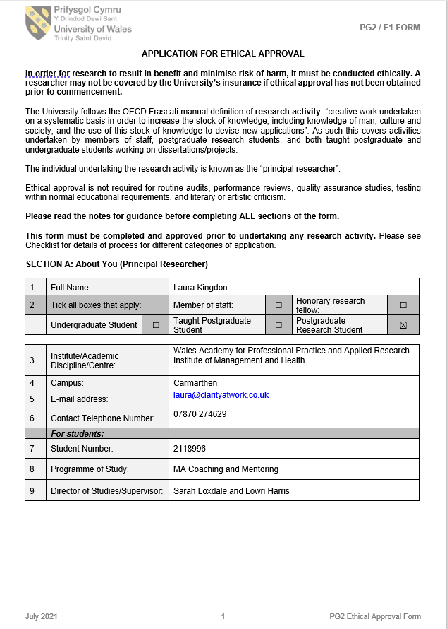

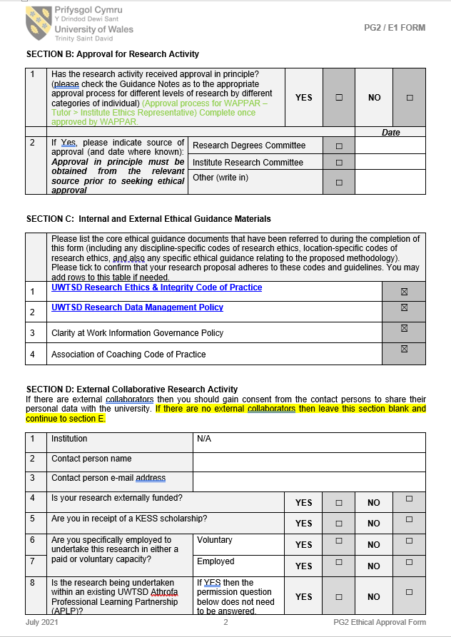

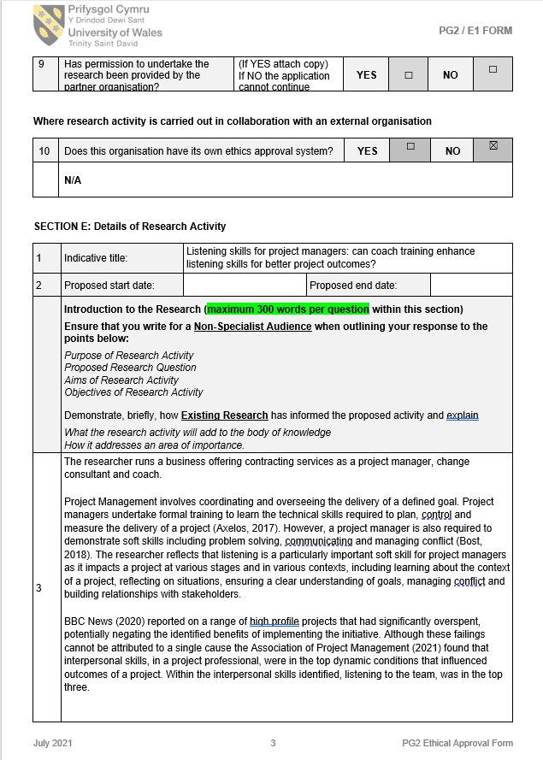

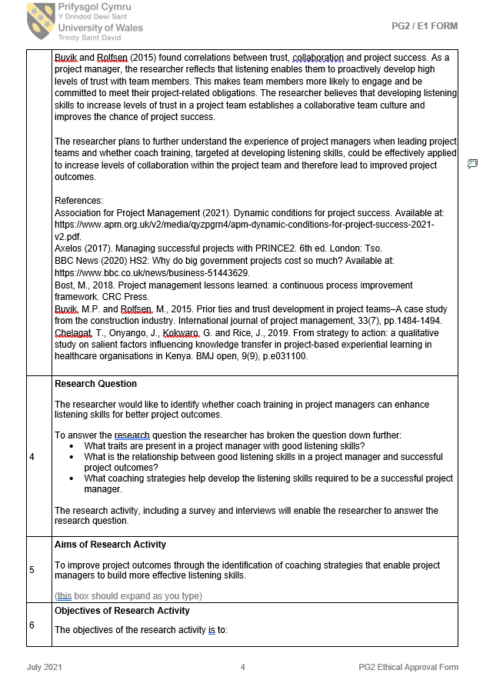

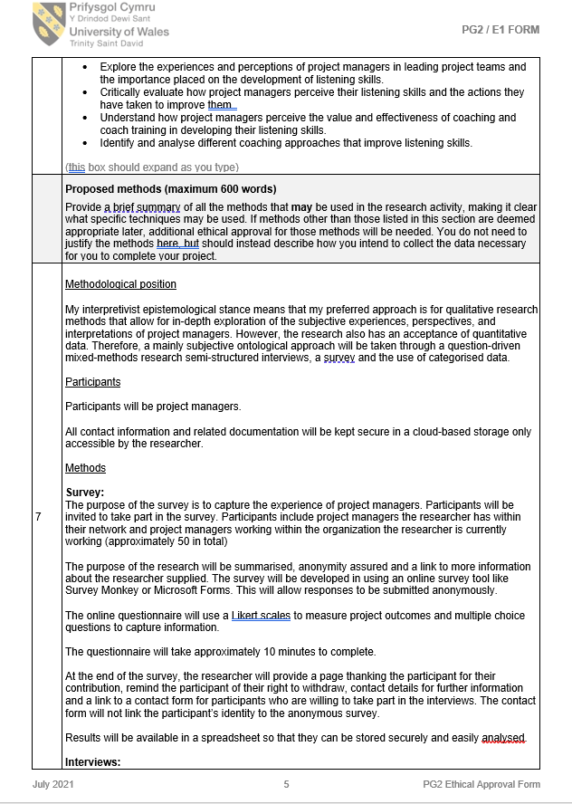

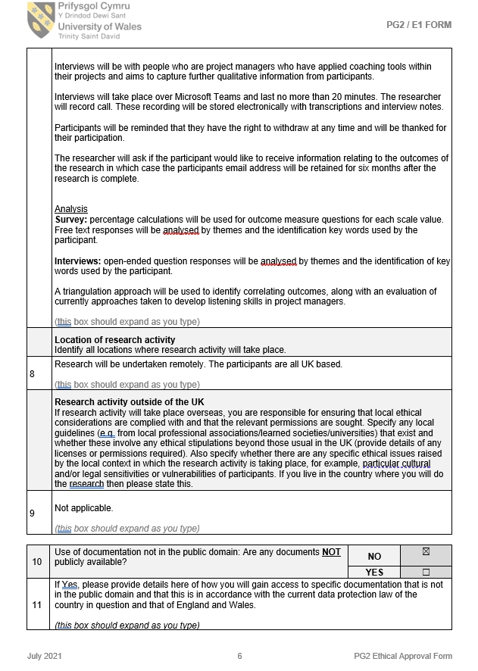

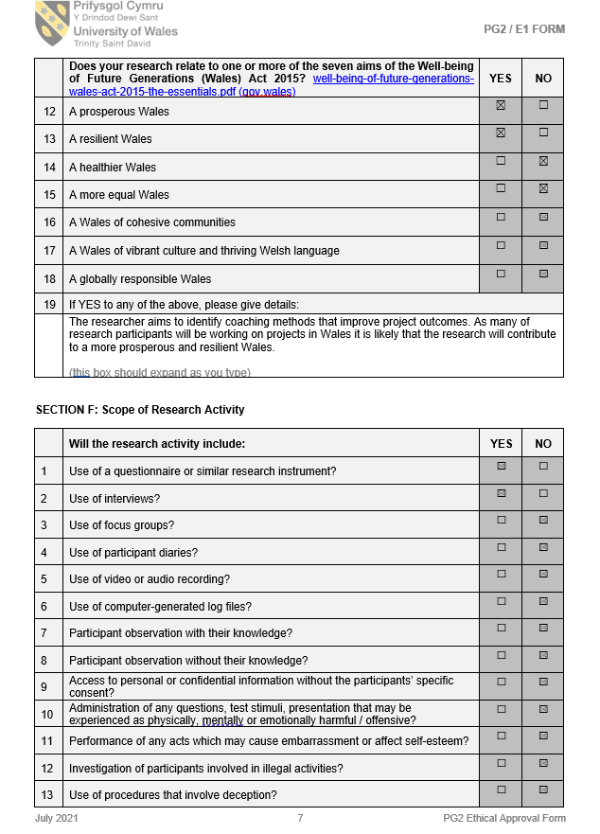

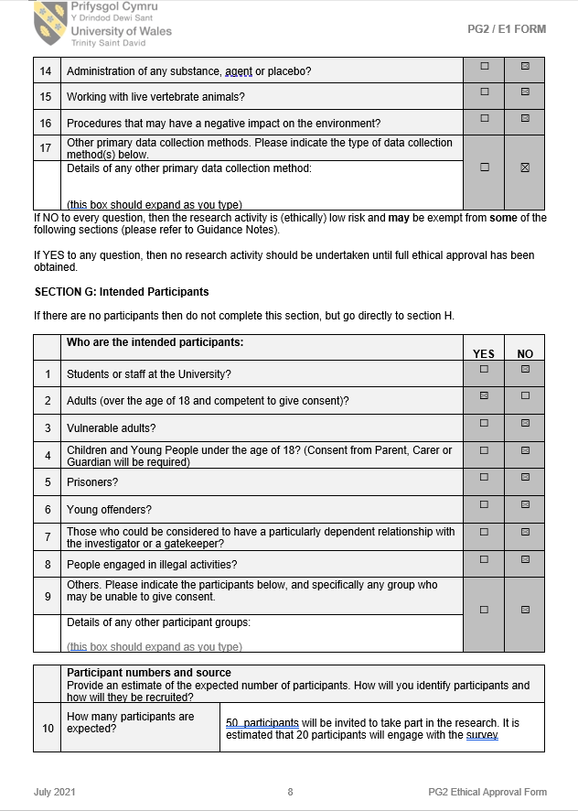

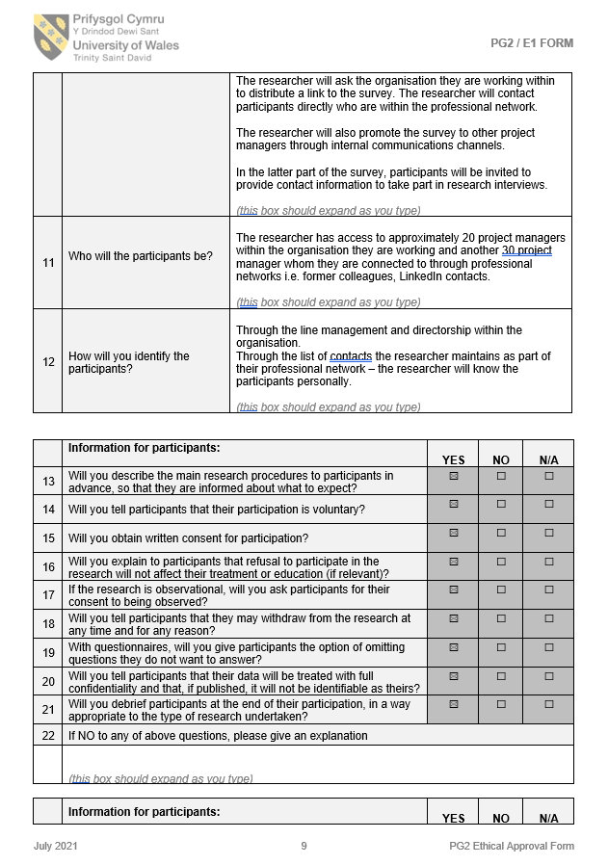

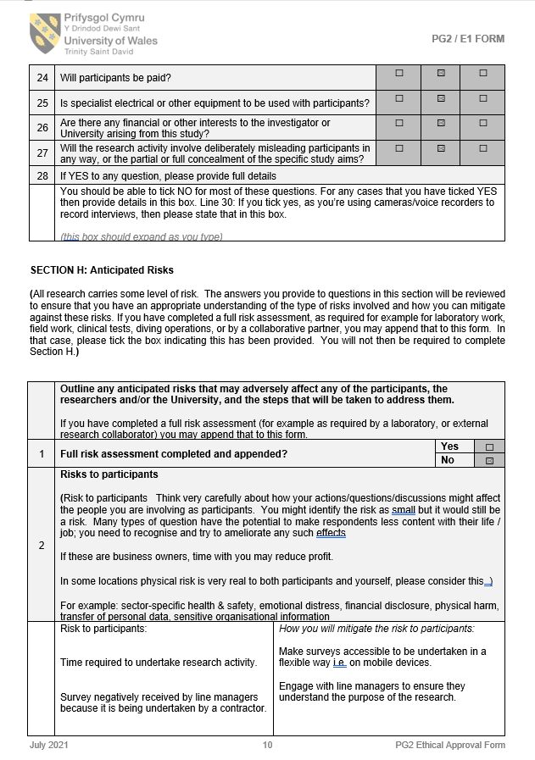

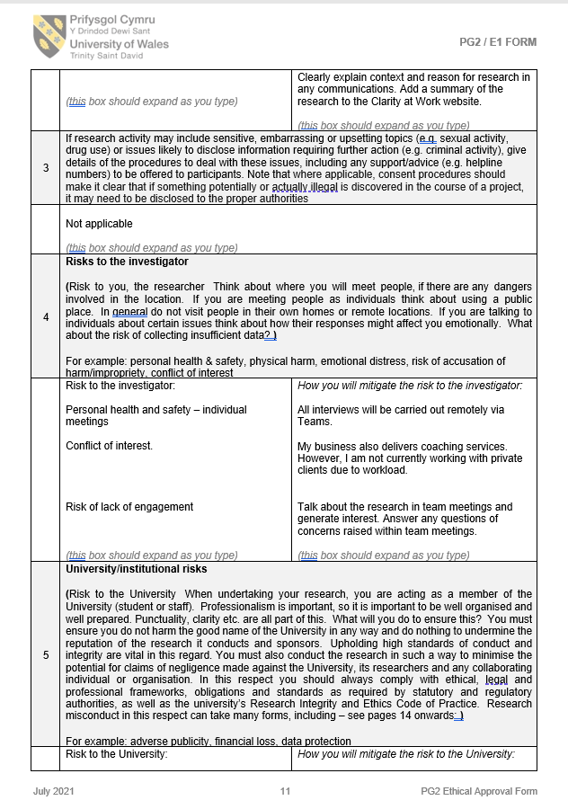

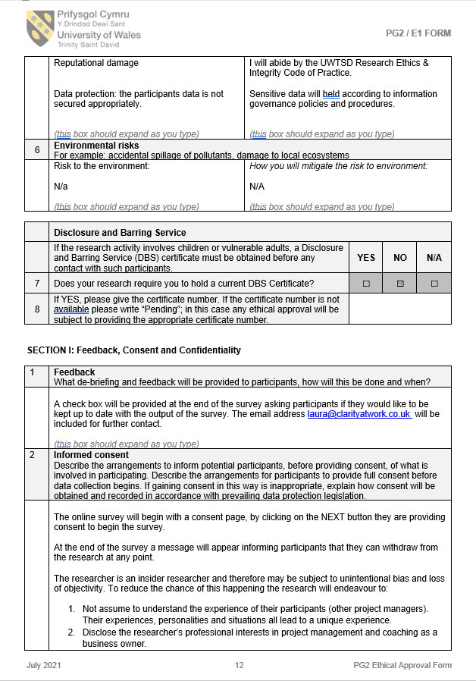

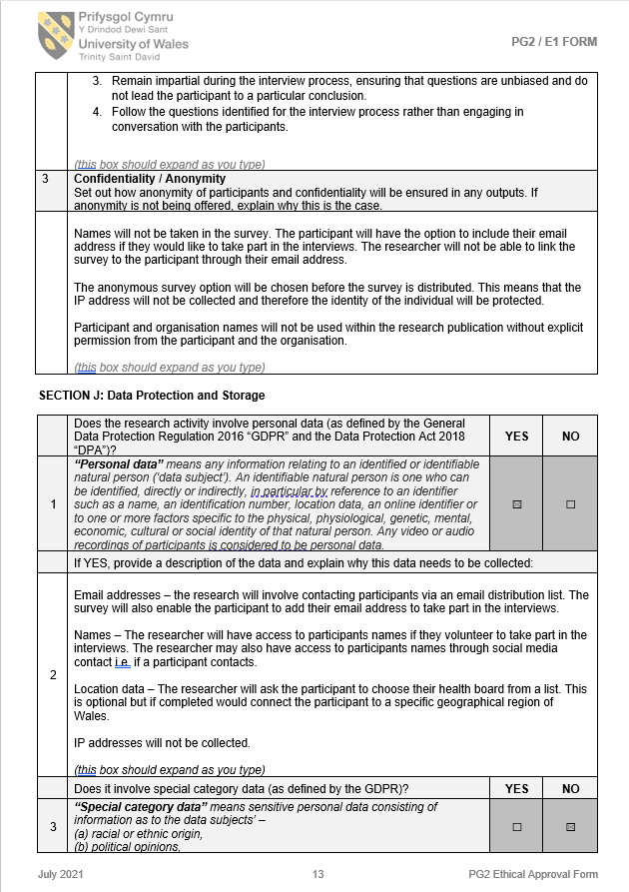

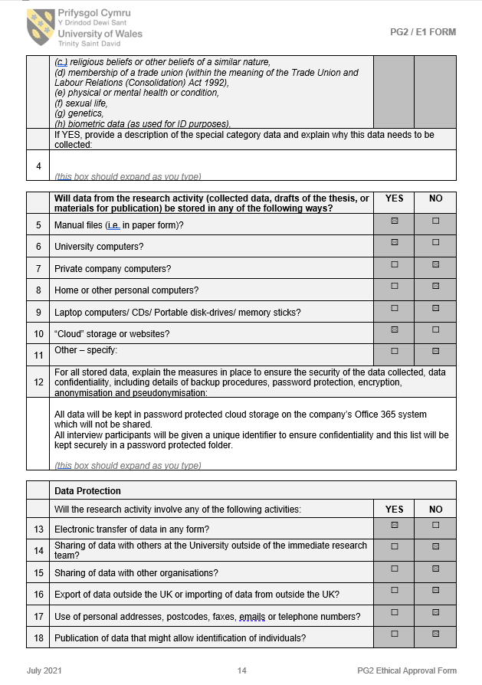

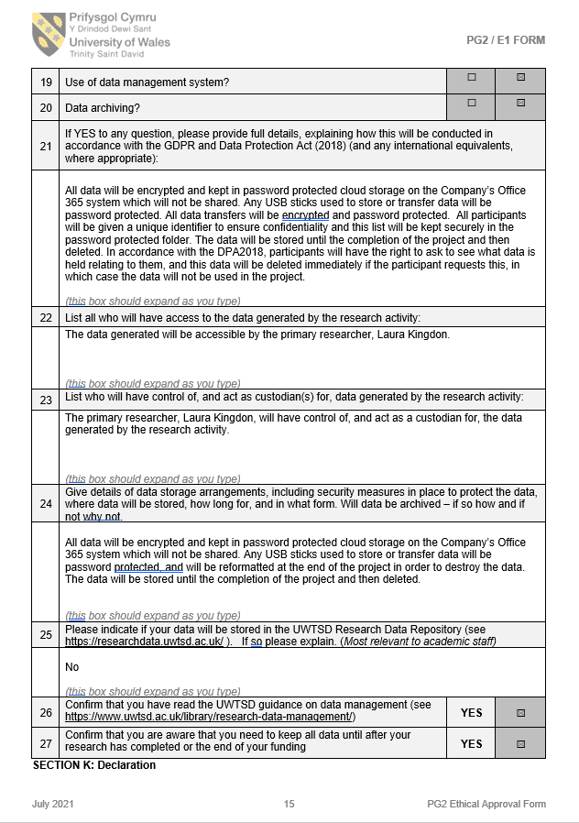

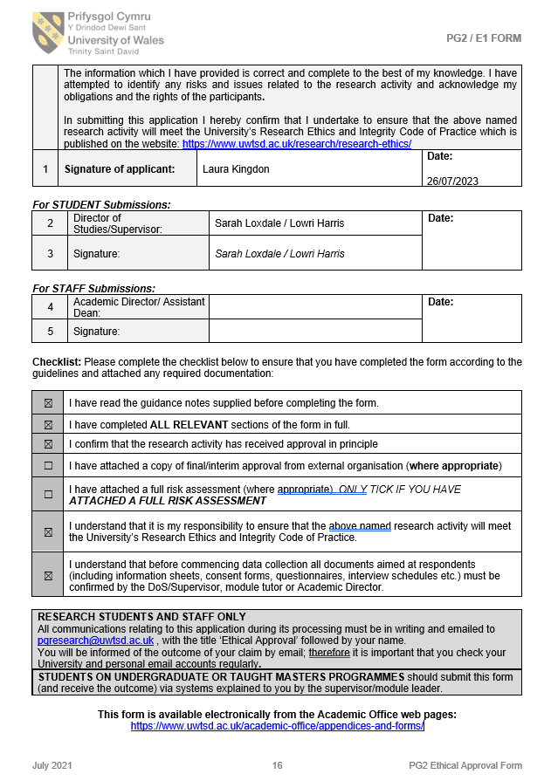

Appendix B: Manager Approval
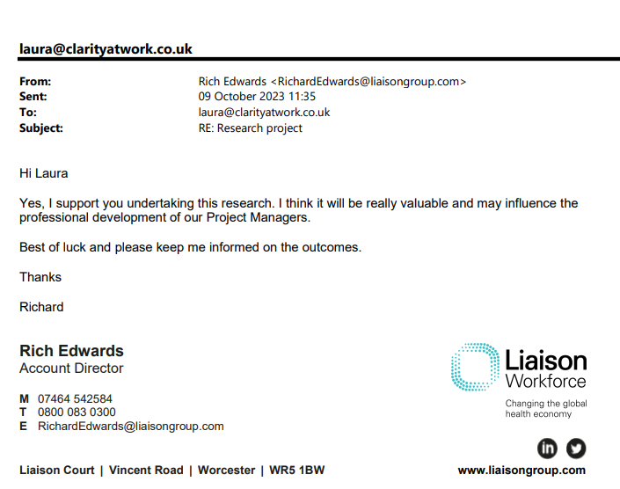

Appendix C: Survey Questions

- What is your age range?
- What is your gender identity?
- What is the highest level of education you have completed?
- How many years project management experience do you have?
- In your current (or last) project management role were you directly line managing employees?
- What types of projects have your delivered?
- Which project management methodologies do you practice?
- How do you perceive your listening skills as a project manager?
- How open and inclusive is your working environment?
- How frequently do you organise reflective sessions where feedback is actively sought?
- Do you recognise any of the following behaviours in yourself? When somebody is speaking to you, do you do any of the following? (Tick all that apply)
Interrupt before the person has finished speaking.
Shift the topic back to yourself.
Hurry the speaker.
Spend your time formulating a response.
Finish the person's sentence.
Forget what people have said.
Avoid eye contact.
Nod excessively.
Think about something else.
Forget people's names.
Feel that you can't wait to speak.
Remain passive and silent when they have finished speaking.
Exhibit unwelcome body language.
Undertake other tasks i.e. answer emails, instant message or use your mobile phone
- In project team meetings what percentage of the meeting involves you speaking?
- How do you perceive your listening skills as a project manager?
- How often do you clarify what you heard by repeating back what has been said to you?
- When you receive feedback on your listening skills, how do you typically respond?
- Have you undertaken any training in coaching or have you been coached yourself?

Appendix D: Interview Responses

Question 1:

Participant 1 described listening using the following phrases:

“Listening is when you’re waiting to talk. You’re registering the words. Listening is like a superficial thing.”

Participant 2:

“I don’t know. I hear the words that you're saying, but also will need to carry talking about it and check that we are actually on the same page. I am always trying to listen whether I do or not, I don't know.”

Participant 3:

“I think listening is picking the tone and the words together because to give you that understanding better. Listening is definitely a conscious act.”

Participant 4:

“It's not listening to the words, but the tones, the body language and stuff like that. To actually get an understanding of how people are when dealing with the project and the feeling you get when they’re in the team.”

Participant 5:

“Trying to understand the underlying message rather than the words being said.”

Participant 6:

“Hearing what is being said, the words and language used, the tone, observing the body language.”

Question 2: Interviewees were then asked what poor listening meant to them.

Participant 1

“When they're not doing the thing that I've asked them to do.”

Participant 2

“When they think they're doing one thing and you think they’re doing something else, and that usually ends badly.”

Participant 3

“If your page is full of doodles, you definitely know you haven't listened.”

Participant 4

“If you're in the middle of a conversation and and suddenly your mind wanders and you come back to it and the conversation has moved on four or five steps and it's like hang on I've missed a bit here.”

Participant 5

“You can hear what they're saying and not really get it.”

Participant 6

“It's those times where you‘ve switched off and you're not engaged anymore. You end up doing or thinking about something else.”
Question 3:

“Working remotely and through conference calls can make it very easy to get distracted and drift into email management or other things.”

“The environment, if it's noisy but also sometimes you can't choose your project team and therefore some members can be disruptive.”

“Laptops - people get easily distracted and it loses people’s attention “

“Having something else important on my mind distracting me”.

“Distracted by worries in work and at home.”

“I don’t think people are as focussed and present as they should be during conversations and meetings. Remote working makes it easier for people to also be checking emails, side chats in teams meetings, checking their phones etc “

Cultural behaviours:

“Poor role models across an organisation who don’t listening. General lack of confidence in Senior Leadership teams means that morale is low”.

“I’m not sure people truly enter into a conversation ready to listen, taking other people’s opinions on board, want to answer questions, think and consider options. There’s a lot of pressure whether it’s work, personal or both.”

“Managing perception and listening to multiple areas of concern from various parts of the business or public all of whom have urgent issue etc”.

“When people are only sharing barriers with no offer to consider possible solutions.”

“When people talk between each other in a meeting and ignore person speaking about intended topics.”

“Hate flummery and not getting to the point.”

“I find a lot of people can divert the conversation off topic - at these moments I struggle to stay silent and listen to what they have to say as I feel as though it is taking us off course.”

“People consciously or unconsciously shifting off topic, so I have to cut them off at the right point while allowing them to have their say.”

Unfamiliarity with the subject matter:

“Filtering what is important to know and what isn't.”

“The instinct to think that I can jump to a solution.”

“Remembering the things! I tend to lose focus in the middle of a conversation however hard I try. I don't always know people's names so I get lost and have to work it out later.”

“The time it takes to start from the same starting point of understanding as different stakeholders “

“Hard to not sideline listening, assume we know the answer and drive the project forward. “
Sacrificing effective listening, due to any of the barriers identified could potentially exacerbate those barriers further.

Appendix E: Presentation Slides



