Assignment Submission Document

Module: L4 - Learning in the Digital Era (ACCA4025)
Assignment: L4 M1 UCM AC Assignment 1
Name: Kes Sumner
Student ID: 2015409
Course name: Networking and Cyber Security Essentials

Contents

The E-portfolio 3
Task 1 – Written summary 3
Task 2 – Mind Map 4
Task 3 – Video presentation 5
Task 4 – Academic Poster 6

The E-portfolio

The URL for my E-portfolio website is:
https://kessumner.wixsite.com/e-portfolio
Screenshot of portfolio page:
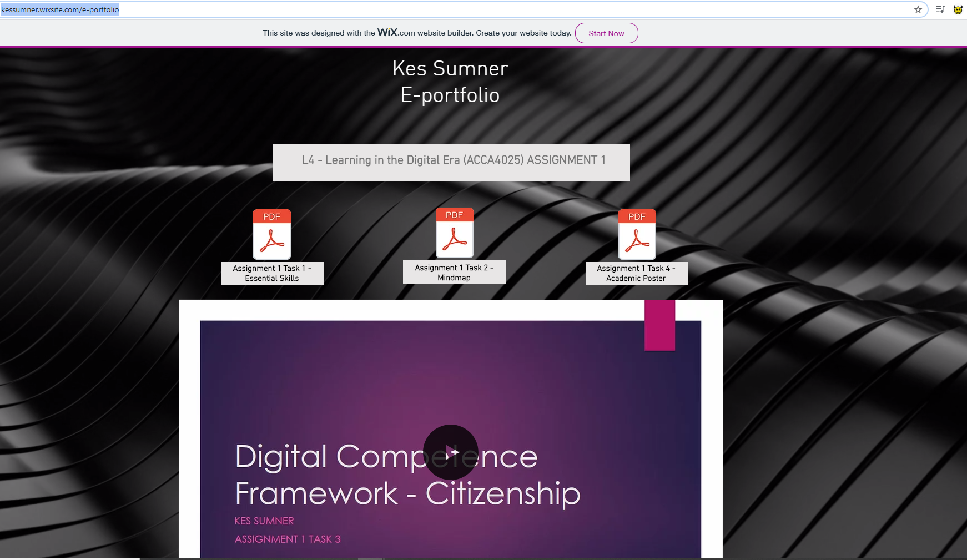

Task 1 – Written summary

Link to task 1 answer in e-portfolio: https://kessumner.wixsite.com/e-portfolio
Screenshot:

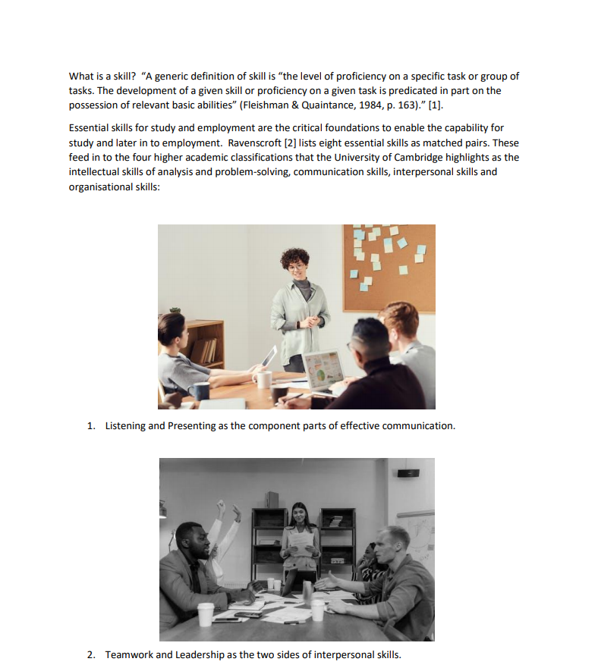

Task 2 – Mind Map

Link to task 2 answer in e-portfolio: https://kessumner.wixsite.com/e-portfolio
Screenshot:

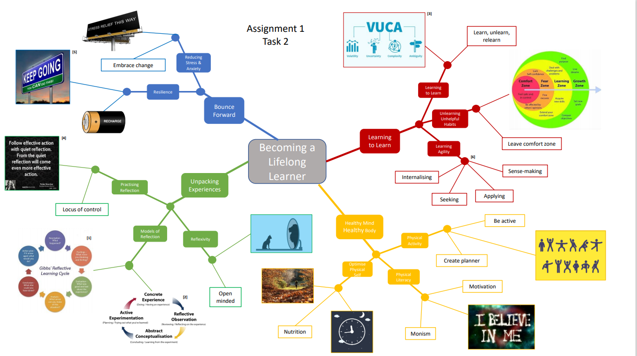

Task 3 – Video presentation

Link to task 3 answer in e-portfolio: https://kessumner.wixsite.com/e-portfolio
Screenshot:

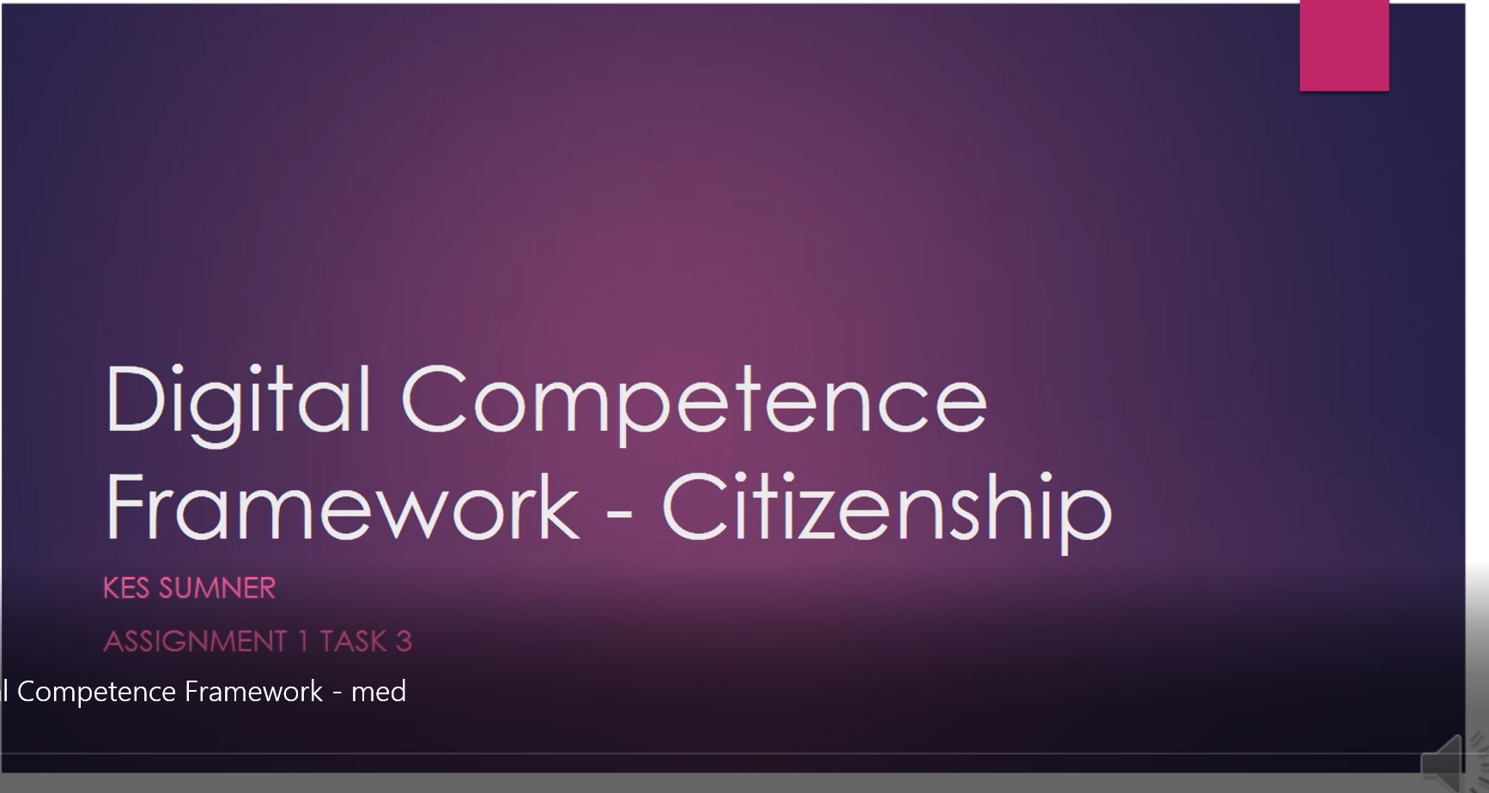

Task 4 – Academic Poster

Link to task 4 answer in e-portfolio: https://kessumner.wixsite.com/e-portfolio
Also, for the poster task, my tutor James did say that it was OK to work with family or friends if there were any problems with contacting assigned student group members, which is what I had to do in the end.
Screenshot:


