

International Business LCMB7014

Samsung International Business in Brazil

Student name: Elsa Almeida
Student Number: 1906940
Lecturer: Dr Hossein Shokri
Submission Date: 03 May 2023
Word Count: 6300
Table of Contents

Table of Contents 2
Introduction 3
Samsung’s Background 4
Samsung’s Objectives and Strategies 6
Countries’ Specifications 8
Home Country 8
Host Country 10
External Analysis 12
A Comparative PESTEL Analysis 12
Industry Five Forces 13
Market Analysis 14
Host Country Analysis 15
Country’s National Diamond 15
Country Business Risks 16
Internal Analysis 17
Global value chain 18
SWOT analysis 22
International Strategies 25
Entry Modes 26
Corporate Social Responsibility 27
Conclusion 30
References 31
Appendix 33
Appendix 1: PESTLE Analysis 33
(MarketLine, 2023) 35

Introduction

This report is about Samsung, and it will discuss and explain the company’s internationalisation strategies, by using various frameworks, it will analyse the management-specific, industry specific and country specific factors. Further it will discuss Samsung’s resources and capabilities in marketing, operations, and Human Resources Management in the international context. The report will also discuss the style of entry into the host country, which is Brazil. Brazil’s National Diamond and the business risk operating in Brazil. SWOT and PESTEL analysis, Industry Five Forces will be conducted, as well as Corporate Social Responsibility explained. Trade of commodities, services, technology, capital, and information across national borders and on a global or transnational scale is referred to as international commerce. Cross-border exchanges of services and goods among two or more nations are involved. For the goal of producing physical commodities and services like financing, banking, insurance, and building on a global scale, economic resources such as funding, skills, and people are traded. Globalisation and international business are two related terms. (Brooks, 2011).
International business can be a complex and challenging, but it can be rewarding for a company. By expanding into new markets, businesses can increase their sales, profits, and market shares. They can also learn new things and develop new skills. However, businesses that operate in multiple countries must be aware of the different cultural, legal, and regulatory environments. The company also has to be prepared to deal with the challenges of managing a global workforce (Brooks, 2011). Despite the challenges, international business is a growing field. The global economy is becoming increasingly interconnected, and businesses that want to succeed in the 21st century must be prepared to operate in a global marketplace.

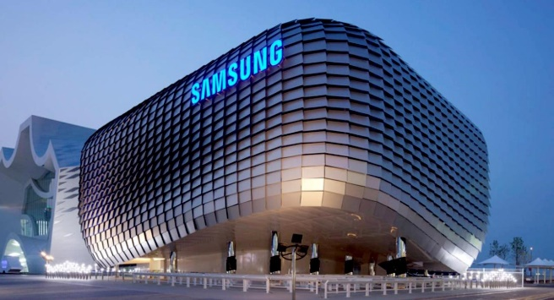

Source of Image: Samsung website, 2023

Samsung’s Background
Among the major producers of electrical items is the South Korean company Samsung. A broad variety of electronic devices for consumers and businesses, comprising systems with integrated circuits, digital media players, semiconductors, and appliances, are produced by Samsung. It currently occupies a key position in technology and accounts for roughly one-fifth of all South Korean exports. Lee Byung-Chull established Samsung on March 1st, 1938, as a grocery store. In the beginning, he traded with China and the surrounding areas, sending noodles and other products made in the Taegu region of Korea. "Three stars" is the name of the firm in Korean for Samsung. Following the Korean War, Lee broadened his company into the textile industry, ultimately creating Korea's largest woollen manufacturing facility. To aid in his nation's recovery from the war, he gave industry a lot of attention. His business benefited at that time from the new trade limitations the Korean government had implemented. By shielding them from competition and easing their access to finance, these policies intended to assist the nation's chaebol, or big domestic corporations. In the 1970s, the company expanded its textile manufacturing methods to cover the entire production line. Additionally, new subsidiaries like Samsung Heavy Industries, Samsung Shipbuilding, Samsung Precision Company, and Samsung Techwin were established (Samsung, 2019).
With several subsidiaries focused on the electronics industry, Samsung made its debut in that industry in 1969. Their first products were monochrome televisions. In the 1970s, the company began exporting home electronics products. Samsung already had a sizable South Korean manufacturing presence at the time, and it controlled 50% of the Korean semiconductor market.
In the 1970s and 1980s, Samsung's technological divisions rapidly expanded. In 1978, separate semiconductor and electronics branch as well as an aviation division were established. In 1985, Samsung Data Systems (now Samsung SDS) was established to address the growing need for systems development among businesses. Due to this, Samsung was able to quickly ascend to the top of the information technology services sector (Samsung, 2019) (Lotha, 2021).
Lee Byung-Chull's son Lee Kun-Hee took control after his death in 1987. There are five distinct companies inside Samsung. The 1990s saw Samsung continue to expand its presence in the world's electronics markets thanks to Lee Kun-Hee's cultural reform of the business. When the Samsung Galaxy smartphone series was first released in the 2000s, it quickly gained notoriety and became one of the most celebrated and well-liked smartphone lines globally. In the latter half of the nineteenth and early 20th centuries, Samsung was one of the world's largest producers of microprocessors, and it also supplied the CPUs for Apple's initial iPhone models. Since 2006, the company has dominated the global market for television manufacture (Bondarenko, 2021) (Samsung, 2019).
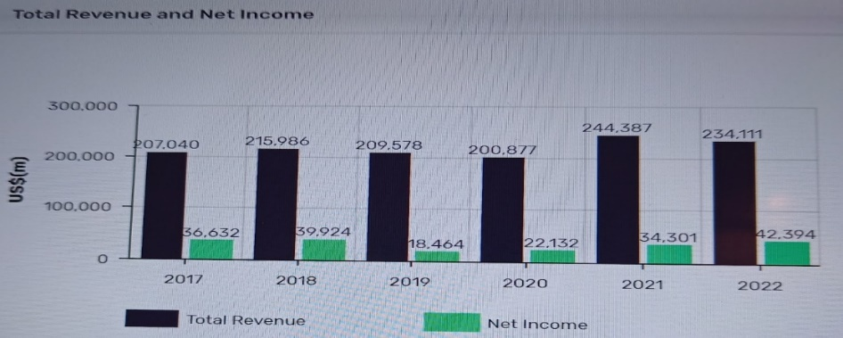
Source of image: Samsung annual report 2022

For the fiscal year that ended in December 2020, or Fiscal Year 2020, Samsung Electronics reported revenues of $203 billion, an increase over Fiscal Year 2019 of 2.7%. Pre-tax profits were $31.2 billion, up 16.3% from the previous fiscal year. Samsung Electronics, which operates factories and distribution networks in 74 countries, employs 300,000 people. (Samsung, 2023)

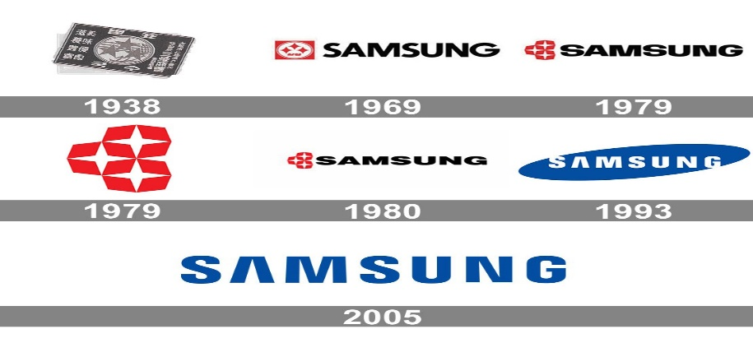
Evolution of the Samsung Logo, source of image Samsung webpage

Samsung’s Objectives and Strategies

Samsung follows a simple basic business strategy, utilising its knowledge and technology to create high-quality products and services that contribute to a more humane world. The innovative Samsung marketing strategy places a strong focus on utilising the power of excellent marketing campaigns to promote the brand's products and engage customers. Through sponsorships, online and social media advertising, the brand was strengthened (Samsung, 2023).
Throughout 2023, Samsung’s strategy is to change its emphasis to competing for the top rank and create competitive devices that will enable them to successfully compete against its lone significant opponent, Apple. By 2050, Samsung wants to use only renewable energy.
Samsung's objectives and strategies are focused on maintaining its leadership position in the global technology market. The company's core objectives include:
Innovation: Samsung is dedicated to delivering consistently innovative goods and services. The business makes significant investments in Research and Development (R&D), and it has a proven track record of introducing cutting-edge items to the market (Samsung, 2023)
Quality: Samsung products are known for their high quality and durability. The company has a rigorous quality control process in place, and it uses only the highest quality materials in its products (Samsung, 2023)
Customer satisfaction: Samsung is dedicated to giving its customers the best experience possible. The business provides a variety of assistance to customers and is always seeking ways to enhance its goods and services (Samsung, 2023).
Samsung's strategies for achieving its objectives include:
Investing in research and development: Samsung makes significant investments in R&D and has a proven track record of introducing cutting-edge technologies to the market. The firm focuses its research and development efforts on creating new technologies that will enhance the functionality, usability, and performance of its products Samsung, 2023)
Expanding into new markets: Samsung is constantly expanding into new markets. The company has a strong presence in the global markets, and it is always looking for new opportunities to grow its business. (Samsung, 2023)
Building partnerships: Samsung builds partnerships with other companies to develop new products and services. The company's partnerships allow it to leverage the strengths of other companies and to bring new and innovative products to market more quickly. (Samsung, 2023)
Branding: Samsung invests heavily in branding. The company has a strong brand identity, and it is recognized as a leader in the global technology market. Samsung's branding efforts help to build customer loyalty and to attract new customers. (Samsung, 2023)
Samsung's objectives and strategies have allowed it to become one of the most successful technology companies in the world. The company is a leader in the global market, and it is constantly innovating and expanding its business. Samsung is committed to providing its customers with the best possible experience, and it is well-positioned for continued success in the future. (Samsung, 2023

Countries’ Specifications
Home Country (South Korea)
A nation in East Asia, South Korea, or the Republic of Korea (ROK), is situated on the southern tip of the Korean Peninsula. North Korea, the East Sea, the Yellow Sea, and the Sea of Japan all about it on its northern, eastern, western, and southern borders, respectively. South Korea has a population of over 51 million people and is a country having a high level of living that is developed. The capital of South Korea is Seoul. South Korea is a major economic power and is one of the world's leading exporters of electronics, automobiles, and shipbuilding. South Korea is also a major tourist destination, known for its beautiful scenery, delicious food, and vibrant culture. (MarketLine, 2023)
Here are some of South Korea's key specifications:
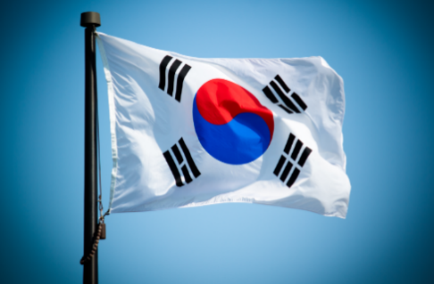
Capital: Seoul
Population: 51,712,545 (2022 est.)
Area: 100,210 km² (38,690 sq. mi)
Languages: Korean (official)
South Korea is a developed country with a stable political and legal system. However, there are still some risks that businesses should be aware of when operating in South Korea.
Political risks:
North Korea has a history of aggression against South Korea, and there is always the risk of renewed hostilities.
Trade disputes:
South Korea is a member of the World Trade Organization (WTO), however it has been involved in a number of trade disputes with other countries, such as the United States and Japan. These disputes can lead to tariffs and other trade barriers, which can hurt businesses that operate in South Korea.
Labor unrest:
South Korea has a strong labor movement, and there is a history of labor unrest. Therefore, strikes and lockouts can disrupt business operations.
Legal risks:
Complex and ever-changing laws, South Korea has a complex and ever-changing legal system. Thus, it can create difficulty for businesses to comply with all of the applicable laws and regulations. Difficult to enforce contracts: therefore, it can be difficult to enforce contracts in South Korea, as the legal system is often slow and inefficient.
High litigation costs: Litigation costs in South Korea are high, which can make it expensive for businesses to resolve disputes.
Economic risks:
High household debt: South Korean households have high levels of debt, which makes them vulnerable to economic shocks.
Fluctuating exchange rates: The South Korean won is a volatile currency, which can make it difficult for businesses to hedge their foreign exchange risk.
Dependence on exports: South Korea's economy is heavily dependent on exports. If exports decline, it can have a negative impact on the overall economy.
Therefore, it is important for businesses to carefully consider these risks before operating in South Korea. By doing so, businesses can mitigate the risks and increase their chances of success. (MarketLine, 2023)
Host Country (Brazil)
Brazil is the biggest nation in South America and the fifth largest in terms of land area in the entire planet. It is bordered by all other South American countries except Ecuador and Chile. Brazil has a population of over 212 million people and is a federal republic. The capital of Brazil is Brasília. Brazil is a diverse country with a wide range of climates, landscapes, and cultures. The Amazon rainforest, the world's largest rainforest, is located in Brazil. Brazil is also home to the Pantanal, the world's largest wetland, and the Cerrado, the world's largest savanna. Brazil is a major economic power and is one of the world's leading producers of coffee, soybeans, and iron ore. Brazil is also a major exporter of airplanes, automobiles, and other manufactured goods. (MarketLine, 2023)
Brazil is a member of the United Nations, the G20, and the BRICS. Brazil is a rising power in the world and is seen as a potential global leader. (MarketLine, 2023)
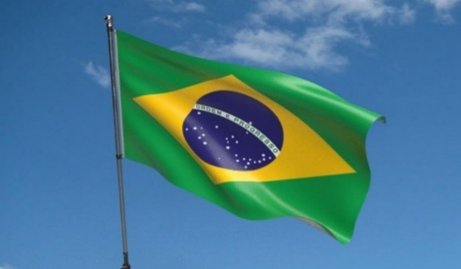
Here are some of Brazil's key specifications:
Capital: Brasília
Population: 212,559,917 (2023 est.)
Area: 8,515,767 km² (3,300,145 sq mi)
Languages: Portuguese (official), English, Spanish, Italian, German, French.
Brazil is a large and diverse country with a complex political and legal system. As a result, there are a number of risks that businesses should consider, when operating in Brazil.
Political risks:
Brazil has endured decades of political unrest, with numerous changes to its administration and public policies. As a result, it may be challenging for firms to plan long-term and operate. Furthermore, corruption is a major problem in Brazil, and it can affect businesses in a number of ways, such as through bribery, extortion, and regulatory capture. As well the country suffer from labor unrest is also a problem in Brazil, and it can lead to strikes, lockouts, and other disruptions to business operations. (MarketLine, 2023)
Legal risks:
Brazil has a complex and ever-changing legal system, which can make it difficult for businesses to comply with all of the applicable laws and regulations. And it can be difficult to enforce contracts in Brazil, as the legal system is often slow and inefficient. As well Brazil has high tax rates, which can put a strain on businesses' profitability. (MarketLine, 2023)

Economic risks:
Brazil has a history of high inflation, which can make it difficult for businesses to plan and budget. Furthermore, the Brazilian real is a volatile currency, which can make it difficult for businesses to hedge their foreign exchange risk. Also, Brazil has high interest rates, which can make it expensive for businesses to borrow money. It is important for businesses to carefully consider these risks before operating in Brazil. By doing so, businesses can mitigate the risks and increase their chances of success. (MarketLine, 2023)

External Analysis

A Comparative PESTEL Analysis
A PESTLE analysis is a technique for understanding an industry's environment in great detail. PESTLE components stand for Political, Economic, Social, Technological, Legal, and Environmental elements. A firm will benefit from knowing the variables that might influence a new industry or business. Management must gather data on the external pressures impacting the organisation in order to identify the factors that might present opportunities or hazards to the organisation (Whittington, 2020) (Brooks, 2011).

Industry Five Forces

Source of Image, created by Author.
The basis for this theory is the idea that there are at least five forces at play when determining a market's appeal and degree of competition. How power is distributed in a corporate context may be determined using the Porter's Five Forces model. This is useful for assessing the effectiveness of any possible initiatives as well as the competitiveness of a company's current operations.
Porter's five forces are frequently used by strategic analysts to evaluate the chances for new goods and services. Knowing where power is focused may help you find your strengths, improve your weaknesses, and avoid mistakes. (Michaux, 2015)
1. The influence of vendors, a measurement of how easy it is for service providers to raise costs. This is determined by the number of providers for each important input, the uniqueness of the good or service, the supplier's ability to compete on price, and the cost of switching between resources (Michaux, 2015).
2. Financial capacity, an assessment of how easy it is for consumers to reduce costs. Market participants, providers from each input source for the business, as well as the costs incurred by the buyer when switching suppliers, each influence this. When a business only has a few clients, standards-setting is common practise (Michaux, 2015).
3. Success of rivals in the industry: The market will become less alluring if there are many companies selling similar goods and services (Michaux, 2015).
4. The possibility of substitutes, when a market offers products that are nearly identical to a substitute, consumers seem to be more likely to transfer to alternatives in response to price increases. The industry's attraction and provider strength are weakened as a result (Michaux, 2015).
5. There is a risk from visitors, profitability declines as new rivals enter prosperous markets. Unless leaders address significant and long-term barriers to competition, including trademarks, scale economies, capital limits, or governmental laws, profitability will fall below competitive price. (Michaux, 2015)
The trade, tax, and regulation policies of the government may constitute a sixth element in many businesses.

Market Analysis
Samsung's competitors are fierce in the construction, mobile, computer, and electronics industries. In the electronics market, Samsung is in competition with Sony and LG. These competitors provide for sale a variety of household products, such as televisions, fridges, photographic equipment, speakers, disc video players, and other items. As a result of these competitors' products dominating the global markets, Samsung's products face intense rivalry from them.. Samsung's rivals in the computer sector include Apple, Dell, HP, Lenovo, Toshiba, and Acer. These rivals produce desktops, laptops, and tablets, which are the three main types of computers sold on international markets (BusinessEssay, 2023).
Apple also offers unique operating systems for PCs and cell phones, such as MacOS and iOS, respectively. As a result, Apple is a fierce competitor of Samsung. Samsung is up against the strongest competition in the mobile market as a result of the emergence of smartphones. Apple, Huawei, and Motorola are Samsung's key competitors in the smartphone industry. Apple is a big adversary of Samsung due to the availability of the iPad and iPhone, which are separate devices due to their operating system and design. In the construction industry, Samsung Heavy Industries competes with its top rivals from the shipbuilding industry, Mitsubishi Heavy Industries, China Shipbuilding Corporation, and Hyundai Heavy Industries (BusinessEssay, 2023).

Host Country Analysis
Country’s National Diamond – BRAZIL
Michael Porter's national diamond advantage is a theory of international trade that attempts to explain why certain countries are more successful than others in certain industries. The theory is based on the idea that a country's competitive advantage in an industry is determined by four factors:
Factor conditions: These are the natural resources, infrastructure, and skilled labor that are available in a country.
Demand conditions: These are the size and sophistication of the market for a particular product or service.
Related and supporting industries: These are the other industries that are closely related to the industry in question.
Firm strategy, structure, and rivalry: These are the factors that determine how firms in a particular industry compete with each other.
The theory argues that a country's competitive advantage is strongest when all four of these factors are favourable. For example, a country with abundant natural resources, like Brazil, as well as a large and sophisticated market, a strong cluster of related and supporting industries, and a competitive business environment is likely to be very successful in industries that use those resources.
Porter's national diamond advantage has been used to explain the success of countries in a wide range of industries, including automobiles, electronics, and pharmaceuticals. The theory has also been used to help policymakers develop strategies to improve a country's competitiveness.
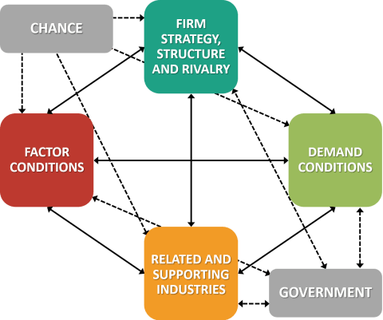
Source of image: (Bruin, 2018)

Country Business Risks BRAZIL
Brazil is a large and diverse country with a growing economy. However, it also faces a number of business risks, including:
Political instability: Brazil has a history of political instability, which can lead to uncertainty for businesses (MarketLine, 2023).
Economic volatility: Brazil's economy is volatile, which can make it difficult for businesses to plan for the future (MarketLine, 2023).
Corruption: Corruption is a major problem in Brazil, which can make it difficult for businesses to operate fairly (MarketLine, 2023).
High taxes: Brazil has high taxes, which can make it difficult for businesses to be profitable (MarketLine, 2023).
Inefficient bureaucracy: Brazil's bureaucracy is inefficient, which can make it difficult for businesses to get things done (MarketLine, 2023).
High crime rates: Brazil has high crime rates, which can make it difficult for businesses to operate safely (MarketLine, 2023).
Environmental risks: Brazil is facing a number of environmental risks, such as deforestation, like the wildfires in the Amazon and pollution (MarketLine, 2023).
Despite these risks, Brazil is a large and growing economy with a lot to offer businesses. Therefore, businesses that are aware of the risks and take steps to mitigate them can be successful in Brazil. Furthermore, it is important to build relationships with local businesses and government officials. This will help you to understand the local culture and to navigate the bureaucracy. However, sometimes it can take time to build a successful business in Brazil, but Samsung has been in Brazil since 1995, for 28 years.

Internal Analysis
An extensive examination of a business's internal components, including both the physical and the intangible ones like workers, assets, and procedures, constitutes an internal strategic factor. The internal analysis aids a company in identifying areas that require enhancement and an effective corporate objective or business plan. To gain a competitive advantage, an organization's environment is examined through an internal examination of its resources, assets, traits, capabilities, and skills. An internal analysis comprises of five key components: Assets, skills, competitive capacity, relative position, and tactical competitiveness are a few examples of strategic competitiveness. Each component lays the groundwork for the subsequent one that comes after it (Whittington, 2020).
Internal assessments are made of an organization's health. It provides crucial information on both its strong and weak points. and alerts to potential issues. Organisations function in the dark without an internal study, which might wind up costing them a lot of money down the line. Information on the organisation’s capabilities is required to pinpoint possible growth opportunities and warn against potential threats. The group may make success and development strategies using this knowledge. (Whittington, 2020).

Global value chain

A tool for assessing each activity in a company's value chain to determine where improvements may be made is called a value chain assessment. It is a group of things that the organisation does (Porter, 2015). By using a value chain model, the organisation is forced to think about how each step enhances or detracts from the service or product. The value chain explains the many divisions inside an organisation, and these all combine to provide a good or a service. The organisation must provide value to its consumers to gain a competitive edge, and managers must recognise the significance of each operation in terms of its potential to provide value or not (Porter, 2015).
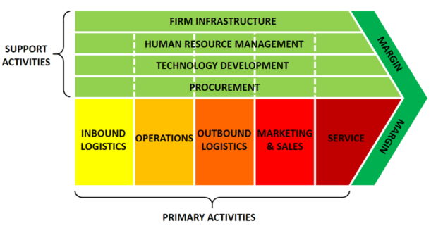
Source of image: (Bruin, 2018)

- Global Production
Global production is the process of producing goods or services in different countries. This can be done through outsourcing, offshoring, or a combination of the two. Outsourcing is the process of hiring a company in another country to perform a specific task. Offshoring is the process of moving production to another country, as Samsung done, opening site in Brazil. Access to new markets and sell their products to a wider range of customers (Porter, 2015). Reduced costs, by outsourcing or offshoring, companies can reduce their costs. This is because labor costs are often lower in other countries, Brazil has a low labor cost for Samsung (Porter, 2015).
It can increase efficiency by breaking down production into different stages and performing each stage in the country where it is most efficient (Porter, 2015). As well as it can improved quality, this is because companies in other countries may have access to better technology or expertise (Porter, 2015) (Rugman, 2012).
Global value chains and global production have a number of benefits for companies. However, they also have some challenges. These challenges include increased complexity as it can be complex to manage. This is because companies need to coordinate the activities of different companies in different countries (Porter, 2015). Also, it can increase risk because companies are more reliant on other companies, and they may be exposed to political and economic risks in other countries. Furthermore, it can increase competition, because companies are competing with companies from all over the world (Porter, 2015). But despite the challenges, global value chains and global production are becoming increasingly important (Rugman, 2012).

- Global Marketing
Global marketing is the process of marketing products or services to customers in different countries. This can be done through a variety of channels, such as advertising, public relations, and sales (Porter, 2015).
Another key factor to remember is that there are a number of challenges that companies face when participating in global value chains and global marketing. These challenges include, cultural differences and companies need to be aware of cultural differences when marketing their products or services in different countries (Rugman, 2012). For example, what is considered appropriate advertising in one country may be offensive in another (Porter, 2015). As well as the language barriers, an organisation need to be able to communicate effectively with customers and workers in different countries. This may require translating marketing materials into different languages (Porter, 2015).
Another factor is the legal and regulatory differences, for example, what is considered acceptable product labelling in one country may be illegal in another. The competition since they are competing with companies from all over the world. This means that they need to be able to offer products or services that are competitive in terms of price, quality, and features (Porter, 2015). Despite the challenges it can be very rewarding for companies.
- Global HRM
Global human resource management (HRM) is the process of planning, organising, directing, and controlling the activities of people in a multinational organization. It is the strategic and integrated approach to managing people in a global context (Porter, 2015).
Global HRM is important because it helps organizations to achieve their strategic goals by, attracting and retaining the best talent, regardless of location. Developing and managing a global workforce that is aligned with the organisation's culture and values.
And ensuring that employees have the skills and knowledge they need to be successful in a global environment. Managing employee relations in a way that is fair and equitable for all employees, regardless of location (Porter, 2015). The organisation needs to comply with all applicable labor laws and regulations in all countries where the organisation operates (Porter, 2015).
There are a number of challenges that organizations face when implementing global HRM practices. These challenges include cultural differences, organisations need to be aware of cultural differences when managing people from different countries, because what is considered acceptable behaviour in one country may be offensive in another (Porter, 2015). The language barriers, organisations need to be able to communicate effectively with employees from different countries. This may require translating HR policies and procedures into different languages. And the legal and regulatory differences, organisations need to be aware of the legal and regulatory requirements in all countries where they operate. Time zone differences, organisations need to be able to manage employees who are located in different time zones (Rugman,2012).This can be challenging when it comes to scheduling meetings and communicating with employees (Porter, 2015). Technology challenges, organizations need to use technology to support global HRM practices. This includes using technology to communicate with employees, manage employee data, and comply with labor laws (Porter, 2015).
Despite the challenges, global HRM is essential for organisations that operate in multiple countries. By implementing global HRM practices, organisations can attract and retain the best talent, develop a global workforce that is aligned with the organisation's culture and values, and ensure that employees are successful in a global environment.

SWOT analysis

You may assess these four aspects of your business using a SWOT analysis. Strengths, Weaknesses, Opportunities, and Threats is referred to as SWOT. SWOT analysis is a method that may help you find your company's present strengths and create a successful strategy. (Johnson, 2017)
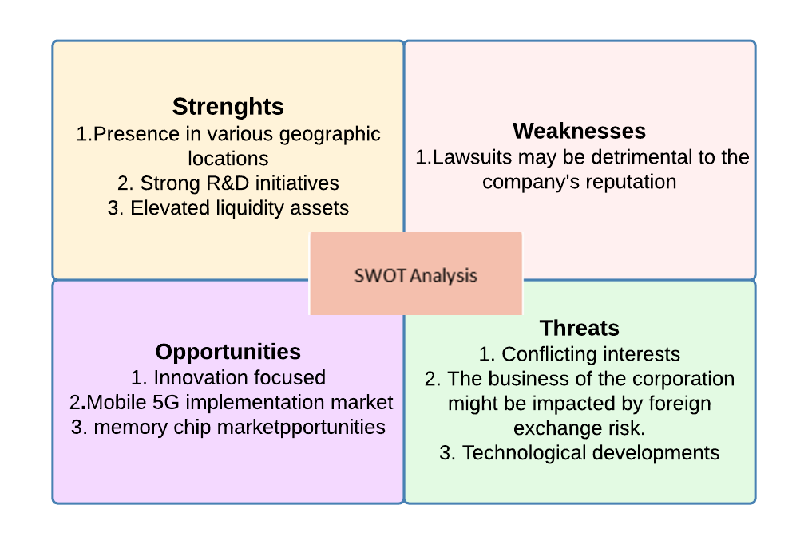
Image created by Author
Strengths
Samsung has operations in several nations. As of December 2021, the company had 228 subsidiaries across the world. The organisation splits its business operations into five geographical regions: China, Korea, the Americas, Europe, Asia, and Africa. In Fiscal Year 2021, the Americas accounted for 35% of the company's total revenue, followed by Europe (18%), China (16.3%), Asia and Africa (15%), Korea (15.7%), and the rest of the world (15%). The company is less susceptible to risks particular to certain markets because of its large global presence. It also provides Samsung with benefits including cost reductions from economies of scale (MarketLine, 2023).
Samsung gives its research and development initiatives a lot of attention. Its research and development efforts are concentrated on developing cutting-edge new technologies and goods as well as enhancing the functioning of ones that already exist. Additionally, it has excellent AI research and development capabilities. (MarketLine, 2023).
A high current ratio was recorded by Samsung throughout the evaluation year. At the conclusion of the company's fiscal year in 2021, its current ratio was 2.5. A higher current ratio gives Samsung an edge, allowing it to seize prospective market opportunities (MarketLine, 2023).
Weaknesses
In a number of legal issues, Samsung is a respondent. Such legal conflicts may harm the company's reputation and erode customer trust. (MarketLine, 2023).
Opportunities
The company, which prioritises innovation, has introduced a variety of novel goods and innovations that are expected to increase its operational efficacy in the market (MarketLine, 2023).
The optimistic forecast for the memory chip business reflects well for the company. The worldwide semiconductor industry is anticipated to increase to us$708.7 billion by 2025, according to internal research (MarketLine, 2023).
The increased need for speedier mobile data connectivity brought on by the development of the Internet sector, smartphone video consumption, and communication services will hasten the adoption of mobile 5G networks. According to internal research, 2.7 billion or 26.3% of the mobile phone population globally will be 5G-enabled by the year 2025 (MarketLine, 2023).
Threats
Samsung faces threats from ferocious competition and escalating commoditization in the mobile sector. Its mobile gadgets face fierce competition on a global scale. The growing need for cellular internet connectivity has had a significant influence on the competitive landscape of the mobile sector (MarketLine, 2023).
Due to its numerous currency exposures, particularly those to the US, the European Union, South America, Japan, and other Asian countries, the company is vulnerable to foreign exchange risk. When international transactions are converted, the company's annual financial statements, working capital, and income statement may be impacted by currency exchange rate variations (MarketLine, 2023).
Samsung may be at risk from rapid technological development. The IT services and products sector, in which Samsung operates, is impacted by a number of issues, including the demand for new and enhanced product specifications, evolving standards in the industry, and changes in how technology items are supplied and/or maintained. While technological advancement, a characteristic of the IT industry, is primarily what drives demand for new products. Furthermore, it renders the current items obsolete. Additionally, if the company is unable to adequately adapt to the launch of different methods of delivery services for hardware and office supplies, future operational performance may suffer (MarketLine, 2023).

International Strategies
The initial step in most organisation’s global development plans is often an international strategy, which includes either importing or exporting products and services abroad while keeping their corporate headquarters in their home nation (Collis, 2014).
Companies may decide to make investments in the markets they are targeting as they expand and scale. An international strategy is a plan that guides a company's activities in multiple countries. It is important for companies to have an international strategy because it helps them to identify and exploit opportunities in new markets. Reduce costs by operating in multiple countries and increase efficiency by coordinating activities across multiple countries (Collis, 2014). As well it can improve risk management by spreading their operations across multiple countries. (Collis, 2014) (Daniels, 2019).
Samsung has spread their operations into various markets globally. Being Brazil one of the countries where they have expanded into since 1995.
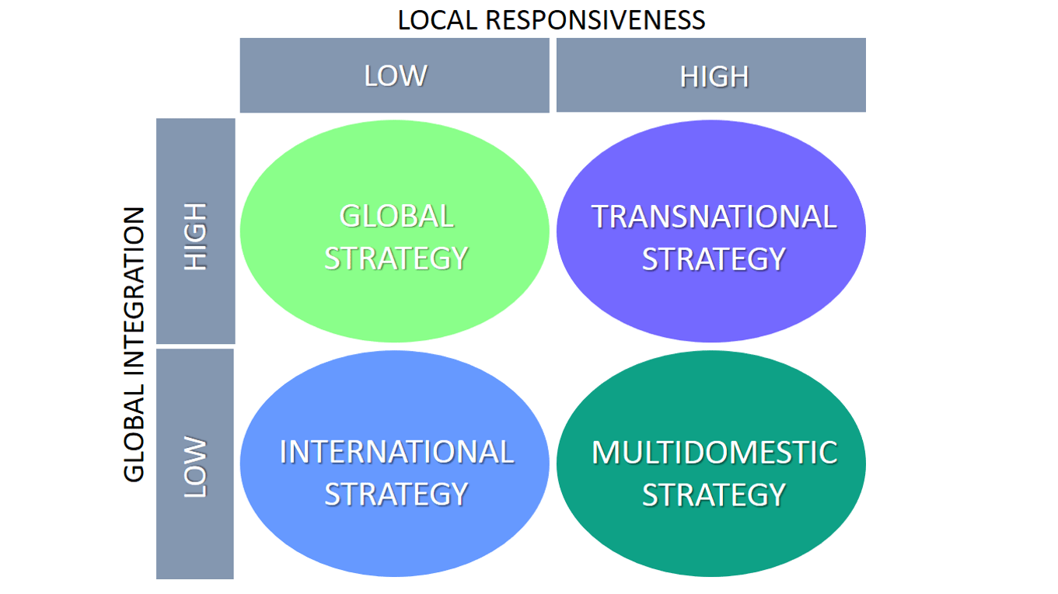
Source of image: (De Bruin, 2017)

Entry Modes
The mode of entrance refers to the approach or channel a company uses to enter a foreign market. A corporation can choose from a range of different entry points to expand. A corporation could break into a new market in a variety of ways. A company's optimal entrance strategy will rely on a variety of elements, including its size, resources, and target market (Daniels, 2019).
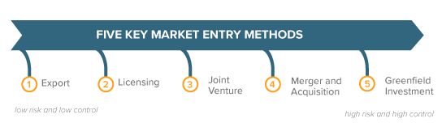
Some of the most common entry modes include:
Exporting: This is the simplest form of international expansion. Companies export their products or services to other countries (Daniels, 2019).
Licensing: This is a strategy in which a company grants another company the right to use its intellectual property, such as patents, trademarks, or copyright (Daniels, 2019).
Franchising: This is a strategy in which a company grants another company the right to use its name, trademark, and business model. (Daniels, 2019).
Joint ventures: This is a strategy in which two or more companies form a new company to operate in a particular market. (Daniels, 2019).
Direct investment: This is a strategy in which a company invests in its own operations in another country. (Daniels, 2019). Samsung has done direct investments globally operating in several countries globally, being Brazil one of the countries.
Each of these entry modes has its own advantages and disadvantages. For example, exporting is a low-risk strategy, but it can also be low-reward. Licensing can be a good way to enter a new market without a lot of investment, but it can also give up control of the company's intellectual property. Franchising can be a good way to scale a business quickly, but it can also be difficult to control the quality of the franchisees' operations. Joint ventures can be a good way to share the risks and rewards of entering a new market, but they can also be difficult to manage. Direct investment is the riskiest entry mode, but it can also be the most rewarding. (Daniels, 2019). The best way to choose an entry mode is to consider the company's specific situation and goals. There is no one-size-fits-all answer.

Corporate Social Responsibility
The method or route a business takes to join a foreign market is referred to as the mode of entry. A company has a variety of access points from which to pick when expanding. A company may enter a fresh market in a number of ways. The best entry approach for a firm will depend on a number of variables, such as its size, materials, and target market. This can be done through a variety of means, such as:
Environmental responsibility, organisations can reduce their environmental impact by using sustainable materials, reducing waste, and conserving energy (Lee, 2019).
Social responsibility, organisations can support social causes by donating to charities, volunteering their employees' time, and providing fair wages and working conditions.
Ethical responsibility, organizations can operate ethically by following all laws and regulations, and by treating their employees, customers, and suppliers with respect.
There are many benefits to organisations that embrace social responsibility. These benefits include improved brand image, consumers are increasingly looking for businesses that are socially responsible, by embracing social responsibility, organisations can improve their brand image and attract more customers (Lee, 2019).
Furthermore, it can increase employee’s morale, as employees are more likely to be happy and productive when they feel like they are working for a company that is making a positive impact on the world. As well as reduce risk of boycotts or other negative publicity because organisations that are socially responsible are less likely to be the targeted (Lee, 2019).
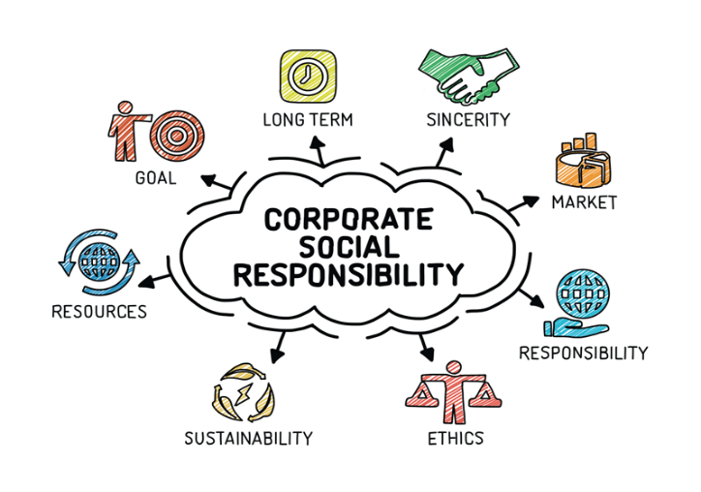
Source of image: (Jackson, 2021)

These organisations can equally increase their profitability, as studies have shown that socially responsible organisations are often more profitable than their less socially responsible counterparts. Overall, organisation's social responsibility is a good business decision. It can help organisations improve their brand image, attract more customers, increase employee morale, reduce risk, and increase profitability (Lee, 2019).
‌Samsung Electronics has emphasised sustainability since 2021 while managing its business interests. It significantly improved its sustainability governance to achieve this.
Samsung Electronics strives to offer ecologically friendly products to its customers. It has developed eco-friendly technologies such mobile phones and monitors constructed from recycled fishing nets and trash from the ocean in addition to brand-new, low-power semiconductors in support of these programmes. Additionally, it has developed AI-powered SmartThings Energy, a software programme that helps preserve energy by utilising a power-saving feature that technologically advanced home gadgets are equipped with, as well as Solar Cell Remote Controls, which can be recharged by sunlight or indoor lighting. Additionally, the company aims to only use renewable energy for its operations (Samsung Newsroom, 2022).
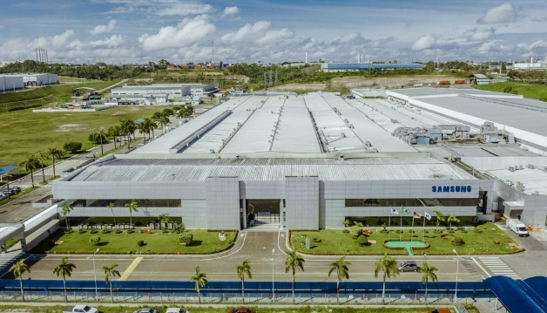

Source of Image: Samsung (Brazil)

Conclusion

This report was about Samsung, in the international contest with Brazil has the host country, and it discussed and explained the company’s internationalisation strategies, by using various frameworks, it analysed the management-specific, industry specific and country specific factors. Further it discussed Samsung’s resources and capabilities in marketing, operations, and Human Resources Management in the international context. The report also discusses the style of entry into the host country, which is Brazil. Brazil’s National Diamond and the business risk operating in Brazil. SWOT and PESTEL analysis, Industry Five Forces was conducted, as well as Corporate Social Responsibility of Samsung was explained.

References
Bondarenko, P. (2021). Samsung | History & Facts. In: Encyclopædia Britannica. [online] Available at: https://www.britannica.com/topic/Samsung-Electronics.

Bruin, L. (2018). Porter’s Diamond Model EXPLAINED with EXAMPLES | B2U. [online] B2U - Business-to-you.com. Available at: https://www.business-to-you.com/porter-diamond-model/.

Bruin, L. (2018). Value Chain Analysis EXPLAINED with EXAMPLES | B2U. [online] B2U - Business-to-you.com. Available at: https://www.business-to-you.com/value-chain/.

Brooks, I. (2011) The international business environment: challenges and changes. Second edition. Harlow, England:, Financial Times/Prentice Hall.
Business-Essay.com. (2023). Samsung Company: Business and Economic’ Analysis | Business Paper Example. [online] Available at: https://business-essay.com/samsung-company-business-and-economic-analysis/.
BusinessEssay. (2023) 'Samsung Market Analysis: Business & Economics'. 10 January. (Accessed: 2 April 2023).
Collis, D. (2014). International Strategy: Context, Concepts and Implications. United Kingdom: Wiley.

Daniels, J. (2019) International business: environments & operations. Sixteenth edition, global edition. Harlow, England:, Pearson.
De Bruin, L. (2017). International Business Strategy Explained with Examples | B2U. [online] B2U - Business-to-you.com. Available at: https://www.business-to-you.com/international-business-strategy/.

Jackson, R. (2021). Corporate Social Responsibility - A Simple Guide. [online] TheGivingMachine. Available at: https://www.thegivingmachine.co.uk/blog/posts/corporate-social-responsibility-a-simple-guide/.

Lee, Y.W. (2019) ‘Enhancing shared value and sustainability practices of global firms: The case of Samsung electronics’, Strategic Change, 28(2), pp. 139–145. Available at: https://doi.org/10.1002/jsc.2255
Lotha, G. (2021) Lifewire - The History of Samsung (1938-Present).
‌MarketLine, (2023). Available at: https://advantage-marketline-com.ezproxy.uwtsd.ac.uk/Analysis/details/samsung-value-chain-analysis-141642
[Accessed 20 Mar. 2023]

MarketLine, (2023). Available at: https://advantage-marketline-com.ezproxy.uwtsd.ac.uk/Analysis/details/country-analysis-report-brazil-in-depth-pestle-insights-25875 [Accessed 24 Apr. 2023].

MarketLine, (2023). Available at: https://advantage-marketline-com.ezproxy.uwtsd.ac.uk/Analysis/details/country-analysis-report-south-korea-in-depth-pestle-insights-25875 [Accessed 24 Apr. 2023].

MarketLine (2023). Available at: https://advantage-marketline-com.ezproxy.uwtsd.ac.uk/Company/Summary/samsung_electronics_co_ltd [Accessed 3 April 2023].

Michaux, S. (2015) Porter’s five forces. Namur. Lemaitre Publishing
Porter, M. (2015) Michael Porter's Value Chain: Unlock Your Company's Competitive Advantage. Belgium, 50Minutes.com.

Rugman, A.M. (2012) International business. 6th ed. Harlow, England:, Pearson.
‌Samsung Newsroom (2022). Samsung Electronics Releases 2022 Sustainability Report. [online] news.samsung.com. Available at: https://news.samsung.com/global/samsung-electronics-releases-2022-sustainability-report.

Samsung (2019) Samsung Market Analysis: Business & Economics | Business Paper Example. Available at: https://business-essay.com/samsung-company-business-and-economic-analysis/ (Accessed: 24 April 2023).
samsungsds.com. (n.d.). Samsung SDS Reports 2022 Financial Results. [online] Available at: https://www.samsungsds.com/en/news/2022-financial-report.html [Accessed 13 April 2023]
Whittington, R. et.al, (2020). Exploring strategy : text and cases. Harlow, England: Pearson.
Wild, J.J. (2016) International business: the challenges of globalization. Eighth edition, Global edition. Boston:, Pearson.
1000Logos. (n.d.). Meaning Samsung logo and symbol | history and evolution. [online] Available at: https://1000logos.net/samsung-logo/
Appendix

Appendix 1: PESTLE Analysis

EXTER NAL DRIVERS |  | 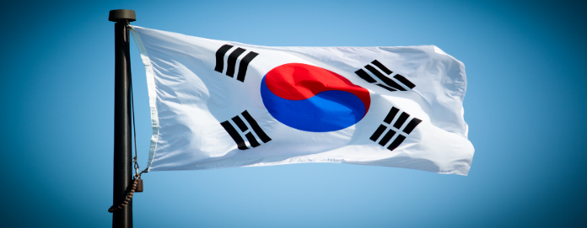  SOUTH KOREA | 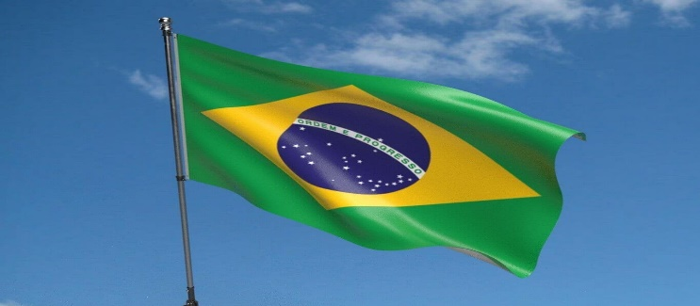  BRAZIL
 | POSITIVE | Democracy with a stable government.  Government is supportive of business.  Good economic growth.  Member of the World Trade Organization (WTO) and other international organizations. | The political system is stable.  The government is supportive of business.
POLITICAL | NEGATIVE |  | There is some corruption.  Some regulations that can be burdensome.
 | POSITIVE | Strong economy with a GDP of over $1.6 trillion.  High standard of living and a well-educated workforce.  Economy is growing at a steady pace, and the unemployment rate is low. | Brazil has a large economy.  The economy is growing.  Unemployment rate is coming down.  The inflation rate is low.
ECONOMIC | NEGATIVE |  | Heavily indebted.  Not growing as fast as some other countries.  Unemployment rate is high.  The inflation rate is rising.
 | POSITIVE | High rate of literate population. | The literacy rate is high.  Brazil is a diverse country with a population of over 210 million people.
SOCIAL | NEGATIVE | South Korea is a rapidly aging society.  Population is becoming more urbanized.  Country is facing a number of social challenges, including income inequality, gender inequality, and discrimination against minorities. | Significant gap between the rich and the poor.  The crime rate is high.
 | POSITIVE | South Korea is a leader in technology.  Strong IT sector and a high level of internet penetration.  Government is investing heavily in research and development. | Brazil is a rapidly developing country with a growing technology sector.  The internet penetration rate is high, and the country is home to a number of successful technology companies.  The government is supportive of innovation.
TECHNOLOGICAL | NEGATIVE
 | POSITIVE | Government is taking steps to address these challenges, but more needs to be done. | Brazil is a large country with a diverse range of ecosystems.  The government is committed to protecting the environment.
ENVIRONMENTAL | NEGATIVE | Facing a number of environmental challenges, including air pollution, water pollution, and deforestation. | Number of challenges, including deforestation, pollution, and climate change.
 | POSITIVE | Well-developed legal system.  Member of the World Trade Organization (WTO) and other international organizations.  Government is committed to protecting intellectual property rights. | Brazil has a complex legal system that is based on civil law.  The government is working to reform the legal system
LEGAL | NEGATIVE |  | The legal system is slow and inefficient, and there is a high level of corruption.

(MarketLine, 2023)

