

Methods and Search Strategy Academic Poster

Student name: Ekos Adamu
Student ID: 2016551

Module name: Independent Project
Module code: BMHP6020

What are the Barriers to receiving mental health services among the ethnic minority group in the UK?
01 Introduction and Research Aim  Research design, execution, and analysis are described in the methodology. It describes how data were obtained, how participants were selected, and how the data were analyzed to answer the study question. It describes how to find, select, and synthesis relevant articles in a systematic literature review. This chapter provides transparency, dependability, and repeatability to evaluate the study methodology's validity and rigor (Creswell & Creswell, 2023). This systematic review examines UK ethnic minority mental health care barriers. | 02 Search Strategy  A secondary research search strategy is a way for finding and selecting relevant studies. Define keywords, choose databases, and apply inclusion and exclusion rules to ensure a full and impartial examination (Aveyard and Bradbury- Jones, 2019). This dissertation searched PubMed, University of Wales Trinity of David library, Jstor, PsycINFO, and Google Scholar for “ethnic minorities,” “mental health services,” “barriers,” and “UK.” Studies from 2010–2025 were selected. To ensure transparency and replicability, the technique was documented in a source tracking table (Creswell & Creswell, 2023).
03 Searching for Information  I performed a systematic search using PubMed, PsycINFO, and google scholar utilizing specified keywords and controlled vocabulary to locate UK-centric literature from 2010 to 2025. Searches were constrained by language and relevancy; result were evaluated based on title/abstract and entire text. Essential data was extracted into a source-tracking table and thematically synthesized to ensure transparency, rigor, and reproducibility of findings influencing the dissertation, while gaps for future study were identified.  Step by step breakdown 1. Define scope and question 2. Select databases 3. Develop search strings 4. Apply filters 5. Screen result 6. Extract and record 7. Synthesize and identify gaps | 04 Picture / Graph / Visual Aid / Statistics  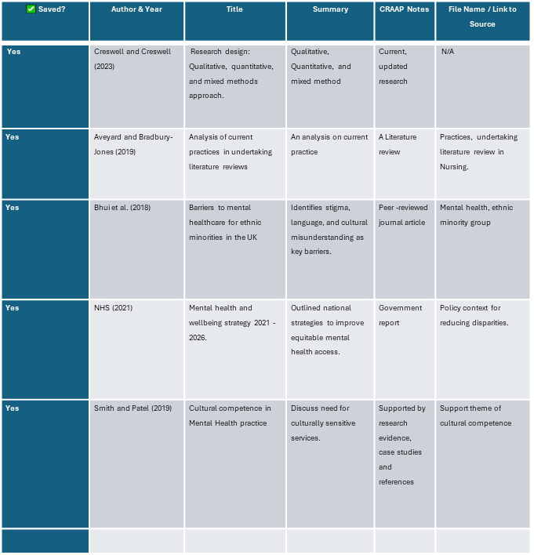Source tracking table
05 Research Validation and Analysis
Validating secondary research data ensures reliability and precision. Critically assessing research quality, methodology, and evidence. Validated data boosts academic credibility. Validation increases transparency, replicability, and confidence in findings but is limited by researcher bias and data access (Aveyard and Bradbury-Jones, 2019). Secondary research analysis interprets data or published studies to answer a research question (Aveyard and Bradbury-Jones, 2019). I performed thematic analysis to identify trends and group data on stigma, language barriers, cultural competency, and access disparities from selected literature for Chapter 4.
06 Inclusion 06 Inclusion Criteria  • Research released from 2010 to 2025  • Focused on ethnic minority groups in the UK  • English language  • Peer reviewed Criteria | 07 Exclusion Criteria  • Research that is not specific to the UK  • Focused on children  • Non mental health focused
08 Ethical Considerations
Research is conducted responsibly when ethical considerations are considered, safeguarding the rights, confidentiality, and integrity of participants. For secondary research to be honest and academically sound, reliable sources must be used, plagiarism must be avoided, and all materials must be correctly referenced (Farrimond, 2012). No ethical approval is needed for this research because it uses secondary data analysis from available literature. However, there will be factual reporting, citation, and data handling.

References

Aveyard, H. and Bradbury-Jones, C. (2019) 'An analysis of current practices in undertaking literature reviews in nursing: findings from a focused mapping review and synthesis,' BMC Medical Research Methodology, 19(1). https://doi.org/10.1186/s12874-019-0751-7.
Creswell, J.W. and Creswell, J.D. (2023) Research design : qualitative, quantitative, and mixed methods approaches. Sixth edition. Thousand Oaks, California: SAGE Publications, Inc.
Farrimond, H. (2012) Doing ethical research. Bloomsbury Publishing.
Halcomb, E. (2011) 'Doing a Literature Review in Health and Social Care A Practical Guide Second edition Helen Aveyard Doing a Literature Review in Health and Social Care A Practical Guide Second edition McGraw Hil /£17.99170pp97803352388590335238858,' Nurse Researcher, 18(4), p. 45. https://doi.org/10.7748/nr.18.4.45.s2.

