Student Name: [enter]  Student ID: [enter]  Module Title: [enter]  Module Code: [enter]  Lecturer: [enter]  Date: [enter] | 
ASSIGNMENT 1: PORTFOLIO
(4 Components)

Component 1: Professional Reflection (500 words +/- 10%)

Weighting: 25%
I was working as a food and beverage attendant at the Hilton Liverpool City Centre during a busy Saturday evening dinner service. It was my turn to be stationed near the entrance of the restaurant to greet guests and show them to their tables. An English family of four approached me to be seated. "Table for four please," the father said politely. However, due to my lack of confidence with the English language, I found it difficult to understand him clearly. I nodded and grabbed four menus but accidentally picked up children's menus instead of the adult menus. I led them to a table near the window as instructed but realised too late it was a highchair table meant for families with small children.
The family looked confused by the children's menus and unsuitable table. I apologised profusely in broken English and tried to explain my mistake. However, my explanation seemed to cause more confusion due to my unclear pronunciation. The mother looked irritated and said something I did not understand. Feeling embarrassed, I quickly swapped the menus and showed them to a more suitable table on the other side of the restaurant. As I turned to leave, the father called me back and asked how to order their drinks. Panicking, I froze momentarily as my mind went blank. I stuttered out the options for non-alcoholic drinks like soda, juice and water but neglected to mention we had a full bar. The frustrated father reiterated they wanted alcoholic beverages with their meal. My limited vocabulary prevented me from describing the choices of beer, wine and cocktails clearly. I rushed off to the bar to get their drink orders taken instead, realising I was in over my head due to my inadequate English communication skills. I felt awful for providing substandard service to the guests and likely damaging the restaurant's reputation. It was at that moment I realised I needed to seriously improve my linguistic competency if I wanted to continue working in this international hotel.
After this experience, I recognised the importance of developing strong cross-cultural communication skills to avoid potential misunderstandings when serving multilingual guests. Not being able to converse fluently in English had disadvantaged me in my role and caused issues for the customers. To enhance language proficiency, it is effectively important to use effective training methods (Bahodirovich, and Romilovich, 2021). I have also enrolled in an intensive English course at the local college to obtain an internationally recognised certification. In future, I will introduce myself to international guests and confirm their primary language to determine the best way to assist them. Carrying translation cards with common phrases might also aid comprehension when linguistic barriers occur (Sanjar, and Doston, 2022). Actively listening attentively and repeating back orders will help ensure I understand requests clearly. Continuing to sensitivity train myself on diverse cultural norms will further support respectful interactions. With dedicated effort to strengthen my bilingual competencies, I aim to deliver consistently excellent customer service across all demographics.
References:
Bahodirovich, O.J. and Romilovich, B.R., 2021. Project for training professional skills for future teachers of technological education. Mental Enlightenment Scientific-Methodological Journal, pp.139-150.
Sanjar, U. and Doston, H., 2022. Innovative methods of improving the professional skills of a teacher of physical culture. INTERNATIONAL JOURNAL OF RESEARCH IN COMMERCE, IT, ENGINEERING AND SOCIAL SCIENCES ISSN: 2349-7793 Impact Factor: 6.876, 16(06), pp.20-23.
Component 2: Training Plan (500 words +/- 10%)

Weighting: 25%

Identified cultural misunderstanding (in a few words):
The identified cultural misunderstanding stemmed from my lack of proficiency in English, which was one of the most common languages spoken by guests at the hotel. Due to limitations in my English abilities, I struggled to clearly understand the requests of an English family who had approached my counter to be seated. This led to a series of unintended errors where I seated them at an incorrect table with children's menus. I was also unable to fully explain the drink options when asked, due to a limited vocabulary. My inadequate English communication skills disadvantage me in my role and caused confusion and frustration for these customers. It highlighted the need for improved language skills among staff to avoid such cultural misunderstandings and best serve our internationally diverse clientele (Rahimova et al. 2022).
Training plan
Why?
This mandatory training program aims to strengthen the English language and cultural awareness capabilities of all frontline employees. As our hotel welcomes many international guests every day, it is crucial that staff can converse confidently and understand cultural norms to provide excellent service. From my own experience, lacking proficiency in a common guest language like English can disadvantage workers and potentially damage the customer experience through misunderstandings. The training seeks to empower employees with communication tools and knowledge to achieve respectful interactions with all demographics.
What?
The program involves weekly interactive English lessons conducted over 6 weeks by an accredited external trainer. Sessions will be tailored to industry terminology and situations employees commonly face. A variety of teaching methods like role-plays, group activities and individual exercises will be used to boost conversational competence. Additional components include easy-access English reference cards, translation software installed on computers, and cultural awareness modules integrated into the curriculum (Weber, Lee, and Crawford, 2020). Progress will be tracked regularly, and certificates awarded on completion to recognize development. An annual refresher will also sustain language abilities long term.
Who?
All permanent frontline staff, including those working in front desk, food/beverage, housekeeping and spa roles, will participate in the mandatory training. These employees interact directly with guests daily so strong English skills are important. Casual workers will be encouraged to join the voluntary program to enhance their skills and career prospects too. Session sizes will accommodate different English levels through a blend of group and individualized learning.
Where?
Lessons will take place in the spacious staff lounge located on the ground floor, which is a central and familiar location. Its seminar-style set up is well-suited for interactive teaching methods involving movement. Distractions will be limited to promote focus during lunch break sessions. Access to facilities like computers and printers allows supplementary materials to be provided.
When?
Training will be conducted twice weekly on Tuesdays and Thursdays from 2pm-3pm to avoid busy operational periods. This hour-long slot utilizes existing meal breaks efficiently. A consistent schedule facilitates planning and availability for all. Progress evaluations will occur fortnightly. An annual refresher session will also sustain English and cultural skills long term.
References:
Rahimova, G., Dedaxanov, B., Adilov, Z. and Qosimov, I., 2022. USE OF INNOVATIVE METHODS IN DEVELOPING PROFESSIONAL SKILLS OF STUDENTS. Journal of new century innovations, 19(2), pp.161-168.
Weber, M.R., Lee, J. and Crawford, A., 2020. A suggested best practices for enhancing performance of soft skills with entry-level hospitality managers. Anatolia, 31(1), pp.76-87.
Component 3: Student Self-Reflection (500 words +/- 10%)

Weighting: 25%
Introduction
This experience at the hotel restaurant was highly formative for me. Prior to this event, I did not fully comprehend the crucial importance of maintaining strong cross-cultural competencies within the customer-centric hospitality industry. However, after facing challenges communicating with guests due to my limited English abilities, I gained new appreciation for how deficiencies in cultural awareness and language proficiency could negatively impact service quality.
Description
As detailed previously, during a busy dinner shift I encountered difficulties properly seating, explaining menus to, and taking drink orders from an English family due to weaknesses in my second language skills. Minor initial misunderstandings snowballed as my inability to converse fluently hampered addressing issues clearly and meeting the guests' requests to their satisfaction (Mistry et al. 2022). This cascade of small problems could have been avoided with stronger communication abilities on my part.
Feelings
I felt immensely embarrassed and disappointed in myself that something within my control, like failing to develop a common language proficiency, contributed to a subpar experience for customers. It was stressful to realize too late that shortcomings in my competence disadvantaged me from delivering my role effectively. I worried this family would complain and damage the hotel's reputation through a negative review.
Evaluation
With hindsight, I can see how important continuous self-improvement is when serving international guests. While customer service fundamentals remain key, without linguistic and cultural fluency, even minor issues risk compounding negatively (Tanković, Kapeš, and Kraljić, 2021). The feedback from this realistic scenario highlighted that best serving a diverse clientele requires constantly renewing expertise to changing needs.
Analysis
This taught me to accept accountability for ongoing training. Even for frontline roles, global competencies are invaluable as demand grows for inclusive workplaces. No skill, no matter how basic like conversational English, should be taken for granted if one aims to excel long-term in hospitality management roles interacting daily with multicultural communities. Constant adaptation is crucial.
Conclusion
I gained important lessons around recognizing learning as a lifelong pursuit and empowering myself with tools to connect respectfully across differences. Industries like ours can only build a sense of community and shared understanding among customers if they stay open to different points of view through new experiences over time.
Action Plan
As a result, I have promised to regularly work on my speaking skills, seek out culture experiences, learn more about working with overseas customers, and get more language certifications. I also want to share what I have learned by encouraging my coworkers to do the same things so that we can all improve our skills for a world that is becoming more linked.

References
Mistry, T.G., Hight, S.K., Okumus, F. and Terrah, A., 2022. Managers from heaven: how do hospitality employees describe good managers?. International Hospitality Review, 36(1), pp.2-24.
Tanković, A.C., Kapeš, J. and Kraljić, V., 2021. Importance of soft skills and communication skills in tourism: Viewpoint from tourists and future tourism employees. Tourism in Southern and Eastern Europe..., 6, pp.167-185.
Component 4: Training Presentation (6 Slides)

Weighting: 25%
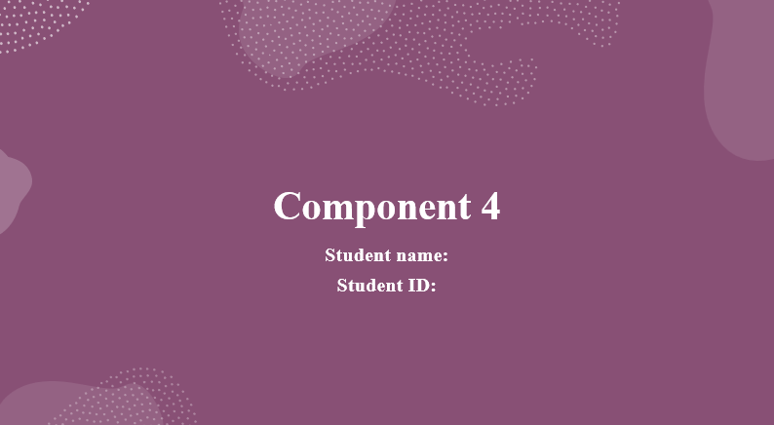
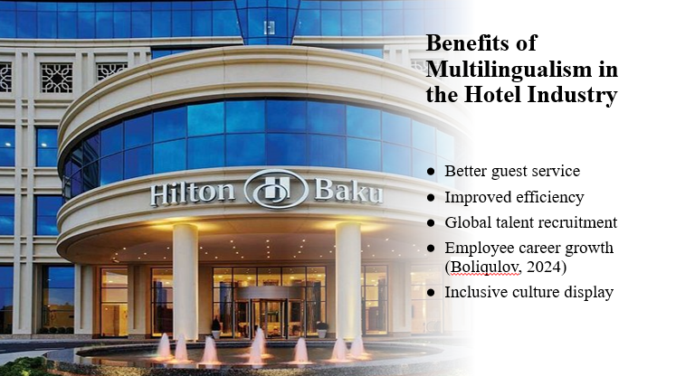
Being able to communicate in multiple languages, especially English as it is so widely used internationally, provides many advantages for hotels. It frees up staff to directly handle more guest requests and questions, without having to rely on language apps or other staff members. This makes things run more smoothly and gives better service. It also helps businesses hire people from a bigger range of talented people around the world and give workers more ways to advance in their careers. For guests, seeing workers who speak more than one language shows that the company values diversity, acceptance, and knowledge of other cultures.
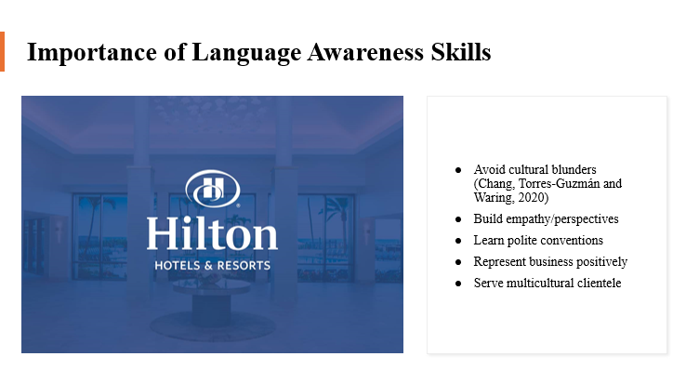
Language recognition skills are important for everyone who works in a hotel, but they are especially important for people who talk to guests directly. This helps keep things from going badly during the stay because of mistakes or misunderstandings that are purely local. It also helps people understand other points of view and shows how important it is to value variety. Learning proper manners like greetings, titles, and etiquette can helps one to be more welcoming, represent the company well, and make connections with people that it will remember. Language knowledge improves everyday exchanges and makes people better workers, ready to serve a growing number of international clients.
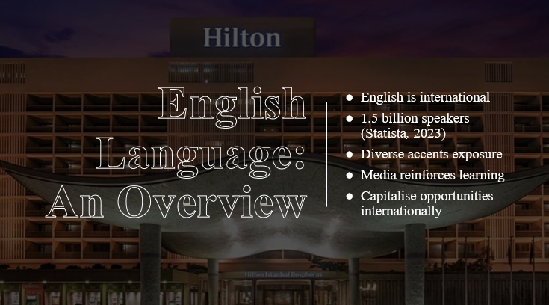
English has become the main language used for business, travel, and internet media around the world. This is why hotel workers who deal with guests from other countries need to know English. One in five people in the world speak English as their first or second language. It is now easier to talk to people from places other than the US, UK, and Australia and to hear English accents from those places. Interactive media also helps people learn English without them even realising it. Keeping up with the latest technology helps hotels take advantage of the chances that come with its broad use around the world.
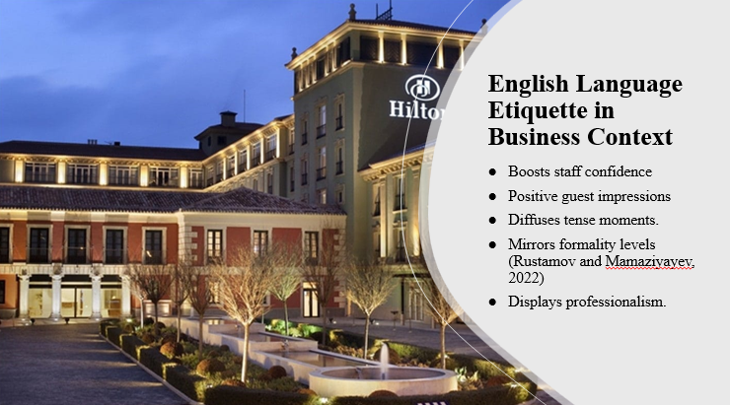
Following proper manners builds trust among employees and makes a good first impression on guests. They also handle stressful situations with ease. There are small differences between relaxed and official work settings. For instance, using titles and honorifics and matching tones and politeness show cultural subtlety. Learning the subtleties of manners shows that I am a professional, which helps brands stand out in a competitive hosting experience.
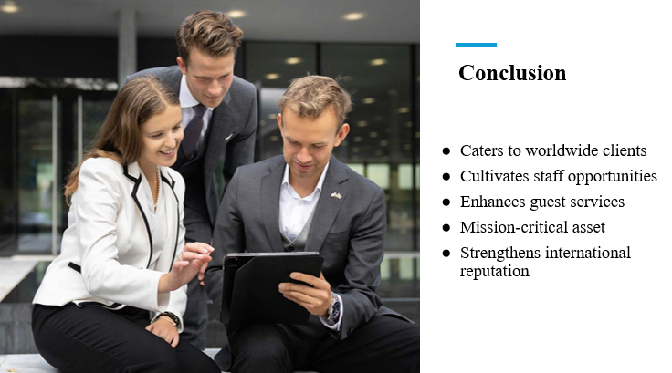
Spending time improving language skills helps hotels serve guests from all over the world. It gives staff more chances and makes services better at the same time. Both are essential tools for companies that want to stay strong. Hilton's image as a true international brand and its top-notch service are both strengthened by its efforts to promote language skills and multilingualism.
References (no screenshots):
Boliqulov, F., 2024, February. THE ROLE AND IMPORTANCE OF FOREIGN LANGUAGES IN THE DEVELOPMENT OF THE TOURISM INDUSTRY. In Conference Proceedings: Fostering Your Research Spirit (pp. 85-88).
Chang, S., Torres-Guzmán, M.E. and Waring, H.Z., 2020. Experiencing critical language awareness as a collective struggle: methodological innovations in language awareness workshops. The Language Learning Journal, 48(3), pp.356-369.
Rustamov, I.T. and Mamaziyayev, Z.X., 2022. Development of speaking comprehension in teaching foreign language for professional purposes. Asian Journal of Research in Social Sciences and Humanities, 12(2), pp.227-233.
Statista, 2023. The most spoken languages worldwide 2023 | Statista, Statista. Available at: <https://www.statista.com/statistics/266808/the-most-spoken-languages-worldwide/ [Accessed on 21 May 2024]>.

