
INTERNATIONAL BUSINESS PLAN
GLAXOSMITHKLINE PHARMACEUTICAL

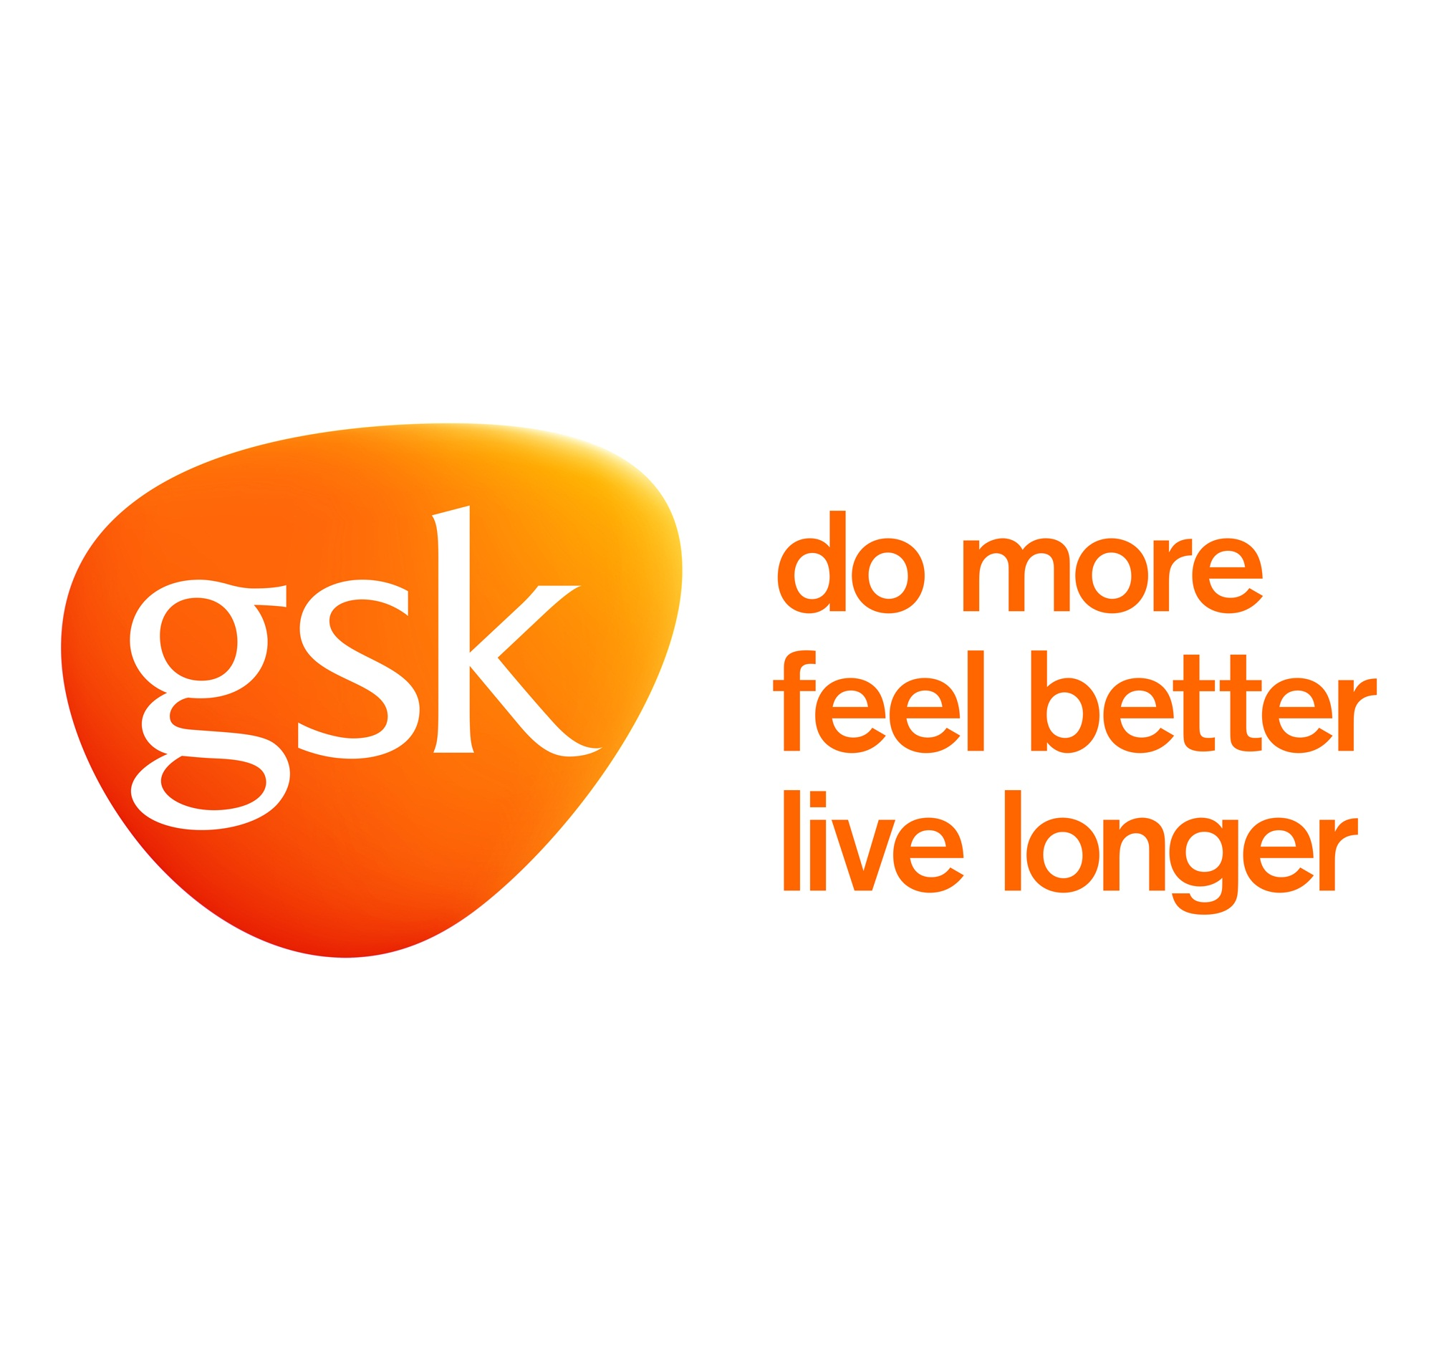

STUDENT NAME: NARESHKUMAR R. PATEL

STUDENT NUMBER: 1713063

LECTURER NAME: JOHN LANG

SUBJECT NAME: INTERNATIONAL BUSINESS

TITLE: INTERNATIONAL BUSINESS PLAN

INDEX

- INTRODUCTION
Competitive situation overview
About company
History
- MACRO ENVIRONMENTAL FACTOR
- PESTLE ANALYSIS
- COMPETITORS
- PORTER’S FIVE FORCES MODEL
- SWOT ANALYSIS
- KET PERFORMANCE INDICATORS
- VALUE CHAIN ANALYSIS
- MARKETING MIX
- STYLE OF INTERNATIONAL ENTRY
- CONCLUSION
- REFERENCE
- APPENDIX

INTRODUCTION

  - Competitive situation overview:
The pharmaceutical business of the world creates, and markets drugs recommended for patients by medicinal experts. The worldwide pharmaceutical industry achieved remarkable statures in twenty eighteen, being assessed at a surprising 1.1 trillion dollars. By twenty twenty, this figure is about to increase to 1.43 million dollars. With rising intense pressure to create medications to fulfil regularly expanding worldwide need, pharmaceutical organizations keep on working eagerly to take the most inventive and front line medicines to the customers & patients.
GSK being research oriented business, around 150 billion dollars is disbursed by medical organizations consistently on innovative work ventures. Out of thousands of mixes, just a little rate increase administrative endorsement can be utilized by patients for treating infection and also improves personal gratification. Notwithstanding, in Twenty eighteen, a highest number of fresh medications created by medical organizations all over the world were endorsed by different administrative bodies. A substantial extent was affirmed by the US administrative organization, the FDA, which endorsed 55 innovative medications and crushed its record for nonexclusive endorsements {781 up from 763 of every 207}.
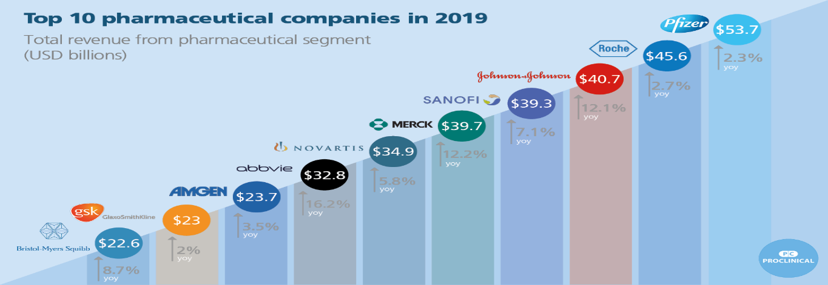
(Anon., n.d.)
Despite the fact that the share of USA of the overall industry of the worldwide medical sector is value over 341.1 billion dollars, the South East Asian, Chinese, South American and Eastern European marketplaces are starting to rise. For instance, China is considered as rich in early clinical medicine, and is one of developing of nucleus activity of biotech. The following couple of years will see worldwide development on account of the expanding riches around the world, just as expanding request to keep up large amounts of advancement to battle neglected therapeutic needs.
  - About company
GlaxoSmithKline is considered as one of the global largest researches oriented pharmaceutical organizations that discoveries, creates, makes and promotes marked human health items. GSK has two principle business divisions, pharmaceuticals and shopper medicinal services. This profile manages the pharmaceuticals division, which produces 85% of GSK's deals. GSK has more than three organisations which, create and make inventive pharmaceutical prescriptions, antibodies and customer medicinal services items. In 2018, GSK conveyed around 2.3 billion packs of medication, 770 million antibody dosages and 3.8 billion customer human services items.
The Medicines business discovers, generates and markets drugs to treat a possibility of acute chronic diseases It has an arrangement of medicines in respiratory and HIV. Its Pharmaceuticals business incorporates Respiratory, HIV, Specialty items, and Classic and Established items. The Vaccines industry provides antibodies to persons of any age from children and youths to grown-ups and more seasoned personalities. It carries more than 2 million antibody portions for each day to persons living in more than 160 countries. The Consumer Healthcare business makes and advertises items in wellbeing, oral wellbeing, nourishment and skin wellbeing classifications.
1.3) History
In 1873 the first company started in the name of Joseph Nathan and co. In the later years started producing dried baby milk products from the excess milk produced on the dairy farms. In 1999 galaxy became the world's third largest pharmaceutical company by revenue with the share of global market around 4%. After 1999 GSK experienced rapid growth in the industrial pharmaceutical. It also opens research and development facility for AIDS and other dangerous diseases. It has become the world's best product seller by selling 50 top pharmaceutical products. The Nobel Prize winning scientist B. Elion and George worked with GSK to invent drugs. In the process it has also acquired companies like Allen& hanbury . GSK's first pharmaceutical product was released in 1924 was vitamin D.. (Emma, n.d.)
India is the world second largest country in population so there are so many opportunities in Pharma sector. GSK is planning to expand in to India of their Manufacturing and Distribution channel. GSK will launch Health care products into India such as Abreva, alli, cetebe, corega etc…For this business plan Further analysis are as follows.

- MaCRO ENVIRONMENTAL VARIABLES

We have analysed the industry and the company’s overview. As the GSK is planning to enter in the Indian market it is necessary to analyse the macro level and remote environmental variable. The macro level factors listed are listed below (John, n.d.)

POWER DISTANCE
In the dimension of power distance Indian scores the rank on 77 which is considered ads quiet high with respect the equality is concerned. Equality of the Indian citizens differs from European region. In Indian it is observed that there is inequality which is existing in the hierarchy of the organisation. In the hierarchy of the organisation employee of the lower range in hierarchy generally dependent on the bosses of the organisation. Approaching the boss in organisation nearly impossible for the lower class workers. Importance to the every person in the hierarchy is not possible in the Indian structure of organisation
Britain scores 35 in the PDI ranking which believes that inequality among the people should not exist and also it should be minimised to the extent possible. Inequality among the people is not acceptable in the organisation

INDIVIDUALISM
“The degree of interdependence a society maintains among its members”
India scoring 48 at this dimension. Indian society which has collectivism and also individualism. In India it is generally dependent on the largest group of the society it is expected in India that the individual’s act according to the largest groups. The action of individual is influenced by his family group’s social networks and also neighbours. In Indian dimension of individualism has one exception which is employer employee relationship in an organisation.
Individuals in Britain prefer to be independent. Also they are expected to take care of their self and their near family. They are hardworking and also focused towards work and punctuality.
INDULGENCE
“The extent to which people try to control their desires and impulses”
India is scoring very less in indulgence factor. The score of India is 26. This is due the fact that Indian people are not overriding the fact of doubt which is creating gap between the people and also low satisfaction. In the workplace also the pears pressure is creating less indulgence to the people of India.
Generally Britain has high score with respect to the indulgence. As the people in this region considers and provide more importance of Indulgence. Even the organisational structures play major role in this case which supports the indulgence of people.
After comparison the cultural difference between two countries (INDIA and U.K) by Hofstede model. It is very crucial to look out the external factor affect the GlaxoSmithKline pharmaceutical company.

- PESTEL ANALYASIS (Daniels, 2011)
PESTAL | UNITED KINGDOM | INDIA
POLITICAL | Political factors in United Kingdom are very strict. The medications security control is high where government can consider the medicines are good and also they may consider that medicine's not good to use. | Indian medication authority has very stringent rule and also they have strict policy to accept the medication. And also they have testing of medications in laboratories are compulsory. These strict rules may affect the entry of GSK in India.
ECONOMIC | Economical GDP growth has ranked 5th in the world. GDP in 2019 is 2.829 trillion US dollars. Which has recorded a growth of 1.6% in 2018? In case of manufacturing industry it has shown tremendous growth of 19.2%. This will be one of the strength of GSK to operate in its home land also in India by diverting the investments to India. | The economic growth in India is generally with compared to other countries in the world  As India is a developing which has more option in the county for new business this will be the major opportunity for the GSK to introduce its business in India.  Exchange rate 1P=90.18INR  GDP growth rate 6.21 (Average)
SOCIAL | Social aspects which involves major variation in consumer approaches. Consumers tend to change the products brands regularly. The consumer behaviour should be considered with respect to the product manufacturing | In India consumers cannot afford the expensive medicines as the most of the Indian people are middles class and prefer low cost medicine rather than high end medicine.  Number of consumers 12 Million  Segment –Adult  Age 30 to 57(Both male and female)
TECHNOLOGICAL | GSK stand out in its Technological capacity. GSK has invested heavily in the research and development aspect of technology to get added benefit in the field of digitalisation in pharmaceutical company. | It is necessary for GSK to adopt major technology to handle competition in India. The competitors are using higher end technology in the industry hence GSK shall contribute more of investment towards research & development of technology.
ENVIRONMENTAL | Since 2015 GSK is using certain technologies and policies which contributing to the environmental factors. With these technologies the effect on the earth will be little but the cost of the medicine will be affordable. | India is concerned about environment issues. Every new entry should follow the certain guidelines issued by government to protect the environment. These guidelines are specifically more stringent towards medical products. Global warming is a main concern in India hence GSK shall contribute towards the environment.
LEGAL | In UK region it has certain set of legal factors to be complied with to produce medical products. There are set of frameworks under which the company shall operate. Legal framework includes local and also international standards. For medical products regulation starts from the point of manufacture till the end of sale and also after sales services. Complying with the standards maybe difficult for a pharmaceutical company. | In India the manufacturer of pharmaceutical industries shall get the licences from the local authorities. Get the licences the set of compliance shall be complied with. Pharmaceutical industry products are tested in the each stage by government.

After the PESTEL analysis, it is most necessary to look how many competitors are there in the market and also analyses the five force for the GSK to get idea about how to make strategy for establishment new business in new country.

- COMPETITORS (Anon., n.d.)

- Sun pharma
OFFERING compares to GSK
- Diversified Portfolio
- Effective Supply chain Management system
- Big House Research and Development Plants
- Trust of Local customers
- Cheap and advanced technology
- Piramal Enter
- Dr. Reddy Labs
- Aurobindo Pharma
- Divis Labs
- Cipla
- Lupin
- Biocon
- Ranbaxy Labs
- Cadila Health

- Porter’s five force model
1) THREAT OF NEW ENTRANTS

Currently the Indian economy is facing the shortage of medicines. There is high demand and less supply in the Indian economy with respect to medical products. Due to this fact there is a bigger opportunity in the field of pharmaceutical industry in the Indian sector. This is creating new opportunity for pharmaceutical companies local as well as international. In the current scenario pharmaceutical industry demands digitalization. The companies which are strong in the technological factor can enter Indian market at any time. Increasing globalisation creating new opportunity for new entries in Indian market. And also as we discussed earlier the shortfall of medication in pharmaceutical industry has given a major opportunity for company’s twin tower Indian market. Hence the threat of new entries is major issue for GSK in Indian market. And it is also easy for new entrants to start their business straight forward. The new candidate can just stretch their products with the help of moment channels with several retail stores and this will make them get things on the racks.. (Torun, 2007)

GSK STRATEGY FOR HANDLE THE THREAT OF NEW ENTRANTS:
- GlaxoSmithKline plc can strengthen by using cost advantage as a measure of competitive.
- GlaxoSmithKline plc can concentrate on development of specific products that can be a leader in the market by its uniqueness.

2) Bargaining Power of Suppliers

Suppliers of GSK are large number for company so they will act as Barganier’s to fix the price which the consumer or the end user of the GSK product impact at high level.
The price what the supplier are going to give may vary because of this effect the GSK can move around other suppliers which they will exchange comparatively lesser than other suppliers. (jarvis, 2006)

GSK STRATEGY TO TACKLE THE BARGAINING POWER OF SUPPLIERS
- GlaxoSmithKline plc can buy materials or inputs for the further production of GSK products they can shift from one supplier to other while looking cost advantage and cheaper with quality.
- Use those geographically scattered suppliers who will give good inputs at reasonable price with appropriate exchange rate.
- Creating network among the supplier groups
3) BARGAINING POWER OF BUYERS

There are different varieties of products inside the business. So, the Buyers get diverged into some other products or substitutes products so their Bargaining power of the buyers will be high.
Buyers are more concern about how much money they are spending from their pocket to buy certain products for the future or present use. So, the pricing advantage they will take care to reduce cost.
Nature of products also be a part of bargaining power of the Buyer. That is the Buyer always looks and feel the product for better understanding Weather this product satisfies my need or not. (Bass, 2008)
GSK STRATEGY FOR HANDLE THE BARGAINING POWER OF BUYERS
- GlaxoSmithKline plc can concentrate Product diversity with large number of products in the market.
- GlaxoSmithKline plc requirements to create big client base by using network and provides additional services like after sales services etc.
- 4) THREAT OF SUBSTITUTE PRODUCTS OR SERVICES

GSK operates in an industry which there is a smaller number of substitutes. It will make revenue and Growth advantage.
The substitute goods whichever in the market is very expensive but more over some products make threat to GSK by progressive way of adapting their technology and formula. (jarvis, 2006)

GSK STRATEGY TO MANAGE SUBSTITUTE PRODUCTS OR SERVICES THREAT

- GlaxoSmithKline shall concentrate to provide quality products in the market.
GlaxoSmithKline plc can concentrate diversifying its items by the way of Innovation and Research in this sector.

5) RIVALRY AMONG EXISTING FIRMS

The rivalry in the industry where GSK works is high. Most of the businesses which operates in pharmaceutical industry extensively big in the size. And also capable of handling the competitors. GSK as a multinational company which is facing major competition from the local pharmaceutical industries as well as from international pharmaceutical companies. To become exhibit Pioneer of the industry GSK shall introduce advanced technologies which can produce the medical products with lower cost and also take to reach the demand off-market quickly. Some of the competitors of GSK in India is Cipla, Biocon, natco Pharma, Caplin labs, Himalayan, etc.. To face such tough rivalry in Indian market GSK shall have competitive advantage. Looking at the current trend it is understood that rivalry among the existing form of pharmaceutical industry is high.

GSK STRATEGY FOR RIVALRY WITH EXISTING FIRMS
GSK shall look for diversify product also concentrate on the various aspects of the products
GSK shall conduct statistical survey to understand and comprehend the requirement it and expectation of consumers and also to understand the circumstances where the demand to be reached and also to stop when the over production taken place. (Bass, 2008)

It is most necessary to analyses the internal factors of its own as well as external factors if we will try to enter in Indian market. Hence, below are the different factors discussed with the help of SWOT analysis theory.

- SWOT ANALYSIS

(The details about SWOT analysis on GSK are available in the appendix.)
Strategies to overcome weakness & Threats
- By Spending on quality Research & Development GSK can come up with cheaper and qualitative products, which will provide competitive edge on its competitors.
- Patent and copy right to be taken on new drug innovation and shall be registered for sole use.
- Diversifying the product with respect to all aspects and also providing all product at one stage and it shall be a one stop solution for every requirement.
- GSK can open its laboratories in the country where it will keep analysing the result of its existing products and keep improvising on the same.
- Develop a customer chain with which GSK can retain its old customers and also generate new customers.(Robsun, 2013)

After analysing both external and internal factor by using various model. Now it is very crucial and imperious to discuss about the key performance indicators about GlaxoSmithKline company. Because it is help to establishment of business in foreign country.

- Key performance indicators

KPI | 2016 | 2017 | 2018
Innovation sales | 2.6 £bn | 4.0£bn | 5.7£bn
Group turnover | 27.9£bn | 30.2£bn | 30.8£bn
Free cash flow | 3.3£bn | 3.5£bn | 5.7£bn
Employee engagement |  | 79% | 78%
(Emma, n.d.)
Innovation Sales
In the table we can see that there is high amount of growth in Innovation sales. It tells about how strong the R&D of GSK. So, it will help in Indian market.
Group Turnover
All-round group turnover of the GSK is Crossing around 30 £ Billion in 2018.It is showing the customer acceptance of the GSK product in the Market.
Free Cash Flow
The company turnover after all expenses it grows from 3 £ Billion to 5.7 £ Billion in 2018.So we can say that the company is financially sound.

Employee engagement
Employee engagement in the workplace showing positive results for the company in terms of revenue and quality of product.

Any company establishment their new business in new country they must look out their supply chain in more in details. So, the below is description about the value chain analysis of GSK.

- Value chain Analysis (Emma, n.d.)

(For model please refer the appendix)
PRIMARY ACTIVITIES
- FIRM INFRASTRUCTURE
India supply chain management of support activities the firm infrastructure which includes general management, quality management, legal planning, services, and also accounts and finance. GSK as a whole has a highest infrastructure all over the globe. Normally the company’s accounts and finance is handled in the corporate office and planning is done by management. Accounting handling legal issues quality management are done at the unit level.

- HUMAN RESOURCE MANAGEMENT
Human resource management are considered as important element of GSK it is also strength of company . Without the labour force GSK cannot operate effectively. The human resource management it includes people planning, hiring the people, training and making them ready for work, it also includes skill assessment of employees and training is the lack of skill, these all are conducted at the business and also at the unit level.

TECHNOLOGY
Technology that helps GSK to operate its business effectively. GSK has technology development and also it has its own research and development units which contribute towards the technology and advanced production methodologies. The distribution channels also depends on the technology. Every part of GSK is conducted through the help of technology. Use of technology starts from the planning stage till the sales and after sale service stage. The digitalization of every field including design of product, research of product, organising product and manufacturing of product includes technology in every step. Asks investing major amount of money in technologies which is must for gaining competitive advantage.
- PROCUREMENT
GSK procurement activities which are undertaken to purchase its raw material in the value chain. Not only the raw materials it also includes all the supplies, manufacturing machines, equipment used in laboratory for research and development, office equipment, and also building items which are used in the office. Requirement has been taken care by GSK effectively..

SECONDARY ACTIVITIES
- Operations
GSK operates and produces 1.4 million doses of medical products it includes manufacturing of the product, formulating the product, feeling in the containers, packing and controlling the products, and finally release in the products which require demand. The team which involving operational sustainability is helping the GSK to carry out its processes effectively. One more aspect of operation is artificial intelligence which is used by GSK in its operational activities to bring systematic operational procedure.
- Inbound Logistics
Inbound logistic of GSK involves the logistic activities which are outsourced by the company to local logistic players. This activity overall includes handle the material, receiving the material, storing, physical verification of stocks, serial handling, and also receiving the information of customers from the stores for using the data to track the customers requirement.
- Out bound logistics
Value chain of GSK which involves distributing the finished goods through its channel partners to the final buyers. These activities include understanding the demand reaching out the wholesalers, coordinating with the retailers and distribution network, scheduling warehousing and processing of finished goods. This is the one of the factor where GSK has strength to handle demand of finished goods.
- Marketing and sales
This is one of the areas where the products which are manufactured will be known by buyers through promotions and marketing. The marketing and sales strategy of GSK includes advertising through TV channels, hospital service, promotion also includes sales force management advertising marketing and channel selection.
- After sales activities
After sales services which is one of the factor of value chain which has got major importance. Successful implementation of products it is necessary to provide service maintenance. The same route supply for maintenance and also technical help and alignment with software’s.
Supply chain Analysis
GSK SUPPLY CHAIN APPROACH
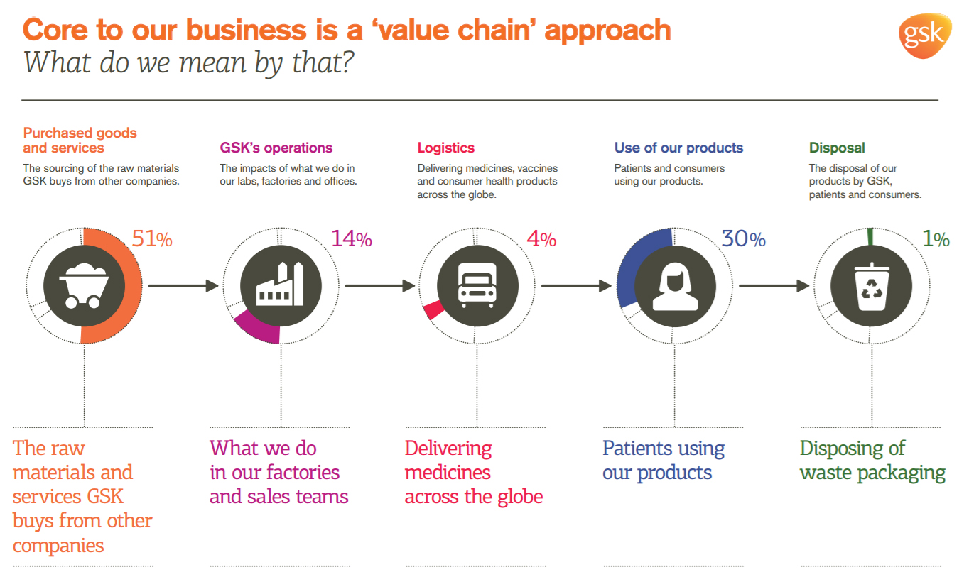
(Source: GSK global)

HOW TO REDUCE COGNITIVE DISSONANCE
To reduce cognitive dissonance it is very important to modify the older approaches which are followed by the company and also it is important to modify behaviour believes to create and connection between two components of the products with one another. Also to put effort to get information’s which will help GSK to overcome its reducing the comprehension which are significant to the company doors includes beliefs and attitudes. One of the examples of dissonance is that thinking about the lung cancer when a person who wants to smoke this will create dissonance .
Example
For example, thinking smoking causes lung cancer will cause dissonance if a person smoke.

Any company after analysis of market, strategy, country, both factors internal as well as external the next momentous step is ascertaining about the product, their price, promotion type and place to where they want to open new business. The below summery mention about it for GSK company.

9) MARKETING MIX

- product
GSK has diversified and large various range of products which includes pharmaceutical and consumer healthcare products. In case of pharmaceutical products GSK is involved in the production of medicines which is helpful for diseases like diabetes, infection, cancer, mental health ,and asthama, the range of products which includes consumer healthcare involving oral health care like aqua fresh, toothpaste, nutritional drinks which includes Horlicks and boost..
In India we are introducing products in the category of Consumer health care products (Cetebe, Alli, Aqua fresh, coraga etc…), Because Indians are more Health care conscious and Peoples in the age of 30 to 57, they more prefer Healthy products. (Emma, n.d.)
- place
GSK which is operating all over the world which has covered its operation in 150 Nations. Which has provided effective workforce. About force of GSK currently having 99000 representatives in the headquarters United Kingdom.
Our product will launch on South India Location Karnataka. Because there is huge number of people working, they are more concern about their health so they will prefer our product in positive manner, and we will get good number of sales as well.
- promotion
GlaxoSmithKline which is using the decent promotional strategies to promote its products in India. Promotions are made majorly through different Medias and electronic media .Generally the nutritional drinks like boost and Horlicks are mostly advertise I'm electronic media like TV radio. Promotions are made also through monthly magazines daily papers and also separately shown as announcements. This design approaches are reaching every customer of India. Promotion for the entry into India is mainly use Print and Visual Medias because there are Millions of people are using Newspaper or TV channel as their daily routine. So, it will get more noticed in public and it will give more awareness in the society.
- price
Essential part of marketing mix is fixing the price. The pricing of the products majorly depends on the quality of the product. In the industry of pharmaceutical the quality matters a lot compromising the quality male lead to major issues in the products. Hence keeping the quality in packed and also fixing the price which is available to the Indian people where most of the people are middle class families and poor. Generally pricing of a product depends on the circumstances ,competitors, and also on the timing. Price is mainly depending on the competitor. It will be cheaper than what competitor giving. We will Use Penetration pricing policy as a pricing Strategy.

After finalising all above things last and most crucial step for any company is to decide which method is suitable for enter into the new country for the business.
10) STYLES OF INTERNATIONAL ENTRY

(FOR MORE INFORMATION ABOUT MARKET ENTRY METHOD AVAILABLE IN APPENDIX)

PARTNERSHIPS AND STRATEGIC ALLIANCES

One of the methods used to enter the international market is strategic alliance or partnership in this method generally the international companies make alliance with local players. Where the local companies provide all the resources technology and other aspects of the business to the international companies. Strategic alliance should be made with the company which has got competitive advantage over its competitors. These strategic alliances include distribution alliance, production alliance, and also logistic alliance. GSK can use strategic alliance to enter Indian market with faster route.. (Kelly, 2009)
- EXPORTING
Exporting is a one of the best method used by every international organisation to enter another country. Generally this is considered as the first stage of entry into the international markets . This involves least difficulty in entering other country economy. All the company's first used this method to penetrate the world market. GSK which operating all over the world and has its own production plants in the European countries. By using the plants and production system of European countries . GSK can export its product to Indian market through shipment. After when the market is penetrated and market share is acquired by the company in the later stage it can of for starting a production plant in India. Exporting is done generally by using all the production and technological aspects in the host country and exporting to the country where it needs to be operative. Exporting should also offer packaging and safety of the products. Advancing expo and participating in the arrangements will provide competitive advantage in the export field.. (Kelly, 2009)
- ACQUISITION
Acquisition is one of the majorly used entry methods in the world. The operations of the company can start in India by acquiring the shares of the existing company in India. GSK which has global reputation and investor support can opt for this method . By acquiring the existing company in India can help GSK to operate effectively. The acquisition shell have the authority over the existing company for this GSK shall acquire more than 50% shares if possible more than that. The control over the company shall be in the hands of GSK so that it can operate in India effectively.. (Kelly, 2009)
- WHOLLY OWNED SUBSIDIARY
This is also one of the major dimensions of entering international market. In this approach the company will open a subsidiary company in the other country. Which normally contains acquisition of existing firms. Or creating its own subsidiaries by investing in other countries. For GSK this method can be used effectively as the investors are more risk takers with respect to GSK. Without investment policies company can acquire or open a wholly owned subsidiary to operate its business in Indian economy effectively. For this purpose company can use the FDI route which will be investing in India through this route. But cost in the risk involvement in this strategy is high

Ranking on the basis of variables
 | Strategic Alliances | International joint Venture | Foreign Direct Investment | EXPORT
Cost | 9 | 6 | 6 | 4
Risk | 9 | 5 | 5 | 5
Control | 5 | 5 | 4 | 2
Rewards | 9 | 6 | 6 | 7
Complexity | 6 | 5 | 4 | 4
35 27 25 22
RECOMMENDATION
Strategic alliance or merging is the most suitable style of International entry. Because it will proffer huge competitive advantage through partner such as GSK get easily resources, technology, market, target group peoples in India and quick growth than other form of entry into the international market.
Analysing GSK’s market entry factor is as important as analysing market entry methods as discussed above, below is the factors discussed with the help of Porters Five Forces model.
MARKET SHARE IN UK
COMPANY NAME | MARKET SHARE
PFIZER | 8.2%
NOVARTIS | 6%
GLAXOSMITHKLINE | 5.3%
MERCK& CO | 5.2%
BAYER | 4.6%
ROCHE | 4.5%
ABBVIE | 4.5%
JOHNSON & JOHNSON | 4.3%
SANOFI | 3.9%
GILEAD SCIENCES | 3.1%
ASTRAZENECA | 3%
BRISTOL-MYERS SQIBB | 2.6%
BOEHRINGER INGELHEIM | 2.3%
MUNDIPHARMA INTERNATIONAL | 2.3%
BIOGEN | 2.2%

*please refer the graph in appendix

CONCLUSION
The globalization of 21st century innovation and expanded universal and transnational mechanical and financial action has helped drive the globalization of R&D. Competitive and mechanical changes in the pharmaceutical business from ground-breaking new medication sciences to creative R&D associations and advertising plans-are reshaping the business methodologies of numerous pharmaceutical and biotechnology organizations. The GSK Company has a wide and vibrant scope in Indian Pharmaceutical industry. The Company planning to launch Health care products in India will make a big part of the revenue in GSK portfolio Because India is a Developing country and the country is not sustain in medical especially in pharmacy industry So there will be a huge demand in Medical health care products. The average age of Indian people is 26 so Majority people use pharmaceuticals products especially health care products and Indian Government main concern is public health. So India will be a huge market for health care products.

RECOMMENDATION
According to above Analysis my recommendation for GSK to enter into the Indian market they can use either strategic alliance or Mergers because There are lot of companies are operating in pharmaceuticals industry. GSK Can enter by Merging with some local companies or taking help of established company with favoured agreement.

References

- Anon., n.d. pmlive. [Online]
Available at: http://www.pmlive.com/top_pharma_list
[Accessed 10 4 2019].
- Bass, A., 2008. side effects: A prosecutor, a whistleblower, and a bestselling antidepressant on trial. 1 ed. s.l.:Alonquin books of chapel hill.
- Daniels, R. a. S., 2011. international business. london: pearson.
- Emma, W., n.d. GSK. [Online]
Available at: https://www.gsk.com/en-gb/about-us/our-history/
[Accessed 16 4 19].
- jarvis, L., 2006. biopharmaceuticals glaxosmithkline forges into biologies. chemical and engineering news, Volume 84(51), p. 14.
- John, n.d. Hofstede-insights. [Online]
Available at: https://www.hofstede-insights.com/
[Accessed 18 4 2019].
- Kelly, P., 2009. international business and management. london: cengage learniong.
- pichai, s., n.d. Google. [Online]
Available at: https://www.google.com/search?q=value+chain+analysis+for+gsk&source=lnms&tbm=isch&sa=X&ved=0ahUKEwiEocmqiPnhAhV8TBUIHaqzAWgQ_AUIDygC&biw=1366&bih=657
[Accessed 5 4 2019].
- Robsun, K., 2013. service-ability creat a customer centric culture and gain competitive advantage. 1 ed. london: wiley.
- Torun, F., 2007. an internal scanning of a pharmaceutical company. Issue munchen:grin verlag GmbH, p. 45.

APPENDIX

1) SWOT ANALYSIS

(Torun, 2007) (Bass, 2008) (Robsun, 2013)

2) value chain analysis of GSK
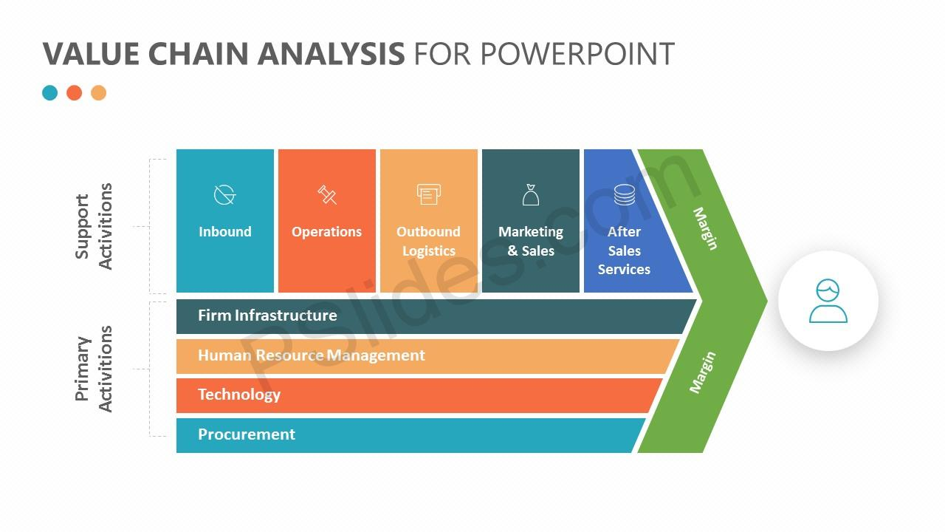
(pichai, n.d.)
3) MARKET ENTRY METHOD:

4) Market percentage share of GSK based on GLOBAL DATA REPORT

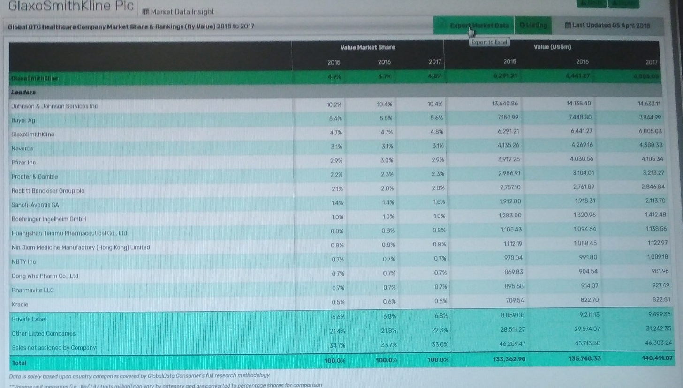

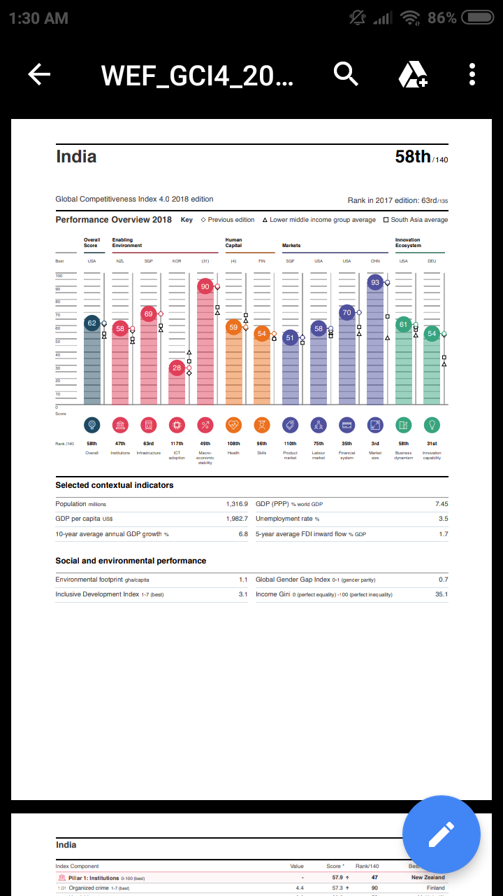
5) Global competitiveness report of INDIA

6) Global competitiveness report of U.K


