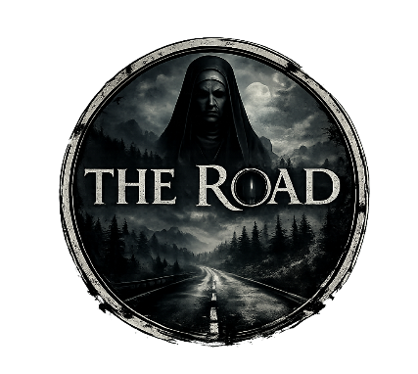
Module title
Master's Project

Project Title
The Road

Document of Intent

Student: Yuxin Li
Student number: 2228381

2026.7.2
Project Overview
This animated horror short film tells the story of two middle-aged men driving along a remote mountain road late at night. As they make their way through thick fog and darkness, a series of unsettling supernatural events begins to unfold. Eerie sounds, distorted sat-nav prompts and the appearance of a mysterious elderly nun gradually transform their journey into a terrifying nightmare. As fear gradually takes hold of them, the line between reality and hallucination becomes increasingly blurred. Through realistic visuals, atmospheric sound design and a suspenseful narrative, the film creates a tense and immersive horror experience, exploring the unknown and the psychological impact of fear.
Creative Vision
Centered on psychological horror and suspenseful storytelling, this film creates an oppressive, tense, and unsettling viewing experience through the confined space of a car, desolate mountain roads, and escalating supernatural phenomena. The film emphasizes atmosphere and emotional build-up, using thick fog, darkness, eerie sounds, and visual illusions to gradually amplify the characters’ inner fears, drawing the audience into a nightmare alongside the characters where reality and illusion blur. Through realistic storytelling and immersive audiovisual elements, we aim to create a horror animation that offers a powerful sense of immersion and psychological impact.
Production Methods
The project will be developed using a combination of digital design and 3D production techniques.
Key software may include
Blender (3D modelling and animation)
Substance Painter (texturing)
Photoshop (concept art and design)
Premiere Pro / After Effects (editing and post-production)
The workflow will include
1. Research and visual development
2. Character design
3. Environment design
4. Storyboarding and animatics
5. Asset creation
6. Animation production
7. Lighting and rendering
8. Post-production and final edit
Roles and Responsibilities
My Principal Role
My primary responsibilities on this project included character design, environment design, 3D modelling, texturing and animation. I was responsible for shaping the project’s visual style throughout the entire process, from concept design to the final animation. My work focused on creating realistic characters, immersive environments and expressive animations to enhance the overall atmosphere of horror and support the storytelling.
Contribution to the Project
My contribution lies in bringing creativity, technical expertise and high production standards to the animation. Through meticulous character design, realistic 3D modelling, detailed texturing and expressive animation, I am committed to creating convincing visual effects that enhance the atmosphere of psychological horror. My work helps to establish a consistent visual style and heighten the audience’s emotional engagement throughout the film.
Target Audience
The primary target audience for this animated series is young adults aged between 18 and 35 who enjoy stories featuring psychological horror, suspense and the supernatural. The series is specifically designed for viewers who prefer an immersive atmosphere, realistic visuals and tension-driven storytelling, rather than traditional ‘jump scare’ horror.
Personal Strengths
1.Strong character design skills with attention to visual storytelling.
2.Good understanding of 3D modelling and animation workflows.
3.Ability to work independently and meet production deadlines.
4.Strong problem-solving skills during asset creation and animation production.
5.Effective communication and collaboration within a production team.
6.Attention to detail and consistency throughout the creative process.
My primary responsibilities will include
- Character Design
1. Analyse the script and character requirements;
2. Gather reference material for character design;
3. Create concept sketches of the characters;
4. Design the characters’ costumes, hairstyles and accessories;
5. Produce three-view drawings and facial expressions for the characters;
6. Refine the characters’ visual style to ensure their distinctiveness and consistency.
2. Environment Design
1. Analyse scene requirements based on the script;
2. Collect reference material on the environment and architecture;
3. Design the scene layout and spatial structure;
4. Determine the overall style and colour scheme of the scene;
5. Produce concept art and renderings of the scene;
6. Assist in ensuring a consistent visual style across the project.
3. 3D Modelling
Responsible for creating character and environment models for the project; constructing 3D models based on character concept art and environment design drawings, ensuring the models align with the project’s overall style and production requirements.
3.1 Character Modelling
Create 3D character models based on character design sketches, faithfully reproducing the character’s appearance, clothing and accessory details, whilst optimising the model structure to provide a foundation for subsequent rigging and animation.
3.2 Environment Modelling
Construct 3D environments based on concept art, creating the main structures and environmental elements to ensure a logical layout and consistent style, whilst meeting subsequent rendering requirements.
4. Texturing
Responsible for creating character and environment textures for the project, and designing materials and textures in line with the project’s overall artistic style. By painting and adjusting textures, I enhance the level of detail in characters and environments, improve the realism and visual impact of the models, and support the final rendering process.
5. Animation Production
5.1 Character Animation Production
I was responsible for the performance animation of the main characters during this period, including:
Facial expression animation (emotional changes such as fear, tension and confusion)
Body movement animation (driving actions, looking back to check, reactions to sudden braking, etc.)
Performance design for key emotional moments (such as discovering something unusual, escalating panic, etc.)
5.2 Shot Pacing and Animation Implementation
Based on the storyboard, I will be responsible for implementing the following types of shot animation：
Direction and pacing control for in-car dialogue and reaction shots
Exterior tracking shots and vehicle motion animation
First-person perspective (driver’s viewpoint) shots
Shot transitions and pacing enhancements for rapid emotional shifts
These responsibilities will ensure consistency throughout the project's artistic direction and final presentation.
Project Schedule
June
Research and concept development
Initial character and environment designs
Document Writing
July
Create storyboard and animatic
Character and Scene Modelling and texturing
Animation Production
August
Animation Production
Special Effects Production
Animation rendering
Post-production editing
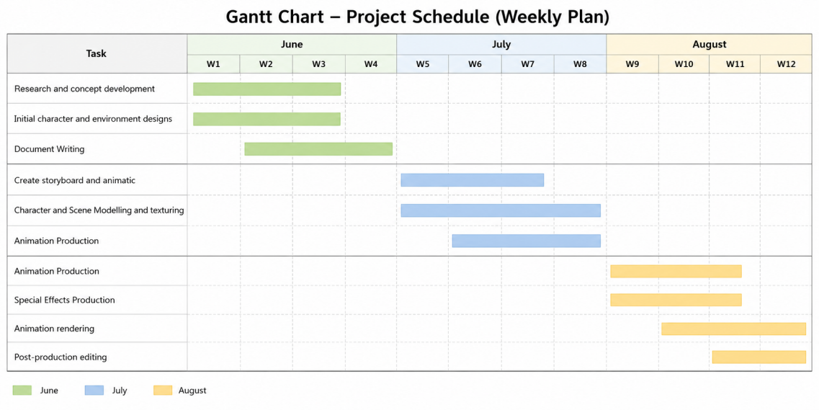
Gantt chart

Conclusion
This project will provide an opportunity to develop both creative and technical skills within animation production. Through careful planning and structured development, I aim to create a visually compelling animated work that demonstrates effective storytelling, world-building, and professional production practices.

