

MSc Engineering Project Management

Design and Implementation of a Pilot Green Hydrogen Facility for Analysis for Upscaling:
A Project Management Perspective

Darren Thomas
Student ID 2117577

MSc Engineering Project Management, University of Wales Trinity of Saint David

ACFA 7003: Dissertation

Supervisor: Andrew Thorn

February 2024

Abstract:

This abstract summarizes the essential findings and project management perspectives collected from the Design and Implementation of the Pilot Green Hydrogen Facility, Pioneer 1. The study explores critical insights crucial for the success of green hydrogen production, with a focus on integration, stakeholder engagement, hydrogen purity, and maintenance practices. Key recommendations for future projects include comprehensive planning, robust stakeholder involvement, and a commitment to quality assurance. Strategic management of critical spares, implementation of digital twin technology. Continuous personnel training ensures competence in safety procedures and regulatory compliance. The recommendations and framework produced serve as a roadmap for the development of efficient, resilient, and environmentally conscious green hydrogen facilities, aligning with global sustainability goals. The experiences shared provide valuable guidance for the transition to sustainable energy sources and underscore the pivotal role of efficient project management in advancing the renewable energy landscape.

Acknowledgements

I would like to express my sincere gratitude to the individuals and organizations that have played a crucial role in the successful completion of my Master of Science thesis on "Design and Implementation of a Pilot Green Hydrogen Facility for Analysis for Upscaling: A Project Management Perspective."

I extend my deepest appreciation to my academic advisor, Andrew Thorn, for their invaluable guidance, expertise, and unwavering support throughout the entire research process. Their insightful feedback and encouragement have been instrumental in shaping the direction of this study.

Special thanks are due to The Protium Team and The USW Hydrogen Centre Staff for their collaboration and provision of resources, which played a crucial role in the successful implementation of the pilot green hydrogen facility.

I am grateful to my friends and family for their unwavering encouragement and understanding during the challenging periods of this academic journey. Their support has been a constant source of motivation.

Lastly, I would like to express my deepest gratitude to all those whose names may not appear here but have contributed in various ways to the completion of this project. Your support has been instrumental, and I am truly thankful.

Thank you all for being an integral part of this journey.

Author’s Declaration

I declare that the work in this dissertation was carried out in accordance with the regulations of UWTSD. The work is original except where indicated by special references in the text and no part of the dissertation has been submitted for any other degree.

Any views expressed in the dissertation are those of the author and in no way represent those of the UWTSD.

The dissertation has not been presented to any other University for examination either in the United Kingdom or overseas.

I hereby give permission for my work, if accepted, to be available for photocopying and inter-library loan, and for the title and summary to be made available to outside organizations.

Signed: ………J.D.Thomas……………………………….

Date: ………21/01/2024……………………………

Contents
Abstract: 2
Acknowledgements 3
Author’s Declaration 4
Contents 5
List of Figures 6
Chapter 1: Introduction 8
1.1 Background 8
1.2 Research Problem 9
1.3 Objectives 10
1.4 Research Questions 10
1.5 Scope 10
1.6 Significance 11
1.7 Structure of the Dissertation 11
Chapter 2: Literature Review 12
2.1 Fundamental Principles of Green Hydrogen Production 12
2.2 How Different Types of Electrolysis Work 13
PEM Electrolysers 13
Alkaline Electrolysers 14
Solid Oxide Electrolysers 15
2.3 Renewable Energy Sources: 20
2.4 Electrolysers: 21
2.5 Energy Storage Systems: 23
2.6 Hydrogen Buffer storage. 24
2.7 Compressors. 27
2.8 Fuel Cells and Hydrogen Purity. 29
2.9 Efficiency and Energy Balance: 33
2.10 Safety and Environmental Considerations: 35
2.11 Digital Twin 38
2.12 System Integration: 41
Chapter 3: Methodology 45
3.1 Research Design: 45
3.2 A Project Managers Perspective 47
3.3 Stakeholder Management: 48
3.4 Communication Management: 49
3.5 Risk Management: 51
3.6 Quality Management: 55
3.7 Resource Management: 57
3.8 Timeline and Schedule Management: 58
3.9 Cost Management: 60
Chapter 4: Results 62
4.1 Design 62
4.2 Installation 76
4.3 Commissioning 84
4.4 Post Commissioning 88
4.5 Framework for design and implementation of a green hydrogen plant. 89
Technical Factors: 89
Economic Factors: 90
Environmental Factors: 90
Chapter 5: Discussion 91
Chapter 6: Conclusion and Recommendations: 97
6.1 Conclusion: 97
6.2 Recommendations for Future Projects: 98
References 100
Appendix 105

List of Figures
Proton Exchange Membrane Electrolyzers (PEM) Figure 1 13
Alkaline Electrolysers Figure 2 14
Solid Oxide Electrolyzers Figure 3 15
Alkaline Electrolysis. Figure 4 17
PEM Electrolysis Figure 5 18
Hydrogen Storage Vessels Figure 6. 24
BOC Manifolded Cylinder Pallet. Figure 7 25
Hybrid storage vessels Figure 8. 26
Hiperbaric Compression technologies. Figure 9. 28
The General Concept of a Fuel Cell (H₂ – O₂) Figure 10. 29
Possible Impurities of SOFC’s Figure 11. 30
Life cycle reduction due to Hydrogen Impurities Figure 12. 31
Hydrogen Purity 99.999% Figure 13. 32
M Series Containerized PEM Electrolysers Nel Hydrogen Figure 14. 34
Digitalization of an Asset Figure 15. 39
The 9 main drivers of digitalization Figure 16. 40
Digitalization Road Map Figure 17. 40
Energy Grid Figure 18. 41
Hydrogen production costs 2022 Figure 19. 44
Power of Interest Matrix Figure 20. 48
Protium Risk Management Plan Figure 21. 51
Pioneer 1 Budget. Figure 23. 60
Pioneer 1 Original Site Plan Figure 24. 63
NRW Risk Assessment Figure 25. 64
Pioneer 1 Project Plan Figure 26. 66
Hydrogen storage limits. Figure 27. 68
Flammable substances and characteristics. Figure 28. 69
Sources of release Figure 29. 70
Hydrogen Vents, Zone 1. Figure 30. 70
Electrolyser Container (Northwest Compound) Figure 31 72
MCP Buffer Storage and Compressor Systems (Northeast Compound) Figure 32 73
Pugh Chart Figure 33. 74
Fill panel original design Figure 34. 75
Container Installation Figure 35. 78
Compressor & Buffer Tank Installation Figure 36. 78
Hydrogen Valve System Figure 37. 79
Fill Panel Figure 38. 80
High pressure MCP’s Figure 39. 81
Site Layout P&ID Figure 40. 82
Pioneer 1 Container Figure 41 83
Digital Twin Dashboard Figure 42 87

Chapter 1: Introduction

1.1 Background
The urgent need to transition towards a sustainable and carbon-neutral energy system has become increasingly evident in recent years. As the detrimental effects of greenhouse gas emissions and climate change become more pronounced, the search for clean and renewable energy sources has gained significant momentum. Among the various alternatives, hydrogen has emerged as a promising candidate for decarbonizing multiple sectors, including transportation, industry, and power generation.
Hydrogen, when produced through green and sustainable methods such as electrolysis powered by renewable energy sources, stands out as a zero-emission fuel. This means that its utilization does not contribute to the release of harmful greenhouse gases, mitigating the adverse impacts on the environment. In contrast to conventional fossil fuels, the combustion of hydrogen generates only water vapor, making it a crucial component in achieving a carbon-neutral future.

One of the key advantages of hydrogen lies in its versatility and applicability across diverse sectors. In transportation, hydrogen fuel cells offer a clean and efficient alternative to traditional internal combustion engines, providing longer ranges and shorter refueling times for vehicles. The widespread adoption of hydrogen-powered vehicles can significantly reduce the carbon footprint of the transportation sector, a major contributor to overall greenhouse gas emissions.

Additionally, hydrogen plays a pivotal role in decarbonizing industrial processes that are traditionally associated with high emissions. Industries such as steel and chemical manufacturing can benefit from hydrogen as a clean energy carrier and feedstock. By replacing carbon-intensive processes with hydrogen, these sectors can make substantial strides towards sustainability without compromising productivity.

In the land of power generation, hydrogen serves as an excellent energy storage solution. It can be utilized to store excess energy generated from intermittent renewable sources, such as wind and solar, addressing the challenge of intermittent and enhancing grid stability. The ability to store and transport energy in the form of hydrogen ensures a reliable and resilient energy system, capable of meeting the demands of a growing population while minimizing environmental impact.

Furthermore, the global push for energy independence is bolstered by the fact that hydrogen can be produced locally, reducing dependence on fossil fuel imports, and enhancing energy security. This localization of energy production not only fosters economic growth but also creates job opportunities in the expanding hydrogen industry.

In conclusion, hydrogen stands as a key player in the pursuit of a sustainable and carbon-neutral future. Its versatility, zero-emission nature, and potential to revolutionize key sectors make it a compelling choice for countries and industries striving to meet ambitious climate goals. As we navigate the complexities of transitioning to a greener energy landscape, investing in hydrogen technologies and infrastructure is not merely an option but a strategic imperative to ensure a resilient and environmentally responsible energy future for generations to come.

1.2 Research Problem
The establishment of green hydrogen plants represents a crucial step towards achieving a sustainable energy future. These plants serve as critical infrastructure for large-scale hydrogen production, storage, and distribution. Designing and implementing such plants require a comprehensive understanding of various engineering disciplines, including renewable energy integration, electrochemical processes, Compression systems, storage technologies, and hydrogen infrastructure. This dissertation addresses the need to explore the design and implementation of a green hydrogen facility, taking into account key considerations such as technical feasibility, economic viability, and environmental sustainability.

1.3 Objectives
The main objectives of this research are as follows:
- Investigate the fundamental principles of green hydrogen production through electrolysis, with a focus on the integration of renewable energy sources.
- Analyze the different technologies and components involved in the design of a green hydrogen plant, including electrolysers, compression, and energy storage systems.
- Develop a comprehensive framework for the design and implementation of a green hydrogen plant, considering technical, economic, and environmental factors.
- Conduct a case study to showcase the practical application of the proposed design framework and evaluate its performance in real-world scenarios.
- Complete the Dissertation in A Project Managers Perspective

1.4 Research Questions
To achieve these objectives, the following research questions will be addressed:
- What are the fundamental principles of green hydrogen production through electrolysis and the integration of renewable energy sources?
- What technologies and components are essential for designing a green hydrogen plant, including electrolysers, compression, and energy storage systems?
- How can a comprehensive framework be developed for the design and implementation of a green hydrogen plant, considering technical, economic, and environmental factors?
- What are the practical implications and performance outcomes of applying the proposed design framework in real-world scenarios.

1.5 Scope
This dissertation focuses on exploring the technical, economic, and environmental aspects of the design and implementation of a green hydrogen facility. It also includes a case study to demonstrate the practical application of the proposed framework. While this research provides valuable insights into green hydrogen production, it acknowledges that specific project details and outcomes may vary based on regional and project-specific factors.

1.6 Significance
This research is significant in the context of engineering project management and the hydrogen industry as it contributes to the knowledge base surrounding green hydrogen production. It provides insights into the practical implementation of green hydrogen facilities learned from the Protium Pioneer 1, 100 kW small scale Pilot system.

1.7 Structure of the Dissertation
The subsequent chapters of this dissertation will delve into each research objective, addressing the fundamental principles of green hydrogen production, technological aspects, economic feasibility, environmental impact, and the development of a comprehensive design framework. The final chapter will present a case study, and the dissertation will conclude with implications, recommendations, and contributions to the broader transition toward a low-carbon energy system.

Chapter 2: Literature Review

2.1 Fundamental Principles of Green Hydrogen Production

Investigate the Fundamental Principles of Green Hydrogen Production through Electrolysis, with a Focus on the Integration of Renewable Energy Sources

Green hydrogen production through electrolysis is a process that holds immense promise for a sustainable and clean energy future. At its core, this objective involves a thorough exploration of the underlying principles governing the conversion of water into hydrogen and oxygen using electrolysis, with a keen emphasis on the integration of renewable energy sources.

Renewable Energy Integration: A key aspect of green hydrogen production is the utilization of renewable energy sources to power the electrolysis process. This involves the integration of technologies such as solar photovoltaics, wind turbines, or hydropower to generate the electricity required for electrolysis. Investigating the principles of renewable energy conversion and their compatibility with electrolysis is pivotal.

Electrolyser Types: The research explores different types of electrolysers, notably alkaline, proton exchange membrane (PEM), Anon Exchange Membranes (AEM) and solid oxide electrolysers. Each type has its unique principles of operation, efficiency, and suitability for integration with renewable energy sources.

2.2 How Different Types of Electrolysis Work
Electrolysis Fundamentals: To begin, the research delves into the core principles of electrolysis.
Similar to fuel cells, electrolysers comprise an anode and a cathode, separated by an electrolyte as in examples. Figure 1,2 and 3.. Various electrolysers operate differently, primarily due to variations in the electrolyte material and the ionic species it conducts. (Yagmur, 2023)

PEM Electrolysers

Proton Exchange Membrane Electrolyzers (PEM) Figure 1
In PEM electrolyzers figure 1, the electrolyte consists of a solid specialty plastic material. At the anode, water undergoes a reaction to produce oxygen and positively charged hydrogen ions (protons). Electrons flow through an external circuit, and the hydrogen ions move selectively across the PEM to the cathode. At the cathode, hydrogen ions combine with electrons to form hydrogen gas.
H2O→1/2O2 +2H+ +2e- (Anode compartment)
2H+ +2e- →H2 (Cathode compartment)
H2O→1/2 O2 +H2 (Overall)

PEM - Advantages-Disadvantages
Simple design. | High gas purity. | Rapid system response.
High current density. | High component cost. | Acidic environment.
Membrane scaling. | Low durability.

Alkaline Electrolysers
Alkaline electrolysers operate by transporting hydroxide ions (OH-) through the electrolyte from the cathode to the anode as seen below in figure 2, resulting in hydrogen generation on the cathode side. Commercially available versions use a liquid alkaline solution of sodium or potassium hydroxide as the electrolyte. Emerging technologies involve solid alkaline exchange membranes (AEM) as the electrolyte, showing promise on a laboratory scale.

Alkaline Electrolysers Figure 2

Alkaline - Advantages-Disadvantages
Cost-effective operation. | Long term durability. | High production efficiency.
Low degree of purity. | Corrosive electrolyte type. | Low dynamic operation.
Low operational pressure. | Prolonged startup procedure. | Low current density.

Solid Oxide Electrolysers
Solid oxide electrolysers utilize a solid ceramic material membrane as the electrolyte, conducting negatively charged oxygen ions (O2-) at elevated temperatures. The hydrogen generation process differs as steam at the cathode combines with electrons to form hydrogen gas and negatively charged oxygen ions. The oxygen ions then pass through the solid ceramic membrane and react at the anode to produce oxygen gas and generate electrons for the external circuit Figure 3.

Solid Oxide Electrolyzers Figure 3

Solid Oxide - Advantages-Disadvantages
High efficiency. | High-pressure efficiency. | Low durability.
Complicated system design.

Solid oxide electrolyzers require higher operating temperatures (about 700°–800°C) compared to PEM electrolyzers (operating at 70°–90°C) and commercial alkaline electrolyzers (typically less than 100°C). Advanced lab-scale solid oxide electrolyzers, based on proton-conducting ceramic electrolytes, show promise in lowering operating temperatures to 500°–600°C. This technology effectively utilizes available heat at elevated temperatures (from various sources, including nuclear energy) to reduce the electrical energy required for hydrogen production from water.
(ENERGY.GOV, 2023)

In the context of direct hydrogen production systems, ongoing research and development (R&D) endeavours are primarily concentrated on fundamental approaches for generating hydrogen using sunlight and water through photobiological, photoelectrochemical, and photochemical methods. These long-term processes are considered the "Holy Grail" of the Hydrogen Economy, representing the ultimate clean and sustainable hydrogen production method. Nonetheless, it is important to note that these technologies currently receive limited R&D investment, necessitating substantial resources to be allocated over an extended period to attain the requisite fundamental understanding before industry can confidently invest in their commercialization (Evans, 2004)

Hydrogen production through electrolysis has gained significant attention since then and is seen as a promising pathway towards the generation of green hydrogen. Electrolysis involves the splitting of water molecules (H2O) into hydrogen (H2) and oxygen (O2) using an electrical current Figures 1,2 and 3. The process can be categorized into four main types: alkaline water electrolysis (AWE), proton exchange membrane electrolysis (PEM), anion exchange membrane electrolysis (AEM), and solid oxide electrolysis (SOE). Each approach requires a direct current (DC) input, and the electrolysers utilized in these systems play a pivotal role in the overall efficiency and performance of the hydrogen production process.

Alkaline Water Electrolysis (AWE or AEL) is one of the oldest and most established electrolysis technologies. It employs an alkaline solution, typically potassium hydroxide (KOH) as the electrolyte shown below in Figure 4. AWE systems operate at relatively high temperatures and require electrodes made of non-noble metals like nickel-based alloys with electrolytic coatings. Although AWE has been widely used, it has certain limitations, including slower response times and higher maintenance requirements. (Brauns, 2020)

Alkaline Electrolysis with KOH solution. (Protium, 2020)

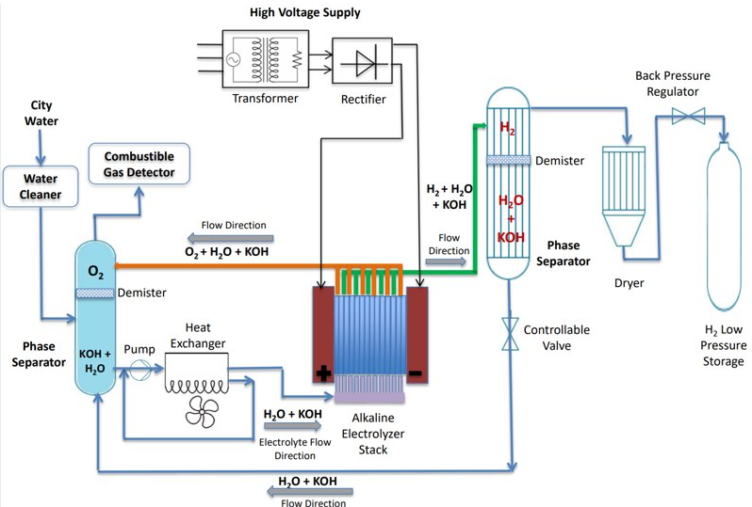

Alkaline Electrolysis. Figure 4

Proton exchange membrane electrolysis (PEM) has gained popularity due to its fast response time, high pressure, efficiency, and compact design. PEM electrolysers utilize a solid polymer electrolyte membrane, such as Nafion, highlighted in Figure 5 that selectively allows the transport of protons. This membrane enables the separation of hydrogen and oxygen, resulting in higher purity hydrogen production. PEM electrolysers operate at lower temperatures and can quickly respond to changes in electrical input. These characteristics make PEM electrolysis suitable for decentralized applications and integration with intermittent renewable energy sources, In principle, PEM technology offers the possibility of operation at such high pressures. (S.A. Grigoriev, 2009) which is advantageous for reduced compression requirements for a hydrogen facility.

PEM Electrolysis with Nafion membrane producing high purity hydrogen. (Protium, 2020)
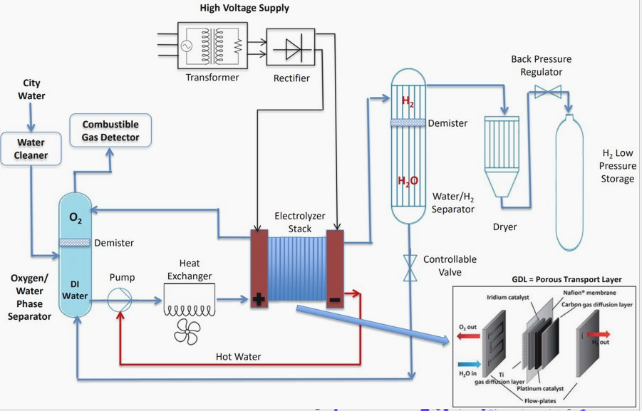

PEM Electrolysis Figure 5

Anion exchange membrane electrolysis (AEM) is a relatively newer technology that has attracted attention for its potential advantages. AEM electrolysers employ a solid polymer electrolyte membrane that allows the transport of both hydroxide ions (OH-) and water molecules, eliminating the need for costly and scarce precious metal catalysts used in PEM electrolysers. AEM technology shows promise in terms of cost reduction and efficiency improvement, as well as the potential for the use of non-precious metal catalysts. AEM shows higher efficiency and purity of produced hydrogen than AWE owing to the use of the anion-exchange membrane (AEM) rather than a liquid electrolyte. (Sun Young Kang, 2022) However, AEM electrolysis is still in the early stages of development and faces challenges such as durability and scaling up. Seen as a contender for small scale pilot facilities.

Solid oxide electrolysis Cell (SOEC) is another promising electrolysis technology that operates at high temperatures using a solid oxide ceramic electrolyte. SOEC electrolysers can directly utilize steam and/or carbon dioxide as feedstocks, enabling the co-production of hydrogen and carbon monoxide (CO) or methane (CH4). This makes SOEC technology particularly relevant for applications such as syngas production and power-to-gas processes and is gaining increasing attention owing to its overwhelming thermodynamic advantages (Gyubin Min, 2022)

In conclusion, alkaline water electrolysis (AWE), proton exchange membrane electrolysis (PEM), anion exchange membrane electrolysis (AEM), and solid oxide electrolysis Cell (SOEC) are the main types of electrolysis technologies used for green hydrogen production. Each technology offers different advantages and challenges, with PEM electrolysis being well-established and suitable for decentralized applications, AEM electrolysis showing potential for cost reduction and catalyst advancements, and SOEC electrolysis enabling the co-production of hydrogen and valuable chemical compounds. Continued research and development in electrolysis technologies will contribute to the advancement and widespread adoption of green hydrogen as a sustainable energy solution.

2.3 Renewable Energy Sources:

Renewable energy sources, such as solar, wind, and hydroelectric power, offer a carbon-neutral and sustainable means of providing the necessary electricity for electrolysis. The integration of renewable energy sources with electrolysis systems allows for the production of green hydrogen, which is free from greenhouse gas emissions and environmental harm. Several studies have demonstrated the viability of renewable energy integration in electrolysis for green hydrogen production.

For example, a study conducted by Qusay Hassan et al 2023 explored the integration of wind and solar power with alkaline electrolysis for green hydrogen production. The researchers utilized wind and solar power generation data and developed a model to optimize the operation of the electrolyser based on the available power. The study demonstrated that the integration of the renewable energy supply and the electrolysis systems can improve the overall efficiency and economic feasibility of green hydrogen production. The authors find that the use of advanced control strategies, such as power smoothing and dynamic operation, can mitigate the negative impacts of power fluctuations and improve the overall performance of the electrolysis system (Qusay Hassan, 2023)

In another study, Li et al. investigated the integration of solar photovoltaic (PV) power with proton exchange membrane electrolysis. The researchers designed and implemented a pilot-scale system to assess the technical performance and economic viability of solar-driven hydrogen production. The results highlighted the potential of integrating solar PV power with electrolysis to achieve high hydrogen production and efficiency rates with reduced carbon emissions. (Guiqiang Li, 2022)

Furthermore, a study conducted by Khem Gwanwali (2022) explored the integration of hydroelectric power with electrolysis for green hydrogen production. The researchers developed a model to evaluate the feasibility of large-scale hydrogen production using hydroelectricity. The study indicated that hydroelectric power, with its high reliability and renewable nature, can effectively support the electrolysis process and enable the production of green hydrogen at a competitive cost (Khem Gyanwali, 2022)

These studies, along with numerous others, underscore the importance of integrating renewable energy sources with electrolysis systems for green hydrogen production. The utilization of renewable energy not only enhances the sustainability of hydrogen production but also contributes to the reduction of carbon emissions and reliance on fossil fuels.

In conclusion, the investigation of the fundamental principles of green hydrogen production through electrolysis with a focus on the integration of renewable energy sources is crucial for advancing the development and implementation of sustainable hydrogen technologies. The cited studies demonstrate the potential and feasibility of integrating renewable energy sources, such as wind, solar, and hydroelectric power, with electrolysis systems to produce green hydrogen. This research provides valuable insights into optimizing the performance, efficiency, and economic viability of green hydrogen production, thereby facilitating the transition towards a more sustainable and carbon-neutral energy system.

2.4 Electrolysers:
Designing a green hydrogen plant requires a comprehensive analysis of various technologies and components involved in the production, storage, and purification of hydrogen. These elements play a critical role in the overall efficiency, reliability, and cost-effectiveness of the plant's operation.

Electrolysers are key components in a green hydrogen plant as they facilitate the electrolysis process, converting electrical energy into hydrogen through the splitting of water molecules. There are different types of electrolysers as previously highlighted, including alkaline water electrolysers (AWE), proton exchange membrane electrolysers (PEM), and solid oxide electrolysers (SOE).

Alkaline electrolysers, such as those developed by Siemens and Nel Hydrogen, have been widely used for large-scale hydrogen production. They operate at relatively high temperatures and utilize a potassium hydroxide electrolyte solution. On the other hand, PEM electrolysers, like those manufactured by ITM Power, Hydrogenic and Nel, operate at lower temperatures and utilize a solid polymer membrane as the electrolyte. PEM electrolysers offer advantages in terms of efficiency, responsiveness, and scalability.
Research has highlighted the critical importance of selecting the most appropriate Electrolyser technology, a decision based on factors such as the scale of the plant, its energy demands, and the prevailing operational conditions. For instance, a comprehensive analysis comparing the performance and cost-effectiveness of Cummins' Alkaline, PEM and Enapter's AEM systems in the context of green hydrogen production has been undertaken. The research findings led to the conclusion that PEM electrolysers excel in smaller-scale applications characterized by intermittent renewable energy sources, whereas alkaline electrolysers prove more adept at larger-scale operations requiring continuous hydrogen production (Hydrogen News, 2023). Enapters Earth Shot Prize Finalists of 2021 with their compact AEM Modules which are suitable for small-scale projects are standardized and modular for easy installation and suited for mass production (Enapter, 2021) Enapter's recent projects have seen development programs for transport, stationary power, and aviation industries of up to 1MW in size (Enapter, 2023) which is a great improvement compared to the 100Kw systems previously available (as Pioneer 1 system.)

Another study carried out by Robert Caponi et al. (2021) compares the PEM Electrolyser technology to low-temperature alkaline electrolysis, highlighting PEM to have a Specific energy consumption of around 6-6.5kWh/Nm³ yielding 55-65% efficiency which is slightly higher, where the alkaline electrolysis requires 5-5.5kWh/Nm³ Yielding 70-75% efficiency. PEMs are more suited to an On of profile for Hydrogen refuelers and can manage a high intermittency profile and power modulation. (EDP Sciences, 2021)

2.5 Energy Storage Systems:
Green hydrogen facilities play a crucial role in energy storage systems, allowing for the effective management and utilization of intermittent renewable energy sources. These systems store excess electricity during periods of high renewable energy generation and can supply it to consumers during periods of low renewable energy availability.

Battery energy storage systems (BESS) and hydrogen energy storage systems (HESS) are two commonly employed technologies available. BESS, such as lithium-ion batteries, offer fast response times, high round-trip efficiency, and the ability to provide ancillary services to the grid. HESS, on the other hand, involves converting excess electricity into hydrogen through electrolysis and storing it for later use. The stored hydrogen can then be converted back into electricity through fuel cells or utilized directly in various applications.

A study conducted by Martinez Alonso et al. (2023) investigated the integration of BESS and HESS in to a production facility. The researchers compared the techno-economic performance of the two storage technologies and concluded that HESS exhibited advantages in terms of long-duration energy storage, system flexibility, and potential revenue streams. Also highlighted was hydrogen was proved to play a complementary role when combined with batteries, enhancing the flexibility of the microgrid and enabling deeper decarbonization by reducing the electricity bought from the grid, increasing renewable energy production (A. Martinez Alonso, 2023)

2.6 Hydrogen Buffer storage.

PEM and AEM electrolysers produce an outgoing pressure of up to 35 bar, which is ideal for utilization in buffer storage tanks prior to compression up to the further required pressure of 300 bar for medium-pressure storage or refueling. And up to 700-1000 bar for high-pressure refueling.

The classification of high-pressure vessels highlighted by Herve Barthelemy in Hydrogen Storage research (Barthe´le´my, 2012) includes the following four types (refer to Figure 6 ):

Type I: A pressure vessel constructed entirely of metal.
Type II: A pressure vessel consisting of a robust metallic liner hoop enveloped by a fiber-resin composite.
Type III: A pressure vessel featuring a metallic liner fully encased in a fiber-resin composite.
Type IV: A pressure vessel comprising a polymeric liner fully wrapped with a fiber-resin composite. The port is metallic and integrated into the structure (boss).

All four types of pressure vessels can be utilized for storing hydrogen. The selection of a specific storage type depends on the intended application, necessitating a balance between technical performance and cost competitiveness. For industrial hydrogen gas storage, Type I tanks are commonly employed, with pressure ranging from 150 to 300 bar (usually 200 bar). These tanks are widely used in various applications and are commonly supplied for various applications.

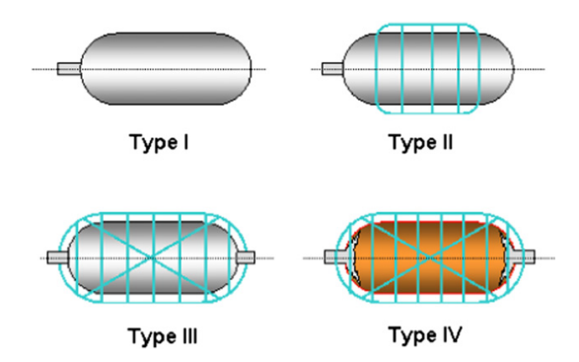

Hydrogen Storage Vessels Figure 6.
Storing hydrogen in a compressed gaseous state is the most straightforward solution in terms of infrastructure requirements, making it the favored and most advanced method of hydrogen storage. Key to current hydrogen refueling stations, seamless pressure vessels crafted from high-strength steel are often used.
Several different options are available for buffer storage one option is the Manifolded Cylinder Pallet’s (MCP’s) seen below in figure 7 (BOC a Linde Comapny, 2023) with a 10 year life before inspection under written scheme of examination for Pressure system regulations.

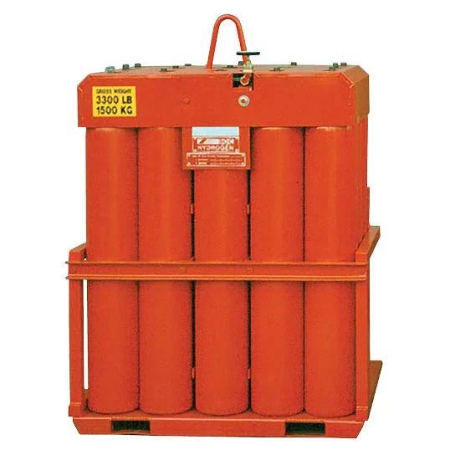

BOC Manifolded Cylinder Pallet. Figure 7

Currently, steel vessels still face limitations in volume and are susceptible to hydrogen embrittlement, addressing these issues, alternatives are available which are more versatile highlighted in previous texts on Vessel Types Figure 6.
Bespoke hybrid storage vessels, as Figure 8. below made from (1) carbon fiber and epoxy resin, (2) a thin layer of aluminum. (Nobuhiko Takeichi, 2003)
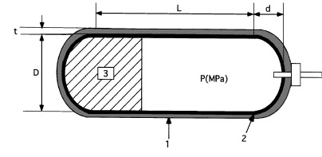

Hybrid storage vessels Figure 8.

One key factor in the choice in the Hydrogen storage vessel is the weight ratio between the cylinders and the hydrogen storage capacity, MCP’s could weight up to 2000kg with 18kg of Hydrogen where the hybrid storage vessel would weight a fraction of the weight and of similar strength. (Nobuhiko Takeichi, 2003)
​

2.7 Compressors.
Hydrogen compression is a key part of delivering high-quality hydrogen to the customer at the required pressures. From the electrolysers at 30-35bar up to 350bar and 700 bar categories, which are the two main pressures commonly used in industry, the 700 bar is required for vehicle refueling, 350 bar where there is currently limited space for fuel storage, in the future as costs decrease more vehicles will be capable of excepting 700 bar. increased pressures can also equate to a greater range for vehicles. Contamination of the hydrogen through the compressor process can damage fuel cells and therefore it is critical that contamination is not passed through the system, either by design of components and operations or by maintenance activities. HASKEL is one of the industry's leading manufacturers, Pneumatic Driven Gas booster models which are durable, safe, and reliable with no heat, flame or spark risks, As well as the H-Drive Gas Booster model for increased pressures and heavy-duty applications (HASKEL, 2023).
Maximator is another High-quality Hydrogen compressor manufacturer from the UK,
(MAXIMATOR UK, 2023)

As well, Hiperbaric is a quality manufacturer of Hydrogen compressors from Spain with 20 years of experience in the field of high-pressure technologies. Boasting many advantages as below in Figure 9. including faster refueling times and compression technology developed by Hiperbaric enables compression up to 1000 bar (Hiperbaric, 2023)

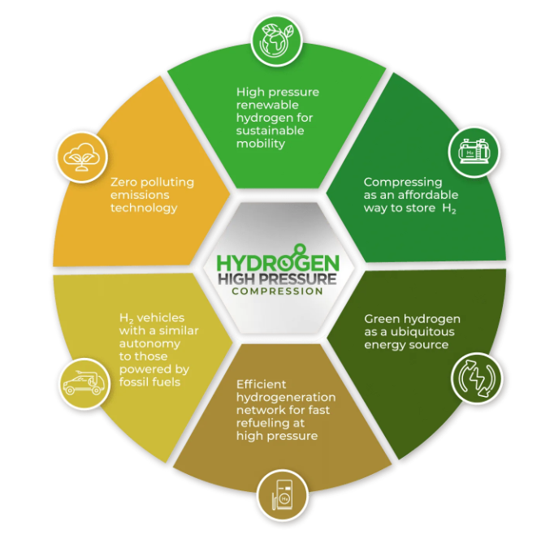

Hiperbaric Compression technologies. Figure 9.

End of life recycling is another key aspect where Johnson Matthey and Enapter jointly investigating opportunities to recycle production scraps and components from end-of-life products. Giving competitive advantage in offering closed loop solutions for Electrolysers and fuel cell equipment. (Enapter, 2022)

2.8 Fuel Cells and Hydrogen Purity.
To understand why high purity hydrogen is required we first need to a general understanding of what a fuel cell is.

Ryan O’Hayre et al 2016 explains that a fuel cell is like a “Factory” and does not consume the hydrogen to produce electricity but transforms the chemical energy stored in the fuel into electrical energy a seen in figure 10. The fuel cell will continue to produce electricity as long as the raw material (Hydrogen) is supplied. And the key difference between a battery and a fuel cell is that the fuel cell is not consumed when it produces hydrogen unlike the battery’s energy. Another difference is in regards to the conventional combustion engine where by the fuel is burned to transform into mechanical or electrical energy releasing the energy as heat. (Ryan O'Hayre, 2016)

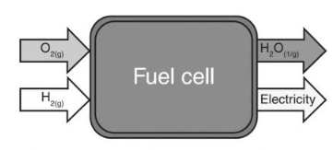

The General Concept of a Fuel Cell (H₂ – O₂) Figure 10.

Hydrogen Purity is therefore essential for use in Fuel Cells to prevent various issues including:

Chemical Reactions: Fuel cells operate on a chemical reaction between the internal electrodes, the most common type of fuel cell is the Proton Exchange Membrane Fuel Cell (PEMFC) which relies on the chemical reaction between the hydrogen and the oxygen to generate electricity. Any impurities in the hydrogen fuel can interfere with the reaction, leading to reduced efficiency or damage to the fuel cell components. Solid Oxide Fuel Cells (SOFC’s) also suffer the same issues if impurities are present within the Hydrogen gas supply, the pipework or components and can poison the Anodes and Cathodes within the Fuel Cell.

Below figure 11. is a representation from K.Sasaki et al on impurities. (Kazunari Sasaki, 2011)

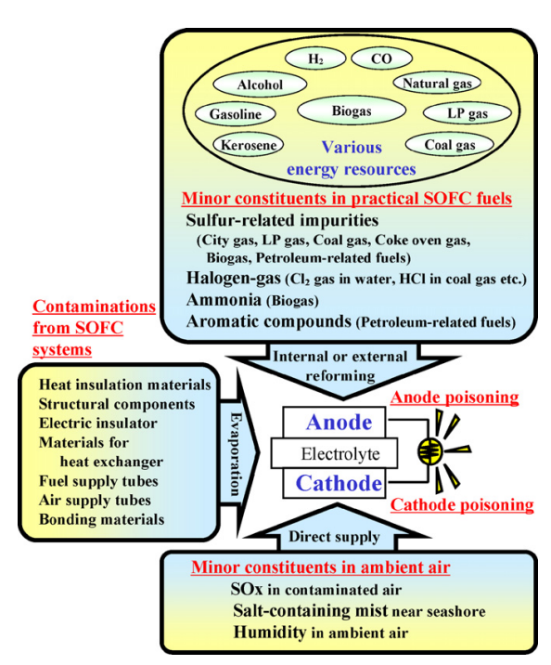

Possible Impurities of SOFC’s Figure 11.

Catalyst Poisoning: Impurities, especially inorganic compounds and sulfur-based contaminants can poison the catalysts used in fuel cells. Catalysts, typically made of precious metals like platinum, play a crucial role in facilitating electrochemical reactions. Impurities can stick to the catalyst surfaces, reducing their activity and causing a decrease in fuel cell performance.

Corrosion: Impurities, such as carbon monoxide (CO) or sulfur compounds, can lead to the corrosion of the fuel cell components, including the membrane and electrode assemblies. Corrosion can degrade the structural integrity of the fuel cell affecting many components including the end cap seals and lead to gas leaks and reduced lifespan of the fuel cell.

Membrane Damage: In PEMFCs, the proton-exchange membrane is a critical component that conducts protons from the anode to the cathode, allowing the electrochemical reaction to occur. Contaminants in the hydrogen can damage the membrane, impairing its proton-conducting ability and causing a decrease in fuel cell efficiency and life cycle (B. Shabania, 2019). highlighted in Figure 12. below life cycle reduction is clearly seen.

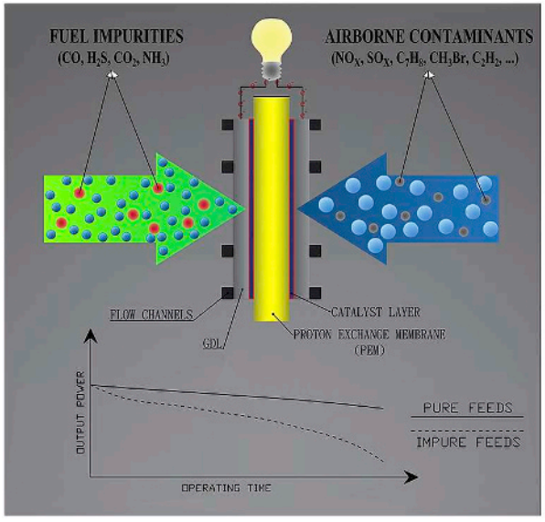

Life cycle reduction due to Hydrogen Impurities Figure 12.

Safety Concerns: High hydrogen purity is also crucial for safety reasons. In certain situations, impure hydrogen can lead to more rapid and unpredictable reactions within the fuel cell, potentially resulting in thermal runaways or other safety hazards.

Efficiency and Performance: For commercial and practical applications, fuel cells are expected to operate at high efficiencies and consistent power output. Impure hydrogen can cause variations in performance and reduce the overall efficiency of the fuel cell system.

To address these issues, hydrogen purity standards have been established for fuel cell applications. These standards specify the maximum allowable levels of impurities, such as carbon monoxide and sulfur compounds, in the hydrogen fuel. Technologies like hydrogen gas purification systems e.g. Pressure swing adsorption (PSA) reducing purity to 99.999 % (Mauro, 2022) and hydrogen purification membranes that can also remove trace impurities are used to ensure that the hydrogen supplied to fuel cells meets these standards, thus optimizing fuel cell performance and reliability. NPL is one of the Hydrogen Purity Analysis companies that perform Purity checks for Hydrogen 5,9‘s. (99.999%) figure 13. below highlights the parameters and limits required for Hydrogen purity for use with fuel cells. (NPL, 2023)
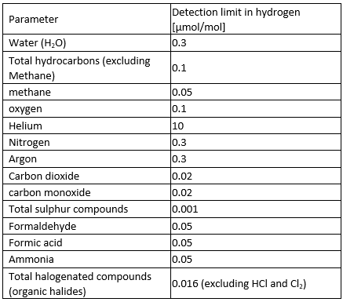

Hydrogen Purity 99.999% Figure 13.
In summary, maintaining high hydrogen purity is critical for fuel cells to achieve their designed efficiency, reliability, and lifespan, and to ensure the safe and effective operation of fuel cell-based systems in various applications, including transportation, stationary power generation, and more.

Hydrogen Purity and Quality: Investigating the principles governing the production of high-purity hydrogen is crucial, as the quality of hydrogen impacts its usability in various applications, from fuel cells to industrial processes.

2.9 Efficiency and Energy Balance:
An essential aspect of this investigation is evaluating the efficiency of the electrolysis process, considering factors like energy losses, voltage requirements, and energy conversion rates. Achieving high efficiency is critical for the economic viability of green hydrogen production.

Using the Enapter AEM Electrolyser, 4.8 kWh are required to generate 1 Nm³ of hydrogen (4.8KWh/NM³) This translates to 53.3 kWh for producing 1kg of hydrogen, considering it's compressed at 35 bar and maintains a purity level of approximately 99.9%. A 1 kg of hydrogen holds 33.33 kWh/kg (lower heating value), signifying that the AEM Electrolyser achieves an inherent efficiency of 62.5%. It is crucial to make fair comparisons, considering uniform parameters such as power input, hydrogen output, pressure conditions, and purity levels, as these variables can significantly differ among manufacturers. It is essential to evaluate system efficiencies, rather than just stack efficiencies, to draw meaningful comparisons. (Enapter, 2023)

The Nel M series PEM Electrolyser example listed below in Figure 14. yields similar results with reduced power requirements, the MC500 model is 2.5MW system giving 492NM³/h at 30bar output with 4.7KWh/NM³ and full system consumption at 100% 5.1KWh/NM³ which is significantly lower than the Enapters AEM example with the Purity of 99.95%. The reduced outlet pressure of 30bar (NEL, 2023) compared to Enapters 35bar output would require further compression costs to be factored in to understand the full efficiency of the system outputs.

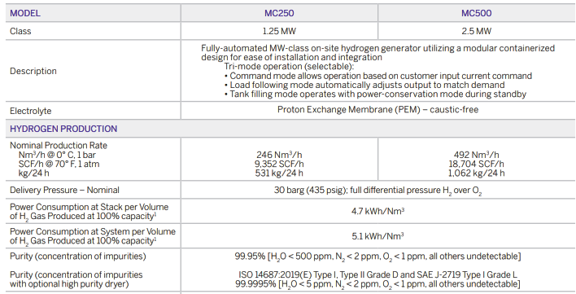
(NEL, 2023)

M Series Containerized PEM Electrolysers Nel Hydrogen Figure 14.

2.10 Safety and Environmental Considerations:
As green hydrogen production involves the handling of potentially explosive gases, understanding the safety principles and environmental considerations associated with the electrolysis process is paramount. This includes gas detection systems, safety relief valves, and measures to mitigate risks.

Hydrogen Leak Detection and Mitigation:
Safety measures should include the installation of hydrogen detectors to identify leaks promptly.
"Hydrogen Safety Checklist" by the European Hydrogen Association provides insights into leak detection and mitigation as well as The US DOE Office of Energy Efficiency and Renewable Energy's Hydrogen and Fuel Cell Technologies Office. (Hydrogen Tools, 2023)

Storage Safety:
Safe storage of hydrogen, whether in compressed gas form, liquid form, or as a metal hydride, is essential. National Fire Protection Association. NFPA 2: Hydrogen Technologies Code provides guidelines for hydrogen storage. (NFPA, 2023)

Ventilation:
Adequate ventilation is crucial to prevent the accumulation of hydrogen in confined spaces.
OSHA's "Hydrogen" safety guidelines address proper ventilation requirements. (OSHA, 2023)

Ignition Sources:
Elimination of potential ignition sources such as open flames, sparks, and electrical equipment that may cause hydrogen fires or explosions are key safety issues to be designed out and by the implementation of robust operating procedures to mitigate the issue. NFPA 2 and ISO 19880 provide standards for hydrogen safety regarding ignition sources and highlights it is advisable to consider hydrogen zones as an explosive gas atmosphere area. (ISO 2020, 2020)

Training and Education:
The correct training and education for personnel working with hydrogen to ensure they understand the risks and safety protocols is delivered by several different learning platforms The HSE deliver The Hydrogen Fundamentals course which helps the learner understand the physical properties and novel phenomena of hydrogen and how it differs from traditional fuels, Appreciate the behavior of hydrogen in different phases, Identify hazards posed by the introduction of hydrogen into an existing system, Know the regulations that relate to the use of hydrogen, thresholds, and when they apply, Design appropriate procedures for handling liquid and gaseous hydrogen which is all advantageous to designing and operating a safe Hydrogen facility. (HSE, 2023)

Emergency Response Planning:
Any organization working with hydrogen should develop an emergency response plan and follow it. As stated in the H2 Hydrogen Tools Best Practices Tool Guide. (Hydrogen Tools, 2023)

Environmental Impact Mitigation:
Consideration into the environmental impact of hydrogen production, storage, and use, and implementation of reduction measures to minimize emissions and waste.
Local environmental regulations and guidance documents from Natural Resources Wales and a permit to produce hydrogen by electrolysis will be required and audited frequently. (Natural Resources Wales, 2023)

Hydrogen Purity and Quality:
Maintain high hydrogen purity levels to avoid contamination and associated safety and environmental risks.
Industry standards like ISO 14687-2 specify purity requirements for hydrogen fuel. Periodic testing and certification are required annually.

Hydrogen Transportation:
Safety measures for the transport of hydrogen via tankers, or cylinders should adhere to relevant regulations. DGSA Audit and Training required. Dangerous goods safety advisers (DGSAs) help prevent the risks involved in the carriage of dangerous goods. This includes risks to people, property and the environment. (GOV.UK, 2023)

Local waste management regulations apply.
It's essential to consult specific regulations, standards, and guidelines applicable to your region and industry when working with hydrogen to ensure safety and minimize environmental impact. Additionally, Businesses have a legal duty to dispose of waste responsibly and have a duty of care. (Neath Port Talbot Council, 2023) and National Resources Wales (NRW) are also required to be contacted if a company produces or deals with waste that has certain hazardous properties eg, Hydrogen, Glycol, KOH 1% for example. (Neath Port Talbot Council, 2023)

2.11 Digital Twin
Digital twins represent a virtual duplicate of a tangible asset, facilitating optimization, testing, monitoring, and digital forecasting of performance, among other advantages. As a component of the Protium Digital Strategy, the objective of this initiative is to construct a Digital Twin for the Pioneer system within the project. This virtual replication aims to enhance overall system efficiency, enable operational optimization, refine asset management, boost productivity and safety, and yield cost savings. Moreover, the project aims to showcase and affirm the value of integrating this technology into forthcoming production units, enhancing comprehension of benefits, risks, implementation procedures, and timelines (Marcela, 2023).

Real-Time Monitoring and Analysis:
A digital twin allows for continuous real-time monitoring of the Pioneer 1 Electrolyser facility. This includes monitoring of key parameters, such as temperature, pressure, flow rates, and energy consumption. Real-time data analysis can help identify trends, anomalies, and potential issues promptly.

Predictive Maintenance:
By analyzing data from the digital twin, operators can implement predictive maintenance strategies. Predictive maintenance uses data and analytics to predict when equipment is likely to fail, allowing for maintenance to be performed just in time, minimizing downtime and reducing maintenance costs.

Process Optimization:
The digital twin can simulate and optimize the electrolysis process under various conditions. This allows operators to identify the most efficient operating parameters, such as optimal temperature, pressure, and flow rates, to maximize hydrogen production while minimizing energy consumption.

Energy Efficiency:
Through the digital twin, energy consumption and efficiency can be closely monitored and optimized. This can involve adjusting operational parameters to ensure the facility operates at peak efficiency, reducing energy waste and overall operational costs.

Scenario Analysis:
The digital twin enables operators to conduct scenario analysis by simulating different operating conditions and configurations. This can be valuable for making informed decisions about potential modifications or expansions to the facility to meet changing demands or improve overall performance.
The digital twin can also serve as a training and simulation tool for operators. It allows them to familiarize themselves with the facility, its processes, and potential issues in a risk-free virtual environment. This can contribute to improved operator competency and response to various situations. By integrating data from the digital twin with advanced analytics and artificial intelligence, operators can make data-driven decisions. This can lead to more informed strategies for improving efficiency, reducing costs, and optimizing overall performance.
In summary, a digital twin of the Pioneer 1 Electrolyser plant provides a powerful platform for real-time monitoring, predictive analysis, and optimization as highlighted in Figures 15. describing what is the Digitalization of an asset and The 9 main drivers of digitalization figure 16. It includes empowerment of operators to make informed decisions, enhance efficiency, and maximize the performance of the Electrolyser plant.

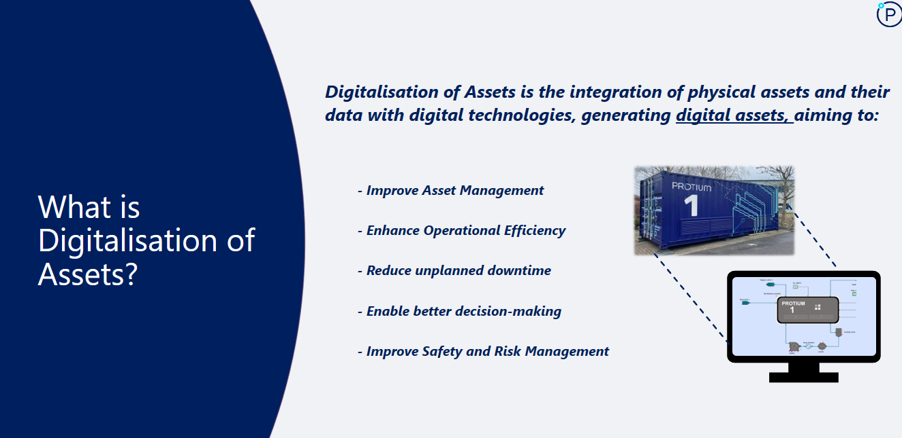

Digitalization of an Asset Figure 15.
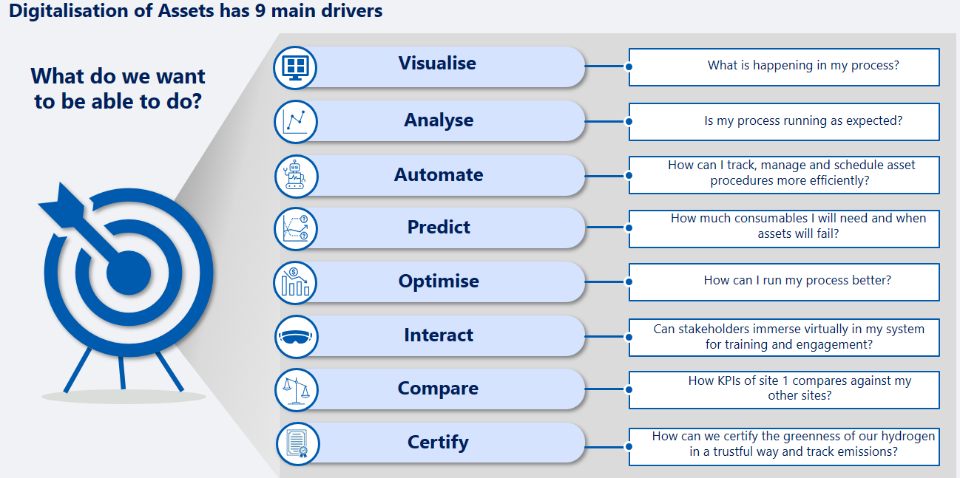

The 9 main drivers of digitalization Figure 16.

Building the digital twin of Pioneer 1 will require many different aspects and integration of Sensors, IoT, Data collection and process models, below Figure 17. is the Protium Steps towards the implementation of the Pioneer 1 pilot system and when finalized can be implemented to the planned Protium projects of 2024-25 and onwards.

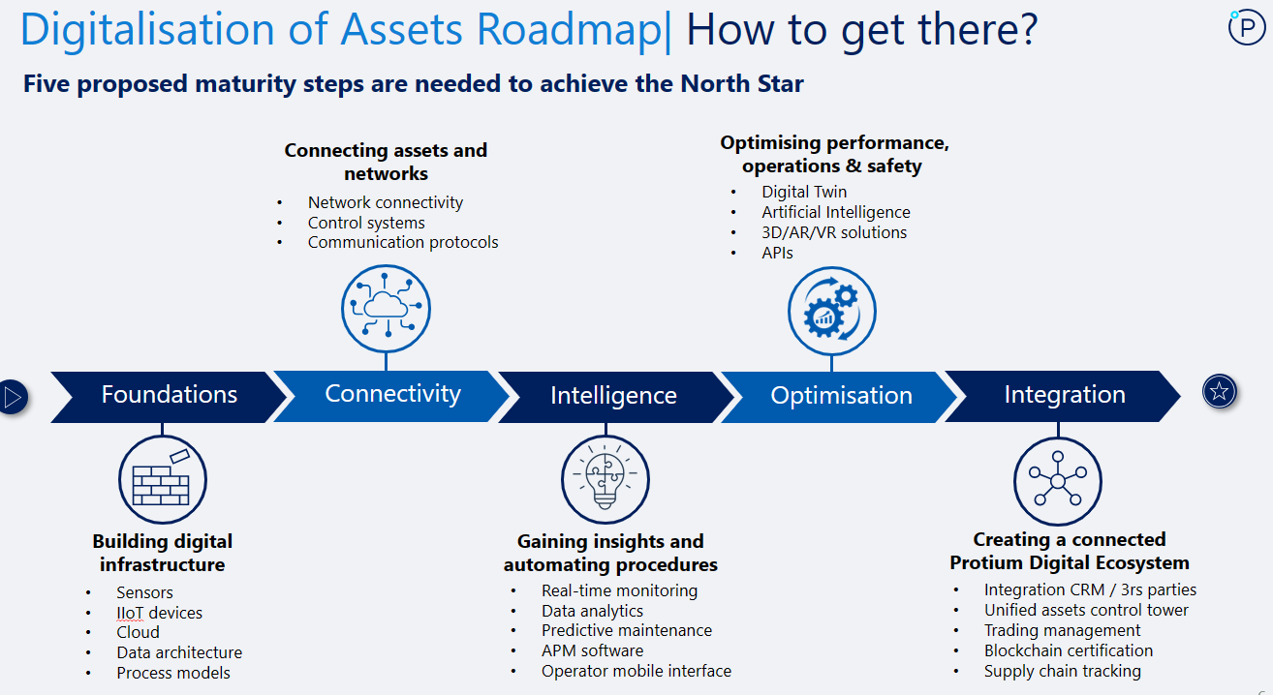

Digitalization Road Map Figure 17.

2.12 System Integration:
Lastly, the research has explored the principles of integrating renewable energy sources, electrolysers, and hydrogen storage systems into a coherent and efficient green hydrogen production system. This involves optimizing the match between energy generation and hydrogen production, ensuring grid compatibility, and addressing intermittent challenges from renewable and or sustainable sources.
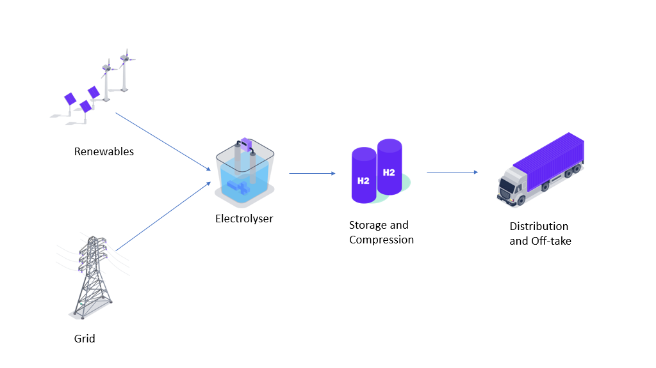

Energy Grid Figure 18.
Grid Compatibility:
Ensuring the seamless integration of the green hydrogen production system with the existing energy grid is a key consideration example Figure 18. The research addresses grid compatibility issues to prevent disruptions and enhance the stability of the overall energy infrastructure. where the University Of South Wales Hydrogen Centre has 2 sources of renewables that may partially power the Pioneer 1 Plant. (H2 Cumru Wales, 2021)
- a 20kW(p) photovoltaic array installed on the roof of the Hydrogen Centre office building.
- a 1.12kWp PV module at the southern side of the office building.
And a Green Tariff Electricity supply from the Grid.

Further Protium projects in 2024/2025 will look to integrate other energy sources such as Bio Energy Plants, wind and solar.

Optimizing Energy Generation and Hydrogen Production:
The research focuses on the capability of aligning energy generation from renewable sources with the hydrogen production process. Advanced control systems and algorithms can be explored via the Digital Twin to match the variable energy input with the demands of the electrolysis process.
This optimization aims to enhance overall system efficiency and minimize energy wastage, this can also be trailed for future projects where flexible tariffs are offered for cheap nighttime or high renewable energy availability rates.
In summary, the research aims to create a comprehensive and optimized system for green hydrogen production by harmonizing renewable energy sources, electrolysers, and hydrogen storage. The long-term goal is to develop a reliable, efficient, and grid-compatible solution that addresses the challenges posed by the intermittent nature of renewable energy.

Renewable Energy Sources: These include solar, wind, hydropower, and other sustainable energy options. The research highlights the utilization of these sources to generate electricity for the subsequent production of green hydrogen. The inherent variability of renewable sources requires careful consideration to ensure a consistent and reliable energy supply for hydrogen production.
Electrolysers: Electrolysis is a crucial process where water is split into hydrogen and oxygen using electricity. The research explores different types of electrolysis technologies, such as alkaline, polymer electrolyte membrane (PEM), or solid oxide electrolysis cells.
Optimizing the efficiency of electrolysers is essential to maximize the conversion of electrical energy into hydrogen.
Hydrogen Storage Systems: Efficient storage is pivotal for balancing the intermittent nature of renewable energy sources. The research delves into various storage methods for compressed hydrogen. The choice of storage method is critical to ensuring a steady and reliable supply of hydrogen, even during periods of low renewable energy production.

Overall, this objective aims to provide a comprehensive understanding of the fundamental principles underpinning green hydrogen production through electrolysis while emphasizing the seamless integration of renewable and sustainable energy sources. It forms the foundational knowledge necessary for designing and implementing sustainable and efficient green hydrogen facilities, contributing to the broader goal of decarbonizing various sectors of the economy.

Incorporating Insights on Hydrogen Production Costs in the EU (2022) into Dissertation

As a critical component of my ongoing dissertation. I have integrated noteworthy findings on hydrogen production costs in the European Union for the year 2022 Figure 19. . These insights are derived from the recently published report, "The European Hydrogen Market Landscape," by the European Hydrogen Observatory. The report can be found Report 1: The European hydrogen market landscape | European Hydrogen Observatory (europa.eu)

Steam Methane Reforming (SMR):
The levelized production costs for hydrogen via SMR averaged approximately 6.23 €/kg H2.
Excluding the impact of CAPEX and other fixed costs (given the operational status of SMR plants), the estimated marginal production costs for SMR hydrogen were around 6 €/kg H2.
SMR with a carbon capture installation resulted in an average hydrogen cost of 6.38 €/kg H2.

Grid Electrolysis:
Hydrogen production costs using grid electricity were estimated within the range of 3.89-16.44 €/kg H2. The average for all countries stood at 9.85 €/kg H2, with a median of 10.65 €/kg H2.

Renewable Hydrogen:
Hydrogen production costs with a direct connection to renewables varied from 4.18 to 9.60 €/kg H2. The average for all countries was 6.86 €/kg H2.
This comprehensive analysis serves as an integral part of my dissertation, providing valuable insights into the diverse costs associated with different hydrogen production methods across the EU. For a deeper understanding and more detailed information, please refer to the complete report. (Panagiotou, 2023)
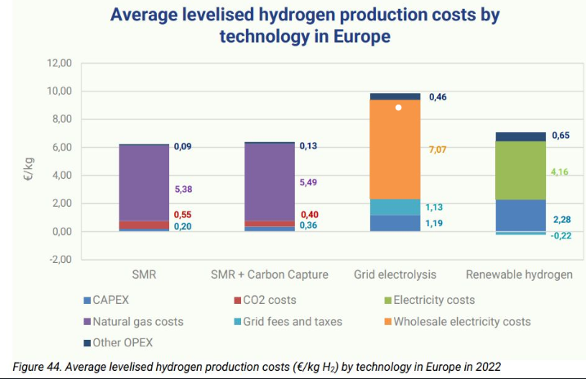

Hydrogen production costs 2022 Figure 19.

Chapter 3: Methodology

3.1 Research Design:
The research approach adopted for this project will be a mixed methods approach, combining both qualitative and quantitative methodologies. Qualitative methods are employed for an in-depth exploration of safety measures, project management practices, and overall system integration, while quantitative methods are utilized for data analysis related to efficiency, energy balance, and Electrolyser performance.

Data Collection:
Site Design: The data collection process will involve a thorough examination of the site design, encompassing the layout of electrolysis units, energy storage systems, and safety features.

Equipment Integration: Detailed documentation of the integration process will be produced, focusing on the seamless incorporation of electrolysers, compressors, and other components within the green hydrogen plant.

Safety Measures: Collection of data on safety measures implemented, including the installation of hydrogen detectors, ventilation systems, and emergency response planning.

Training: Information on training programs for personnel handling hydrogen, ensuring awareness of safety protocols is essential.

Data Analysis:
Quantitative Analysis: Utilization of quantitative methods to analyze efficiency, energy balance, and Electrolyser performance data.

Integration of Digital Twin Technology: Integration of digital twin technology for real-time monitoring and analysis, allowing for a virtual representation of the green hydrogen production system will be key for this project and the next.

Safety Measures and Risk Assessment:
Safety Measures: Comprehensive documentation of safety measures, including hydrogen leak detection, storage safety protocols, and adherence to regulations (e.g., NFPA 2, ISO 19880).

Risk Assessment: A thorough risk assessment will be conducted, identifying potential hazards and implementing measures to mitigate risks As Low As Reasonably Possible (ALARP).

Project Management Practices:
OEM Contractor Engagement: Engagement with Original Equipment Manufacturers (OEMs) Fuel Cell Systems for electrolysers, Haskel for compressors, and other critical components, ensuring seamless integration and adherence to specifications.

Weekly Project Meetings: Adoption of project management practices, including regular weekly meetings to track progress, address challenges, and ensure effective communication among team members.

In summary, this research adopts a mixed methods approach to comprehensively explore various aspects of green hydrogen production. Data collection focuses on site design, equipment integration, safety measures, and training, while data analysis combines quantitative methods for technical aspects and qualitative methods for broader system evaluation. The integration of digital twin technology enhances real-time monitoring and analysis. Safety measures include detailed documentation of protocols, risk assessment, and adherence to regulations. Project management practices involve OEM contractor engagement and regular project meetings for effective coordination and progress tracking.

3.2 A Project Managers Perspective

The project has adopted an Agile project management methodology to enhance flexibility and responsiveness throughout its lifecycle. The Agile framework facilitated iterative development, allowing for continuous adjustments to project requirements based on feedback. This approach was particularly beneficial in the dynamic environment of a Pilot Green Hydrogen Electrolyser Plant Project.

Key Agile principles were applied, such as iterative development cycles, collaborative decision-making, and frequent stakeholder involvement. These principles played a crucial role in adapting to evolving project needs, ensuring that the project team could quickly respond to changes in requirements, technology, and stakeholder expectations.

The Agile methodology's impact on project success was significant. The iterative cycles allowed for continuous improvement and optimization, resulting in enhanced efficiency and resource allocation. Regular stakeholder involvement ensured that their expectations were consistently aligned with project progress, reducing the likelihood of misunderstandings, and facilitating smoother decision-making processes.

Additionally, the Agile framework promoted a culture of adaptability and continuous learning within the project team. This proved helpful in addressing unforeseen challenges and leveraging emerging opportunities. The iterative nature of Agile also contributed to improved risk management, allowing the team to identify and mitigate potential issues early in the project lifecycle.

In summary, the adoption of an Agile project management framework, with its emphasis on flexibility, collaboration, and iterative development, played a pivotal role in the success of the project. It allowed the project team to navigate complexities, respond to changes effectively, and deliver a solution that aligned closely with stakeholders.

3.3 Stakeholder Management:

There are four ways to manage communication with stakeholders based on the power interest matrix highlighted in Figure 20: Manage them closely, keep them satisfied, keep them informed or simply monitor them. (Tristancho, 2023)

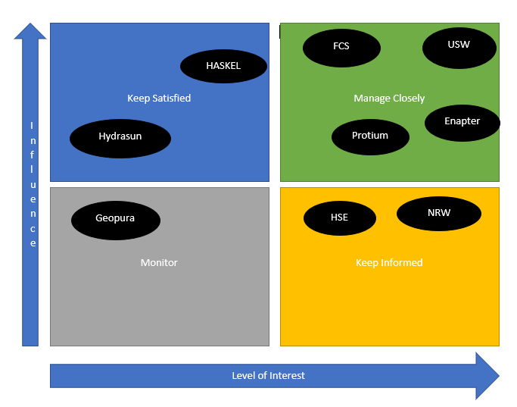

Power of Interest Matrix Figure 20.

If a stakeholder holds considerable influence in the project but demonstrates a lower level of interest, it is imperative to maintain their satisfaction by providing regular updates and valuing their feedback. Stakeholders with both a high level of influence and interest are categorized as key stakeholders, necessitating meticulous management of their expectations throughout the project.

This involves more frequent meetings compared to the "keep satisfied" category, and their feedback plays a pivotal role in decision-making.

Stakeholders characterized by lower influence, yet heightened interest are typically the customer base. While they also require updates on project progress, the frequency of these updates can be less than that for the "manage closely" and "keep satisfied" groups. On the other hand, those with low levels of both influence and interest still need project status updates, albeit with a focus on informing them about significant milestones in the project.

3.4 Communication Management:
Effective communication is paramount throughout the project, encompassing both internal team interactions and external stakeholder engagement. The communication plan is designed to facilitate transparency, collaboration, and timely dissemination of information.

Stakeholder Mapping: The project team conducted a thorough stakeholder analysis to identify key internal and external stakeholders. This mapping has helped inform the development of tailored communication strategy based on each stakeholder group's information needs, influence, and interest in the project.

Communication Channels: A diverse set of communication channels is employed to cater to different stakeholders. Regular team meetings, progress reports, and shared documentation platforms facilitate internal communication, ensuring that team members are well-informed and aligned with project goals. External communication included newsletters, project updates on the company website, and direct engagement with regulatory bodies and the local community.

Frequency and Format: The frequency and format of communication have been adapted to the specific requirements of each stakeholder group. Key stakeholders, such as the OEM contractor and regulatory authorities, have been engaged more frequently with detailed updates, while broader project summaries have been shared with the wider community and customer base.

Issue Resolution Communication: In instances where unexpected challenges have arisen, transparent and proactive communication are prioritized. Rapid response communication protocols have been established to address unforeseen issues promptly. This approach has helped foster a culture of openness and problem-solving within the project team and with external partners.

Feedback Mechanisms: Two-way communication has been encouraged through feedback mechanisms, such as regular progress meetings, surveys, and dedicated communication channels. This has ensured that stakeholders have had the opportunity to provide input, express concerns, and contribute to decision-making processes.

Crisis Communication: A crisis communication plan has been put in place to address any major setbacks or emergencies. This plan has included predefined communication channels, spokespersons, and messaging strategies to manage information flow during critical situations, if and when they arise.

3.5 Risk Management:
The risk management plan implemented for the project is comprehensive and follows the Protium Risk Management Process figure 21. Below. Covering all stages of the project lifecycle, from planning to execution. Risk identification has involved a thorough analysis of potential threats and uncertainties that could impact project objectives, including technical, environmental, and economic factors associated with the Pilot Project.

The Risk assessment has been conducted using a quantitative and qualitative approach. Risks were categorized based on their impact and likelihood, allowing for prioritization and focused attention on high-priority risks. Mitigation strategies have been devised to address identified risks and minimize their potential impact on project success.

The objective of this process is to provide guidance and align expectations for all stakeholders
on the project risk and issue lifecycle- including identification, assessment, management,
monitoring and governance.

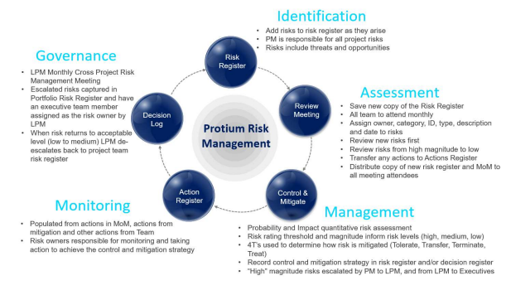

Protium Risk Management Plan Figure 21.
The following categories should be considered, at a minimum, when reviewing risks on the
project:
- Development – land, grid, planning and permitting, EIA, HSE
- Technical – Engineering
- Political / Reputational / Strategic
- Commercial – HESCO™
- Stakeholder
- Project Business Case
- Operation and Maintenance
- Health Safety and Wellbeing
The Risk Register Figure 22 can then be populated to high light and put mitigation in place to ensure project completion is on time and in budget.
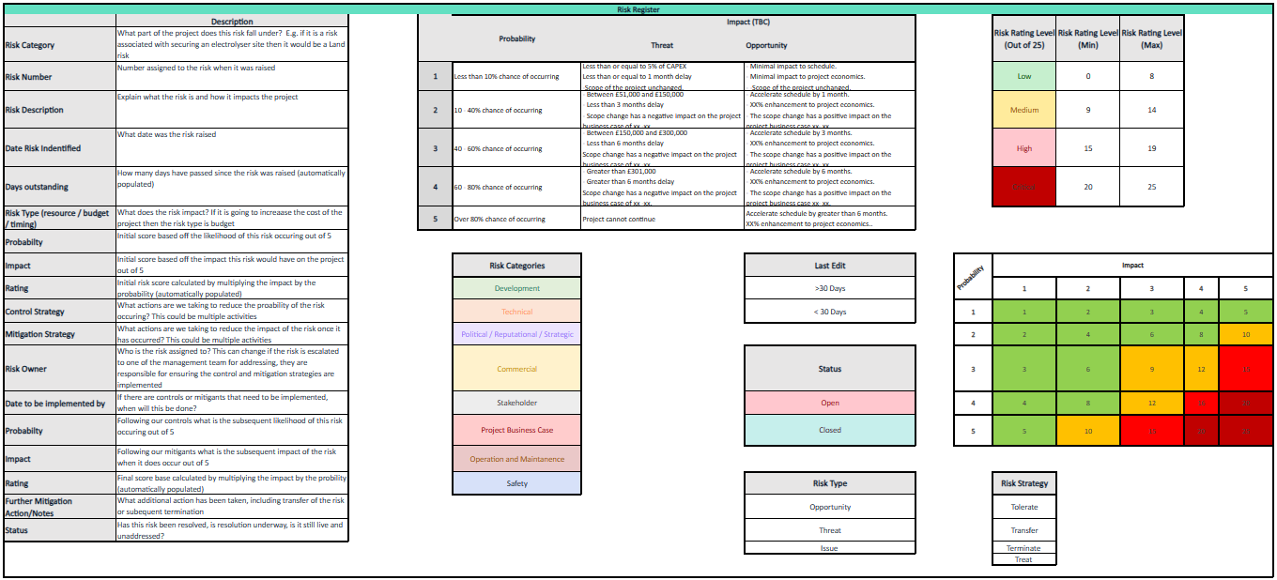
Figure 22. Risk Register
Examples of unexpected risks managed during the project lifecycle include:

Supply Chain Disruptions: The project encountered unexpected delays in the delivery of critical components due to supply chain disruptions. To mitigate this risk, alternative suppliers were identified in advance, and contingency plans were activated to ensure minimal impact on the project timeline. E.g., several components from Enapter, Haskel and Fuel Cell Systems could be sourced from local dealers like Screwfix or Talbot Hydraulics, Hydraulic hoses were sourced from local call out company who measured and made several hoses on site for the chiller. Swagelok fittings sourced directly from Swagelok.

Regulatory Changes: Unforeseen changes in environmental regulations posed a risk to project compliance. The risk management plan included ongoing monitoring of regulatory developments, allowing the project team to promptly adjust plans and ensure adherence to updated requirements.

Technology Integration Challenges: During the implementation phase, unforeseen challenges in integrating Enapter electrolysers with other systems emerged. The risk management plan had contingency measures, including collaboration with Enapter's technical support and adjusting the project schedule to accommodate additional testing and integration time.

Safety Incidents: Despite rigorous safety measures, unexpected safety incidents occurred during the construction phase. The risk management plan included immediate response protocols, emergency drills, and continuous safety training, ensuring that the incidents were effectively managed with minimal impact on personnel and project progress.
Market Price Fluctuations: Economic factors, such as fluctuations in the prices of materials and energy, posed a risk to the project's economic viability. The risk management plan included financial buffers, contractual agreements with suppliers, and periodic economic assessments to adapt to market changes.
By proactively identifying, assessing, and mitigating these unexpected risks, the project's risk management plan demonstrated its effectiveness in preserving project objectives and ensuring the overall success of Pioneer 1. The adaptive nature of the risk management approach allowed the project team to respond dynamically to challenges and uncertainties, contributing to the project's resilience and successful outcomes.

3.6 Quality Management:
The project has employed a robust system of quality assurance and control measures to ensure the delivery of a high-standard facility. Several key elements were integrated into the project's quality management approach and from this protium is progressing with ISO 9001 Certification in 2024, below is an example of some of the tasks carried out.

Quality Assurance Framework: A comprehensive quality assurance framework was established, encompassing all phases of the project. This framework outlined the processes, standards, and guidelines to be followed to meet predetermined quality objectives. Regular audits and reviews were conducted by the Team to ensure compliance with established quality assurance protocols.

Adherence to Industry Standards: The project strictly adhered to relevant industry standards and certifications associated with green hydrogen production and Electrolyser technology. Compliance with standards such as ISO 22734:2020 for hydrogen generators ensured that the project met internationally recognized benchmarks, contributing to the reliability and safety of the produced hydrogen.

Certifications and Compliance: The project obtained necessary certifications to validate the adherence to quality standards. Certifications from regulatory bodies and industry organizations were acquired, providing external validation of the project's commitment to quality. These certifications played a pivotal role in building trust with stakeholders and ensuring market acceptance.eg Engaging with British Engineering Services (BES) to complete a Written Scheme of Examination for the system proved fundamental with other partners when discussing the safety and integration of systems.

Supplier Quality Management: The quality of components and materials from suppliers was a critical aspect of the project. A stringent supplier quality management system was in place, involving supplier assessments, inspections, and continuous monitoring to guarantee that all supplied elements met the specified quality standards.

Testing and Validation Protocols: Rigorous testing protocols were implemented to validate the performance and safety of the green hydrogen Electrolyser plant. This included factory acceptance tests (FAT) and site acceptance tests (SAT) to ensure that all components operated as intended and met the predetermined quality criteria.

Continuous Improvement: Continuous improvement initiatives were integrated into the quality management system. Regular feedback loops, lessons learned sessions, and post-implementation reviews were conducted to identify areas for improvement. This iterative approach contributed to the ongoing enhancement of project processes and outcomes.

The impact of these quality management measures on the project outcome was substantial. By adhering to industry standards, certifications, and rigorous testing, the project achieved a high level of reliability and safety in its green hydrogen production. The commitment to quality also enhanced stakeholder confidence for this project, ensuring the long-term success and sustainability of the Electrolyser plant. The lessons learned and continuous improvement practices further positioned the project for adaptability and excellence in future endeavors.

3.7 Resource Management:
The efficient allocation and management of project resources, spanning personnel, equipment, and technology, were critical components contributing to the success of the Pilot Project.

Personnel Allocation: Human resources were allocated strategically, considering the expertise required at different project phases. Specialized training programs were implemented to equip personnel with the skills necessary for the operation and maintenance of the Enapter electrolysers and compressor system. Regular communication channels were established to facilitate collaboration and ensure effective knowledge transfer among team members.

Equipment Procurement and Integration: The procurement and integration of equipment, including the Enapter electrolysers, required careful planning. Challenges such as lead time variations and unforeseen technical specifications were addressed through close collaboration with suppliers and thorough risk assessments during the planning phase. This proactive approach minimized delays and ensured a seamless integration process.

Technology Deployment: The deployment of digital twin technology for real-time data analysis and production planning necessitated careful consideration of technology resources. The project team ensured that the chosen technology aligns with the project's objectives and integrates seamlessly with existing systems. Ongoing monitoring and support were provided by Operations to maintain optimal performance.

Challenges and Strategies: Resource management faced challenges such as unexpected personnel turnover and evolving technological requirements. These challenges were addressed through cross-training initiatives to mitigate the impact of staff changes. Additionally, contingency plans were developed to address unforeseen technological issues, ensuring minimal disruption to the project timelines.

Adaptability and Scalability: The resource management strategy incorporated adaptability and scalability to accommodate changes in project scope and scale. This was particularly crucial during the commissioning phase, where the flexibility to scale resources ensured a smooth transition from testing to full-scale production. Pulling on internal and external resources was key.

Continuous Monitoring and Optimization: Regular monitoring of resource utilization was conducted throughout the project lifecycle. This involved performance assessments, feedback mechanisms, and key performance indicators to identify areas for optimization. Continuous improvement initiatives were implemented to enhance resource efficiency and mitigate any emerging challenges.

The impact of effective resource management was evident in the timely completion of project milestones and the overall success of the Project. By addressing challenges proactively, optimizing resource allocation, and fostering adaptability, the project team ensured that personnel, equipment, and technology worked synergistically to achieve project objectives. This approach not only contributed to project efficiency but also positioned the facility for long-term sustainability and adaptability in a dynamic operational environment.

3.8 Timeline and Schedule Management:
The project timeline and scheduling methodologies employed in the Pioneer 1 project played a pivotal role in orchestrating the complex interplay of activities, ensuring efficiency, and meeting critical milestones.

Scheduling Methodology: The project adopted a hybrid scheduling approach, incorporating elements of Agile methodologies to enhance adaptability and responsiveness to changes while maintaining a structured framework resembling aspects of the Waterfall model. This facilitated a dynamic yet well-organized progression through various project phases.

Milestone Definition: Critical milestones were identified at the outset, aligning with key project objectives such as Factory Acceptance Tests (FAT), Site Acceptance Tests (SAT), commissioning, and full-scale production. Each milestone was accompanied by detailed tasks, timelines, and resource allocations, providing a roadmap for the project team.

Deviation Analysis: Despite careful planning, certain deviations from the original schedule occurred. Unforeseen challenges in equipment procurement, specifically related to global supply chain disruptions, led to delays in the delivery of Enapter electrolysers. The project team responded by resequencing tasks and reallocating resources to mitigate the impact on subsequent activities.

Root Causes of Deviations: Deviations were primarily attributed to external factors beyond the project team's control, including supplier delays and unexpected regulatory approvals. A proactive risk management approach was crucial in identifying potential delays early, allowing for timely adjustments to minimize overall project impact.

Impact on the Overall Project: While deviations posed challenges, the project's flexibility and adaptive scheduling mitigated the potential negative consequences. Regular communication and transparency with stakeholders helped manage expectations, and contingency plans were activated to address critical path delays. The overall impact on the project timeline was limited, and the team successfully realigned activities to maintain progress.
Lesson Learned and Continuous Improvement: The deviations experienced underscored the importance of agility in project scheduling. Post-project evaluations led to the identification of areas for improvement in risk mitigation and contingency planning. These lessons learned were incorporated into future project planning, enhancing the team's ability to navigate unforeseen challenges effectively.

In conclusion, the project's timeline and schedule management demonstrated a balanced approach, combining structured planning with adaptability. While deviations occurred, the proactive identification of risks and timely adjustments ensured that the project remained on course. The experience provided valuable insights for refining future scheduling methodologies and reinforcing the project's overall resilience in the face of unforeseen challenges.

3.9 Cost Management:
The project's cost management was a critical aspect that demanded thorough planning, effective estimation, and stringent financial controls.
Budget Formulation: The project began with a comprehensive budget formulation, incorporating detailed cost estimates for equipment procurement, site preparation, personnel, safety measures, and unforeseen contingencies highlighted below in Figure 23. The budget was structured to align with the project timeline and milestones.

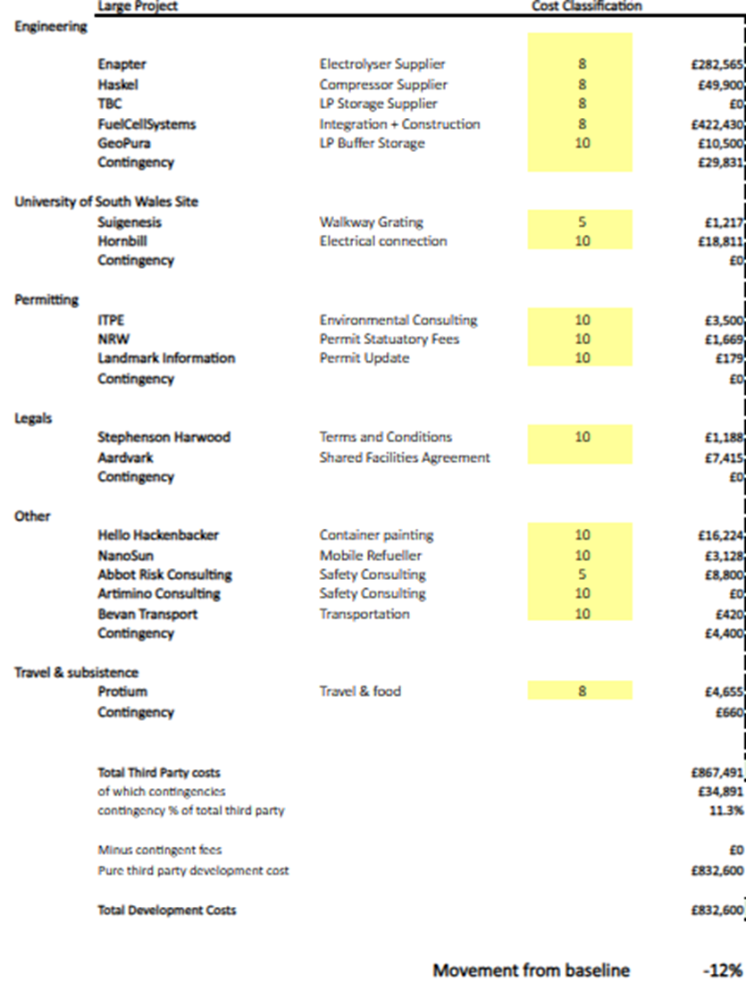

Pioneer 1 Budget. Figure 23.
Cost Estimation Methods: Accurate cost estimation relied on a combination of historical data, supplier quotations, and industry benchmarks. Collaborative efforts with suppliers and contractors were essential in refining estimates for specialized components, such as Enapter electrolysers, considering their unique specifications.

Financial Controls: Financial controls were implemented to track expenditures, monitor resource allocations, and identify any potential budget overruns. Regular financial reporting and reviews ensured transparency and facilitated informed decision-making throughout the project lifecycle.

Staying Within Budget: Despite the inherent challenges in large-scale projects, the project team successfully adhered to the established budget. This accomplishment was attributed to proactive cost monitoring, early identification of potential deviations, and swift corrective actions. The team's ability to negotiate favorable terms with suppliers and optimize resource utilization contributed to maintaining financial discipline.

Cost-Related Challenges: The project encountered challenges related to global supply chain disruptions, affecting the timely delivery of Enapter electrolysers. This necessitated renegotiations with suppliers and adjustments to the project schedule. The financial impact of these challenges was carefully managed through contingency funds earmarked for unforeseen circumstances.

Chapter 4: Results

4.1 Design
Permitting and Planning

The initial permitting and planning for Pioneer 1 facility at USW site was granted by National Resources Wales, the process required a Risk Assessment (RA) amongst other reports and tests to be completed, this RA highlights Very Low Residual Risks in regards to The Local Human Population, Surface Water Contamination, Soil Contamination, Noise Pollution and Damage to Protected Nature Conservation sites in the Area which allowed the project to progress update on the permit can be seen in appendix 5. Although the initial planning site plan was changed several times after only on final completion did the permit need updating as this would not affect the outcomes of the facilities inputs or outputs. Please see Figure 24 below for original site plan. Figure 25 is the NRW Risk assessment which was completed together and provided the confidence to progress with the facility at the designated site with limited issues to safety to personnel or the environment.

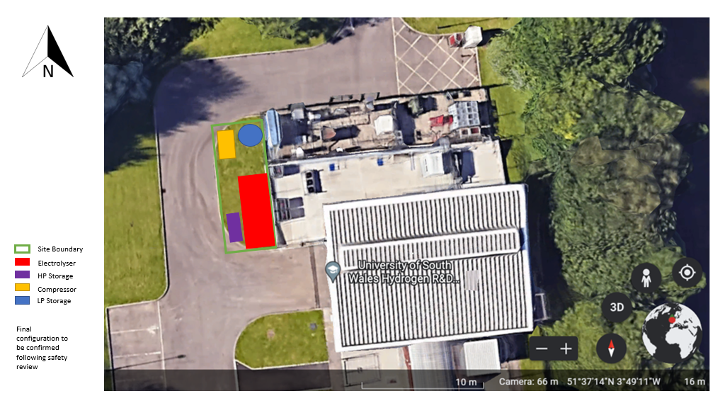

Pioneer 1 Original Site Plan Figure 24.
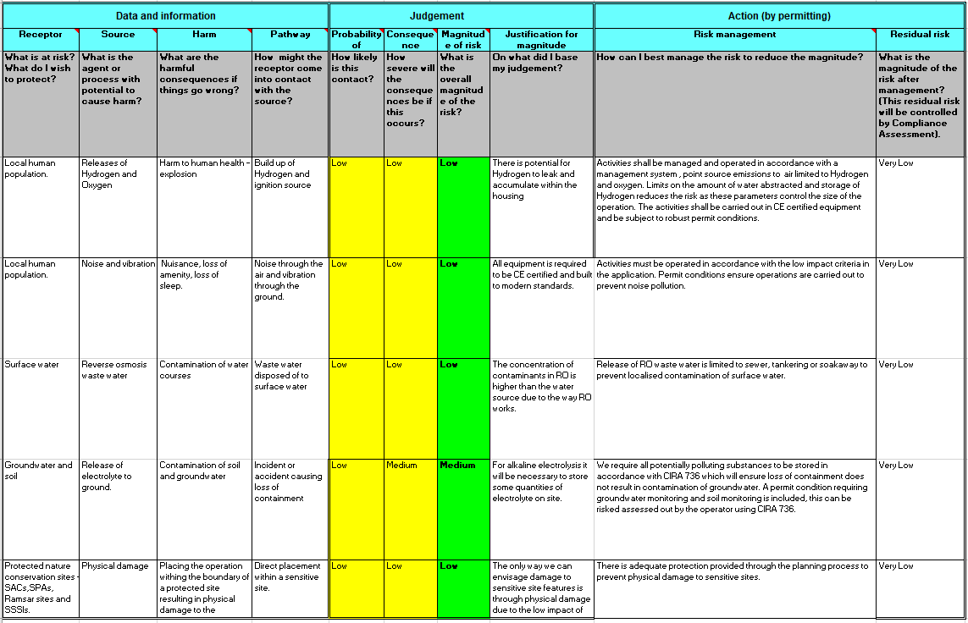

NRW Risk Assessment Figure 25.
Electrolyser Container Integration.

After discussions with Enapter on Their AEM Electrolysers it was seen to be a good decision to work with Enapter and partners to increase publicity of small scalable Green Hydrogen Packages and production of Hydrogen through Modular AEM Units Electrolysers, Enapter had been announced that they were finalists of the HRH Prince William and The Royal Foundation Earth Shop Prize. And a key foot in the door for both parties.

Fuel Cell Systems (FCS) were the UK Integration Partner of Enapter and working together, the 40 available Enapter Units were installed, safety systems integrated, and the Electrolyser container sited at USW. This was the largest integrated system at the time for all parties, 100Kw system producing at maximum capacity 40Kg/day of Green Hydrogen, I attended the FCS site at Hungerford on several occasions to witness the integration, testing and coordinated the Lift and positioning of the container at the USW site. From this point the Project plan was started in February 2023. Figure 26.
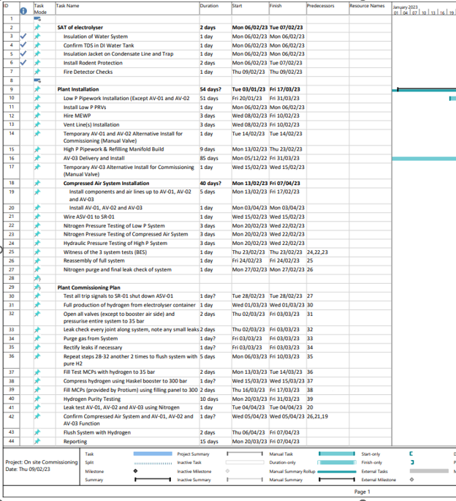

Pioneer 1 Project Plan Figure 26.

Site Design

When planning the design there were several critical factors that demanded careful consideration:

Determining the appropriate size of hydrogen storage tanks based on anticipated usage and storage requirements was essential as this would ensure the correct capacity of hydrogen could be produced to maximize efficiency of plant and stored hydrogen would act as a buffet to ensure planned production rates could be met .
Establishing the maximum pressure limits for the storage tanks needed to be thought through to ensure safe and efficient operations.
Evaluation of compression needs was required, distinguishing between Low Pressure (LP) and High Pressure (HP) requirements, depending on the specific application. Adhering to dsafety protocols that come with PSSR regulations.
Consideration of the temperature conditions under which the plant would run and what the stored hydrogen would be utilized at, as it could have an impact of the efficiency and safety of storage of the hydrogen.

Strategical planning of the location and position of the storage tanks needed to be completed to optimize space utilization and facilitate operational efficiency.
Assessments of the dimensions of the storage tanks needed to be completed to ensure they would align with the available space and operational requirements, working with University of South Wales (USW) to ensure the footprint of the Facility did not encroach on their equipment and boundaries.

Selection of the appropriate materials for the tank construction and paying particular attention to nozzle design for compatibility and durability. NOVAC 38 preferred compared to BS341 No 4, due to new pressure regulations. 250bar – 300 bar. (BCGA., 2002). Also the design needed to ensure that no ingress of air or moisture could enter the line when carrying out changeover of cylinders or MCP’s.

Ensuring compliance with Control of Major Accident Hazards (COMAH) regulations needed to be met to ensure safety and regulatory standards were adhered to.

Requirements for the planning of the Lower/Higher tiers depended on the amounts of Hydrogen to be stored Figure 27 below shows the limits, 2 tons for planning, 5 tons lower tier and 50 tons for COMAH higher tier, these limits should be taken into consideration when designing the storage capacities as greater safety and costs would need to be taken into consideration depending on the level sought after.
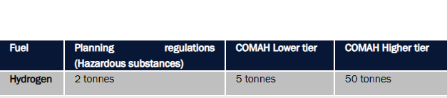

Hydrogen storage limits. Figure 27.

Addressing these considerations comprehensively was essential for the effective and safe implementation of on-site hydrogen storage, contributing to the overall success of hydrogen-related projects.

Main Hazards associated with H2:​
Fire: wide range of flammability & self-ignition of H2/Air mixtures, Lower Explosive Limit: 4% (v/v). Higher Explosive Limit: 75% (v/v)​
Explosion: Explosive at concentrations of 18% - 59%​
Leaks: H2 is asphyxiant in confined spaces as it displaces oxygen from air​
Embrittlement & cracking: Due to its small size, H2 can cause embrittlement of high strength steels, titanium and aluminum alloys, with cracking and catastrophic failure of the metals.

Were by the utmost of care must be given to choosing safety systems and materials throughout the plant.

COMAH Regulations: COMAH tier will not be affected on the Pioneer 1 site as all H2 storage will be kept to a minimum, max holding on site 12 MCP’s of 16.7kg = ​200Kg.

Standard Dangerous Substances and Explosive Atmosphere Regulations (DSEAR) Risk Assessment: The zoning of hazardous areas around the combustion plant and fuel supply systems needed to be reviewed, USW has been producing hydrogen on site for approximately 10 years but increasing the capacity at the site and expansion of the site foot print with different hazards and associated risks updated safety protocols needed to be put in place specifically around the hydrogen production and storage areas of Pioneer 1.
Gas leak detection equipment is required, including infra-red sensors in enclosed spaces​.
Ventilation procedures were required to ensure that H2 leaks are safely vented and dispersed into the atmosphere and away from the main site, ensuring no potential ignition sources are in that area/zone.

Prior to Full installation of the facility the completion of the DSEAR Risk Assessment (RA) was completed and due to the flammability characteristics of Hydrogen Figure 28 below. Artimino Consulting were taken on board to facilitate the process of the RA, included in the meetings were the Protium Engineering Team, USW team, and I lead the Teams throughout the review. The RA revealed that the area Figure 33 (for reference) around the buffer tank, compressor, and high-pressure MCP’s was to be designated as Zone 2. Where a 1m seclusion area would be required. No Non-Atex rated equipment to be within that seclusion zone.

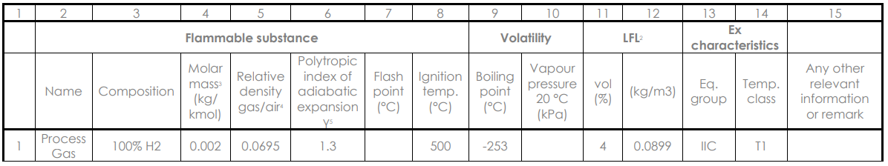

Flammable substances and characteristics. Figure 28.
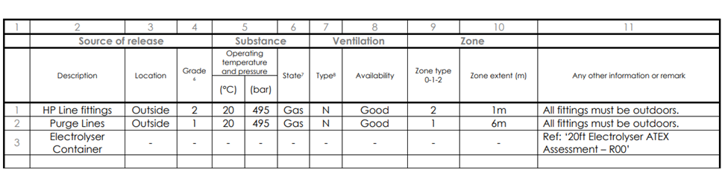

Sources of release Figure 29.

Where all the H2 Vent line releases Figure 30 would be Zone 1. Which would require to be 6m seclusion area highlighted in Figure 29 above, given from Artimino’s RA.(3rd parties who are Competent Persons (Fire Protection Association, 2023) are recommended to be used as they are impartial and should have nothing to gain or lose from the outcomes of the RA)

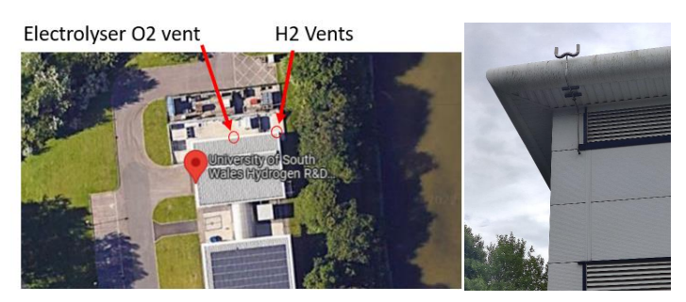

Hydrogen Vents, Zone 1. Figure 30.

This designation implies that all electrical and mechanical components in this area must adhere to ATEX certification regulations (HSE, 2023), on the other hand no hydrogen line fittings could be close to any Non ATEX rated equipment, as the Tubing for the Hydrogen lines are delivered in 6m length the pipe install had to be calculated to ensure this was not in breach of the findings, and if so actions should be taken to improve or change the design.

Operators working in this zone would be mandated to use ATEX-rated clothing and footwear, a calibrated Personal Gas Monitor, and non-spark tools for any maintenance tasks. The Container area figure 31. is classed as a non-ATEX classified area due to the safety protocols implemented within the container, particularly related to forced air flows within the container. These PPE safety precautions stated above are not required in this area; however, operators visiting the site would still adhere to these additional safety measures as a standard practice.

Summary of ATEX (Atmosphères Explosibles) Guidelines for Protium’s Hydrogen Production Plant:
The hazardous areas for Protium’s planned Hydrogen Production Plant were identified using BS EN 60079-10-1:2021, specifying hazardous zones for pressure line fittings and purge lines.

Fuel Cell System’s (FCS) 20ft Electrolyser Container will supply Hydrogen at a maximum rate of 40kg/day at up to 35 bar. Four MCP storage bundles act as a buffer, feeding into the Haskell hydrogen booster compressor unit. Downstream, system components are rated to a minimum of 1034 bar and are protected by PRVs. Hydrogen is regulated down to 300bar before filling external storage tanks via hoses.

'Hydrogen Line Fittings' are considered at 495 bar, creating an ATEX Zone 2 of 1m in all directions for these fittings in the event of a leak.

For 'Purge Line Vent,' a PRV set to 330 bar vents a full 300 bar WP, 800L MCP in case of overheating. The Purge Line Vent creates an ATEX Zone 1 extending 12m in all directions upward from the source during PRV release due to overheating of stored hydrogen. Note: A different cylinder bundle may alter the ATEX zone, requiring recalculation. (Fuel Cell Systems, 2023)

The site design was planned to optimize the layout of Pioneer 1 facility. Key considerations included the positioning of electrolysers to ensure safety in the area and access to all sides of the container where important controls and systems were sited, Figure 29 below shows the position and walkway around the container, also the MCP buffer storage systems and compressors figure 32, and safety features were designed to ensure maximum adherence to the required regulations and safety protocols met. The successful integration of the Electrolyser container was achieved through a collaborative effort involving engineering teams, university of South Wales staff (USW) and FCS the Original Equipment Manufacturers (OEMs). The container fits well into the overall plant layout, ensuring efficient workflow and accessibility for maintenance, and a key priority for USW was that it fitted in with their future activities at the facility where the old Hydrogen Refueler units in Figure 31 below would be upgraded or replaced in due course.

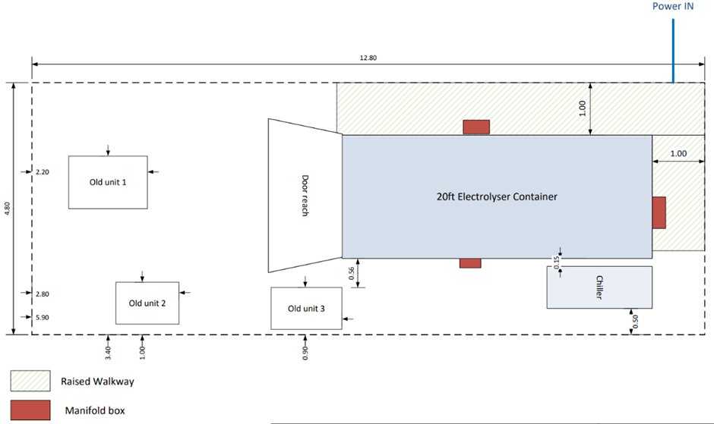

Electrolyser Container (Northwest Compound) Figure 31

MCP Buffer Tanks and Compressor Compound
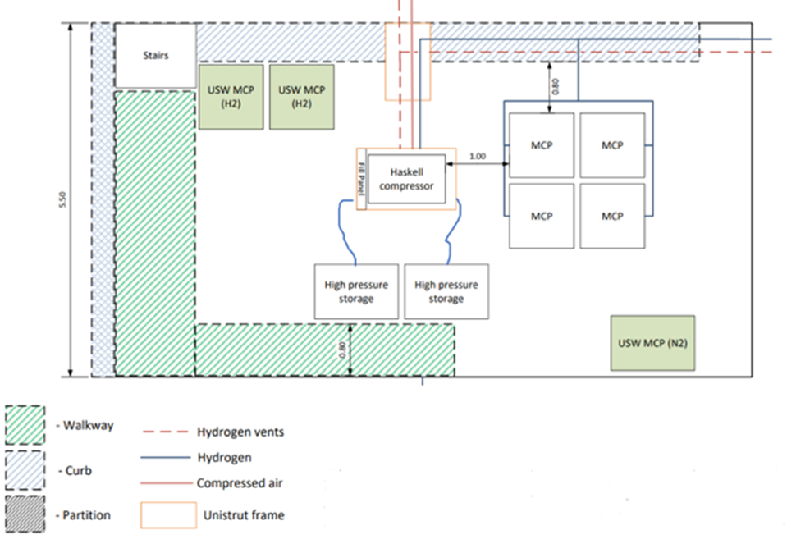

MCP Buffer Storage and Compressor Systems (Northeast Compound) Figure 32

The original design for buffer storage was a 5.320m high x 1.930m Diameter storage vessel costing £78.000 and a holding capacity of 12,000Lt, after careful consideration and discussions with all stakeholders the decision was made to utilize a 4 piece Manifolded Cylinder Pack, (MCP) each MCP containing 16 individual cylinders, holding 50lt each. 800lt MCP, 4 x MCP’s giving a storage capacity of 32,00lt, with a low rental charge, where at a later date Protium could buy new units. This reduced costs substantially but only by working with the Stakeholders FCS, the original designed vessel could be utilized on one of their other projects. Tank drawing and quote can be seen in Appendix 3 and 4.

Compressor
Several Hydrogen Compressor companies were approached amongst PDC Machines, Hyperbaric and Haskel.
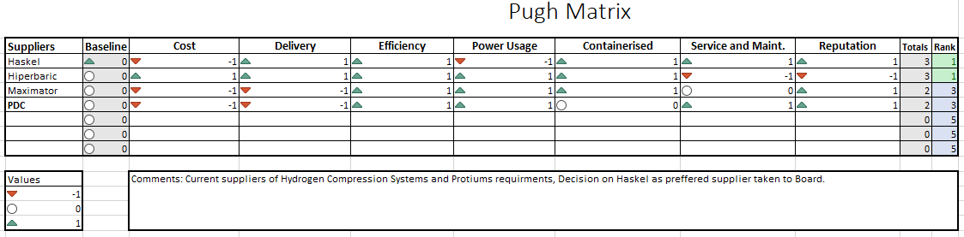

Pugh Chart Figure 33.

Completion of a Pugh chart Figure 33 above was carried out. The data available yielded that Haskel would be the preferred option due to Costs, Delivery, Efficiency and Reputation, Haskel were also ear marked for supplying larger H2 Compressors for future projects for Protium including Pioneer 2.

Fill panel design
The fill panel design required collaboration with myself and Hydrasun an Oil and Gas company from Aberdeen are who specialize in such panels, the panel would require a back board of stainless steel, a configuration of hydrogen rated valves, pressure gauges, a pneumatic actuated safety shut off valve, a pressure regulator, non-return valves to prevent back flow, several filling lines with 2 x 3 way valves to prevent ingress of air or moisture on cylinder change over as well as a safety pressure relief valve to prevent system over pressurization. Figure 34 below shows the original design, also highlighting long lead items. The long lead items were critical to plant commissioning times and during the design process highlighted as a bottle neck and risk to the project. Putting an alternative design and filling process in place in the design phase would prevent delays.

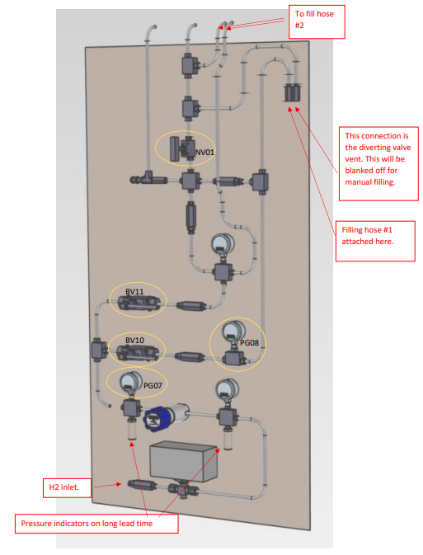

Fill panel original design Figure 34.

Final Design Drawing updates.
The final draft design was completed after DSEAR RA, Compressor and MCP positioning Figure 32. Before the update discussions with all stakeholders took place and ensured mitigation of all risks were put in place with safety in mind at all times.
As built drawings would need to be completed if any changes after commissioning but before signing off project completion.

4.2 Installation
Contractors for installation work.

To optimize project costs and timelines, particularly in response to resource constraints with the integrator, a proactive approach was taken to engage the services of two reputable local contractors for the installation phase. This decision proved beneficial on multiple fronts.

The installation scope covered critical components such as the compressor, system pipework, safety relief valves, and filling panel. The proposal to involve local contractors gained approval from FCS, acknowledging the unforeseen challenges in staffing resources and recognizing the necessity to adhere to the project timeline.

A noteworthy advantage of selecting local contractors was the significant cost savings realized by eliminating the need for travel expenses and accommodation. Given the proximity of the contractors to the project site, this not only streamlined logistical considerations but also resulted in a considerable reduction in the overall project timeline and costs.

The selection process for these contractors was thorough, emphasizing competence and adherence to safety standards. Each contractor underwent rigorous assessments, including the completion of a site safety passport or a Construction Skills Certificate Scheme (CSCS) qualification. Additionally, a Swagelok pipe fitting course was mandatory, ensuring proficiency in handling the specific components of the project. Comprehensive site inductions were conducted, encompassing an overview of the project, safety protocols, and specific requirements.

Additionally, a thorough evaluation of the contractor workforce included a sampling of their skills, ensuring alignment with the intricate demands of the installation. The contractors were also required to provide necessary insurances, reinforcing compliance with industry standards and mitigating potential risks.

Use of the local contractors also gave us direct access to alternative suppliers, where tubing, connectors and associated valves could be sourced without raising purchase orders and various department approvals, we could go direct through the contractors and be billed at a later date.
Working alongside the contractors were myself and FCS in a supervisory capacity to ensure the design and integration of the system was completed correctly. Ensuring precision cutting where required and cleanliness at all times due to the purity requirements, any residue of particles, oils or cutting fluids may contaminate the system.
Positioning of all fittings to ensure connections were in the correct zoned areas was paramount, this was not highlighted on any of the drawings from the design process and needed to be adhered to for Atex reasons.
Positioning of the Buffer Tank MCP and Compressor required fixing and framework manufactured from Uni-strut to support the pipe work, including valve manifold configurations, safety relief valves and pneumatic shut off valves all needed to be fixed and secure.

Daily Meetings were carried out with toolbox talks, any safety concerns were highlighted and addressed asap.
Risk Assessments and Job Method Statements (RAMS) needed to be produced by the working parties, highlighting the work to be undertaken, the hazards and risks of the job and the mitigation to be put in place to reduce risks to As Low As Reasonably Practicable, (ALARP). From here permits to work were completed by myself with additional permits for working at height, hot work and any confined space works, signed by the relevant Person in Charge of Working Party, (PICWP). All tooling and lifting equipment to be used must be fit for purpose and employees trained and competent to use, including forklift trucks and tele handlers where required. PPE requirements are also stated in the RAMS and all employees adhere to the Permit.

Daily site meetings were carried out to ensure the project and installation work was going to plan, several audits undertaken ensuring safety at all times and ensuring all personnel on site that day had completed the site safety induction, understood the RAMS and permits that were in place.

The Electrolyser container and chiller were sited first, ensuring the level of the container was correct so the Enapter unit water levels would also be correct not to reduce efficiency of the electrolysers. Figure 35. A walkway had already been fitted by USW previously where the container needed to be butted up against. The compressor and buffer tanks were then positioned Figure 36, and over the next few weeks the contractors fabricated and installed the pipe work system.
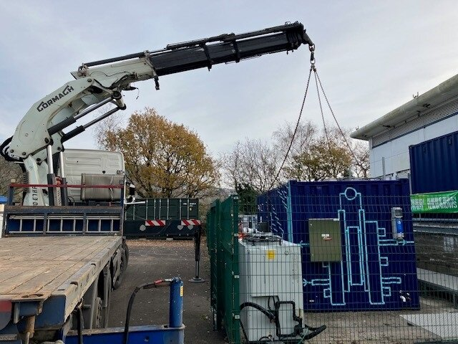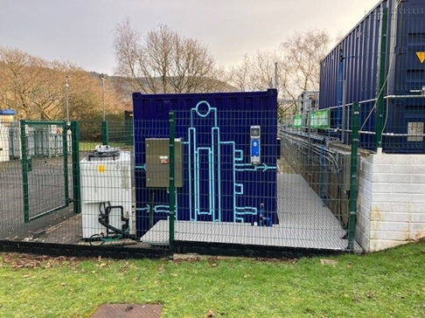

Container Installation Figure 35.

Compressor & Buffer Tank Installation Figure 36.
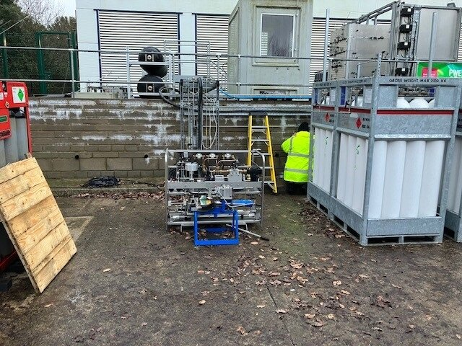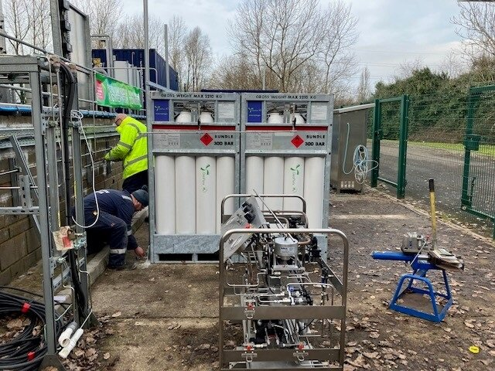
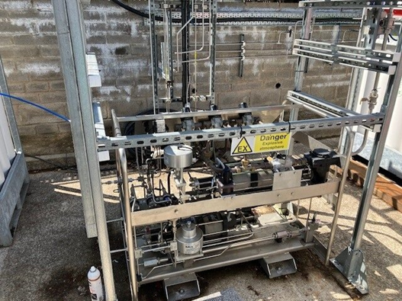

Hydrogen Valve System, including Pressure relief valves, pneumatic actuated safety valves, check valves, isolation valves and Nitrogen purge inlet were fabricated and installed as below Figure 37 allowing the system to be controlled manually and have an automatic safety shut off valve integrated into the circuits as per design. This would close (Fail closed) if failure occurred on plant, or the Emergency Stop Button was pressed.

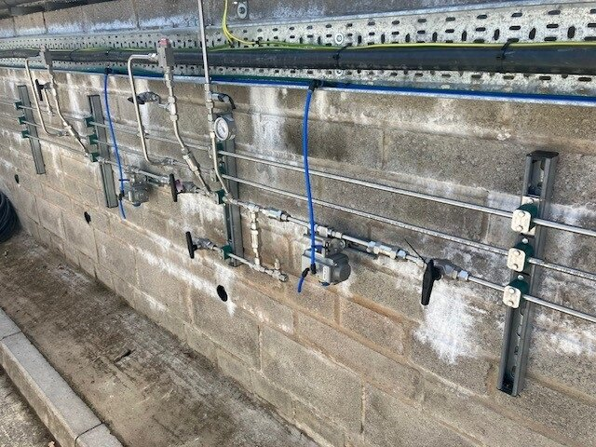

Hydrogen Valve System Figure 37.

The Fill panel was then manufactured and installed to the Compressor framework figure 38. Panel required 3 personnel to fit and consisted of Pneumatic safety shut off valve, pressure gauges, pressure regulator, isolation valves, check valves, vent valves, safety relief, Fill hoses and 3 way valve to connect to the MCP. MCP connectors can be interchanged to suit customers’ MCP, either BS341 no 4 or ISO 38. Rated between 250 and 300 bar.
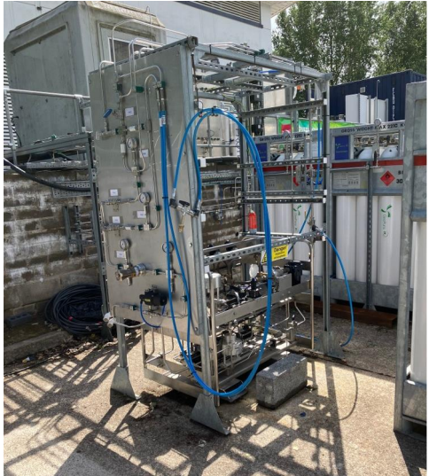

Fill Panel Figure 38.

High pressure MCP’s were then brought to site and positioned within the compound ready for commissioning. Figure 39 shows the MCP’s with safety signs.
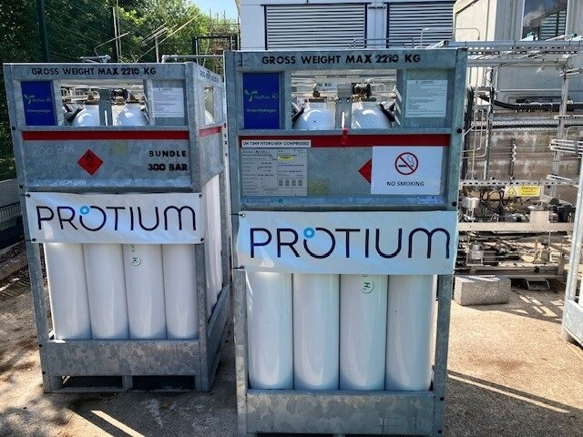

High pressure MCP’s Figure 39.

After complications sourcing a new air compressor to power the Hydrogen compressor in time for commissioning, Utilization of USW air compressors meant that Protium no longer required the air compressor, and the system could be tied into an existing pipe line in the compound.

On completion of all the installation work British Engineering Services (BES) were requested to attend site to complete a Written Scheme of Examination (WSE) of the system to ensure the system was correct to design, Figure 40, all safety systems were in place, certificated and compliant, and a pressure test was completed with Nitrogen at 1 ½ times working pressure, 450 Bar for 30 mins, the test was completed and BES were satisfied with the quality and design of the 100kw Electrolyser facility Figure 41 and we could progress to the commissioning stage.
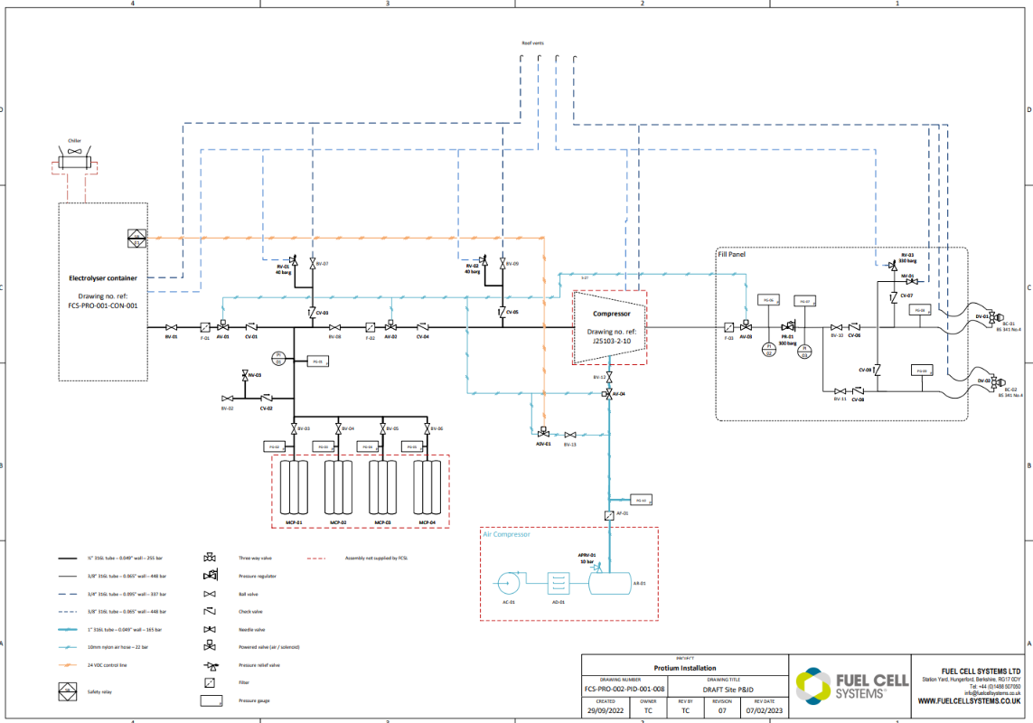

Site Layout P&ID Figure 40.

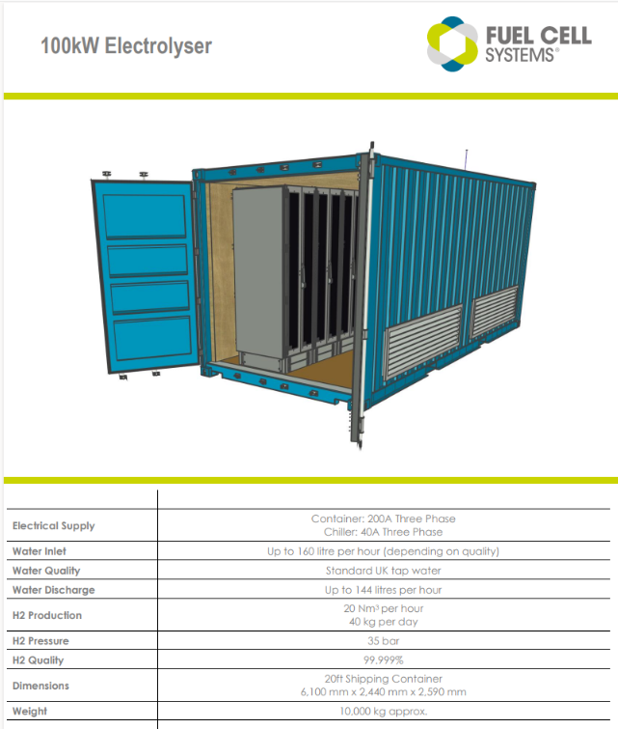

Pioneer 1 Container Figure 41

4.3 Commissioning
The Pioneer 1 Facility underwent a thorough safety implementation strategy alongside its comprehensive Factory Acceptance Tests (FAT) and Site Acceptance Tests (SAT) to ensure conformity to industry standards and safety protocols. Visual inspections of all systems have confirmed system quality even down to the container paint, while examinations of ATEX fans, and the construction of pipes and electrics verified compliance with safety directives. Thorough checks on water systems, coolant systems, and tubing were conducted to identify and rectify any defects, ensuring optimal performance.

In parallel, comprehensive safety measures were implemented to prioritize the well-being of personnel and uphold facility integrity. This included the installation of hydrogen detectors for rapid leak detection, well-ventilated areas to prevent hydrogen accumulation, and emergency response plans drawn up for swift and effective actions during unforeseen events. A thorough risk assessment was conducted, identifying and mitigating potential hazards, while all personnel underwent rigorous safety training from FCS to familiarize them with protocols and procedures. This extended out to the Engineering teams and Project managers of Protium as a learning for all involved.

The facility's pressure systems, including pressure relief valves, underwent thorough testing with BES witnessing as a 3rd party, with an emphasis on calibration and adherence to certification standards. The integrity of the water filtration system and internet connectivity was confirmed, and emergency stop systems were tested thoroughly to ensure immediate and effective responses in emergencies. Enapter’s were pre-filled with KOH 1% and subjected to testing before hydrogen production initiation.

Upon successful completion of these tests, the Pioneer 1 facility progressed to the warm-up and initial hydrogen production phase. Gas monitors, alarms, and pressure gauges underwent calibration and cross-referencing, demonstrating the commitment to reliable monitoring. The collaborative effort between the Original Equipment Manufacturer (OEM) and Protium culminated in the facility receiving certification and sign-off, confirming its readiness for efficient and safe green hydrogen production.

Enapter electrolysers played a pivotal role as a central component in the entirety of the green hydrogen production process. The operational staff underwent specialized training that covered various aspects of Enapter Electrolyser usage. This training included detailed instructions on startup procedures, equipping personnel with the necessary knowledge to initiate and control the electrolysis process effectively. Additionally, it provided insights into comprehensive monitoring techniques, enabling operators to oversee the system's performance closely by use of the Enapter online App.

The training schedule extended beyond routine operations to include thorough instruction on shutdown procedures, ensuring a systematic and secure shut down of electrolysis processes when required. In anticipation of potential breakdowns or plant issues, the personnel were also equipped with an in-depth knowledge of fault-finding procedures, enabling them to quickly identify and address any operational issues that may arise during the Enapter electrolysers usage. This proactive approach will contribute to the overall reliability and resilience of the hydrogen production system.

The implementation of regular maintenance schedules has become an integral part of the operational strategy. These schedules have been designed to address preventive maintenance measures, promoting longevity, and allowed the best performance of the Enapter electrolysers. In essence, the comprehensive approach to Enapter Electrolyser usage, from training to maintenance, underlined a commitment to operational excellence and reliability in the green hydrogen production process.

Ensuring the availability of critical spares, including those for Enapter, Haskel compressors, and general components, is essential for minimizing downtime in the event of unforeseen breakdowns. These spare parts are vital to swiftly bring the plant back online without significant delays.

Data analysis has revealed promising results in terms of plant efficiency, energy consumption, and production planning. The efficiency of the electrolysis process has been consistently high, meeting or exceeding expected values. Energy consumption data has indicated that the facility operates within anticipated parameters, showcasing the viability of the integrated system. Production planning, guided by real-time data from the Enapter App and a digital twin, has allowed for optimized scheduling and resource allocation, contributing to enhanced overall efficiency of Pioneer 1.
In-depth data analysis uncovered highly promising outcomes across key performance metrics, affirming the success of the Pioneer 1 Facility. Notably, the efficiency of the electrolysis process emerged as a standout achievement, consistently meeting or surpassing anticipated values. The performance underscored the robustness and effectiveness of the integrated systems implemented within the facility.

Furthermore, scrutiny of energy consumption data has now taken place and has revealed that the facility has operated within the predefined parameters. This has not only validated the sustainability of the integrated system but also highlighted its capability to maintain optimal energy efficiency throughout its operations so far. Such findings have substantiated the facility's standing as a viable and eco-friendly green hydrogen production hub.

A critical aspect of the data analysis applies to the production planning, where real-time insights seen from the digital twin technology have played a pivotal role. The integration of this advanced technology has empowered the facility with the ability to optimize scheduling and resource allocation. This, in turn, has translated into heightened overall efficiency, as the facility can adapt dynamically to fluctuations in demand and resource availability.

In essence, the data analysis findings have not only confirmed the efficiency and energy consumption aspects of the facility but also showcased the transformative impact of leveraging digital twin technology for informed decision-making in production planning, The dashboard can be seen in Figure 42 below. These insights have collectively reinforced the Pioneer 1 Facility's position as a cutting-edge and forward-thinking contributor to the green hydrogen landscape.

Project Pioneer 1 represents the displacement of up to 111 tons of CO2e per annum which is equivalent to Planting 4,440 trees (or covering 34 football fields with trees); Removing 59 cars off the UK roads, Offsetting emissions of 113 London – New York return flights, Emissions from the electricity consumption of 181 average households, and Emissions from the gas consumption of 51 average households.

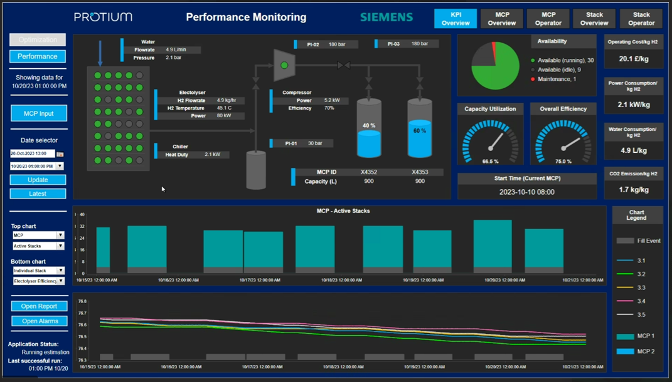

Digital Twin Dashboard Figure 42

Customer engagement through weekly meetings and open communications has been key to the project success, emphasizing responsiveness and continuous improvement. A structured framework enabled regular interactions for customers to share perspectives, feedback, and specific requirements, fostering a deep understanding of their needs. This feedback loop guided iterative refinements, addressing immediate concerns, and contributing to the project's evolution to meet emerging challenges and evolving expectations.

The transparent and collaborative nature of customer engagement was crucial for a positive working relationship, instilling a sense of shared ownership and alignment. This approach exceeded expectations, establishing a foundation for enduring partnerships and future collaborative endeavors. In summary, the robust customer engagement strategy not only addressed operational challenges but also significantly contributed to the success of the green hydrogen production initiative.

Moreover, the success of Pioneer 1 facility was a result of the collaborative site design, safety implementation, Enapter Electrolyser usage, data analysis, and customer engagement. The project's commitment to efficiency, safety, and customer satisfaction was underscored by careful planning and responsiveness to feedback.

4.4 Post Commissioning

Following the commissioning phase, a comprehensive series of Hydrogen Purity tests were conducted to ensure the integrity and quality of the green hydrogen produced. Initial testing by SGS revealed the presence of moisture and higher-than-optimal oxygen levels within the gas, accompanied by certain impurities. In response, a strategic and thorough re-purging of the system upstream of the Electrolyser container was undertaken.

The subsequent round of testing, conducted post re-purging, was instrumental in identifying the root causes of the initially detected issues. This investigative phase allowed for a targeted and effective rectification of the factors contributing to the observed deviations from the desired hydrogen purity standards, and lessons learned have been logged for future projects.

Upon the completion of the second round of testing, the Hydrogen Purity results demonstrated a significant improvement. The rectification measures undertaken in response to the identified issues proved successful, resulting in the attainment of Grade D fuel cell-grade hydrogen. This outcome signified not only the thorough attention to detail in addressing the initial challenges but also the commitment to achieving and maintaining the highest standards in hydrogen quality.

The iterative and diagnostic approach taken during the post-commissioning Hydrogen Purity tests not only resolved the identified issues but also showcased the adaptability and responsiveness of the project team. The attainment of Grade D fuel cell-grade hydrogen marked a crucial milestone in ensuring that the green hydrogen produced met stringent industry standards, reaffirming the reliability and efficiency of the production system.

4.5 Framework for design and implementation of a green hydrogen plant.

Technical Factors:
Electrolysis Technology Selection: The Challenge: Choosing the appropriate electrolysis technology (e.g., PEM, AEM, SOEC) with consideration for efficiency, scalability, and operational requirements.
Mitigation: Conduct thorough technology assessments, pilot studies, and engage with experienced vendors to select the most suitable technology for the plant.

Integration with Renewable Energy Sources: The Challenge: Efficiently integrating the Electrolyser plant with renewable energy sources to ensure a stable and continuous power supply.
Mitigation: Implement advanced control systems, energy storage solutions, and grid integration strategies to manage fluctuations in renewable energy generation.

Hydrogen Purity and Quality: The Challenge: Maintaining high hydrogen purity levels to meet industry standards and fuel cell requirements.
Mitigation: Employ advanced purification technologies, conduct regular maintenance, and implement rigorous quality control measures.

Safety Protocols: The Challenge: Ensuring the safety of personnel and the facility during hydrogen production, storage, and transportation.
Mitigation: Develop and implement comprehensive safety protocols, including gas detection systems, emergency response plans, and ongoing safety training.

Equipment Reliability: The Challenge: Ensuring the reliability of electrolysis equipment to minimize downtime and production interruptions.
Mitigation: Critical Spares availability and regular equipment maintenance, condition monitoring, and predictive maintenance techniques to identify and address potential issues proactively.

Economic Factors:

Initial Capital Costs: The Challenge: Managing the high initial capital costs associated with establishing a green hydrogen Electrolyser plant.
Mitigation: Explore government incentives, subsidies, and financing options. Optimize the plant design for cost efficiency and scalability.

Operational and Maintenance Costs: The Challenge: Addressing ongoing operational and maintenance costs to ensure economic viability.
Mitigation: Implement efficient maintenance practices, leverage automation technologies, and continually optimize operational processes.

Energy Costs: The Challenge: Fluctuating energy costs can impact the overall cost-effectiveness of hydrogen production.
Mitigation: Invest in renewable energy sources, negotiate long-term energy supply contracts, and explore energy storage solutions to mitigate the impact of energy price volatility.

Environmental Factors:

Carbon Emissions: The Challenge: Minimizing carbon emissions during the production process to achieve green hydrogen status.
Mitigation: Prioritize renewable energy sources, implement carbon capture and storage technologies, and participate in carbon offset programs.

Water Usage: The Challenge: Managing water consumption in the electrolysis process, considering potential environmental impacts.
Mitigation: Implement water recycling systems, explore water-efficient electrolysis technologies, and adhere to sustainable water management practices.

By addressing these technical, economic, and environmental factors and implementing effective mitigation strategies, a green hydrogen Electrolyser plant can enhance its overall performance, sustainability, and economic feasibility.

Chapter 5: Discussion

The choice of Electrolyser technology is pivotal in green hydrogen plant design, influencing efficiency, responsiveness, and scalability. Alkaline, PEM, and AEM electrolysers have unique advantages and are suitable for different applications based on factors like scale, energy demands, and operational conditions.

Comparative studies, such as the analysis between Cummins' Alkaline, PEM, and Enapter's AEM systems, provide valuable insights. Findings suggest that PEM electrolysers are well-suited for smaller-scale projects with intermittent renewable energy sources, while alkaline electrolysers are more efficient for larger-scale operations requiring continuous hydrogen production.
Enapter's AEM Modules exemplify advancements in compact, standardized, and modular Electrolyser design, making them suitable for small-scale projects and mass production. This showcases the importance of continuous innovation and adaptability in Electrolyser technology.

The study by Robert Caponi et al. underscores the need for considering application-specific requirements when selecting Electrolyser technology. PEM electrolysers, with slightly higher specific energy consumption but better efficiency, are deemed more suitable for applications with high intermittent profiles and power modulation.

Electrolyser technology selection directly impacts both the environmental and economic aspects of green hydrogen production. The efficiency of electrolysis processes and the ability to integrate with renewable energy sources play a crucial role in minimizing carbon emissions and managing operational costs.

The field of Electrolyser technology is dynamic, with ongoing developments and improvements. The transition from 100Kw to 1MW systems in Enapter's recent projects highlights the industry's commitment to scalability, efficiency, and meeting the growing demands of diverse industries.

Energy Storage Systems:
Battery vs. Hydrogen Storage: The study by Martinez Alonso et al. (2023) highlights the advantages of Hydrogen Energy Storage Systems (HESS) over Battery Energy Storage Systems (BESS) in terms of long-duration storage, system flexibility, and potential revenue streams.
Complementary Role: Hydrogen plays a complementary role when combined with batteries, enhancing microgrid flexibility and enabling deeper decarbonization by reducing grid electricity reliance.

Hydrogen Buffer Storage:
Pressure Vessel Types: Four types of pressure vessels (Type I to IV) are utilized for hydrogen buffer storage, each with specific applications and considerations. Selection depends on technical performance and cost competitiveness.
Storage Infrastructure: The favored method of storing hydrogen is in a compressed gaseous state using seamless pressure vessels crafted from high-strength steel. Options like Manifolded Cylinder Pallets (MCPs) and bespoke hybrid storage vessels offer versatile and weight-efficient alternatives.
Weight Ratio Consideration: The weight ratio between cylinders and hydrogen storage capacity influences storage vessel choice. Bespoke hybrid storage vessels, made from carbon fiber, epoxy resin, and a thin layer of aluminum, provide a weight-efficient solution.

Compressors:
Hydrogen Compression Importance: Hydrogen compression is crucial for delivering high-quality hydrogen at required pressures, such as 350 bar and 700 bar. Contamination prevention during the compression process is critical to avoid damage to fuel cells.
Leading Manufacturers: HASKEL, Maximator, and Hiperbaric are notable manufacturers of high-quality hydrogen compressors. Their offerings include durable, safe, and reliable pneumatic-driven gas boosters with varying pressure capabilities.
Recycling Initiatives: End-of-life recycling initiatives by companies like Johnson Matthey and Enapter contribute to sustainability, offering closed-loop solutions and a competitive advantage.

Implementing the proposed design framework (section 4.5) for a green hydrogen Electrolyser plant carries significant practical implications and produces tangible performance outcomes in real-world scenarios. By delving into the details of this comprehensive framework, several key practical implications and performance outcomes emerge:

1. Enhanced Operational Efficiency:
The framework ensures streamlined operational processes by addressing technical challenges and optimizing system configurations.
Performance Outcome: Increased operational efficiency leads to consistent and reliable hydrogen production, minimizing downtime and maximizing the plant's overall productivity.

2. Improved Economic Viability:
The framework mitigates economic challenges by optimizing initial capital costs, managing ongoing operational expenses, and strategically negotiating energy supply contracts.
Performance Outcome: Improved economic viability ensures the long-term sustainability of the green hydrogen plant, making it a financially sound investment with potential cost savings over time.

3. Sustainable Environmental Impact:
The framework prioritizes environmental considerations, incorporating renewable energy sources and implementing carbon capture and storage technologies.
Performance Outcome: Minimizing carbon emissions and adopting sustainable water management practices contribute to the plant's green credentials, aligning with global sustainability goals.

4. Adaptable to Fluctuating Energy Markets:
Mitigating the impact of fluctuating energy costs by investing in renewable sources and exploring energy storage solutions enhances adaptability.
Performance Outcome: The plant becomes more resilient to market dynamics, ensuring stable and cost-effective hydrogen production regardless of energy price volatility.

5. Safety Assurance for Personnel and Facilities:
Implementing comprehensive safety protocols, gas detection systems, and emergency response plans addresses safety challenges associated with hydrogen production, storage, and transportation.
Performance Outcome: Ensuring personnel and facility safety leads to a secure operational environment, preventing accidents and fostering a culture of safety consciousness.

6. Reliability through Advanced Maintenance Practices:
Utilizing advanced maintenance practices, including critical spares availability and predictive maintenance techniques, addresses challenges related to equipment reliability.
Performance Outcome: Enhanced equipment reliability minimizes downtime, contributing to a consistent and reliable hydrogen production process.

7. Real-World Adaptability and Scalability:
The framework's emphasis on optimization and scalability ensures adaptability to real-world scenarios and varying operational conditions.
Performance Outcome: The plant can effectively scale its operations to meet increasing demand or adapt to changes in the energy landscape, demonstrating flexibility and resilience.

8. Technological Innovation and Continuous Improvement:
Regular technology assessments and pilot studies encourage ongoing technological innovation and improvement.
Performance Outcome: Continuous improvement fosters technological advancements, keeping the plant at the forefront of industry standards and ensuring its competitiveness in the evolving green hydrogen landscape.

In the context of the Pioneer 1 project management, the adoption of Agile methodology proved instrumental, facilitating iterative development and adaptability to changes in project requirements, technology, and stakeholder expectations. This approach, emphasizing collaborative decision-making and frequent stakeholder involvement, significantly contributed to the project's success by allowing continuous adjustments throughout its lifecycle.

Stakeholder management played a pivotal role, with a differentiated communication approach based on the power-interest matrix. Key stakeholders, characterized by high influence and interest, received careful management, fostering effective engagement and streamlined decision-making. Tailored communication strategies, feedback mechanisms, and transparent issue resolution further contributed to a collaborative project environment.

Communication management, encompassing both internal team interactions and external stakeholder engagement, was comprehensive. The project team conducted a thorough stakeholder analysis, informing the development of a communication strategy tailored to each stakeholder group's information needs, influence, and interest. Diverse communication channels adapted frequency and formats, and proactive issue resolution communication protocols ensured effective communication throughout the project.

Risk management emerged as a cornerstone of the project, with a comprehensive plan covering all stages and a Protium Risk Management Process guiding the identification, assessment, and mitigation of potential threats. The project team demonstrated proactive risk identification and mitigation, effectively preserving project objectives and ensuring the overall success of Pioneer 1.

Quality management measures were robust, adhering to industry standards and certifications, ensuring reliability and safety in green hydrogen production. Certifications and compliance validations provided external assurance, fostering stakeholder confidence. Continuous improvement initiatives, feedback loops, and post-implementation reviews further enhanced project outcomes.

Resource management focused on the strategic allocation of human resources, equipment procurement, and technology deployment. Challenges such as unexpected personnel turnover and evolving technological requirements were addressed through cross-training initiatives and contingency plans. The approach emphasized adaptability and scalability, contributing to the timely completion of milestones and the overall success of the project.

Timeline and schedule management employed a hybrid approach, combining Agile methodologies with structured frameworks. Critical milestones were identified and accompanied by detailed tasks, timelines, and resource allocations. Deviations from the original schedule were managed through proactive risk identification and timely adjustments, minimizing the overall impact on the project timeline.

Cost management was a critical aspect, demanding thorough planning, effective estimation, and stringent financial controls. The project began with a comprehensive budget formulation, aligning with the project timeline and milestones. Accurate cost estimation methods, financial controls, and negotiations with suppliers contributed to staying within the established budget, despite challenges such as global supply chain disruptions.

Chapter 6: Conclusion and Recommendations:

6.1 Conclusion:
In conclusion, the Design and Implementation of the Pilot Green Hydrogen Facility, Pioneer 1, has shed light on critical elements vital for the success of green hydrogen production, especially through renewable sources. As the global pursuit of achieving net-zero emissions intensifies, hydrogen, particularly Green H2, emerges as a key player in the sustainable energy landscape.

Key learnings from Pioneer 1 emphasize the importance of integrating various components seamlessly, including electrolysers, buffer storage, safety systems, compressors, and filling panels. Effective stakeholder engagement, facilitated by regular communication and a sense of ownership among all parties, emerges as a foundational aspect for success.

The significance of hydrogen purity becomes evident, not only due to the substantial costs associated with testing but also to avoid the production of substandard hydrogen that may necessitate venting. Rigorous cleaning and maintenance practices, particularly for pipe, valves, and fill panel components, are imperative to maintain oxygen-quality standards and ensure purity levels exceeding 99.9%.

A comprehensive approach to facility permits, encompassing both operations and plant design, is crucial to streamline commissioning and minimize post-commissioning adjustments. The availability of critical spares and consumables, alongside accurate forecasting through digital twin technology, proves instrumental in optimizing production efficiency, managing electricity costs, and mitigating environmental impact.

Contracts with off-takers, including those for ADR transportation, contribute to the facility's operational resilience. Equally important is the presence of well-trained and competent personnel, adhering to stringent safety protocols, emergency preparedness, permit systems, and compliance with the latest rules and regulations governing hydrogen plant operations.

In essence, the findings from the Pioneer 1 project underscore the multifaceted nature of successful green hydrogen production, emphasizing the importance of meticulous planning, robust communication, adherence to safety standards, and a holistic approach to facility operations and maintenance. These insights serve as a valuable foundation for future endeavors in scaling up green hydrogen facilities to meet the demands of a sustainable and net-zero future.

6.2 Recommendations for Future Projects:

Comprehensive Planning: Prioritize thorough planning in all project phases, emphasizing integration, safety, and adherence to quality standards.

Stakeholder Involvement: Foster strong stakeholder engagement through consistent communication and instill a sense of ownership among all parties.

Quality Assurance: Implement stringent measures for hydrogen purity, including regular testing, to ensure high-quality production and avoid unnecessary costs.

Maintenance Protocols: Develop and adhere to comprehensive maintenance protocols, with a focus on keeping components clean and maintaining oxygen-quality standards.

Permitting Strategy: Invest time and resources in a detailed permitting strategy during the design phase to streamline operations and reduce post-commissioning adjustments.

Inventory Management: Maintain an inventory of critical spares and consumables to address breakdowns promptly and minimize downtime.

Digital Twin Implementation: Embrace digital twin technology for accurate forecasting and optimization of production processes, electricity consumption, and environmental impact.

Contractual Agreements: Establish clear and robust contractual agreements with off-takers and other stakeholders to enhance project resilience.

Continuous Training: Prioritize ongoing training for personnel to ensure competence in safety procedures, emergency response, and compliance with evolving regulations.

By incorporating these recommendations into future projects, organizations can enhance the efficiency, safety, and overall success of green hydrogen facility initiatives, contributing to the broader goals of sustainable energy production.

References
A. Martinez Alonso, D. C. M. M. T. C., 2023. Techno-economic assessment on hybrid energy storage systems comprising hydrogen and batteries: A case study in Belgium,. International Journal of Hydrogen Energy,, Volume 0360-3199.
B. Shabania, M. H. S. K. A. R. A. R., 2019. Poisoning of proton exchange membrane fuel cells by contaminants and. Journal of Power Sources, Volume 427, pp. 21-48.
Barthe´le´my, H., 2012. Hydrogen storage e Industrial prospectives. International Journal of Hydrogen Energy, Volume 37, pp. 17364-17372.
BCGA., 2002. TECHNICAL INFORMATION SHEET 10. BRITISH COMPRESSED GASES ASSOCIATION,. [Online]
Available at: https://bcga.co.uk/wp-content/uploads/2021/09/TIS-10-Rev-3-For-Publication.pdf
[Accessed 14 01 2024].
BOC a Linde Comapny, 2023. High Purity Hydrogen Manifolded Cylinder Pallet. [Online]
Available at: https://www.boconline.co.uk/shop/en/uk/high-purity-hydrogen-manifolded-cylinder-pallet
[Accessed 16 October 2023].
Brauns, J. T. T., 2020. Alkaline Water Electrolysis Powered by Renewable Energy. Processes, 248(8), p. 2.
EDP Sciences, 2021. Hydrogen refueling station cost model applied to five real case studies for fuel cell buses. E3S Web conference, Volume 312, p. 16.
Enapter, 2021. Enapter Named as Earthshot Prize Finalist. [Online]
Available at: https://www.enapter.com/newsroom/earthshot-prize
[Accessed 17 November 2023].
Enapter, 2022. Johnson Matthey expands presence in green hydrogen with stake in AEM electrolyzer pioneer. Focus on Catalysts, 2022(8), p. 3.
Enapter, 2023. Enapter AG sells 1MW electrolyser to UK firm after AEM Multicore demo. [Online]
Available at: https://www.enapter.com/newsroom/enapter-ag-sells-1mw-electrolyser-to-uk-firm-after-aem-multicore-demo
[Accessed 17 November 2023].
Enapter, 2023. What is the overall efficiency of Enapter’s electrolyser?. [Online]
Available at: www.enapter.com/newsroom/kb_post/what-is-the-overall-efficiency-of-enapters-electrolyser
[Accessed 05 November 2023].
ENERGY.GOV, 2023. Hydrogen Production: Electrolysis. [Online]
Available at: https://www.energy.gov/eere/fuelcells/hydrogen-production-electrolysis
[Accessed 17 November 2023].
Evans, C. C. E. R. J., 2004. OVERVIEW OF HYDROGEN PRODUCTION. National Renewable Energy Laboratory, 49(2), p. 481.
Fire Protection Association, 2023. WHO CAN CARRY OUT A DSEAR RISK ASSESSMENT?. [Online]
Available at: https://www.thefpa.co.uk/advice-and-guidance/advice-and-guidance-articles/who-can-carry-out-a-dsear-risk-assessment-
[Accessed 17 January 2024].
Fuel Cell Systems, 2023. Pioneer 1 Systems Manual., Bristol: FCS.
GOV.UK, 2023. Dangerous goods safety advisers. [Online]
Available at: https://www.gov.uk/government/publications/carriage-of-dangerous-goods-guidance-note-19/employing-a-dangerous-goods-safety-adviser
[Accessed 05 November 2023].
Guiqiang Li, J. L. R. Y. X. C., 2022. Performance analysis of a hybrid hydrogen production system in the integrations of PV/T power generation electrolytic water and photothermal cooperative reaction,. Applied Energy,, Volume 323, p. 119625.
Gyubin Min, S. C. J. H., 2022. A review of solid oxide steam-electrolysis cell systems: Thermodynamics and thermal integration,. Applied Energy, Volume 328, p. 120145.
H2 Cumru Wales, 2021. Turning Hydrogen Vision into Reality. [Online]
Available at: http://www.h2wales.org.uk/pages/hydrogen-centre/renewable-hydrogen-production.html
[Accessed 26 November 2023].
HASKEL, 2023. Hydrogen Compressors. [Online]
Available at: https://www.haskel.com/en-gb/products/hydrogen-refuelling/hydrogen-compressors
[Accessed 16 October 2023].
Hiperbaric, 2023. Hiperbaric, High Pressure Technologies.. [Online]
Available at: https://www.hiperbaric.com/en/h2-compression/
[Accessed 16 October 2023].
HSE, 2023. ATEX and explosive atmospheres. [Online]
Available at: https://www.hse.gov.uk/fireandexplosion/atex.htm
[Accessed 17 January 2024].
HSE, 2023. Hydrogen: The Fundementals. [Online]
Available at: https://solutions.hse.gov.uk/health-and-safety-training-courses/hydrogen-the-fundamentals
[Accessed 05 November 2023].
Hydrogen News, 2023. A comprehensive analysis on PEM electrolyzer vs AEM electrolyzer. [Online]
Available at: https://www.hydrogennewsletter.com/a-comprehensive-analysis-on-pem-electrolyzer-vs-aem-electrolyzer/
[Accessed 10 September 2023].
Hydrogen Tools, 2023. H2 Hydrogen Tools. [Online]
Available at: https://h2tools.org/bestpractices/emergency-response
[Accessed 05 November 2023].
Hydrogen Tools, 2023. Welcome to the Hydrogen Tools Portal. [Online]
Available at: https://h2tools.org/
[Accessed 05 November 2023].
ISO 2020, 2020. ISO 19880-1:2020 (en). [Online]
Available at: https://www.iso.org/obp/ui/#iso:std:71940:en
[Accessed 05 November 2023].
Kazunari Sasaki, K. H. T. Y. D. M. E. Y. R. L., 2011. Chemical durability of Solid Oxide Fuel Cells: Influence of impurities on. Journal of Power Sources, Volume 196, pp. 9130-9140.
Khem Gyanwali, A. B. T. R. B. R. K. Y. F., 2022. Assessing green energy growth in Nepal with a hydropower-hydrogen integrated power grid model,. International Journal of Hydrogen Energy,, 47(34), pp. 15133-15148.
Marcela, K., 2023. Digital Twin Pioneer, London: Protium.
Mauro, L. H. A., 2022. Review of Polybed pressure swing adsorption for. ScienceDirect, Volume 47, pp. 10911-10933.
MAXIMATOR UK, 2023. Highway Hydrogen Refuelling Systems. [Online]
Available at: https://www.maximator.co.uk/hydrogen-highwayhrs/
[Accessed 16 October 2023].
Natural Resources Wales, 2023. Natural Resources Wales. [Online]
Available at: https://naturalresources.wales/search?lang=en&query=hydrogen
[Accessed 05 November 2023].
Neath Port Talbot Council, 2023. Commercial waste. [Online]
Available at: https://beta.npt.gov.uk/bins-and-recycling/commercial-waste/
[Accessed 05 November 2023].
Neath Port Talbot Council, 2023. Duty of care for businesses. [Online]
Available at: https://beta.npt.gov.uk/bins-and-recycling/commercial-waste/duty-of-care-for-businesses/
[Accessed 05 November 2023].
NEL, 2023. M Series Containerized PEM Electrolysers. [Online]
Available at: M Series Containerized PEM Electrolysers
[Accessed 17 November 2023].
NFPA, 2023. National Fire Protection Assosiation. [Online]
Available at: https://www.nfpa.org/
[Accessed 05 November 2023].
Nobuhiko Takeichi, H. S. T. Y. H. T. K. H. H. T. T. H. T. T. K. T. T. N. K., 2003. Hybrid hydrogen storage vessel. International Journal of Hydrogen Energy, 28(10), pp. 1121-1129.
NPL, 2023. Gas reference materials. [Online]
Available at: https://www.npl.co.uk/products-services/gas
[Accessed 29 October 2023].
OSHA, 2023. Occupational Safety and Health Administration. [Online]
Available at: https://www.osha.gov/laws-regs/regulations/standardnumber/1910/1910.103
[Accessed 05 November 2023].
Panagiotou, A., 2023. The European hydrogen market landscape, Europe: Clean Hydrogen JU.
Protium, 2020. H2 Infrastructure – Feasibility Considerations, London: Protium.
Qusay Hassan, A. Z. S. H. M. S. M. J., 2023. Large-scale green hydrogen production via alkaline water electrolysis using solar and wind energy,. International Journal of Hydrogen Energy,.
Ryan O'Hayre, S.-W. C. W. C. F. B. P., 2016. Fuel Cell Fundemantals. 3rd ed. New Jersey: John Wiley & Sons.
S.A. Grigoriev, P. M. S. K. V. P. M. P. C. E. C. P. V. F., 2009. Hydrogen safety aspects related to high-pressure polymer electrolyte membrane water electrolysis. International Journal of Hydrogen Energy, 34(14), pp. 5986-5991.
Sun Young Kang, J. E. P. G. Y. J. O.-H. K. O. J. K. Y.-H. C. Y.-E. S., 2022. High-performance and durable water electrolysis using a highly conductive and stable anion-exchange membrane,. International Journal of Hydrogen Energy,, 47(15), pp. 9115-9126.
Tristancho, C., 2023. Stakeholder Mapping 101: A Quick Guide to Stakeholder Maps. [Online]
Available at: https://www.projectmanager.com/blog/stakeholder-mapping-guide
[Accessed 16 November 2023].
Yagmur, G. I. D. A. K., 2023. A comprehensive review on environmental and economic impacts of hydrogen production from traditional and cleaner resources. Environmental Chemical Engineering, Volume 11, p. 111187.

Appendix
Appendix 1 Project Plan
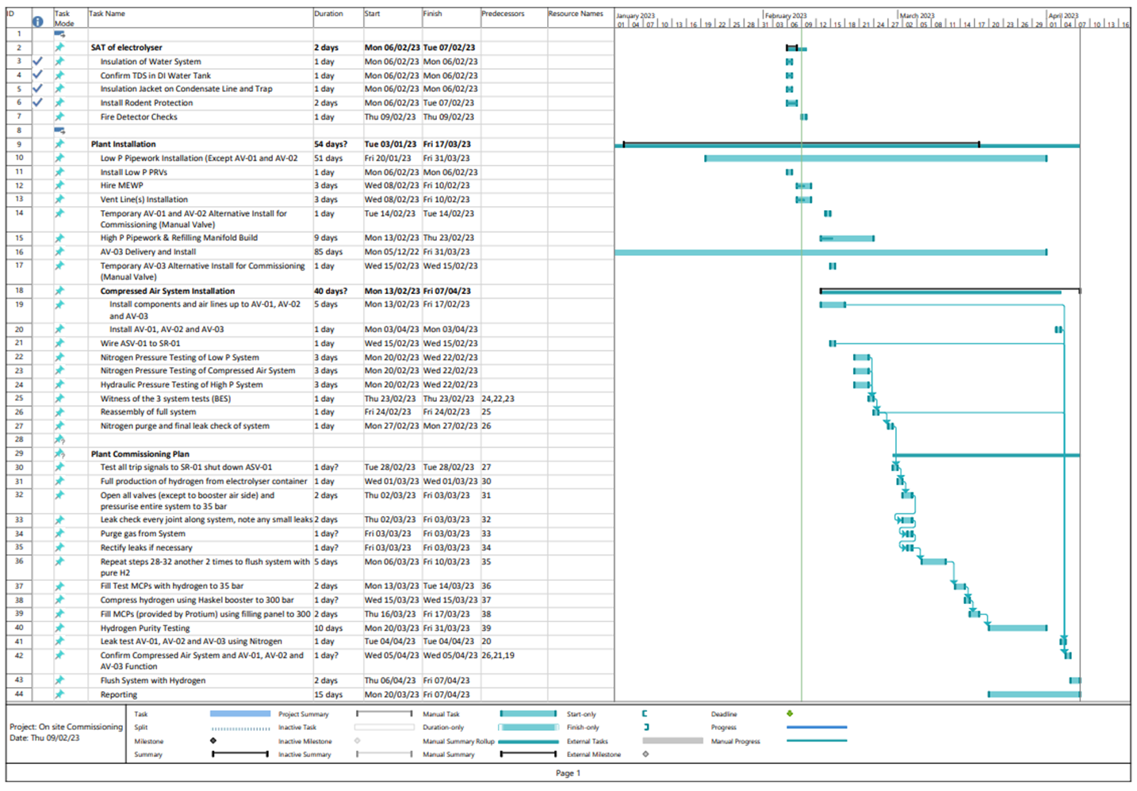
Appendix 2 Haskel Compressor
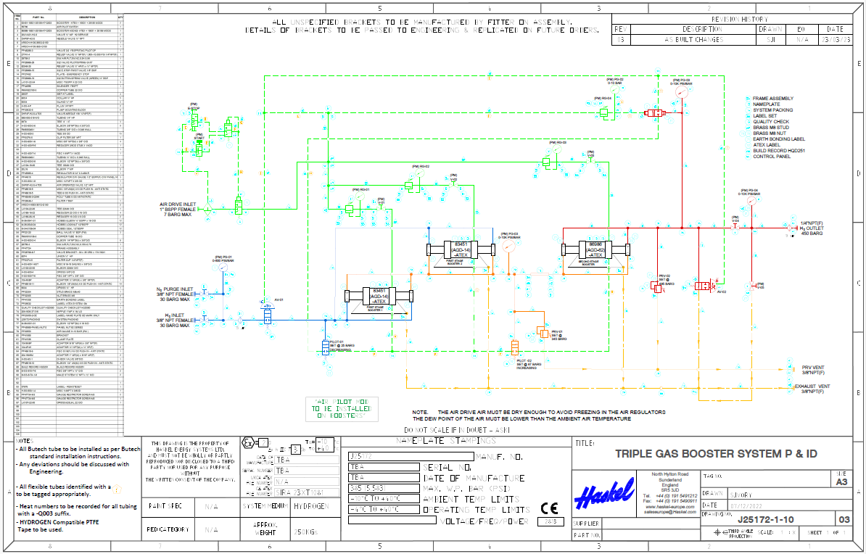
Appendix 3 Original Buffer Tank
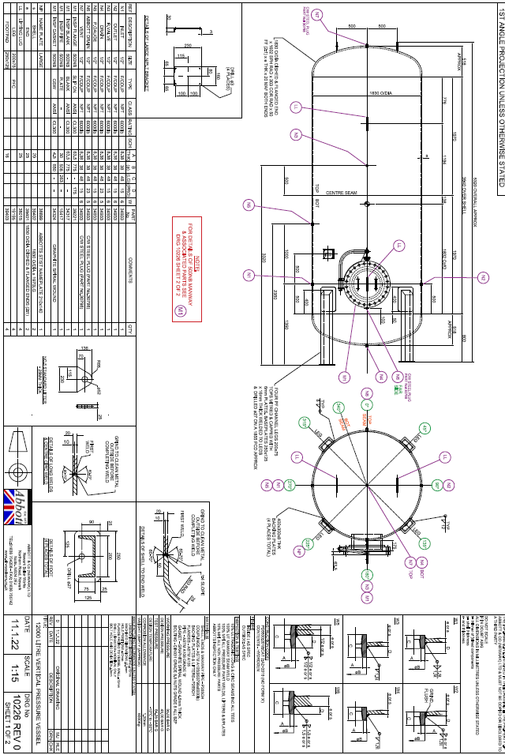

Appendix 4 Buffer Tank Quote

Appendix 5 NRW Permit


