University of Wales Trinity Saint David

Heat Exchanger Assignment
Thermofluid Mechanics

Steffan Robinson
Thermofluid Mechanics
Robert Goodson
27/4/2020
Contents
Introduction 3
Experimental procedures 3
Results and Analysis 4
Varying Water flow rate 4
Varying Air flow rate 7
Varying Temperature 10
Excel Spreadsheet 13
Further Work 14
Table of Figures 15
Evaluation 16
Conclusion 17
References 18

Introduction
This assignment is to investigate heat exchangers and how results vary by changing different aspects of it. There were three experiments that needed to be done to complete this assignment on heat exchangers. One of which was varying the flow rate of the water in the heat exchanger for a set water temperature and air flow. The other experiment was varying the flow rate of the air passing through the heat exchanger for a set water flow and temperature. The final experiment was to see the effect of varying temperature on the heat exchanger given a fixed flow.

Experimental procedures
We didn’t do the experiments in the order above we decided to do it in order of 3,2,1 to save time as the session wasn’t long enough for us to wait for the water to cool down rather we heated it up which was quicker. Therefore, for the first procedure we made sure that we were running the heat exchanger at a counter flow and set the temperature at 45⁰c. We then had to set the water flow at 0.25l/min with a tolerance of 0.01l/min, thankfully it was electronically controlled and would stay within that. We also had to make sure on this one because we were changing the pressure using the sliding valve we had to be as accurate as possible and stay within the +/-5Pa tolerance. We would be changing the pressure in intervals of 50Pa from 250 to 50Pa (250, 200, 150, 100, 50). We allowed 4 minutes between each pressure difference to allow temperature stabilization to make it equilibrium. Before starting we had to do a quick last-minute check to see the orifice and its diameter, this was stamped on the top of the orifice. Once we had done this, we were ready to start taking results.
For the next experiment we varied the temperature. We again made sure the heat exchanger was in counter flow and set put the temperature to 60⁰c, 15⁰c higher. We then did the same for this experiment as the last, still trying to get the pressure as accurate as possible. Still allowing four-minute intervals to allow the temperature to set. We then recorded our results
For the last experiment we set up the TD1007 and connected it up as counter flow and kept the temperature at 60⁰c. We had one of us setting the sliding valve to 250Pa on this setup with a tolerance of +/- 5Pa, thankfully we got it at exactly 250Pa. We then set the water flow at 2l/min. This had a tolerance of 0.01l/min. We then had to wait for four minutes to allow the temperature in the heat exchanger to get stable for us to begin experimenting. We then repeated this for water flow rates from 2 down to 0.75 at 0.25 intervals. (2, 1.75, 1.5, 1.25, 1, 0.75l/min) allowing 4 minutes between each flow rate to allow temperature stabilization. We then recorded our results.
I know that with the conservation of energy states that the principle that in a system that does not undergo any force from outside the system, the amount of energy is constant, irrespective of its changes in form. Therefore during the course of the system, I can be aware that the energy in there I moving and changing into different forms

Results and Analysis

Varying Water flow rate

Graph 1- Water mass flow against Qa and Qw
*Water mass flow in order from left to right: high to low*
It is clear to see that there is a correlation between the water mass flow and the power absorbed by air and emitted by the water. As the water mass flow increases the amount of energy increases from both water and air. However, it is positive correlation increasing at a negative rate and begins to slow down. It looks like Qa hits its maximum amount of energy absorbed by the air at around 0.286kg.s^-1 this is when the flow rate is at 1.75l/min. For the entire energy system, I would imagine that it would hit peak power around 0.38kg.s^-1. My energy balance coefficients seem to be reasonable between 0.82 and 0.89, I feel when they separate is when slight external conditions come into play. Also, during the change of water mass flow, they seem to have a linear increase in between around 0.016 and 0.02.

Graph 2- Water mass flow against Water, Air and Mean efficiency
Overall, there is a decrease of efficiency as you increase the water mass flow. There is a significant decrease in water efficiency as the flow rate increases and an increase in air efficiency. As the flow rate of water increases you would see a drop in water efficiency because the air has less time to cool the water and the temperature difference between the inlet and outlet would be exceedingly small giving a low efficiency. Obviously then if you slow the flow rate of water down it gives the water more time to be cooled by the air in the working section. This then creates a greater temperature difference and therefore a higher water efficiency. There is little to no change in the air efficiency which is to be expected because of the minimal air temperature difference between Ta1 and Ta2.

.

Graph 3- Water mass flow against Heat Transfer coefficient
There is a correlation between water mass flow and heat transfer because as you increase the flow of water this is because the more water passing through the pipes provides more opportunities for heat transfer into the air. There is a slight inconsistency with the results because at 0.02 flow rate the heat transfer goes down ever so slightly this could be down to slight changes in external factors and could be a void result. It does increase but at a decreasing rate I would imagine that the mass flow rate would get to a point where there would not be an increase in heat transfer, I would imagine this to be around 0.04-0.045 at these settings.

Varying Air flow rate

Graph 4- Air Mass Flow against Qw and Qa at 60 degrees Celsius
* Air mass flow is, from left to right, high to low*
It’s interesting to note that the energy absorbed by the air and emitted by the water do not start together but merge together towards the end this would suggest that at lower air flow there would be more loses to the surrounding areas. As air mass flow increases, I imagine that the external losses decrease this is when both values start to merge. The energy does continue to increase as in the air mass flow increases and it probably would carry on increasing linearly, especially the energy being absorbed into the air. This is slightly different if you compare it to the varying water flow graph because in that one the energy starts to level out and stops increasing.

Graph 5- Air mass flow against Air, water and average efficiency at 60 degrees Celsius
This graph is much different to the last efficiency graphs in terms of trends. Here the water efficiency increases as the air mass flow increases because with more air passing through the pipes the more heat transfer is going to occur therefore it creates a greater temperature difference between Tw1 and Tw2 meaning its cooling down the water better. With the air efficiency it decreases as you increase the air mass flow this is because there’s more air passing through the heat exchanger which is allowing more heat transfer however it doesn’t give as much of a temperature difference because of the speed at which its going through in a given time period. Then there is an overall increase because of the effect rising the air mass flow has on the water efficiency.

Graph 6- Air mass flow against Heat Transfer Coefficient at 60 degrees Celsius
There is a clear positive linear correlation between air mass flow and heat transfer. This is similar to what was said in graph 5, with more air flow it allows for more heat transfer to happen, it could be to suggest that with increasing the air mass flow more that the heat transfer would continue to rise higher and higher.

Varying Temperature

Graph 7- Air mass flow against Qw and Qa at 40 degrees Celsius

*Air mass flow is, from left to right, high to low*
In terms of values the power absorbed and emitted is lower because of the values being less at 45⁰c such as average temperature, temperature difference and Cpw of water is less. They both do also follow similar trend lines in the sense they are quite far apart to start and begin to merge. They do not merge on this graph due to the temperature change however with a higher air mass flow the powers could continue to increase and merge that way. It would seem then that more heat transfer occurs at a higher temperature because this is around 100W less in places compared to 60⁰c

Graph 8- Air mass flow against Air, Water, and average efficiency at 45 degrees Celsius
In terms of values and trends this graph and graph 5 are near identical water efficiency goes from around 46% to 61% in both and air efficiency does the same, it starts at 15% and decreases to 9% on both. This to me shows that varying the temperature does not make much of a difference with the efficiency at all. A suggestion maybe would be instead of comparing temperature difference compare the efficiencies of parallel and series heat exchangers.

Graph 9- Air mass flow against Heat Transfer coefficient at 45 degrees Celsius
Again, there is little difference between the heat transfer coefficient between 45⁰c and 60⁰c. They both start at around 93/94W.m^-2K^-1 and both increase linearly towards around 134/138W.m^-2K^-1. Therefore, again varying temperature does not have a big effect on the values calculated. If we could vary the temperature by a bigger margin it could maybe create interesting differences but with the temperature difference so narrow it only varies minutely.

Excel Spreadsheet
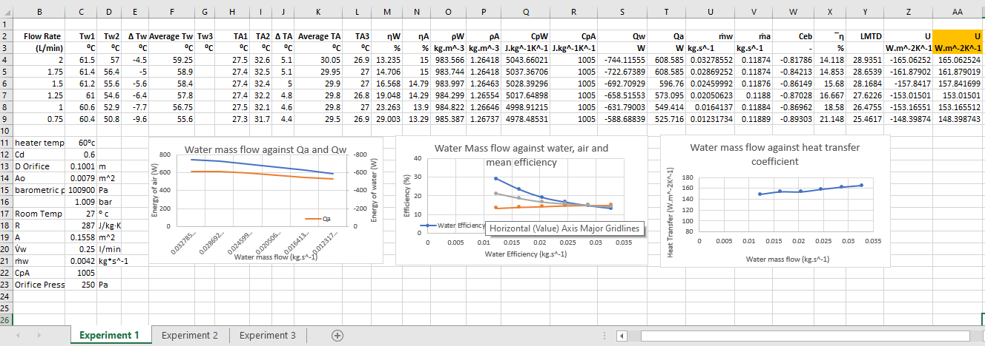
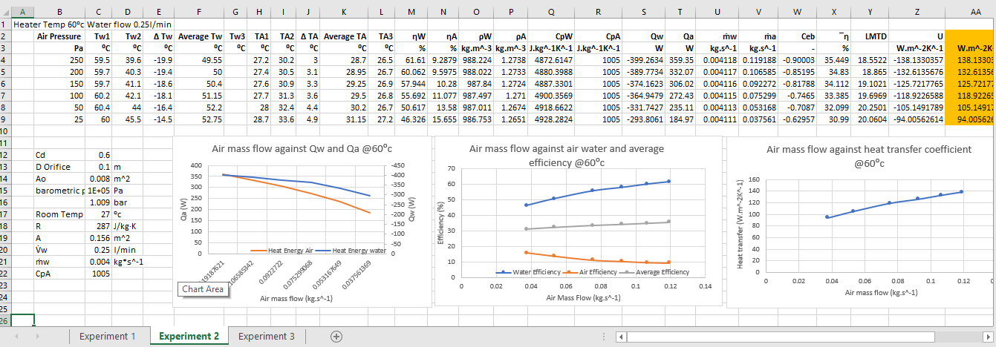
Here is the spreadsheet I used to create my values
Figure 1- Varying Water Flow Spreadsheet
Figure 2- Varying Air Flow Rate Spreadsheet
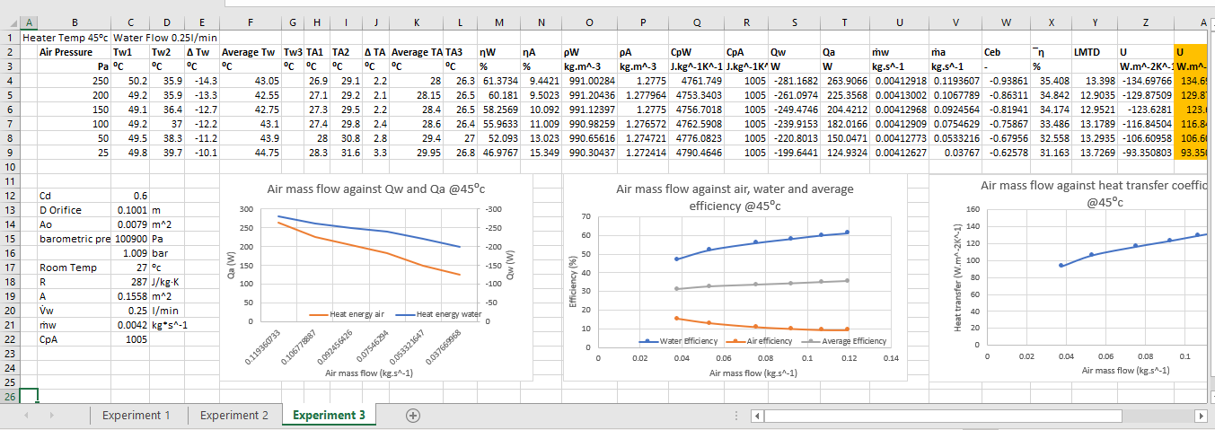
Figure 3-Varying Temperature Spreadsheet

Further Work
For some further work I decided to use the tolerance values for the Air pressures, because we were allowed a tolerance of +/- 5Pa and the sliding sleeve was difficult to get it on the correct values we did use tolerance values. I want to see the impact that the tolerance had on the results and will be creating another spreadsheet to see how they effected the results if any.
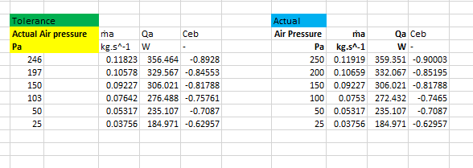

Table 1- A table to see the effect of changing the air pressure to what it was within tolerance limit

In the lab session we wrote down the actual air pressure to see if there would be much of a change in results, therefore that is what I have done. I found out what varying the air pressure effected and pulled those out of the table to create this new one. One the left we have the tolerance values. As you can see not all of them are off, 25, 50 and 150 were spot on but the rest had changed. On the right we have the values we’re meant to have. If we look at the effect on the air mass flow (ma) there is little change if we look at the difference from 246 and 250Pa it is a small amount from 0.11823 to 0.11919, respectively. A difference of 0.00096 kg. s ^1, considering this had the largest gap of 4Pa that is a minute difference. However, this then had a knock-on effect because you need ma to work out Qa it did have a larger effect. If we take 246Pa as an example the difference between Qa’s is around 3W which is considerable and for 103Pa it changed 4W. This then has an effect on the energy balance coefficient which decreases because its inversely proportional to Qa but again it doesn’t see a big change.

Table of Figures

Graph 1- Water mass flow against Qa and Qw 3
Graph 2- Water mass flow against Water, Air and Mean efficiency 4
Graph 3- Water mass flow against Heat Transfer coefficient 5
Graph 4- Air Mass Flow against Qw and Qa at 60 degrees Celsius 6
Graph 5- Air mass flow against Air, water and average efficiency at 60 degrees Celsius 7
Graph 6- Air mass flow against Heat Transfer Coefficient at 60 degrees Celsius 8
Graph 7- Air mass flow against Qw and Qa at 40 degrees Celsius 9
Graph 8- Air mass flow against Air, Water, and average efficiency at 45 degrees Celsius 10
Graph 9- Air mass flow against Heat Transfer coefficient at 45 degrees Celsius 11

Figure 1- Varying Water Flow Spreadsheet 12
Figure 2- Varying Air Flow Rate Spreadsheet 12
Figure 3-Varying Temperature Spreadsheet 12

Table 1- A table to see the effect of changing the air pressure to what it was within tolerance limit 13

Evaluation

I am pleased with the results I had, I had one or two very slight anomalies in my results but nothing too major. For example, on graph 9- air mass flow against heat transfer coefficient at 45⁰c the starting point is slightly low and doesn’t line up with the rest of the point but this is only a slight marginal error and could’ve been down to a slight upset in an external factor.
I felt that our means of getting the values were correct we made sure to wait 4 minutes in between each reading and had the same person changing the air pressure to make sure our results were reliable. We didn’t leave anything to chance and made sure to use the equipment properly. We made sure to do the experiments in a specific order to optimise our time as it was only one session we had. We started with the 45⁰c test and then did the 60⁰c test because heating it up was much more efficient and time saving than letting it cool down from 60⁰c to 45⁰c. To finish we then did the 60⁰c flow rate test as we were already at 60⁰c. We had a few of us recording results just to be sure we didn’t miss hear anything. Therefore, because of this I feel that the experiment went pretty well and the consistency with the results and the minimal anomalies highlight that this experiment went well.

Conclusion

To conclude I feel that heat exchangers are a complex piece of machinery and that there are a lot of different factors that can have an influence on the outcome of results. It shows that temperature change air flow and water flow can all influence different results and efficiencies. Also its interesting to see how efficiencies change when you change the water flow rate and how they decrease whereas if we were changing the air flow rate is has a much more different effect. Also I maybe feel we should’ve used the tolerance values in some cases because it would’ve been an interesting topic to see how they would’ve affected results.

References

https://moodle.uwtsd.ac.uk/pluginfile.php/145911/mod_resource/content/1/TD1007_HX_laboratory_guide.pdf
www.dictionary.com/browse/conservation-of-energy

