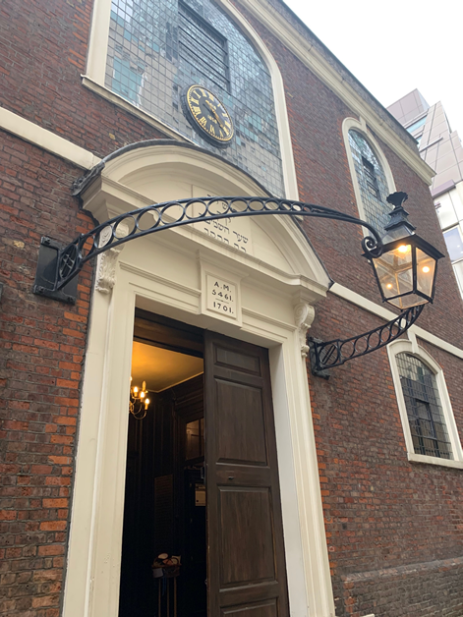
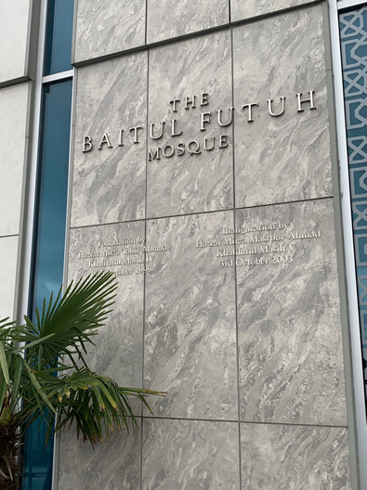
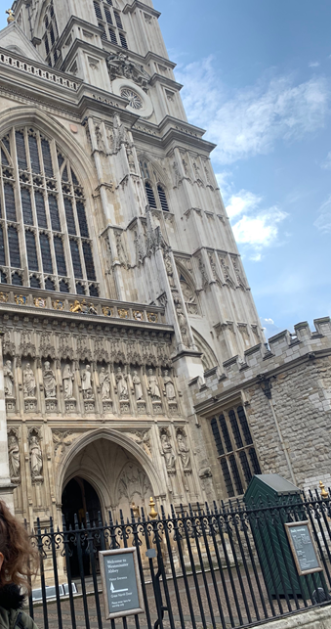
Fig 2
Fig 1

Introduction

Religion in Britain

Westminster Abbey

Bevis Marks Synagogue

Baitul Futuh Mosque

Religion in contemporary Britain

Bibliography

Places of Worship in London
Table of Contents

By Amy Seale 1700646
Fig 3
and their impact on the Abrahamic Faiths
This study guide will focus on the understanding of religious communities of the Abrahamic faiths; Christianity, Judaism and Islam, and their acceptance into modern British culture. There are numerous sights of religious significance in Britain that have impacted British culture and the understanding of religion in Britain. However, with this, I will focus on a day trip in London which will visit three main sights of religious places of worship which include: Westminster Abbey, Bevis Marks Synagogue and finally the Baitul Futuh Mosque.

Religion has fluctuated over the history of Britain, but significant changes can be seen in England. With a large amount of multiple cultures and even a range of diversity can be seen in numerous different areas. As mentioned by Linda Woodhead and Rebecca Catto, that religions formed to “make space for themselves in a society and culture which has not been shaped around them.” With this, the introduction of religions such as Judaism, Buddhism, Hinduism and Islam have further began to shape British culture into what we have today. As Britain is a majority Christian influenced country, the introduction of different religions has made a positive impact on our social understandings of not only world religions but also different cultures. Paul Badham goes on to further examine how “freedom of religious belief is a freedom which was won at a heavier price in earlier ages,” which further shows how religion has taken a long time to flourish even to what we can understand today. This also implies on the struggles of practising specific beliefs that were not Christian at the time, further highlighting the significance of the change of religion and religious acceptance in modern Britain. Assimilation has been a major factor in the way that religions, beside from Christianity, have changed to be accepted into British society. Woodhead and Catto continue this by mentioning that Judaism has been “most successful in becoming established in British society- … some members of the community now worry that it has been too fully assimilated.” However, with this, the Jewish community is still flourishing across Britain with many places consisting of largely Jewish communities. Further to note is the challenges of the Islamic communities on life in Britain. Woodhead and Catto further note that the chapter on Islam highlights “how and why its settlement has been more controversial… but also that it has been established in many arenas of British society.” With this, the introduction of Islam into British culture may have started off in a negative way but the community have since grown across Britain and have greatly impacted the understanding of living in a multi-cultural society in modern Britain.
Religion in Britain
Westminster Abbey

In Westminster Abbey, which would be the first location to visit on the day trip, the religious significance from Christianity can be explored through the place of worship and also the cultural impact this site has on the location it is based. As noted on Westminster Abbey website, although the abbey is considered a place of worship, they note the importance of “the shrine of St Edward the Confessor, the tombs of kings and queens, and countless memorials to the famous and the great.” With this, the religious significance can be seen not only through the way the religion is presented but also how the multi-functional abbey is used as a display of the history of our monarchy as well as our remembrance for important British figures that have shaped our British history. Christianity has influenced our society for hundreds of years with the construction of Westminster Abbey in central London further highlighting the importance of such a place of worship for the community but also for visitors to experience and learn about British history through the monarchy. To further acknowledge is that Westminster Abbey can be seen as “a work of architectural genius, a place of daily worship, deploying the resources of high musical expertise, a burial place of kings, statesmen, poets, scientists, warriors and musicians, is the result of a process of development across the centuries.” This is noted on their website which further enables us to learn about the historical significance of such a grand building for the religious history of our country and also architectural history of Britain. This also enables many people, not only Christian worshippers, to experience in the spiritual and historical atmosphere of this religious site.
Practical Information

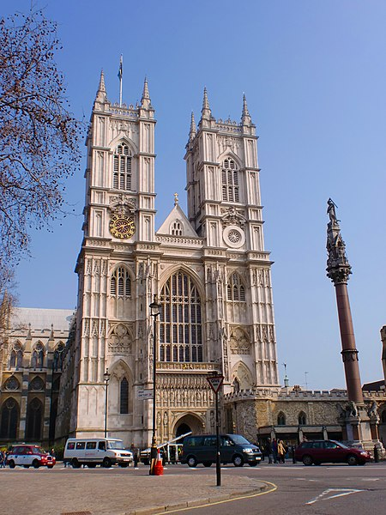
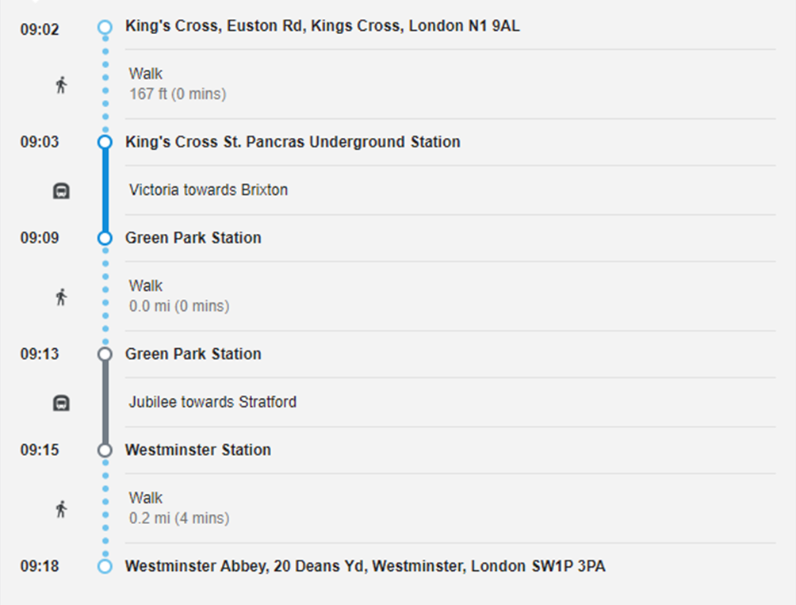
For visitors, there may be a wait due to services that take place throughout the day, which is why it would be recommended to arrive slightly earlier than the time at booking due to this. Visitors must acknowledge that this is a religious building where images are not permitted inside the Abbey due to the
Fig 4
impact on the religious spirituality of the building.
Opening Times and Travel

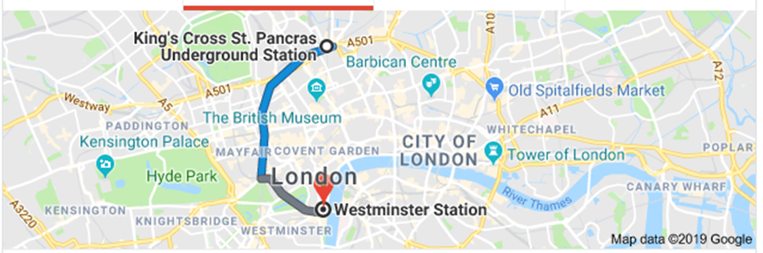
Monday- Friday | 9.30am-3.30pm
Wednesday Lates | 4.30pm-6.00pm
Saturday (May-August) | 9.00am-3.00pm
Saturday (September- April) | 9.00am-1.00pm
Sunday | Open for services

The travel links are quicker by using London Underground services. For accessing the Abbey, the tube station will further require some walking to get to the required destination which only 4 minutes.
Image 1 and 2
Visitor Information
Bevis Marks Synagogue
Adult | £23.00
Children (6-16) | £10.00
Children (0-5) | Free, when accompanied by an adult
Concessions (people aged 60+ and students) | £20.00 (wheelchair users and carers go Free)

These prices are for when tickets are purchased at the Abbey on the day, however these costs can change if booking online before going to the Abbey. When booking, be aware that there may be services held throughout the day of your visit, which will make some areas inaccessible at certain times. With this, there is much to see at the Abbey while waiting to access certain areas for services to finish.
Fig 5

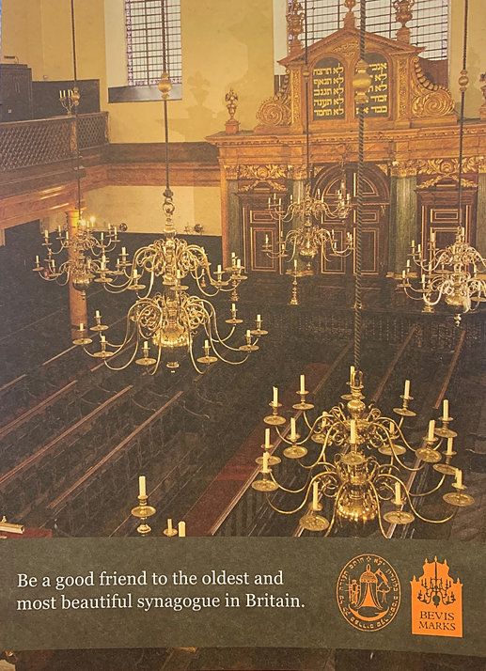
The synagogue in Bevis Marks is the oldest place of worship in Europe, which has been in this area for nearly 300 years. Judaism has flourished into British society today from first introductions of small groups of religious followers to large communities that we see today. To further note is the history of the synagogue and the Jewish community that have grown around this particular place of worship. Bevis Marks Synagogue is a Sephardi Jewish Synagogue, which is influenced by the Portuguese and Spanish Jewry that were exiled. As mentioned on their website, that the synagogue “expresses gratitude for the safe refuge established by the first Sephardim in the City of London.” With this, since 1701 there has been a refuge for Sephardic Jews in London which also unites the community to their oldest and still functional Synagogue that we can see today. Mainly with original features still in tact from the original building which further expresses not only the age of the building but also the way that it has been maintained to the highest standard with the aid from the community. The cultural significance of this building for the current Jewish community proves the understanding of the past and how they have rebuilt a community after settling into an unknown area. Services within the synagogue are very important for participants due to the religious impact of festivals and important dates in the calendar throughout the year. With this, dates such as Rosh Hashanah would see the synagogue with large numbers as compared with another day not as religiously significant. Also to note is that the synagogue is a “Grade I listed building and is the only synagogue in Europe that has held regular services continuously for over 300 years.” This also has an impact on not only the society that has formed since and how, even after 300 years, the synagogue is still central to the community that are still in London today. Not only do the Jewish community find sanctuary within the walls of their place of worship but also visitors are in awe of the interior and the vast space inside that is also thought provoking. This allows for many to be inspired by the way that the community come together as one inside this building for all. This also enables both students studying religion and even people who want to understand their local culture to visit the Synagogue to experience different beliefs and practises of London.
Fig 5
Opening Times and Travel

Monday | 10.30am- 2.00pm
Tuesday | 10.30am- 1.00pm
Wednesday | 10.30am- 2.00pm
Thursday | 10.30am- 2.00pm
Friday | 10.30am- 1.00pm
Saturday | N/A
Sunday | 10.30am- 12.30pm

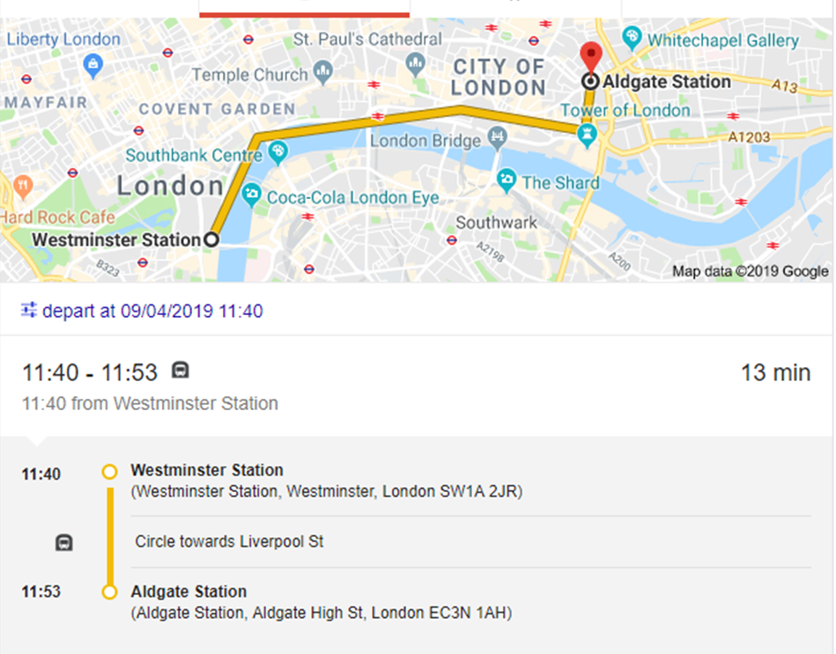
Due to the religious day of rest within Judaism, the synagogue is not open for visitors on a Saturday and also the synagogue will not be available on weekdays during festivals and holy days that may be held throughout the year.
There are available transport links from Westminster Station that can arrive directly to Aldgate, with a small walk to the Synagogue from Aldgate Station.

There is an admission fee which ranges between different groups which include:
Visitor Information
Adult | £5.00
Child | £2.50
Senior Citizen | £4.00
National Trust | £2.50

Image 3 and 4
Men who enter the Synagogue must wear a Yarmulke, however the synagogue do have a selection of Yarmulke’s to borrow before going into the synagogue for visitors who are not Jewish males.
The synagogue chooses also to not allow photography of the interior due to keeping the spirituality of this religious site.

Some images of the synagogue can be found on the website below:
https://www.sephardi.org.uk/bevis-marks/visit-bevis-marks/
Although images of the exterior are permitted, there are lovely images of the interior online and also on the Sephardi synagogue website which can be seen before visiting and also appreciated after the visit.
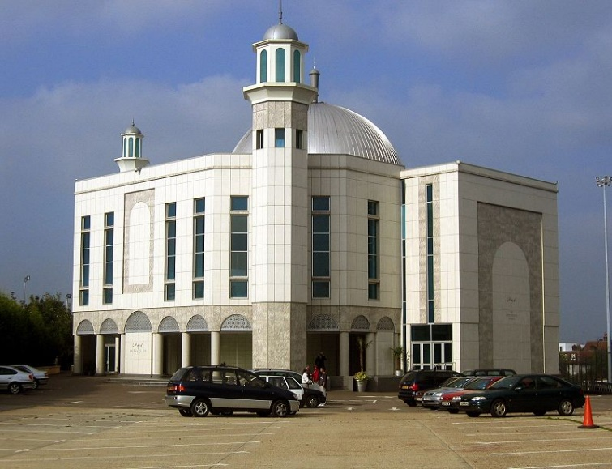
The final site to be visited is the Mosque that is situated in Morden. As we have explored different religions from Christianity to Judaism, the final of the three Abrahamic faiths is Islam. To note is the first Mosque, that is considered as the Ka’aba in Mecca, which is the West direction that Muslims face towards when in prayer. This Mosque focuses on a large Muslim community that all follow the same branch of Islam called Ahmadiyyah Islam. In London’s largest Mosque, some Ahmadi worshippers visit numerous times a day for services held in the Mosque. Services are not limited by age; men and boys of all ages gathered together (women and girls were separate) all to worship as a community. On the Mosque website, it comments that “the purpose of the creation of man, according to Islam, is that he should worship Allah.” This shows the significance of having a Mosque where everyone can worship Allah together and also the importance of having such an influential building in the centre of the community. The Ahmadiyyah movement within Islam was founded fairly recently, in 1889, by Hadhrat Mirza Ghulam Ahmad who sought to spread the message of Islam and the correct belief in Islam across the world. His ideas would soon be a reality as further noted is that “the Ahmadiyya Movement, within a century, has reached the corners of the Earth.” After the passing of Ahmad, an elected succession of Khalifas were then chosen to lead the worldwide Ahmadiyyah community. The community that arrived in London largely emigrated from Pakistan due to persecution of their religion. Other Muslims felt that the Ahmadiyya community are not ‘true Mulims’ therefore were not respected in Pakistan due to their beliefs on the Messiah. With this, large groups decided to leave Pakistan in the aim of creating a new life away from persecution, which many found in Britain. Now owners of the largest Mosque in Europe, the Mosque holds up to 4,000 members within the Mosque during important festivals around the year. This number can increase due to specific festival days where it was mentioned that even the carpark would be used due to the number of worshippers that attend on certain days. Modern culture has impacted greatly on the Muslim community that have settled in Britain however this has been seen to improve the lives of many Ahmadi Muslims. With this, the community have grown around the completion of their Mosque and are continuing to thrive in London and even across the world.
Fig 6
Baitul Futuh Mosque
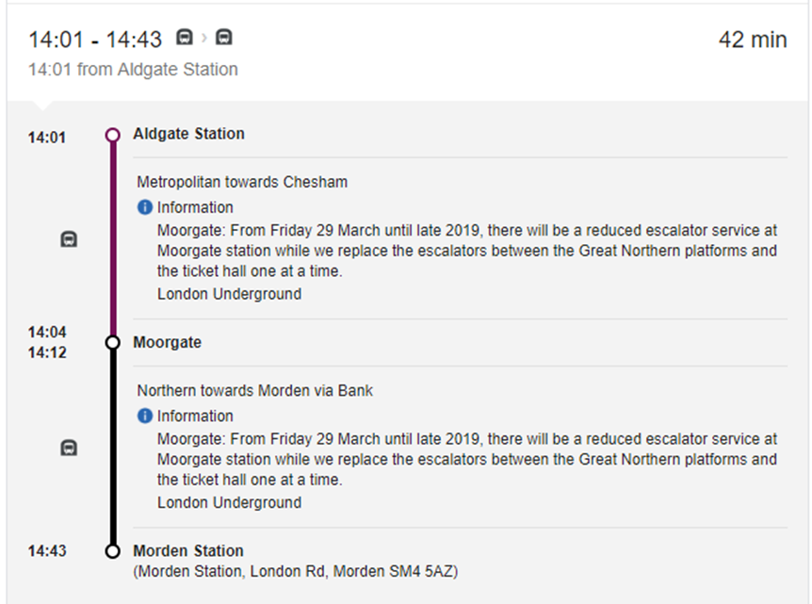
Opening Times and Travel

The Mosque is open 24hrs a day, therefore visits can be made throughout the day. However, with a large group, it would be advisable that you book in advance before arriving. This may be due to a festival or large event happening at the Mosque on specific days.
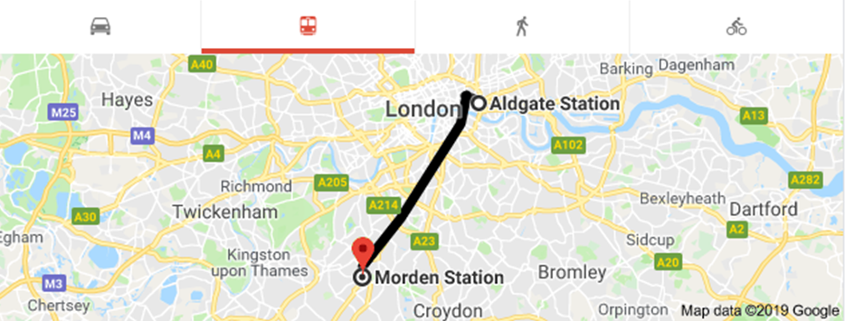
There is a tube running to from Aldgate to Moorgate, with a direct transfer onto the Northern line to continue to the last stop in Morden. With this, there will be roughly a 10-minute walk to the Mosque from the station. More information can be seen in the map and tube chart overleaf. There is also further information on the website if any prior information of the Mosque or of the Ahmadiyyah community may be needed before visiting:
Image 5 and 6
http://www.baitulfutuh.org/index.html

There are no restrictions on images being taken within the Mosque, with groups being able to take photographs of the interior of the Mosque and even not only witnessing a prayer service while attending the Mosque but being able to take photos of the service as it was taking place. With this, it would be advisable to ask before taking photos if you can.
Visitor Information
There was no charge to enter the Mosque, however donations could be made within. There is also a bookshop that the Mosque runs within the grounds, with numerous items to purchase relating to the religion and also small gifts such as keyrings.
Religion in Contemporary Britain

As expressed throughout this study guide, there are a vast amount of areas where we can explore religious diversity in London. With this, the understanding of how different cultures and religions can live together and work together is truly the most inspiring aspect of learning about religion in modern Britain. Through exploring Christianity, to Judaism and finally ending with Islam has shown a range of diverse religious beliefs and their respective places of worship.
With this, understanding religion in contemporary Britain is very important for future generations to assimilate and learn about not only British culture but the culture of Muslims or Sephardi Jews and many other cultures in a multi-cultural society. This can be seen not only in London but across the UK, with a range from small communities settled around Wales to larger communities that are living in Central London.
Understanding and learning the ways of different religions helps to understand our society as it is ever changing and growing with diversity that can see a large impact on the way we can interact with numerous different people.
As I have explored the Abrahamic faiths and their respective places of worship throughout this study guide, what can also be noted is other religious traditions that can be found in the UK alone. This can include, but not limited to:
Hinduism, Buddhism, Sikhism as the largest 6 religions in Britain. However, there are more listed that include:
Baha’i faith, Pagan practices, Rastafarian, Scientology and many more that add religious and cultural diversity to Britain which can be seen throughout England and Wales today.
Such practices further highlight, the importance of community and the way that these communities’ function around their religious places of worship. The construction of these sites further allows such communities to grow and flourish.
The way that all three religions work around each other and also work together shows the unity between religions. Westminster Abbey, although seen as a religious building within Christianity, also houses much historical aspects of Britain which includes the burial places of many monarchs; from Edward the Confessor to Elizabeth I. There can also be found many inspirational people from Britain who are noted within plaques around the Abbey which consist of Dylan Thomas, Jane Austen and even Stephen Hawking who are all significant people within their fields within Britain.
The synagogue is home for many Sephardic Jews who are still worshippers within the synagogue even today. However, with changing times, the community has less members than when they first arrived. With this however, the rise in Ashkenazi Jews in the area have influenced the community to merge and grow together in a shared environment. This impacts greatly on the ways the two communities work together today and even share the amenities if needed.
With this, the understanding that the Mosque and the local comprehensive school in the area both work together when needed. For example, the Mosque opens its halls for the school to use during exam season for the pupils to sit exams in silence. With this, the two buildings help each other when needed also for the Mosque to use parking spaces within the school grounds during large services held. This further shows the importance of both groups sharing amenities for the benefit of the local area.
This study guide aims to show the ways that the Abrahamic faiths have not only settled into Britain as individual groups but can work simultaneously with each other. This further emphasises the importance of community and the ways that these communities have formed around and for their respective places of worship. This has all aided in the continuation and growth of these communities.
GILLEY, Sheridan, and W. J SHEILS, A History Of Religion In Britain (Cambridge, Mass.: Blackwell, 1994)
Bibliography
Unknown Author, "History Of Westminster Abbey | Westminster Abbey", Westminster Abbey, 2019 https://www.westminster-abbey.org/about-the-abbey/history/history-of-westminster-abbey [Accessed 9 April 2019]
Unknown Author, "The Baitul Futuh Mosque In London. Ahmadiyya Muslim Community.", Baitulfutuh.Org, 2019 http://www.baitulfutuh.org/index.html [Accessed 8 April 2019]
Unknown Author, "Visit Bevis Marks - S&P Sephardi Community", S&P Sephardi Community, 2019 https://www.sephardi.org.uk/bevis-marks/visit-bevis-marks/ [Accessed 8 April 2019]
Woodhead, Linda, and Rebecca Catto, Religion And Change In Modern Britain (Abingdon: Routledge, 2012)
Images

Fig 1: Seale, Amy, “Westminster Abbey, London”, [3 April 2019]
Fig 2: Seale, Amy, “Baitul Futuh Mosque, London”, [2 April 2019]
Fig 3: Seale, Amy, “Bevis Marks Synagogue, London”, [3 April 2019]
Fig 4: Westminster Abbey, 2013 https://en.wikipedia.org/wiki/File:Westminster-Abbey.JPG [Accessed 9 April 2019]
Fig 5: Seale, Amy, “Bevis Marks Synagogue Interior”, [9 April 2019]
Fig 6: Wikipedia, The Baitul Futuh Mosque, 2007 https://en.wikipedia.org/wiki/Baitul_Futuh_Mosque#/media/File:Baitul_Futuh.jpg [Accessed 9 April 2019]
Image 1 and 2: Unknown Author, "Kings Cross St Pancras Station Euston To Westminster Station - Google Search", Google.Co.Uk, 2019, https://www.google.co.uk/search?ei=TYWvXK6HDYSg1fAP_a-O2A0&q=kings+cross+st+pancras+station+euston+to+westminster+station&oq=kings+cross+st+pancras+station+euston+to+westminster+station&gs_l=psyab.3...37342.41065..41488...1.0..1.468.1919.0j10j1j0j1......0....1..gws-wiz.......0i71j33i10.PyXG3gk6gAk [Accessed 11 April 2019]
Image 3 and 4: Unknown Author, "Westminster Station To Aldgate Station - Google Search", Google.Co.Uk, 2019 https://www.google.co.uk/search?ei=eYWvXIaiMsPZxgPYx4f4AQ&q=westminster+station+to+aldgate+station&oq=westminster+station+to+aldgate+station&gs_l=psy-ab.3..0i22i30.552887.561787..562520...0.0..3.516.5444.12j21j2j1j1j1......0....1..gws-wiz.......0i71j0i131i67j0i67j0j0i131j0i3.zN0VT-RRj1Y [Accessed 11 April 2019]
Image 5 and 6: Unknown Author, "Aldgate Station To Morden Station - Google Search", Google.Co.Uk, 2019 https://www.google.co.uk/search?ei=aoivXM_IK7SJ1fAPj-aMmAI&q=aldgate+station+to+morden+station&oq=aldgate+station+to+morden+station&gs_l=psy-ab.3..0i22i30.3708.4981..5497...0.0..0.250.927.6j1j1......0....1..gws-wiz.AzmYzpgnWxA [Accessed 11 April 2019]

Linda Woodhead and Rebecca Catto, Religion And Change In Modern Britain (Abingdon: Routledge, 2012).pg.85.
Paul Badham, Sheridan GILLEY and W. J SHEILS, A History Of Religion In Britain (Cambridge, Mass.: Blackwell, 1994).pg.488.
Linda Woodhead and Rebecca Catto, Religion And Change In Modern Britain (Abingdon: Routledge, 2012).pg.85.
Linda Woodhead and Rebecca Catto, Religion And Change In Modern Britain (Abingdon: Routledge, 2012).pg.85.
Unknown Author, "History Of Westminster Abbey | Westminster Abbey", Westminster Abbey, 2019 https://www.westminster-abbey.org/about-the-abbey/history/history-of-westminster-abbey [Accessed 9 April 2019].
Unknown Author, "History Of Westminster Abbey | Westminster Abbey", Westminster Abbey, 2019 https://www.westminster-abbey.org/about-the-abbey/history/history-of-westminster-abbey [Accessed 9 April 2019].
Unknown Author, "Visit Bevis Marks - S&P Sephardi Community", S&P Sephardi Community, 2019 https://www.sephardi.org.uk/bevis-marks/visit-bevis-marks/ [Accessed 8 April 2019].
Unknown Author, "Visit Bevis Marks - S&P Sephardi Community", S&P Sephardi Community, 2019 https://www.sephardi.org.uk/bevis-marks/visit-bevis-marks/ [Accessed 8 April 2019].
Unknown Author, "The Baitul Futuh Mosque In London. Ahmadiyya Muslim Community.", Baitulfutuh.Org, 2019 http://www.baitulfutuh.org/index.html [Accessed 8 April 2019].
Unknown Author, "The Baitul Futuh Mosque In London. Ahmadiyya Muslim Community.", Baitulfutuh.Org, 2019 http://www.baitulfutuh.org/index.html [Accessed 8 April 2019].

