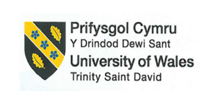

Programme: BA (Hons) International Hotel Management
Module: Sustainable Hospitality & Tourism Management
Module code: BMIH5006

Lecturer:Lisa Knight

Student name: Adina Cirmaciu
Student ID number: 2233579

I confirm that I have not used any AI tools in the research and creation of this assignment. I confirm that I have not presented any AI generated materials as my own work. I confirm I have copies of my drafts, notes, and other resources I used, which I may be asked to provide in evidence.

Executive Summary
This report, in particular its discussion of hotels, stresses the need for the travel and hospitality business to adopt environmentally friendly methods. As more people learn about environmental problems, many hotels are starting to use eco-friendly practices to save resources, lower waste, and run more efficiently. The article starts by talking about the idea of "greener practices" and what its pros and cons are. It then talks about an example of a green practice project—energy-efficient lighting—and how it was used in a well-known hotel chain. The paper talks about the problems that need to be solved, the good things that could happen for the chosen hotel's finances and the environment, and how other companies have finished similar projects successfully. Looking at the meaning of approval marks like the Green Key shows how eco-friendly practices can make guests happier and boost a hotel's image. Lastly, ideas are made to improve the hotel's environmentally friendly activities by suggesting more steps to fix problems with the way things are done now.

Table of Contents
Executive Summary 3
Introduction 6
Main Findings 7
Identified Green Practice: Energy-Efficient Lighting 7
Benefits of Energy-Efficient Lighting for Hotels 8
Reduction in Energy Consumption and Costs 8
Reduced Environmental Impact 9
Improved Brand Image and Guest Satisfaction 9
Challenges of Implementing Energy-Efficient Lighting 10
Initial Capital Investment 10
Operational Disruptions 10
Balancing Aesthetic and Functional Lighting Needs 10
Case Study: Marriott’s Current Sustainability Efforts and Gaps 11
Environmental and Economic Impact of the Proposed Solution 12
Energy and Cost Savings 12
Environmental Benefits 12
Improved Market Position 13
Statistical Analysis of Sustainable Practices in Hospitality 13
Recommendations 14
Conclusion 16
References 17

Table of Figures
Figure 1: World Energy Transitions Outlook 2023 8
Figure 2: Total residence-based accounting (RBA) carbon footprint in CO2e for different countries in 2013 for international (blue) and domestic (yellow) holidays 9
Figure 3: Sustain Responsible Operations of Marriott International Serve360 11
Figure 4: The Split Of The Consumption Of Hotel Energy 12

Introduction
As time goes on, sustainability is becoming more significant in the hotel and tourism industries. Companies must do more to protect the earth. Greener practices are ways of doing things that try to use less water, energy, and trash and promote the use of long-lasting materials (Cooper, 2021). Some examples are using lights that use less energy, taking steps to reduce waste, saving water, and buying products that are good for the environment. In terms of hotels, these cleaner options make a big difference in lowering the general environmental impact of the business. They meet global standards and certifications for sustainability, like Green Key, which gives eco-certifications to businesses that meet certain sustainability standards. Hotels that follow these rules get more brand recognition and customer trust, and they also save money by running their businesses more efficiently. This piece will mostly be about the Marriott International hotel company. It has come a long way in terms of sustainability, but it still has problems in a number of areas. This piece will focus on using energy-efficient lights as an environmentally friendly practice. It will also highlight any possible problems with what they are already doing and offer a practical way to improve their total sustainability strategy.

Main Findings

Identified Green Practice: Energy-Efficient Lighting
One of the best green ideas in the hotel business right now is lighting that uses less energy. LED (light-emitting diode) lights are used in this project because they use a lot less energy than regular electric lights. The Green Globe says that lighting systems that use less energy may save up to 75% more electricity than regular ones. By lowering greenhouse gas pollution, this plan not only makes the hotel eco-friendlier but also saves money on energy costs.
A lot of restaurants around the world have spent a lot of resources on lighting that uses less energy (Inkson and Minnaert, 2018). To meet long-term environmental goals, Hilton buildings, for example, have put a lot of money into LED lights for all of its buildings. InterContinental Hotels Group (IHG) has put LED lights in guest rooms, public areas, and back-of-house areas. This has saved a lot of energy and made the experience of guests better by making the lighting better.
This piece is about Marriott International, which has put energy-efficient lighting in many of its hotels. However, this plan could be made better by extending it to older buildings that still use lighting systems that do not work as well. By making this plan bigger, Marriott may improve its image as a green company and save even more energy.

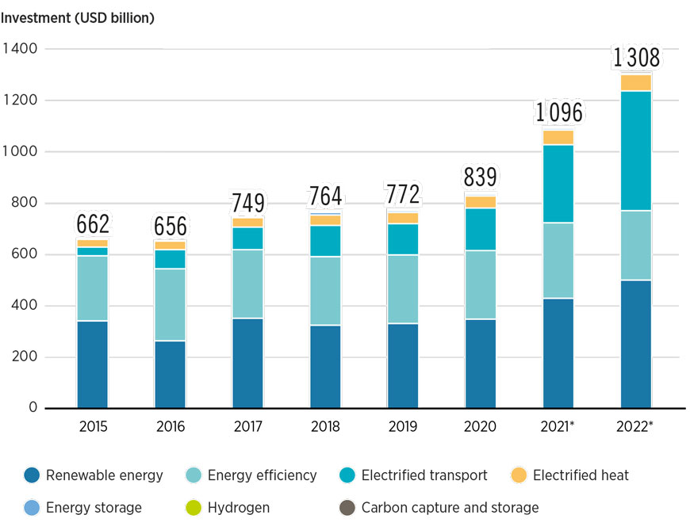
Figure 1: World Energy Transitions Outlook 2023
Source:(IRENA, 2023)

Benefits of Energy-Efficient Lighting for Hotels

Reduction in Energy Consumption and Costs
Using a lot less power to light up a hotel's main areas, halls, and rooms is possible with energy-efficient lighting. Data from the US Department of Energy shows that LED lights use up to 75% less energy and last 25 times longer than standard incandescent lights. Costs could go down a lot for big hotels like Marriott that have thousands of rooms all over the world. Hotels may be able to save money on power costs by switching to lighting that uses less energy. This makes the business more profitable overall.

Reduced Environmental Impact
Due to their energy-intensive activities, hotels put out a lot of greenhouse gases. By using lighting that uses less energy, the hotel is less reliant on power made from fossil fuels, which lowers its carbon footprint. The United Nations World Tourism Organization (UNWTO) says that the tourism industry is responsible for about 8% of the world's greenhouse gas emissions. The amount of energy used by hotels has a big effect on this. Using lighting that uses less energy is an important first step towards fixing this problem and is in line with global environmental goals like the Sustainable Development Goals (SDGs).

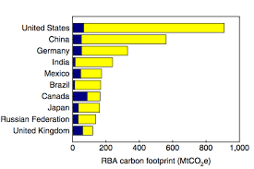
Figure 2: Total residence-based accounting (RBA) carbon footprint in CO2e for different countries in 2013 for international (blue) and domestic (yellow) holidays
Source:(Dunne, 2018)

Improved Brand Image and Guest Satisfaction
Using better methods, like lighting that uses less energy, can help a hotel show that it is a more environmentally friendly business (Haski-Leventhal, 2018). Studies show that 87% of customers prefer lodging options that are good for the environment. This means that eco-friendly travellers choose hotels based on how good they are for the environment. Marriott can attract this growing group of clients who care about the environment by actively encouraging the use of lighting that uses less energy. This will make guests happier and more faithful.

Challenges of Implementing Energy-Efficient Lighting

Initial Capital Investment
One of the hardest parts of switching to energy-efficient lighting is buying and putting LED lights all over the hotel. Long-term, LED lighting saves money, but the starting cost might be too high for some hotels, especially older ones that need to update whole buildings. This cost is lessened by government grants, refunds, and long-term energy bill cuts.

Operational Disruptions
When a hotel is retrofitted with energy-efficient lights, the way it works may have to be changed in big ways, especially if the work is done while the building is still being used (Sloan, Legrand and Chen, 2017). During the changeover phase, having to temporarily close guest rooms or public areas could be inconvenient for guests and hurt the hotel's bottom line. To keep things as smooth as possible, hotels may spread out the changes over time or do them when the hotel is not full.

Balancing Aesthetic and Functional Lighting Needs
LED lighting saves energy, but some hotels may find it hard to keep the look they want because the light they produce is different from that of regular bulbs. However, improvements in LED technology have made it possible for more lighting choices, such as warmer tones that are better for the mood of high-end hotels. Marriott can pick LED lights that match the style and feel of any of its names and also save energy.

Case Study: Marriott’s Current Sustainability Efforts and Gaps
Marriott International has been a star in the hotel business when it comes to sustainability. One of its programs, Serve360, works on four main areas: Nurture Our World, Sustain Responsible Operations, Empower Through Opportunity, and Welcome All and Advance Human Rights. Even though Marriott has done a lot of great things, some of its older buildings do not have energy-efficient lights installed all the way through.
Many newer Marriott hotels are designed with LED lighting in mind, but older hotels still use poor lighting systems, which not only raises costs but also goes against Marriott's general green goals. To close this gap, Marriott should start a full remodelling program for these older hotels, focussing on high-traffic areas like guest rooms, hallways, and meeting rooms.
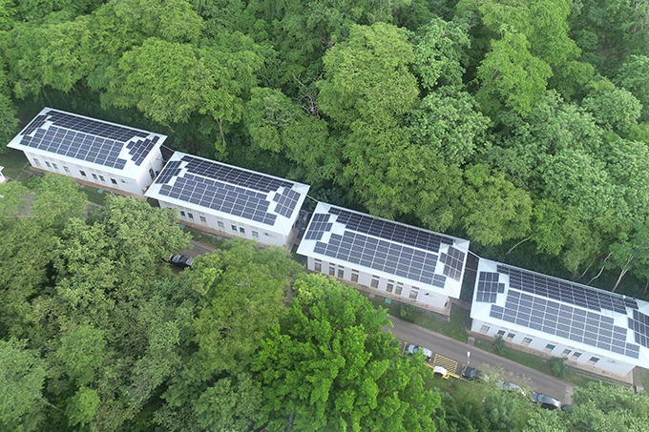
Figure 3: Sustain Responsible Operations of Marriott International Serve360
Source: (Marriott, 2024)

Environmental and Economic Impact of the Proposed Solution

Energy and Cost Savings
By using more energy-efficient lights, Marriott may be able to cut its power use by a large amount. The Events Industry Council thinks that hotels can cut their energy use by 20–30% if they do a lot of things to save energy, like changing their lights. This would save a lot of money, especially for big buildings that are open all the time. It's possible for a big Marriott hotel to save tens of thousands of dollars every year by going green.

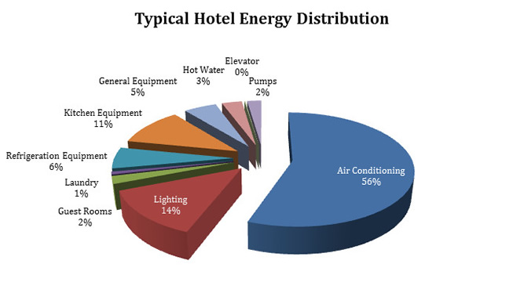
Figure 4: The Split Of The Consumption Of Hotel Energy
Source: (Maja Štimac, Matković and Daria Karasalihović Sedlar, 2023)

Environmental Benefits
Not only does cutting back on energy use lower Marriott's running costs, but it also quickly lowers the hotel's carbon footprint. Energy-efficient lighting cuts down on greenhouse gas emissions, which is in line with Marriott's approach to doing business in an honest way, as we already said. The UNWTO says that for the travel business to meet the goals of the Paris Agreement, carbon pollution must be cut in half by 2030. Getting closer to this goal would be made easier if Marriott used more LED lights (UNWTO, 2023).

Improved Market Position
Hotels that are very committed to sustainability may get more business from tourists who care about the environment. Getting an eco-certification, like the Green Key, helps a hotel's image as a responsible business even more. Marriott could improve its position as a leader in hotel sustainability by using more energy-efficient lights. This is becoming more important in today's very competitive business.

Statistical Analysis of Sustainable Practices in Hospitality
Key findings from a number of industry studies show that the travel and hotel business has recently embraced environmentally friendly methods with great enthusiasm. Green Globe says that eco-certified hotels have cut their energy use by 20% on average by putting in place sustainable features like lights and water-saving systems. 90% of tourists around the world choose eco-friendly lodging. The UNWTO says that sustainable tourism can help the economy grow while protecting natural resources (UNWTO, 2023). The EIC Centre for Sustainability and Social Impact says that big hotels can cut their costs by 10 to 15 percent a year by using green energy and other environmentally friendly methods. Also, information from the UNWTO's "Tourism for SDGs" site shows that hotels with green policies may help a lot with meeting Sustainable Development Goal (SDG) 12, which is about making responsible choices about production and spending (Janith Iddawala, Binuri Mehara Welengoda and Banudee Thisali Rathnayaka, 2024). These numbers show the environmental and financial benefits of sustainability efforts in the hotel business. They also show what might happen if a lot of people started using technology like lighting that uses less energy.

Recommendations
If Marriott International wants to be more environmentally friendly and fill in any holes, the following ideas should help:
- Comprehensive LED Lighting Retrofitting: Marriott should start with high-traffic areas like guest rooms, hallways, and meeting rooms when updating all of its older sites. So, energy savings will happen quickly in the places that are used the most (Irvine, 2023).

- Leverage Financial Incentives: Marriott should look for government grants, refunds, and other green financial options to help pay for the upfront costs of installing energy-efficient lights and other environmentally friendly technologies. Helping with money like this could make the cost of switching to cleaner activities a lot lower.

- Sustainability Certifications and Public Relations: Marriott should try to get or update eco-certifications like Green Key and Green Globe for each property in order to build awareness of its commitment to sustainability through marketing. The brand's image might improve, and more eco-friendly travellers might be interested (Shaikh and Bhautik, 2022).

- Employee Training and Engagement: Sustainability is important, and employees should be taught how to run daily processes in a way that uses less energy. To make sure that sustainability is built into every part of the hotel's processes, employees might be encouraged to help save energy.

- Technology Integration for Monitoring: To keep track of and improve how much energy it uses; Marriott should buy high-tech tools to control it. Knowing how much energy is being used in real-time with these systems lets changes be made all the time to get the best results.

- Guest Engagement Initiatives: Marriott could get people to join in sustainable programs by giving them reward points, digital platforms, or notices in their rooms for doing eco-friendly things like refusing to have their linens changed every day or lowering the amount of energy used in their rooms.

Conclusion
Sustainability is not just a cool trend in the hotel business anymore; it's an important part of doing business in an honest way. This piece looks at how using lighting that uses less energy is a practical way to be green, especially for Marriott International, which has come a long way in being green but still needs to work on some key areas. Using energy-efficient lights can help Marriott cut down on energy use and carbon emissions by a huge amount while also making operations run more smoothly. These kinds of changes could also improve the hotel's image, bring in people who care about the earth, and save money in the long run. Leading sustainability companies' scientific data shows that using green practices in daily operations has clear benefits. This supports the idea that sustainability is not only profitable but also possible. By filling in the holes and putting the suggested solutions into action, Marriott can not only meet its environmental goals but also lead the way in the hotel business around the world. Long-term, environmentally friendly actions like lighting that uses less energy are not only good for the environment but also important for hotels to stay open and grow in a market that cares more about the environment.

References
Cooper, C. (2021). Essentials of Tourism. 3rd ed. London: SAGE.
Dunne, D. (2018). Tourism responsible for 8% of global greenhouse gas emissions, study finds. [online] Carbon Brief. Available at: https://www.carbonbrief.org/tourism-responsible-for-8-of-global-greenhouse-gas-emissions-study-finds/.
Haski-Leventhal, D. (2018). Strategic corporate social responsibility : tools & theories for responsible management. London: SAGE.
Inkson, C. and Minnaert, L. (2018). Tourism management : an introduction. 2nd ed. London: SAGE.
IRENA (2023). World Energy Transitions Outlook 2023. [online] www.irena.org. Available at: https://www.irena.org/Digital-Report/World-Energy-Transitions-Outlook-2023.
Irvine, J. (2023). LED Lighting Benefits for Your Hotels Brand – Part 2 Interior Spaces. [online] Action Services Group. Available at: https://actionservicesgroup.com/blog/led-lighting-benefits-for-your-hotels-brand-part-2-interior-spaces/ [Accessed 2 Oct. 2024].
Janith Iddawala, Binuri Mehara Welengoda and Banudee Thisali Rathnayaka (2024). Sustainability practices in the Hospitality Industry: Evidence from Chain Hotels in Kandy. International Conference on Tourism Research, 7(1), pp.130–139. doi:https://doi.org/10.34190/ictr.7.1.2038.
Maja Štimac, Matković, M. and Daria Karasalihović Sedlar (2023). Correlations between Hotel Size and Gas Consumption with a Feasibility Analysis of a Fuel Switch—A Coastal Case Study Croatia Adriatic. Sustainability, 15(11), pp.8595–8595. doi:https://doi.org/10.3390/su15118595.
Marriott (2024). Sustain - csr-marriott. [online] csr-marriott. Available at: https://serve360.marriott.com/sustain/.
Shaikh, P. and Bhautik, P. (2022). A Comprehensive Study on Sustainable Practices in the Hotel Industry: A Review. ECS Transactions, 107(1), pp.479–491. doi:https://doi.org/10.1149/10701.0479ecst.
Sloan, P., Legrand, W. and Chen, J.S. (2017). Sustainability in the hospitality industry : principles of sustainable operations. 3rd ed. Amsterdam ; Boston: Butterworth-Heinemann/Elsevier.
UNWTO (2023). TOURISM 4 SDGs | UNWTO. [online] www.unwto.org. Available at: https://www.unwto.org/tourism4sdgs.
WTO (2023). World Trade Organization - Global trade. [online] Wto.org. Available at: https://www.wto.org/.

