University of Wales Trinity Saint David

School of Engineering

Investigation of Three Forces in Equilibrium

Hussain Khan

1701219

Automotive Engineering Foundation STEM

21/01/2019

Science/M3X01513

Contents Page

Contents
Introduction 2
Discussion 3
Conclusion 5

Introduction

For this technical report we are going to investigate how the angles between two strings varies, when the load they are supporting is increased. We are required to produce an experimental report and have been asked to answer a set of questions on our set of data. We have been asked to identify and apply physical principles and relations of the solution to the problem, then we have to manipulate the equations and produce numerical values by using engineering units known as SI units.

Discussion

With each load of mass M we took two measurements of Length 1 (l1) and Length 2 (l2), then the lengths of the springs measured at each end of the loops and then take two measurements of angle$θ$. Then we were asked to produce a table with ten columns including three columns for our derived data, we needed this to record our measurements.

When doing the experiment, we insured that the mass hanger was correctly positioned on the mark of the string, we did this before taking measurements.

Then we measured l1, l2 and the angle$θ$. We recorded the data in our table and used M=100g. We added 100g to the mass hanger which was M=200g, then we measured and recorded l1, l 2 and$θ$.

Table 1: Reading 1 Table of Results

Results
 | Reading 1
Mass/g | L1/mm | L2/mm | $$θ$$
100g | 65 | 42 | 70
200g | 80 | 68 | 45
300g | 110 | 90 | 85
400g | 130 | 115 | 60
500g | 158 | 130 | 55
600g | 290 | 275 | 40

We repeated the previous steps and included M =600g and then we removed the load from the string and the slotted masses. We then placed the mass hanger on the string and in its original position. Then we repeated the experiment again and increasing M from 100g to 600g, as before. This was our second set of readings. We then calculated each value of M and L from the mean of our lengths L1, L2 values and we calculated the mean angle $θ$m.

Table 2: Reading 1 and Reading 2 Table of Results

 | Reading 1 (Before) |  |  | Reading 2 (After)
Mass/g | L1/mm | L2/mm | $$θ$$ | L1/mm | L2/mm | $θ$
100g | 65 | 42 | 70 | 52 | 42 | 65
200g | 80 | 68 | 45 | 80 | 68 | 63
300g | 110 | 90 | 85 | 100 | 127 | 58
400g | 130 | 115 | 60 | 124 | 93 | 68
500g | 158 | 130 | 55 | 154 | 133 | 48
600g | 290 | 275 | 40 | 172 | 160 | 57

Table 3: Mean Length and $θ$m

L | $θ$m | M  Cos  ($θm$  2)
50.25 | 67.5 | 120.5
74 | 54 | 224.5
106.75 | 71.5 | 369.7
115.5 | 64 | 471.7
143.75 | 51.5 | 555.1
224.25 | 48.5 | 658.7

We needed the value of M to calculate the mean value of L from our L1 and L2.

Image 1: Plot of L against M
Cos
($θm$
2

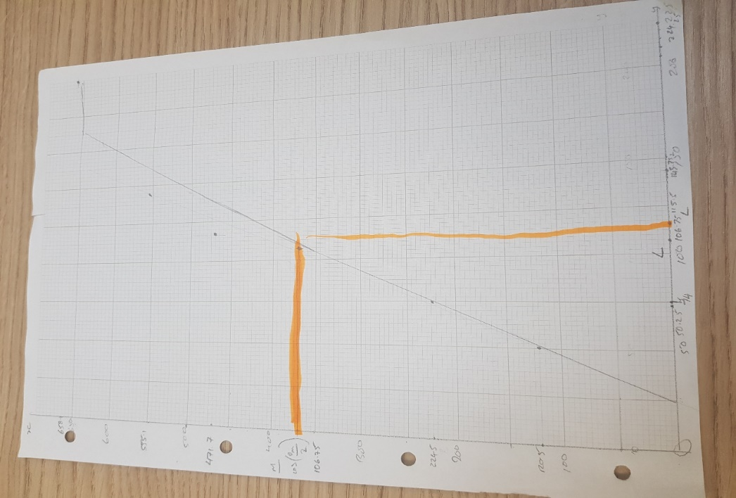

Conclusion

Throughout this experiment I have learnt many new things of measuring angles and lengths and also learning the formula to measure and calculate results used in this experiment. I have learnt about the issue to do with the uncertainty of results which I know now can occur when taking measurements. The equipment was already set up and I needed to make sure everything was balanced including: the spirit level, the ruler, protractor, the two springs, the weight and the masses. I needed to make sure the spirit level was level and it was straight. After I made sure everything was okay I added the masses on the string starting with 100g and taking measurements of length 1, Length 2 and angle $θ$. I took my measurements when the spring stopped moving as this helped me to get an accurate result. We had a pencil mark on the ruler as this helped us to get a reliable and accurate result.

After I got my results I recorded them on a table and worked out the range of my results and including the angle$θ$. You can find the table of results on page 4 of this document. When I finished my calculation I produced a graph of the results I had and I had a straight line of the best fit, but some of the results I had from my table I plotted on the graph were out. This is because some of my results were an overestimate and not average.

To prevent this from happening were I to repeat this experiment in the future, I would make sure I measured my angles correctly and check if the results are reliable. At first I did not measure my angles properly or the lengths and when I took the second reading I did my measurements correctly and I know where I went wrong.

I measured in centimetres instead of millimetres. Therefore I have had to convert from cm to mm. This took time to get accurate results .This showed that I needed to measure really carefully as I could get systematic errors in my readings.

In my results I had some systematic errors for Length 1 and $θ$m. They were not accurate as they were not measured to decimal places. This made my results unreliable and which were because of poor measurement techniques. When I did the experiment for the first time I measured my length incorrectly as the process was completely new to me and I realised I made some mistakes in my first test.

Calculations Used to work out the range of L1 and L2

These were the calculations I have used to find the range for my results.

65+42+52+42 L= 50.25. 80 + 68+ 80+ 68 L=74 110 + 90+100+127 L=106.75
4 4 4

130+115+124+98 L=115.5 158+130+154+133 L=143.75 290+275+172+160 L=224.25
4 4 4

Calculations for the value of M using the equation of M
Cos($θ$m)
2

100g
Cos(67.5/2) =120.5

200g
200
Cos( 54=224.5
2

300g
300
Cos(71.5)=369.7
2

400g
400
Cos( 64)=471.7
2

500g
Cos(51.5) = 555.1
2

600g
Cos(48.5 )= 658.7
2
These were the values of my results from my calculations which I used to plot on my graph and they were accurate and my graph had a line of best fit although some of the plots on the graph were out as they were an overestimate.

To calculate the uncertainty of the mean Length from my results and I subtracted the highest uncertainty from the lowest uncertainty results. Therefore this became 224.25 – 50.25. The uncertainty of the mean Length was +=174.

If I repeated this experiment, I would make sure not to look at other people and how they conduct the experiment as this made me lose focus and I was not sure if I did the experiment correctly and other people were doing it right. I should trust my results even if they are wrong, I know where the mistakes are. I should ask my lecture for support if I am stuck at any part with the experiment and I should do a test experiment first before taking my results.

