

Your Exit Strategy: Personal Promotional Material
Personal Portfolio Development

Andrew davis
2220233
ACCA6033

Contents
Task 1 Data Bases……………………………………………………………………………………………………….pg. 2.
Task2 Show reel…………………………………………………………………………………………………………pg. 5.
Task 3 Business Card……………………………………..……………………………………………………………pg. 6.
Design Iterations………………………………………………………………………………………………pg. 7.
References & Bibliography………………………………………………………..…………………………………pg. 8.

Task 1
Database for employment
Organisation | Type of work | Job Role | Contact | Rationale
Pirate Software | Games Development | Developer | Contact | Pirate Software | Small Indie studio, like what I want to set up myself.
Heart of Yorkshire Education Group | Educational | Lecturer | rcharlish@heartofyorkshire.ac.uk | Operating in a pseudo work-based environment with superb facilities, the Team is run like a game’s development company
Rebellion | Modelling & Texturing | Lead Environment Artist | Rebellion : Careers | Creating content that I have a genuine interest in, and sharing a similar ethos
Rebellion | Management | Board Game Developer | Rebellion : Careers | Creating content that I have a genuine interest in, and sharing a similar ethos
Double Eleven | Narrative Design | Senior Quest Designer | contact@double11.com | Have experience In Quest creation, and gained an interest in this process of game design
University of Wales Trinity ST Davids | Educational | Computer Games Design MA | https://www.uwtsd.ac.uk/programme-courses/postgraduate-pgce/film-media-and-animation/computer-games-design-full-time-full | To further my Education in Games Design
University of South Wales | Educational | MA Games Enterprise | https://www.southwales.ac.uk/courses/ma-games-enterprise/ | To further my Education in Games Design
University for the Creative Arts | Educational | MA Games Design | https://www.uca.ac.uk/study/courses/ma-games-design/ | To further my Education in Games Design
Infinity Games | Game Development | Founding Member | Andrew_Davis@email.com | This is the end goal for a group of students after graduation
Playground Games | Game  Development | Gameplay  Animator | http://www.playground-games.com | Capable of doing this but not ideal
Team17 Digital | Game  Development | Lead Developer | http://www.team17.com/ | Have basic experience within this role.
Langham Recruitment | 3D Artist | 3D Prop and Animation Artist | LinkedIn | Having experience in the software, and a good understanding of the of rigging and 3D modelling.
Epic Games | Game Development | Gameplay Systems Programmer, Fortnite | https://www.epicgames.com/site/en-US/careers/jobs/5458326004 | Great experience of Unreal engine and a desire to work with the company that provides the software.
SODA | Game Development | Front-end Game Development | https://www.trustinsoda.com/jobs/front-end-developer-35062204 | UK based company looking for UXR designer which I feel I have some experience in.
Ghostpunch  Games | Audio Engineer | Games Dialogue | Ghostpunch Games jobs and careers | Indeed.com | Uk based games developer London, Creating an aspect I feel reasonably comfortable with.
Side | Lead Artist | 3D Character Artist | Side - Current Openings | Remote full-time work in a field I have good experience in.
Radical  Forge | Senior Technical Artist | Lead Artists | Radical Forge jobs and careers | Indeed.com | Remote work, Knowledge of UI development and Maya.
Rocket Science Group | Game Developer | UI/UX Designer | UI/UX Designer @ Rocket Science Group | Local hybrid work in Cardiff. Experience in developing and creating UI/UX.
Rebellion | Environment  Development | Environment Artist | https://rebellion.com/ | Willing to relocate and help with costs, exciting opportunity to work on a project I would enjoy. Requirements are like my strengths.

Task 2
Link to showreel.

https://youtu.be/dt7FPGGDFR0

Task 3
Business Card.
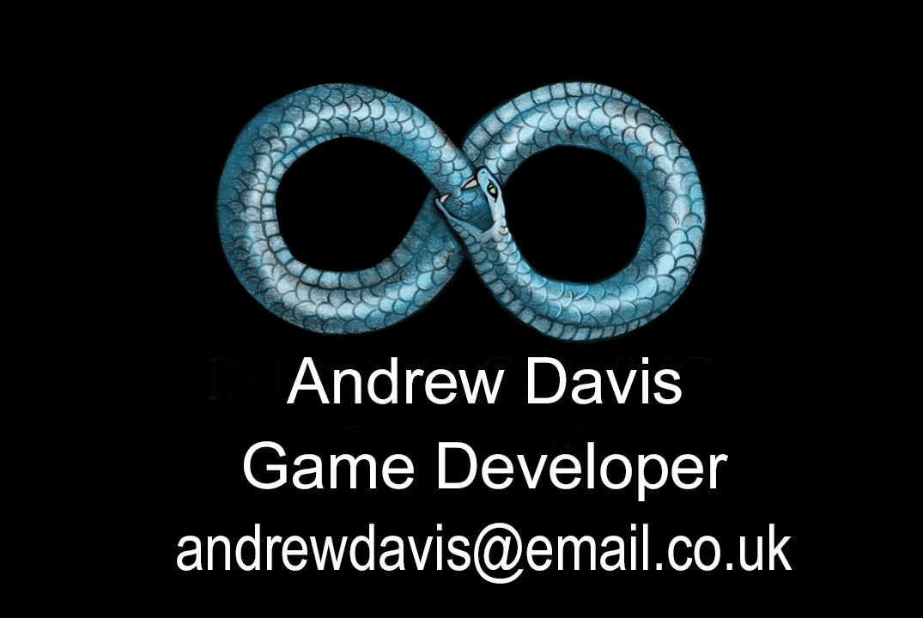

[Figure 1: Business Card Front]


[Figure 2: Business Card Back]


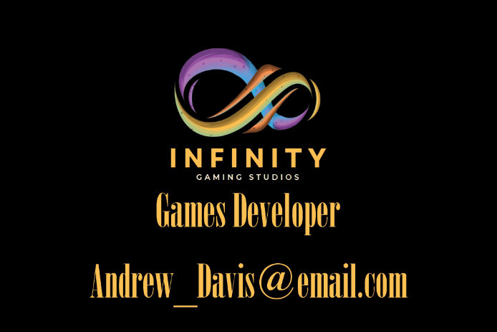
Design Iterations.

[Figure 3: Business Card Front v2] [Figure 4: Business Card Front v3]


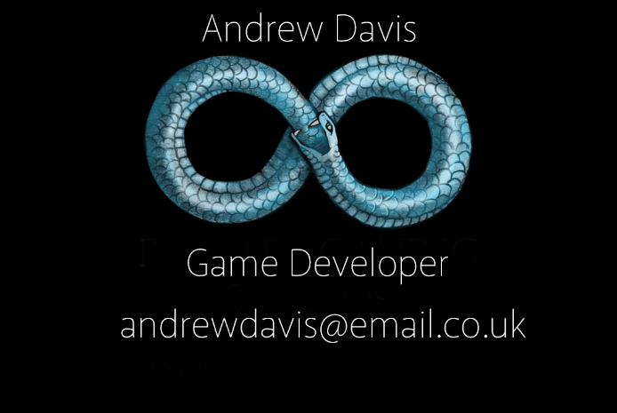

[Figure 5: Business Card Front v4] [Figure 1: Business Card Front]



[Figure 5: Business Card Back] [Figure 6: Business Card Back v2]
References and Bibliography
‌ “Rebellion Careers,” Rebellion.com, 2025. https://careers.rebellion.com/ (accessed Jan. 30, 2025).
“Heart of Yorkshire Education Group,” Heartofyorkshire.ac.uk, 2023. https://www.heartofyorkshire.ac.uk / (accessed Jan. 30, 2025).
‌ “Pirate Software,” www.gopiratesoftware.com. https://www.gopiratesoftware.com/crew/
“GamesIndustry.biz,” GamesIndustry.biz, 2025. https://jobs.gamesindustry.biz/job/senior-quest-designer-39864 (accessed Jan. 30, 2025).
‌ “Contact - Double Eleven,” Contact - Double Eleven, 2025. https://double11.com/contact-us/ (accessed Jan. 30, 2025).
J. Edwards, “How To Create The Perfect Showreel,” Artlist Blog, Nov. 15, 2023. https://artlist.io/blog/how-to-create-a-showreel/
‌ Chris Burkard Studio, “Chris Burkard 2021 Director Reel,” YouTube, Jan. 19, 2022. https://www.youtube.com/watch?v=CGtkXYbnZws (accessed Jan. 28, 2025).
Evan Pollock, “Evan Pollock - Director/Cinematographer 2021 Production Reel,” YouTube, Jun. 18, 2021. https://www.youtube.com/watch?v=ibkLgKs Wrmo (accessed Jan. 28, 2025).
Chris Schmid, “CHRIS SCHMID DIRECTOR / DOP SHOWREEL,” YouTube, Dec. 17, 2022. https://www.youtube.com/watch?v=ZgMLN3GXWVs (accessed Jan. 28, 2025).
R. Ostlere, The Actor’s Career Bible : Auditioning, Networking, Survival and Success. London: Bloomsbury Publishing PLC, 2019.
QR code Generator, “QR Code Generator - Create QR codes here,” Qr-code-generator.com, 2014. https://www.qr-code-generator.com/
‌ “Computer Games Design (Full-time),” University of Wales Trinity Saint David, Dec. 05, 2024. https://www.uwtsd.ac.uk/programme-courses/postgraduate-pgce/film-media-and-animation/computer-games-design-full-time-full (accessed Feb. 02, 2025).
‌ university for the creative arts, “University for the Creative Arts - University for the Creative Arts - UCA,” University for the Creative Arts - UCA, 2019. https://www.uca.ac.uk/study/courses/ma-games-design/

“MA Games Enterprise - University of South Wales,” Southwales.ac.uk, 2025. https://www.southwales.ac.uk/courses/ma-games-enterprise/ (accessed Feb. 02, 2025).
‌ “Easy photo editing software - Adobe Photoshop Elements 2025,” Adobe.com, 2025. https://www.adobe.com/uk/products/photoshop-elements.html?msockid=23ee93799c776882333b80d19d506961 (accessed Mar. 13, 2025).
‌ “Join Epic Games Today! See Our Latest Career and Job Opportunities.,” Epic Games, 2025. https://www.epicgames.com/site/en-US/careers/jobs/5458326004 (accessed Mar. 13, 2025).
‌ “Unreal Game Developer - London - England, London - (2692),” Langham Recruitment, 2025. https://jobs.langhamrecruitment.com/job/unreal-game-developer-2692 (accessed Mar. 13, 2025).
‌ “FREE IEEE Citation Generator [Updated for 2020],” MyBib. https://www.mybib.com/tools/ieee-citation-generator
‌“Front-End Developer | Trust in SODA - Tech Recruitment,” Trust in SODA - Tech Recruitment, 2025. https://www.trustinsoda.com/jobs/front-end-developer-35062204 (accessed Mar. 13, 2025).
‌Indeed, “Job Search | Indeed,” uk.indeed.com, 2024. https://uk.indeed.com/viewjob?jk=9cfdcaffc3b52d8c&from=comp-individual-job
“Side,” Workable.com, 2025. https://apply.workable.com/sideinc/ (accessed May 09, 2025).
Indeed, “Job Search | Indeed,” uk.indeed.com, 2024. https://uk.indeed.com/viewjob?jk=cd57f89c7ffd678a&from=comp-individual-job
“UI/UX Designer” Rocket Science Group https://jobs.ashbyhq.com/rocketsciencegg

‌

‌

‌

