

LEVEL 5 ASSESSMENT SPECIFICATION
Reflective Report
Component 1: Reflective Report
Student Name: Happy Chowdhury
Student Number: 2432687
Module Title: Principles of Health and Social Care Practice
Module Code: BMHP5016
Assignment Title: Component 1: Reflective Report
Word Count: Approximately 2,000 words
Submission Date: 5th July 2026

Table of Contents
1. Introduction 3
2. Task 1: Reflection on the Importance of Principles of Health and Social Care 4
3. Task 2: Practical Examples of Concepts in Practice 5
4. Task 3: Self-Reflection as a Health and Social Care Professional 7
4.1 Description 7
4.2 Feelings 7
4.3 Evaluation 7
4.4 Analysis 8
4.5 Conclusion 8
4.6 Action Plan 8
5. Conclusion 9
6. Reference 10

Introduction
This reflection report serves to review the theoretical and practical aspects of health and social care principles. In particular, the main principles of person centred care, partnership working and ethical practice are examined within the context of providing the best quality of care in the health and social care system in the United Kingdom (Health Health and Care Professions Council, 2017). The report aims to review each of these principles in terms of how they may be defined or described, and how they are used or applied either conceptually or theoretically, as well as how they are applied through practice using a variety of case studies. The theoretical frameworks discussed in this report include Maslow's Hierarchy of Needs (1943), Bronfenbrenner's Ecological Model (1979), the Medical and Social Models of Health, Alderfer's ERG Theory (1969), and Bradshaw's Taxonomy of Social Needs (1972). These theoretical frameworks will provide an overview of each of these principles and help to give a background understanding of the principles being discussed within the report.
The structure of the reflective report consists of three different tasks. Task One involves describing and defining the principles and their theories; Task Two involves evaluating the application of these principles through the use of the Case Study of Joan - a patient with COPD and Crohn's Disease; and Task Three is to reflect on my own professional development using the Gibbs Reflective Cycle of (1988) while identifying my current competencies and competencies to develop further as a health and social care professional. Throughout the reflective report, reference will be made to the Care Act 2014 and the Health and Care Act 2022 as statutory legislation influencing the discussion on the three principles of person-centred care, partnership working and ethical practice as they relate to current health and social care policy in the United Kingdom.
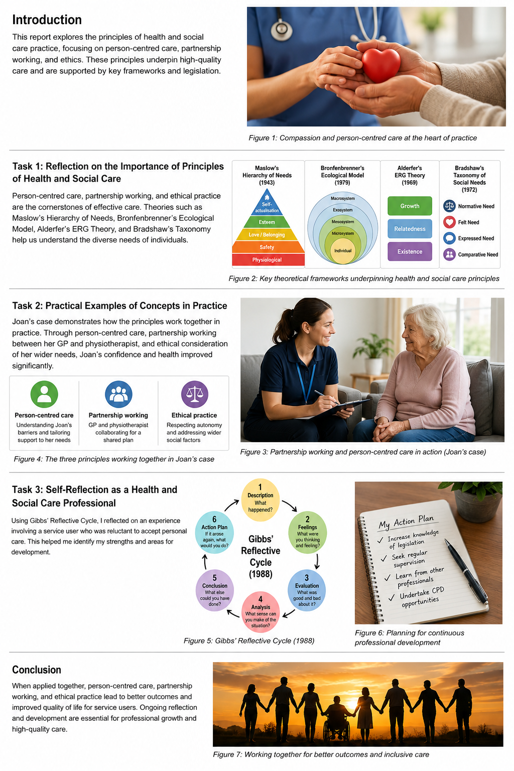
Figure 1: Compassion and person-centred care

Task 1: Reflection on the Importance of Principles of Health and Social Care
Person-centred care, partnership working and ethical practice are recognised as the principles underlying effective health and social care in the UK. Thus, understanding how each of these principles are applied is an essential component for any professional working within the health and social care sector, as the quality of these principles has a direct impact on the type of care received by an individual.
The concept of person-centered care involves personalized approaches towards health care based on the client’s needs, interests, and expectations. (NHS England, 2023). The model describes how health services can be improved through the active engagement of service users as opposed to providing a paternalistic approach to care provision. The Health Foundation has listed four pillars of person-centred care: dignity and respect, co-ordinated care, personalised support and developing the individual.
The theory of Maslow's hierarchy of needs outlines how individuals have physical, social, emotional, and self-actualisation needs (Maslow, 1943). As such, for healthcare to be successful, it isn't solely about treating a condition/injury but rather must incorporate all of the individual’s needs. Alderfer’s ERG Theory demonstrates the need for addressing the existence, relatedness and growth of individuals simultaneously whilst supporting all three needs (Alderfer, 1969). The Care Act 2014 explicitly requires the wellness and involvement of individuals to be key aspects of the care-planning process (Department of Health, 2014).
Collaborative approaches to care and support amongst multiple service providers, including health professionals, social care providers, users of services, family members and other organisations, to achieve common objectives as defined by Glasby and Dickinson (2014). According to Bronfenbrenner, family, community, and society influence the development of an individual through an ecological perspective (Bronfenbrenner, 1979).This provides a clear rationale for co-ordinated multi-agency approaches to care. The Health and Care Act 202 to strengthen collaborative approaches through the development of Integrated Care Systems (ICS); however, there are instances where professional cultural variance between professionals creates barriers to collaboration (Heenan and Birrell, 2018).
Ethical practice within the sphere of health and social care is grounded in four essential principles, namely: Autonomy, Beneficence, Non-maleficence and Justice (Beauchamp & Childress, 2019). Application of the Social Needs Taxonomy (Bradshaw, 1972) will help to guide ethical decision making through knowledge of normative, felt, expressed and comparative needs. The interplay between the Medical Model, concerned with the aspects of diagnosis and treatment of illnesses and the Social Model that takes into consideration how social and environmental factors affect health (Dahlgren & Whitehead, 1991) is essential for the provision of ethical health care.
Figure 2: Key theoretical frameworks underpinning health and social care principles

Task 2: Practical Examples of Concepts in Practice
Through the story of Joan - a patient living with chronic obstructive pulmonary disease (COPD) as well as Crohn's disease - many different aspects of care, partnerships and ethics can be seen to work well in the UK to enhance health and well-being.

Examples of a person-centred approach in Joan's physiotherapy include recognising Joan's lived experience versus a pre-determined treatment route or pathway based upon standard approaches. The physiotherapist's assessment of Joan’s knowledge, understanding and confidence in relation to managing her health was conducted through the use of the Patient Activation Measure (Hibbard et al 2004). At first, Joan’s low activation score indicated she had very little ability to engage in self-care, and therefore could not move up Maslow’s hierarchy of needs (1943) due to her Crohn's disease being unmanaged, as she did not have her basic safety or physiological needs met. Bradshaw's taxonomy (1972) identifies how Joan had very little in the way of felt need or met need relating to her health in comparison to what her clinical team thought the met needs were. Weekly home visits established a flexible, person-centred flexible response to Joan by her home physiotherapist as per NHS England (2023) in that they could provide care that was expected of them, but in a way that worked for Joan.
The two teams working together, her GP and her physiotherapy team, along with their collaborative work with the other agencies were also examples of partnership working. Bronfenbrenner (1979) described how Joan's difficulties were caused by the interaction of systems - including Joan's health condition at the micro level and the services that she uses not working together at the meso level. Once communication routes were established and a joint plan agreed, the barriers to care were removed for Joan. According to Care Quality Commission (CQC) (2022), integrated care has been proven to improve health outcomes for people with complex health conditions. Joan was assisted with her engagement through integrated care coordination, which has enabled her to achieve considerable improvement in her PAM score, increased attendance to appointments and reduced need for emergency admissions.
The application of the Social Model of Health demonstrates that Joan’s disconnection was a result of environmental and social barriers rather than lack of motivation and reflects the team’s ethical practice. The use of the Medical Model ensured that both the clinical and social needs of Joan were met. The team’s embedding of the NHS six Cs – care, compassion, competence, communication, courage and commitment (Department of Health, 2012) is apparent throughout their interactions with Joan, particularly evident in the team’s empathetic manner of providing communication to Joan and adapting the care they delivered.
In conclusion, the case of Joan demonstrates that when person-centred care, collaborative working and the principles of ethical practice are integrated, significant improvements in health outcomes and quality of life can occur.
Figure 3: Partnership working and person- centred care in action

Task 3: Self-Reflection as a Health and Social Care Professional
This is going to be a thorough explanation of myself within the role of care worker including; the principles of person-centred care, best practice partnerships and ethics of practice as they pertain to my daily activities and what areas I need developing within myself as a professional.

4.1 Description
Currently as a care worker I work with many individuals with different types of disabilities such as older people who live with long-term illnesses etc. An example from my experience that stands out to me is; a service user who needed assistance with personal care services but was assessed by the multidisciplinary team and therefore it was encouraged/expected that I assisted the service user. The Service user had stated previously that they did not want any assistance with personal care as they value their independence, and the service user was distraught due to staff imposed care routines without discussing these routines with the service user. Due to the individual’s experience, I feel this was a difficult situation to handle from both ethical and person-centred perspectives.

4.2 Feelings
I was worried about the individual’s well-being if I didn’t provide personal care; but at the same time, I had a strong sense of duty to respect the individual’s right to make decisions about their own body and care. To some degree, I found myself in conflict with my own and the other staff members’ perspectives on what would be beneficial for this individual, and the individual’s right to choose how to live their life (autonomy). I was a little unsure of how to communicate with the service user in a respectful, sensitive and constructive manner.

4.3 Evaluation
Upon review of how I dealt with this situation, I think I did some things right. For example, I sat down with the person and listened to their feelings, instead of just going through the motions of caring for them as scheduled. I provided an honest, calm explanation of what I was doing and asked them to tell me how they wanted to receive care. However, I think I could have included this person better in developing their care plan right from the beginning, perhaps in order to avoid distress altogether. The Care Act (2014) states that it is the responsibility of care providers to meet the needs of the individual while also considering the individual’s views about their care needs and making choices about the care they receive from providers.

4.4 Analysis
When I apply the Beauchamp and Childress (2019) ethical framework against this experience, I can see that I was dealing with a conflict between autonomous and beneficent roles. Under the Mental Capacity Act (2005), you must assume that any individual has capacity to make decisions regarding their own care until there is sufficient evidence to the contrary; in this case, the individual had every capacity to make their own choices and decisions from the beginning of their care plan. In using Bronfenbrenner’s Ecological Model (1979), it is easily apparent to me that the reluctance to participate in the planning of their care was not simply a personal issue, but probably the result of other environmental factors such as past experiences of being cared for, family relationships or dynamics, and other broader, more socially acceptable attitudes toward those needing care and dependent, as they age. Alderfer's ERG Theory (1969), suggests that through unmet Demand there may also be an individual’s Resistance to the way in which they were cared for due to their unmet Growth needs - to maintain one’s identity, sense of control, autonomy and sense of self - which were, in turn, inadvertently (due to the current care routine) being undermined. My impression, therefore, is that the individual’s felt need (to maintain independence) was being disregarded in comparison to their normative need (as established by the care team). This Disparity is precisely where Ethical Tension arises and requires careful consideration and a more thoughtful response, as called for in person-centred practice.

4.5 Conclusion
From this experience, I have learned that I have many good and proficient communication skills to support the elderly in my care, but I also acknowledged that I must also become more proficient and establish the foundational skills to facilitate person-centred care planning.
I also understand the importance of collaboration in working with both the service users and other professionals or multi-disciplined teams in order to provide an integrated, holistic and co-ordinated care plan that will meet the needs of the service user in line with their wishes.
I have demonstrated an ethical awareness and applied the six Cs in my daily practice; however, I would benefit from furthering my knowledge of existing legislation as well as understanding the Theoretical Models that underpin Quality Care.

4.6 Action Plan
To address these areas of development, I plan on carrying out A Number of Specific Actions; first, I will complete the online training modules on the Care Act 2014 and the Mental Capacity Act 2005 as provided by Skills for Care to further my knowledge of the Law and the application of the Law to Quality Care. Regular supervision will take place with my direct line manager in order to explore the challenges to ethical standards I face, as well as support me in being confident enough to express myself in the profession; Furthermore, I will be shadowing professionals (e.g. social workers and district nurses) for the purposes of improving inter-professional working relationships. I will also continue my continuing professional development (CPD) by engaging in courses on person-centred care planning, and health model training, to help me provide evidence-based care.

Conclusion
This report has looked into person-centred care, partnership working, and ethical practice as key principles across the health and social care systems within the UK. All of these principles can be linked to several theories including those of Maslow, Bronfenbrenner, Alderfer, and Bradshaw; and the legislative frameworks of the Care Act (2014) and the Health and Care Act (2022). This case study provided an example of how increased outcomes can be achieved through providing integrated care; whilst reflection has created a clear structural understanding of my strengths and development areas. Based on these findings, it is clear that all of these principles are integral to providing effective, evidence-based and compassionate care.
Figure 4: Working together for better outcomes and inclusive care

Reference
Alderfer, C.P. (1969) 'An empirical test of a new theory of human needs', Organizational Behavior and Human Performance, 4(2), pp. 142-175.
Beauchamp, T.L. and Childress, J.F. (2019) Principles of Biomedical Ethics. 8th edn. Oxford: Oxford University Press.
Bradshaw, J. (1972) 'A taxonomy of social need', New Society, 30, pp. 640-643. Bronfenbrenner, U. (1979) The Ecology of Human Development. Cambridge, MA: Harvard University Press.
Care Act 2014. London: HMSO. Available at: https://www.legislation.gov.uk/ukpga/2014/23/contents (Accessed: 12 June 2026).
Care Quality Commission (CQC) (2023) The state of health care and adult social care in England 2022/23. Newcastle: CQC. Available at: https://www.cqc.org.uk/sites/default/files/2023-10/20231020_stateofcare2223_print.pdf (Accessed: 12 June 2026).
Dahlgren, G. and Whitehead, M. (1991) Policies and strategies to promote social equity in health. Stockholm: Institute for Future Studies.
Department of Health (2012) Compassion in Practice: Nursing, Midwifery and Care Staff - Our Vision and Strategy. London: NHS Commissioning Board.
Department of Health (2014) Care and Support Statutory Guidance. London: HMSO.
Department of Health and Social Care (2022) Health and Care Act 2022: Explanatory Notes. London: HMSO. Available at: https://assets.publishing.service.gov.uk/media/6363d911e90e0705a8c35457/health-and-care-act-2022-summary-and-additional-measures-impact-assessment.pdf (Accessed: 12 June 2026).
Gibbs, G. (1988) Learning by Doing: A Guide to Teaching and Learning Methods. Oxford: Further Education Unit, Oxford Polytechnic. Available at: https://www.scirp.org/reference/referencespapers?referenceid=478921 (Accessed: 12 June 2026).
Glasby, J. and Dickinson, H. (2014) Partnership Working in Health and Social Care. 2nd edn. Bristol: Policy Press
Health and Care Professions Council (2017) Multi-professional Framework for Advanced Clinical Practice in England. London: Health Education England. Available at: https://www.hcpc-uk.org/news-and-events/news/2017/multi-professional-framework-for-advanced-clinical-practice-in-england/ (Accessed: 12 June 2026).
Health Foundation (2016) Person-centred care made simple. London: The Health Foundation.
Heenan, D. and Birrell, D. (2018) The integration of health and social care in the UK: policy and practice. London: Palgrave.
Hibbard, J.H., Stockard, J., Mahoney, E.R. and Tusler, M. (2004) 'Development of the Patient Activation Measure (PAM): conceptualizing and measuring activation in patients and consumers', Health Services Research, 39(4), pp. 1005-1026.
Health and Care Professions Council (HCPC) (2016) Standards of conduct, performance and ethics. London: HCPC.
Maslow, A.H. (1943) 'A theory of human motivation', Psychological Review, 50(4), pp. 370-396. Available at: https://psycnet.apa.org/record/1943-03751-001 (Accessed: 12 June 2026).
Mental Capacity Act 2005. London: HMSO. Available at: https://www.legislation.gov.uk/ukpga/2005/9/contents (Accessed: 12 June 2026).
NHS England (2023) Person-centred care. Available at: https://www.hee.nhs.uk/our-work/person-centred-care (Accessed: 12 June 2026)

