Introduction
Optimal nutrition is essential for supporting performance and recovery in triathlon, given the high training demands and reliance on the aerobic energy system. Efficient use of Carbohydrates (CHO) Fats (FATS), alongside appropriate hydration, underpins endurance performance. This case study assesses Zac’s current nutrition and provides evidence-based guidance for training and competition.

Zac’s Profile

Overview
A 26-year-old male triathlete, focused on maximising performance and reducing body fat %. (BF%)

Physical Status
Height 1.89 m, Weight 101.6 kg, BF% 12.1%, Skeletal Muscle Mass – 51.8 kg, Water Total – 65.4L.

Training Goals
Increasing cardio before competition, maintaining strength and conditioning (S&C) and refining body composition.

Training Load & Schedule
Four S&C sessions, six cardio sessions a week, (three short, three long).

Physiological & Performance Data
VO₂ Max (on a treadmill) 47.8ml/kg/min, average cycling power - 159.57 watts, Aerobic Hr zone - 140-160bpm, Anaerobic Hr zone of 160+, resting Hr - 42

Daily Physical Activity
Daily steps - 10300, Intake - 3500 Kcal, estimated expenditure - 3719 kcal, resting expenditure - 3105 kcal

Current Nutrition and Hydration Habits
Three main meals plus post-exercise protein shake and fruit smoothie. Diet provides adequate CHO and PRO but is relatively high in saturated fat.

Dietary Preference
Snails, bugs, mushrooms, vinegar

Nutrition Guide

Training
A macronutrient list of foods necessary to hit the food goal is;

High Protein Foods
Chicken Breasts (100g)
165-190 kcal, 31-33g PRO, 0.5g FAT, 0g CHO
Salmon (100g)
200 kcal, 22g PRO, 12g FAT (omega-3 included), 0g CHO
Low-Fat Greek Yoghurt (170g)
100-130 kcal, 15-17g PRO, 0-4g FAT, 5-7g CHO
Eggs (2 medium, 100g)
140-160 kcal, 12-13g PRO, 10-11g FAT, 1g CHO

Carbohydrate-rich foods
Cooked White Rice (100g)
120 – 135 kcal, 26-29g CHO, 2-3g PRO, 0.3-1g FAT
Pasta, Cooked (100g)
150 kcal, 30g CHO, 5g PRO, 1-2g FAT
Medium Banana (1, 118g)
100-110 kcal, 26-28g CHO, 1g PRO, 0.3g FAT
Oats, Dry (40g)
150 kcal, 27g CHO, 5g PRO, 3g FAT, some fibre.
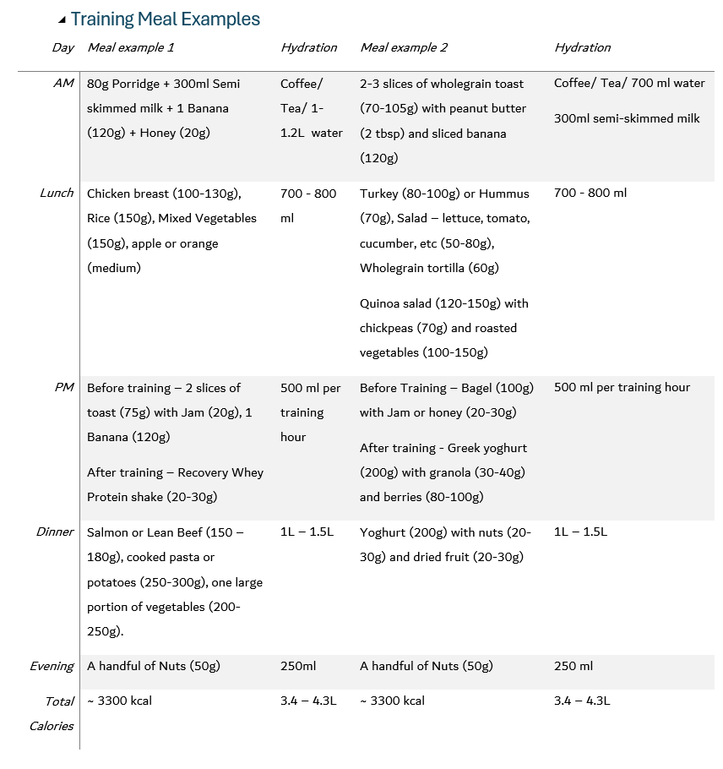
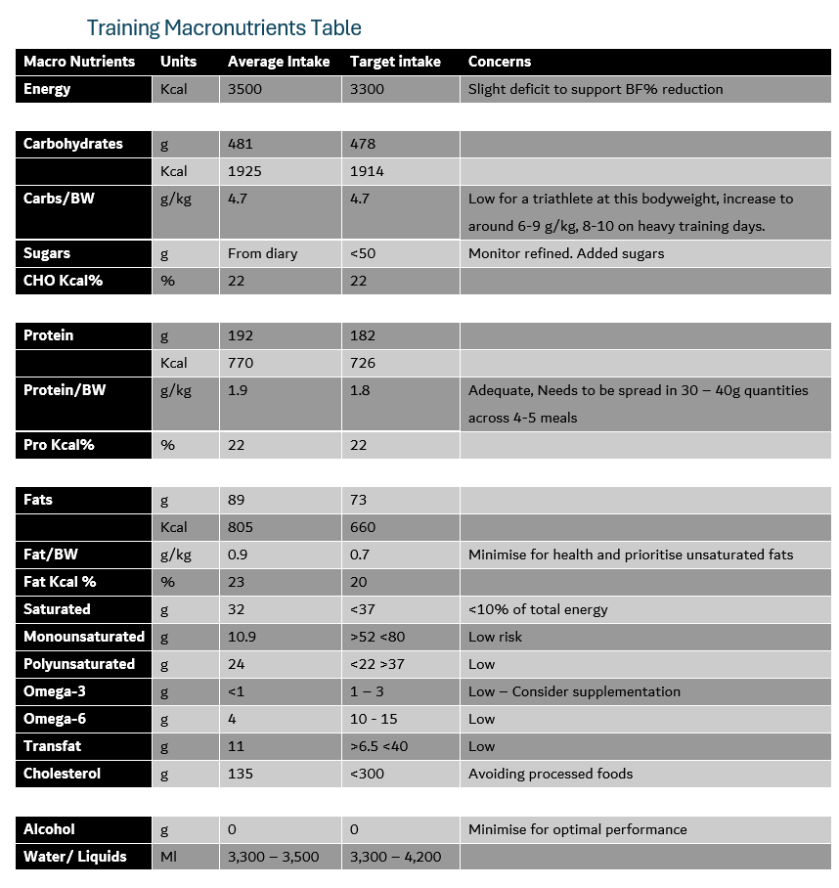

Pre-Competition
A List of goals pre-race with timings.

48 – 24 hours Pre Competition race
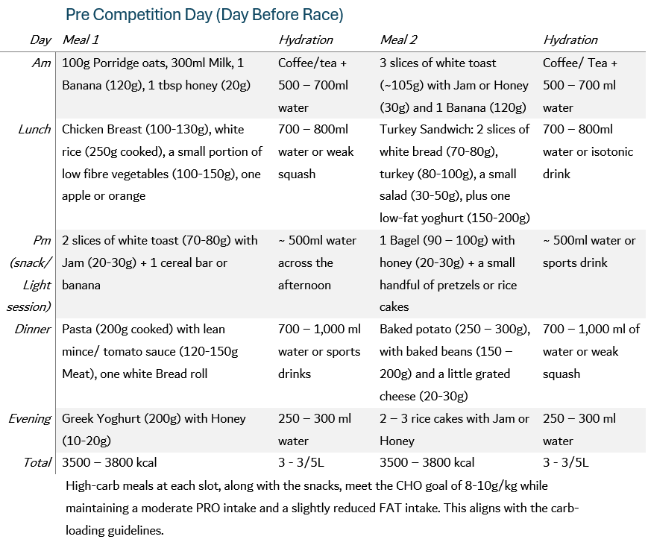
Top up your glycogen stores without overloading your gut by keeping similar foods, reducing fibre and fat slightly, and staying hydrated.

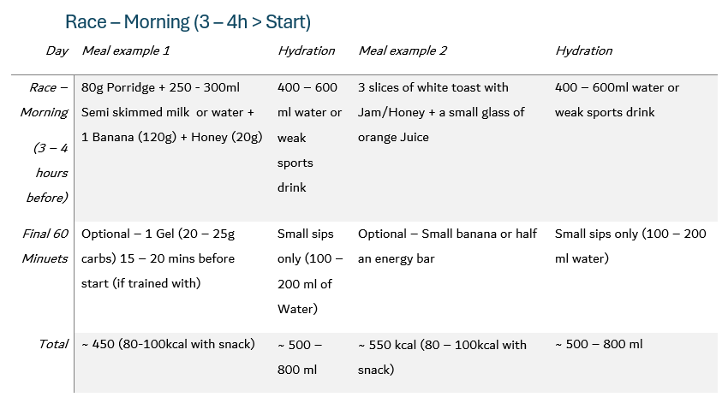
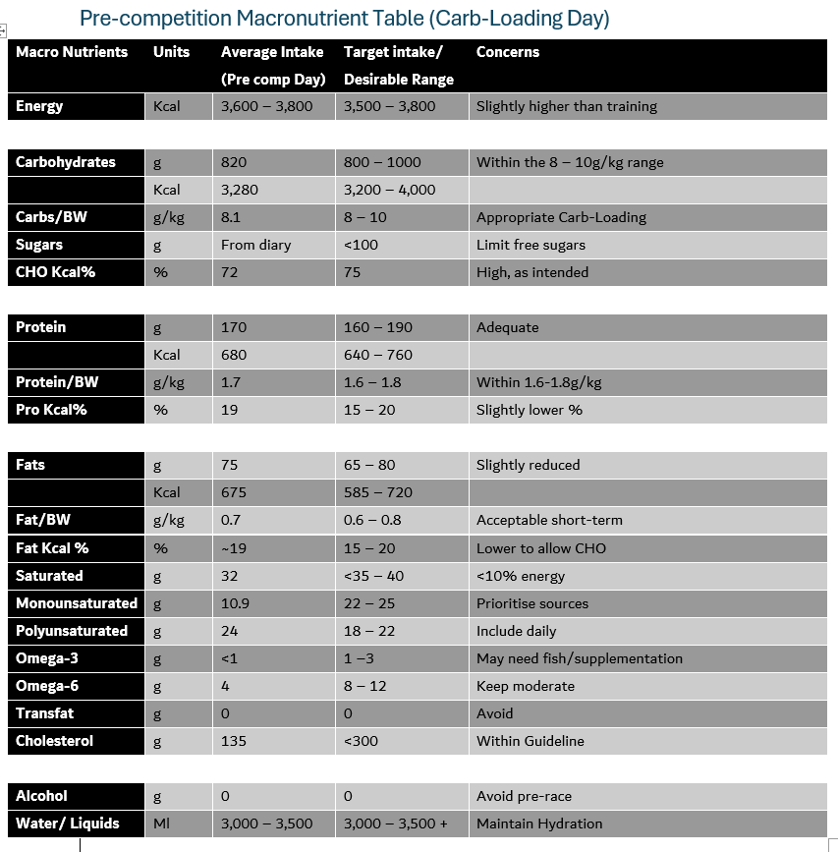

During Competition
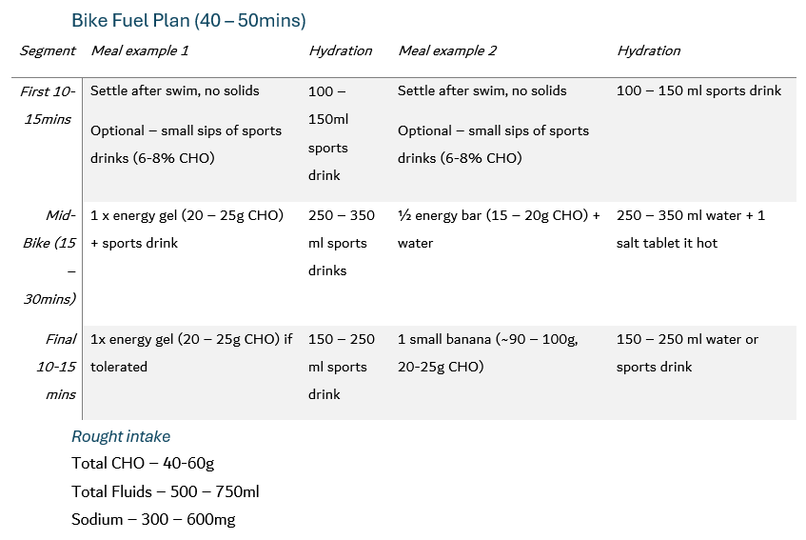
In a sprint triathlon, maintaining blood glucose, supporting hydration, and minimising gut discomfort over the entire race is crucial. This event is relatively short; the fuelling strategy throughout focuses on moderate CHO intake from the simplest, most digestible sources. This should be taken during the bike section of the event, in addition to regular but not excessive fluid and sodium intake.

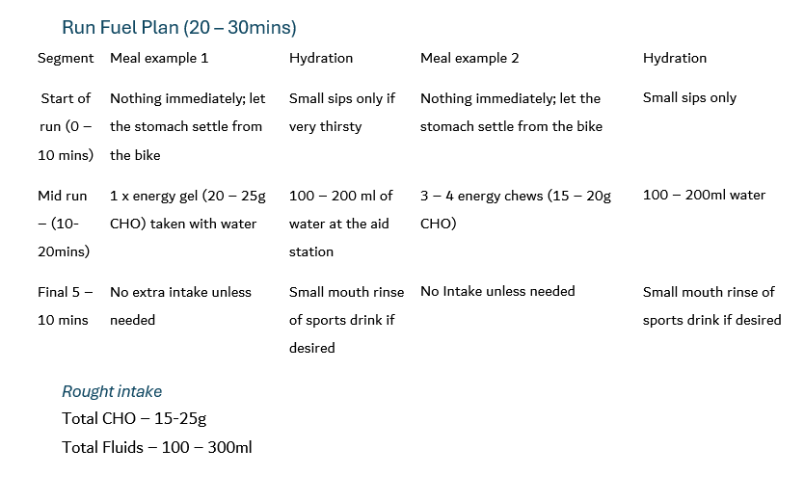

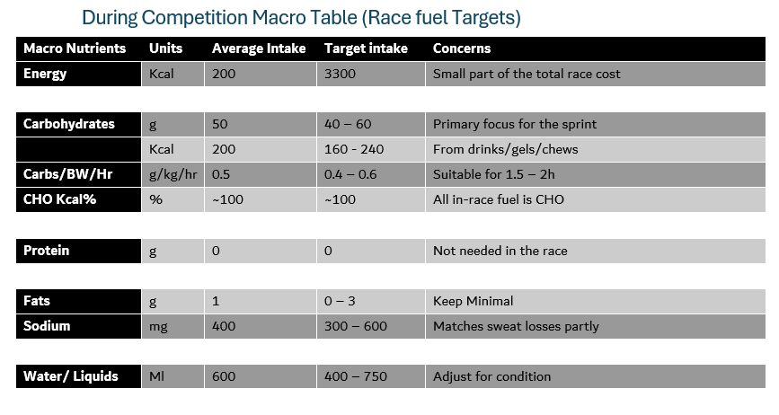

Post-Competition
A macronutrient list of foods necessary to hit the food goal;

High-Carb Recovery foods (per portion, approx.)
White Rice, Cooked (200g)
260 kcal, 58 CHO, 5g PRO, 1g FAT
Pasta, cooked (200g)
300 kcal, 60g CHO, 10g PRO, 2g FAT
Large banana (140g)
130 kcal, 33CHO, 1g PRO
2 slices white bread + Jam (60g Bread + 30g Jam)
260 kcal, 52 CHO, 6g PRO, 2g FAT
Sports Drink (500ml)
120 kcal, 20g CHO, Some sodium

Protein-rich foods
Whey Protein Shake (30g powder in milk/water)
120 kcal, 24g PRO, 2g CHO, 2g FAT
Chicken Breast (100g)
170 kcal, 32g PRO, 3g FAT
Greek Yoghurt (200g)
130 kcal, 18-20g PRO, 7-10g CHO, 0-4g FAT
Cottage Cheese (150g)
130 kcal, 20g PRO, 4g CHO, 4g FAT

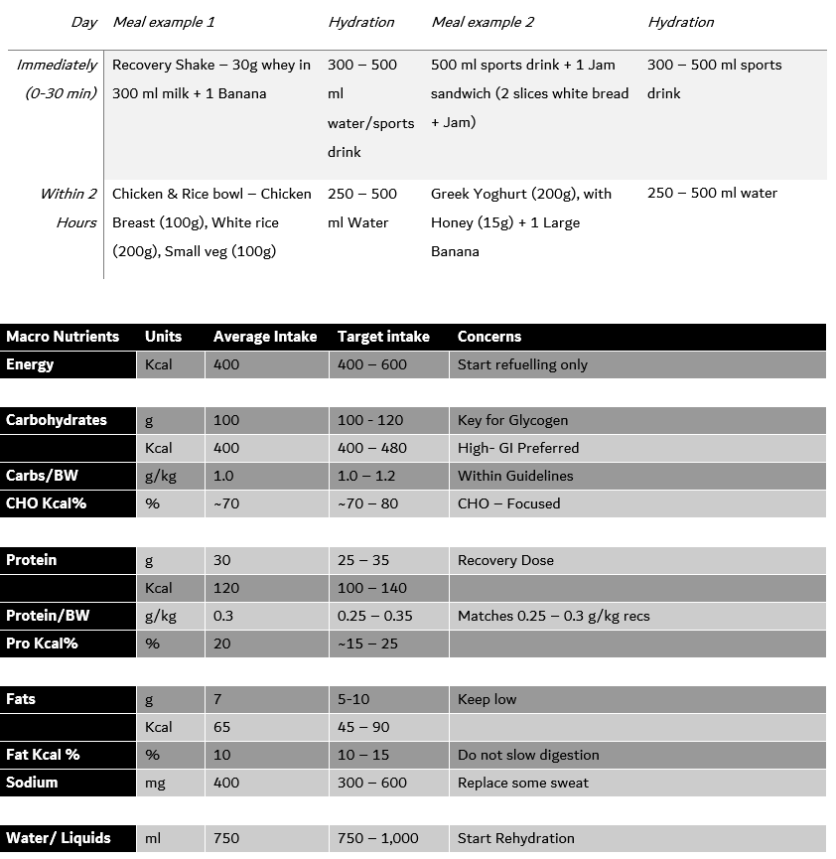

Justification

Training Phase
In this section, the aim for Zac, a 101.6kg male, was to refine body composition while supporting training needs. This was addressed by providing adequate PRO, CHO, and FAT to maintain training quality and recovery while creating a small energy deficit.

The choice of CHO at a level of 4.7 g/kg body weight/day was selected as it represents a low to moderate training load for an endurance athlete and reflects Zac's goal of gradual body fat reduction rather than maximising glycogen stores (Burke et al., 2011; Kerksick et al., 2018). Current guidelines suggest that endurance athletes should consume 3–5 g/kg/day during periods of low-intensity training, 5–7 g/kg/day for moderate training volumes, and 7–12 g/kg/day during high-intensity or competition preparation phases (Jeukendrup, 2021; Rothschild & Kilding, 2016). This should support aerobic sessions, but it is on the lower side of CHO intake for high-intensity sessions or higher-volume days, where higher CHO availability would better support performance. Because Zac is targeting body-fat reduction, the training day CHO intake (4.7 g/kg) is intentionally at the lower end of the endurance range, with higher CHO preserved for pre-competition days.

PRO is set at 1.6–1.8 g/kg body weight per day. This range is consistent with current recommendations for endurance athletes. It is implemented to support muscle PRO synthesis and offset the increased amino acid oxidation that occurs during training, particularly when energy intake is slightly restricted (Campbell et al., 2007; Jäger et al., 2017; Morton et al., 2018). The International Society of Sports Nutrition recommends PRO intakes ranging from 1.4 to 2.0 g/kg/day (Campbell et al., 2007) for athletic populations, with endurance athletes typically requiring intakes at the lower-to-middle end of this range (Campbell et al., 2007; Stokes et al., 2018). This is especially important for Zac because his slight energy deficit during the training phase increases the risk of negative PRO balance if PRO intake is too low

Dietary FAT is set at 0.9 g/kg body weight per day, which falls within the recommended range of 0.5–1.5 g/kg/day (approximately 20–35% of total energy) for endurance athletes and helps maintain overall energy intake and hormonal health (Jeukendrup, 2021; Rothschild & Kilding, 2016). Including a sufficient amount of FAT is also important because type I muscle fibres store large amounts of intramuscular triglycerides (IMTG), which serve as a significant fuel source during prolonged, moderate-intensity exercise (Shaw et al., 2010; Van Loon et al., 2003). Studies have demonstrated that endurance-trained athletes exhibit higher IMTG content in type I fibres and that these stores contribute substantially to energy provision during submaximal exercise (Hearris et al., 2018; Shaw et al., 2020). Therefore, this level of FAT intake, adequate CHO, helps support a sustained energy supply and can help spare muscle glycogen.

Pre Event (48 hours – 60mins)
The pre‑competition nutrition strategy aimed to maximise CHO availability and minimise gastrointestinal discomfort on race day, while maintaining practical and realistic guidelines for Zac.

In the 24–48 hours before a competition, Zac's overall CHO intake was increased from his usual intake during training (4.7 g/kg bw/day) to approximately 8–10 g/kg bw/day, with a slight increase in total energy intake and a relative reduction in FAT and fibre. For Zac, temporarily increasing CHO to 8-10 g/kg/day in race week offsets the lower intake on training days and ensures his glycogen stores are fully restored before the sprint triathlon. This increase in CHO aligns with guidelines for endurance athletes, which recommend around 7–10 g/kg body weight (bw) per day in the lead-up to events lasting 1–3 hours, to maximise muscle glycogen stores and support higher-intensity race efforts (Burke et al., 2011; Jeukendrup, 2021). For the sprint triathlon Zac will be completing, this level of intake is expected to enhance his CHO availability during the bike and run legs, potentially delaying fatigue compared to his habitual intake of 4.7 g/kg bw/day. For Zac, this will mean increasing portions of familiar, high-CHO, low-fibre foods (e.g., white bread, rice and pasta) while slightly reducing FAT and fibre to reduce gastrointestinal load. A potential limitation is that such high CHO intakes can be challenging to achieve in the real world; therefore, the use of sports drinks and simple snacks (e.g. jam sandwiches) is included to make this more realistic (Kerksick et al., 2018).

On race morning, Zac is advised to consume a high-CHO meal providing 1–4 g/kg body weight of CHO, finished 3–4 hours before the start, using low-FAT, relatively low-fibre foods such as porridge with banana or white toast with jam. This timing and composition are in line with recommendations for pre‑event meals for endurance athletes, which suggest 1–4 g/kg bw CHO 1–4 hours before exercise with minimal FAT and fibre to optimise gastric comfort and reduce the risk of gastrointestinal symptoms (Burke et al., 2011; Jeukendrup, 2021). The primary purpose is to replenish liver glycogen after the overnight fast and provide an additional source of CHO before the swim starts.

For Zac, a 3–4 hour window was selected to allow sufficient digestion before the swim, as he has reported some gut sensitivity in previous training sessions (where this routine was trialled). The meal options use foods that Zac has been training with (porridge, toast and bananas), which should improve tolerance. However, this strategy assumes he can maintain his usual breakfast routine on race day; travel constraints or early start times may limit adherence and would require advanced planning (Rothschild & Kilding, 2016).

In the final hour before the start of the race, intake is deliberately kept light and restricted (small sips of fluids and, if tolerated, a single energy gel taken 15–20 minutes before the start) to avoid excessive stomach fullness before the race. This approach is consistent with guidance to avoid large volumes of fluid or unfamiliar foods immediately before high‑intensity exercise, particularly in athletes prone to gastrointestinal symptoms (Burke et al., 2011; Jeukendrup, 2021).

During Competition
The competition nutrition strategy aimed to maintain blood glucose levels, support hydration, and minimise gastrointestinal discomfort, particularly during transitions between disciplines.

During the race, Zac is advised to consume approximately 0.4–0.6 g/kg body weight per hour of CHO (≈40–60 g/h), mainly from CHO gels, energy chews and sports drinks. This falls within the recommended range of 30–60 g/h for events lasting 1–2 hours, which supports improved endurance capacity and performance (Burke et al., 2011; Jeukendrup, 2021). CHO oxidation from exogenous sources appears to plateau at around 1 g/min when single transportable CHO (e.g. glucose) are used, so that higher intakes would be unnecessary for this event duration (Jeukendrup, 2021).

Fluid intake is typically set at around 400–700 ml per hour, adjusted for specific conditions, to prevent dehydration without inducing overhydration, which aligns with general recommendations for endurance events (Rothschild and Kilding, 2016; Kerksick et al., 2018). Given that Zac’s expected race duration is about 75 minutes, this provides enough CHO and fluid to support the performance without overloading his gut. Sodium intake of roughly 300–600 mg/h is included via sports drinks and/or salt tablets to help maintain plasma sodium levels and support performance, particularly in hot conditions (Rothschild and Kilding, 2016). Most of Zac’s fluid and CHO intake is planned on the bike leg, where it is easier to drink and handle gels. On the run, intake is simplified to small amounts of water and gels and, if needed, CHO mouth rinses, to reduce gastrointestinal risk while still supporting the final part of the race (Jeukendrup, 2021). This approach strikes a balance between physiological needs and what is realistically achievable at race pace.

Post competition
The post-competition strategy aimed to replenish all CHO stores in the body, restore muscle glycogen, support muscle repair, and rehydrate effectively after the race. This is particularly important for Zac because he will return to regular training soon after the race and needs to restore glycogen and support muscle repair quickly.

In the immediate period 0-2 hours, Zac is advised to consume approximately 1.0 – 1.2g/kg CHO every hour in the first 1 – 3 hours post-exercise to maximise the glycogen resynthesis (Burke et al., 2011; Kerksick et al., 2018). Starting CHO intake early is particularly important when there is a short recovery window before the next training session or event. For Zac, this means consuming a recovery shake or meal containing both CHO and PRO within 30 – 60 minutes of finishing, using the familiar foods such as Whey Protein shakes, Rice and Greek Yoghurt. A potential barrier for immediate post-race intake can be appetite suppression. Therefore, liquid options such as recovery shakes and sports drinks may be more tolerable than solid meals.

PRO intake is set at approximately 0.25 – 0.35 g/kg body weight (=25-35 g) in the immediate recovery period and again at the next main meal. This dose is consistent with current recommendations suggesting that 20-40g of high-quality PRO post-exercise maximises muscle PRO synthesis and supports recovery (Jäger et al., 2017; Stokes et al., 2018). For endurance athletes, PRO also helps offset the increased amino acid oxidation that occurs during prolonged exercise. Practical options for Zac include whey protein shakes, Greek yoghurt, or a chicken and rice meal, all of which he has been training with.

Fluid replacement is advised at approximately 1.25 – 1.5L per kg of body mass lost during the race, consumed gradually over the next 2-4 hours. This is consistent with guidance on effective post-exercise rehydration (Rothschild and Kilding, 2016). For Zac, this means weighing before and after the race (if practical) and consuming water and/or electrolyte drinks steadily rather than glugging large volumes, which can increase urinary losses and reduce net retention.

A key limitation is that appetite and gastrointestinal tolerance may be reduced immediately after the race, particularly following high-intensity efforts. Therefore, the plan prioritises easily digestible, familiar foods and includes liquid options. If Zac is unable to consume solid food within the first hour, focusing on a recovery shake or sports drink with CHO and PRO is a practical alternative that still meets the key targets.

References
Burke, L.M., Hawley, J.A., Wong, S.H.S. and Jeukendrup, A.E. (2011). Carbohydrates for training and competition, Journal of Sports Sciences, 29(sup1), pp. S17–S27. doi:10.1080/02640414.2011.585473.

Campbell, B., Kreider, R.B., Ziegenfuss, T., La Bounty, P., Roberts, M., Burke, D., Landis, J., Lopez, H. and Antonio, J. (2007). International Society of Sports Nutrition position stand: protein and exercise, Journal of the International Society of Sports Nutrition, 4(8). doi:10.1186/1550-2783-4-8.

Hearris, M.A., Hammond, K.M., Fell, J.M. and Morton, J.P. (2018). Regulation of muscle glycogen metabolism during exercise: implications for endurance performance and training adaptations, Nutrients, 10(3), p. 298. doi:10.3390/nu10030298.

Jäger, R., Kerksick, C.M., Campbell, B.I., Cribb, P.J., Wells, S.D., Skwiat, T.M., Purpura, M., Ziegenfuss, T.N., Ferrando, A.A., Arent, S.M., Smith-Ryan, A.E., Stout, J.R., Arciero, P.J., Ormsbee, M.J., Taylor, L.W., Wilborn, C.D., Kalman, D.S., Kreider, R.B., Willoughby, D.S., Hoffman, J.R., Krzykowski, J.L. and Antonio, J. (2017). International Society of Sports Nutrition Position Stand: protein and exercise, Journal of the International Society of Sports Nutrition, 14, p. 20. doi:10.1186/s12970-017-0177-8.

Jeukendrup, A.E. (2021). Dietary carbohydrate and the endurance athlete: contemporary perspectives, Sports Science Exchange, 34(204), pp. 1–8.

Kerksick, C.M., Wilborn, C.D., Roberts, M.D., Smith-Ryan, A., Kleiner, S.M., Jäger, R., Collins, R., Cooke, M., Davis, J.N., Galvan, E., Greenwood, M., Lowery, L.M., Wildman, R., Antonio, J. and Kreider, R.B. (2018). ISSN exercise & sports nutrition review update: research & recommendations, Journal of the International Society of Sports Nutrition, 15, p. 38. doi:10.1186/s12970-018-0242-y.

Morton, R.W., Murphy, K.T., McKellar, S.R., Schoenfeld, B.J., Henselmans, M., Helms, E., Aragon, A.A., Devries, M.C., Banfield, L., Krieger, J.W. and Phillips, S.M. (2018). A systematic review, meta-analysis and meta-regression of the effect of protein supplementation on resistance training-induced gains in muscle mass and strength in healthy adults, British Journal of Sports Medicine, 52(6), pp. 376–384. doi:10.1136/bjsports-2017-097608.

Rothschild, J.A. and Kilding, A.E. (2016). Recent nutritional guidelines for endurance athletes, German Journal of Sports Medicine, 67(1), pp. 10–16. doi:10.5960/dzsm.2016.218.

Shaw, C.S., Clark, J. and Wagenmakers, A.J.M. (2010). The effect of exercise and nutrition on intramuscular fat metabolism and insulin sensitivity, Annual Review of Nutrition, 30, pp. 13–34. doi:10.1146/annurev.nutr.012809.104817.

Stokes, T., Hector, A.J., Morton, R.W., McGlory, C. and Phillips, S.M. (2018). Recent perspectives regarding the role of dietary protein for the promotion of muscle hypertrophy with resistance exercise training, Nutrients, 10(2), p. 180. doi:10.3390/nu10020180.

Van Loon, L.J.C., Koopman, R., Stegen, J.H.C.H., Wagenmakers, A.J.M., Keizer, H.A. and Saris, W.H.M. (2003). Intramyocellular lipids form an important substrate source during moderate intensity exercise in endurance-trained males in a fasted state, The Journal of Physiology, 553(2), pp. 611–625—doi:10.1113/jphysiol. 2003.052431.

