Portfolio of work

Module: Professional and Career Development
BMSW 4005_BIRM
Lecturer: Olubukola Adegbite
Student: Iskra Tsvetanova Valkova-2026742
University of Wales Trinity Saint David

Content page

Content page 2
1.Introduction. 3
2. Analytical tools 4
2.1Personal Development Plan 4
2.2 SWOT analysis 5
2.3 Personality Test 7
3.Types of learning and development methods 7
3.1 8
3.2 8
3.3 9
4. Evaluation 10
5. Reflection on my experience before, during and after the course. 12
6.Conclusion 14
7.References 15
8.Appendices 16

1.Introduction.

In this reflective portfolio I will be highlighting my desire future career plan using different tools, methods and theories. I will display my short and long-term career plan and how will I achieve my goals using various theoretical skills. Also, I will present the different styles of learning and explore how they would help employees to develop themselves. I will evaluate on my skills, experience and overall, I will reflect on my training that I gathered for the past one year during my university course.

2. Analytical tools

2.1Personal Development Plan
 | Specific | Measurable | Achievable | Relevant | Time Bound
Short Term | *To achieve a diploma in Health and Social Care Level 4 Access to Higher Education | *The feedback from my lectures  *The grades that I would receive  The diploma that I would achieve | *I am extremely confident with my set goal  -I will make sure all my assignments are completed before the due date and I will do more work in advance | *This goal will provide me with the accurate training, and it will set me on the right path to become a manager | 1-2 months  ( May 2022)
Long Term | *To become successful manager in a care setting | *The CQC report for the facility I am managing;  *The feedback from my team and their achievements;  *The feedback of the clients I am responsible for;  *The feedback from my employer  *The track record I will create while I am on this position | *I am extremely confident that I will achieve my set goal  -I have Health and Social Care Diploma in Management to support me in my journey and years of experience | *This goal will make sure I am staying on the right path of my career life;  *My achievements in this field will essure that I am providing the best management experience to my colleagues, clients and employer | 3-5 years  ( 2025-2027)

The Personal Development Plan is an action plan that highlights an individual set goals in a time frame. It helps people to identify and prioritise the achievements that they wish to accomplish. The PDP puts an individual’s goals in perspective and visualises their dreams in order to achieve them in appropriate timeline. ( Beausaert, S., Segers, M. and Grohnert, T., 2014).

I have chosen a career path that best suits my personality and interest. I see my career path as a long-term goal. To become a successful manager in my chosen field will require a lot of dedication, years of experience and relevant training courses in order to become the best of myself. I believe that as an outstanding manager in health and social care sector it will be required to choose a suitable management style, to understand the importance of self-reflect and always to be a team player. To my understanding of management, it is crucial that I know how to have different approach to each individual I am working with but at the same time treating everyone equally.

2.2 SWOT analysis

Strengths | Weakness
- Leadership  - Team Building strategies  - New Starters training  - Excellent Communication Skills  - Outstanding Documentation Keeping  - Medicine Administration | - My type of personality indicates that I am:  - Stubborn  - Struggling to contain my emotions  - Direct and Honest  - Might be judgemental in certain situations
Opportunity | Threats
- Good support network  - Knowing who to contact  - Knowing how to access the relevant trainings  - Understanding of how and when to support the individuals that I am responsible for | - Understanding the laws and legislations and how rapidly they are changing  - Approaching individuals in various groups such as: age, race, sex, religion and beliefs, disability, pregnancy and maternity, civil partnerships and etc

SWOT analysis is strategic method for highlighting an individual’s strengths, weakness, opportunities and threats in order to develop their set goals. ( GURL, E., 2017).

My SWOT analysis underline my long-term goal of becoming a successful manager in the health and social care sphere. I believe I have the right perspective and good support network to start my journey. My previous trainings and years of experience have prepared me for this position.

2.3 Personality Test
Personality test is a simple questionary, that works with Myers Briggs Type Indicator to provide accurate results. There are 4 different categories, and each individual has one preferred, which produces 16 unique types of personalities. (Pittenger, D.J., 1993).

According to my Personality Test I have Executive personality. This type of personality is quite unique. It shows that I have excellent leadership skills and I am able to give clear guidance. This test highlights that I am outstanding in bringing people together and managing difficult situations. Also, the Personality test site is able to provide me with an accurate list of my strengths and weaknesses. For example, that I am a very dedicated person, who is strong willed, loyal and reliable with excellent organisation skills. On the other hand, I am direct and honest individual who might become judgemental in certain situations, and who is struggling to contain or express my emotions. That type of personality proves that I am quite suitable for all kinds of management positions.

3.Types of learning and development methods
During this course I came across 3 different types of learning methods. They provide a unique view which emphasizes the various techniques we use in order to divide the staff into different learning categories so they can develop their full potential. (Pashler et al. 2008)

3.1 David Kolb’s model developed in 1984 is typically represented in four stages: Active experimentation, Concrete experience, Abstract conceptualisation and Reflective observation. His main concept is that an individual is more likely to learn by thinking about an experience rather than absorbing information. In other words, Kolb believes that his training programme would be more successful if it is visualised. However, according to the theorist, effective learning only occurs when a person has progressed through all four stages, therefore just one stage is not effective for the learning process.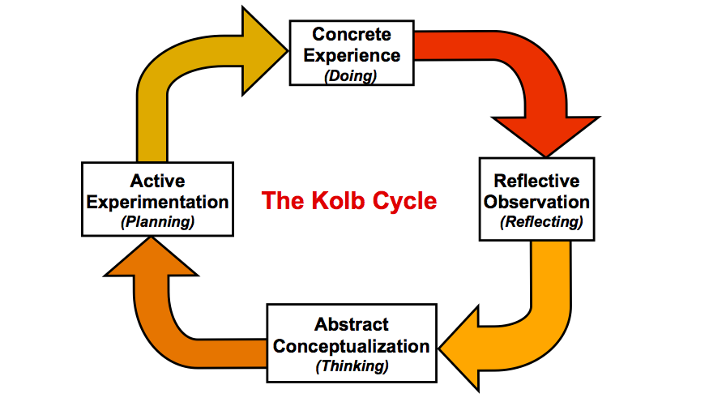

3.2 Honey and Mumford’s learning style selects individuals in four different groups: Activists, Pragmatists, Theorists and Reflectors. The first group suggests that these individuals learn by joining tasks in short and concrete way. The second group type uses their imagination much more, which means they use their life experience to develop new ideas. The Theorists are type of people who use theories to link their ideas. The Reflector type uses their own experience to reflect on their past with focus on creating new ideas.
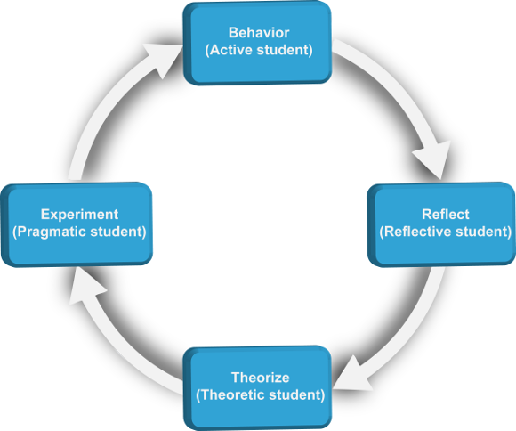

According to the Honey and Mumford’s learning style I believe am an Activist. I like to have an active involvement in the tasks, but I prefer using my own style and do not rely on team work too much. I like to have the job done at any cost and often I am doing too much myself and do not follow the rules strictly, therefore do not give many chances to the others to express themselves. I sometimes do take risks in determination to deliver the best of myself which I do not find beneficial regarding the whole team’s performance. This makes the group work inefficient and I do think that at times I should step back and give opportunities to the other team players or just be a better mentor for them and take time to explain better, despite of just performing the tasks on my own.
I believe in order to improve my continuing personal development or that of the other group workers I am responsible for, I should use performance reviews or provide more training for them, so we can all become more productive and efficient as a team. My goal is to work towards the Reflector group type in order to succeed as a manager. As I mentioned above, I believe good management is a management that reflects on every occurred situation aiming to prevent it from happening again or improving the quality of service that we provide.

3.3 One of the most prominent learning styles was developed by Neil Fleming in 1987. It has been named VARK model of learning, which stands for Visual, Aural, Read/write and Kinaesthetic (Tactile).
According to that learning style I am an Auditory/Tactile learner. This means that I understand better things that I have already read and visualised in my mind as well as things I have heard and have been explained to me. I can help myself by making some recordings to I can listen afterwards and make better decisions. Also, it is easy for me to learn by touching, respectively practising the things. The negative side is that I easily get bored but by taking often breaks I can relax myself and booster my energy levels.
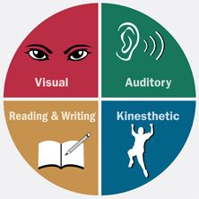

4. Evaluation

I have unique set of skills, which I gathered from my 15 years of experience in health and social care sector. All my life I have been driven to help others and organise their work environment in order to make everyone’s life easier. I practiced as a nurse for 10 years back in my country. I moved to England 6 years ago and since then I always held management position. At first, I was working 2 years as a line manager in a food factory. In the meantime, I decided to pursue my dreams of working in health and social care sector. I joined small family-owned care home and I have been senior staff there for over 2 years.

Currently, I work as a Care Leader in a Care Home for the past 2 years and a half. I met various individuals and I had to deal with complicated situations on daily basis. I know that I have good support network of people that I have met during my work placements.
Within my management position my set of skills would be extremely useful in order to fulfil my duties. This position requires spot on judgment in some situations, which may be crucial to the individuals that I am responsible for.

I find most difficult that I need to meet everyone’s needs and wishes, which means that I need to consider the desires of my clients, my employer and my employees. Unfortunately, I found out that even as a manager you cannot make everyone happy. I need to act in people’s best interest in order to ensure everyone’s safety and wellbeing. I think I will struggle with that because people would not be always happy with my decisions. That is why is important to know how to self-reflect and learn from my mistakes. My philosophy is that we learn every day and in order to upgrade ourselves we have to reflect on a daily basis ( Heron, B., 2005).

To my opinion, to be a manager is quite challenging position. I do not think that anyone have a proper guide for every situation at the workplace and I do not think everyone could be suitable for this position. My long-term goal is to be a manager of a care home. I think that I have the required set of skills to fulfil this position. I am quick to take executive decisions on my feet. I believe I know how to manage a team to work towards their best performance. For example, I am very careful how I pair my team, so everyone can feel comfortable and relaxed at the workplace. (Schouten, M., Khattab, J. and Pahng, P., 2020).
One of the things that I strongly believe is that teamwork is the most important thing. I feel that my team building skills could really be useful here. For example, I like to bring sweets to work daily. Also, I like to start and finish every meeting with something positive. I always thank the staff for their hard work. I am able to provide relaxing working space for new starters. Manager should be able to make everyone feel welcome and included. I like to make sure every new person who joins the team is happy and accepted. My practise is to provide up to date training for every staff member including myself. I strongly believe that If I am not able to cover a shift, I should be able to come and work with my colleagues. I am aware that everyone is making mistakes and the most important thing for me is to learn and use these mistakes to our advantage. I prefer that the team is having regular reflective meeting with each other. I welcome any sort of criticism as I believe this is building my knowledge and understanding of my surroundings. I like to have monthly meetings with my clients to discuss any issues and their opinion of how we should sort them. Also, I think my employer should be a person who I can rely on as well as they can rely on me(Fapohunda, T.M., 2013).

On the other hand, I have my flaws like everyone else. However, I am always trying to improve and upgrade myself. I believe that is what makes a difference in my work ethic. I find myself to be extremely hones and direct person, which is not always a good approach for everyone. I understand that I can be slightly judgemental in certain situation, because I know how hard I work, and I do expect that from everyone around me. At the same time, I believe my colleagues have different work ethic and their level of experience is on different stages. I aim for all my staff to have the same level of training, so no one is excluded. I work on myself daily and I try to contain my emotions when possible. (Schermerhorn Jr, J.R., Bachrach, D.G. and Wright, B., 2020).
As a manager of a care home, I should be familiar with up-to-date law and legislations that are relevant to my establishment. Currently, I am learning the law of employment. I know the importance of all stages of employment, such as recruitment, employment contract, data protection, pay and holiday entitlement, discrimination, working time, health and safety at the workplace, dismissal, redundancy, maternity leave. In other words, all the legislations are in place to protect each employee and the service user. I strongly believe that no one should feel uncomfortable, isolated, offended or discriminated at their workplace. Each employee is equally important, and everyone should be treated equally with respect. (Bennett-Alexander, D.D., 1998).

5. Reflection on my experience before, during and after the course.
I started this course a year ago. I was not sure how to plan my goals and how to achieve them. I was struggling with my office 365 skills, such as writing reports in academic style, presenting a slideshow of my own work. Also, I was finding it difficult to work in groups and rely on someone besides me. The most challenging of all was organising my time around my children and assignments. I was not aware of who to approach if I find myself struggling or even to admit that I needed help.

During this course I learned how to present my work more clearly. My lectures taught me how to effectively communicate and be a part of a team. We learned how to make critical decisions and solve problems for uncommon situations. I was introduced to different type of support network. I was asked to work with unique individuals, who had their own style and work ethic that I needed to accept. I learned how to be professional and kind at the same time. It showed me the importance of first impression in interview base situation. The course highlighted how a smile and appropriate outfit could change someone’s opinion of you. I saw how different body language could affect your whole image.

At the moment, I am extremely confident that I will achieve all my goals in my own timeline. I know how to be presentable and always look professional. I know how to manage a good team and maintain wonderful professional work relationship between each other. I know how to organise my time and be the most productive version of myself. I believe and I know that I would be an outstanding manager!

6.Conclusion
In my future, I see myself learning from my experience and acknowledging everyone’s right of choice and wellbeing. That includes my colleagues, my clients and my employer. As I always say, good management is a management that is having different approach towards everyone, but at the same time treating each individual equally. That will be my moto in my future professional career. Professor Tonya Evans believed that real learning occurs only when it is supported by real world experience (Neugebauer, J. and Evans-Brain, J., 2016 ).That is why I am looking forward to starting my professional career and upgrade myself while practising.

7.References
1. Beausaert, S., Segers, M. and Grohnert, T., 2014. Personal development plan, career development, and training. The Wiley Blackwell Handbook of the Psychology of Training, Development, and Performance Improvement, pp.336-353.
2. Bennett-Alexander, D.D., 1998. Employment law for business. Irwin, McGraw-Hill.
3. Fapohunda, T.M., 2013. Towards effective team building in the workplace. International journal of education and research, 1(4), pp.1-12.
4. Fleming, N.D., 1995, July. I'm different; not dumb. Modes of presentation (VARK) in the tertiary classroom. In Research and development in higher education, Proceedings of the 1995 Annual Conference of the Higher Education and Research Development Society of Australasia (HERDSA), HERDSA (Vol. 18, pp. 308-313).
5. GURL, E., 2017. SWOT analysis: A theoretical review.
6. Heron, B., 2005. Self‐reflection in critical social work practice: subjectivity and the possibilities of resistance. Reflective practice, 6(3), pp.341-351.
7. Neugebauer, J. and Evans-Brain, J., 2016. Employability: Making the most of your career development. Sage, pp.95-98.
8. Pashler, H., McDaniel, M., Rohrer, D. and Bjork, R., 2008. Learning styles: Concepts and evidence. Psychological science in the public interest, 9(3), pp.105-119.
9. Pittenger, D.J., 1993. The utility of the Myers-Briggs type indicator. Review of educational research, 63(4), pp.467-488.
10. Schermerhorn Jr, J.R., Bachrach, D.G. and Wright, B., 2020. Management. John Wiley & Sons.
11. Schouten, M., Khattab, J. and Pahng, P., 2020. Managing Team Diversity in the Workplace. In Oxford Research Encyclopedia of Business and Management.
12. Stice, J.E., 1987. Using Kolb's Learning Cycle to Improve Student Learning. Engineering education, 77(5), pp.291-96.
13. Zubizarreta, J., 2009. The learning portfolio: Reflective practice for improving student learning. John Wiley & Sons.

8.Appendices



