Portfolio
Thomas Nurse

Logo

The logo is inspired by the 3D compass seen in many 3D software where it represents the 3 axes of movement.
The colour scheme was chosen by using ‘Adobe Color’
I originally intended to use the colour blue for the brand, however after seeing the logo with the colour, I decided against using it and went with this pink-purple instead.

Previous Iterations

Original Idea for the logo
I liked it but it was too simple and looked too similar to the logo of the car brand ‘Mercedes-benz’.



I decided to try rotating the logo to see if I liked it and found that putting it at an angle looked good while also forming the shape of the letter A, this was later used when finalising the name for the brand.


I added gaps between the letter and the outlining circle as the logo felt too cluttered when they were touching.


I decided to add a second outlining circle when I was thinking about how I wanted the motion graphic to be animated and thought it was a great fit.

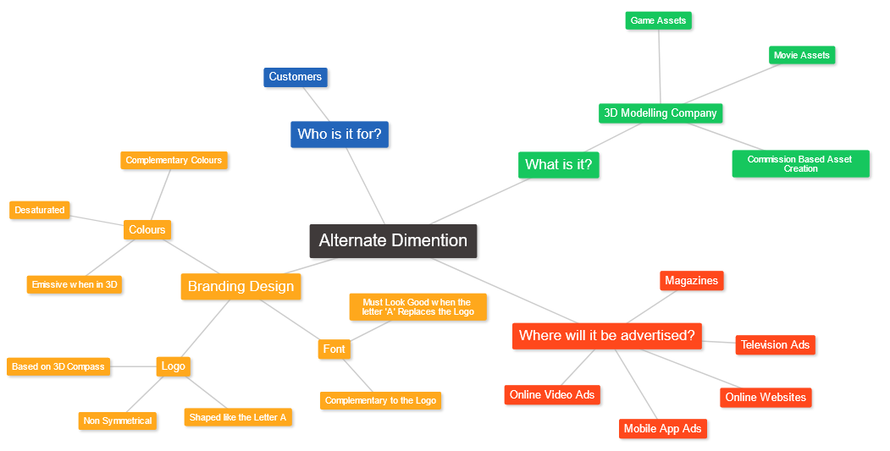
Mind Map

Banners
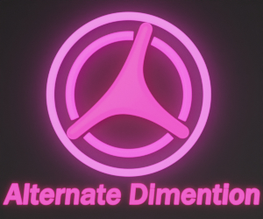
Medium Rectangle – 300 x 250 (73KB)

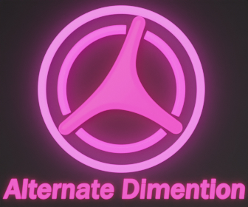
Large Rectangle – 336 x 280 (93KB)


Leaderboard – 728 x 90 (62KB)

Mobile Leaderboard – 320 x 50 (20KB)

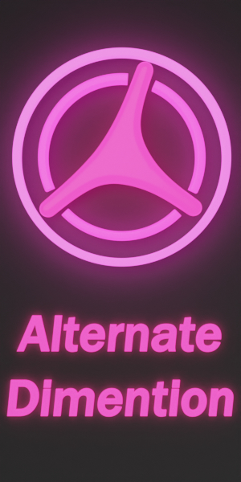
Half Page or Large Skyscraper – 300 x 600 (144KB)

Motion Graphic Sequence
https://www.youtube.com/watch?v=pM8_uhpwCkQ
(11 Seconds, 1920 x 1080 Resolution)

