Abstract

In this project, we conducted an initial exploratory data analysis on the mnist fashion dataset, and found that the quantity of each category was the same, indicating that there was no label imbalance in the data. Therefore, we did not need to resaminate the data. The extreme value of data features is large, and the variance is also large, indicating that the distribution of data features is uneven, which easily leads to the machine learning model is not easy to converge during training, and the model learning effect becomes worse. We use a standardized method to normalize the data features. After processing, the data features tend to be evenly distributed. In this project, we will use knn and decision tree model respectively to model and analyze the preprocessed data. In order to obtain the optimal model, the key parameters of each model were superselected. At the same time, the five-fold cross-validation method was used to evaluate the training results of the model, so as to select the best model. For two machine learning models. The model performs well on the test set without obvious overfitting phenomenon. At the same time, we find that the model has the lowest prediction accuracy in category 6 and the highest prediction accuracy in category 1. The number of misjudgments in category 1 is the least, and the number of misjudgments in category 6 is the most, and the number of misjudgments in category 6 is the most. From the sample image analysis, we can see that category 6 and category 0 both belong to clothes, so the difference in feature distribution is not very obvious, resulting in the model can not distinguish the two categories well. We calculate the classification results of the two best models on the test set. KNN model is superior to decision tree model in every index. KNN model is simple and easy to understand; No training, no estimation of parameters; High accuracy; Suitable for multi-label problems. Decision tree model is easy to overfit; The generation of decision trees is unstable, and small data changes may result in different decision trees. Therefore, the performance of KNN model on this data is generally better than that of decision tree model.

Keywords: KNN, Decision Tree, Machine learning, fashion mnist

- Introduction

In this project, we will take the mnist fashion data set as the research object, hoping to achieve the classification of mnist fashion data by establishing a corresponding classifier. Different from the MNIST handwriting dataset, the Fashion-MNIST dataset contains 10 categories of images, namely: t-shirt, trouser, pullover, dress, coat, sandal, shirt, sneaker, bag, ankle boot. We will conduct initial exploratory data analysis on the data set, and use KNN model and decision tree model to model and analyze mnist fashion data respectively. By using classification parameters such as accuracy rate, recall rate and f1 value to evaluate the model, the optimal model is obtained.

- Related work

Many datasets are used for clothing image classification, such as Fashion MNIST and DeepFashi-C. For Fashion MNIST, use this data set [1] . In this work, the authors propose a retrieval framework for image-based fashion products that draw inspiration from biology and are similar to the human brain, which is thought to have a two-stream visual processing system. The attention heterogeneous bilinear network (AHBN) is assumed to consist of a fully convolutional network branch and a deep CNN branch. They are used to extract landmark location data and fine-grained appearance attribute information respectively. After applying a compact bilinear pool layer to simulate the interaction of two flows, the combination then uses a channel-following mechanism to focus on heterogeneous properties derived from important channels in the network. Fashion MNIST is also used [2] . Their fashion model integrates two attention channels, landmark-driven and spatial channel-focused, to enhance the clothing category. By using these attention channels, their model is able to represent multi-scale contextual information about landmarks, which improves classification by identifying the location of the most critical features, thereby improving the accuracy of the input image. In [3] , the author introduces a semi-supervised multi-task learning strategy for attribute prediction and clothing classification.

- Model introduction

3.1 KNN model
KNN nearest neighbor algorithm, one of the famous statistical methods of pattern recognition, plays a high role in machine learning classification algorithms. KNN nearest neighbor algorithm is relatively mature in theory. It is not only one of the simplest machine learning algorithms, but also one of the most basic and best text classification algorithms in case-based learning methods.
The basic approach of KNN nearest neighbor algorithm is: given a test case, find the k closest instance points in the training set based on a certain distance measure, and then predict based on the k nearest neighbor information.
KNN nearest neighbor algorithm does not have an explicit learning process. In fact, it is a famous representative of lazy learning. This kind of learning technology only saves samples at the training stage, and the training time cost is zero. It will be processed after receiving the test samples.
The implementation of KNN algorithm mainly includes the following three steps:
1. Calculate distance: given the sample to be classified, calculate the distance between it and each sample in the classified sample;
2. Find neighbors: circle the K classified samples closest to the samples to be classified as the nearest neighbors of the samples to be classified;
3. Classification: determine the classification of the samples to be classified according to the category of most of the K nearest neighbors;

3.2 Decision tree model

The foundation of decision tree model is mainly the concept of Keeny coefficient. The Keeny coefficient is used to calculate the degree of disorder in a system. The higher the KEENY coefficient is, the more chaotic the system is. The lower the Keeny coefficient is, the more orderly the system is. The decision tree model is established to reduce the chaotic degree of the system, and the nodes are divided according to the Keeny coefficient, thus obtain the appropriate data classification effect. A decision tree using Gini coefficients is also called a CART decision tree.

- Data set introduction
The 60K images in the training set and 10K images in the test set constitute the fashionable MNIST data set. The size of each image is 28 * 28. They can be divided into ten different categories. Each image has a related label. There are ten labels in total, namely: T-shirt, pants, pullover, dress, coat, sandals, shirt, sports shoes, bag, ankle boots
In this project, we used keras' datasets library to import the fashion_mnist dataset. The implementation code is as follows:

(x_train,y_train),(x_test,y_test) = fashion_mnist.load_data()

We output the dimensions of the training set and the test set. The results show that the training set contains 50,000 samples and the test set contains 10,000 samples.

- Exploratory analysis of data

We use the Counter method to count the number of samples of training set tags, and the result is as follows:

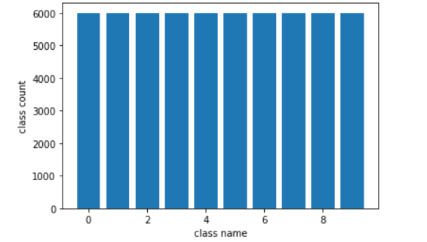
Fig1 Label counts

As shown in the figure above, we counted the number of different tags in the training set. As can be seen from the figure, the quantity of each category is the same, indicating that there is no label imbalance in the data. Therefore, we do not need to resampler the data.
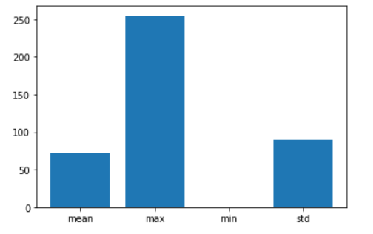
Fig2 Feature statics

As shown in the figure above, we calculated the mean value, maximum value, minimum value, variance and other information in the features of the training set. As can be seen from the figure, the extreme value of data features is large, and the variance is also large, indicating that the distribution of data features is uneven, which is easy to cause the machine learning model is not easy to converge during training, and the model learning effect becomes worse. Therefore, we need to normalize the data characteristics.

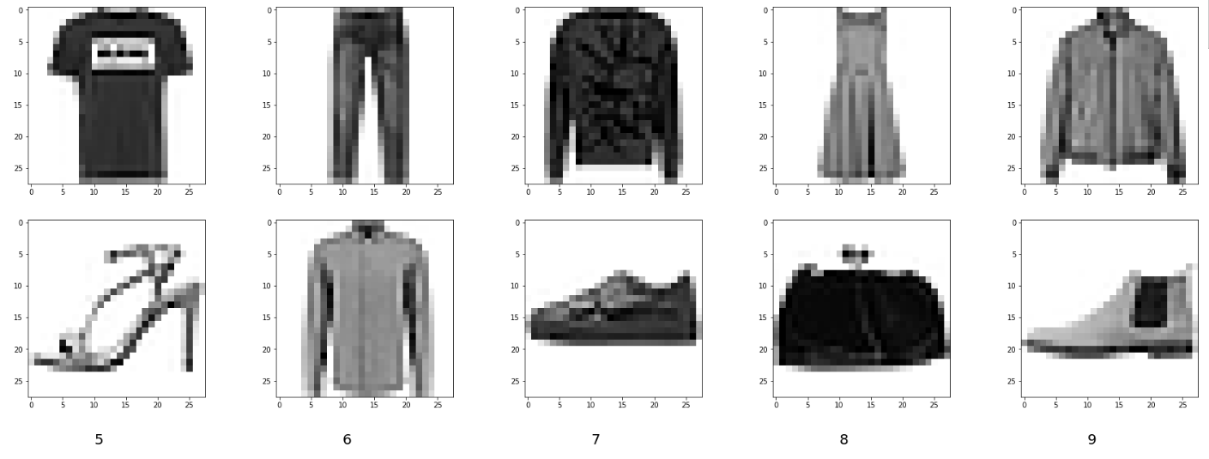
Fig3 Sample data
As shown in the figure above, we plotted samples for each category. As can be seen from the figure, the features of sample pictures of different categories are quite different, which is conducive to the learning of machine learning model. Because traditional machine learning models cannot extract features from data, the greater the difference in original data features, the better the model learning effect will be.

- Data preprocessing

In the exploratory analysis of data, we found the phenomenon of uneven distribution of data features, which is not conducive to the training of the model. Therefore, we need to normalize the data. In this project, we use a standardized method to normalize data characteristics, and the implementation code is as follows:
s=StandardScaler()
s.fit(x_train.reshape(-1,28*28))
x_train_scale=s.transform(x_train.reshape(-1,28*28))
x_test_scale=s.transform(x_test.reshape(-1,28*28))

As shown above, since the original data is stored in 28*28 format, in order to meet the need of normalization, we need to change the 3-dimensional data into 2-dimensional data.

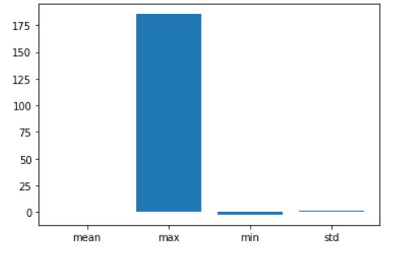
Fig4 Feature statics after scaled

The figure above shows the statistical information of normalized data features. As can be seen from the figure, the variance of data features is basically close to 0, indicating that the distribution of data features is basically uniform, thus meeting the requirements of machine learning model modeling.

- Model training

In this project, we will use knn and decision tree model respectively to model and analyze the preprocessed data. In order to obtain the optimal model, the key parameters of each model were superselected. At the same time, the five-fold cross-validation method was used to evaluate the training results of the model, so as to select the best model.

7.1 KNN model

The super parameter selection of KNN model is: 'n_neighbors':[1,5,10,20]. We use girdsearchCV method to optimize the super parameter. The implementation code is as follows:

parms_grid={
'n_neighbors':[1,5,10,20]
}
knn =KNeighborsClassifier()
model = GridSearchCV(knn,parms_grid, cv=5)
model.fit(x_train_scale, y_train)

Finally, the best parameter of KNN model in this data set is 'n_neighbors': 5. The output of parameter debugging is as follows:
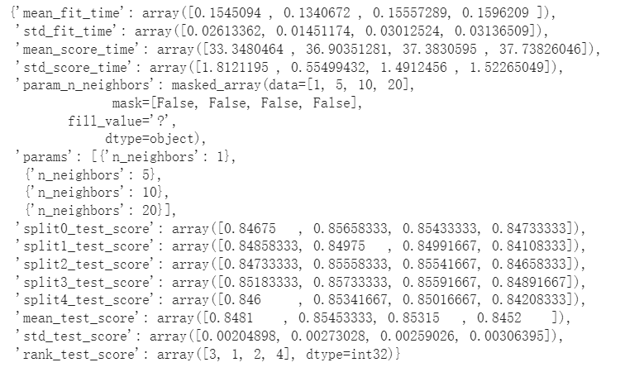
Fig5 KNN model training results

The figure above shows the hyperparameter tuning process of the KNN model. It can be seen from the figure that there is little difference in the accuracy of the model in 5 fold cross-validation, indicating that different n_neighbors have little influence on the results of the model in the test set.

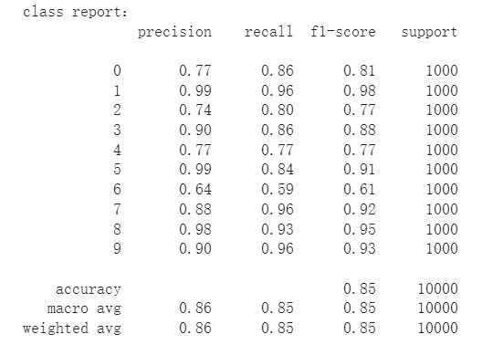
Fig6 KNN model testing results

The figure above shows the classification report of the optimal KNN model on the test set. As can be seen from the figure, the classification accuracy and accuracy of the model on the test set are 0.85, 0.86, 0.85, and 0.85, respectively. On the whole, the model performs well in the test set without obvious overfitting phenomenon. At the same time, we find that the model has the lowest prediction accuracy in category 6 and the highest prediction accuracy in category 1.

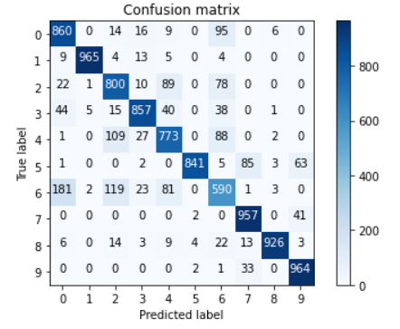
Fig7 KNN model testing confusion matrix

The figure above shows the confusion matrix of the optimal KNN model on the test set. As can be seen from the figure, the number of misjudgments of the model in category 1 is the least, the number of misjudgments in category 6 is the most, and the number of misjudgments in category 6 is the most. From the sample image analysis, we can see that category 6 and category 0 both belong to clothes, so the difference in feature distribution is not very obvious, resulting in the model can not distinguish the two categories well.

7.2 Decision tree model

We selected 'max_depth':[1,5,10,20] as the super parameter of the decision tree model. We used girdsearchCV method to perform the super parameter tuning. The implementation code is as follows:

parms_grid={
'max_depth':[1,5,10,20]
}
dc =DecisionTreeClassifier()
model = GridSearchCV(dc,parms_grid, cv=5)
model.fit(x_train_scale, y_train)

Finally, the optimal parameter of the decision tree model under this data set is 'max_depth': 10, and the output of parameter adjustment process is as follows:
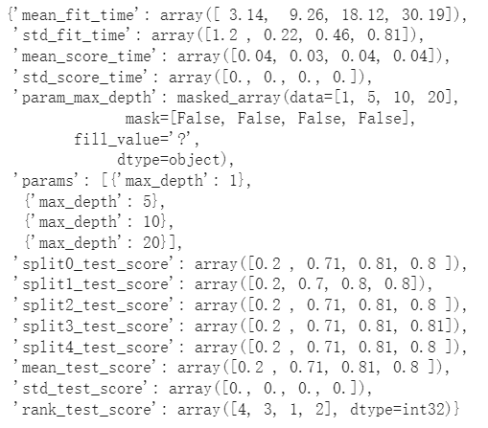
Fig8 DecisionTree model training results

The figure above shows the superparameter optimization process of the decision tree model. It can be seen from the figure that the accuracy of the model varies greatly in the 5-fold cross-validation, and the classification accuracy of the model on the test set also increases with the increase of the division depth, because the division depth is small, the model is in the underfitting state on the training set. So the model will perform poorly on the test set; When the partition depth is too large, the model is easy to overfit on the training set, resulting in poor performance of the model on the test set.
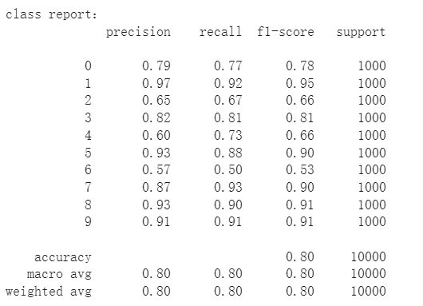
Fig9 DecisionTree model testing results

The figure above shows the classification report of the optimal decision tree model on the test set. As can be seen from the figure, the classification accuracy and accuracy of the model on the test set are 0.80, 0.80, 0.80, 0.80 and 0.80 respectively. On the whole, the model performs well in the test set without obvious overfitting phenomenon. At the same time, we find that the model has the lowest prediction accuracy in category 6 and the highest prediction accuracy in category 1.
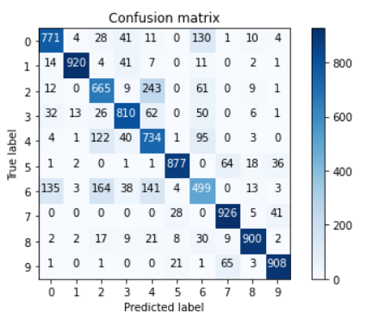
Fig10 DecisionTree model testing confusion matrix

The above figure shows the confusion matrix of the optimal decision tree model on the test set. As can be seen from the figure, the number of misjudgments of the model in category 1 is the least, the number of misjudgments in category 6 is the most, and the number of misjudgments in category 6 is the most. From the sample image analysis, we can see that category 6 and category 0 both belong to clothes, so the difference in feature distribution is not very obvious, resulting in the model can not distinguish the two categories well.

7.3 Comparison of optimal models

Model | accuracy | precision | recall | F1 score
KNN | 0.85 | 0.86 | 0.85 | 0.85
Decision tree | 0.80 | 0.80 | 0.80 | 0.80

Table 1 model comparison metrics

As shown in the figure above, we counted the classification results of the two best models on the test set. As can be seen from the table, KNN model is superior to decision tree model in all indexes.
KNN algorithm has the following advantages
(1) It is simple, easy to understand, easy to implement, and does not need to estimate parameters.
(2) The training time is zero. It does not show the training, unlike other supervised algorithms, which use the training set to train a model (that is, fit a function), and then use the model to classify the verification set or test set. KNN only saves samples and processes them when receiving test data, so KNN training time is zero.
(3) KNN can deal with classification problems, and can deal with multi-classification problems naturally, which is suitable for classification of rare events.
(4) Especially suitable for multi-classification problems (multi-modal, objects with multiple category labels), KNN performs better than SVM.
(5) KNN can also deal with regression problems, that is, prediction.
(6) Compared with naive Bayesian algorithm, it has no assumptions about data, high accuracy and is insensitive to outliers.

8.Conclusion

In this project, we conducted an initial exploratory data analysis on the mnist fashion dataset, and found that the quantity of each category was the same, indicating that there was no label imbalance in the data. Therefore, we did not need to resaminate the data. The extreme value of data features is large, and the variance is also large, indicating that the distribution of data features is uneven, which easily leads to the machine learning model is not easy to converge during training, and the model learning effect becomes worse. We use a standardized method to normalize the data features. After processing, the data features tend to be evenly distributed. In this project, we will use knn and decision tree model respectively to model and analyze the preprocessed data. In order to obtain the optimal model, the key parameters of each model were superselected. At the same time, the five-fold cross-validation method was used to evaluate the training results of the model, so as to select the best model. For two machine learning models. The model performs well on the test set without obvious overfitting phenomenon. At the same time, we find that the model has the lowest prediction accuracy in category 6 and the highest prediction accuracy in category 1. The number of misjudgments in category 1 is the least, and the number of misjudgments in category 6 is the most, and the number of misjudgments in category 6 is the most. From the sample image analysis, we can see that category 6 and category 0 both belong to clothes, so the difference in feature distribution is not very obvious, resulting in the model can not distinguish the two categories well.We calculate the classification results of the two best models on the test set. KNN model is superior to decision tree model in every index. KNN model is simple and easy to understand; No training, no estimation of parameters; High accuracy; Suitable for multi-label problems. Decision tree model is easy to overfit; The generation of decision trees is unstable, and small data changes may result in different decision trees. Therefore, the performance of KNN model on this data is generally better than that of decision tree model.

Reference：
[1] Su, H.; Wang, P.; Liu, L.; Li, H.; Li, Z.; Zhang, Y. Where to look and how to describe: Fashion image retrieval with an attentional heterogeneous bilinear network. IEEE Trans. Circuits Syst. Video Technol. 2020, 31, 3254–3265.

- Shajini, M.; Ramanan, A. An improved landmark-driven and spatial–channel attentive convolutional neural network for fashion clothes classifification. Vis. Comput. 2021, 37, 1517–1526.

- Shajini, M.; Ramanan, A. A knowledge-sharing semi-supervised approach for fashion clothes classifification and attribute prediction. Visual Comput. 2022, 38, 3551–3561.

