Introduction to Excel Tutorial
In this tutorial, we’ll learn how to use the basic features used in the presentation on a simple example of spreadsheet information.

Opening Files in Excel
Within the tutorial files for Moodle you should see a file called “Tutorial5.xlsx”; download this file. You’ll be presented with a table similar to that on Figure 1. This table is from the UK Data Service’s Infuse platform, which allows us to view aggregated results of the census based on a certain number of categories. The spreadsheet we are currently observing is with regard to the Welsh speaking ability of respondents in Wales.
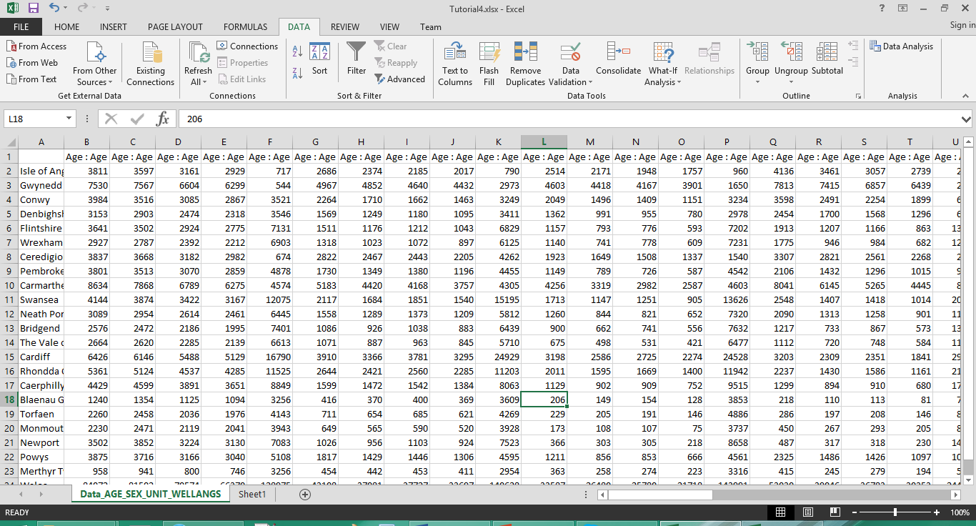
Figure 1: Excel Spreadsheet Example
At the moment the data in its current format is unclear, so we’ll need to use some of the features we’ve learned from the presentation to get a better overview.

Expanding Column Views
Currently we can only see some of the information present within the columns. We can expand upon this by clicking the arrow icon on the top right corner, and then double clicking the edge of one of the column letters. This will cause the columns to expand to fit the content in order to give us a better view of what we’re looking at. Figure 2 shows this information expanded.
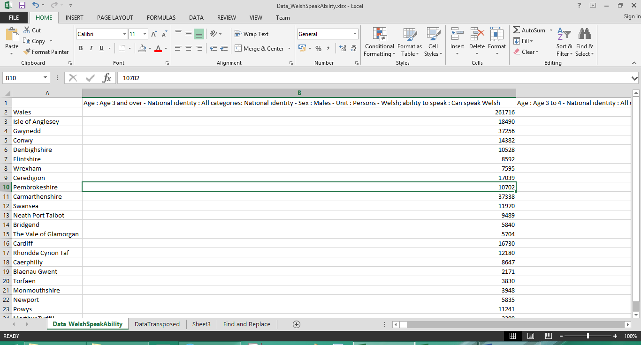
Figure 2: Column View Expanded
Click the scroll bars on the bottom and right of the window to see what information is contained within the spreadsheet. We can see that the columns represent counts of certain categories of information (such as age range, gender, language skills) while the rows represent local authorities within Wales.

Transposing Results
The categories that are present within the columns share similar information which could be more beneficial in separate columns. In order to do this however, we will need to transpose the spreadsheet. To make this easier, click the arrow on the top right and drag the edge of one of the column letters to make all columns the same size and smaller. Once you have done this, click and drag the mouse over the entire spreadsheet. Right click the highlighted area and select Copy (or press Ctrl and C on the keyboard at the same time).
As we’re creating a table in a different format, create a new sheet by clicking the plus icon. In this new sheet, right click a blank cell and select the “Transpose” option amongst the options available for paste. For older versions of Excel you will need to select “Paste Special” and select the transpose option from the pop up window. You should end up with something similar to Figure 3.
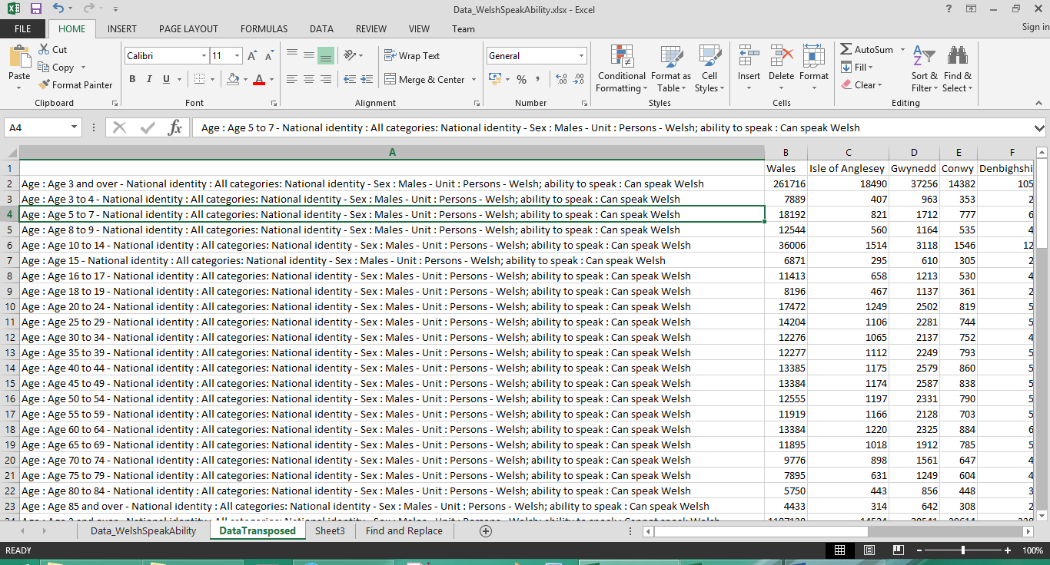
Figure 3: Results Transposed

Using Text to Column Wizard
Now that our category information is in a single column, we can ask Excel to split the information into separate columns. We need to insert appropriate space into the spreadsheet to accommodate these columns. Select Column B, and right click it. From there, click “Insert” to generate a new column. Do this another 2 times so that 3 blank columns are on the sheet.
Once this is done select column “A”, and from the Data tab at the top select “Text to Columns”. A window should appear similar to the text import wizard; as the categories are separated by a specific character we can click “Delimited”. Click next and Excel will ask to select which characters are used to separate the columns. Tick the “Other” box and select “-“ (as shown in Figure 5). You should see the categories split into columns. Click next to proceed to Step 3 of the wizard.
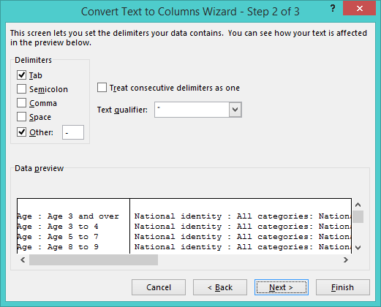
Figure 5: Text to Column Wizard (Step 2)
The next step will ask you to select the specific format you would like for the columns it has found. Some of the information, such as nationality and unit, will not be necessary to display. Click and drag the navigation bars to access these columns, and click them to select the columns. Once selected, pick the option not to import (as shown in Figure 6). Leave the remaining columns to default settings and click finish to complete the conversion. You should end up with something similar to Figure 7 once the conversion has been completed.
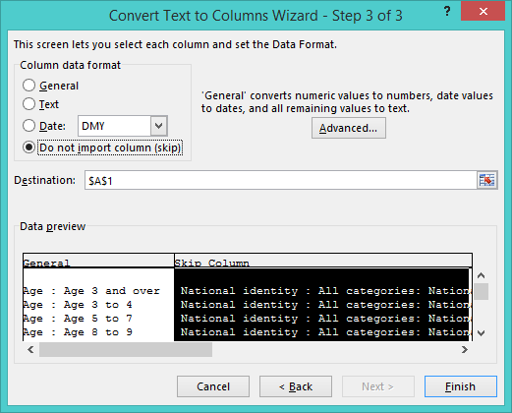
Figure 6: Text to Column Wizard (Step 3)
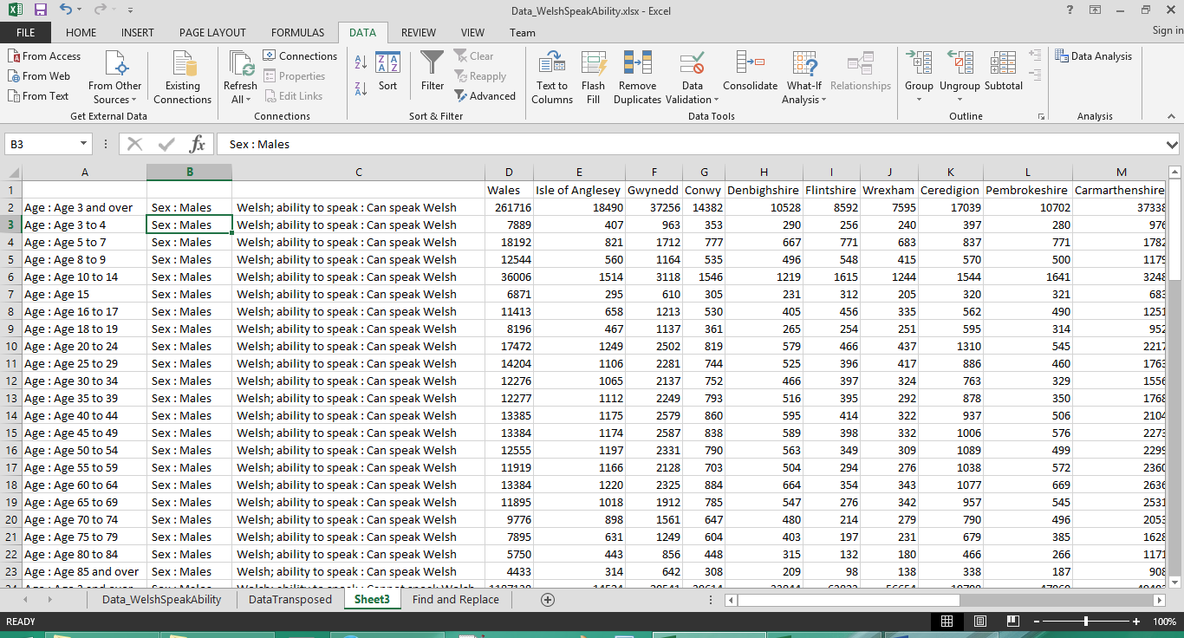
Figure 7: Excel Spreadsheet with new columns

Using Find and Replace
As you can see, what should be the column definition for these categories is now displayed on every row. We can remove this information from our columns by using the find and replace feature in Excel. Select the column in A and press Ctrl and F on the keyboard. A window should appear with a tab to find information and a tab to replace information. Select the Replace tab, and type the following into the two fields:
- In Find What, type “Age : “ (without the speech marks)
- Leave Replace Fields Blank.
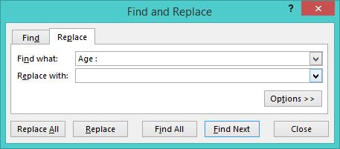
Figure 8: Find and Replace Window
Click on “Replace All”. You should notice that the information in column A has now been trimmed. Perform the same find and replace operation on the text in the other 2 category columns and you should end up with something similar to Figure 9.
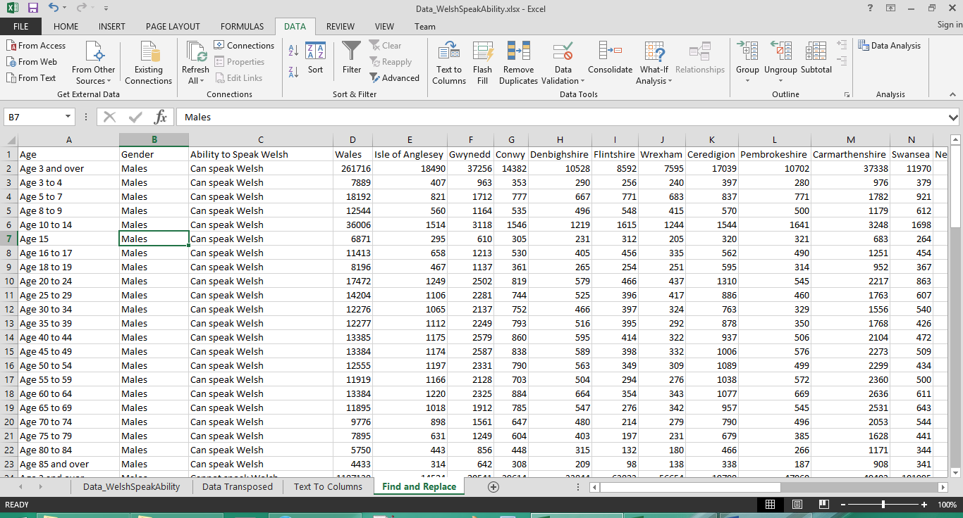
Figure 9: Excel Spreadsheet with information formatted

Sorting Information
Now that our information has been formatted, we can consider exploring some of the information within it. One of the ways we can do this is by sorting one or several columns of information. For this example, we’re going to sort the column of Gwynedd. To do this, click on a cell within the column and in the data tab click on either the A-Z or Z-A column. The information in the spreadsheet should adjust to reveal the highest figures in Gwynedd as shown in Figure 10.
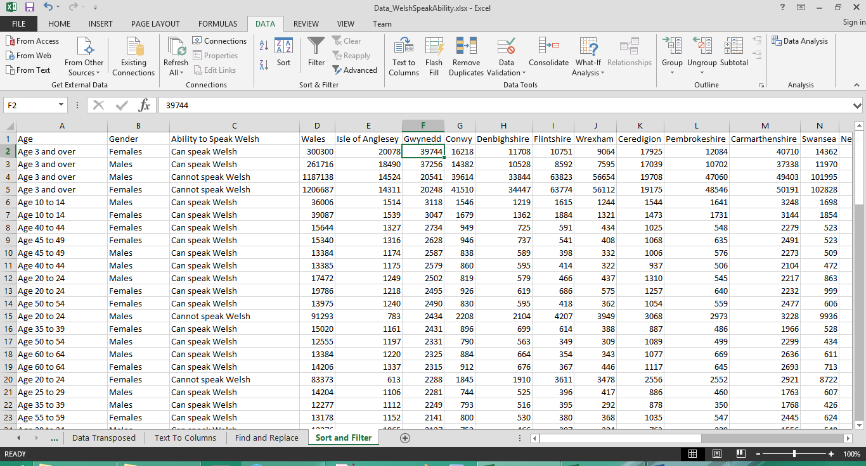
Figure 10: Screenshot of numbers sorted in Gwynedd
We can see quite quickly through the results that Gwynedd is primarily dominant in welsh speakers, while those with no skills rank the lowest. Feel free to explore and document your findings in the other local authorities.

Filtering Information
As the information encompasses a wide variety of categories, you may only wish to view records of a certain category. To display filters on columns, click a cell after the headers and click “Filter” on the data tab. Icons should appear next to the headers; if you click one of them, a drop down box will appear which lists the categories in the column selected. You can click on the checkboxes to remove categories from the spreadsheet. Figure 11 shows a screenshot of the filter in the gender column.
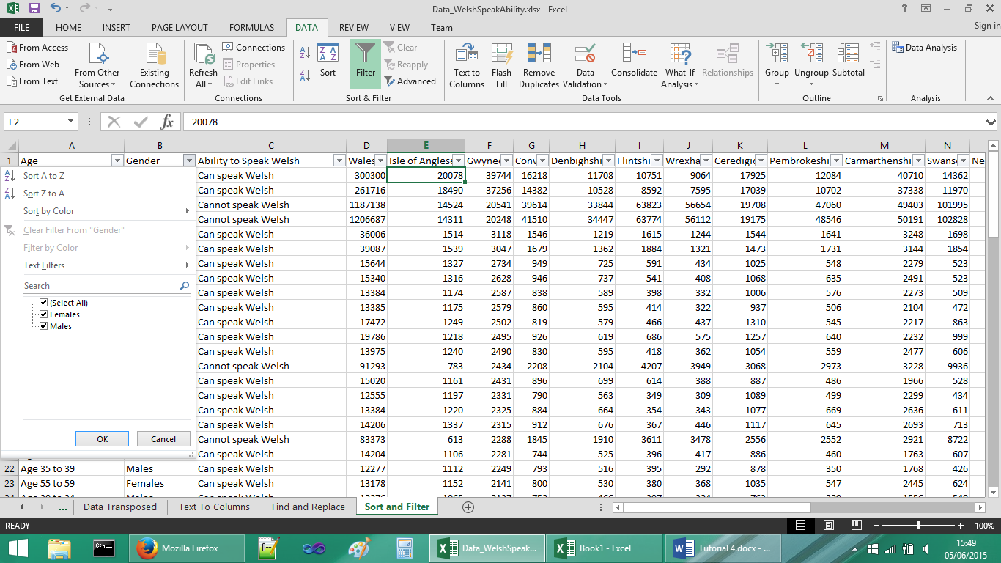
Figure 11: Filtering Window on a column
On removing a checkbox and clicking “OK”, the spreadsheet’s display will adjust to only display the categories selected (don’t worry, the removed information will still exist within the spreadsheet). If you wish to keep this filtered information separate, you can select the filtered information and paste it within a new sheet. This will be helpful if you wish to create charts or calculations on only the filtered information. Figure 11 shows a screenshot with only the Male gender selected.
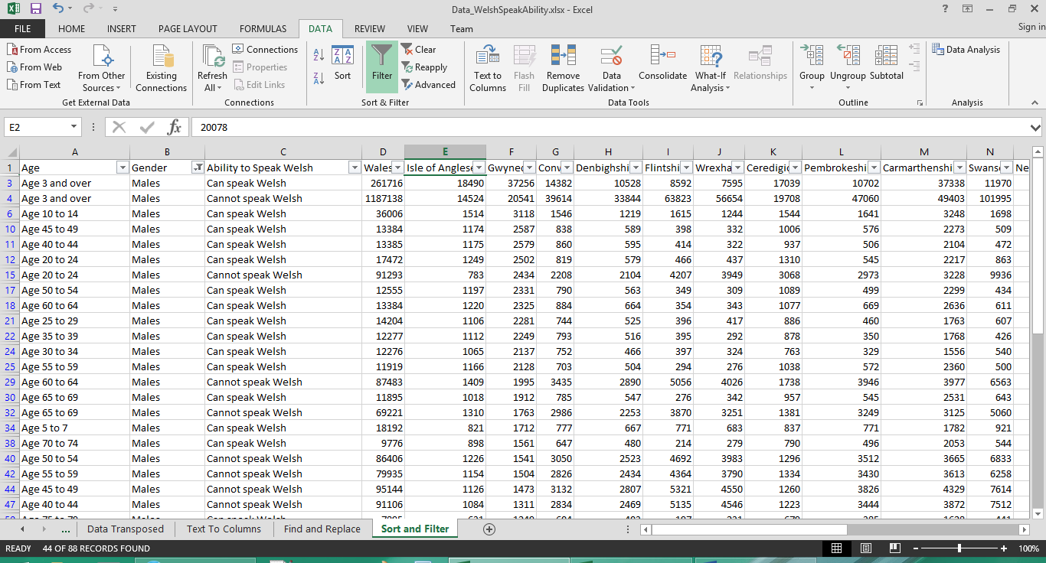
Figure 11: Filtered Information

