International Financial Management
LCBB6002

by Mirela L Andrei 1914800
lecturer Dr Konstantina Mari

Table of Contents
Introduction 3
Importance of International Financial Management concerning Tesco 3
Analysis of Tesco dividend distribution policy 4
Market hypothesis theories 5
Tesco’s methods of appraising projects 6
Conclusion 7
References 8

Introduction
Tesco is a multinational company that works in the retail sector and has a presence in many countries around the globe (Tesco, 2023). Tesco's financial operations are vulnerable to currency fluctuations, political risks, and regulatory changes as a result of its global expansion, making international financial management (IFM) essential for the business's performance. This report evaluates and critically analyses the value of IFM to Tesco while also outlining potential difficulties the corporation faces in various global financial markets. The claims presented in this report are supported by the application of pertinent IFM theories and empirical data based on Tesco.

Importance of International Financial Management concerning Tesco
The management of a company's financial resources in a worldwide setting is known as international financial management (IFM) (Shapiro and Hanouna, 2019). It entails controlling the financial risks that come with conducting business in other nations with various currencies, tax structures, legal frameworks, and political systems. IFM's main goal is to maximise financial returns while lowering risks, making sure that a company's financial resources are used effectively and efficiently across all of its international operations.
Tesco is a multinational corporation that works in the retail sector. Its headquarters are in the UK, and it also has operations in Thailand, Ireland, Poland, and Hungary (Tesco, 2023). The corporation offers a wide range of goods and services, including clothing, groceries, telecommunications and financial services. Tesco's economic activities are influenced by currency fluctuations, political risks, and regulatory changes as a result of its global activities, making IFM important. To control risk and maximise financial returns, Tesco's global expansion has led to a more complicated corporate structure, which calls for a comprehensive approach to IFM.
Currency risk is one of the biggest obstacles Tesco faces in various global financial markets. Currency changes, particularly the exchange rates of the currencies of the nations where the organisation conducts business, have an impact on its financial performance (McMaster et al., 2020). For instance, Tesco's revenue from its foreign operations declines in value when translated to sterling when the British pound is weak against other currencies. Its profitability and shareholder returns are impacted by the same. Regulatory compliance is a more significant challenge Tesco encounters across various financial markets. In the nations where it conducts business, the organisation must adhere to several laws. For instance, Tesco's economic activities in the UK are governed by the Financial Conduct Authority's rules, whereas those in Ireland are governed by the Central Bank of Ireland's rules (Rosnizam et al. 2020). The company must make sure that it has the resources and knowledge required to adhere to various regulations in various nations.

Analysis of Tesco dividend distribution policy
Tesco has a dividend distribution policy that tries to balance the requirement for investing in the company with the need to pay shareholders a sustainable and progressive dividend (A2 Finance, 2023). With a present policy of paying an interim and final dividend each year, the corporation has a history of paying dividends.
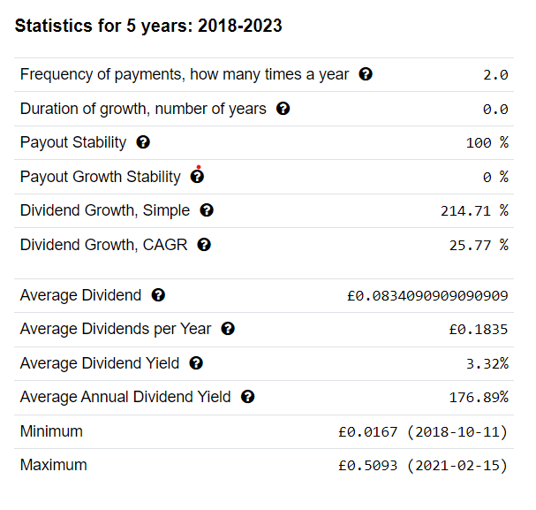
Figure 1: Tesco Dividend History
(Source: A2 Finance, 2023)
Due to the COVID-19 pandemic's uncertainty, Tesco temporarily suspended its dividend policy in 2020. However, the business declared in January 2021 that it would resume paying dividends, citing a healthy balance sheet and liquidity position (Tesco, 2023). Tesco's strategic goals, which include boosting sales and profitability, lowering debt, and investing in growth possibilities, are in accordance with its dividend policy. The business consistently produces excellent financial results.
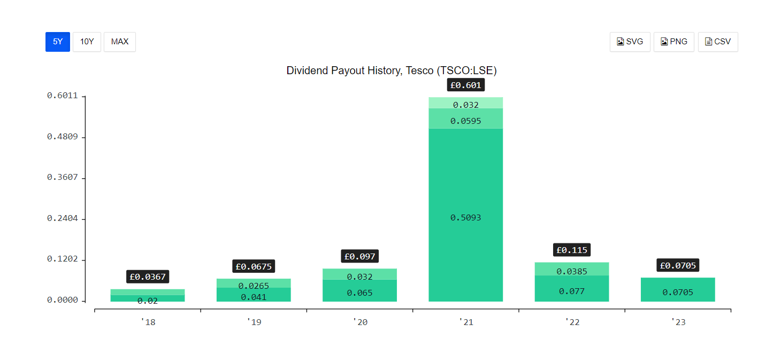
Figure 2: Tesco Dividend
(Source: A2 Finance, 2023)
The company has encountered difficulties in the fiercely competitive retail sector due to mounting pressure from online merchants and shifting consumer habits. Tesco now needs to make significant investments in technology and digital transformation, which may have an immediate impact on the company's capacity to pay dividends. In addition, Tesco has to deal with regulatory challenges, such as the introduction of the UK Sugar Tax 2018, which has had an adverse impact on the sales of sweetened beverages (Rosnizam et al. 2020).
Overall, Tesco’s dividend distribution strategy reflects both its financial results and its strategic goals. The company's emphasis on long-term sustainability and investment in new prospects will probably have an effect on its ability to pay dividends in the near future. However, the company is well-positioned to provide long-term value to stakeholders due to its strong balance sheet and liquidity position.

Market hypothesis theories
The theories of market hypothesis reflect the concept that the price of the share reflects all its information. The first theory relevant to the market hypothesis is investment theory which explains that the costs of instruments which are financial in nature reflect all the information which is available in the market. Therefore, investors in the market cannot have competition on the basis of stock analysis and adopting different strategies at different times because such information can be accessed through the investment theory of market hypothesis. Such a theory is developed by Eugene Fama (Corporate finance institute, 2023). The theory states that investors are capable of earning high returns only when they have the ability to take higher risks in the market. Moreover, the assumptions that take place as a part of such theory are that on the fair value of market prices, the exchange in stocks takes place. The market value of stocks depicts all the information which is relevant for the purpose of the market. Investors cannot make decisions without the usage of investment theory as it helps in representing all the information, which is crucial. The market hypothesis theory reflects whether the robust, semi-strong or weak efficient market hypothesis is taking place in the market.
Another theory based on the market hypothesis is known as the random walk theory, which helps in identifying the information related to assumptions based on the security market and how they function in the market (Groww, 2023). Such security market analysis is also done on the basis of the hypothesis that the investors have all the relevant information in the market. The stock price knowledge is always with the investors with the use of such market hypothesis theory. This theory is also somehow related to the investment theory as it works on the assumption that the stocks are always valued at fair prices, which makes it impossible virtually to buy the undervalued stocks or sell the stocks which are undervalued at higher prices to attain profits in the market. The stock analysis cannot even be done by the expert as well as no strategies in the market can be formed on a timely basis with the hope that the performance can be enhanced in the market on an overall basis. Therefore, the only way can improve the rate of return is for the investors who have the capability to take higher risks in the market and which leads to attaining overall profit and growth of the organisation.

Tesco’s methods of appraising projects
Tesco uses a variety of project appraisal techniques to assess the viability of possible investment opportunities. Some methods used by the company are Net Present Value (NPV), using a discount rate; this method calculates the present value of anticipated future cash flows produced by a project (García-Holgado et al. 2020). The project is regarded as financially viable if the NPV is positive. Next is the Internal Rate of Return (IRR); using this formula, you may determine the discount rate at which the predicted cash inflows and outflows are equal in value. The project is regarded as financially viable if the IRR exceeds the company's required rate of return.
The payback period method is used to calculate how long it will take a project to generate enough cash flow to cover its initial expenditure. Projects that take longer than the maximum payback period are often rejected by Tesco. Another measure is the profitability index, which measures the relationship between the initial investment and the present value of anticipated cash streams. The project is deemed financially viable if the profitability index is higher than one. The Accounting Rate of Return (ARR) approach determines the typical annual profit a project makes as a share of its initial investment. In general, projects with higher ARR are favoured (Shaturaev, 2022). Tesco evaluates possible investment opportunities using a combination of these techniques. The type of project, anticipated cash flows, and level of risk all influence the method of selection. The company's IFM staff is crucial to the appraisal process, analysing financial data and advising top management on suitable investment options.

Conclusion
From the above report, it is concluded that Tesco's globalisation exposes the company to a variety of risks, including currency fluctuations, regulatory changes, and political risks, which need to be mitigated with efficient IFM practices. In order to assess possible investment opportunities, the company uses a variety of project appraisal techniques, such as NPV, IRR, payback period, profitability index, and ARR. The report also looked at the company’s dividend distribution policy, which strives to give shareholders a steady and growing income while balancing the requirement for business reinvestment. Tesco's ability to successfully manage financial risks as well as recognise and seize growth opportunities will determine its capacity to successfully navigate the obstacles presented by the global financial markets and achieve its strategic goals.

References
A2 Finance, 2023. Tesco Dividends. [Online] Accessed through<https://a2-finance.com/en/issuers/tesco/dividends>. [Accessed on 2nd May 2023]
Corporate finance institute, 2023. Efficient Markets Hypothesis. [Online] Accessed through<https://corporatefinanceinstitute.com/resources/capital-markets/efficient-markets-hypothesis/>. [Accessed on 2nd May 2023]
García-Holgado, A., Marcos-Pablos, S. and García-Peñalvo, F., 2020. Guidelines for performing systematic research project reviews.
Groww, 2023. Efficient Market Hypothesis. [Online] Accessed through<https://groww.in/p/efficient-market-hypothesis>. [Accessed on 2nd May 2023]
McMaster, M., Nettleton, C., Tom, C., Xu, B., Cao, C. and Qiao, P., 2020. Risk management: Rethinking fashion supply chain management for multinational corporations in light of the COVID-19 outbreak. Journal of Risk and Financial Management, 13(8), p.173.
Rosnizam, M.R.A.B., Kee, D.M.H., Akhir, M.E.H.B.M., Shahqira, M., Yusoff, M.A.H.B.M., Budiman, R.S. and Alajmi, A.M., 2020. Market opportunities and challenges: A case study of Tesco. Journal of the Community Development in Asia (JCDA), 3(2), pp.18-27.
Shapiro, A.C. and Hanouna, P., 2019. Multinational financial management. John Wiley & Sons.
Shaturaev, J., 2022. efficiency of Investment Project Evaluation in the Development of Innovative Industrial Activities. ASEAN Journal of Science and Engineering, 3(2), pp.147-162.
Tesco, 2023. About Us. [Online] Accessed through<https://www.tescoplc.com/about/>. [Accessed on 2nd May 2023]
Tesco, 2023. Dividends. [Online] Accessed through<https://www.tescoplc.com/investors/shareholder-centre/dividends/>. [Accessed on 2nd May 2023]

