Cai Howes (2205975)


Digital Era assignment

- Study and Employability Skills

Finding the right place to study can influence how effectively a person can work. Finding an environment that is quiet, comfortable and has the required facilities, can be a good step to take. Turning off mobile phones and minimising distractions is also a necessary step to help get the most out of study time. Everyone is different and performs better at different times of the day so establishing peak performance time is another way to maximise workload (UCAS, 2019)
Establishing a routine can help mental health greatly, as it gives a reason to do things at a certain time of day rather than procrastinating and leaving everything till the last minute. To help establish a routine, writing down set times for studying and then maintaining it, can be an effective strategy in managing and completing workload and is also a useful transferable skill that can be used in employment (UCL, 2021)
Taking regular breaks when studying helps to reduce the risk of a heavy workload and burnout. Spending too long studying can affect physical and mental well-being. Watching tv, speaking to friends or exercising are some examples of things that can be done during breaks (Weir, 2019)
Time management is a very important study skill. Problems can occur when proper time management is not in place. Moore et al., (2010) and Cotrell (2019) suggest planning out the day and setting specific times to study and complete tasks, this can help to avoid falling behind.

With regard to communication and interpersonal skill, it is important to speak clearly and understand what the other person has said when they speak. You need to be able to relate to the person speaking and if any instructions are to be given you will need to follow them. A good way to help your communication skills is by joining a debating club this will help you get used to speaking in public with others watching. It can also help your listening skills as you will need to listen carefully to what other people have said.
Using good initiative is crucial in the workplace it shows a strong personal drive and the eagerness on wanting to learn more. It shows that you don’t wait to be told what to do and I trust yourself to do it alone. One of the most important things to have when working in the workplace is teamwork. The ability to mix well with others and not judge people by their beliefs or what they look like. Having good teamwork is crucial for any business to succeed in the twenty-first century. A good way to improve your teamwork skills is by joining clubs where team working is important you could try things like joining a football team or getting involved in community lead projects. When someone is not working as part of a team that’s where things can get messy and may get out of control, they may think that they know what’s right and aren’t willing to change their opinion. An employer will want to get rid of anyone who thinks that they are better than everyone else or who doesn’t want to be a part of the group.

- Mind map of interconnected themes and concepts

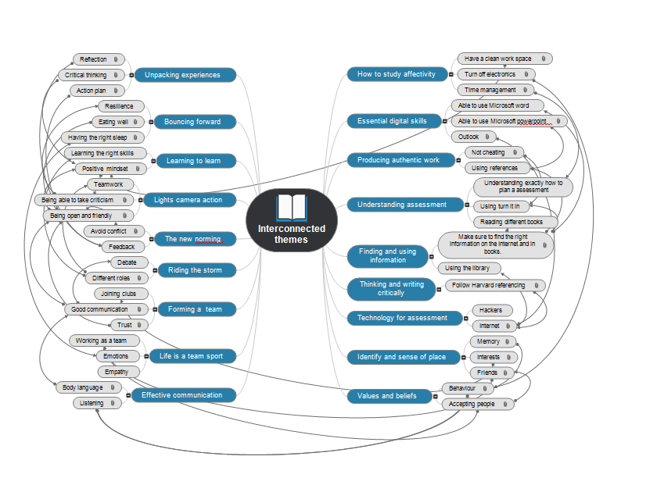

Unit 0 -

Topic 1 – Study Effectively

Studying effectively can be seen as being twofold - a time and a place. Fundamentally, it is about creating the appropriate environment for you to learn effectively. Furthermore, studies suggest that we spend approximately nine hundred hours studying independently. Ergo, this indicates that it is paramount to look in the correct location. Following my research and experiences, I have learnt that it is essential to minimise distractions to studying. Such distractions are to turn your phone off and other electronic devices. Fundamentally speaking, finding the correct time of day to study effectively is vital. Whether in the morning or afternoon, we must understand the right time to learn. The importance of taking regular rest breaks is also pivotal. These could include watching tv, reading a book or catching up with friends. Time management is especially important for studying. Learning to plan and prioritise your workload helps you create good habits. Planning your time is an essential skill, most problems arise when there is no plan or by having vague or unrealistic targets. Using the Eisenhower Principle can help you decide which tasks are the most important to you. Eisenhower organised it into two categories, the important tasks, and the urgent tasks. It is fundamental to use the said method as it prioritises the most important and urgent tasks. I recall watching a video recently on Ted Talks about the dangers of procrastinating and what can happen if you do not prepare. Furthermore, this can be scarier when you do not have a deadline and there is also an issue with perfectionism with regard to students. Some students feel the necessity to try and perfect their work in order to acquire the best results in order to please those around them and themselves.

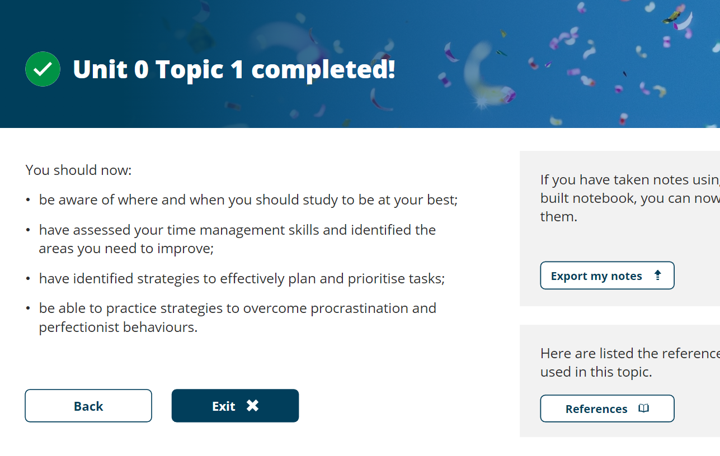

Topic 2 – Office Programmes

Of course, it is important to have an adept understanding of Office programmes. Such programmes consist of – PowerPoint and Word. During my course, it is vital that I can use both for different pieces of work. Through Microsoft PowerPoint, I can make a presentation on a subject given to me by my lecturers and will then be able to present it to them or a class depending on the requirements given. Furthermore, Word will allow me to write pieces of work required for my course and can help me bring my ideas to fruition. With regards to quotes, I am able to use both Word and PowerPoint to do so as research can help back up both different styles of work. Furthermore, with Office, I am able to communicate with my Lecturers, attend Classes and speak with my fellow classmates on Microsoft Teams. This is an innovative app that allows me to do group calls with those in my class to discuss relevant topics at hand and speak face-to-face on a webcam to my lecturer if needs be. Last but not least – I have a good understanding of Microsoft Outlook. Outlook is where I will be able to receive emails regarding assignments and important updates with my course. Furthermore, this is another method of communication that enables me to send emails to those I need to speak to surrounding a particular subject. Moreover, by using these digital apps, I must ensure that I am always staying safe online. By ensuring that I make a strong password and that nobody is given such, I can ensure that I can minimise the risks of using online methods of communication and work. Another tip would be to ensure that I am cautious about opening certain emails I am unsure of as these could contain viruses or malware. I must ensure that my computer runs a virus checker too which can try and weed out any suspicious emails or activity that might occur when searching for information online.

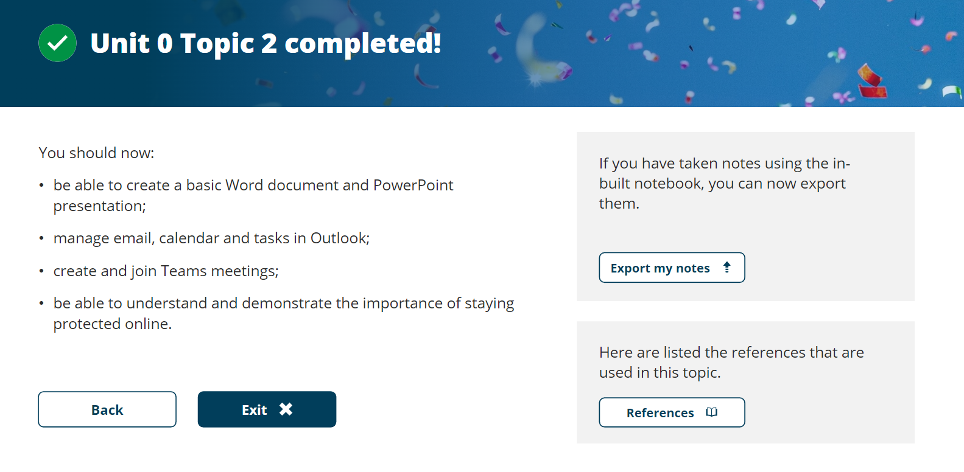

Topic 3 – Plagiarism

This topic highlights the importance of plagiarism. It is important as a learner to not copy the work of those around me or the work of those who have previously submitted an assignment. By doing this, my assignment could be invalid and scrutinised for simply copying what someone else has completed previously. Serious ramifications can come of this such as having my assignment discarded and invalid or even having my position on this course coming into question. However, in terms of finding relevant quotes to support the argument, I am making and to help me with my assignments I am allowed to use these from the internet and other sources if I am referencing these appropriately. It is important that I ensure to use a variety of sources to find relevant information on what I am writing about as it is a means of supporting any argument or piece of writing I have been asked to do. Without doing so, my arguments can simply be seen as subjective and unsupported by others. To conclude, a level of plagiarism can be important with regard to finding relevant quotes and information but merely copying and pasting work from a source and claiming that it is mine can allude to serious consequences.

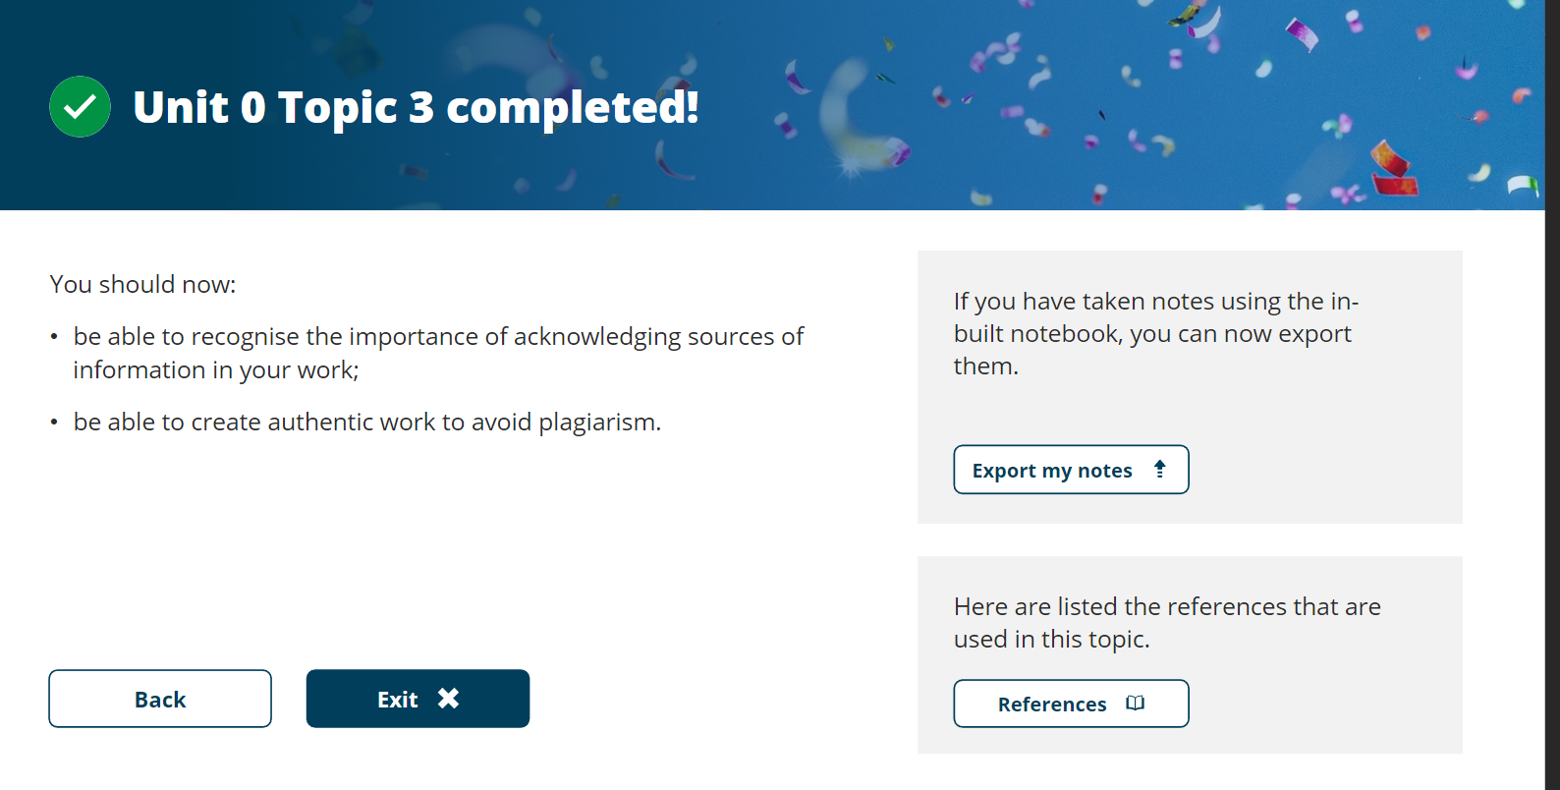

Topic 4 – Understanding assessment

Similar to the topic above – during this unit I have learnt the importance of using a variety of different assessment methods. It would not be wise or favourable for me to only use one type of source when looking at how I can write an assignment or discover information as there are many different ways in which to do so. Some examples of these could be referencing videos online, reading through books that could help support a statement and of course, looking online at different sources to find out more about the subject at hand. With regard to handing in assignments, I understand the role of Turnitin, which is where I send my assignments. After doing so, I then receive a level of plagiarism. As stated previously, having close to zero would suggest that I have not quoted enough sources and have not found enough evidence for my work. Ideally, I would like to aim for roughly twenty to thirty per cent as it would show that I have been able to find a range of different information from a variety of sources that would be relevant to my writings having a high score would mean I have copied too much and would affect my final mark.
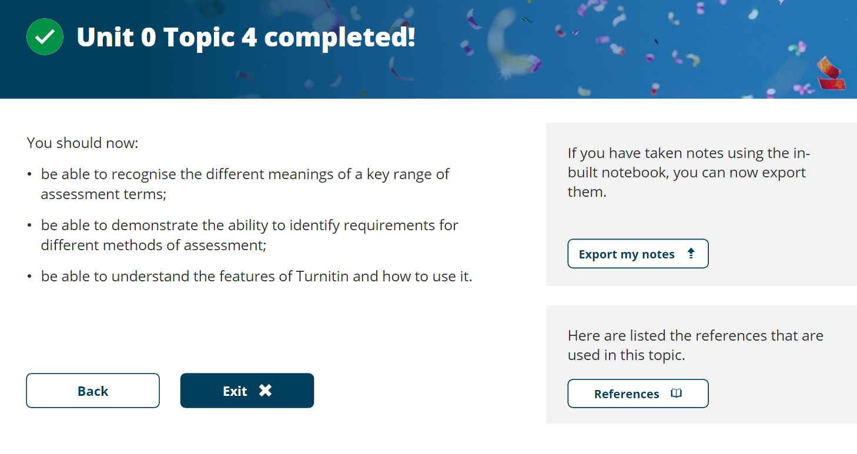

Unit 1 –

Topic 1 – Finding and Using Information –
Firstly, one of the methods of using and finding information is by using the ‘Library Work Pages’. The library offers a wide range of different resources to help learners and me with our studies. By using the URL, ‘www.UTSD.ac.uk.library, I am able to search for information that is relevant to the topic I am studying. Furthermore, I can bookmark certain pages that I am interested in and read them at a later date should I prefer. It is a fact that those that use the library are more likely to outperform those that do not. As stated previously, it is fundamental that learners are using a range of different reading materials to conduct their research. The more you read, the more you know! Moreover, by searching for said information mentioned, I must ensure that the research I am conducting is relevant to what I am studying. Sadly, despite the plethora of advantages of using the internet as a source of information, we have seen a huge rise in ‘Fake News’ that has completely swamped our search engines. It is important that we navigate past these and are able to look at news from reliable sources to ensure that what we are quoting, and researching is reputable. However, it must be noted that are certain disadvantages to using search engines. Many are littered with adverts which can be extremely distracting, and some will provide as stated above, ‘fake news’ on a particular subject. Those with a lot of funding are able to pay to have their results appear first on search engines thus meaning, I must endeavour to search through a variety of sources and ensure that what I am looking at is relevant and of course, reputable and reliable.

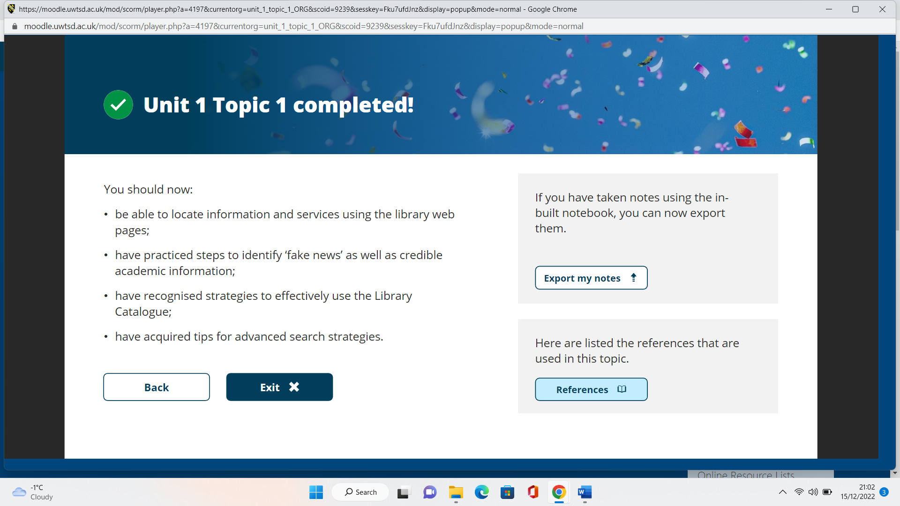

Topic 2 – Thinking and Writing Critically –
To quote Sir Isaac Newton, “If I have seen further than certain other men, it is because I have stood upon the shoulders of giants”. What Newton was suggesting by this was the discoveries he had made could not have been possible without the discoveries made before his time. This is likewise for every assignment and piece of work I write for my course. Without the hard-earned research of those before me, I would not be able to conduct a level of study into the said subject. In order to write academically, I must ensure that I am paraphrasing, summarising and of course, synthesising the research I have conducted. As I have previously stated, I would not be able to pass off information or quotes from scholars as if they were my own. I would need to ensure that I had followed the Harvard Referencing guide with regard to quoting the research from those that I would like to use for my work. Doing this demonstrates that I am not relying purely on the information given to me by my lecturers and I am using a breadth of different sources in order to find and quote the information required. Furthermore, doing a fair share of research into different sources will undoubtedly help me to decide my opinion on the subject matter after I have weighed up the numerous sides to the argument or task given.

Topic 3 – Technology for Assessment –
In 2022, I believe it is safe to say that we are living in the Digital Age. More and more people are turning to use the internet as a means of completing everyday life tasks. Whether it be shopping, researching or even gaming, technology has been a fundamental part of our lives. Technology allows me to turn my assignments in on time, enables me to do a breadth of research surrounding the subjects I am studying and to be able to communicate with those from all across the globe should I need to. In the blink of an eye, I am able to send a message to my lecturers and fellow learners should I require to discuss anything further with them. Furthermore, with technology, I am able to create PowerPoint presentations for my lecturers that contain snappy and tech-savvy graphics to demonstrate my level of IT. However, I understand that there are also disadvantages to relying upon technology. Work can be lost or hacked fairly quickly by anyone, and everyone should they wish to. Also, sometimes it can only be available to those with the funds to be able to spend money on what is required. Furthermore, as stated previously, viruses can completely ruin a perfectly good computer or laptop thus requiring a replacement for a hefty fee. Overall, in spite of the negatives, I can safely say I believe that technology has made the lives of my generation and older a lot easier with everyday life and I strongly believe that we would find it difficult to revert to a time without it.

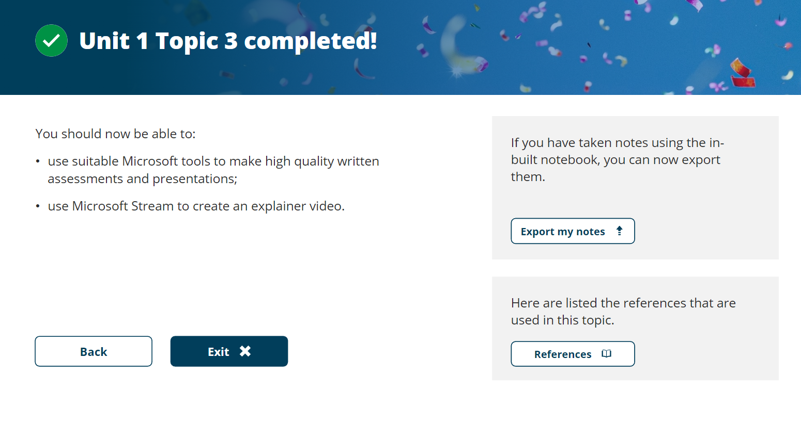
Unit 2 –

Topic 1 – Understanding identity and sense of place –

During this topic, I will be explaining what identity is. Identity can be described as ‘Who you are’, but also, this can be both personal and social. Everyone on the planet has their own sense of identity and how they fit into their own society. No two people can be described as having the exact same identity as we all have different personalities with our own norms and values which depend on the society that we live in. Broadly speaking, there are two theories as to what ‘identity’ means. These are namely – Body and Memory. The body identity theory suggests that you are who you are due to your physical characteristics. You could be someone who is tall or short – perhaps you wear glasses or have a certain hair colour. This can also comprise your interests, such as if you have a particular hobby or that you are the way that you are due to your love for going to the gym, or potentially your lack of love thereafter! The latter theory is to do with your memory. This theory suggests that you are who you are due to your experiences in life. Perhaps you did well at school and achieved something or potentially the complete opposite. In layman’s terms, your identity is shaped by the experiences and memories that you hold. Both would argue that everyone is different as there are no two people that have the same characteristics or the same memories. However, it could certainly be argued that neither of these theories is foolproof. Both your physical attributes and your memories change over time. Bodies change and likewise do memories as we age.
A sense of place would suggest that the places that we visit throughout our life shape who we are and our identity. There could be a particular place that you hold happy memories from, or potentially the complete opposite. Of course, these would all differ from person to person.
To give a quote regarding a sense of place, “We are at any moment the sum of our moments, the product of all experiences”, Menidlow, 1985. It is important that we find our place within a team and understand the importance of working collectively. Llopis, 2014, suggests that in the workplace, “You are part of a greater community, one defined by those areas of expertise and interests that you share with the people well beyond the limits of the organisation itself”. It could be argued that every workplace succeeds based on the relationships built by those inside it, creating a strong framework and producing the best results. An anthropologist named ‘Dunbar’ in the 1990s concluded that there were different layers to the different relationships any individual can have. He suggested that with regard to close loved ones, the maximum number of people is five. The next layer comprising good friends was up to fifteen individuals and up to fifty people you could see as friends. Ro, 2021, followed up on Dunbar’s research to state that, “People migrate in and out of these layers, but the idea that it is the membership of these groups is key to the individuals’ sense of identity. With regards to the benefits of working in a team, it is widely known that there is more creativity with regards to group work. Furthermore, it allows for more than just one view to be shared at one time, allowing others to see from that person’s point of view. In short, the more diversity, the more diversity of opinion. If those involved feel a sense of purpose, they can feel comfortable sharing their views and be able to build bonds with those around them. To summarise, your sense of place within a team is dependent on your role within your workplace. It is important to respect the views of those around you and ensure that everyone feels comfortable with contributing when working in a group.

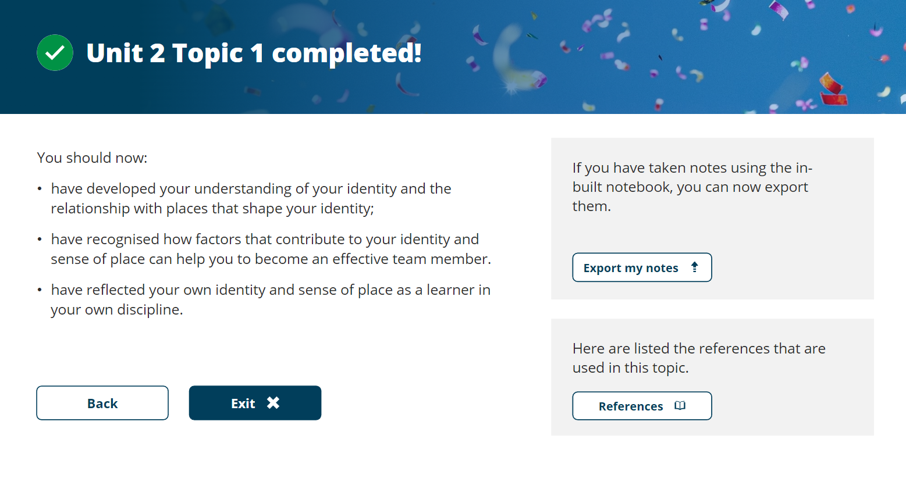
Topic 2 – Values and Beliefs

I have learned in this topic that we all have different beliefs and that childhood experiences can influence the way we see the world. But there can be other things like convenience and peer pressure. The combination of your values, beliefs and attitudes will result in your behaviour.
I learned in this section that professionalism is very important in the modern world and being professional to everyone around makes everyone happy. I’ve learned that it is important to accept people with different values and beliefs than my own and not everyone will have the same viewpoint as mine. Simmerly(1987) taught me that understanding people’s values will help me when I am working in a team in the future to have harmony with everyone around me and improves teamwork with each other.
I found the video they showed in this topic very interesting as it shows many different people from different backgrounds have a lot more in common than they think this can use in my life as a student as I will now try and see similarities within us rather than things that we don’t have in common. A good way of meeting someone new whom you don’t know is to go for a cup of tea with them or something which is less formal this will make us relax more and get to know each other.
People’s values and beliefs may have different from each other there is no right, or wrong answer like in the trolley problem where the person had a choice whether to kill 5 people or kill 1 but there is no easy choice and someone was going to die either way. I have learned that individuals see things differently and there isn’t always a right or wrong answer.

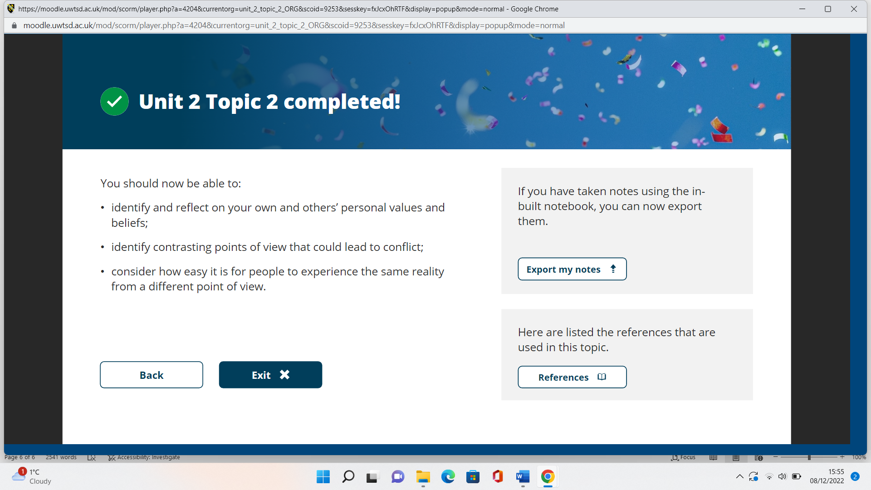

Topic 3
Effective communication
During this topic, I have learnt the importance of good communication. Moreover, many studies suggest that it is one of the most important things that employers look for with regard to employees, along with good listening skills.
I have learned that good communication consists of body language and good listening skills. Furthermore, the way in which someone speaks is as important. It is vital to conduct yourself appropriately when in an interview in order to make a good impression. Terrible things can occur with poor communication - such as what was shown in the video where a bridge fell down and killed many people as a cause of poor communication. Similarly, I have learned that getting clear communication during my university days will help everyone around me as it ensures that I make positive and fruitful relationships.
Using the sender message channel receiver, (SCMR module) I learned that communication is not always as easy as it seems when they said let’s get a dog! Two different people can have two different perspectives on that, thus meaning it is important to give more information so that both sender and receiver know what they mean. I will use this when I am writing emails in university adding visuals emojis to this may help if I am struggling to explain what I am talking about. I have learned that is important to actively listen so that we can fully understand what the person is talking about. I can do this by giving nonverbal feedback, give verbal feedback. Make sure you keep your ears open for the big picture they are saying. Make sure you keep all the conversations relating to the topic they are speaking about and keep responses short with respect to the speaker and use action by telling the speaker what you are going to use this information for. I will use all of this when I listen next and answer a question in class.
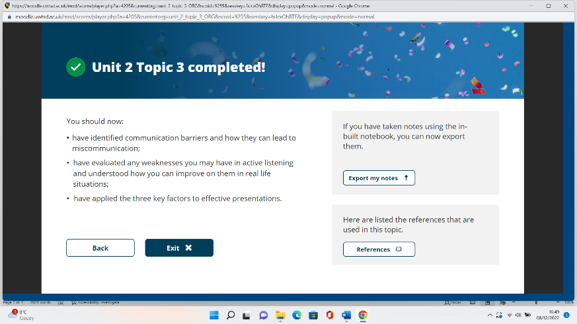

Topic 4 - Life is a team sport
Managing emotions is essential when maintaining a professional environment in work. It is important to realise what triggers you and that will make you more aware of how to deal with them in a positive way rather than getting too emotional. Writing down why I’m frustrated and trying to find an answer will help me get over it. I have learnt that when dealing with worry a good thing to do is to breathe slowly and take deep breaths. Next time I am getting angry I will temporarily leave the place I am in and come back to it later leaving myself to cool down. Martin Luthor king said, “we must accept finite disappointment, but never lose infinite hope” this is very true life has twists and turns and just because bad things happen doesn’t mean there’s no light at the end of the tunnel. There are many things that will help me deal with my emotions these are having plenty of exercises, getting enough sleep, being kind, being positive and socialising.
Empathy is a feeling when people are feeling low empathy helps to show that you are on the same side as that person and are there to reassure them. As humans, we try to sympathise with people and solve problems when someone says something bad has happened, we can be quick to say well at least you still have your job etc. but this doesn’t always make them feel any better than they did before. It is best to hear what they had to say and sometimes saying nothing is the best way to deal with it.
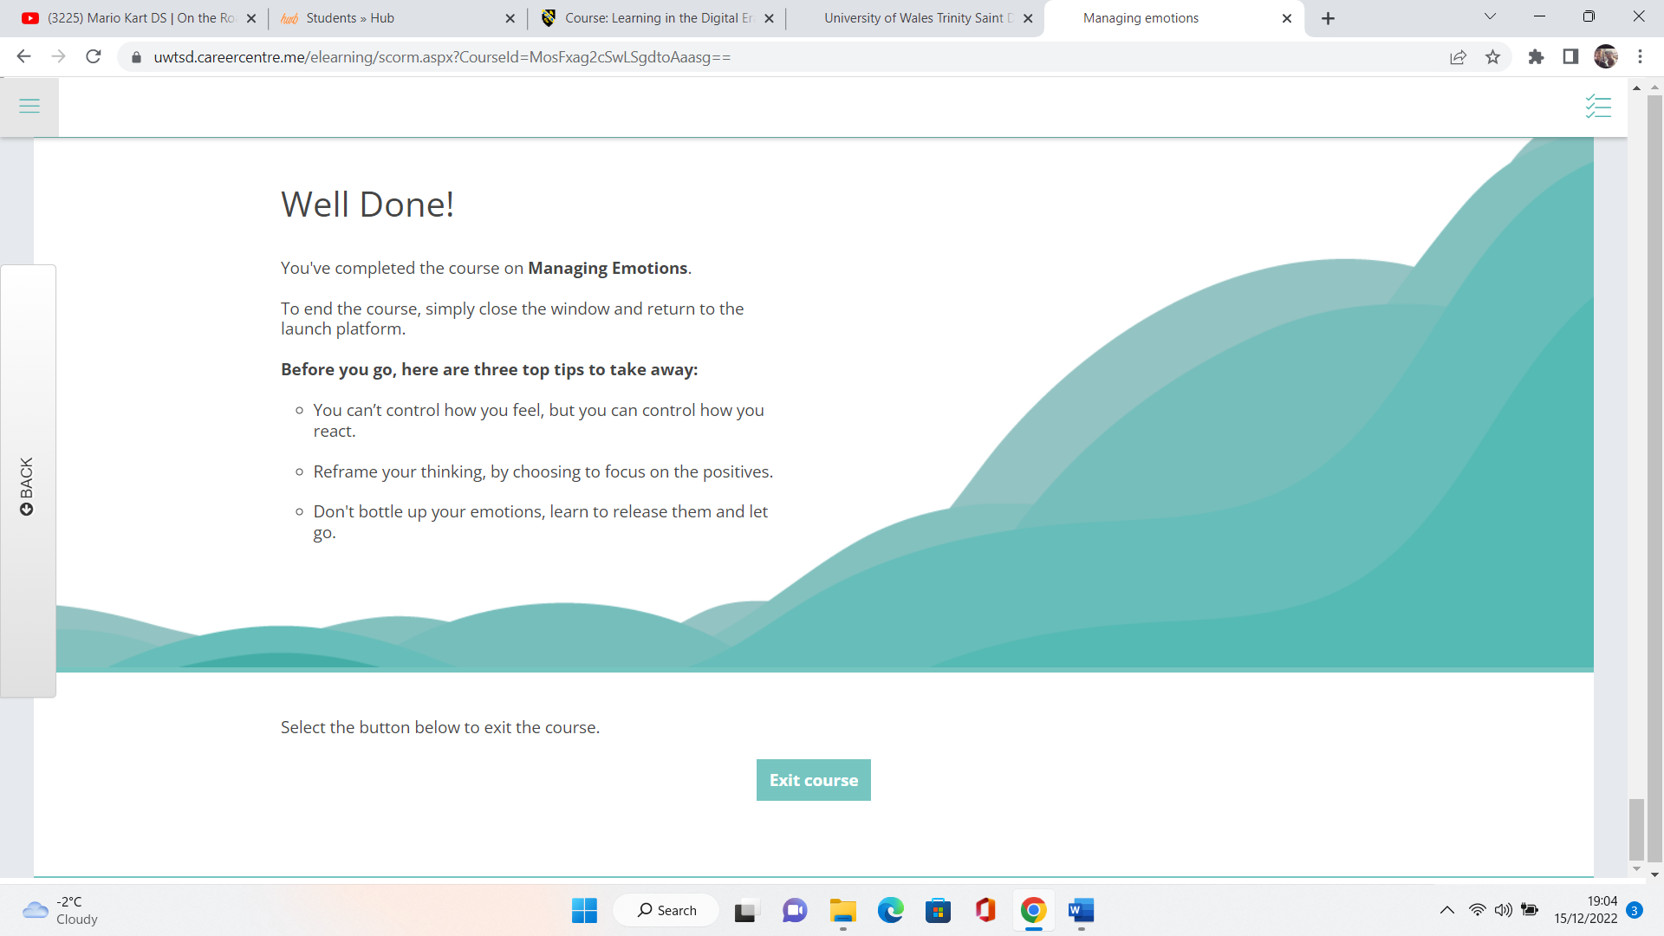

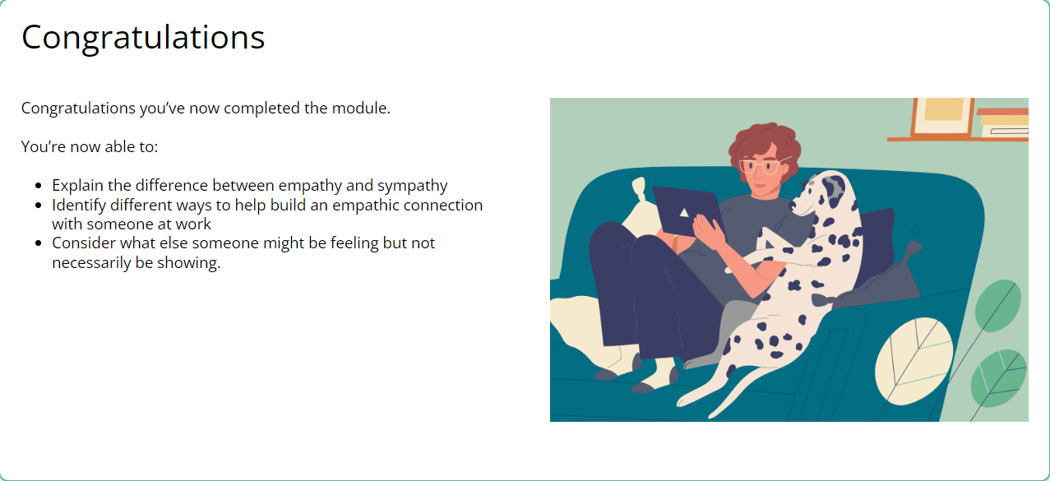

Unit 3 – Virtual Collaboration

Topic 1 – Forming a Team –
As stated previously – when working in a team, it is imperative that there is good communication with those involved. Everyone must feel comfortable in order to gain an equal and honest amount of work from all involved. One of the most fundamental aspects of teamwork is trust. Ultimately, it could be argued that whether a team works cohesively or not is based upon the trust those involved have with one another. (Hayes, 2019), suggests that “When people feel comfortable being open and honest with one another and are in a state of psychological safety, it, in turn, fosters creativity and diversity of ideas”. The importance of trust within a group ensures that all involved have time to build bonds and stronger relationships. (Hickok, 2021) suggests that, “Trust is about spending time together and forming social bonds. Distance breeds distrust”. This implies that when working in a team, it is important that work is conducted together as much as possible, as opposed to everyone doing their own part in different locations. With regards to how this applies to me when I conduct any work as a part of a team, I must ensure that I know how to introduce myself appropriately. It is important that I am authentic and make those around me feel comfortable in order for them to get to know me. “Authenticity helps us to build deeper connections with others by being honest and transparent. Trust can only be built when we are practising authenticity”, (Henna Inham, 2016). Some people may feel it is difficult, to be honest about whom they are when introducing themselves to someone – particularly if it is someone online. This could be from a position of jealousy, shame or even anxiety as they are scared, to be honest about who they are in case of being judged.

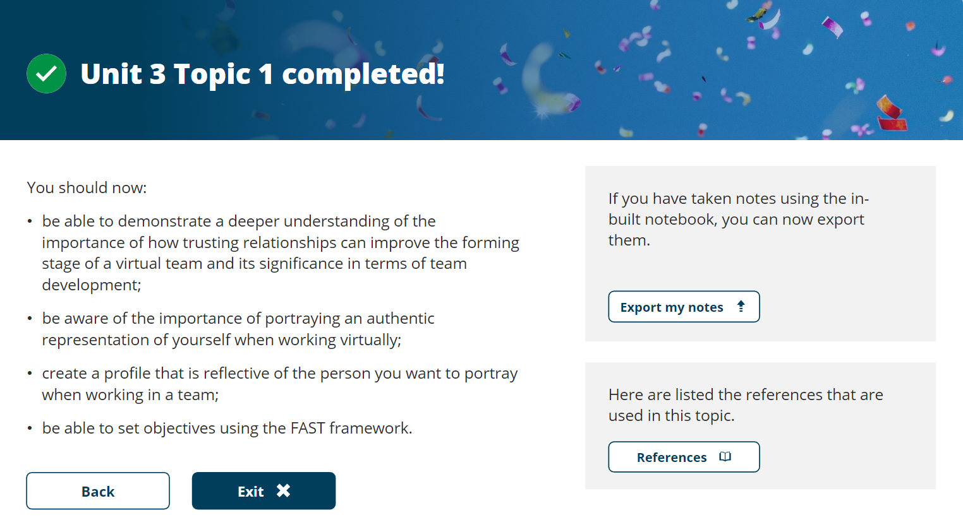
Topic 2 - Riding the Storm
Whilst working in a group, there is always a chance of conflict with those involved – particularly if you have people with strong personalities. (Mullins, 2019) believed that during the ‘storming’ stage of teamwork, groups can show competitive behaviour which can lead to members getting irritated. He argued that sometimes during this stage, subgroups can form, and people begin to take sides depending on whom they get on with best. However, it could be argued that without a level of conflict, there would not be any honest or constructive debate with team members being more preoccupied with what is right as opposed to searching for a solution. When I work in a group at University, I must ensure that all of the team have a particular designated role. (Mullins, 2019, p101) states that a role is, “The expected pattern of behaviour associated with members occupying a particular position within the structure of the organisation”. When working in a team, it soon becomes apparent that roles are usually undertaken by those that they suit best. There are those that are natural leaders, some that are better communicators and some that are very adept at finding and sourcing information. It is of paramount importance that when all learners are being honest with each other about their strengths and weaknesses, everyone is given a slightly different role that suits their ability.

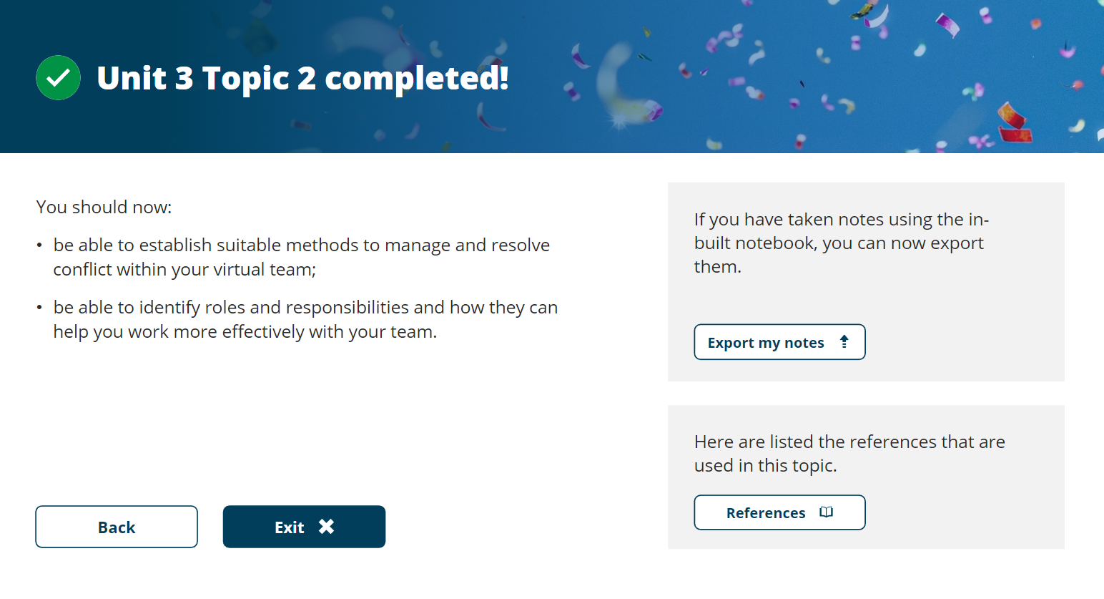

Topic 3 – The New Norming.

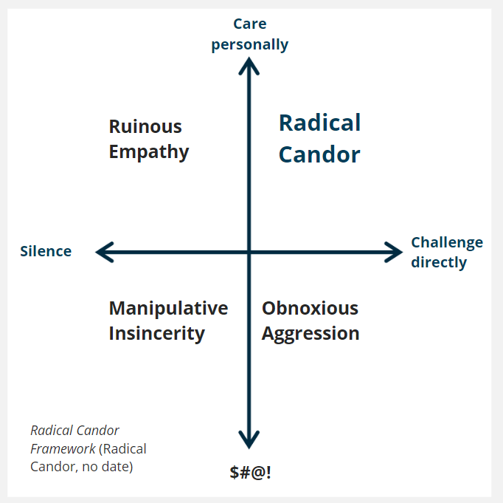
Following, (Tuckman’s Stages of Team and Development, 1977), after Storming which was referred to in the previous topic, the third unit consists of a subject called, ‘Norming’. During this stage, members of the group begin to resolve their differences and form an understanding. Through this section, the members understand who the leader of the group is and who plays what role within the team. (Mullins, 2019) believed that during this stage, members begin to avoid conflict, wish to conform and start to trust one another and the needs of each individual. Following the, Radical Candor principle, will help those in a team to build trusted relationships with all involved. As referred to on the right, in order for this principle to work, it is important that the feedback you receive is appropriate and subject orientated. Furthermore, having a holistic and honest approach with regard to advice can facilitate those that receive feedback are understanding why they are being given such. Feedback is an important tool in the pursuit of self-improvement and working more efficiently in a group.
In the scenario where one of my group members joins another team and we gain one of theirs its important to go into with an open mind and see the positives of what has happened that’s why welcoming them into the group can help this.

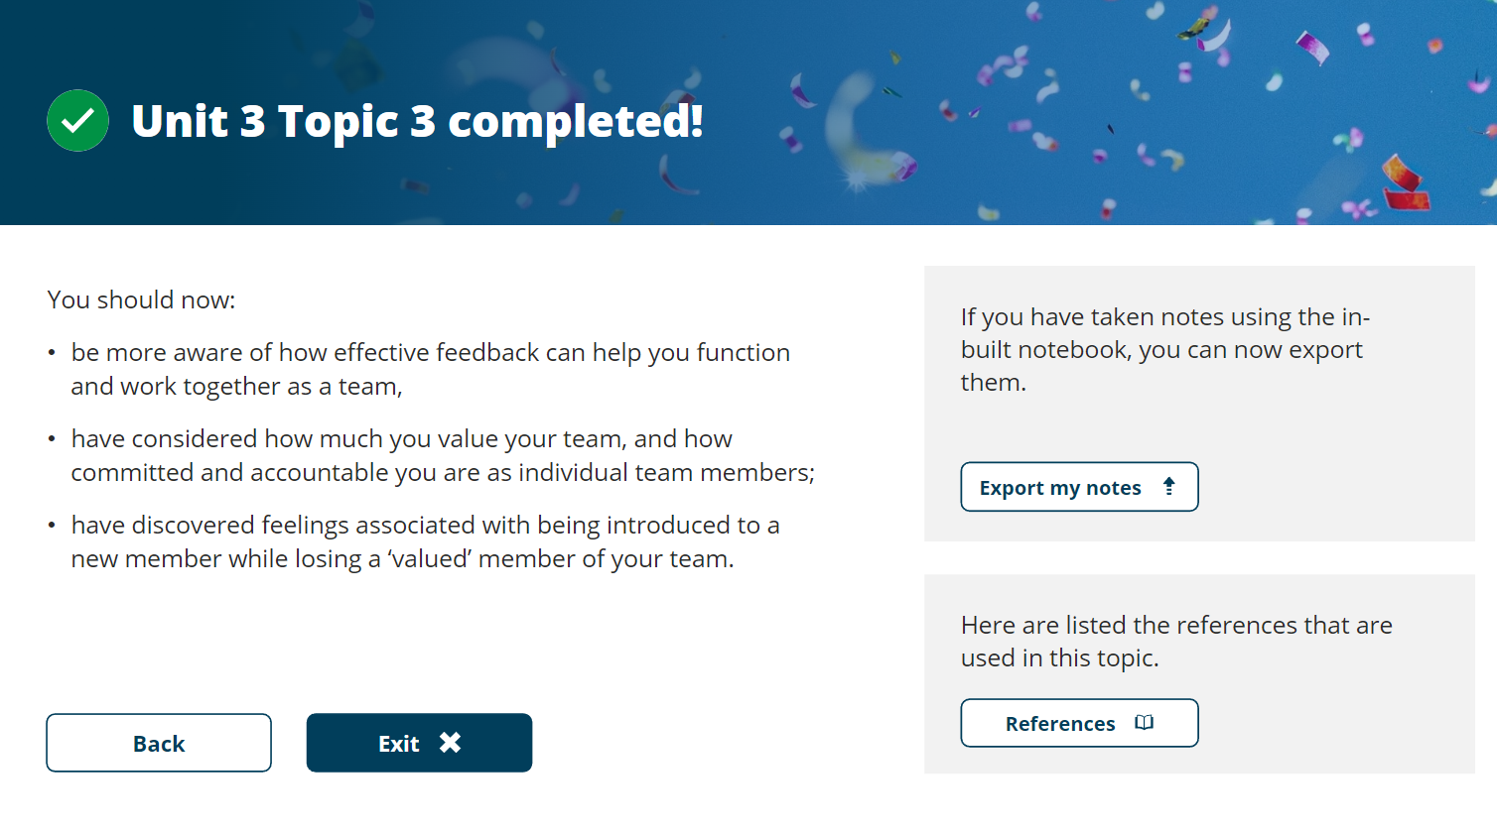

Unit 3 topic 4

In this topic, they show Tuckman’s 4th topic which is performing and how to avoid two key concepts inattention to results and groupthink. I learned in Lencioni video that it isn’t about who is the best at something I learned it is important to focus on what’s best for the team. The team’s best player showed that he was not a team player and showed an inattention to results. What I’m going to use in my student life to make sure I don’t have inattention to results is to get to know my teammates, have a shared vision, set clearly defined objectives, celebrate the success of other team members and remind the team members of their contributions. When I’m doing my assignments with people, I need to do be sure not to fall into groupthink which dismisses the new members’ claims as threats and dismisses their claims. I can do this by always welcoming new input from people and welcoming any new member into the group. Taking criticism is important as what other people have to say will help you improve in the future. I have learned some ways to not fall behind with my assignments to creating a project outline to get team goals, and milestones and gathering project indicators. Checking in regularly will help me to see other team members and talk about the task is very important so you’re all on the same wavelength. Not being afraid to ask for help is extremely important and will let the team feel less stressed and anxious before the task. I can use Microsoft planner to help me be more organised and write down key objectives that each member should fill out.

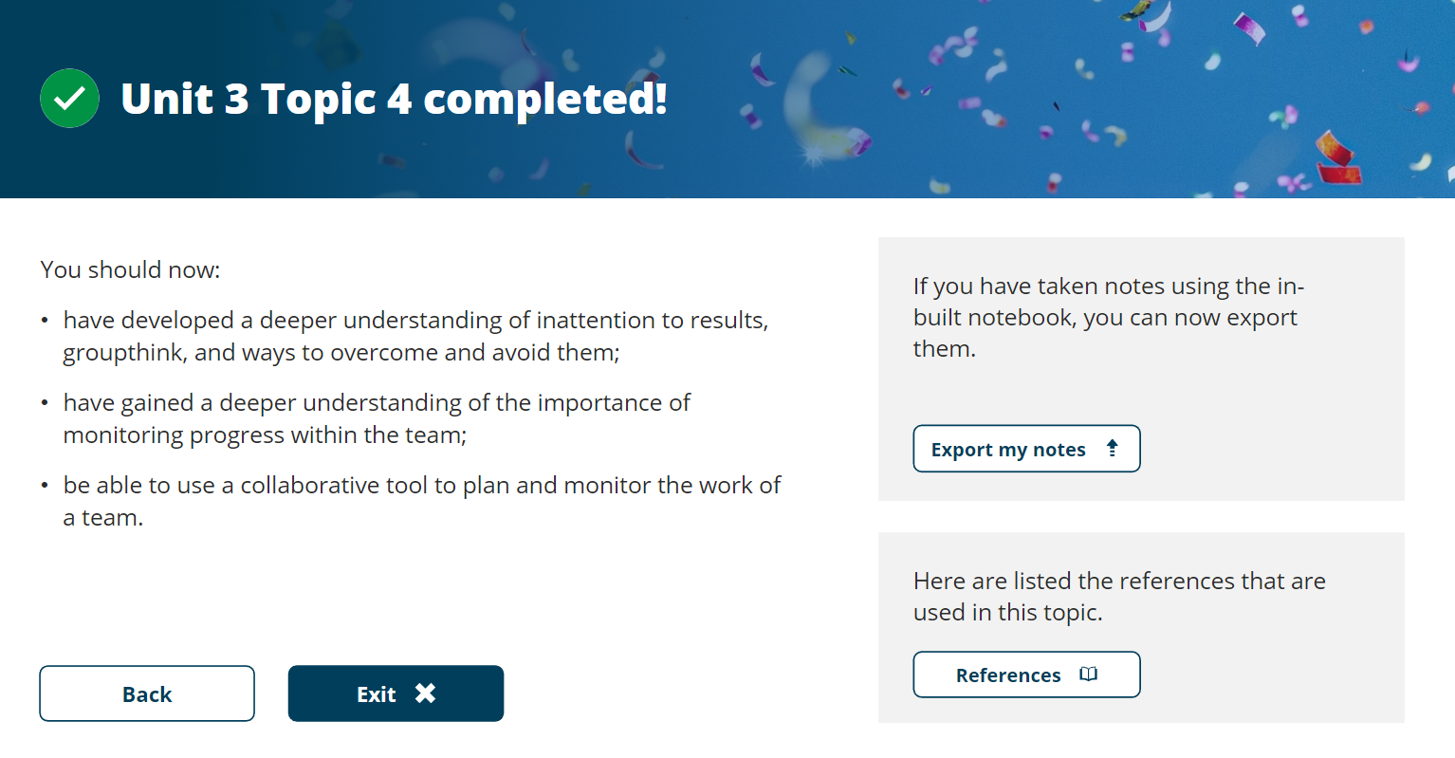

Unit 4
Topic 1
In this topic, I learned that the skills I have now might not be as useful in the future. With the rapid pace, at which technology is moving it is impossible to know exactly what will be there in the future. I learned in the video that having the right skills is more important than where you went to school/university and employers will look for someone who has the essential skills that are right for the company. The author C S Lewis wrote “isn’t it funny that day by day nothing changes but when you look back everything is different” I agree with him we don’t often notice small changes in our day-to-day life but when there are lots of them it suddenly dawns on us those small changes have made one massive one. Agile learning is something that I can use in the future it is someone who isn’t afraid to take risks when unsure and not sure exactly what to do. They aren’t afraid to be embarrassed and thrive under pressure. It is important to have the right mindset when Michael Jordan said that he failed in a lot of areas of his basketball career but because of those failures has made him the player he is today. I can use that by not giving up no matter how hard things get in life as a student and no matter how many times I have failed I have to get back up and fight this will make me into a much stronger individual. English poet John Dryden said that “we first make our habits then our habits make us” this is a great point it’s about making the right habits instead of the wrong ones it is easy to procrastinate but we have to change our mentality and start to make positive habits instead of negative this will help my university life and make it is easier to stay on track. Duhigg (2012) talks about the habit loop in the video this is when we get a stimulus with automatically triggers a routine behaviour and then gives your brain a shot of dopamine, but the trick is understanding the habits you can work your mind to create the habits that you want rather than your mind going onto auto-pilot giving yourself small incremental rewards helps this. I have learned in the anatomy of learning that doing everything to try and avoid stress will lead us to miss out on great opportunities that we wouldn’t have been able to there if we had taken the easy route and quit and it is important to give things a good go before quitting and relish every opportunity you can.

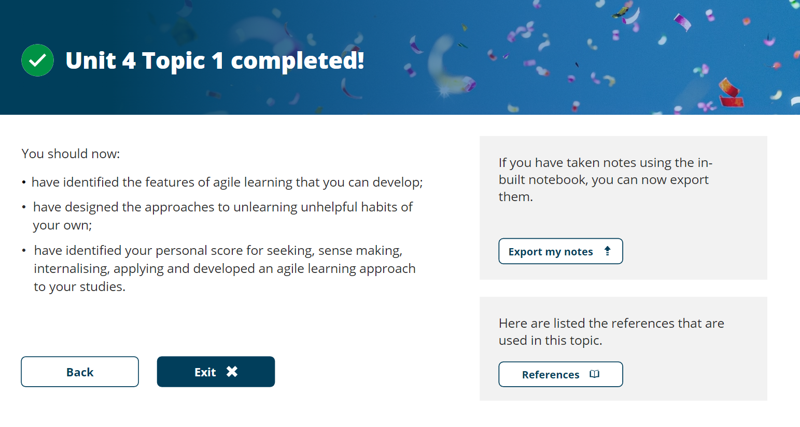

Unit 4
Topic 2
I learned in this topic all about resilience and how important it is. Resilience can be defined as “the ability of a person to adjust or recover readily from illness, adversity, major life changes etc” (Owen2020) resilience can be a great asset for employability with companies wanting someone who has shown that he can pick himself back up when times get tough this shows confidence and strong will power. I have learned that is important to deal with stress and anxiety in the right way some methods I can use to deal with stress or anxiety are recognise the factors that trigger stress, meditating, practising mindfulness practising deep breathing, and talking to a friend can help you out a lot and making sure that you get enough rest. Taking drugs or alcohol to help your stress and anxiety can make things worse and it is important to find help if you are struggling. John Fisher’s (2012) personal transition curve, it shows how anxiety builds into a depressive state which then goes into a positive mindset. It is important to note that not everyone who goes through the transition curve will go through all the steps and the transition phase is completely unique to whoever is going through it. I have learnt having the right nutrition and the right sleep is important to perform at my best.
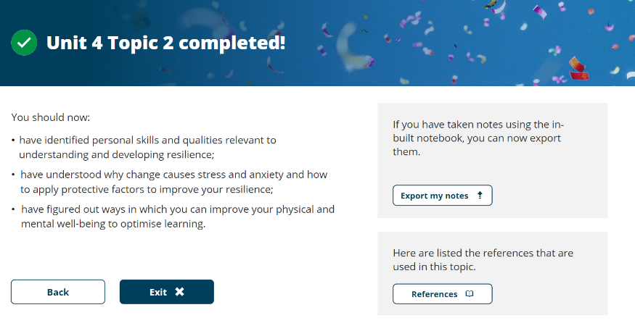

Unit 4
Topic 3
Unpacking experiences
In this topic, I learned first about the importance of reflection and how it can be very important when studying. It is important to look back at the experiences you have and reflect on them and see if you should have done something different and what impact that may have had. I learned in Cunliffe’s video that it’s important to question your own assumptions I answered a young lady in the picture but in reality, there was no right answer, and some people may have just as likely seen an old lady. Critical thinking in life is essential so it requires you to unpack your thoughts and not accept everything you see at face value. In Gibbs’s action plan I learned that there are 6 action plans these are an action plan, feelings, evaluation, analysis, conclusion, and action plan. In the locus of the control section, it made me think if I’m really in control or do I leave everything to chance and hope for the best outcome. I’m going to try and have more of an internal locus of control which is someone who believes that they have the power to control and tend to be hard workers I feel like having this mindset will help my confidence and believe anything is possible.

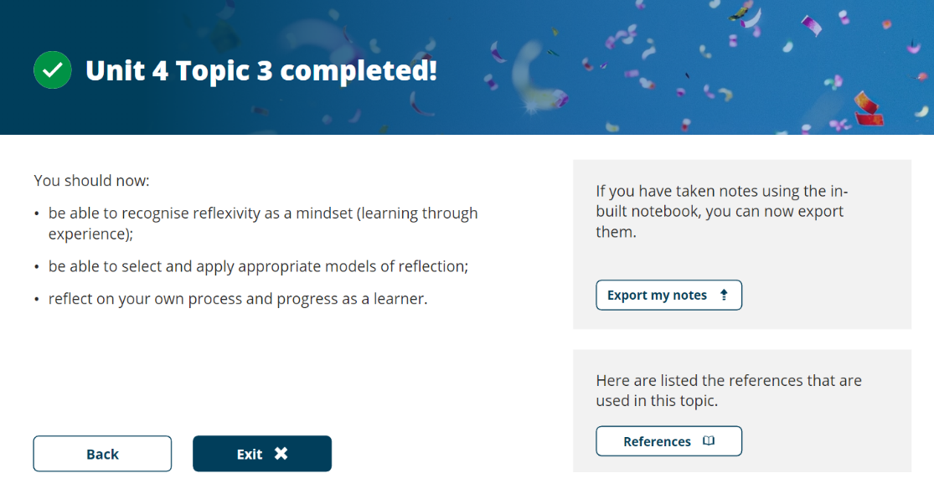

References

Cottrel, S. (2019). The Study Skills Handbook. London: Macmillan Education UK.
Moore, S., Neville, C., Murphy, M., and Connolly, C. (2010) The Ultimate Study Skills Handbook. Berkshire: Open University Press.
UCAS. (2019). How your surroundings affect the way you study. Available at: https://www.ucas.com/connect/blogs/how-your-surroundings-affect-way-you-study (Accessed: 10 December 2022)
UCL. (2021). Creating healthy habits: routine. Available at: https://www.ucl.ac.uk/students/news/2021/apr/creating-healthy-habits-routine (Accessed: 12 December 2022)
University of Exeter. (2022). Employability Skills. Available at: https://www.exeter.ac.uk/students/ambassadors/HESTEM/resources/General/STEMNET%20Employability%20skills%20guide.pdf (Accessed: 15 December 2022)
Weir, K. (2019). Give me a break. Available at: https://www.apa.org/monitor/2019/01/break (Accessed: 12 December 2022)

