BSc CIVIL ENGINEERING
MODULE: MATERIAL ENGINEERING
MODULE CODE: ACBA5005

PLASTICS IN CIVIL ENGINEERING
BY TIMOTHY ISSAC MILLS

- Introduction
According to Statista, in 2021 global plastic production is an estimated 370 million metric tonnes, with the UK having an estimated 2.1 million metric tonnes of waste plastic [1]. Due to the durability of plastics and the degradation time between 450 to 1000 years, there is a push for innovation to introduce recycled waste plastics into all industries.

Waste plastics: -
Polyethylene terephthalate (PET) – Water bottles / plastic trays.
High-Density Polyethylene (HDPE) - Milk cartoons/shampoo bottles.
Polypropylene (PP) – Margarine tubs and ready-meal trays
Polystyrene – Disposable cutlery / CD cases
Polyvinyl chloride (PVC) - Drainpipes, gutters, and roofing sheets

The objective of this research is to establish if current research projects have found plastic to be a suitable replacement for a proportion of fine aggregates.
It will also look at the potential for recycled waste plastics to be used as a bitumen replacement.
The plastic properties that can have the most impact as a replacement are density, thermal properties, fire resistance, mechanical properties & chemical and weather resistance.

- The plastic used as a proportionate replacement of fine aggregate

The traditional concrete build-up is of water, cement, fine aggregate & aggregates. The application of the concrete will depend on the mixture required. Different applications can give different test results, depending on aggregate type and size.
Reviewing recent research papers on waste polyethylene terephthalate (PET) used in concrete, the results are all based on a reference mix using 0% PET replacement. [2/3/4]

  - Density

2.1A. Fresh Unit Weight
The test results show that the fresh unit rate of the reference mix was 24.02kN/m³. When 10% PET was used there was only a 6% decrease to 22.51kN/m³. When more PET replaces the fine aggregate the fresh unit rate decreases with it. 30% PET replacement showed a result of 20% decrease to 19.33 kN/m³ & 50% PET Replacement showed a decrease of 32% decrease to 16.42 kN/m³. These results are expected because the weight of PET is lighter than aggregate. See Table 1 for Results.

2.1B. Slump Test
The slump test results showed a more impactful result when PET was used as a replacement because it shows that even though the expected weight decreases the more PET is added. The slump test is a consistency test and the workability of the mix.

The results shown in Fig.1 [2] show that the standard concrete mix has a slump of 90mm, as the percentage of PET increases the concrete mix becomes more difficult to work with. After 10% of PET replaces sand, the workability decreases by 13% (78mm) to the reference concrete mix. This drastically reduces the more PET replaces sand with 20% PET decreases by 31% (62mm), at 30% PET decreases by 50% (45mm) to the reference mix, at 40% PET decreases by 75% (22mm) to the reference mix & 50% PET replacement reduces the workability by 88% (11mm) to the reference mix.
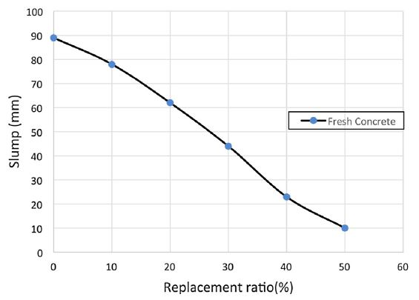

Fig.1 – Slump Test Results with a percentage of PET added. [2]

2.1C. Dry Weight
The readings for the results on the dry weight were taken on days 7 / 28 / 56. The Fresh unit weight of the reference mix was 24.02kN/m³, after 7 days the dry weight of the reference mix dropped down to 23.45kN/m³ with the final dry weight of the reference mix after 56days there is an increase to 23.58kN/m³. See Table 1 below.

 | Fresh Unit Rate  (kN/m³) | Dry Unit Weight (kN/m³)
 | Fresh Unit Rate  (kN/m³) | 7 Days | 28 Days | 56 Days
Reference Mix. | 24.02 | 23.454 | 23.486 | 23.582
PET 10% | 22.51 | 23.176 | 23.234 | 23.241
PET 20% | 21.34 | 22.325 | 22.530 | 22.544
PET 30% | 19.33 | 21.492 | 21.687 | 21.696
PET 40% | 17.84 | 19.194 | 19.542 | 19.669
PET 50% | 16.42 | 17.556 | 17.712 | 17.804

Table 1. Fresh & Dry Unit Weight [2]

As the results show the comparison between the dry weight of the reference mix and the mix including 10% PET only has a minor difference of 0.441kN/m³. It also shows how the more PET is added the lighter the mix becomes.

  - Mechanical Properties

2.2A. Compressive Strength

In the test result of [3], the results show that the reference mix overall has a weaker compressive strength compared to the samples shown with 5 to 12.5% PET included. The 15% Mix shows similar compressive strength to the reference mix with the decline in the compressive strength occurring in the PET mix with 20% and greater included.

These results differ from other results researched where the reference mix has a higher compressive strength than any PET percentage mix. These results highlight that up to a 20% PET mix, there is only a minor drop in compressive strength, once the 30% of PET is included the compressive strength drops drastically. [2/4/5/6]
Fig.2 - 28-day compressive strength of concrete with recycled plastic aggregates [6]

2.2B. Tensile Strength

The test results in all research papers show a similar pattern of compressive strength which is expected, where the reference mix has the greatest tensile strength and the more PET percentage introduced the gradual decline in the tensile strength. These results are expected because of the connection between the PET surface and the cement paste, and the interaction of the wet paste with a smooth surface. Whereas the light aggregate has a rougher surface and allows the bind to be greater allowing the concrete properties to be stronger.

2.2C. Fire Resistance

Fire resistance is a concern when plastic is introduced due to the shrinkage of plastic when heat is applied. The test results in [2] shows the effects of the samples after being applied with 300 seconds of direct flame.
The results explained highlight that the higher plastic content within the concrete mix (30% / 40% & 50%) continued to burn after the 300 seconds had ended, releasing a toxic white smoke. There were also signs of small plastic bubbles forming on the surface.
A positive sign from the fire resistance test for the plastic sample is that there were no signs of cracking showing yet the reference sample had cracking forming on it. The reference sample also had signs of heat penetrating through the sample making the rear hot, whereas the Plastic sample didn't show signs of heat coming through the sample.

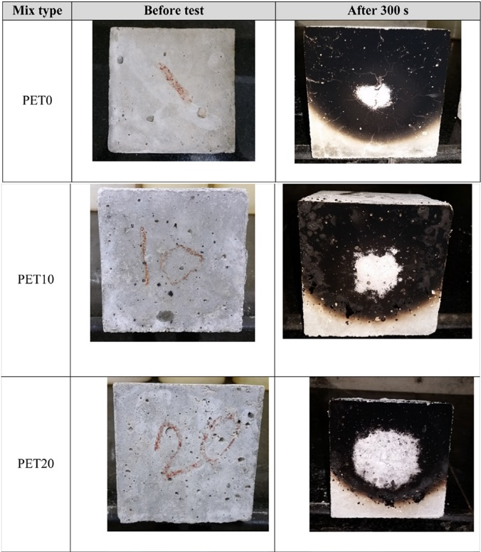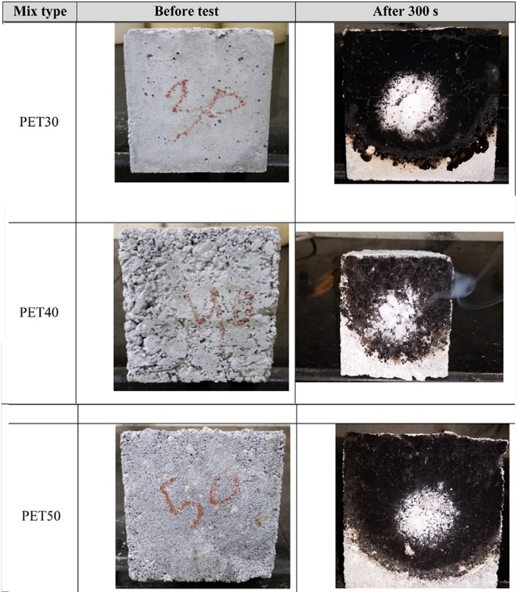
Fig 3. Concrete samples before and after flame test

- Recycled waste plastics as a bitumen replacement

Waste plastic has been introduced into many applications and roads are just one area where they have been introduced both in the UK and internationally. In 2019 the Department for Transport released a £1.6 million budget to trail and develop plastic road technology, this funding was awarded to MacRebur.

Internationally some companies look at using plastic as a bitumen replacement and others have designed a whole roadway out of recycled waste plastic, utilizing underground services within the designs.

I will look at the construction techniques, production processes a case studies where recycled waste plastic has been utilized in roadways. I will then conclude my findings to highlight the advantages and disadvantages of recycled waste plastic in asphalt.

3.1 Road construction techniques & production process

In 2015, the Indian government made it mandatory that any business in the road construction industry is required to have recycled waste plastic within its road construction [8]. This was developed and patented by Rajagopalan Vasudevan of the Thiagarajar college of engineering in 2001 [9]. His technique was to use the same road construction process but to replace 1/10 of the bitumen with plastic, by putting the plastic through the mixing chamber with the aggregate after the aggregate is heated at 165°C the plastic naturally melts and binds to the aggregate giving it a stick/oily look. The plastic-coated aggregate is then mixed with the bitumen and put through the road-laying machine at a temperature of 110°C. which provided the bind between the bitumen and the plastic-coated aggregate.

“The advantages of using waste plastics for road construction are many. The process is easy and does not need any new machinery. For every kilo of stone, 50 gms of bitumen is used and 1/10th of this is plastic waste; this reduces the amount of bitumen being used. Plastic increases the aggregate impact value and improves the quality of flexible pavements. Wear and tear of the roads has decreased to a large extent,” [8]

The plastic road in the Netherlands is the first company to produce a prefabricated fully plastic road, which they installed in 2018 [7]. They have a method of using a fully plastic module that can be used to run services or drainage lines underneath the road.

MacRebur is a company who have developed a method of taking non-recyclable plastics and transforming them into roads. They take the plastic and melt it into an oil-based product, this is then added to the remaining asphalt to create the plastic road. MacRebur is the UK's leading company in the manufacture of plastic roads.

3.3 Case studies of recycled waste plastic in roadways

Some of the case studies which have used the method of Rajagopalan Vasudevan have been the Jamshedpur plastic road [10], which was a twelve to fifteen-kilometre road. Bhagwat lane at Navi Peth was constructed by Pune Municipal Corporation, only a 150mm stretch of road but using a total of 1 tonne of shredded plastic (4% total) [12]. India has pushed for the innovation of plastic roads in the 20th century and has currently installed 60,000 miles of recycled waste plastic roads.

The plastic road company in the Netherlands has two case studies of their application, the first they installed was a 30-meter-long bike path in Deventerstraatweg, Zwolle. The application was to help the water storage capacity, with the unique design that the plastic road has, allowing a large hollow space below which can act as a surface water runoff.
The second application was the same as the first just in a different location in Geithoorn. The reasoning for the application here was due to the poor quality of the existing infrastructure and subsoil. The lightweight construction of the plastic road allowed this application possible.

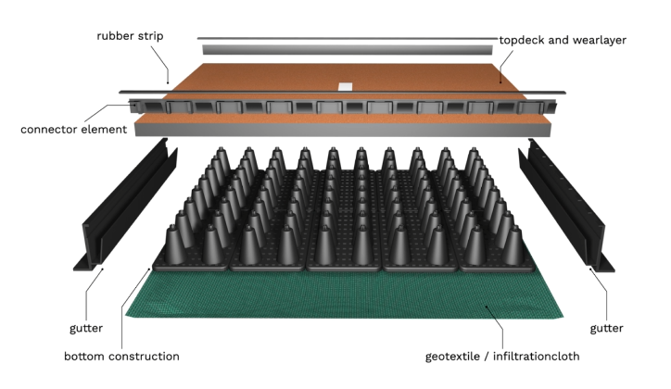
Fig 4. – The Plastic Road – Netherlands [7]

MacRebur has many applications of their plastic road, from across the UK to South Africa, Estonia, and Slovakia, and currently looking to break into the United States of America [15]. The application method has been used for repairing roadways to creating new roads. The application can be based on the use and which product they required.
The MR6 is a complex arrangement of different polymers to enhance the bond between the bitumen and the asphalt used in road surfaces. The typical application for the MR6 is on Large slow-moving vehicles that require the road surface to resist deformation.
The MR8 is a range of polymers used to support the binding of the bitumen to the asphalt. This is the more common mixture used for general road surfaces.

I contacted a local tarmac contractor to ask if they supply tarmac with recycled waste plastic used as a bitumen replacement. The response received was
“Until it becomes a common tarmac manufacture procedure, they will not consider it”

- Conclusion

The plastic used as a proportionate replacement of fine aggregate
Following the research of other tests and reports, I find that a percentage of waste plastic can be used as a replacement for fine aggregate, but the development and tests need to continue to cover all basis before standardizing the process. I believe overall the results show that by replacing 10% of the fine aggregate with plastic (PET) the results are similar in all aspects with only a minor reduction in density and mechanical properties. Once the percentage increases over 10% then the decrease in performance such as the workability of the mixture reduces by 31%, and another is the reduction in compressive and tensile strength. The less strength the mix provides the greater the quantity will be required, increasing the costs and depths required.
More research done on plastics in concrete will only benefit its case, it will surely have a future impact within the industry to reduce the amount of aggregate required. The development needs to include how to make the concrete more fire resistant, whether it's a simple case of introducing additives. Also, the highlight on the compressive and tensile strength reduction needs to be captured during the analysis stage and be included in British standard documents if this concrete method was to be used as a construction solution.
The Plastic could be used as a replacement in items that are not reliant on its strength properties such as pavement curbs.

Recycled waste plastics as a bitumen replacement
Overall, there has been some real progress with the integration of plastics in the road construction industry. One of the major factors is that it is cutting the number of waste plastics that are going to landfills and polluting the earth. All countries are looking at innovation in the plastic road industry, and with more research into plastic roads, it can only get better and be more efficient and sustainable for companies going forward.
The main issues that waste plastics in asphalt are the toxics that presents themselves during the plastic road construction, and the leaching produced which can cause difficulty in cleaning. This should be resolved with approved suppliers who have the correct procedures to reduce/eliminate the presence of these toxins.
The application that the plastic road company in the Netherlands is exquisite for any new proposed roads/infrastructures. The problem may arise when trying to integrate this system into an existing roadway, with current drainage systems and manholes that could cause the system some problems.
The quote from the local tarmac contractor was not a surprise. I think if the innovation needs to be across the UK then the government needs to standardize the process and promote the innovation of the use of plastics in road surfaces.
MacRebur road surfaces have been able to stand out from any other UK manufacturer due to the funding they received to develop the use of plastics in asphalt. They have produced a system where they are averaging 6% replacement with recycled waste plastics. MacRebur has proven there is a solution to adding plastics into the asphalt to make the road surface a more sustainable and robust material.

- REFERENCES
- https://www.statista.com/topics/4918/plastic-waste-in-the-united-kingdom-uk/#dossierKeyfigures
- Ibrahim Almeshal, Bassam A.Tayeh, Rayed Alyousef, Hisham Alabduljabbar, Abdeliazim Mustafa Mohamed. Eco-friendly concrete containing recycled plastic as partial replacement for sand, J Mater res technol.2020;9(3):4631–4643.
- Abbas O.Dawood, Hayder AL-Khazraji, Raad S.Falih. Physical and mechanical properties of concrete containing PET wastes as a partial replacement for fine aggregates, Case Studies in Construction Materials 14 (2021) e00482
- Juki MI, et al. Relationship between compressive, splitting tensile and flexural strength of concrete containing granulated waste polyethylene terephthalate (PET) bottles as fine aggregate. Adv Mater Res 2013;795:356–9.
- Frigione M. Recycling of PET bottles as fine aggregate in concrete. Waste Manag 2010;30(6):1101–6.
- Adewumi John Babafemi, Branko Šavija, Suvash Chandra Paul, Vivi Anggraini, Engineering Properties of Concrete with Waste Recycled Plastic. Sustainability 2018,10,3875.
- Circular, climate-adaptive, and Lightweight [Internet]. PlasticRoad. 2022 [cited 2022Dec14]. Available from: https://plasticroad.com/en/
- Menon A. Roads made of plastic waste in India? yes! meet the professor who pioneered the technique. [Internet]. The Better India. 2016 [cited 2022Dec14]. Available from: https://www.thebetterindia.com/43685/plastic-waste-in-road-construction-plastic-man-india-prof-vasudevan/
- P. Guruswamy Goud, M. Rajasekhar, N. Vijayakumar, K Snehalatha, B. Bhanu Prasad. Case Study on Plastic Roads. Journal of Transportation Engineering and Its Applications, Mantech Publications 2021:1-10
- Bisoee A. Jusco shows plastic road map to four cities [Internet]. Telegraph India. Telegraph India; 2018 [cited 2022Dec14]. Available from: https://www.telegraphindia.com/jharkhand/jusco-shows-plastic-road-map-to-four-cities/cid/1371328
- Team WS. Can we make Indonesian roads out of recycled plastic? [Internet]. WowShack. 2017 [cited 2022Dec14]. Available from: https://www.wowshack.com/indonesian-plastic-roads/
- Desk P. Roads made from plastic waste on the way for Pune [Internet]. Pune Mirror - Get the latest news of Pune &amp; Pimpri Chinchwad. 2016 [cited 2022Dec14]. Available from: https://punemirror.com/pune/civic/roads-made-from-plastic-waste-on-the-way-for-pune/cid5233951.htm
- Cameron J. What are plastic roads: How to make plastic roads: Who invented plastic roads: First man made plastic road: Advantages &amp; disadvantages of Plastic Roads [Internet]. CivilJungle. 2021 [cited 2022Dec14]. Available from: https://civiljungle.com/plastic-roads/
- Sparrow N. Scotland's MacRebur brings plastic roads to Us [Internet]. plasticstoday.com. 2021 [cited 2022Dec14]. Available from: https://www.plasticstoday.com/automotive-and-mobility/scotlands-macrebur-brings-plastic-roads-us
- Case studies [Internet]. Macrebur. [cited 2022Dec14]. Available from: https://macrebur.com/case-studies

