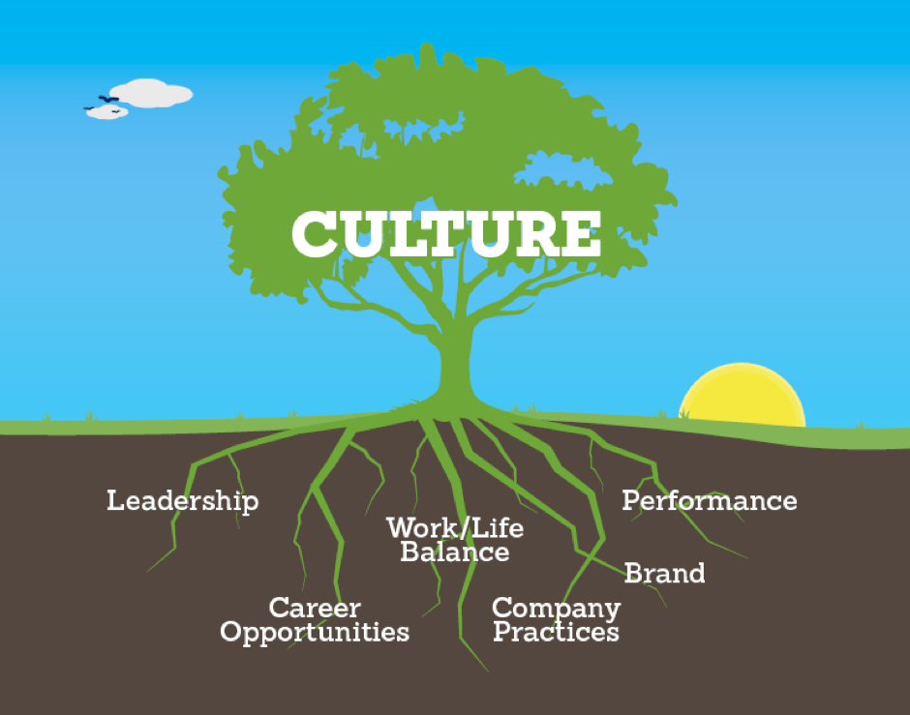
Workplace Culture and its impact on Organizational Efficiency
BMSW5005

Name: Shameem Akhtar
Student No: 1708753
Lecturer: Mr Yohan Mendis
Group: 3

Contents
Introduction: 3
Company Overview: “Home Instead” 4
Task 01 The External Environmental Analysis of Home Instead: Porter’s Five Forces Framework: 4
1.1 Bargaining Power of the Customers: Moderate 5
1.2 Bargaining Power of the Suppliers: Low 5
1.3 Barriers to Entry: Moderate to High 5
1.4 Threat of Substitute: Low 6
1.5 Competitive Rivalry: High 6
Legal Requirements for the Area of Work: 7
Task 02 Analysis of the internal context of Home Instead: Mckinsey’s 7S Framework 8
2.1 Strategy: 8
2.2 Structure: 8
2.3 Systems: 9
2.4 Skills: 9
2.5 Staff: 9
2.6 Style: 10
2.7 Shared Values: 10
Task 03 The Ethical Stance of the Organisation: 11
Task 04 A Comparison of Culture of “Home Instead” to That of “Elder”: 12
Task 05 Recommendations to Further Enhance the Workplace Culture Home Instead in the Future: 14
Conclusion: 15
References: 16/17

Introduction:

The undertaking of this report intends to provide information regarding different aspects of the organization that provides a range of diverse services to senior people including dementia care, personal care, housekeeping, etc. The report initiated the discussion by giving a short overview of Home Instead, and then, Porter’s five forces framework has been deployed to examine the external environment, mainly the factors concerning the client, supplier/caregiver, and competition in the industry. The internal analysis has been conducting using Mckinsey’s 7s framework and their impact on the agency’s performance has been explained with scrutiny. The ethical position of the organization in terms of ensuring the interests of the different stakeholders is clarified in the report, which is followed by the discussion on the comparison of the corporate culture of the firm with that of a competitor. Lastly, some recommendations are communicated so that the culture of the company can be improved further.

Company Overview: “Home Instead”

Home instead is considered as one of the leading senior care organization, which matches a carer best suited to the needs and requirements of the elderly people. The company provides a number of services through the carer, that is, live-in care, companionship, personal care, housekeeping and home help, palliative care, respite emergency homecare, etc. (Homeinstead.co.uk, 2019). The company is committed to ensuring the continuity of the superior and bespoke homecare service quality, local services embedded with global expertise, improvement of the homecare services to augment the customer experience.

Task 01 The External Environmental Analysis of Home Instead: Porter’s Five Forces Framework:

The attractiveness of the market and industry is important for both the employer and the employee, which can be evaluated by examining the external environmental factors, which will affect the industry and eventually the organization working within the industry. The established framework of Porter’s five forces examines the external factors on five different dimensions that relate to the consumers, suppliers, competitors, new entrants, etc.
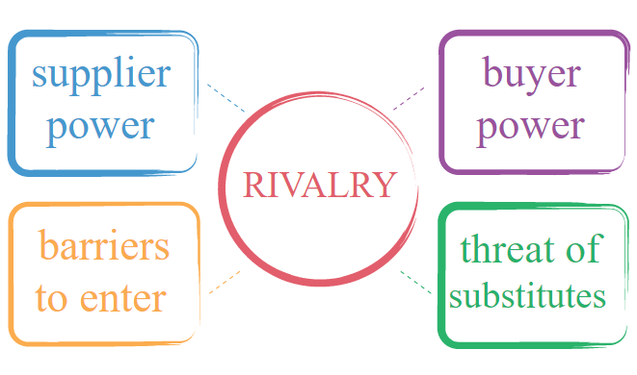
Figure 1: Porter’s Five Forces Framework, Source: Author

1.1 Bargaining Power of the Customers: Moderate
The switching costs of the customer are moderate because they are expected to have full information about the services of other companies providing the similar services (Baron, 2013), however, the quality of the services “Home Instead” provides at a reasonable price is difficult to find, which is why they do neither possess high nor low bargaining power in terms of influencing the price. Another reason behind the moderate level of bargaining power of the customers is the fact that the number of customers is high and there exists no threat of backward integration.

1.2 Bargaining Power of the Suppliers: Low
The bargaining power of suppliers does not fit the context and hence, the bargaining power of the carers will be considered under this dimension. The number of carers is large and hence, the company needs not to rely on a few ones, though the long-term relationship is an important factor the company values. The switching cost of the organization is very low as it can procure the skilled workforce easily with little cost involved. The threat of forward integration is a remote possibility, however, the carers may choose to provide services on a personal basis, which does not pose a significant threat.

1.3 Barriers to Entry: Moderate to High
The capital requirement for entering the business is not very high, which induces the new entrants to operate the business in this prospective industry because of the demographic change towards the composition of the UK populations, which will include more elderly citizens. The existing customer base and customer relationship activities of the industry incumbents will bar the entrance to the market as the new market players will find it cumbersome to build their own client base (Ananthan, Appannaiah, and Reddy, 2018). The stringent government regulations, which will be covered under the legal requirements on the area of the work segment, also discourages some organization to enter into the industry.

1.4 Threat of Substitute: Low
The hospital and nursing homes provide similar types of services; however, it does not fit well to the requirements and preferences of the customer segment this industry serves, and hence, the switching costs of the customers are high and they are less likely to shift. The threat is further undermined by the cost comparison between these two different types of services, and that is why the threat is observed to be low.

1.5 Competitive Rivalry: High
The current growth rate of the industry is revolving around 3-5%; however, this rate is expected to rise with the quick pace of the demographic pace. The slower growth rate implies fierce competition the market players are engaged in because the only way they can grow is by taking away the market share of the other companies. The number of businesses competing in the market is neither high nor low and is of somewhat equal size, which breeds another reason behind the heated competitive environment. The companies are offering a better quality of service at competitive prices, which are forcing the organizations to engage in stiff competition.
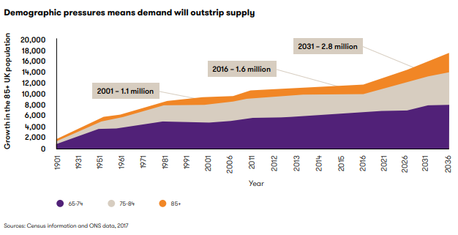Figure 2: Demographic change in the UK, Source: (Grantthornton.co.uk, 2019)
The Porter’s five forces framework led to conclude that currently, the industry conditions are not very attractive, however, the industry shows great prospects for the future, which ramps up its lucrativeness.

Legal Requirements for the Area of Work:
To work in this segment, several regulations will have to be complied with (Grelecki and Willey, 2017), for example, the license must be acquired from Department of Health and Social Care (DHSC), NHS, Care Quality Commission, and other regulatory authorities to be qualified as a carer, who will be allowed to provide several homecare services to the customers while working for the company. In addition, the Health and Social Care Regulations 2014 (act 2008) will dictate the quality of service that must be ensured in regard to personal care, Live-in care, etc. The other regulations that the company will have to abide by are Care Quality Commission, IP right act., Health and Safety at Work act, Company act., etc.

Task 02 Analysis of the internal context of Home Instead: Mckinsey’s 7S Framework

The internal analysis is as crucial for the company as the external analysis as it has a substantial impact on the performance of the company. The internal environment can be examined from the perspective of the strategies it employs, the manpower it manages, the skills it develops, etc. Mckinsey’s 7S framework is regarded as a good tool for the purpose of conducting internal analysis.

2.1 Strategy:
The company adopted a long-term strategy of the best cost provider, that is, the company offers value for money instead of cost-leadership or differentiation strategy because the company believes it can serve a greater portion of the market if it carves its services to the characteristics of the different segment of it. The company believes that the customers will be willing to pay a higher but reasonable price in exchange for better service quality, upon which the performance of the company depends. The strategy is well-articulated and communicated to all the stakeholders of the company so that the employees and carer work in the right direction, which will bring economic moat to the company enabling it to sustain its business activities in the long run (Thompson, Scott and Martin, 2017). The company differentiates its high-quality service from others by communicating the fact that it gathers global expertise from the global franchise to improve the quality of local services and the company also provides tailor-made services and expertly trained Caregivers, which are central to the performance of the company.

2.2 Structure:
The structure of the company refers to the way business divisions and units are organized, which helps to communicate the information of who is accountable to whom (Demir and Kocaoglu, 2019). The company has developed two organizational structure: functional structure for local offices and geographical divisional structure for the parent organization.

Figure 3: Geographic divisional structure, Source: Author
The company has offices in more than 200 locations, and hence to demonstrate a glimpse of their geographic reach, the divisional structure has been shown below.

Figure 4: Functional Structure of the company.
The functional structure has ensured the responsibility and accountability by assigning the roles based on the functions that are carried out in the company. The structure is quite decentralised, thus providing responsibility with power and the structure shows the chain of command as well.

2.3 Systems:
The company has increased the convenience with which the customers can avail the services and the caregivers can join the workforce of the company. The daily operations of the company include two major processes: responding to customer requests and registration of the new caregivers of the company. The clients of the company are approached by the promotional and advertising through social media and traditional means and when the clients solicit for the services, one member of the marketing department is assigned to the client to assess the preferences and requirements of the customer and the financial condition to tailor the product according to their needs. The process through which new members join the team starts with accepting solicitations from the potential caregivers and then using a standard screening process they are on-boarded after which they are given short training to fill the skills gap. The efficiency of the system will ensure the good performance of the company, otherwise, the company cannot fulfill its promise.

2.4 Skills:
As the company offers a diverse set of services, it needs to instill different types of skills to provide a good quality service. The hard skill set that the company has and is trying to improve more encompasses healthcare-related skills, homecare and housekeeping related skills. In addition, the soft skills that the company helps the caregivers to develop are patience, empathy, connection skills, communication, etc. These skills are crucial to the company’s performance as they determine the quality of the services.

2.5 Staff:
The company divides its staff into front-office and back-office employees. The front-office employees are the caregivers and the staff in the client relationship management department. The company usually prefers experienced people in the front office, however, recently the company is also recruiting young blood and then, they are given the training to bridge the skill gap in order for the company to perform well (Bacal, 2011). The back-office employees refer to the staff working in marketing, accounting and finance, and the human resource department and the company mainly on-board employees only with experience.

2.6 Style:
The company culture exhibits that the participative leadership style is followed by the managers to handle the workforce. The organization forms four teams (companionship, homecare and housekeeping, dementia care, and personal care), one of which simultaneously interacts with both the clients and the caregivers to match the needs of the clients. The staff are allowed to approach anyone in the organization and can share their ideas and thus, helps the company to perform well as the acceptability of the decisions is increased. The decisions are also taken with the participation of the staff except for the caregivers.

2.7 Shared Values:
The managers of the company stimulate teamwork, responsibility, trust, and ethics as shared values of the company to enrich the corporate culture. The values allow the staff to understand the vision of the founders and the direction that they should follow to drive the company’s performance (Hiriyappa, 2017). The managers pass these values through conversation, by exercising the values themselves, appreciation the employees showing the values, etc.

Task 03 The Ethical Stance of the Organization:
The ethical and altruistic policies gain more in terms of increased client base, a good corporate image, and gaining admirers and supporters. The company works relentlessly to satisfy its internal and external stakeholders and behaving ethically is one of the ways the company can adopt to meet the expectations of the stakeholders (Ahmed, 2017).
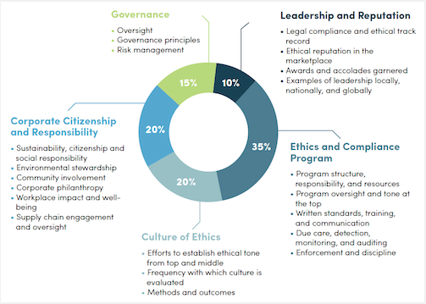
Figure 5: Good ethics bring good business, Source: (McKeefry, 2019)
The statistics show that 55% of the good business the companies make comes from areas related to the ethical stance of the companies as it enhances the companies’ image, which prompts the clients to choose Home Instead. The organization instills the ethical standards among the employees, especially among the caregivers, who directly interact with the clients and sometimes the staff is given training through workshops, seminars, etc. to ensure ethical behavior (Jeurissen and Rijst, 2017). The ethical stance of the company helps it to protect the client’s interest and boost the confidence and trust of the clients on the business, which results in more consumers. The ethical standards of the company are set in order to enable the company to meet up the promise that it makes regarding the quality of the service and the ethical standards are clearly communicated to all the employees to clarify the ethical position of the company.
As part of the ethical stance of the company, it offers free services like providing advice and support through social media and other online media to the elderly people who cannot afford the live-in care services. The company also has undertaken a Christmas gift-giving scheme under which it sends gifts to the elderly people, especially, who are deserted by their families to combat loneliness. In addition, it also takes initiatives to protect seniors from fraud and it also arranges community workshops as a part of their community involvement, through which, it teaches the elderly people how to eat well and prevent hospitalization.
That is how, the organization exhibits its ethical stance and by carrying out carefully stipulated activities, it satisfies the different stakeholders of the company, which also leads to enhanced corporate image and brings good business.

Task 04 A Comparison of Culture of “Home Instead” to That of “Elder”:

The culture of Home Instead values the participation of the employees in decision making and decentralization, whereas the Elder promotes a culture, where the employees and staffs follow the instructions and decisions that are made on local and global head offices without having much to say or refute (Rhodes and McGuire, 2013). Both the companies are successful in the way they operate the business, however, the approach to carry out the function to drive the organizational business.
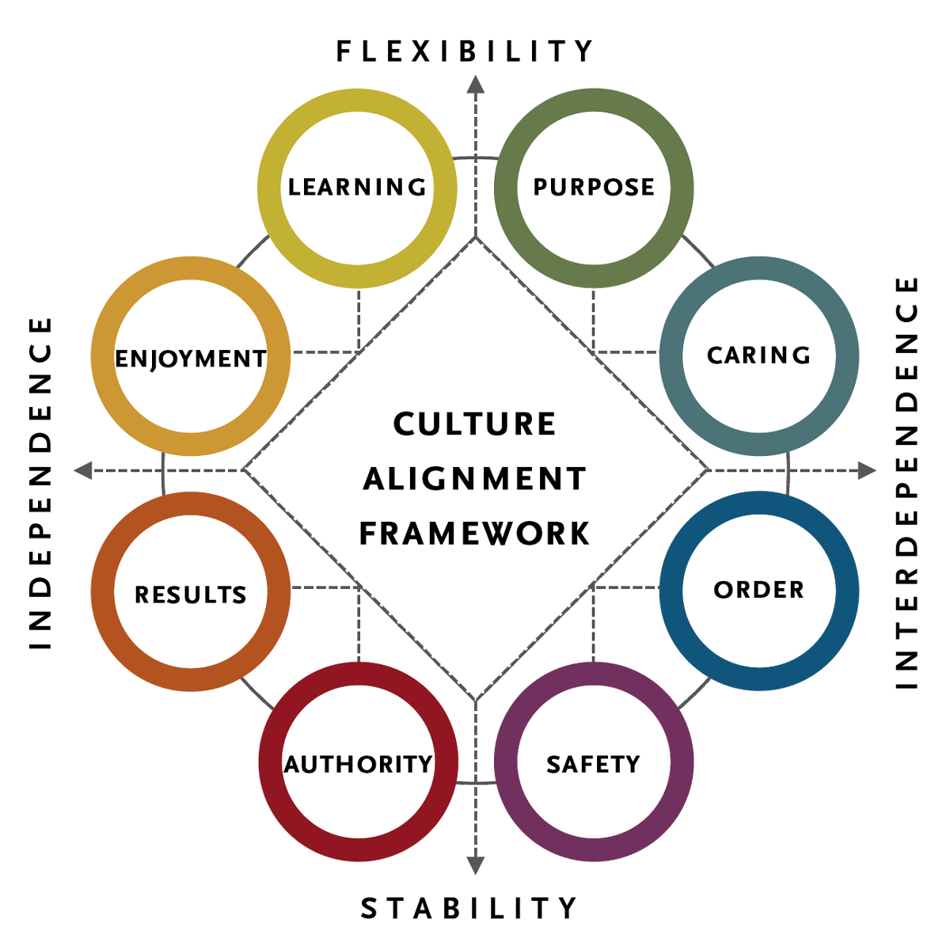
Figure 6: Culture Alignment Framework, Source: (Irani and Sharp, 2017)
Home instead develop teams and instill the teamwork values among the staffs so that the team can bring success for the company, on the other hand, workforce at “Elder” perform only their individual tasks, although the company also forms teams for special purposes, however, this practice of the company is not regular and consistent, which differentiates it from the culture of Home Instead.
Elder believes that responsibility and accountability can only be attained by assigning the tasks individually, which the teamwork sometimes cannot ensure. Another limitation of the culture of Overreliance on an employee is a side effect of the Elder’s culture, which is eliminated by forming teams in Home Instead.
The culture of the organisation promotes the interpersonal relationships among the staff more than what its competitor does, which breeds important values in the company’s culture like trust, empathy, mutual help, etc. (Smith and Mounter, 2018). These values have enriched the culture of the company, which helped it to outperform its competitor in terms of the satisfaction level of both the client base and the caregivers.

Task 05 Recommendations to Further Enhance the Workplace Culture Home Instead in the Future:
The culture Home Instead nurtures is superior to that of its competitor, however, it left some room for further improvement, which is why the company should implement the following suggestions. The company should conduct a periodic culture audit to decide whether the company should make changes in its culture and if so, how they can do it without hurting the company’s performance. The company should ensure accountability in the team environment to get rid of one of the limitations of its culture. The company must assign tasks individually in the team, set clear expectations, and communicate clearly to all the members in the team to ensure accountability and responsibility preventing the tendency to shrug off responsibility (Rhodes and McGuire, 2013). The company must also have to assure that the commands are communicated formally.
The company should give challenging tasks and stimulate the culture, where the employees will view the challenge as an opportunity to prove their worth. The team leader should follow up with the members and provide continuous feedback to foster the culture of accepting 360 feedback and convert it to feedforward. The employees are bound to make mistakes; however, the managers should identify and provide guidance in order for the employees to learn from the mistakes and improve their performance (Eccles, Ioannou and Serafeim, 2016).
Lastly, the company should ensure that the employees are accepting cultural modification as human beings are always resistant to change. The company can attach the reward system with the demonstration of the corporate culture through behavior at the workplace. Moreover, the company should reward in public to encourage such adaptability of the employees to the cultural change and reprimand in private so that employees do not feel humiliation, which may lead them to show unruly demeanor. That is how they can enrich their culture by bringing the recommendations alive.

Conclusion:

The report focused on the external and internal environmental analysis of the company along with the discussion on its ethical stance and culture that nurtures. The analysis of the external factors divulged the industry shows great potentials to grow in the future, and hence, provides a lucrative career opportunity. The internal analysis helped to pinpoint the causes behind deviation between expected and actual performance as the company gets to know how the internal factors affected its performance. The ethical stance of the company is helping and will continue to do so to boost the image and is expected to result in a broader client base. Mckinsey’s 7s framework and the comparison of the culture of the company with one of its competitors underpinned the ground for giving suggestions to enhance the culture and it is presumed that following the recommendation will allow the company to ameliorate its culture.

References:

Ahmed, S. (2017). Analysis of Workplace Surveillance in a Quest for an Ethical Stance. Journal of Business Systems, Governance and Ethics, 2(4).
Ananthan, B., Appannaiah, H. and Reddy, P. (2018). Business Management. New Delhi: Himalaya Pub. House.
Baron, D. (2013). Business and its environment. Singapore: Pearson.
Demir, E. and Kocaoglu, B. (2019). The use of McKinsey s 7S framework as a strategic planning and economic assestment tool in the process of digital transformation. Pressacademia, 9(9).
Eccles, R., Ioannou, I. and Serafeim, G. (2016). The Impact of a Corporate Culture of Sustainability on Corporate Behavior and Performance. SSRN Electronic Journal.
Grantthornton.co.uk. (2019). [online] Available at: https://www.grantthornton.co.uk/globalassets/1.-member-firms/united-kingdom/pdf/documents/care-homes-for-the-elderly-where-are-we-now.pdf [Accessed 4 Nov. 2019].
Grelecki, R. and Willey, S. (2017). Applying Legal Concepts to Business in a Legal and Ethical Environment of Business Course: The Build-a-Business Project. Journal of Legal Studies Education, 34(1), pp.89-126.
Hiriyappa, B. (2017). Organizational behavior. New Delhi: New Age International (P) Ltd., Publishers.
Homeinstead.co.uk. (2019). High-Quality Elderly Home Care With Home Instead. [online] Available at: https://www.homeinstead.co.uk/ [Accessed 4 Nov. 2019].
Irani, Z. and Sharp, J. (2017). Integrating continuous improvement and innovation into a corporate culture: a case study. Technovation, 17(4), pp.199-223.
Jeurissen, R. and Rijst, M. (2017). Ethics & business. Assen: Koninklijke Van Gorcum.
McKeefry, H. (2019). 21 High-Tech Companies Proving Good Ethics is Good Business - EBNOnline. [online] EBNOnline. Available at: https://www.ebnonline.com/21-high-tech-companies-proving-good-ethics-is-good-business/ [Accessed 4 Nov. 2019].

Rhodes, G. and McGuire, J. (2013). Transforming your leadership culture. San Francisco, Calif.: Jossey-Bass.
Smith, L. and Mounter, P. (2018). Effective internal communication. London: Kogan Page.
Thompson, J., Scott, J. and Martin, F. (2017). Strategic Management. Andover: Cengage.

