

Project Management
Module:LCBB6006
Georgiana Piticas
Student ID : 2315601
Table of Contents
Introduction and Background to Contracting in Project Management 3
Main Body 4
Turnkey Contracting 4
Multicontracting 6
DIY Contracting 7
Multicontract + DIY Contracting 8
Comparative Analysis of Contracting Methods 9
Conclusion 10
References 11

List of Figures:
Figure 1: Project management (PM) 3
Figure 2: Turnkey contracting 4

Introduction and Background to Contracting in Project Management
Project management (PM) is the art of planning, organizing and controlling projects in order to achieve set goals, objectives which may be in terms of time, cost and quality (Asfoor et al., 2022). In construction, project management is very important since the huge projects involved demand accuracy in terms of coordination, risk avoidance and resource management. One of the important issues in the management of construction projects is that the selection of a suitable contracting method defines the way of distributing responsibilities and risk between the project owner and the contractors.
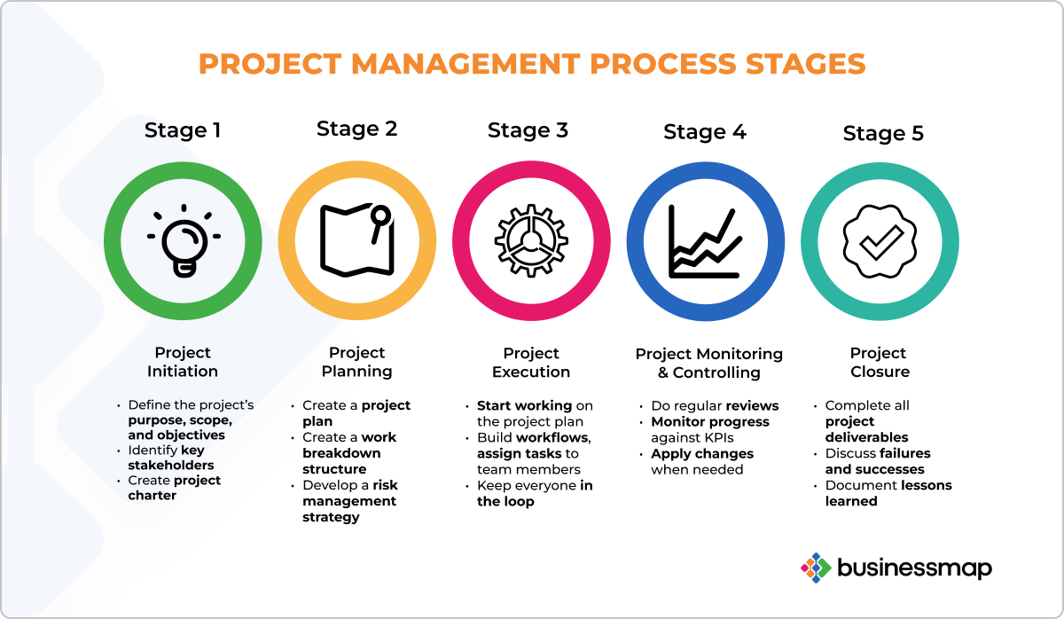
Figure 1: Project management (PM)
Source: (Chervenkova, 2024)
Contracting in project management is described as written agreements between parties in order to execute some tasks under agreed conditions (Merrow, 2022). Contracting techniques used in construction projects may have a considerable impact on success of the project because they establish the level of scope of work, roles, schedule and budget. Selection of the appropriate contracting method will aid in the smooth running of the project and minimize the possible conflicts.

Project management has a number of contracting methods that are applicable to various types and levels of project management (Kerzner, 2025). These involve Turnkey, Multicontract, Do-it-yourself (DIY) and Multicontract + DIY. All of the methods have their benefits and limitations based on such aspects as the project size, complexity, the budget limitation, and expertise of the owner. These approaches and how to apply them are essential to understand them properly and make informed decisions that would suit the needs of the particular project and help to complete it on time and successfully. This essay will discuss and critically examine these four approaches to contracting, their application in construction projects, their advantages, and the challenges they might cause.

Main Body

Turnkey Contracting
Turnkey contracting is a project delivery method in which the contractor is in charge of the overall lifecycle of the project including design and procurement, construction and final handover (Maria João Mimoso, 2020). Under this model, the client gives the broad specifications, and the contractor takes the whole process through and produces a project that is fully operational upon its completion. The turnkey is named in accordance with the idea that the client can take a simple step and turn the key and start using the facility when completed.
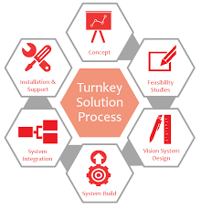
Figure 2: Turnkey contracting
Source: (Treloar, 2017)

Benefits of Turnkey Contracting:
- Single Point of Responsibility: The primary benefit of this system is that the client encounters a single contractor to handle every part of the projects. This simplifies the communication and makes the process of managing many contracts easier.
- Fixed Rates and Dates: Turnkey contracts normally exhibit a fixed price on the project, and this gives the client cost certainty. Also, the contractor will take charge of timely delivery of the project, and delays are minimized.
- Reduced Risk to Clients: All the risk associated with the project implementation such as delay or cost increase are transferred to the contractor. These risks are avoided, and this makes it a safer choice to the client who is inclined towards the hands-off form of leadership.

Drawbacks of Turnkey Contracting:
- Minor Flexibility: Once the scope and design is agreed-upon changes may be hard and complicated to effect. This reduces its flexibility in case the needs of the client change throughout the project.
- Risk of Increasing Costs: Contractors can provide contingencies to fixed price to meet the unexpected costs which can make the total costs higher.
- Less Control by the Client: Since all the project aspects are done by the contractor then the client is not involved in the nitty-gritty of the project design and material selection, and this may result in dissatisfaction in the end-reduced output is not as per their expectations (Cooke and Williams, 2020).
Real-World Example:
Burj Khalifa, the highest building in the world, in Dubai is also a prominent example of Turnkey Contracting. This was a project run by a group of contractors, with the leading contractor, a South Korean firm, Samsung C&T, fully responsible of the construction process to the end. The fixed cost and time scale was advantageous to the client, Emaar Properties as it provided them with a completed skyscraper that they could occupy.
Construction Projects Suitability:
Turnkey contracting is often applicable in large-scale and intricate projects such as skyscrapers, industrial facilities or large commercial facilities, in which the client wants to have very little input and wishes to have a hassle-free and predictable project completion.

Multicontracting
Multicontracting is a project delivery technique in which the project owner contracts several contractors to do a particular component of the project (Amirtash, Parchami Jalal and Jelodar, 2021). Under this style, the work is not given to a single contractor, but the owner splits the project into individual contracts with the various activities of the project, including the excavation, electrical work, plumbing, or structural work. All the contractors are independent and ultimately aim at achieving the same objectives which is the completion of the entire project.
The benefits of Multicontracting:
- Specialization and Expertise: Multicontracting is mainly advantageous in the sense that it allows one to choose contractors who possess talents in specialized areas of the project. This means that specialized skill will be used in the project activity resulting to increased quality work in every area.
- Cost Control: The owner will be able to enter into individual contracts with each contractor, and this may lead to cost reduction. Secondly, there can be competition among the contractors which can result in low bids.
- Flexibility and Control: The owner has greater control over contractors choice, and it can be changed in individual contract cases when necessary. This flexibility comes in handy with projects on which some of the aspects might change or require some modifications during the construction.
The drawbacks of Multicontracting:
- Coordination Problems: There are coordination problems associated with dealing with various contractors. The project schedule and quality can be adversely affected by the delays or disagreements between the contractors.
- Growing Administrative Load: The owner must cope with numerous contracts, control the work of every contractor, make payments, and solve the conflicts (Gurgun and Koc, 2021).
- Risk of Conflict: When there are several contractors, chances are high that there will be disagreements particularly where responsibilities fall in another contractor or where delays by one contractor will impact on the work of the other contractor.
Real-World Example:
A Multicontracting project is the building of the London Olympic stadium in 2012 Olympics (Hub, 2021). The project entailed various contractors at various phases including structural engineering, landscaping and installation of specialized sports equipment.
Construction Projects Suitability:
Multicontracting maximizes on large and complicated projects such as sports stadiums or huge commercial buildings where various expertise is needed in different regions.

DIY Contracting
Do-it-yourself (DIY) contracting is a project delivery project approach in which the project owner assumes the role of project management and directly employs individual subcontractors. This model involves the owner not outsourcing a single contractor to do the whole job but rather undertaking the procurement and execution of various sections of the project including plumbing, electrical and structural work and in many cases in a hands-on manner.
The benefits of DIY Contracting:
- Cost Savings: The owner saves on overhead expenses that involve fees charged by a general contractor since he directly hires subcontractors (Hendrickson, Haas and Au, 2024). This could lead to a large-scale cost cut in small project.
- Full Control: The owner retains full control over the project, where he or she has the option of making decisions on materials, schedules, and designing decisions. Such involvement may result in a more individual project outcome.
- Flexibility: DIY contracting is flexible in scope and design of projects, as the owner can make changes throughout without the fixedness of the rigid contract.
Limitations of DIY Contracting:
- Absence of experienced: The owner might not have the technical skills and expertise to run a construction project successfully and thus will make some errors or inefficiency.
- Time-Consuming: Project management is time-consuming, and one has to be keen to details, co-ordination and continuous decision-making. This can be very demanding especially in huge projects.
- Raised Risk: The possibility of having bad quality work, delayed schedule or an increase in the project budget is high and this may compromise success of the project without the presence of an experienced contractor.
Real-World Example:
One DIY contracting case in point is a home renovation project whereby the homeowner has assumed the role of contracting various specialists to do the various work such as installing a kitchen, laying floors, and painting without a general contractor.
Construction Projects Suitability:
DIY contracting best suits small and low-budget contracts like a home improvement or a home renovation where the owner possesses some level of experience in construction.

Multicontract + DIY Contracting
Multicontract + DIY contracting This is a hybrid type of project delivery method in which the project owner integrates both Multicontracting and DIY. In this model, the owner takes direct control in some aspects of the project (DIY) and contracts a specialist to handle other aspects (Multicontract) (Merrow, 2022). It is much more flexible, and the owner can have control over certain tasks, which he or she can perform and leave more complicated or technical ones to professionals.
Benefits of Multicontract + DIY Contracting:
- Cost Control: The owner is able to save on costs by carrying out some work manually and negotiating with other subcontractors on other aspects of the project. This may save a significant amount of money depending on the costs that would be incurred when a general contractor is hired to do the whole job.
- Flexibility and Control: The owner has control over aspects of the project they are conversant with like minor design decisions or landscaping and enjoys the services of a contractor in more difficult areas.
- Specialization: This strategy also means that special jobs like electrical or plumbing jobs are done by experienced engineers so that there is quality and safety.
Cons of Multicontract + DIY Contracting:
- Coordination Problems: There will be coordination problems when dealing with various contractors and DIY works, especially when there is a delay or conflict between two contractors and/or the work of the owner (Khahro et al., 2023).
- Greater Responsibility: The owner becomes more responsible in running the project, which could be time-consuming and stressful, in particular, when it comes to large projects.
- Possibility of Miscommunication: The hybridity of this method can create a communication breakdown between the owner and contractors, which will cause errors or delays.
Real-World Example:
An example of such an approach is a residential redesign that involves the homeowner handling the design and interior decoration and bringing in contractors to do electrical and plumbing jobs.

Comparative Analysis of Contracting Methods
The Turnkey, Multicontracting, DIY, and Multicontract + DIY contracting methods have their merits and fit various construction projects. Turnkey contracting presents one point of contact, and this is appropriate in large, complex projects such as commercial buildings whereby the client prefers to involve himself or herself less. Its inflexibility may however be considered a disadvantage when the construction process is faced with some changes.
Multicontracting is flexible and specialized and thus suitable in large projects that would demand a wide range of expertise. It is cost saving and should be well coordinated to prevent time wastage.
Small-scale projects benefit more with DIY contracting, and the owner is a hands-on individual with some knowledge about construction. It is completely controllable and yet risky or potentially inefficient.
Multicontract + DIY approach is flexible and is specialized, so it is best suited to residential projects, where homeowners would like to do some of the work, but require professional contractors to do others. It must however be coordinated well.

Conclusion
Finally, it is important to note that the choice of the method of contracting is the key to the success of the construction project. Turnkey is the best option of large projects that the customer wishes to have a hands-off approach. Multicontracting is flexible and could be highly skilled, but it needs to be coordinated properly. DIY contracting is applicable to small projects in which the owner is experienced and wants to save on costs, but it is high-risk. The Multicontract + DIY approach is a midway between control and specialization, which is appropriate in residential projects. Finally, the selection of the appropriate methodology is determined by the size and complexity of the project and preferences of the client.

References
Amirtash, P., Parchami Jalal, M. and Jelodar, M.B. (2021) Integration of project management services for International Engineering, Procurement and Construction projects. Built Environment Project and Asset Management, 11(2), pp.330–349. https://doi.org/10.1108/bepam-06-2020-0106.
Asfoor, H.M.A., AL-Jandeel, A. a. T., Igorevich, K.K. and Ivanovna, L.A. (2022) Control of Time, Cost and Quality of Construction Project Management. E3S Web of Conferences, 336, p.00072. https://doi.org/10.1051/e3sconf/202233600072.
Chervenkova, M. (2024) 16 Benefits of Project Management to Keep in Mind in 2024, Kanban Software for Agile Project Management. Available at: https://businessmap.io/blog/project-management-benefits.
Cooke, B. and Williams, P. (2020) Construction Planning, Programming and Control. Wiley-Blackwell.
Gurgun, A.P. and Koc, K. (2021) Administrative risks challenging the adoption of smart contracts in construction projects. Engineering, Construction and Architectural Management, ahead-of-print(ahead-of-print). https://doi.org/10.1108/ecam-09-2020-0678.
Hendrickson, C., Haas, C. and Au, T. (2024) Construction Pricing and Contracting. ecampusontario.pressbooks.pub, Available at: https://ecampusontario.pressbooks.pub/projectmanagementforconstructionanddeconstruction/chapter/construction-pricing-and-contracting/.
Hub, G.I. (2021) London 2012 Olympics, infrastructuredeliverymodels.gihub.org. Available at: https://infrastructuredeliverymodels.gihub.org/case-studies/london-2012-olympics-commission-for-a-sustainable-london/.
Kerzner, H. (2025) Project management : a systems approach to planning, scheduling, and controlling. 12th ed. Hoboken, N.J.: John Wiley & Sons.

Khahro, S.H., Shaikh, H.H., Zainun, N.Y., Sultan, B. and Khahro, Q.H. (2023) Delay in Decision-Making Affecting Construction Projects: A Sustainable Decision-Making Model for Mega Projects. Sustainability, 15(7), p.5872. https://doi.org/10.3390/su15075872.
Maria João Mimoso (2020) The Turnkey Contract and the Globalization Era. https://doi.org/10.33422/8th.mah.2020.02.17.
Merrow, E.W. (2022) Contract Strategies for Major Projects. John Wiley & Sons.
Treloar, J. (2017) Which One is Better for your Business? DIY or Turnkey Solutions? Medium. Available at: https://medium.com/@jaspertreloar/which-one-is-better-for-your-business-diy-or-turnkey-solutions-b580ef142682.

