

EXAMINATIONS 2013/2014 Semester 2-Resit
AHOLIADAU 2013/2014

FACULTY OF: Applied Design and Engineering
School of Applied Computing

NAME OF COURSE/PROGRAMME: | BSc (Hons) Computer Networks  HND Computer Networks
YEAR OR LEVEL: | 4
NAME OF MODULE/UNIT/EXAM PAPER: | IP Internetworking
MODULE NO: | M1X8609  M5X8914
DATE OF EXAMINATION:

EXAMINATION TIMES:

START TIME:

FINISH TIME:

TIME ALLOWED:

INSTRUCTIONS TO CANDIDATES:

Answer three out of four questions. Each question carries equal marks.

Only basic calculators are permitted. Scientific calculators especially with internal memories are not allowed.
QUESTION ONE
- Explain interior gateway routing protocols and exterior gateway routing protocols and give some examples. (6 marks)

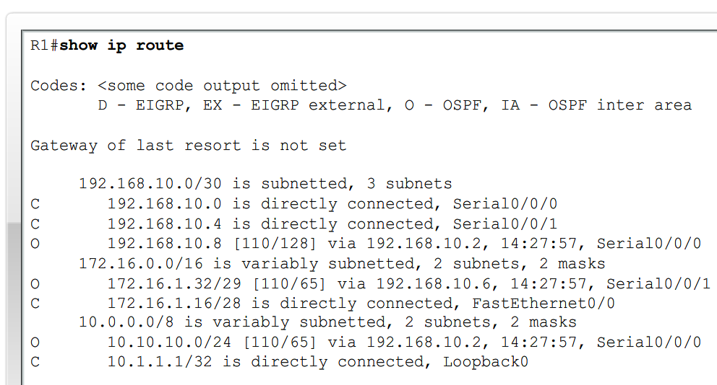
Figure 1
Refer to the partial output shown above in Figure 1 answer the following:
- Which routing protocol is configured on router R1?
- What are the remote networks learned by R1 using the protocol?
- What is the cost used by the protocol to reach each remote network? (6 marks)

- In reference with OSPF, explain hello intervals and dead intervals. (3 marks)

- Explain EIGRP packet types. (10 marks)

QUESTION TWO
- List the metrics used in IP routing protocols. (6 marks)

- What is the purpose of Administrative Distance? Write the AD value for protocols listed below.
- Connected interface
- Static
- RIP
- EIGRP
- OSPF
- Unknown (8 marks)

- Refer to figure 1, answer the following:
How many subnets are there?
How many collision domains and broadcast domains?
Identify the devices and describe their functions. (11 marks)
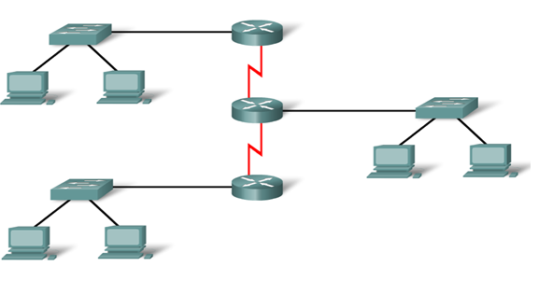
Figure 2

QUESTION THREE

- With reference to Figure 2, design a addressing scheme using VLSM. The network address is 200.120.10.0/24. Write subnet address, subnet mask, first IP address, last IP address and broadcast address for each segments: LANs on Fastethernet and Serial links between the routers. (25 marks)
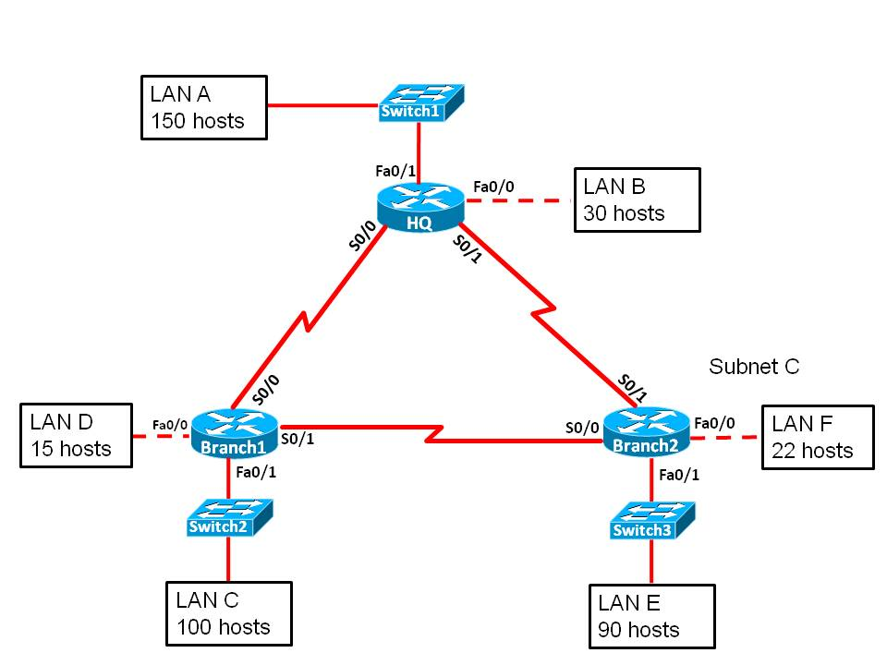
Figure 3

QUESTION FOUR
- For the network shown in Figure 3, explain static route and when to use static route.
(9 marks)
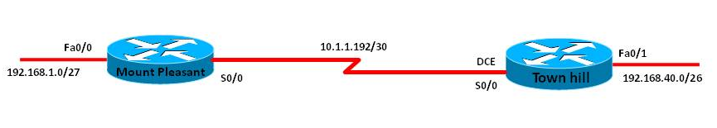
Figure 4

- Compare Distance Vector and Link State routing protocols. (6 marks)

- Compare classful and classless routing protocols (10 marks)

