How a School Develops One Aspect of its SDP: A Report That Critically Reflects on The Actions, Impact and Evidence Base.

Introduction

Schools across Wales are continually developing in order to provide learners with the best possible experience and the Welsh Government has provided improvement guidance for schools under Section 10 of the Education Act 1996 (Welsh Government, 2022). To identify and track improvements a school develops a ‘School Development Plan’, an ‘SDP’. Within this, the school outlines the improvements they intend to make, how they will do this, who is involved and then when they plan to revisit it to collect results of the change. For the Welsh Government (2022), one of the most important factors of a schools is its inclusion of aspects that develop learners who show progress and in turn contribute to the Four Purposes (Welsh Government, 2022). This essay will focus on how a school identifies one area of progress, how they make this decision, their action plan and then their revisiting. The school this essay is focusing on is based in West Wales, it is a large primary school containing over 650 pupils, with 38% of pupils identified as eligible for Free School Meals (eFSM), which is above the three-year average of 30% (National Academy for Educational Leadership Wales, 2021). As well as outlining the development of an action plan, evaluating the impact and the evidence gained for a specific area, this essay will include relevant literature surrounding the theoretical level of the SDP as well as focusing in on the specific aspect.

Literature Review

The Welsh Government announced a new curriculum for 2022 focused on raising the standards of education and improving learner outcomes (Welsh Government, 2022). In 2012-13, Estyn released a report stating that self-evaluation and planning for improvement was a strength for many schools in Wales (Estyn, 2013 in Welsh Government, 2014, pg. 2). As outlined by the Welsh Government’s guidance, the purposes of an SDP are to; 1. Raise the standards of education in relation to literacy, 2. Numeracy and 3. The Welsh Government provides vast guidance on the framework to follow to develop an SDP and to efficiently identify areas of improvement. They have developed a framework for schools in Wales to follow as seen in Figure 1.
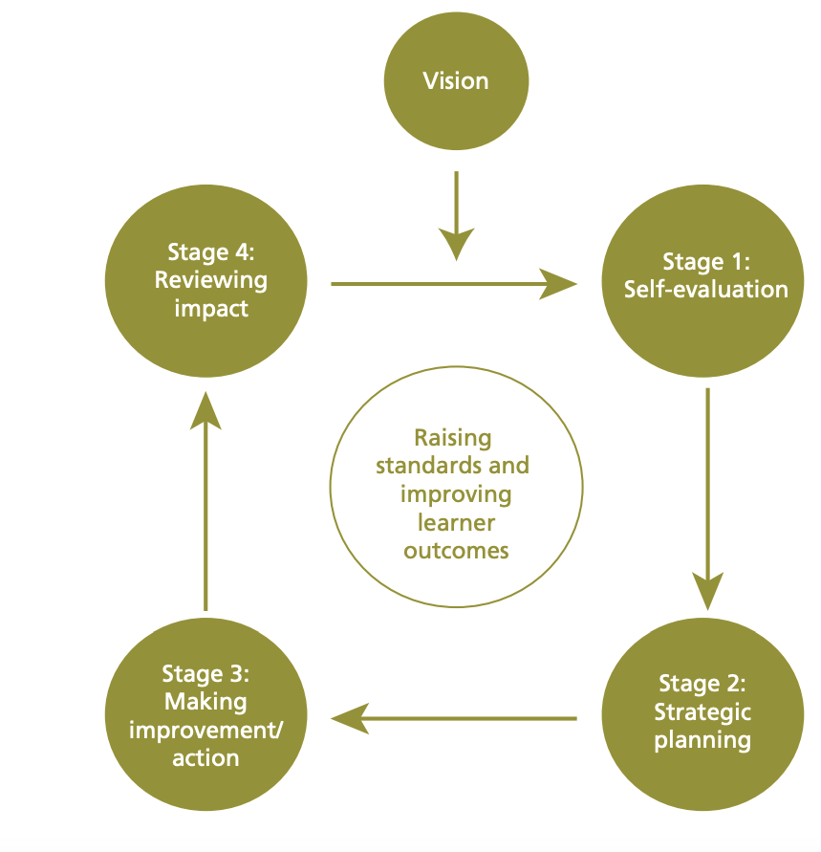
Figure One: The School Development Planning Cycle (Welsh Government, 2014, pg. 7).

Each school will have an aim in which they intend to meet and this can be seen labelled as ‘Vision’ in the above framework. The vision is what the school is constantly aspiring to achieve and all evaluation takes place with this in mind as their motivation. One of the most important areas of the creation of a school development plan is that of self-evaluation. For many schools, self-evaluation is a key strategy for discovering problem areas or areas of improvement and it includes a whole school approach by where the staff take a reflective position on their performance and take time to uncover where they may need to improve and the actions to take (Welsh Government, 2014, pg. 8). Literature by Faddar, Vanhoof and De Maeyer, (2018, pg. 661) outlines the process of self-evaluation that many schools follow. They state that it is a process by which schools often rely on data being collected by teachers, stakeholders and anyone who is involved in the everyday functioning of the school which makes their opinion one of value (Faddar, Vanhoof and De Maeyer, 2018, pg. 660). There are issues that have been outlined in literature regarding the possible issues with using self-evaluation techniques such as questionnaires. Many self-evaluations methods rely on reflection of the self which could lead to individuals providing answers which portray them or their school in a good light which could in turn lower the reliability of these results (Faddar, Vanhoof and De Maeyer, 2018, pg. 661). However, literature states that this seems to be the case when there is no motivation to provide an accurate response. In terms of developing an SDP, it is the hope that there is a whole school approach and motivation to uncover where improvements are needed which seems to be the case as Estyn claims most schools in Wales are successful in their application of self-evaluation techniques (Faddar, Vanhoof and De Maeyer, 2018pg. 661). Therefore, the outcome of the self-evaluation methods is taken as valid and reliable. Furthermore, it is through ‘an intelligent and sophisticated use of evidence, based on rigorous, enquiry-based approaches that schools can accurately identify their strengths and areas for development’ (Education Wales, 2021,pg. 6) describing how intense the process of evaluation is, further solidifying its reliability. It is after this stage where strategic planning takes place. This process involves including all school partners and stakeholders to ensure their commitment to the improvement that will be outlined for each aspect of the SDP. As outlined by Education Wales, a school only needs to have one clear strategic plan which includes the improvements and the actions to do so for their outlined priorities (Education Wales, 2021, pg. 11). After the strategic planning of how to implement improvements takes place, they are then put in to action after which, depending on the timeframe outlined by the school, the impact of said improvements will be reviewed. This review is used to see if the school is any closer to or is continually working towards its vision (Welsh Government, 2014, pg. 15) with the SDP plan being updated annually to report the developments as required by Estyn (Welsh Government, 2014, pg. 15). The school this essay is focusing on, which will be known as School X for anonymity, develops what they label as ‘Priority Areas’ from their self-evaluation phase, which they number in importance from 1-4. The aspect, or priority area, this essay will focus on is that of improving Health and Well-being. One of the national priorities as identified by Education Wales (2021, pg. 3) is reducing the impact of poverty on educational attainment and literature states the clear link between these two and School X is shown to have a high level of poverty due to its high rate of eFSM pupils. One major reason poverty leads to lower educational attainment and achievement is due to the affect it has on attendance. The Welsh Assembly Government’s policies for children and young people believe that any barriers that may be stopping children from engaging in education need to be identified and removed (Welsh Assembly Government, 2011, pg. 1). When carrying out self-evaluation, schools will be reflecting on whether they need to improve their actions towards reducing poverty, for example they need to focus on their attendance especially if said school is based in a poor area (Welsh Assembly Government, 2011, pg. 1). The school will have data readily available to them on this subject and they can self-evaluate their attendance techniques, such as whether they offer breakfast club, after school care, to develop improvements to then put in to action before reviewing.

Action Plan

At the heart of the new curriculum are the four purposes (Welsh Government, 2022) and schools in Wales evaluate themselves against their development of these areas to ensure they are providing a well-rounded education. As mentioned in the literature review, it is the vision that feeds into the framework for developing the SDP and a vision is shared as a whole school and aims to enhance learning experiences (Welsh Government, 2018, pg. 2). For School X, their mission statement is ‘Proud to be a community school, striving for success for all!’ (hwbcymru.net, 2023). It is this vision that is used during self-evaluation to recognise areas of improvement. This next section of the essay will outline and detail the workings of the processes involved in an SDP for School X which I have been made aware of during conversations that took place between myself and the headteacher.

School X have a whole review of their current SDP and its priority areas in summer, this involves all senior staff, the head teacher and any other stakeholders. During this review, they come together to discover whether the current priority areas are keeping within the time scale. When the time comes for new priority areas, all staff are given a chance to share where they think the school can improve and then it is through self-evaluation that new priority areas are developed. School X has 5 priority areas at a time, from 1-5 in order of importance respectively. This essay looks at priority area 4 which focuses on Safeguarding and Wellbeing (PDCS, 2022, pg. 17). This area includes improving school attendance and working with the School Council to reduce incidents of bullying. School X is located in one of the ‘Most Deprived’ electoral divisions in Wales (PDCS, 2022, pg. 3) and therefore their safeguarding constantly requires self-evaluation to ensure it is providing as expected. For the process of self-evaluation, bullying questionnaires were sent out to pupils to see what their response was and to determine whether there were high levels of bullying, to which they discovered there was. However, the data gained regarding bullying statistics has come from learners. This then raises the issue of reliability as it is using data that relies heavily on the honesty of the individual. Literature states that it can be the case that children reply to questionnaires with what they want to which may not be a true representation of the environment. So, could it be that School X is focusing money, time and effort on a priority that may have been influenced by corrupt data? However, schools are areas of learning where children should feel safe, and therefore it is argued that children and their answers should be seen as reliable as who else can report on child’s experience better than themselves (Lobe, Livingstone and Haddon, 2007, pg. 1). Also, School X are focusing on increasing attendance as an area of improvement. All schools have readily available data regarding attendance and this was analysed during the self-evaluation stage where School X found that attendance was decreasing drastically. This data for the priority area allowed them to evaluate their techniques towards safeguarding and wellbeing and to recognise it as a priority area. School X has developed a plan which involves working with the School Council to get learners views on bullying and how to improve it, they provide anti-bullying assemblies to insure it is a whole school approach. Furthermore, in terms of attendance, Year 6 pupils have been focusing on their own attendance data and have been linking it to effective learning. However, as mentioned previously, School X resides in an area high in poverty and a child’s family socioeconomic status has links to their attendance (Sosu et al., 2021, pg. 2) so is this action plan enough to increase attendance if it does not involve families? However, the Government provides a framework for teachers to follow when absences occur which can be seen below in Figure 2 (Welsh Assembly Government, 2011, pg. 11). By applying this framework and its own improvements, School X can hopefully work with families to provide further support and in turn, increase attendance, as explained by the senior member of staff (Senior Staff B, 2023).

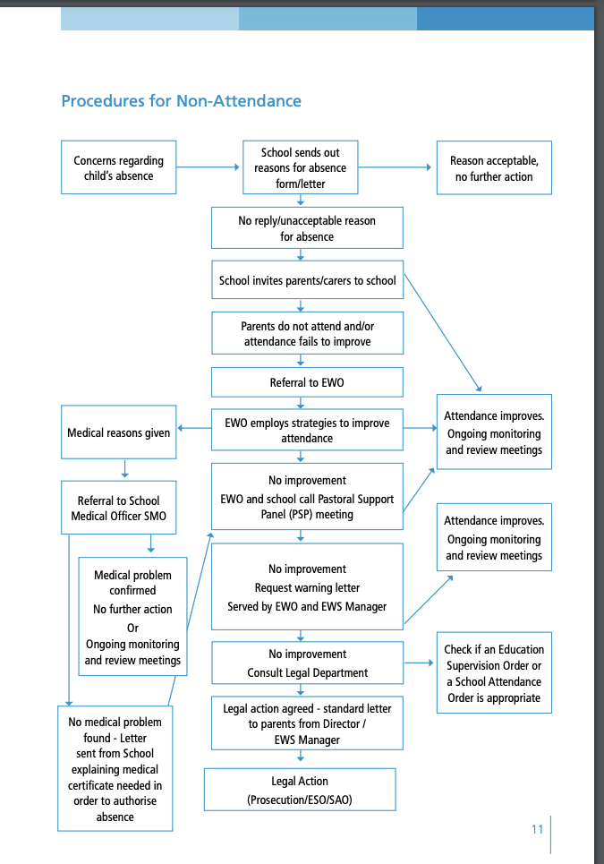
Figure 2: Procedures for Non-Attendance (Welsh Assembly Government, 2011, pg. 11)

The impact for this priority area is measured every 6 months, here a second evaluation takes place where all staff related to this area decide whether they are seeing enough improvement or if they need to adapt. The success criteria are improved attendance figures compared to 2021/2 and learners reporting fewer incidents of bullying (PDCS, 2022, pg. 17). Then, the SDP as a whole gets reviewed in the summer.

Furthermore, it is important to remember that schools do not exist in isolation but are a part of a much wider community and multi-agencies (Welsh Government, 2015, pg. 5) and the same goes for the development of an SDP. School X has close ties to governors and they link each area to a governor who can help to monitor, evaluate and adapt this area. Also, the SDP is live within the school system and can be found on their website, and therefore it can be constantly seen and input can be given, allowing for constant criticality. Before the publishment of an SDP, the headteacher of School X develops a report about the chosen priority areas and this is shared with the connected governors who can then critically discuss it. This process ensures that the SDP is understood by all stakeholders and is a whole-school approach which will allow it to be more successful (Galloway, 1994, pg. 20).

Reflection and Evaluation

The full impact of the improvements will not be seen until the end of summer term. However, I have seen the work the Year 6s have carried out on attendance and from my time speaking to them, it is clear that they understand the importance of school and so I feel as though this improvement has been beneficial. In terms of bullying, I was told that when the staff carried out a questionnaire based on what they had seen, the reports of incidents were low, but when a questionnaire was sent out to the pupils, the incidents sky rocketed, and so this does make me question the validity of the data. However, regardless of this, I am in support of Lobe, Livingstone and Haddon (2007, pg. 1) and their literature that states that we need to place value in the responses of children, especially as the overarching aim of an SDP is to provide the best learning opportunity to all (Education Wales, 2022). For bullying, I know School X has introduced restorative practice and I wholly support this due to its success in improving the school environment as outlined by Lodi et al., (2022, pg. 1). I would suggest that this continues throughout all years so that pupils are able to learn this form of communication at a young age. For those who may struggle socio-economically, I believe School X offers an abundance of support such as Breakfast Club and free breakfast in the classroom for some, free school meals for eFSM, after school activities and after school care and some free school trips (Headteacher X, 2023). Therefore, I believe it is through the continuation of these, the involvement of stakeholders and its close ties to their community that School X will succeed in its improvements. However, I am of the opinion that schools should be reviewing their improvements more often. For me, I think it is important to constantly monitor and assess the outcome to ensure that all staff are aware of what they need to do and to have a constant link to what pupils are experiencing because it is only from this that schools will be able to adapt and change their action plan to better suit their priority area. However, I am aware of the time this may take as it involves talking to all staff, pupils and governors which is not a small task, as I understand from my conversation with school members, but I do think it is only through close observation and monitoring that a school can be sure of the success of its improvements.

Conclusion

As outlined in the introduction, this essay focused on the development of an action point within one aspect of an SDP, while including related literature to the theoretical level of the process before focusing in on the chosen aspect. During time researching the process of an SDP, I got to speak to staff within the school, included above, which showed me the in-depth involvement all staff has with the process in School X, which really solidified the importance of a whole-school approach in making an impact. I have learnt how important it is to be clued up on self-evaluation techniques, and all of the guidance provided by the Welsh Government (Welsh Government, 2014) to ensure that a school is providing the best environment for its pupils to learn and to develop upon the four purposes (Welsh Government, 2022). In the future, I plan to immerse myself with the SDP process and any schools I may work in in the future, if it is acceptable to do so. This is because, I feel it is a beneficial way to get to know the strengths and weaknesses of a school and to be a part of the action plan to ensure I am contributing to creating a successful and supportive school.

References

Education Wales, (2022). ‘School Improvement Guidance: Framework for Evaluation, Improvement and Accountability’, [online] Available at: https://hwb.gov.wales/evaluation-improvement-and-accountability/school-improvement-guidance-framework-for-evaluation-improvement-and-accountability/ [Accessed 2nd April 2023].

Faddar, J., VAnhoof, J. and De Maeyer, (2018). School Self-Evaluation: Self-Perception or Self-Deception? The Impact of motivation and Socially Desirable Responding on Self-Evaluation Results, School Effectiveness and School Improvement, pgs. 660-678 Volume 29(4) [online]
Available at: https://www.tandfonline.com/doi/pdf/10.1080/09243453.2018.1504802 [Accessed 4th April 2023].

Galloway, D. (1994). Bullying: ‘The Importance of a Whole School Approach’ Therapeutic Care and Education, pgs. 19-26 Volume 31(1) [online] Available at: https://psycnet.apa.org/record/1995-15415-001 [Accessed 2nd April 2023].

Hwbcymru.net, (2023). Pembroke Dock Community School. [online] Available at: https://sites.google.com/hwbcymru.net/pdcsprimary/home [Accessed 1st April 2023].

Lobe, B., Livingstone, S. and Haddon, L. (2007). Researching Children’s Experiences Online Across Countries: Issues and Problems in Methodology, pg. 1. [pdf] Available at: https://www.lse.ac.uk/media-and-communications/assets/documents/research/eu-kids-online/toolkit/frequently-asked-questions/FAQ-27.pdf [Accessed 3rd April 2023].

Lodi, E., Perrella, L., Lepri, G., Scarpa, M., and Patrizi, P. (2022). ‘Use of Restorative Justice and Restorative Practices at School: A Systematic Literature Review’, International Journal of Environmental and Public Health, Volume 19(96), pgs. 1-34, [online] . Available at: https://www.ncbi.nlm.nih.gov/pmc/articles/PMC8751228/pdf/ijerph-19-00096.pdf [Accessed 2nd April 2023].

Pembroke Dock Community School, (2022). School Development Plan, pgs. 1-21. Available at: https://sites.google.com/hwbcymru.net/pdcsprimary/key-information/school-development-plan [Accessed 3rd April 2023].

Sosu, E., Dare, S., Goodfellow, C. and Klein, M. (2021). ‘Socioeconomic Status and School Absenteeism: A Systematic Review and Narrative Synthesis’, Review of Education, pgs. 1-28, Volume 9(3291) [online] Available at: https://bera-journals.onlinelibrary.wiley.com/doi/epdf/10.1002/rev3.3291 [Accessed 3rd April 2023].

Welsh Assembly Government, (2011). All Wales Attendance Framework: An Operating Toolkit for the Education Welfare Service, pgs. 1-82. [pdf] Available at: https://www.gov.wales/sites/default/files/publications/2018-03/all-wales-attendance-framework.pdf [Accessed 3rd April 2023].

Welsh Government, (2022). Developing a Vision For Curriculum Design [online] Available at: https://hwb.gov.wales/curriculum-for-wales/designing-your-curriculum/developing-a-vision-for-curriculum-design [Accessed 1st April 2023].

Welsh Government, (2016). Theme 5: Developing Community Partnerships and Multi-Agency Working, Resources 1-2. [pdf] Available at: https://www.gov.wales/sites/default/files/publications/2018-12/theme-5-developing-community-partnerships-and-multi-agency-working-resources-1-2.pdf [Accessed 4th April 2023].

Welsh Government, (2014). School Development Plans, pgs. 1-21. [pdf] Available at: https://www.gov.wales/sites/default/files/publications/2018-03/school-development-plans.pdf [Accessed 4th April 2023].

Welsh Government, (2018). Schools in Wales as Learning Organisation, pgs. 1-9. [pdf] Available at: https://hwb.gov.wales/api/storage/f87e720f-8568-4a60-9383-55e20b9a1bb7/schools-in-wales-as-learning-organisations.pdf [Accessed 3rd April 2023].

Appendices-

Figure One- Welsh Government, (2014). School Development Planning Cycle, pg. 7. Available at: https://www.gov.wales/sites/default/files/publications/2018-03/school-development-plans.pdf [Accessed 4th April 2023].

Figure Two- Welsh Assembly Government, (2011). Procedures for Non-Attendance, pg. 11. Available at: https://www.gov.wales/sites/default/files/publications/2018-03/all-wales-attendance-framework.pdf [Accessed 4th April 2023].

