


UNIVERSITY OF WALES
Trinity St. David

BA (Hons) Leadership and Management Skills for the Workplace

Developing Innovation and Creativity for Business Advantage

BMSW6102

Lecturer: Charles Nwaogwugwu
Student: Oksana Mrsic (2131895)

Table of Contents
Introduction 2
The Innovative Product or Unique Service Proposition 2
Description of the Innovation 2
Target Customers 3
Sales and Distribution 3
Business Name and Branding 4
Sustainability of the Business Proposition 4
Competitive Analysis 5
E-commerce 5
Content Creation 6
Payment Services 6
User Experience and Security 6
Marketing 7
Promotion Strategy 7
Target Market 8
Digital Marketing Tactics 8
Email Marketing and Pre-launch Promotion 8
Privacy and Data Protection 9
Compliance with GDPR and Data Protection Act 2018 9
Privacy and Electronic Communication Regulations (PECR) 9
Security Measures 10
User Rights and Opt-out Options 10
Reference List 11
Appendix 13

Introduction

With this project, I want to define a new dental service that will use technology to enhance patient care and maximise dental practices' efficiency. As a result, creativity and innovation are vital trends in today's business environment since they support differentiation and growth while meeting changing customer needs (Juliana et al., 2021). The rise of digital disruption in many industries also impacts dentistry because new technologies must be adopted to remain in business. This report suggests a novel dentistry service that includes an AI diagnosis, evidence-based treatment recommendations, and a tele-dentistry platform for virtual consultations. This platform aims to improve patient waiting times, increase service accessibility, and integrate low-cost dental service delivery methods. The service offering, target market, e-commerce strategy, marketing plan, and the company's compliance with regulatory standards for data and privacy protection will thus be the main topics of the report.

The Innovative Product or Unique Service Proposition

Description of the Innovation

To solve the issue, I would like to present a tele-dentistry platform that offers personalised treatment plans, online consultations, and artificial intelligence diagnosis (Batra et al., 2022). This service uses artificial intelligence to analyse dental images, diagnose accurately, and implement virtual consultations. Patients can consult the practitioners of their choice and receive recommendations for treatment without having to leave the comforts of their own homes. By effectively utilising technology in the care delivery process, this approach seeks to increase patients' quality of life and, simultaneously, alleviate the burden on them caused by lengthy visits to the dentist while minimising costs implicated by traditional forms of dental practice.

Target Customers

My direct customers are individual patients, dental clinics, and independent practitioners. A common challenge patients experience is delayed access to dental care because of a long waiting list and geographic barriers, which my tele-dentistry platform solves. Using A.I. for diagnosis can significantly benefit dental clinics and practitioners since it would make their service even faster and more accurate, thus increasing their capacity to attend to more individuals (Vodanović et al., 2023). Moreover, patients with poor mobility and those living where it is difficult to see a dentist can get professional dental consultations and treatment plans without leaving their homes. It enhances the accessibility, convenience, and general satisfaction of the patients since it provides specialised services for a diverse customer population (Trott, 2012).

Sales and Distribution

My strategy will be to sell my tele-dentistry service on the Internet since e-commerce allows easy access to many people. The service will be accessible through a website and a mobile application to enable easy access to patients and dentists. To increase the utilisation of the service, I will seek alliances with dental practices and other healthcare organisations that can incorporate the service into their portfolio. Also, I will engage insurance carriers to include the tele-dentistry consults as part of insurance benefits. This multi-channel approach helps provide wide availability and convenience for users and enhances credibility and trust with our partners.
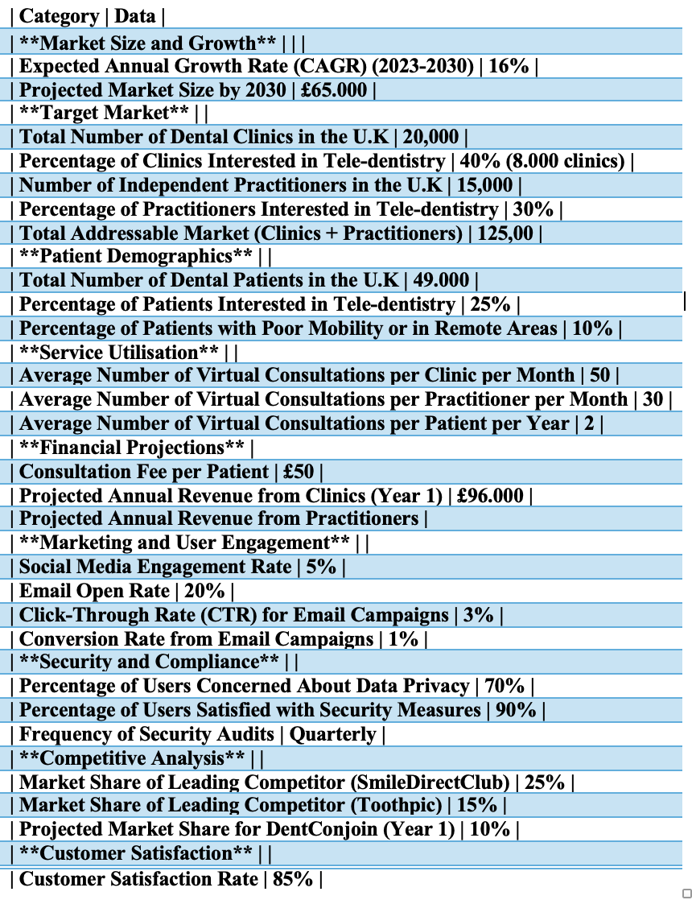

Business Name and Branding

I have created a website, which can be found https://free-5331683.webadorsite.com/
The name I would like to give my tele-dentistry business is DentConjoin. The branding strategy will be based on the key pillars of trust, innovation and accessibility. The logo will be clear and straightforward, and the colours will be calm to demonstrate professionalism and concern. Advertising messages will focus on the enhanced technology, simplicity of the application, and the ability to receive dental treatment at home. Promotion activities such as messages on microblogs, posts, and personal testimonials will describe success stories and the platform's utility (Enrique, Valdes and Miguel, 2018). Through investing in DentConjoin’s brand, the website will appeal to patients in need of quickly accessible dental care services as well as professionals who want to optimise their practice.

Sustainability of the Business Proposition

The income model of DentConjoin will be based on annual membership fees from the dental clinics and practitioners and consultation fees from the patients. The platform will incorporate paid services, including enhanced A.I. diagnostic capabilities and individualised treatment recommendations. Therefore, I will regularly acquire technology upgrades and diversify the services offered based on the client's feedback and market trends to sustain a competitive advantage (Al-Hakim et al., 2016). Continuous engagement with the dental associations and participation in relevant industry events will ensure the platform remains current. DentConjoin will continue to grow and stay relevant to the ever-changing dental market by focusing on customer satisfaction and embracing change.

Competitive Analysis

Other players in the tele-dentistry market are Toothpic and SmileDirectClub, offering online consultations and home-based treatment solutions (The TeleDentists, 2024). Such competitors specialise in some fields of dentistry and occasionally in orthodontics or other minor conditions in dentistry. The reason for taking such a stand is that DentConjoin deals with a larger, more all-inclusive view, from artificial intelligence diagnosis to treatment plans it can offer clients. Compared to the other competitors, the approach of DentConjoin will be much more trusted because of its association with dental clinics and insurance companies. This will make DentConjoin a flexible and dependable tele-dentistry service provider because it has more services in its portfolio and has built strategic relationships with other key players in the industry.

E-commerce

Website Platform

Regarding the DentConjoin platform, I want to ensure that the website design is professional and has straightforward navigation while addressing the needs of dentists and patients. DentConjoin will be an interactive platform for remote dental consultations, artificial intelligence approaches to diagnostics, and individualised care. To achieve this, I will use a SaaS solution like Shopify. Shopify has robust features, flexibility, and usability, which are critical for establishing a productive and efficient online store (Shopify, 2019). The software supports multiple payment systems, has robust security measures, and has numerous options to create a professional and friendly website. Although choosing marketplaces such as Amazon or eBay can increase visibility, focusing on the Shopify platform will help maintain better brand control and compatibility with specific dental software. This allows patients and practitioners to have a well-coordinated journey and interactions throughout the healthcare process.

Content Creation

Providing users with quality content is essential to keep them interested and ensure the information is trustworthy. The copy will include informative texts on the DentConjoin website and high-quality photographs and videos. These will consist of tutorials on using the platform, client satisfaction videos, and informative clips on dental care. Business photographs shall depict the user interface and the virtual consultation, while videos demonstrate the functionalities of A.I. diagnosis and tailor-made treatments. This will attract the traffic and improve their confidence and readiness to use the service, making it an essential aspect of our marketing strategy.

Payment Services

To enhance the user experience, DentConjoin will provide several payment methods, including credit card and PayPal. In the case of credit card transactions, compliance with the Payment Card Industry Data Security Standard (PCI-DSS) is essential to safeguard customer information. This calls for incorporating reliable payment options such as payment gateways and observing standard security measures like encryption or tokenisation of payments (Twarogal, 2024). With multiple safe payment options, I can address users' needs and improve their shopping experience while ensuring trust. Adhering to the PCI-DSS requirements will prevent legal complications and promote a secure payment process.

User Experience and Security

The design of the graphic interface will be amiable and instinctive to facilitate access to services offered by DentConjoin without any difficulties. There will be simplification of the design process, proper placement of the call-to-action buttons and sections, and the website's overall design will be compatible with desktop and mobile versions. Security is equally significant; hence, adequate security measures to safeguard client data shall be adopted, such as employing Secure Sockets Layer (SSL), conducting security assessments periodically, and using safe cloud solutions (Borky & Bradley, 2019). Also, I will establish limitations on access and control of data protection to meet legal requirements. These efforts shall cultivate a reliable and integrated environment that will prompt users to come back and refer our services to others.

Marketing

Promotion Strategy

To market DentConjoin effectively, I shall use a marketing mix of product, place, price and promotion. My product, a platform for virtual dental consultations and using artificial intelligence for diagnostics, will be distinguished as unique and revolutionary in dentistry. Pricing will be affordable while aligning to the products' value and convenience to the buyers. Promotional activities will entail social media advertising, where we will use Facebook, Instagram, and LinkedIn to market our services and the success stories of users (Kenan, 2023). With the permission of my potential and existing customers, I will send them emails about new features in my dental clinic, special offers on services, and essential tips on dental health. Moreover, content like blog articles, webinars, and video tutorials will make DentConjoin an expert in dental technologies. I will also reach out to the relevant dental associations and opinion leaders to increase the visibility and authority of the site.

Target Market

My crucial audience includes dental clinics, independent practitioners, and patients interested in comfortable and innovative dental treatment options. Specifically, I target the critical demographic of individuals 25 to 60 who are active in technology and prioritise their receptiveness to health improvement. In the psychographic sense, my customers are technological pioneers. They are inclined to convenience and actively take care of their health. I will target the relevant marketing methods they prefer online to reach this audience. Sharing valuable and engaging content like live question-and-answer sessions and informative posts will also help establish trust and grow audience engagement. As a result, I can reach out to the target group directly and design my marketing strategies according to their needs.

Digital Marketing Tactics

Facebook and Instagram pages will also be necessary for the DentConjoin’s development. I will post frequent updates in the form of informative articles on dental hygiene, exciting features of our product, and our clients’ success stories. As a form of paid search engine marketing, Google Ads will highlight the keywords associated with virtual dental consultations and A.I. diagnosis to generate traffic on my site. Customer journey mapping will enable me to identify the areas where potential consumers may engage with my brand (Miranda & Watts, 2021). This allows me to provide a one-stop shopping experience from when a person first learns about my services to when they book an appointment with me. Outlining these paths helps ensure that I remove barriers and deliver information that customers find helpful at each step, thus increasing conversion rates and customer satisfaction.

Email Marketing and Pre-launch Promotion

Creating an email list will be part of my marketing strategy. I will obtain email addresses from signup forms on my site, social media promotions, and my affiliation with companies related to the dental industry. Marketing campaigns before the launch will generate interest and desirability through teaser content and limited-time incentives. In my case, consent and data protection remain critical when conducting email marketing. To adhere to data protection laws, I will ask subscribers for their permission and make it easy for them to opt out at any time (Uzialko, 2024). My email content will include newsletters, special offers, and information about the latest additions to the website. I also consider user privacy and provide exciting and relevant content so customers follow the site regularly.

Privacy and Data Protection

Compliance with GDPR and Data Protection Act 2018

DentConjoin must adhere to the General Data Protection Regulation (GDPR) and the Data Protection Act 2018 (Uzialko, 2024). These regulations require personal data to be processed legally, openly, and expressly. To address this, I will adhere to strict data protection measures by only collecting personal data based on the user's consent and only using it for the intended purposes disclosed to the user. Compliance shall be checked regularly through audits and assessments. Privacy is essential; I will always disclose the intended data use and request permission before collecting the data. This increases the level of trust among the users since they are confident that their privacy is valued and respected.

Privacy and Electronic Communication Regulations (PECR)

Privacy and Electronic Communication Regulations (PECR) “prohibits the sending of unsolicited communications for direct marketing using electronic mail to individual subscribers” (Coe, 2023, p. 1). Following the provisions of PECR, my marketing communications will also be appropriately regulated to avoid instances where users are misdirected. Before sending out marketing emails or messages, I will ensure the recipient agrees to receive them. During the signup, straightforward opt-in methods will be included, and users will be informed of the kind of content that will be delivered. Furthermore, all marketing communications shall accompany clear options to opt-out and cancel the consent. This compliance helps me respect the user's preferences and privacy to maintain a healthy working relationship.

Security Measures

Safety is the primary concern for DentConjoin since it deals with its clients' personal information. To facilitate the users’ security, I will use secure cloud storage mechanisms such as secure data encryption during transfer and storage. Proper access control measures will be implemented to guarantee that only the authorised persons can access the secured information. Security updates and patches will be conducted systematically to avoid any openings. Also, a multi-factor authentication (MFA) approach will be adopted to enhance user account security. Recurrent security audits and risk assessments will address any possible threats. These measures will ensure that the user data is secure from unauthorised access and breaches, among other security threats, which will add value to my users.

User Rights and Opt-out Options

DentConjoin recognises that respect for users' rights is primary to the issue of data privacy. To ensure compliance, I will provide options enabling users to exercise their rights under GDPR, including exercising the right to data access and rectifying and erasing inaccurate data (Uzialko, 2024). This means that clear and easily understandable opt-out mechanisms will accompany any form of direct marketing to the users to enable them to stop receiving newsletters or promotional emails. Furthermore, I will have procedures to address data deletion requests and ensure they are handled efficiently and securely. In this way, I guarantee users control over their data, making our relationship as transparent and trusting as possible.

Reference List

‌
‌
Al-Hakim, L., Wu, X., Koronios, A. and Shou, Y. (2016). Handbook of research on driving competitive advantage through sustainable, lean, and disruptive innovation. Hershey, Pennsylvania (701 E. Chocolate Avenue, Hershey, PA 17033, USA): IGI Global.
Batra, P., Himanshu Tagra & Katyal, S. (2022). Artificial Intelligence in Teledentistry. [online] 10(3), pp.153–153. doi:https://doi.org/10.15190/d.2022.12.
Borky, J.M. & Bradley, T.H. (2019). Protecting Information with Cybersecurity. Effective Model-Based Systems Engineering, [online] pp.345–404. doi:https://doi.org/10.1007/978-3-319-95669-5_10.
Coe, E. (2023). A timely reminder of the U.K.'s electronic marketing rules - Edwin Coe LLP. [online] www.edwincoe.com. Available at: https://www.edwincoe.com/blogs/main/a-timely-reminder-of-the-uks-electronic-marketing-rules/
Enrique, J., Valdes, S.O. and Miguel, L. (2018). Applications of Conscious Innovation in Organizations. IGI Global.
Juliana, N.O., Hui, H.J., Clement, M., Solomon, E.N. & Elvis, O.K. (2021). The Impact of Creativity and Innovation on Entrepreneurship Development: Evidence from Nigeria. Open Journal of Business and Management, 9(4), pp.1743–1770. doi:https://doi.org/10.4236/ojbm.2021.94095.
Kenan, J. (2023). How to build your social media marketing strategy for 2019. [online] Sprout Social. Available at: https://sproutsocial.com/insights/social-media-marketing-strategy/
Miranda, D. and Watts, R. (2021). Customer Journey Map: Everything You Need To Know. [online] Forbes Advisor. Available at: https://www.forbes.com/advisor/business/software/customer-journey-map/
Shopify (2019). What is Shopify? [online] Shopify. Available at: https://www.shopify.com/blog/what-is-shopify
The TeleDentists (2024). Teledentistry Global Market Opportunities and Strategies to 2032 - The TeleDentists. [online] www.theteledentists.com. Available at: https://www.theteledentists.com/in-the-news/teledentistry-global-market-opportunities-and-strategies-to-2032 [Accessed 3 Jul. 2024].
Trott, P. (2012). Innovation management and new product development. Harlow, Essex: Financial Times/Prentice Hall.
Twarogal, P. (2024). The Importance of PCI DSS Compliance in Payment Gateway Integration. [online] Neontri. Available at: https://neontri.com/the-importance-of-pci-dss-compliance-in-payment-gateway-integration/
Uzialko, A. (2024). Email Marketing in the Age of the Digital Privacy Laws. [online] business.com. Available at: https://www.business.com/articles/email-marketing-and-data-privacy-laws/
Vodanović, M., Marko Subašić, Milošević, D. and Ivana Savić Pavičin (2023). Artificial Intelligence in Medicine and Dentistry. Acta stomatologica Croatica, 57(1), pp.70–84. doi:https://doi.org/10.15644/asc57/1/8.

Appendix


