Dissertation Proposal BMBM6008
A Critical Analysis of the Impact Tesco’s Clubcard has on the Loyalty of its’ Customers.
Benjamin John (1707698)
Word Count - 1625
Contents
1.Introduction 2
1.1 Rationale 2
1.2 Background 3
1.3 Aims and Objective 4
2. Research Design 5
2.1 Research Methodology 5
2.2 Research Philosophy 6
2.3 Research Approaches 6
2.4 Data Collection 6
2.5 Data Analysis 7
2.6 Sample 7
3. Limitations and Ethical Considerations 8
3.1 Time Limitations 8
3.2 Ethical Considerations 8
4. Resources 9
4.1 Resources 9
5. References 10
6. Appendix 12

1.Introduction

1.1 Rationale
There is a problem within Tesco, despite revolutionising customer loyalty schemes within supermarkets with the launch of their Clubcard scheme in 1994, customers who are on the hunt for value are now choosing to shop at discount supermarkets (Statista, 2020). Despite launching new initiatives to keep the Clubcard scheme current as well as enticing Clubcard customers with exclusive deals (Tesco, 2020), customer loyalty is still being questioned. The shift in customer loyalty to discount supermarkets is having a negative impact on Tesco as their market share continues to gradually decline while the market shares of their discount competitors continue to grow in a crowded market (Statista, 2020). A possible cause of this problem is economic uncertainty as well as growing inflation with the prices of products within supermarkets.
This dissertation will critically analyse how the Clubcard scheme within Tesco plays a role in the loyalty of its customers and whether or not it has an impact on where they choose to shop. The dissertation will analyse a range of different factors that could impact the loyalty of customers as well as investigating whether or not loyalty schemes play a role in the loyalty of customers. Finally, the dissertation will seek to find whether loyalty schemes are still effective in the current day when competing against the no-frills discount retailers.
This dissertation will use questionnaires aimed at customers of Tesco who partake in the Clubcard loyalty scheme in the hope of understanding the different factors impact customer loyalty towards supermarkets and whether or not the Clubcard plays a role in the decisions made by the customers and their loyalty towards the supermarket.

1.2 Background
Loyalty schemes within supermarkets are not a new concept, however, loyalty schemes and their link to loyalty and consumer satisfaction as well as consumer behaviour, is something that has been discussed and analysed by a number of researchers who seek to understand the different factors that play a role in the loyalty of consumers towards a supermarket. The dissertation will be looking at key authors and theorists who discuss customer satisfaction, customer loyalty as well as consumer behaviour and their links to customer loyalty towards a supermarket. Factors impacting customer decisions will also be discussed.
In a study by Buckingham (2018), it was found that 85% of shoppers are more likely to shop at a supermarket if it offers a loyalty scheme, it was also found in the same study that 27% of shoppers would avoid a supermarket all together if a loyalty scheme was not available. A study by Liu (2007), found that loyalty schemes within supermarkets broaden the customers relationship with the supermarket as well as finding that customers who took part in loyalty schemes, over time purchased more from the supermarket and became more loyal to the particular supermarket.
Customer retention is a factor which is important for the success of a supermarket and can be measured to understand the loyalty of customers. Walkers loyalty matrix which can be seen as figure 2 in the appendix, provides a framework to assess and measure the stability and loyalty of customers within an organisation (Walker, 2020). Magatef and Tomalieh (2015), state that retention is important for supermarkets as it is cheaper to keep existing customers than to draw in new ones. Similarly, it was found by Singh and Imran (2012), that retaining a customer can increase profits by 25%.

1.3 Aims and Objective
Project Aim
This project aims to critically analyse whether or not the Tesco Clubcard impacts consumer behaviour and the loyalty of its customers towards the supermarket.
Project Objectives
- To conduct an extensive literature review that will discuss the key literature and theories produced by credible authors who have discusses and analysed the impact loyalty cards and loyalty schemes have had on the behaviour of consumers.

- To undertake primary research through the use of a survey aimed towards those who possess a Clubcard to better understand the extent in which the Clubcard plays a role in the loyalty of the consumers when choosing a supermarket.

- To make recommendations based on the findings of the project that will allow Tesco to better understand the impact their loyalty scheme has on the loyalty of its customers.

2. Research Design

2.1 Research Methodology
Research has been defined as the investigative process that allows for the finding of a reliable solution to any problem through the systematic selection, collection, analysis, and interpretation of any data that has been collected in order to gain a better understanding and a deeper knowledge of the problem faced (Muredzi, 2019).
For the purpose of this research, the researcher will be using the research onion model as developed by Saunders, Lewis, and Thornhill, as this model clearly indicates the steps that are required in order to conduct successful research. The model consists of six layers which require the researcher to use at least one step from each layer to ensure complete and successful research (Saunders, Lewis, and Thornhill, 2019).
The six layers of the research onion are as follows, Philosophies, Approaches, Strategies, Choices, Horizons and Techniques. Figure 1 as seen below demonstrates the pathway that the researcher intends to use for the purpose of this research.
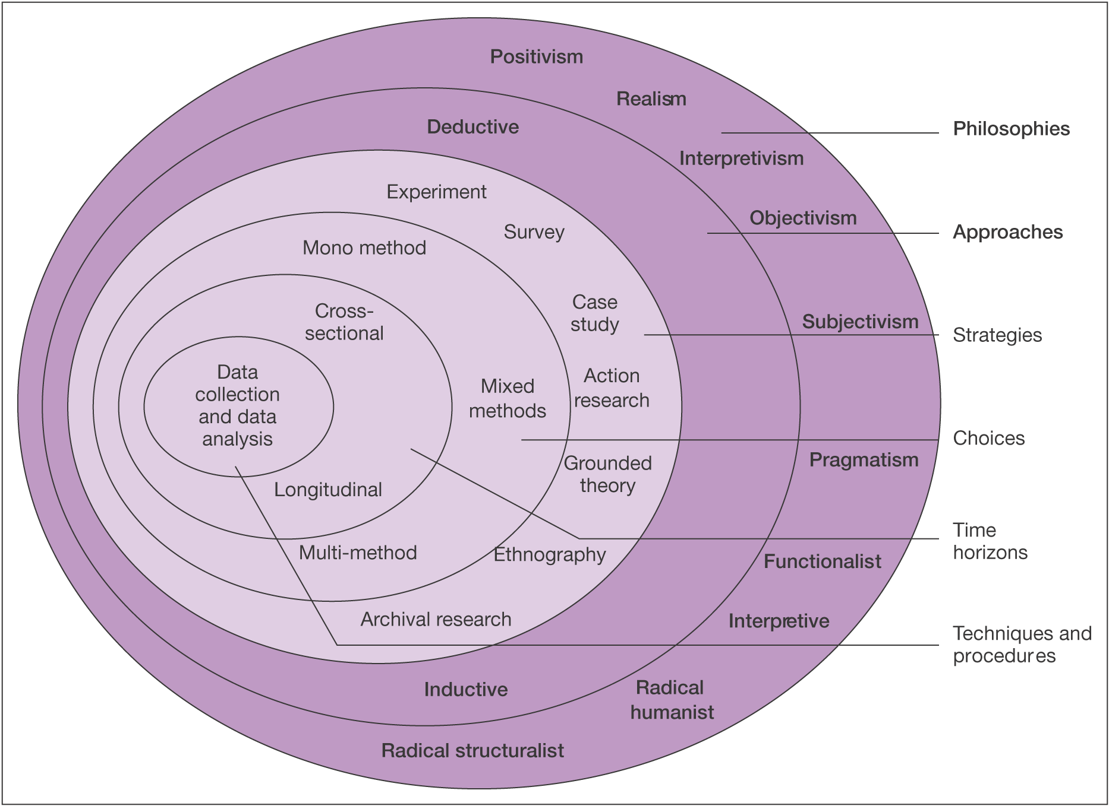

Figure 1. ‘Research Onion’ (Saunders, Lewis, and Thornhill, 2019).

2.2 Research Philosophy
The philosophical approach to the research within this project is the positivism approach. The positivism philosophy depends on observations that lead to results from scientific analysis (Buchanan, 2018). This philosophy is necessary for the research as the results found from the statistical analysis will be used to aid the project. As a general rule, the positivism philosophy adopts the deductive approach to research (Crowther and Lancaster, 2008) and therefore the deductive approach will be the approach used within the research.

2.3 Research Approaches
The research approach adopted within this research will be the deductive approach. The deductive approach to research applies theory to a hypothesis and allows for it to be tested against the theory (Wilson, 2010). According to Saunders et al (2019), this approach is seen as a more scientific approach to research as it allows for theory to be rigorously tested. Using this approach alongside the positivism philosophy is the most appropriate for this research.

2.4 Data Collection
The primary data collection method that will be adopted within this research to ensure the completion of the researchers aim and objectives is a questionnaire. A questionnaire will be drafted using Google Forms and will be distributed online via social media platforms to those who partake in the Clubcard loyalty scheme at Tesco.
Questionnaires allow for the collection of quantitative data and allow for a range of open and closed questions to be asked to the participant. This allows the researcher to gather information about the participants as well as their behaviours, experiences, and social interactions (McGuirk and O’Neill, 2016).

2.5 Data Analysis
Quantitative data allows for the data collected to be turned into numerical data that can be analysed using mathematical methods such as statistics (Muijs, 2011). This allows for appropriate statistical tests to be undertaken with the data set collected from the primary research and allows for statistical software to be used to analyse the data to ensure the most significant findings have been outlined.

2.6 Sample
The sample of the data collection will be a convenience sample as this is a nonprobability sample that allows for participants to be chosen in the most convenient way. As the research will be conducted over social media this is considered a convenience sample (Dudovskiy, 2016).

3. Limitations and Ethical Considerations

3.1 Time Limitations
The researcher has a limited time to complete the project, therefore it important that all necessary tasks are completed on time. A Gantt chart is a practical and useful way of planning activities and their durations to aid within the strategic planning of a project (Geraldi and Lechter, 2012). Therefore a Gantt chart as seen as figure 1 in the appendix has been produced by the researcher to outline the appropriate time scale for the completion of tasks within the project.

3.2 Ethical Considerations
When conducting research which involves members of the public it is important to consider ethical guidelines to ensure that all participants are protected against any possible risks that may arise as the result of their participation (Krishnaswamy, Sivakumar and Mathirajan, 2009).
The research will only allow for those over the age of 18 to participate in the questionnaire and the nature of the questions will be unlikely to cause psychological harm to participants. The participants choice to partake is voluntary and they are able to withdraw from the study at any time. All the data collected from participants of the questionnaire will be stored in a safe and secure manner at all times to ensure that the data is only shared with those which it is intended.
An ethics form will be completed by the researcher prior to the research outlining the ethical considerations of the project.

4. Resources

4.1 Resources
In order to successfully complete the aim and objectives of the project, the researcher will use a range of resources. The most useful resource to the researcher will be the internet. The internet will allow the researcher to access articles and journals as well as the online university library to access information that will aid with the completion of the project. To ensure the most credible sources are accessed when the researcher is not using the online university library, Google Scholar will be used.
The second resource that the researcher will use is SPSS software. The software will allow the researcher to statically analyse all the data that was collected from participants of the questionnaire in order to gain a deeper understanding of the responses collected.

5. References

Buchanan, I., (2018). A Dictionary of Critical Theory. 2nd ed. Oxford University Press.
Buckingham, D., (2018). The True Impact of Loyalty Schemes, Rewards and Personalisation on Consumer Behaviour. [online] Available at: <https://www.ecrebo.com/blog/true-impact-loyalty-schemes-rewards-personalisation#:~:text=The%20first%20is%20that%20loyalty,that%20didn't%20have%20one. [Accessed 30 November 2020].
Crowther, D. and Lancaster, G., (2008). Research Methods: A Concise Introduction to Research in Management and Business Consultancy. 2nd ed. Butterworth-Heinemann.
Dudovskiy, J., (2016). The Ultimate Guide to Writing a Dissertation in Business Studies: A Step-By-Step Assistance. 1st ed. Research-Methodology.net.
Geraldi, J. and Lechter, T., (2012). Gantt Charts Revisited. International Journal of Managing Projects in Business, 5(4), pp.578-594.
Krishnaswamy, K., Sivakumar, A. and Mathirajan., (2009). Management Research Methodology: Integration of Principles, Methods and Techniques. 3rd ed. Delhi: Pearson Education, p.563.
Liu, Y., (2007). The Long-Term Impacts of Loyalty Programs on Consumer Purchase Behaviour and Loyalty. Journal of Marketing, 71(4), pp.19-35.
Magatef, S. and Tomalieh, E., (2015). The Impact of Customer Loyalty Programs on Customer Retention. International Journal of Business and Social Science, 6(8).
McGuirk, P. and O’Neill, P., (2016). Using Questionnaires in Qualitative Human Geography. Faculty of Social Sciences, pp.246-273.
Muijs, D., (2011). Doing Quantitative Research in Education with SPSS. 2nd ed. Sage Publications, pp.1-12.
Murezdi, P., (2019). Research and the Concept of Research. [online] Available at:<https://www.researchgate.net/publication/331706666_Research_and_the_Concept_of_Research> [Accessed 19 November 2020].
Saunders, M., Lewis, P. and Thornhill, A. (2019). Research Methods for Business Students. 8th ed. London: Pearson Education.
Singh, R. and Imran, K., (2012). An Approach to Increase Customer Retention and Loyalty in B2C World. International Journal of Scientific and Research Publications, 2(6).
Statista., (2020). Great Britain: Grocery Market Share 2015- 2020 | Statista. [online] Available at: < https://www.statista.com/statistics/280208/grocery-market-share-in-the-united-kingdom-uk/> [Accessed 28 October 2020].
Statista., (2020). Supermarkets in the United Kingdom – Statistics and Facts. [online] Available at: <https://www.statista.com/topics/1983/supermarkets-in-the-united-kingdom-uk/> [Accessed 27 October 2020].
Tesco PLC., (2020). Tesco Offer Hundreds of Exclusive Deals for Clubcard Customers. [online] Available at: <https://www.tescoplc.com/news/2020/tesco-offer-hundreds-of-exclusive-deals-for-clubcard-customers/> [Accessed 28 October 2020].
Walker., (2020). Walker Loyalty Matrix. [online] Walkerinfo.com. Available at: <https://www.walkerinfo.com/loyalty-matrix> [Accessed 30 November 2020].
Wilson, J., (2010). Essentials of Business Research: A Guide to Doing Your Research. Sage Publications, p.12.

6. Appendix
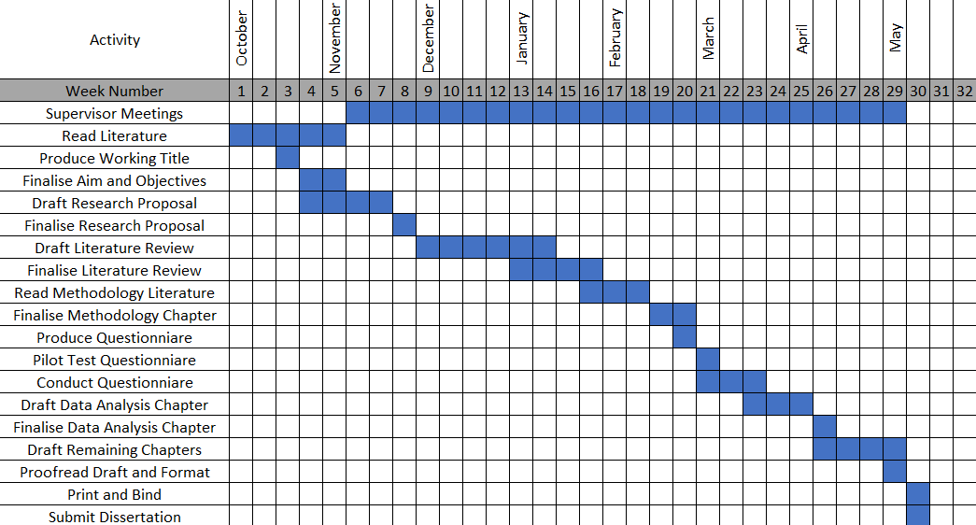
Figure 1. Gantt Chart

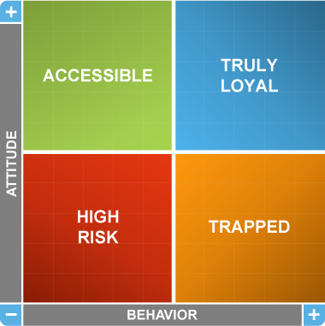
Figure 2. Walkers Loyalty Matrix

