A Report into the effectiveness of the Current Structure of the NHS in Wales

Student name: Rebecca Pritchard
Student Number: 1904605
Course Lead: Dr Jayne Griffith-Parry
Module title: Managing Organisations
Course code: BMHP4010

A Report into the effectiveness of the Current Structure of the NHS in Wales

This report will discuss the effectiveness of the current structure of the NHS in Wales. To begin the report, an overview of the history of the NHS will be provided with an insight into the formation of the NHS in Wales. When considering the NHS in Wales, illustrations surrounding the seven Local Health Boards (LHB) and four Trusts have briefly been examined, implicating maps and tables examining the coverage of the LHB and the hospitals that are represented. The report provides an evaluation of the structures within the NHS in Wales, implementing funding allocations and processes. Following the conclusion, personal recommendations have been made as a suggestion on how the NHS in Wales could be improved in the future.
Earlier approaches to health within not only Wales but the UK as a whole generally saw it as the responsibility of the individual to seek and pay for required health services; this generally meant that people living in poverty were unable to get access to the health care they frequently needed, resulting in people living for decades with untreated illnesses (Grosios, Gahan and Burbidge, 2010). Powell (2018) remarks that prior to the formation of the National Health Service (NHS), many people relied solely on charity and their healthcare being provided by voluntary hospitals, unfortunately, due to the increasing demand and growing population, generosity alone could not provide all that was needed. In 1948 the labour minister for health’ Aneurin Bevan, demanded changes within healthcare – this began one of the biggest and most expensive social reforms. The NHS Wales (2020a) reports that the service was created based on the principles that health services would be free at the point of delivery and was to be funded from general taxes. It was assumed that once the NHS was formed, the need for medical treatment would decrease, unfortunately, the demand for health care continued to rise, resulting in the government having to provide further amounts of funding (NHS Wales, 2020b). As the newly formed National Health Service continued to struggle, in 1997 a vote was carried out; with the outcome of 50.3 percent voting for the creation of a devolved National Assembly for Wales – this meaning that the power from central government was passed to local or regional administrators; resulting in a more effective method of policymaking (National Assembly for Wales, 2020a). Devolution meant that in 1999 the NHS in Wales was passed to the Welsh Government and has since been the responsibility of the Welsh Cabinet Secretary for Health and Social Services - Mr Vaughan Gethin AM.
The NHS Wales (2009) report remarks that one of the biggest reforms within the NHS took place in Wales in 2009, this saw 22 LHB and seven NHS Trusts being replaced with seven integrated LHB; who is now responsible for all health care services within Wales, the main purpose of this reform was to remove market leavers in order to improve the care of patients, with the hope that the NHS in Wales could provide seamless care. Market levers and bureaucratic levers are known as the levers of success and are a large part of the formation of health care within wales, market levers provide competition, efficiency and responsiveness, whereas’ bureaucratic levers emphasise on co-operation, teamwork and integration (National Assembly for Wales, 2015a). Due to the high rates of cancer, ageing population and the large amounts of rural, urban and valley areas, NHS Wales are required to provide a more tailored form of care in order to increase the number of people living independently. By combining multiple services within health and social care, the NHS in Wales has been able to provide care closer to people’s homes and have also implemented self-care programmes by looking at the system as a whole, rather than just the hospitals (Health Careers, 2020).
At the centre of the health systems in Wales, there are seven Local health Board’s and four NHS Trusts - below is a geographical map of Wales, displaying the coverage of the seven LHB:
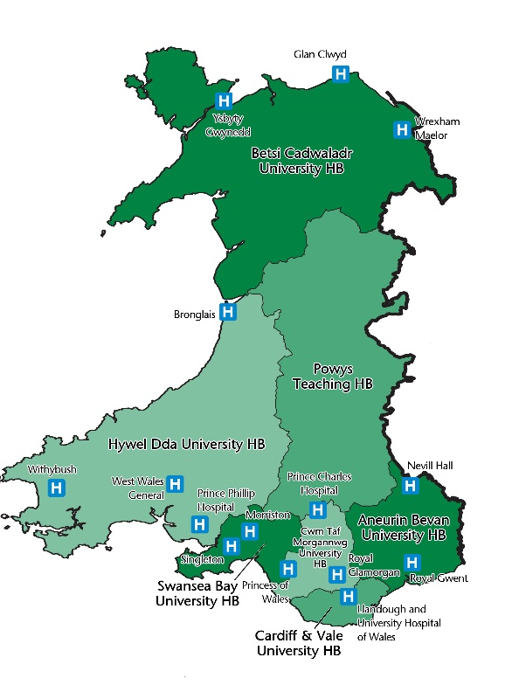
There were crucial changes made in 2019 to the LHB boundaries. Following the name change of Swansea Bay University LHB, formerly ‘Abertawe Bro Morgannwg University LHB’ the geographical layout had to be revised – this meant that Cwm Taf Morgannwg University LHB was required to extend its boundaries and began covering the Princess of Wales Hospital Bridgend. The above map outlines the hospitals within Wales and which of the seven LHB cover that area following its most recent changes (Welsh Government, 2019a). Each of the seven LHB within Wales is subdivided into locality offices, all of which have the responsibility of the planning, funding and the delivery of healthcare within their area. Furthermore, it is the obligation of the LHB to ensure sufficient delivery of Doctors, pharmacies, dentists, inpatient and outpatient services within hospitals and community services locally to the service users (GP One, 2019a).
The below table provides a brief overview of the delivery of services being provided by each LHB – this includes the geographical areas to where the LHB deliver their services, a list of hospitals and populations within each area, plus any additional services the hospitals may provide.
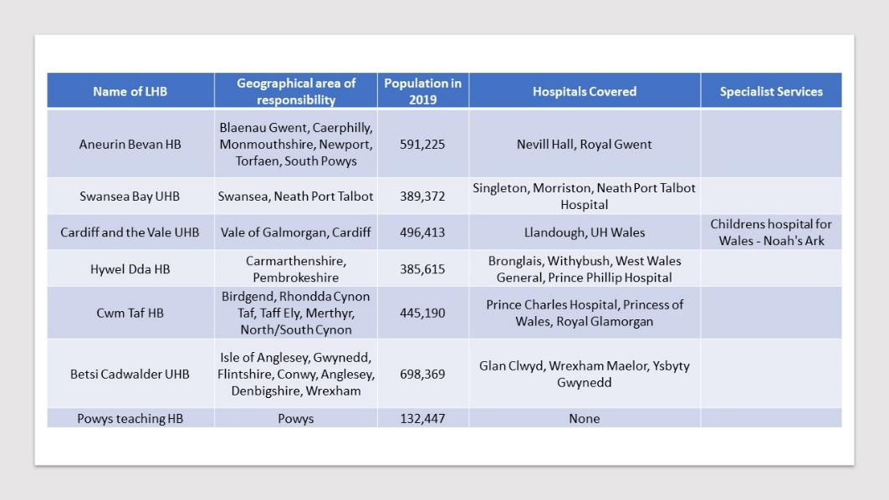
(Welsh Government, 2019c)
In addition to the LHB in Wales, there are four NHS trusts, these are - the Welsh Ambulance Services NHS Trust, Velindre NHS Trust, Public Health Wales Trust, Health Education and Improvement Wales (HEIW) - all four trusts provide Wales with remarkable medical services. The Welsh Ambulance Services NHS Trust (2020) reportedly serve an estimated three million people in Wales, providing a variety of services across the country, this includes not only ambulances but also provides NHS direct and 111 services, the service is becoming one of the most clinically advanced within the UK ensuring a high standard of care to all who need it.
Velindre NHS Trust was formed in 1994, providing Wales with specialist cancer care services and complements the Welsh Blood Service. The trust receives around 5,000 new patients per year intending to provide patients, donors, hospitals, charities and all service users with the best possible care (Velindre University NHS Trust Wales, 2020).
The Public Health Wales (2020) have the responsibility of improving health and equalities within Wales, it is also the role of the trust to protect individuals against infectious hazards.
Finally, the fourth NHS Trust in Wales was established in 2018, all other trusts prioritise patient care, what makes the Health Education and Improvement Wales (HEIW) different from the others, is that the trust was set out to improve the education, training and development of the NHS workforce.
Evolving health care needs within Wales are putting extreme pressures on the NHS, an increase of diabetes and obesity along with an ageing population are only a few of the factors impacting the NHS in Wales (NHS Wales, 2001). All too often hospitals within LHB in Wales are publishing statements; generally, on social media, advising individuals to refrain from attending the medical services within hospital A&E departments unless absolutely necessary; this is due to increased waiting times, an increase in the number of patients and staff shortages. The online Choose Well Wales (2020) service, provides patients with key information on the hospitals they may need to attend in the event of an emergency – depending on the symptoms or injury, the service also provides average waiting times within the emergency departments and are updated at real-time. Prudent Healthcare (2020) suggests that the discussed service was implemented to ease the pressures on the larger hospitals within Wales, with the hope that service users would take alternative measures when hospitals are extremely busy, unfortunately, all hospital services are extremely stretched, requiring changes to be made in order for service users to become more reliant on other medical services within the NHS in Wales. Statistics show that the number of GP surgeries within Wales is decreasing, raising the question as to how GP closures will impact the services within hospitals’ both now and in the future.
General Practitioner (GP) services are delegated from the Local Health Boards via the General Medical Services contract; which became effective in 2004, the aim of the contract was to impose sustainability within the profession, with the outlook of creating a healthier Wales, the contract provided a significant change by imposing practice-based, rather than practitioner-based funding (GP One, 2019b). In 2018 the LHB was issued with data collection forms in order to gather statistics on the number of GP practices within Wales as compared to previous years. As retrieved from the Welsh Government’s (2019b) report, the below graph identifies the number of GP practices within each LHB before the changes, demonstrating that the numbers are slowly decreasing:

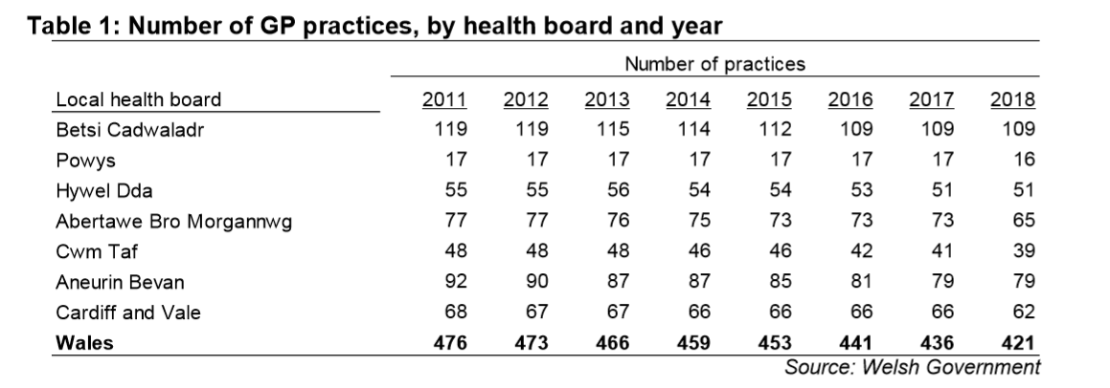
The funding allocations for the NHS Wales acts as part of a negotiation process between the Welsh Government and Westminster, Wales is predominantly provided with what is known as a block grant which is then divided into areas controlled by the Welsh Assembly Government since devolution (NHS Wales, 2020c). The NHS is composed of multiple complex organisations, a diagram provided by the National Assembly for Wales (2015b) illustrates the structure of the NHS in Wales as:
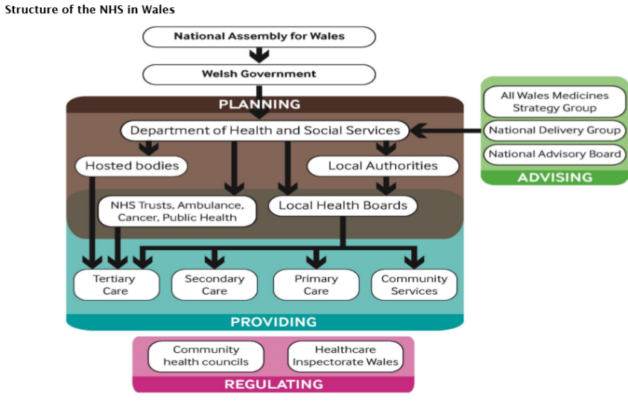
At the core of the NHS system in Wales, is a substantial amount of planning between the Welsh Government and NHS bodies, conversations surrounding how the funding is to be used and distributed are vital when implicating a three-year plan to improve health care needs within Wales. Once an agreement has been made between the Welsh Government and the NHS bodies, it is then the responsibility of the LHB and NHS Trusts to deliver the care set out in the imposed targets (The Welsh NHS Confederation, 2017). The National Assembly for Wales (2020b) below draft statistics, provides a breakdown on how NHS funding is distributed between local authorities within Wales, suggesting that in 2020 funding will be decreased for many areas.
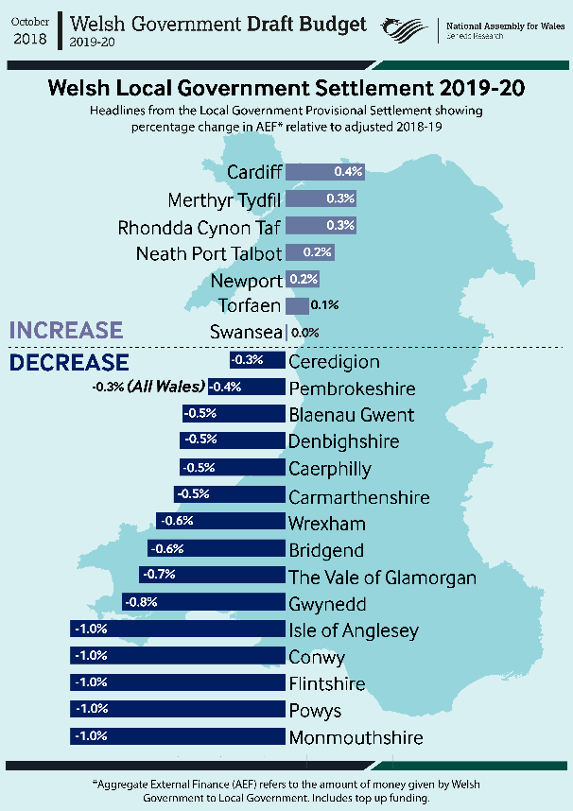
A decrease in funding in local areas may have a further negative impact on the GP surgeries within Wales. The BMA (2018) suggests that a reduction in funding will force further closures to the much-needed GP practices in Wales, this will send accident and emergency services into crisis’ due to limited appointment times and inaccessible practices, particularly in the rural areas of Wales.
To conclude, it is evident that the NHS in Wales has provided remarkable health care to all that requires it. There have been multiple changes to the structures of the NHS in Wales since it began, each one aiming to provide a better service. When carrying out research on the NHS in Wales it is obvious that continuing pressures on the services are having a major impact on both the staff and patients.

Recommendations
Statistics have shown that the NHS in Wales is under considerable amounts of pressure due to various reasons as outlined within this report, this includes an increase of an ageing population, obesity, diabetes and misuse of the service. Waiting times within hospital services such as A&E departments could benefit from more practical use of GP Surgeries. Should GP surgeries implicate; weekend appointments, longer opening hours and better appointment systems this may, in turn, reduce the pressures on local hospitals and the NHS Wales. In order for GP surgeries to consider the above, changes must be made to the way funding is being provided and General Practitioner training must once again be made beneficial (Statistics for Wales, 2019).

Reference list
BMA (2018) BMA - GP practices 'at risk' of closure. Available at: https://www.bma.org.uk/news/2018/february/gp-practices-at-risk-of-closure (Accessed 5th February 2020).
Choose Well Wales (2020) My A&E Live - Time spent in NHS Wales Accident and Emergency Departments. Available at: http://www.choosewellwales.org.uk/home (Accessed 5th February 2020).
GP One (2019a) GP-one: Structure. Available at: http://www.gpone.wales.nhs.uk/nhs-wales-structure (Accessed 3rd February 2020).
GP One (2019b) GP-one: GP Contract. Available at: http://www.gpone.wales.nhs.uk/gp-contract/ (Accessed 3rd February 2020).
Grosios, K. Gahan, P. and Burbidge, J. (2010) ‘Overview of healthcare in the UK’. EPMA Journal. 1 (4) pp 529-534.
Health Careers (2020) UK health systems. Available at: https://www.healthcareers.nhs.uk/working-health/uk-health-systems (Accessed 3rd February 2020).
National Assembly for Wales (2015a) The organisation of the NHS in the UK: comparing structures in the four countries. Available at: https://www.assembly.wales/research%20documents/15-020%20-%20the%20organisation%20of%20the%20nhs%20in%20the%20uk%20comparing%20structures%20in%20the%20four%20countries/15-020.pdf (Accessed 3rd February 2020).
National Assembly for Wales (2015b) Research paper: The organisation of the NHS in the UK: comparing structures in the four countries. Available at: https://www.assembly.wales/research%20documents/15-020%20-%20the%20organisation%20of%20the%20nhs%20in%20the%20uk%20comparing%20structures%20in%20the%20four%20countries/15-020.pdf (Accessed 5th February 2020).
National Assembly for Wales (2020a) History of Welsh devolution. Available at: https://www.assembly.wales/en/abthome/role-of-assembly-how-it-works/Pages/history-welsh-devolution.aspx (Accessed 3rd February 2020).
National Assembly for Wales (2020b) Welsh Government budget 2019-20: Draft Budget 2019-20. Available at: https://www.assembly.wales/en/bus-home/research/financial-scrutiny/budgets/Pages/wg-budget-2019-20-draft.aspx (Accessed 5th February 2020).
NHS Wales (2001) Improving Health in Wales: the future of primary care. Available at: http://www.wales.nhs.uk/publications/primcare_e.pdf (Accessed 4th February 2020).
NHS Wales (2009) NHS in Wales: Why are we changing the structure. Available at: http://www.wales.nhs.uk/documents/NHS%20Reform%20leaflet_October%202009.pdf (Accessed 3rd February 2020).
NHS Wales (2020a) Health in Wales: History & Context. Available at: https://www.wales.nhs.uk/nhswalesaboutus/historycontext (Accessed 1st February 2020).
NHS Wales (2020b) Health in Wales: 1950's. Available at: https://www.wales.nhs.uk/nhswalesaboutus/historycontext/1950s (Accessed 1st February 2020).
NHS Wales (2020c) Health in Wales: Budget’s and Changes. Available at: https://www.wales.nhs.uk/nhswalesaboutus/budgetcharges (Accessed 5th February 2020).
Powell, M. (2018) ‘Exploring 70 Years of the British National Health Service through Anniversary Documents’. International Journal of Health Policy and Management. 7 pp 574-580.
Prudent Healthcare (2020) Securing Health and Well-being for Future Generations. Available at: https://gov.wales/sites/default/files/publications/2019-04/securing-health-and-well-being-for-future-generations.pdf (Accessed 5th February 2020).
Public Health Wales (2020) About Us: Public Health Wales. Available at: https://phw.nhs.wales/about-us/ (Accessed 4th February 2020).
Statistics for Wales (2019) Statistical First Release: GP Access in Wales, 2018. Available at: https://gov.wales/sites/default/files/statistics-and-research/2019-03/gp-access-in-wales-2018-156_0.pdf (Accessed 5th February 2020).
Velindre University NHS Trust Wales (2020) Velindre NHS Trust: About us. Available at: http://www.velindre-tr.wales.nhs.uk/about-us (Accessed 3rd February 2020).
The Welsh Ambulance Services NHS Trust (2020) About Us. Available at: https://www.ambulance.wales.nhs.uk/en/8 (Accessed 3rd February 2020).
The Welsh NHS Confederation (2017) Finance and the NHS in Wales. Available at: https://www.nhsconfed.org/-/media/Confederation/Files/public-access/Welsh-NHS-Confederation-Finance-Briefing.pdf (Accessed 5th February 2020).
Welsh Government (2019a) Statistical First Release: GP Access in Wales, 2018. Available at: https://gov.wales/sites/default/files/statistics-and-research/2019-03/gp-access-in-wales-2018-156_0.pdf (Accessed 3rd February 2020).
Welsh Government (2019b) Written Statement: Health board boundary change: Bridgend. Available at: https://gov.wales/written-statement-health-board-boundary-change-bridgend (Accessed 3rd February 2020).
Welsh Government (2019c) Stats Wales: Population estimates by local health boards and age. Available at: https://statswales.gov.wales/Catalogue/Population-and-Migration/Population/Estimates/Local-Health-Boards/populationestimates-by-lhb-age (Accessed 4th February 2020).

