MSc Lean & Agile Operations
Cameron Davies – P150422
University of Wales Trinity Saint David
Introduction and Application of Yield Improvements
The Impact of Yield Improvements in Investment Castings

This thesis is the result of the author’s original research. It has been composed by the author and has not been previously submitted for examination which has led to the award of a degree.

Signed: Date:

1.0 Executive Summary
This project was undertaken to address a critical operational challenge within the investment casting department at Wall Colmonoy: increasing yields to meet growing market demands and enhance productivity. The department’s baseline output of 56 parts per tree was identified as a limiting factor in achieving cost efficiency and scaling production. The initiative sought to develop, trial, and implement an optimised tree design that would significantly increase the number of parts per tree while maintaining the company’s stringent quality standards.
Through a structured approach, four distinct tree design variants were developed and rigorously tested. Each variant was evaluated against key criteria, including yield improvement, mould integrity, process efficiency, and implementation feasibility. After comprehensive analysis, design variant 1 emerged as the optimal solution, achieving an increase from 56 to 96 parts per tree. This design demonstrated the best balance between productivity gains, quality assurance, and operational feasibility, requiring only moderate adjustments to existing equipment and processes.
The implementation of the selected variant offers transformative benefits, including increased throughput, reduced cost per part, and enhanced sustainability through lower material and energy waste. Additionally, the project provides a framework for continuous improvement, fostering a culture of innovation within the organisation.
Recommendations for further improvements include adopting predictive analytics, enhancing sustainability practices, and expanding automation efforts to ensure long-term success. This project exemplifies Wall Colmonoy’s commitment to operational excellence and positions the company as a leader in the competitive investment casting industry.

Contents
1.0 Executive Summary 2
2.0 Introduction 5
2.1 Wall Colmonoy 5
2.2 Yield Improvements 6
2.3 Project Aim 6
2.4 Project Objectives 6
3.0 Literature Review 9
3.1 Investment Casting 9
3.1.1 Tooling 9
3.1.2 Waxroom 10
3.1.3 Mould Room 11
3.1.4 Foundry 13
3.1.5 Fettling 14
3.1.6 Machining 15
3.1.7 Inspection 15
3.2 Benefits of Yield Improvements in Investment Casting 16
3.2.1 Cost Reduction 16
3.2.2 Enhanced Product Quality 16
3.2.3 Increased Efficiency 17
3.2.4 Competitive Advantage 17
3.2.5 Sustainability 17
3.2.6 Profitability 17
3.3 Investment Casting Alternatives 17
3.4 Quality Cost / Poor Quality Cost 18
3.5 Casting Defects 20
3.6 9 Lean Wastes 21
3.7 Kaizen Methodology 22
3.8 How is Yield Measured? 22
4.0 Main Body 24
4.1 Case Study – Wall Colmonoy 24
4.1.1 Current Status 24
4.1.2 Lean Methodology 26
4.1.3 Design Phase (4 Different Versions) 28
4.1.4 Cost Analysis / Justification 30
4.1.5 FEA 31
4.1.6 Considerations 33
4.1.7 Trial 36
4.1.8 Feedback 36
4.2 Results 37
4.2.1 Visual/Tolerance 37
4.2.2 X-Ray 38
2.2.3 Machining 41
2.2.4 Review 41
2.2.5 Change / No Change 42
5.0 Conclusion 43
6.0 Further Recommendations 47
7.0 References 49
8.0 Appendix 54
8.1 Appendix 1 – Investment Casting DC Drawing 54
8.2 Appendix 2 – DC2499-2 (Current Cost) 55

List of Figures
Figure 1: Investment Casting Flowchart, (Inspired, 2024) 9
Figure 2: Investment Casting Tooling, (Niagara Investment Casting Ltd. 2024) 9
Figure 3: Wax Tree, (PACE Ltd., 2024) 11
Figure 4: Mould Room, (RMC, 2024) 12
Figure 5: Foundry, (Investment Casting Systems, 2024) 13
Figure 6: Fettling, (NoveCast, 2024) 14
Figure 7: ProCast - Example Simulation 20
Figure 8: 9 Lean Wastes, (LinkedIn, 2024) 21
Figure 9: Case Study: As Cast Insert Drawing 24
Figure 10: Case Study: Current Assembly Design 25
Figure 11: Case Study - Design V1 28
Figure 12: Case Study - Design V2 29
Figure 13: Case Study - Design V3 29
Figure 14: Case Study - Design V4 30
Figure 15: Case Study - Design V4 (Insert Part) 30
Figure 16: Wall Colmonoy Costing Template 31
Figure 17: Simulation Results: Design V2 34
Figure 18: Simulation Results: Design V1 34
Figure 19: X Ray Part Samples 40
Figure 20: X Ray Results 41
Figure 21: X Ray Results Document 42

List of Tables
Table 1: Wall Colmonoy Case Study - Cost Analysis 31
Table 2: Wall Colmonoy Case Study - Cost Analysis 41

2.0 Introduction

This report focuses on analysing yield improvements in investment casting and evaluating it’s impact on optimising manufacturing efficiency and productivity. Investment casting, renowned for its ability to produce intricate and highly accurate components, often encounters challenges in maximising yield—the ratio of successful castings to defective ones. These challenges can arise from inconsistencies in material quality, flaws in mould design, or deviations in critical process parameters such as pouring temperature, cooling rates, and wax pattern accuracy. Additionally, external factors like operator skill and equipment maintenance can further influence yield outcomes.

This study explores these key factors in depth, identifying areas where precision and consistency can be improved. By systematically assessing and implementing targeted yield improvement strategies, such as advanced simulation techniques, better quality control measures, and optimised process workflows, the research aims to enhance process performance, reduce production costs, minimise material waste, and drive overall advancements in industrial manufacturing practices. Ultimately, these improvements not only contribute to operational efficiency but also support sustainability goals by reducing resource consumption and environmental impact.

2.1 Wall Colmonoy
Wall Colmonoy Limited, is a global leader in the development, manufacture, and application of high-performance materials and coatings, and has a long-standing reputation for innovation and excellence in metallurgy, (Wall Colmonoy, 2021). Established in 1938, the company has grown to become a trusted name in various industries, including aerospace, automotive, and energy, where precision and durability are paramount.
As part of the company’s commitment to continuous improvement and operational excellence, this report focuses on yield improvements within their investment casting process. Investment casting, also known as lost-wax casting, (Hecker, 2021), is a vital technique in the company’s manufacturing operations, enabling the production of complex and high-integrity components. However, like any manufacturing process, it presents challenges that can impact efficiency, cost, and overall product quality.
This report will explore and identify strategies for optimising yield in investment casting, thereby enhancing productivity, reducing waste, and increasing profitability. By implementing targeted improvements in casting processes, Wall Colmonoy aims to strengthen its competitive edge and continue to deliver superior products to their clients.
Improving yields in investment casting could boost Wall Colmonoy’s profitability, by reducing defects and waste, leading to lower production costs. There is also the relevance for enhanced product quality and consistency, which could increase customer satisfaction and reliability, while streamlined operations elevate productivity and competitiveness in meeting market demand efficiently.

2.2 Yield Improvements
Yield improvements refer to the enhancements made to increase the efficiency and output of a production process, encompassing both the quantity and quality of the final product, (Villoria, 2013). In manufacturing, this involves optimising processes to produce more units with fewer defects, reducing waste, and improving operational efficiency. In agriculture, yield improvements focus on increasing crop output per unit of land through better farming techniques, advanced seed varieties, and effective pest and disease management. Overall, yield improvements aim to maximise productivity and profitability by making the most efficient use of resources, (Tahir, 2021).
An article on the improvement of quality and yield for investment casting, (Kim, 2024), refer to strategies and processes aimed at increasing the efficiency and output quality of the casting process. Yield, in this context, is the ratio of acceptable, high-quality castings to the total number of castings produced. Improving yield involves minimising defects, reducing waste, and optimising processes to ensure that a higher percentage of the cast products meet the required specifications without needing rework or rejection.

2.3 Project Aim
The aim of improving yield in investment casting, is to enhance the overall efficiency and effectiveness of the casting process, thereby increasing the proportion of high-quality castings produced. This involves reducing defects, minimising waste, and optimising the use of materials and resources. By achieving higher yield rates, the company seeks to lower production costs, improve product quality, and strengthen its competitive position in the market. Ultimately, these improvements aim to drive profitability, customer satisfaction, and sustainable growth for Wall Colmonoy Limited.

2.4 Project Objectives
- To enhance product quality and consistency, reduce production costs and waste, and increase operational efficiency within investment casting. By minimising defects and variability, optimising resource utilisation, and streamlining processes through advanced technologies and best practices, this study seeks to achieve higher quality standards, improved reliability, and customer satisfaction.
- Fully analysing the operational efficiency with Wall Colmnoy, referring to the ability to deliver products or services in the most cost-effective manner without compromising quality. It involves optimising processes, reducing waste, minimising errors, and maximising resource utilisation, including time, labour, and materials.
- To draw conclusions and formulate recommendations based on the findings related to product quality, performance, and process improvements. This involves analysing data, identifying key trends and issues, and providing actionable insights to enhance product reliability, customer satisfaction, and operational efficiency.

3.0 Literature Review

3.1 Investment Casting
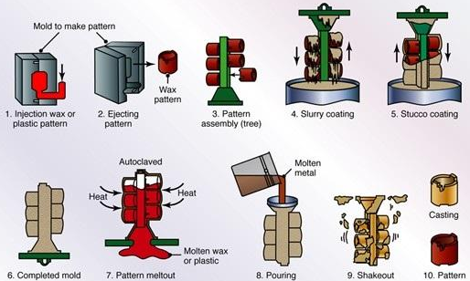
Figure 1: Investment Casting Flowchart, (Inspired, 2024)

3.1.1 Tooling
Tooling for investment casting, also known as lost-wax casting, involves creating precision tooling used to form intricate wax components. The process aim is to produce a master part/pattern, typically made from wax or a similar material, which is an exact replica of the desired final part. This part/pattern is made via creating a tool, predominantly made from aluminium, to which then wax is injected into the tooling, to produce the wax part. This wax pattern serves as the ‘tooling’ for the metal casting process, (Singh, 2021).
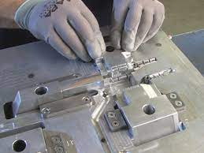
Figure 2: Investment Casting Tooling, (Niagara Investment Casting Ltd. 2024)
Tooling for investment casting is critical because it determines the accuracy, surface finish, and dimensional consistency of the final product. High-quality tooling ensures that complex geometries and fine details are faithfully reproduced, making investment casting ideal for manufacturing precise components used in aerospace, automotive, medical, and industrial applications. Proper design and maintenance of the tooling are essential to achieving optimal results and extending the life of the moulds, (Cheah, 2005).
In the tooling stage of investment casting, waste can manifest in several critical areas that impact overall yields, (Diez-Barcenilla, 2021). Inefficient tooling design, such as inadequate venting or gating systems, can lead to defects in the castings and increased material wastage. Using suboptimal or low-quality materials for tooling can result in tool wear or failure, causing defects and additional waste. Manufacturing tooling to incorrect tolerances may produce inaccurate castings, necessitating rework or resulting in scrap. Furthermore, lack of proper maintenance and calibration of tooling can degrade performance, leading to higher defect rates. Additionally, improper setup, alignment, or heat treatment of tooling can compromise casting quality, contributing to increased waste.
Addressing these factors through meticulous design, material selection, and maintenance practices is essential for reducing waste and enhancing yields in investment casting. With the focus on yield improvements in particular, an area to focus on could be to ensure that a tool has as many cavities (Number of parts), as possible. As the more parts produced by the waxmaker/toolmaker, the less time waiting time required.

3.1.2 Waxroom
The waxroom stage of investment casting is a crucial initial phase where the foundation for the entire casting process is established. During this stage, wax patterns that replicate the final metal parts are created. These patterns are produced using metal dies, which are injected with molten wax or plastic. Once the wax cools and solidifies, the pattern is carefully removed from the die, ensuring it retains all the intricate details and dimensions required for the final product. Multiple wax patterns can be assembled onto a central wax sprue, forming what is known as a "tree" or "cluster", (Zamani, 2014).
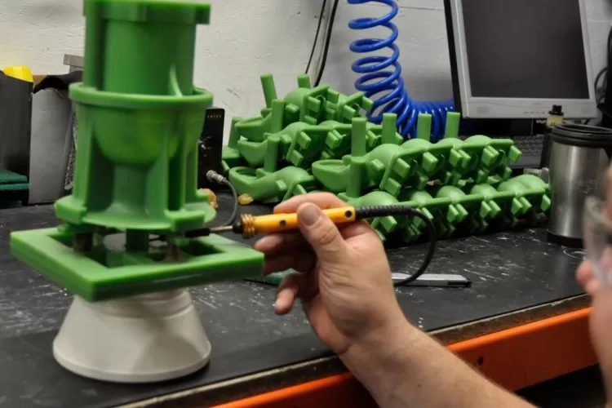
Figure 3: Wax Tree, (PACE Ltd., 2024)
The precision of the wax patterns is vital, as any flaws or deviations at this stage will be replicated in the final metal casting. Quality control measures are implemented to inspect and correct any imperfections in the wax patterns. The assembled wax trees are then coated with a ceramic slurry in subsequent stages, but the accuracy and detail of the initial wax patterns set the standard for the entire investment casting process. The waxroom stage is essential for achieving high-quality, precise castings, as it directly influences the dimensional accuracy, surface finish, and overall quality of the final metal parts, (Rahmati, 2007).
In the waxroom stage of investment casting, waste can occur in several key areas that affect overall yields. Inefficient wax pattern production can result from improper temperature control, leading to defects such as incomplete or malformed patterns. If the wax patterns are not correctly coated with the ceramic shell or if the shell coating process is inconsistent, it can cause issues during the burnout phase, leading to defects or wasted materials. Additionally, excess wax waste can accumulate if there are issues with the wax recovery and recycling processes. Inefficient use of wax, such as overuse or improper handling, can also contribute to material wastage.
Furthermore, errors in pattern assembly or alignment can result in defective castings, increasing scrap rates. Optimising these processes through precise control, better equipment, and careful handling could help reduce waste and improve yields in the wax room stage.

3.1.3 Mould Room
The mould room stage of investment casting, also known as the shell building stage, involves creating a durable ceramic shell around the wax patterns that will serve as the mould for the final metal castings. This process begins by repeatedly dipping the wax pattern assemblies, or "trees," into a ceramic slurry, followed by sprinkling them with fine sand or stucco. Each layer is allowed to dry and harden before applying the next, building up a robust shell capable of withstanding the molten metal's heat and pressure. Typically, multiple layers are applied to ensure the shell's strength and integrity, (Song, 2024).
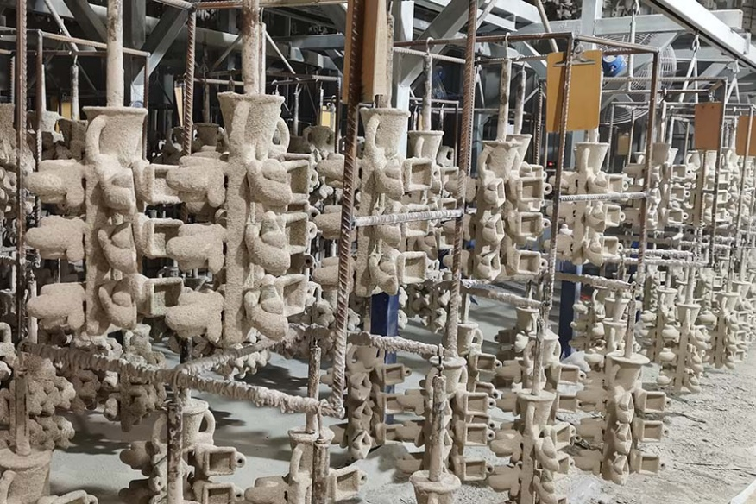
Figure 4: Mould Room, (RMC, 2024)
During the shell building process, it is crucial to control the environmental conditions, such as humidity and temperature, to ensure the ceramic material adheres properly and cures without defects. Quality control is vital at this stage to inspect for cracks, incomplete coverage, or other issues that could compromise the mould's performance. Once the shell is sufficiently thick and cured, it undergoes a dewaxing process, where the wax is melted and drained out, leaving behind a hollow ceramic mould in the exact shape of the original wax patterns. The mould room stage is critical for defining the precision and quality of the final cast parts, as any imperfections in the ceramic shell can directly impact the outcome of the metal casting process, (Liu, 2007).
In the mould room stage of investment casting, waste can arise from several significant areas that affect overall yields. Inefficiencies in the shell building process, such as inconsistent coating thickness or poor application techniques, can lead to weak or uneven moulds that fail to produce quality castings, resulting in increased scrap and rework. Defects in the mould’s surface from improper curing or drying conditions can also compromise casting integrity and lead to material wastage.
Additionally, improper handling or storage of moulds can cause damage or contamination, which further impacts yield. Ineffective management of the mould curing process, including temperature and time controls, can result in moulds that do not meet required standards, leading to higher defect rates. By refining these processes through better quality control, precise application techniques, and proper handling practices, waste can be minimised and yields improved in the mould room stage.

3.1.4 Foundry
The foundry stage of investment casting is where the ceramic moulds, created in the previous stages, are used to cast the final metal parts. This process begins with preheating the ceramic shells to remove any residual moisture and to ensure they can withstand the thermal shock of the molten metal. Once heated, the moulds are placed in a sand bed or on a pouring platform to provide stability during the casting process. Molten metal, prepared in a furnace, is then poured into the preheated ceramic shells. This metal can be a variety of alloys, including steel, aluminium, or superalloys, depending on the desired properties of the final product, (Yousef, 2023).
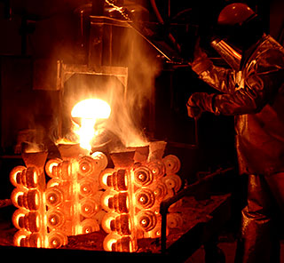
Figure 5: Foundry, (Investment Casting Systems, 2024)
The precision of this stage is paramount, as the temperature of the molten metal, the speed of pouring, and the handling of the ceramic moulds all affect the quality and integrity of the final casting. After pouring, the metal is allowed to cool and solidify within the ceramic shells. Once the metal has sufficiently solidified, the ceramic moulds are broken away through mechanical methods or water blasting, revealing the raw metal castings. These castings are then cleaned, often by removing any residual ceramic material and cutting off the gates and runners used during the pouring process. The foundry stage is crucial for translating the meticulous work of previous stages into high-quality, precise metal parts that meet stringent specifications and performance requirements, (Sata, 2021).
In the foundry stage of investment casting, waste can occur in several areas that impact overall yields. Inefficient melting and pouring practices can lead to defects such as inconsistent metal temperatures or contamination, resulting in castings with flaws or reduced quality. Poor control over the pouring process, including incorrect filling rates or temperatures, can cause incomplete fills, air pockets, or misruns, leading to increased scrap and rework. Inadequate handling or storage of castings before and after cooling can result in damage or contamination, further affecting yield. Additionally, inefficiencies in the gating and riser systems, such as improper placement or design, can result in excessive material waste and casting defects. Optimising these processes through better temperature control, precise pouring techniques, and effective handling procedures can significantly reduce waste and improve yields in the foundry stage.

3.1.5 Fettling
The fettling stage of investment casting is the final production process where the rough cast metal parts are cleaned, finished, and inspected to ensure they meet the desired specifications and quality standards. During this stage, the metal castings are separated from the gating system, which includes the sprues and runners used during the pouring process. This separation is typically done using mechanical cutting or grinding tools. Following this, any excess metal, surface imperfections, or residual ceramic material is removed through processes such as sandblasting, grinding, and polishing, (Keat, 1999).
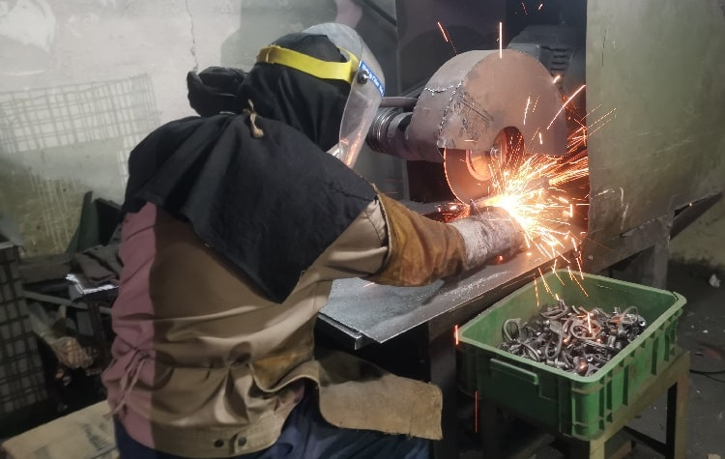
Figure 6: Fettling, (NoveCast, 2024)
Fettling is crucial for achieving the final dimensions, surface finish, and aesthetic qualities of the cast parts. This stage often includes additional heat treatment to enhance the material properties and final inspections to identify and correct any defects. Non-destructive testing methods, such as X-ray inspection, dye penetrant testing, or ultrasonic testing, may be employed to ensure the internal integrity of the castings. The fettling stage is essential for transforming the raw castings into precise, high-quality components ready for their intended applications, ensuring they meet all functional and performance criteria before delivery to the customer, (Yu, 2021).
In the fettling stage of investment casting, waste can arise from several key issues that impact overall yields. Inefficient or excessive removal of casting residues and gating systems can lead to material loss and increased labor costs. Poorly executed fettling processes, such as incorrect trimming or grinding techniques, can damage the castings, necessitating rework or scrapping of parts. Inadequate quality control during fettling might result in undetected defects, which can affect the performance and integrity of the final product. Additionally, improper handling of castings during fettling can cause further damage or contamination. By implementing more precise fettling techniques, better quality control measures, and effective handling procedures, waste can be minimised and yields improved in this crucial stage of investment casting.

3.1.6 Machining
The machining stage of investment casting is where the raw castings are precisely shaped and finished to meet exact specifications and tolerances required for their final application, this is not always required, as in the case of many instances with Wall Colmonoy, the customer may just ask for a casting part so that they can do the machining themselves. After the fettling process, cast parts often need further refinement that can only be achieved through machining. This stage involves various techniques such as milling, turning, drilling, and grinding to achieve the desired dimensions, surface finish, and functional features of the part. Advanced computer numerical control (CNC) machines are frequently used to ensure high precision and consistency across large production runs, (E. S. Gevorkyan, 2022).
During machining, it is essential to carefully plan and execute the operations to avoid introducing stresses or defects into the parts. This includes selecting appropriate cutting tools, speeds, and feeds, and using cooling fluids to maintain the integrity of the material. Machining not only ensures that the parts meet stringent dimensional and geometric tolerances but also prepares them for assembly and use in complex systems where precision is critical. Quality control is integral during this stage, with rigorous inspections to verify that the parts comply with the required specifications. The machining stage transforms castings into fully functional, high-precision components ready for their final use in industries such as aerospace, automotive, and medical devices, (Bose, 2022).

3.1.7 Inspection
The inspection stage of investment casting is a critical phase where cast parts undergo rigorous evaluation to ensure they meet the specified quality standards and performance requirements. This stage is essential to identify any defects or deviations that may have occurred during the casting, fettling, or machining processes. Inspection procedures typically involve both visual and non-destructive testing methods to assess various aspects of the parts, (Mery, 2021).
Visual inspection is the initial step, involving careful examination of the surface finish, dimensional accuracy, and overall appearance of the castings. This helps detect any visible defects such as surface cracks, porosity, or incomplete filling of the mold. Non-destructive testing techniques are then employed to examine the internal integrity of the parts without altering or damaging them. These methods include X-ray or radiographic testing to reveal internal defects, ultrasonic testing to detect flaws beneath the surface, and dye penetrant testing to identify surface cracks or discontinuities, (Taweelerd, 2021).
The results of these inspections are meticulously documented and analysed against established acceptance criteria. Any parts that do not meet the specified standards are either rejected, repaired, or subjected to further evaluation to determine if they can be salvaged. The inspection stage plays a crucial role in ensuring the reliability, safety, and performance of investment cast parts, especially in industries where precision and quality are paramount, such as aerospace, defense, and medical sectors. By maintaining rigorous inspection standards, manufacturers can deliver components that consistently meet customer expectations and regulatory requirements, (Nikolic, 2021).

3.2 Benefits of Yield Improvements in Investment Casting

3.2.1 Cost Reduction
- Improved yields mean less scrap and fewer rejected parts, leading to more efficient use of raw materials and reduced costs, (Paknejad, 2015).
- Fewer defects result in less time and resources spent on reworking or repairing faulty castings, thereby lowering labor costs and overheads, (Paknejad, 2015).

3.2.2 Enhanced Product Quality
- Higher yield rates ensure a more consistent production of high-quality castings, which can improve customer satisfaction and loyalty, (Zhu, 2023).
- By addressing common issues that lead to defects, the overall quality of the final product is improved, reducing the risk of field failures and warranty claims, (Zhu, 2023).

3.2.3 Increased Efficiency
- Optimising the casting process can lead to faster production cycles and increased throughput, allowing the company to meet higher demand without compromising on quality, (Meng, 2022).
- Efficient use of materials, energy, and labour resources contributes to a more productive operation, (Meng, 2022).

3.2.4 Competitive Advantage
- Superior quality and lower production costs can differentiate the company from competitors, providing a stronger market position, (N. Oyku Iyigun, 2019).
- Consistently delivering high-quality products strengthens the company’s reputation, leading to greater trust and long-term partnerships with clients, (N. Oyku Iyigun, 2019).

3.2.5 Sustainability
- Reducing waste and optimising resource use contribute to more sustainable manufacturing practices, which can enhance the company’s environmental footprint and appeal to environmentally conscious customers, (Stuart, 2018).
- Improved processes can help meet stringent environmental and quality regulations, avoiding penalties and fostering a positive corporate image, (Stuart, 2018).

3.2.6 Profitability
- Higher yields lead to more sellable products from the same amount of input, boosting overall profitability, (Avohou, 2011).
- With increased production efficiency and quality, the company can scale operations and explore new market opportunities, driving revenue growth, (Avohou, 2011).
By investigating and implementing yield improvements, Wall Colmonoy Limited has the potential to achieve significant operational, financial, and competitive benefits, fostering sustainable growth and long-term success. Which will be analysed in greater detail throughout this report.

3.3 Investment Casting Alternatives
There are several alternative manufacturing processes to investment casting, each with its own advantages and applications. Some common alternatives include:
- Sand Casting - Uses a sand mould to form the casting. The sand mould is created by packing sand around a pattern and then removing the pattern to leave a cavity in the sand. Will be typically used for larger parts, that doesn’t have as good of a finish as a typical investment part would, (Tiacci, 2024).
- Die Casting - Involves forcing molten metal into a mould cavity under high pressure. The moulds are typically made of steel, (Hu, 2021).
- Permanent Mold Casting (Gravity Die Casting) - Uses reusable moulds made from metal (usually steel or cast iron). Molten metal is poured into the mould by gravity, (Lin, 2014).
- Centrifugal Casting - Involves pouring molten metal into a rotating mould. The centrifugal force pushes the metal against the mold walls, (Huang, 2011).
Wall Colmonoy will generally use investment casting over each of these, due to being more cost effective for high volume parts, as well as being capable of producing better quality finished products. Each of the above, not in all cases but would be typically for larger parts that may require further machining/processing.

3.4 Quality Cost / Poor Quality Cost
An author, (Wojciech, 2022), discusses quality management and quality cost. Quality cost, also known as cost of quality (CoQ), encompasses all expenses related to ensuring products or services meet specified standards and the costs associated with failing to achieve these standards. It is typically divided into four categories: prevention costs, appraisal costs, internal failure costs, and external failure costs. Prevention costs involve investments in activities that prevent defects, such as training and process improvement. Appraisal costs are incurred through inspection and testing to ensure quality. Internal failure costs arise from defects found before delivery, like rework and scrap. External failure costs occur when defects are discovered after delivery, leading to returns, repairs, and reputational damage.
Anderson (2014) argues avoiding poor quality costs is crucial. As it directly impacts a company's profitability and reputation. Poor quality can lead to significant internal and external failure costs, including wasted resources, increased production time, and customer dissatisfaction. By investing in quality assurance and control, companies can minimise defects, reduce waste, and enhance customer satisfaction, leading to repeat business and a strong market position. Additionally, focusing on quality can drive continuous improvement, innovation, and efficiency, ultimately contributing to long-term success and sustainability.
For the analysis of this report, with yield improvements, essentially requiring a change in the process, this could therefore have a knock-on effect to quality. This must be reviewed, and if need changed/aligned so that any improvements to the business, do not affect the quality of the finished product going to the customer. An effective away to review this could be the 8D methodology.
The 8D (Eight Disciplines) problem-solving methodology is a structured, team-oriented approach primarily used to identify, correct, and eliminate recurring problems. Originally developed by Ford Motor Company, it is widely used in the manufacturing sector and other industries to ensure quality control and continuous improvement, (Elangovan, 2021).
D1 - Establish the Team:
Assemble a cross-functional team with the knowledge, time, authority, and skill to solve the problem and implement corrective actions.
D2 - Describe the Problem:
Clearly define the problem in quantifiable terms, including who, what, when, where, why, how, and how many (5W2H).
D3 - Develop Interim Containment Actions:
Implement temporary measures to isolate the problem and prevent it from affecting customers until a permanent solution is found.
D4 - Root Cause Analysis:
Identify the underlying causes of the problem, not just the symptoms.
D5 - Develop Permanent Corrective Actions (PCAs):
Formulate and implement long-term solutions to eliminate the root cause and prevent recurrence.
D6 - Implement and Validate Permanent Corrective Actions:
Execute the selected permanent corrective actions and verify their effectiveness.
D7 - Prevent Recurrence:
Modify systems, processes, and practices to prevent the problem from recurring.
D8 - Recognise the Team and Celebrate Success:
Acknowledge the team's efforts and success in solving the problem.
The 8D methodology emphasises teamwork, thorough analysis, and systematic implementation of solutions, making it an effective tool for quality management and problem-solving in various industries.

3.5 Casting Defects
Casting defects are imperfections that occur in metal castings during the manufacturing process, which can compromise the integrity, strength, and appearance of the final product. These defects can arise from various factors such as improper cooling rates, mould material issues, and incorrect pouring temperatures. One common type of casting defect is shrinkage, which occurs when there is insufficient material to compensate for the volume reduction as the metal solidifies and cools. Shrinkage manifests as voids or cavities within the casting, leading to weak spots that can affect the performance and durability of the part. Effective design, proper material selection, and controlled cooling rates are essential to minimise shrinkage and other casting defects, ensuring the production of high-quality, reliable castings, (Serrano-Munoz, 2016).
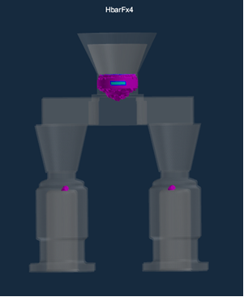
Figure 7: ProCast - Example Simulation
ProCast is a simulation software that Wall Colmonoy use, which investigates the FEA (Finite Element Analysis) of a casting component, (Figure 6) above is an example image of a simulation with the pink highlighting the potential shrinkage porosity that will likely cause defects within the part, shrinkage is a useful indicator for Wall Colmonoy to understand how best to design a part.
Casting defects could significantly contribute to energy wastage in the manufacturing process. Defects such as porosity, misruns, and inclusions often result in parts that do not meet quality standards, necessitating rework or complete scrapping of the defective items. This not only wastes the energy consumed during the initial casting process but also requires additional energy for remelting and recasting new parts. Furthermore, the need for quality control inspections and potential downtime during defect rectification, further increases energy consumption. Wall Colmonoy as of 2024, had energy costs of £0.26kW/ph. Naturally the more defects you had, wasting energy, the higher the costs would be.

3.6 9 Lean Wastes
Lean manufacturing is a systematic approach focused on minimising waste and maximising value in production processes. Originating from the Toyota Production System, lean aims to create more value for customers using fewer resources by optimising workflows and reducing inefficiencies. Central to lean is the identification and elimination of waste, which is categorised into nine types: defects, overproduction, waiting, non-utilised talent, transportation, inventory, motion, extra processing, and unused creativity, (Antosz, 2023).
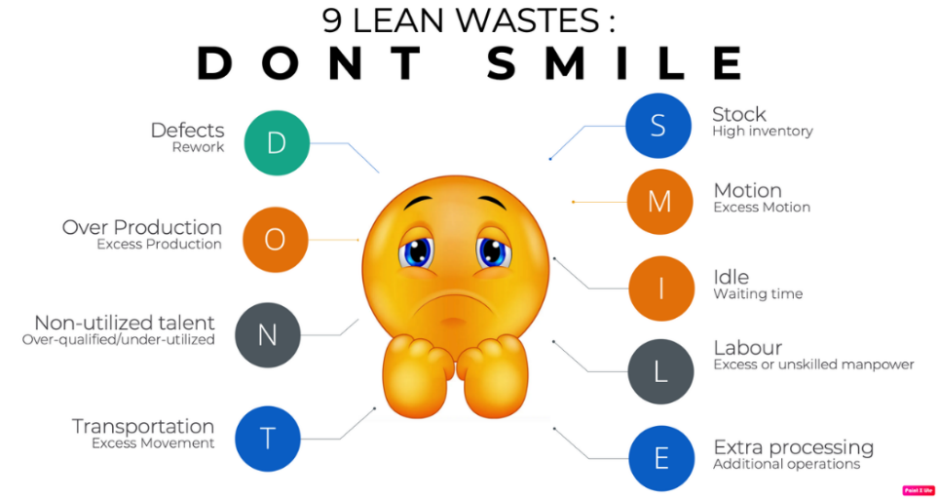
Figure 8: 9 Lean Wastes, (LinkedIn, 2024)
Defects refer to products that fail to meet quality standards, necessitating rework or disposal. Overproduction involves producing more than what is needed, leading to excess inventory and wasted resources. Waiting occurs when there are delays between production steps, causing idle time. Non-utilised talent is the underuse of employee skills and abilities. Transportation waste involves unnecessary movement of materials between locations. Inventory waste refers to holding more raw materials or finished products than necessary. Motion waste is the extra movement by workers or machines that does not add value. Extra processing includes any redundant or unnecessary steps in production. Finally, unused creativity refers to failing to leverage employee insights and innovations, (Gladysz, 2020).
By addressing these nine wastes, lean manufacturing enhances efficiency, reduces costs, and improves overall product quality and customer satisfaction. With yield improvements specifically being reviewed in this report, these can investigate to ease some of these 9 waste’s, extra processing and unused creativity being two, as with more parts being on a tree / runner system, it will mean less trees are going through the process, reducing the extra processing and enhancing creativity.

3.7 Kaizen Methodology
Kaizen is a Japanese term meaning "continuous improvement" and is a core principle of lean manufacturing and management practices. It emphasises the incremental, ongoing improvement of all functions and involves all employees from the CEO to assembly line workers, (Hosono, 2020).
The philosophy of Kaizen fosters a culture where employees at every level are encouraged to suggest and implement small, incremental changes in their work processes. These small changes, when consistently applied, lead to significant improvements in efficiency, quality, and overall performance over time. Kaizen focuses on enhancing productivity, reducing waste, and improving safety and workplace culture by systematically identifying and addressing problems, (Cherrie, 2017).
This collaborative approach not only drives operational excellence but also empowers employees, fosters teamwork, and creates a more engaged and proactive workforce. By continuously striving for improvement, organisations can adapt more readily to changing market demands and maintain a competitive edge, (Berhe, 2022).
Productivity is measured by assessing the efficiency of output relative to inputs. Key metrics include labour productivity, which is output divided by labour hours or number of employees, and total factor productivity (TFP), which compares total output to a weighted average of all inputs like labour and capital. Capacity utilisation measures the percentage of potential output achieved. Cycle time gauges the duration to complete production cycles, while cost per unit and revenue per employee reflect financial efficiency. Additionally, yield and scrap rates assess quality and waste. Combining these metrics provides a comprehensive view of productivity and operational effectiveness, (Song, 2018).

3.8 How is Yield Measured?
Yield measurement is a fundamental concept across industries such as agriculture, finance, and manufacturing, representing the efficiency or productivity of a given process or investment. Yield quantifies the output relative to the input, providing a metric for performance evaluation and decision-making. Depending on the context, different methodologies and metrics are applied to measure yield effectively. In agriculture, yield typically refers to crop productivity per unit area, such as kilograms per hectare.
It is calculated by measuring the total harvested produce and dividing it by the area cultivated. Factors like soil quality, irrigation, and pest control impact agricultural yield, and precision tools like GPS mapping and remote sensing are increasingly employed to assess productivity accurately. Crop cutting experiments (CCEs) and sample surveys are traditional methods used to estimate yield, complemented by advanced technologies like drones and satellite imagery for large-scale assessments, (Tahir, 2021).
Yield metrics help businesses compare different opportunities and align their targets with their financial goals. Manufacturing and production yield is the ratio of usable or quality outputs to total inputs or units produced. It is a critical metric in assessing the efficiency of a production process. Yield in this context is often expressed as a percentage and calculated by dividing the number of defect-free units by the total number of units produced. High yields indicate efficient processes, whereas low yields highlight areas for improvement, such as quality control or process optimisation.
Modern tools like data analytics, IoT devices, and AI enhance yield measurement accuracy and predictive capabilities across industries. By integrating advanced sensors, real-time monitoring, and analytics, businesses can identify bottlenecks, reduce waste, and improve overall productivity. Measuring yield is therefore not merely an end but a vital feedback mechanism driving innovation, sustainability, and economic growth, (Kim, 2024).

4.0 Main Body

4.1 Case Study – Wall Colmonoy

4.1.1 Current Status
Within the investment casting process for Wall Colmonoy, there are multiple parts that are manufactured through the business, these can vary with multiple different criteria, such as; size, weight, complexity, priority, etc. The part that will be focused on within this particular case study, will be the “insert”.
The insert, whose functionality is predominantly being used as a subpart within a conveyor belt system, is one of the highest runners within the investment casting process for Wall Colmonoy. The insert most noticeable characterises are that they are semicircular and have four lips which are pivotal for the function of the conveyor belt, making them a key feature to ensure is correct within the casting process. There are multiple different variants of the insert part, all ranging in sizes, from on outer diameter 20mm-45mm, while the length could vary from 15mm-50mm. The highest runner of the insert family, is DC2499-1, (See, Figure 1 / Appendix 1), where on average 34,000 parts are produced per year.
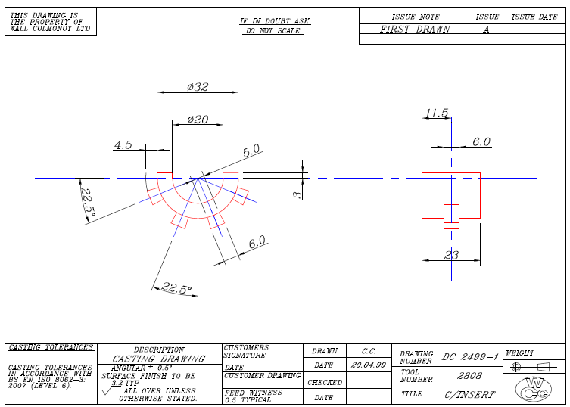
Figure 9: Case Study: As Cast Insert Drawing
This insert is currently manufactured via assembling 56 parts per tree (Figure 10). These parts will then go through the casting process, where an overall cost per unit can be calculated, (See, Appendix 2).
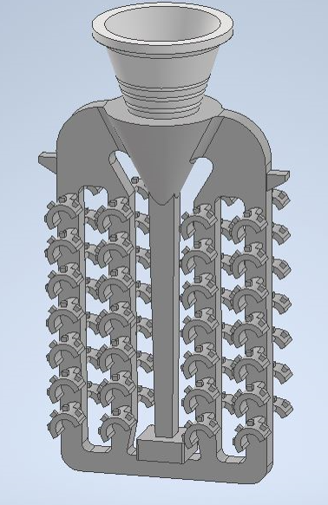
Figure 10: Case Study: Current Assembly Design
The overall cost per unit can be broken down through reviewing each of the following;
- Tooling Cost – Is typically only used for a part which requires a new tool or a tool modification, in this instance it wouldn’t be considered as the part is an old design which has been used for a number of years. The cost if it were to be considered, what take the material, particularly aluminium, and the time taken to produce the tool multiplied to the cost per hour of the toolmaker.
- Waxroom Cost – This takes time, labour and consumables costs, (The wax usage, ceramic cones if required), into consideration. Wax cost will vary depending on market value, in time of the design review, wax cost £3.35 per kg. The weight of a wax insert part would be 0.01kg (They are very small, light parts).
- Mould Room Cost – This takes time, labour and consumables costs, (The slurry usage), into consideration. Overall mould costs would vary as, it would depend entirely on the number of coats that would be placed on the design. On average taking the fact a number of designs have 6 coats on them, it would costs £11.14 for the cost of the slurry material.
- Foundry Cost – Again takes the time, labour and consumables costs into consideration, this is often difficult to estimate as a number of pours are done, where several trees/designs are poured at the same time, making it difficult to get an accurate figure, unless a full time study was completed.
- Fettling Cost – The time, labour and consumable costs are taken into consideration.
- Machine Shop Cost – The time, labour and consumable costs are taken into consideration.
- Metal Cost – Arguably the most costly element of the process, as the cost per kg of a metal will vary quite erratically depending on the market, at times it could be very cheap and cost effective, other times it may be difficulty to attract customers. The material used for the insert part, is typically a Wall Colmonoy specialised material called Colmonoy 40D.
- Energy Costs – This takes all energy costs into consideration, the running of equipment, power, electrical, gas, water.
- Overhead costs – This takes the overheads of all labour outside of the process which will have a specific cost to a part.
All of these costs can come together, to give an overall cost per unit for the insert, which is £3.34 per part. If more accurate costs were to be considered, some further recommendations could be looking into specific energy related equipment which relates to the process in question, as the energy costs which are used, are plant wide, which gives immediate negatives that that may be impacting overcharging on some parts, or perhaps undercharging.
The other recommendation could be reviewing the scrap rate, as the cost per unit of £3.34, takes into consideration the part runs through the process ‘perfectly’, with no issues. Which would be very unrealistic, as through things as simple as human error, parts can often be damaged and require to be reworked through the process, which naturally will incur an extra cost.

Lean Methodology
A number of different lean methodology can be used to support with reviewing where waste is within the process. Initially it is important to assemble a team with the appropriate personnel that can support with identifying the issues. For example, a project lead, a casting supervisor, a casting team leader, a casting operator and an external individual to support with an ‘outside view’ so that bias isn’t taken into account, when reviewing what is a process that would have been done for years.
The 9 Wastes
- Transport: Minimise unnecessary movement of parts or materials between process stages. With increased yields this would mean less, trees are required to go through the process, hence less transport.
- Inventory: Reduce excess inventory of raw materials, partially finished trees, or finished castings waiting for further processing. This again would be supported by increased yields as within castings there is often a large number of inventory in trees waiting in the process, taking up space, the more parts on a tree, the less space/inventory for number of trees.
- Motion: Eliminate unnecessary movements of workers or machines. Wouldn’t be something with great significance with regards to yield, as the motion will likely remain the same.
- Waiting: Identify and reduce idle time where trees or parts are waiting for the next process step.
- Overproduction: Avoid producing more trees or parts than needed, which ties up resources and creates excess inventory.
- Over-processing: Simplify processes that are more complex than necessary (e.g., excessive inspection steps or redundant quality checks).
- Defects: Reduce the occurrence of defects in the casting process that require rework or result in scrap (e.g., misaligned parts on the tree, shell cracking, or casting defects).
- Labour: An example of labour waste in this process, is where 56 parts per tree are assembled it could be "under excessive manual handling and assembly. Especially if more parts can get onto a tree"
- Underutilised Talent: The underutilisation of skilled workers and problem-solving abilities, very often an operator could make the recommendation they believe more parts could get on a tree, but the topic was never further looked into.
5S Methodology
- Sort: Remove unnecessary tools, materials, and equipment from the casting area.
- Set in Order: Arrange the tools and materials that are needed so they are easy to find and access.
- Shine: Keep the workspace clean and organised to prevent defects and improve safety.
- Standardise: Develop standardised procedures for tasks to ensure consistency and reduce variability.
- Sustain: Maintain the improvements through regular audits and continuous improvement efforts.

Kaizen (Continuous Improvement):
- Encourage workers to suggest small improvements in their daily tasks that can reduce waste.
- Implement regular Kaizen events focused on specific areas of the investment casting process, such as tree assembly or shell building, to identify and eliminate waste.

Design Phase (4 Different Versions)
A team was assembled to explore multiple design versions aimed at increasing yields in. Comprised of engineers, quality, wax room operators & Team Leaders / Managers, the team brought together diverse expertise to address the challenges of efficiency and quality in the casting process. Initial brainstorming sessions focused on identifying bottlenecks in current designs, from wax pattern creation to shell building and molten metal flow. The team discussed the importance of using simulation software to prototype the design iterations, optimising gating systems, reducing shrinkage, and minimising defects. Collaboration across departments ensured that each design version was rigorously tested and refined, with the hope in resulting in improved casting yields and overall productivity.
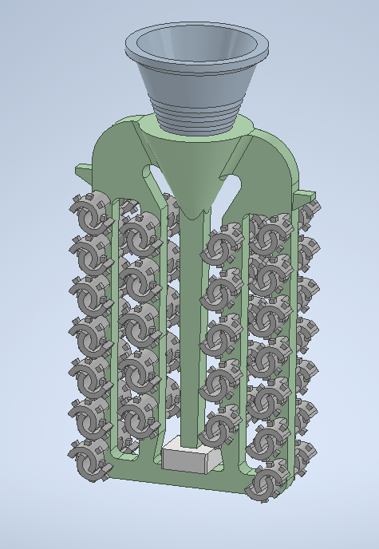
Figure 11: Case Study - Design V1
96 inserts on the tree, assembled via a cross section orientation. Major concern brought up was both moulding and fettling of finished design. As the parts were so close to one another there was the belief that this could potentially cause issues with defects.
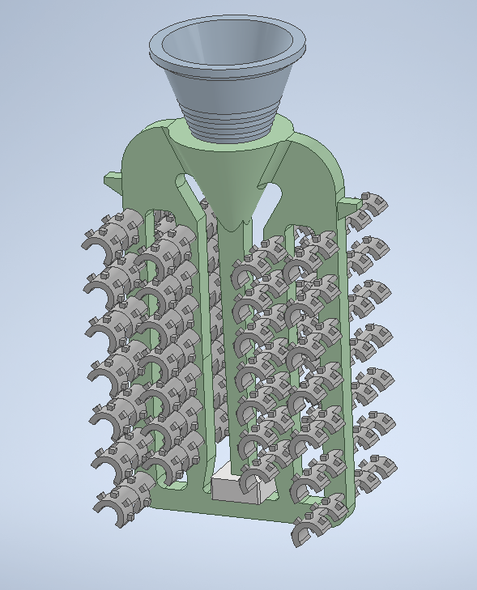
Figure 12: Case Study - Design V2
112 inserts on the tree, assembled via a normal design, but with the inserts glued on top of each other, doubling the number of parts on the tree from the original. Major concern brought up was the fettling of finished design. As at least half of the parts would need to be fettled both sides. As there will be the feed going into the tree/runner system, and the feed going into the bottom part.
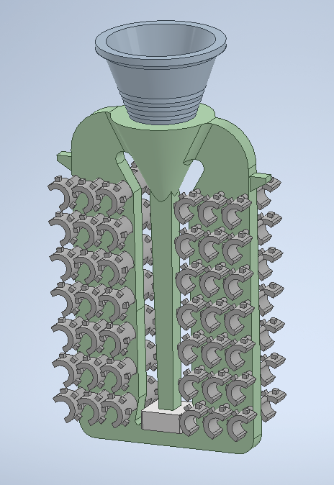
Figure 13: Case Study - Design V3
84 inserts on the tree, assembled via a tree mod, with the traditional gap of the tree being filled in with wax, to allow for more parts to be assembled. Was considered as the most viable option of increasing yields without having a risk of defects. Concern was the overall pour weight was going to go up slightly hence “less” savings could be made.
Figure 14: Case Study - Design V4
More or less, exactly the same as V3, but this time a smaller feed was the design variant (Figure 15), so that with the feed being so small, potentially could trial knocking off by hand, rather than cutting off. Cutting off is a far more time bearing task for labour, while also having the added cost of consumables for requiring to change the blade on the cut off machine.
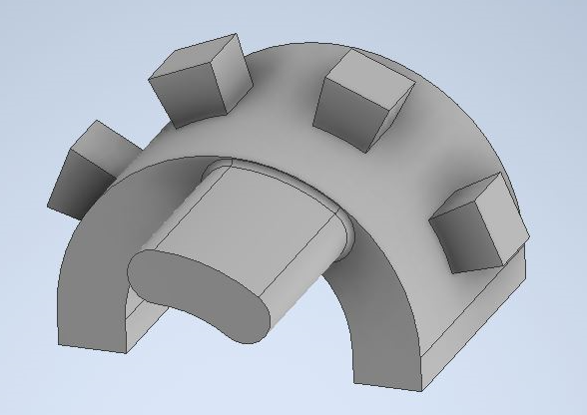
Figure 15: Case Study - Design V4 (Insert Part)

4.1.4 Cost Analysis / Justification
Conducting a cost analysis when investigating ways to increase yields is essential for making informed and sustainable business decisions. A thorough cost analysis helps assess whether the investment required to boost productivity will generate a profitable return. It allows businesses to understand the direct and indirect costs associated with increasing yields, such as labour, equipment and other resources. By comparing these costs with the expected gains, decision-makers can evaluate the financial feasibility of the strategies being considered. A cost analysis provides insight into the break-even point, helping businesses determine how much yield must increase to cover expenses. It can also highlight potential inefficiencies and areas where resources might be wasted, allowing companies to optimise their operations and avoid unnecessary expenditures.
A well-executed cost analysis can consider long-term impacts, such as maintenance costs and sustainability. Without a clear understanding of the financial implications, businesses risk investing in strategies that may not provide significant returns or, worse, lead to financial losses. In sum, cost analysis is a critical tool that supports strategic planning, ensuring that efforts to increase yields align with the company's financial health and growth objectives.
Figure 16: Wall Colmonoy Costing Template
The costing model provided above outline the breakdown of costs associated with producing specified parts, the below is an analysis of:
Key Cost Drivers
- Total Cost Per Order
- Cost Per Unit
- Breakdown of Costs Per Order: Tooling Cost, Wax Room Cost, Mould Room Cost, Foundry Cost, Fettling Cost, Machine Shop Cost, Metal Cost, Energy Cost & Overhead Cost
- Breakdown of Costs Per Unit: Tooling, Wax Room, Mould Room, Foundry, Metal, Energy & Overhead
Observations & Key Points
- Metal will usually account for the largest single cost driver at typically 35.5% of the total cost, this is down to the high cost of metal compared to other consumables.
- Overhead & energy costs, combined these two contribute to almost 48% of the cost per order, this was a is considered a vital are in the year 2024, as energy costs have risen drastically across the UK in recent times, meaning so have the costs for businesses.
- It can give an indication on the exact yield figures, as for example using the current insert design of 56 parts per tree, it suggests a yield of 20.2% indicating a significant amount of raw material is lost in the process, but it is also important to stress some of this material is recycled back into the process so is not all lost.
Recommendations for Cost Optimisation for Costing Model
- Investigate ways to improve material yield (e.g., reduce waste during pouring), the main function of this report.
- Conduct an energy audit to identify opportunities for savings.
- Analyse overhead costs for potential reductions, such as labour, administrative, or facility costs.
- Optimize stages with longer production times, particularly wax room and fettling.
The cost analysis for each of the new insert assembly designs are as follows, (Costs calculated via Figure 16 / Appendix 2 costing template);
Design Variant | Parts Per Tree | Cost Per Unit (£) | Annual Saving (Based Off Average 34,000 Parts Per Year)
Current | 56 | £3.34 | -
1 | 96 | £2.76 | £19,720.00
2 | 112 | £2.60 | £25,160.00
3 | 84 | £3.13 | £7,140.00
4 | 84 | £2.88 | £15,640.00
Table 1: Wall Colmonoy Case Study - Cost Analysis
Design variant 2 offers the highest savings at £25,160, making it the most economically advantageous option. Design variant 1 is the next best alternative, providing again significant savings £19,720. Design variant 3 is the least cost-effective, producing fewer parts per tree at a higher cost per unit, resulting in the lowest savings. While design variant 4 shows the cost effect over a year reducing the fettling process can achieve, as the design has better savings than Variant 3, but is still less efficient than Variants 1 and 2. Based off the cost analysis, opting for design variant 2 would maximise the financial benefits.

4.1.5 FEA
Finite Element Analysis (FEA) is a powerful computational tool widely used in investment casting design, to predict and optimise performance before manufacturing. In investment casting, FEA enables engineers to simulate the casting process and assess potential issues related to thermal, structural, and fluid dynamics, leading to cost savings and improved product quality. By creating a digital model of a part, FEA divides it into small elements, allowing for precise simulations of complex stresses, strains, and deformations under varying conditions. This is crucial in investment casting, where factors such as shrinkage, solidification, and thermal gradients can significantly affect final part dimensions and mechanical properties, (Xia, 2024).
Using FEA in investment casting design helps engineers foresee potential defects, like porosity or hot tearing, by simulating cooling rates and material flow within the mould. This predictive capability allows for adjustments in mould design, gating, and riser placement, ensuring even material distribution and controlled solidification. As a result, FEA reduces the need for physical trial and error, accelerating product development and enhancing quality control. Additionally, FEA assists in optimising material usage, as it enables precise wall thickness and structural integrity adjustments, especially important for lightweight, high-strength applications like aerospace and automotive components. Thus, FEA's application in investment casting streamlines production, minimises material waste, and increases confidence in achieving final dimensional and structural accuracy, making it an invaluable asset in modern casting design, (Dal Piva, 2018).
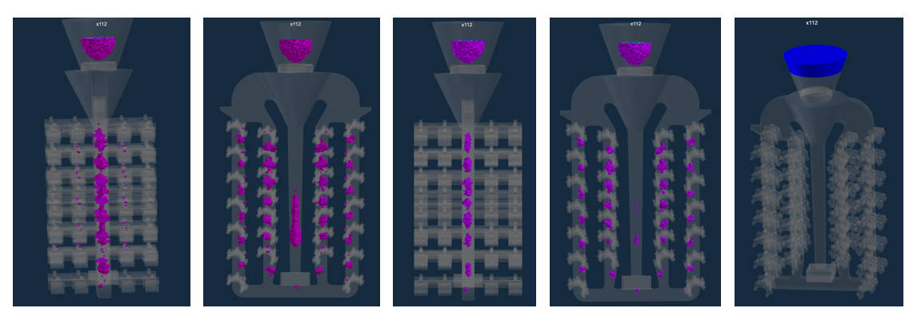
Figure 17: Simulation Results: Design V2
A simulation was taken of each of the different designs, with pink/purple highlighting potential levels of shrinkage, as seen in above figure 16, results indicate that there is the potential risk of shrinkage, but not much. The blue indicated on the right image, is essentially a “weak” spot in the metal. This being so high up on the tree design would not be an area of concern for the design.
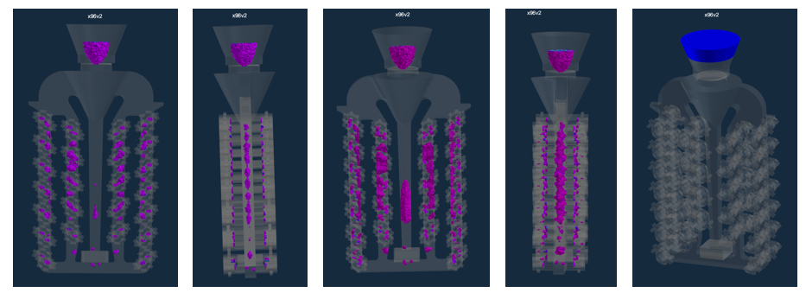
Figure 18: Simulation Results: Design V1
In contrast, as shown in figure 17, the interlocking part assembly design, shows a significantly higher potential of shrinkage within the parts, which would suggest that there could be a high fallout of parts with defects. The voids however do suggest that there is good potential of strong metal strength in the main areas required.
It is most important to think about when utilising a simulation software such as ProCast used for the above, they are not 100% accurate as they don’t always consider all conditions that would happen in real life, environmental factors, operator skill level etc. It is therefore important to use them as a good gauge of the potential design.

4.1.6 Considerations
Manual Handling
Increasing the yield in investment casting often necessitates handling larger moulds, more extensive assemblies, or higher quantities of material, each of which can elevate manual handling concerns. As yield increases, the individual moulds or assemblies that workers must carry, position, or transfer tend to become bulkier and heavier. This can raise the risk of strain-related injuries, especially for the back, shoulders, and wrists, from repetitive lifting or carrying tasks. Workers tasked with moving heavier or larger moulds may face additional strain if the designs are awkwardly shaped or lack proper grips, increasing the likelihood of slips, trips, or falls, (Roffey, 2010).
Larger designs also require precise positioning, which can lead to extended holding or fine-tuning times, placing static loads on muscles and heightening fatigue. Furthermore, increased mould handling may require prolonged bending, twisting, or awkward postures, which are key risk factors for musculoskeletal disorders. This becomes particularly concerning if workers are expected to handle hot or recently poured moulds, as these add not only weight but also the risk of burns, requiring personal protective equipment (PPE) that can limit dexterity, (Roffey, 2010).
In facilities where yields are increased without automated assistance, the frequency of these manual handling activities can also rise significantly, further compounding physical stress. With more moulds to lift and position, repetitive strain injuries like carpal tunnel syndrome or tendinitis become more likely if ergonomic controls aren’t properly implemented. Additionally, if casting yield enhancements involve handling more significant quantities of raw materials or molten metal, the increased weight and required precision can lead to hazardous work conditions, especially in confined spaces where manoeuvring is difficult, (Kay, 2014).
To mitigate these risks, investment casting facilities may need to evaluate ergonomic practices, provide lifting aids or hoists, train workers in safe handling techniques, and redesign workflows to reduce excessive manual handling. By doing so, facilities can enhance worker safety and efficiency, ensuring that increased yields don’t compromise employee health, (Nolan, 2018).

Workforce Pushback
When investment casting yields increase, operators may experience significant concerns, which could lead to pushback. One primary concern is the physical demand on operators, as increased yields often mean handling larger desings, more materials, or additional components without proportional automation or mechanical assistance. Operators might fear heightened strain, fatigue, and potential injuries, especially if ergonomic improvements or additional support are not implemented. This can lead to resistance, as workers might feel that increased productivity is prioritised over their health and well-being. Additionally, increased yields can mean longer shifts or more intensive work periods, leading to potential burnout or frustration. Operators may feel that they’re expected to meet higher productivity standards without adequate compensation or rest breaks, particularly if these increases are sudden or not aligned with workload adjustments. The perception of unfair expectations may reduce morale, fostering resistance and diminishing engagement over time, (Ng, 2019).
Another key area of concern for operators could be the need for retraining or adaptation to new processes. Higher yields often necessitate adjustments to workflows, equipment, or handling techniques, which may require operators to learn and adapt quickly. For seasoned workers used to established practices, this can be seen as disruptive or even unnecessary, especially if the changes are not clearly communicated or if management doesn’t seek their input on process modifications, (Glavin, 2024).
Lastly, increased yields can elevate the risk of defects or quality issues if the pace of work outstrips quality control measures. Operators who pride themselves on producing high-quality parts may resist if they feel that increased yields compromise the standards of workmanship. This concern is especially pronounced in industries like aerospace or medical, where precision and quality are paramount. To address potential pushback, management could consider open communication, ergonomic improvements, clear retraining initiatives, and incentive structures, all of which can help ensure that increased yields are achieved without undermining operator satisfaction and safety.

Other
Increasing yields in investment casting introduces several technical and operational concerns beyond workforce pushback and manual handling. One major issue is quality control; as yields increase, ensuring consistent quality across a larger output becomes more challenging. High yields can strain inspection processes, making it difficult to catch defects such as porosity, shrinkage, or surface irregularities. Without robust quality control measures, these defects may go undetected, leading to rejected parts, costly rework, or even compromised safety in critical industries like aerospace or medical devices. Additionally, higher yields can stress equipment, from furnaces to wax machines, as they run more frequently or at higher capacities. This increased usage accelerates wear and tear, potentially reducing equipment lifespan and necessitating more frequent maintenance. Downtime for repairs or replacements can disrupt production schedules, offsetting the benefits of higher yields. Moreover, increased production can place extra demand on cooling and heating systems, requiring careful monitoring to avoid overheating or inefficient cooling, which can impact the integrity of the castings, (Yun, 2024).
Material handling and storage also become concerns when yields increase. Higher production levels mean more raw materials and finished parts to manage, potentially straining inventory systems and requiring additional storage space. Poorly managed storage can result in disorganisation, making it difficult to maintain production flow, track inventory, or efficiently transport materials. Increased yields can also complicate environmental management and compliance with safety regulations. The use of more materials and chemicals, as well as increased energy consumption, can lead to higher emissions and waste generation. Facilities may face additional regulatory scrutiny and may need to invest in improved waste management systems, emissions control, or environmental compliance programs to address these impacts, (Crowley, 2018).
Addressing these concerns effectively requires careful planning, investment in quality and maintenance systems, and potential redesigns of workflow and storage solutions, helping to balance increased yields with operational stability and regulatory compliance, (Nelson, 2023).

4.1.7 Trial
A live trial was conducted to evaluate the four different tree designs, aiming to enhance production yield. Investment casting, widely used for producing complex components with tight tolerances, relies heavily on tree design to optimise material usage, minimise defects, and improve overall efficiency. The trial involved fabricating and casting components using each tree design under identical conditions, including wax pattern assembly, ceramic shell coating, and alloy pouring. The primary objective was to identify the configuration that maximised the number of defect-free castings per batch while minimising waste and post-processing requirements. An old tool was use that could be easily modified, so that the original tool was not to have any potential damage should the trial be unsuccessful.
Each tree design varied in parameters such as the number of components per tree, spacing between parts, sprue diameter, and riser placement. Supervisors worked closely with the wax room operators to ensure that usual conditions would be the same for the trial so that it could be understood how much longer it would take to glue the parts onto the tree compared to the original design, in particular the original design of 56 parts per tree would take 5 minutes to assemble, potentially understandably the average time of assembling the new designs varied from 8-10 minutes, this would be down to in case of one of the designs exactly double the parts being on the tree.

4.1.8 Feedback
The initial feedback from varied depending on each department;
- Waxroom – Time consuming, with less space between each part meant that precise placement was required where if there was parts touching, it will likely lead to defects.
- Mould Room – A surprise to all operators, when trial was mentioned, initial pushback due to the likelihood that the trees/moulds would be much heavier, this was not the case as due to wax being very dense and light, there was no manual handling concerns, all moulds did end up coating well in the slurry.
- Foundry – No real feedback, as process was the same as other designs, however mentioned easier that less moulds needed to be loaded into furnace making it a more efficient process.
- Fettling – The clear concern of the process, became very time consuming to fettle some of the parts, specifically the parts with feeds ever side of the faces.
Operator feedback is crucial for improving processes, ensuring safety, and driving efficiency in any industry. Operators have firsthand experience with equipment, workflows, and challenges, offering valuable insights into real-world performance that may not be evident in design or theoretical models. Their feedback helps identify inefficiencies, potential hazards, and areas for innovation, enabling management to implement practical, impactful changes.
Additionally, involving operators fosters a sense of ownership and engagement, motivating them to contribute actively to continuous improvement. By integrating operator feedback, organisations can enhance productivity, reduce downtime, and create safer, more effective work environments, aligning operations with real-world needs and conditions.

4.2 Results
The results of the trial were as follows;
- Design V1 (Figure 11) – Most productive results, no defective parts, due to parts being close together actually improved fettling process, as parts cut easier to the natural flow of blade, only area of concern came from wax room with the assembly time.
- Design V2 (Figure 12) – Despite having the greatest potential in terms of the savings, was considerably the most time consuming, both wax room in particular fettling, with one tree taking 20 minutes to fully cut, compared to design V1 which only took 4 minutes.
- Design V3 (Figure 13) – There was little issues suggested in the simulation before the live trial, but shrinkage was present in the parts, meaning it was mostly a failure of a design, despite beforehand most individuals believing it had the best chance of success.
- Design V4 (Figure 14) – The smaller feed had much possibilities with its ability to remove the need for the cut off machine in fettling. However, the parts being knocked off instead did have it’s own issues, was not as easy as initially thought to actually knock off. While if to much pressure was given there were slight marks to the parts.

4.2.1 Visual/Tolerance
Surface quality were observed in the parts, primarily due to reduced spacing between components some issues were identified in the designs. This caused restricted slurry penetration during shell building, leading to uneven coating and minor surface roughness. Shell cracking incidents increased by 10%, particularly at high-stress junctions where the tree design concentrated thermal and mechanical loads. Furthermore, increased turbulence in the sprue and runner systems resulted in porosity defects in 12% of the parts, especially those farthest from the sprue, highlighting inefficiencies in metal flow dynamics.
While most of the parts adhered to dimensional tolerances, design V3 & V4 exhibited warping or shrinkage beyond acceptable limits. These deviations were attributed to uneven solidification caused by localised heat accumulation in the more densely packed tree structure. Shrinkage-related defects rose indicating insufficient riser compensation. Dimensional repeatability was slightly compromised, with deviations averaging ±0.02 mm beyond target specifications in some cases.
The recommendations are to enhance performance, the tree design should incorporate optimised spacing, improved sprue/runner geometry for balanced flow, and reinforced shell structures to manage increased thermal and mechanical stresses effectively.

4.2.2 X-Ray
Analysing a part via X-ray in investment casting is essential for ensuring the quality, reliability, and performance of cast components. Investment casting often involves intricate designs and tight tolerances, making it susceptible to internal defects such as porosity, inclusions, shrinkage cavities, and cracks that are not visible to the naked eye. X-ray inspection, a form of non-destructive testing (NDT), provides a detailed internal view of the part, enabling manufacturers to identify and address these issues without damaging the component.
One of the primary benefits of X-ray analysis is its ability to detect internal defects early in the production process. This ensures that substandard parts are identified and either reworked or discarded before further processing, saving time and cost. Moreover, X-ray imaging can reveal the root causes of defects, such as inadequate gating, poor material flow, or improper solidification, providing critical feedback for process optimization.
X-ray inspection also plays a pivotal role in ensuring the structural integrity and safety of parts used in critical applications, such as aerospace, automotive, and medical industries. For instance, in aerospace, even minor internal defects can compromise a component’s strength and lead to catastrophic failures. X-ray analysis helps verify that castings meet stringent quality standards and comply with industry regulations.
Additionally, X-ray imaging enhances process control and repeatability. By analysing successive batches of castings, manufacturers can monitor consistency and quickly detect deviations from established norms. This supports continuous improvement efforts, leading to higher yields and reduced defect rates.
X-ray analysis is indispensable in investment casting, combining precision, reliability, and efficiency. It not only ensures that the final product meets quality requirements but also enhances process understanding, reducing costs and fostering innovation in producing high-quality cast components.
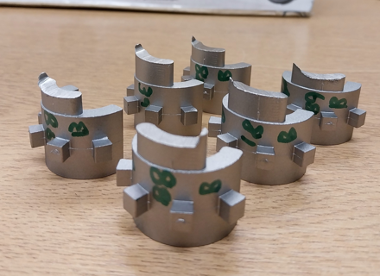
Figure 19: X Ray Part Samples
Figure 18, shows some of the parts that were sent to be X-Rayed, with the number done by the company Oceaneering.

Figure 20: X Ray Results
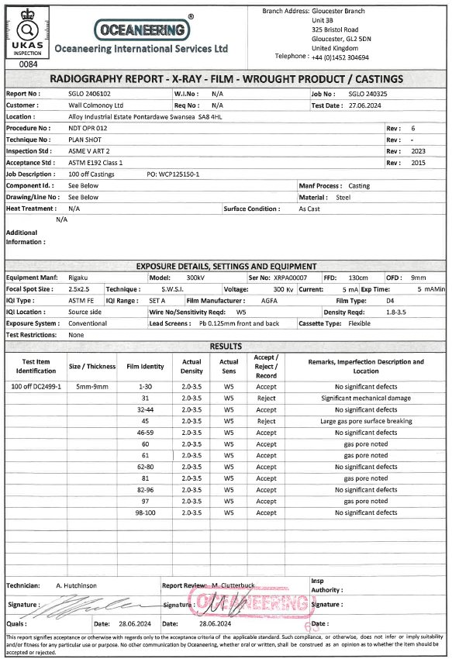
Figure 21: X Ray Results Document
The x-ray results were taken for 100 off of the parts, as design V2 had the best results. 100 were taken predominantly from them for greater validity, 6 out of the 100 suggested some concern, meaning 94% were good, this is something that would be considered a positive for the team, as with over makes often being done for inserts due to the high quantities, such a high success rate would mean less chance of reworks / customer issues occurring.

2.2.3 Machining
A batch of each of the designs were machined, 3mm either side of the part, this was done to verify if there were any underlying issues. This could arguably be considered an over the top exercise by Wall Colmonoy, as the parts are not typically machined, but the aim from trialling this was to be on the side of caution, as if the parts were sent to the customer after making the change without all angles covered, it could leave the company to both financial and customer loyalty issues as the change was made to save cost with potentially lowering the quality.
Machining is necessary because it enables the precise shaping and finishing of materials into specific dimensions and tolerances required for various applications. It is crucial in industries like aerospace, automotive, and manufacturing, where accuracy is paramount. Machining processes such as turning, milling, and drilling allow for the creation of complex geometries that would be impossible to achieve with raw materials alone. Additionally, machining improves the surface finish, ensuring components meet functional and aesthetic standards. By removing excess material, machining customizes parts to fit exact specifications, enhancing performance, reliability, and compatibility in assemblies, which is essential for modern engineering and production.

2.2.4 Review
Upon final review of the trial, a comprehensive scoring system was developed to objectively evaluate the performance and effectiveness of each design. This system was carefully discussed and refined by a cross-functional team comprising the tool designer, toolmaker, area supervisors, and the castings manager. Each team member brought unique expertise and insights to the discussion, ensuring a well-rounded assessment process. The tool designer provided technical insights into design feasibility and functionality, while the toolmaker contributed practical knowledge about manufacturability and precision. Area supervisors offered operational perspectives based on workflow efficiency and resource utilisation, and the castings manager focused on overall production outcomes and alignment with business objectives. The team collaboratively established key evaluation criteria, such as design complexity, material usage, production time, and defect rates, to ensure that every aspect of the casting process was thoroughly assessed. This collaborative approach fostered a sense of shared responsibility and accountability, with each team member playing a crucial role in delegating scores to the designs. As a result, the scoring system not only provided a structured framework for evaluation but also created a foundation for continuous improvement in future design iterations.
1 – Poor
2 – Okay
3 – Good

Design Variant | Parts Per Tree | Wax  Room | Mould Room | Foundry | Fettling | Visual / Tolerance | X -Ray | Machining | Total
Current | 56 | 2 | 2 | 2 | 2 | 3 | 3 | 2 | 16
1 | 96 | 1 | 3 | 3 | 3 | 3 | 3 | 2 | 18
2 | 112 | 1 | 3 | 3 | 1 | 1 | 1 | 1 | 11
3 | 84 | 1 | 3 | 3 | 1 | 1 | 1 | 1 | 11
4 | 84 | 1 | 3 | 3 | 1 | 1 | 1 | 1 | 11
Table 2: Wall Colmonoy Case Study - Cost Analysis
The reasoning behind the teams decision to score as they did was as follows;
- Waxroom, naturally the current design would be the most efficient as it is less parts meaning less time is required.
- Mould Room & Foundry, all new designs were greater than the original, as there is less overall trees/moulds to process, therefore less time consuming.
- Fettling, designs 2-4 were very time consuming, whereas design 1 was surprisingly to most an improvement to the current design with less parts on tree.
- Visual / Tolerance, X-Ray & Machining, poor results compared to that of the current version and design variant 1, this was down to issues in pouring / porosity.

2.2.5 Change / No Change
Design Variant 1 was deemed a successful trial, primarily due to the significant number of successful parts produced throughout the process and the impressive projected annual savings of nearly £20,000 (£19,720). This outcome demonstrated not only the reliability and repeatability of the design but also its potential to positively impact long-term operational efficiency. The streamlined design reduced material waste, minimised production bottlenecks, and enhanced overall workflow within the casting process.
Additionally, the trial provided valuable data on process stability and highlighted areas for further refinement in future iterations. With these compelling results, Wall Colmonoy made the strategic decision to adopt Design Variant 1 as the new standard. This change reflects the company’s commitment to continuous improvement, cost efficiency, and innovation in manufacturing practices. Moving forward, the insights gained from this trial will serve as a benchmark for evaluating future design enhancements, ensuring sustained performance improvements and a competitive edge in the market.

5.0 Conclusion
The primary objective of this report was to enhance productivity and efficiency in the investment casting department by identifying the optimal method to increase yields. The existing capacity of 56 parts per tree was identified as a constraint limiting the department’s ability to meet growing demand while maintaining cost-effectiveness. To address this, four distinct tree design variants were developed, tested, and evaluated.
The project followed a systematic approach, beginning with an analysis of the department’s current state, including material flow, process constraints, and customer requirements. A combination of computational simulations and physical trials was employed to test the feasibility and performance of each variant. Collaboration among engineers, technicians, and management ensured the project remained aligned with operational and strategic objectives.

Trialling the Variants
The evaluation of four different tree design variants was the cornerstone of this project. Each variant represented a unique approach to increasing the parts per tree while addressing critical factors such as mould integrity, thermal dynamics, and process efficiency. Key aspects of the trials included:
Design Version 1 (Figure 11) – 96 Parts Per Tree: Focused on minor modifications to the existing tree design to accommodate additional parts with minimal infrastructure changes. This design increased the number of parts per tree to 96 while maintaining quality, reliability, and process efficiency. Its implementation required moderate adjustments to equipment and processes, making it the most feasible solution.
Design Version 2 (Figure 12) – 112 Parts Per Tree: Assembled all parts on to the current layer, essentially attempting to create columns of the design, with double the yield than that of the original, had the potential for the most savings but with poor results, particularly post poured.
Design Version 3 (Figure 13) – 84 Parts Per Tree: Emphasised uniformity in part distribution to optimise material flow and solidification. While the results were promising, challenges in pouring made this variant less practical.
Design Version 4 (Figure 14) – 84 Parts Per Tree: A new variant, with the attempt to trial a smaller feed, so that the parts could be knocked off instead of cut off via fettling, which is a time consuming process, again despite being a similar design as version 3 and attempting to utilise material flow, it had erratic results.
Selecting the Best Variant
Following comprehensive testing and evaluation, Variant design version 1 emerged as the optimal solution. The decision was based on its ability to balance increased yields with practical considerations such as cost, quality, and implementation feasibility. Key factors influencing this choice included:
- Yield Improvement: Variant 1 successfully increased parts per tree from 56 to 96, representing a substantial productivity boost.
- Quality Assurance: Rigorous testing confirmed that the design maintained Wall Colmonoy’s high-quality standards, with no significant increase in defects or rework.
- Operational Feasibility: The adjustments required for Variant q were manageable within the department’s existing infrastructure, minimising disruptions and new equipment implementation costs.
- Sustainability: The increased efficiency aligned with Wall Colmonoy’s commitment to reducing waste and energy consumption.

Benefits of Implementation
Implementing the selected tree design variant offers transformative benefits across multiple dimensions, enhancing Wall Colmonoy’s operational efficiency and market competitiveness.
Increased Productivity: By doubling the output per casting cycle, the investment casting department can significantly enhance throughput, addressing customer demand more effectively.
Cost Efficiency: The higher yields reduce the cost per part by distributing fixed expenses—such as labor, energy, and equipment maintenance—over a greater number of products, improving profitability.
Shortened Lead Times: With more parts produced in each cycle, the department can fulfil orders more quickly, strengthening customer relationships and competitive positioning.
Sustainability Gains: The optimised tree design reduces material waste and energy usage per part, aligning with sustainability goals and reducing the environmental impact of operations.

Addressing Challenges
The project’s success required addressing several challenges associated with the increased parts per tree. Proactive measures were taken to mitigate potential risks:
Quality Control: Ensuring that the larger trees maintained the same level of quality required enhanced testing protocols, including real-time monitoring and non-destructive evaluation methods.
Employee Training: The transition necessitated comprehensive training programs to familiarize staff with the new tree design and updated processes, fostering a culture of adaptability and continuous improvement.
Equipment Adjustments: Modifications to autoclaves, furnaces, and handling systems were necessary to accommodate the larger trees. These changes were implemented with minimal disruption to ongoing operations.
Risk Management: Contingency plans were developed to address potential process disruptions, ensuring a smooth transition to the new system.

Strategic Implications for Wall Colmonoy
The successful implementation of this initiative has broader implications for Wall Colmonoy, reinforcing its reputation as an industry leader in investment casting. The project’s outcomes contribute to the company’s strategic objectives in several ways:
Competitive Advantage: The ability to produce more parts per cycle enhances Wall Colmonoy’s competitiveness by enabling cost-effective production while maintaining quality.
Scalability: The methodologies and insights gained from this project provide a framework for addressing similar challenges in other departments or facilities, supporting long-term growth.
Customer Satisfaction: By reducing lead times and maintaining high-quality standards, the company strengthens its relationships with key customers, building trust and loyalty.
Innovation Culture: The project exemplifies Wall Colmonoy’s commitment to innovation and continuous improvement, inspiring future initiatives to drive operational excellence.

The decision to improve yields within the investment casting department at Wall Colmonoy by increasing the parts per tree from 56 to 96, following extensive trials with four different variants, marks a significant milestone for the company. This conclusion synthesises the insights gained throughout the project, evaluates the implications of the proposed changes, and underscores the anticipated benefits of implementing the selected variant. By leveraging rigorous testing, process optimisation, and innovative design, this initiative addresses key operational challenges and positions Wall Colmonoy for sustained success in the competitive investment casting industry.
The decision to improve yields within the investment casting department by increasing parts per tree from 56 to 96, based on the successful trialling of four variants, represents a landmark achievement for Wall Colmonoy. This initiative not only addresses critical operational challenges but also reinforces the company’s commitment to innovation, efficiency, and sustainability. By selecting and implementing the optimal solution, Wall Colmonoy has laid the groundwork for sustained growth, enhanced customer satisfaction, and continued leadership in the investment casting industry. The insights gained from this project will serve as a valuable foundation for future advancements, ensuring the company remains at the forefront of industry excellence.

6.0 Further Recommendations
This project underscores the importance of data-driven decision-making, collaboration, and a commitment to excellence in achieving operational improvements. As the implementation progresses, several recommendations can enhance the initiative’s impact:
- Continuous Monitoring: Establishing robust monitoring systems ensures that the new process remains optimised and adaptive to evolving requirements.
- Advanced Technologies: Investing in advanced manufacturing technologies, such as machine learning and automation, can further enhance process control and predictive maintenance. For example, a cobot/robot could be used in the assembly or moulding stages increasing the productivity.
- Knowledge Sharing: Documenting and disseminating the lessons learned during this project can foster a culture of innovation across the organisation.
- Exploring Additional Enhancements: While the increase to 96 parts per tree is a significant achievement, future efforts could explore the potential for further yield improvements through automation and advanced tree assembly techniques.
Building on the success of this project, several additional recommendations can ensure long-term benefits and pave the way for future advancements within Wall Colmonoy’s investment casting department, (Nordegren, 2004):
- Adoption of Predictive Analytics: Integrating predictive analytics into the casting process can provide early insights into potential issues, such as mold failures or thermal imbalances. This proactive approach will enable the department to address challenges before they escalate, minimising downtime and maximising efficiency. This could be investigated further with Wall Colmonoy’s FEA software ProCast, further analysing to ensure more accurate results.
- Lean Manufacturing Initiatives: Incorporating lean manufacturing principles across the department can further optimise workflows, reduce waste, and improve overall process efficiency. This could include streamlining material handling systems, enhancing layout designs, and reducing non-value-added activities.
- Enhanced Collaboration with Supply Chain Partners: Establishing stronger relationships with suppliers and customers can enable better synchronisation of material deliveries and production schedules. Collaborative forecasting and inventory management strategies can reduce bottlenecks and improve responsiveness to market demands.
- Focus on Research and Development (R&D): Allocating resources to R&D can foster innovation in materials, processes, and technologies. For example, exploring new ceramic materials for mould-making or advanced alloys could open new opportunities for improving casting performance and reliability.
- Integration of Sustainability Goals: Expanding the company’s sustainability efforts by investigating renewable energy options for powering casting operations or adopting more environmentally friendly materials in the process will enhance Wall Colmonoy’s reputation as a responsible manufacturer.
- Employee Engagement Programs: Actively involving employees in process improvement initiatives can lead to valuable insights and higher morale. Establishing forums for idea-sharing and recognition programs for contributions to efficiency and quality improvements can strengthen workforce engagement.
- Benchmarking Against Industry Leaders: Conducting regular benchmarking exercises to compare performance metrics with industry leaders will help identify areas for improvement and inspire the adoption of best practices. This could include attending industry conferences or participating in consortiums focused on casting technologies.
- Expanding Automation Efforts: While Variant D’s implementation requires moderate equipment modifications, the company can consider additional automation investments, such as robotic tree assembly or automated inspection systems, to further enhance precision and reduce labour intensity.
- Digital Twin Technology: Developing a digital twin of the investment casting process can simulate and optimize operations in a virtual environment. This technology would allow Wall Colmonoy to test changes without risking disruptions to live production.
- Training and Skill Development: Providing ongoing training to employees on emerging technologies and advanced manufacturing techniques will ensure the workforce is well-equipped to handle future challenges and opportunities.
By implementing these recommendations, Wall Colmonoy can sustain the gains achieved through this project and continue to set new benchmarks for excellence in the investment casting industry. These steps will not only enhance operational performance but also ensure the company’s adaptability and resilience in an ever-evolving market.

7.0 References
Wall Colmonoy (2021) ‘Wall Colmonoy - Who are we?’ [Online] Available: https://www.wallcolmonoy.com/company-profile/who-we-are/t
Hecker, S. (Ed.). (2021). Finding lost wax : the disappearance and recovery of an ancient casting technique and the experiments of Medardo Rosso. Brill.
Villoria, N. B., Golub, A., Byerlee, D., & Stevenson, J. (2013). Will Yield Improvements on the Forest Frontier Reduce Greenhouse Gas Emissions? A Global Analysis of Oil Palm. American Journal of Agricultural Economics, 95(5), 1301–1308.
Tahir, M., Imran, M., Nawaz, F., Shahid, M., Naeem, M. A., Ahmad, I., Akram, M., Khalid, U., Farooq, A. B. U., Bakhat, H. F., Kamran, M., & Shah, Z. A. (2021). Effects of Bacillus sp. MR‐1/2 and magnetite nanoparticles on yield improvement of rice by urea fertilizer under different watering regimes. Journal of Applied Microbiology, 131(5), 2433–2447.
Kim, Y.-C., Paek, N.-I., Ri, B.-G., & O, R.-H. (2024). Improvement of quality and yield for investment casting of centrifugal pump impeller by tilting mold and optimizing runner/riser system. International Journal of Advanced Manufacturing Technology, 130(5–6), 2369–2379.
Paknejad, J., Nasri, F., & Affisco, J. F. (2015). Yield improvement and yield variability reduction in an EOQ model with planned shortages and random yield. Computers & Industrial Engineering, 88, 386–394.
Zhu, W., Zeng, K., Tian, Y., & Yin, B. (2023). Achieving the Simultaneous Improvement of
Rice Yield and Quality Using an Improved Fertilization Method in Southern China. Journal of Soil Science and Plant Nutrition, 23(2), 2053–2065.
Meng, T., Zhang, X., Ge, J., Chen, X., Zhu, G., Chen, Y., Zhou, G., Wei, H., & Dai, Q. (2022). Improvements in grain yield and nutrient utilization efficiency of japonica inbred rice released since the 1980s in eastern China. Field Crops Research, 277, 108427-.
Iyigun, N. O. (Ed.). (2019). Creating business value and competitive advantage with social entrepreneurship. Business Science Reference, an imprint of IGI Global.
Stuart, A. M., Devkota, K. P., Sato, T., Pame, A. R. P., Balingbing, C., My Phung, N. T., Kieu, N. T., Hieu, P. T. M., Long, T. H., Beebout, S., & Singleton, G. R. (2018). On-farm assessment of different rice crop management practices in the Mekong Delta, Vietnam, using sustainability performance indicators. Field Crops Research, 229, 103–114.
Avohou, T. H., Houehounha, R., Glele-Kakai, R., Assogbadjo, A. E., & Sinsin, B. (2011). Firewood yield and profitability of a traditional Daniellia oliveri short-rotation coppice on fallow lands in Benin. Biomass & Bioenergy, 35(1), 562–571.
Singh, S., Kumar, P., & Singh, J. (2021). An approach to eliminate shell cracking problem in fused deposition modeling pattern based investment casting process. IOP Conference Series. Materials Science and Engineering, 1091(1), 12035-.
Niagara (2024) ‘All About Tooling, Patterns and Cores’ [Online] Available: All About Tooling, Patterns and Cores - Niagara Investment Castings
Cheah, C. M., Chua, C. K., Lee, C. W., Feng, C., & Totong, K. (2005). Rapid prototyping and tooling techniques: a review of applications for rapid investment casting. International Journal of Advanced Manufacturing Technology, 25(3–4), 308–320.
Rahmati, S., Akbari, J., & Barati, E. (2007). Dimensional accuracy analysis of wax patterns created by RTV silicone rubber molding using the Taguchi approach. Rapid Prototyping Journal, 13(2), 115–122.
Zamani, J., Hemati, M. H., & Morsaluie, R. (2014). An Experimental Comparison on Dimensional Accuracy of Wax Patterns of Gas Turbine Blades Produced by Rapid Tooling. Arabian Journal for Science and Engineering, 39(10), 7289–7297.
PACE Ltd. (2024) ‘Investment Casting’ [Online] Available: Investment Casting - PACE Ltd (pace-ltd.com)
Song, Q., Zha, X., Ou, M., Lu, C., Li, J., & Ma, Y. (2024). High-Temperature Flexural Strength of Aluminosilicate Ceramic Shells for the Investment Casting of Nickel-Based Superalloy. International Journal of Metalcasting, 18(2), 962–974.
Liu, Q. B., Leu, M. C., & Richards, V. L. (2007). Fracture toughness of ceramic moulds for investment casting with ice patterns. International Journal of Cast Metals Research (Online), 20(1), 14–24.
RMC (2024) ‘Shell Building for Investment Casting’ [Online] Available: Shell Building for Investment Casting | Investment Casting Company | Stainless Steel Foundry (steel-foundry.com)
Yousef, N., & Sata, A. (2023). Innovative Inspection Device for Investment Casting Foundries. International Journal of Metalcasting, 17(4), 2663–2673.
Sata, A. V., & Maheta, N. R. (2021). 5 Cs of Investment Casting Foundries in Rajkot Cluster – An Industrial Survey. Archives of foundry engineering, 102–108.
Investment Casting Systems Ltd. (2024) ‘Moulding’’ [Online] Available: Investment Casting Mouldings Experts, AS9100 compliant - ICS Ltd (investmentcastingsystems.co.uk)
Keat, J., Balendran, V., Sivayoganathan, K., & Sackfield, T. (1999). An Adaptive Connectionist Front-End for Automated Fettling. Integrated Computer-Aided Engineering, 6(1), 67–89.
Yu, Z., & Lin, H.-I. (2021). Development of robotic polishing/fettling system on ceramic pots. International Journal of Advanced Robotic Systems, 18(3), 172988142110128-.
NovaCast (2024) ‘Investment Casting Process/ [Online] Available: The Investment Casting Process - Novacast
Gevorkyan, E. S., & Rucki, M. (2022). Remanufacturing and advanced machining processes for new materials and components : remanufacturing and advanced machining processes (First edition.). CRC Press.
Bose, G. K. (2020). Machine learning applications in non-conventional machining processes (G. K. Bose & P. Pain, Eds.). IGI Global.
Mery, D. (2021). Aluminum Casting Inspection using Deep Object Detection Methods and Simulated Ellipsoidal Defects. Machine Vision and Applications, 32(3).
Taweelerd, S., Chang, C. C., & Tzou, G. Y. (2021). Vision system based on deep learning for product inspection in casting manufacturing: pump impeller images. Journal of Physics. Conference Series, 2020(1), 12046-.
Nikolić, F., Štajduhar, I., & Čanađija, M. (2021). Casting Microstructure Inspection Using Computer Vision: Dendrite Spacing in Aluminum Alloys. Metals (Basel ), 11(5), 756-.
Sadkowski, W., & Jedynak, P. (2022). Quality management and accounting in service industries : a new model of quality cost calculation (First edition.). Taylor & Francis.
Anderson, D. M. (2014). Design for manufacturability : how to use concurrent engineering to rapidly develop low-cost, high-quality products for lean production (First edition.). Productivity Press, an imprint of Taylor and Francis.
Serrano-Munoz, I., Buffiere, J.-Y., Verdu, C., Gaillard, Y., Mu, P., & Nadot, Y. (2016). Influence of surface and internal casting defects on the fatigue behaviour of A357-T6 cast aluminium alloy. International Journal of Fatigue, 82(Part 3), 361–370.
LinkedIn (2024) ‘9 Lean Wastes’ [Online] Available: (12) 9 Lean Wastes | LinkedIn
Antosz, K. (Ed.). (2023). Lean thinking in industry 4.0 and services for society. IGI Global, Information Science Reference.
Gładysz, B., Buczacki, A., & Haskins, C. (2020). Lean Management Approach to Reduce Waste in HoReCa Food Services. Resources (Basel), 9(12), 144-.
Hosono, A. (2020). Workers, Managers, Productivity Kaizen in Developing Countries (Akio. Hosono, John. Page, & Go. Shimada, Eds.; 1st ed. 2020.). Springer Nature.
Cherrie, J. W. (2017). Kaizen. Annals of Work Exposures and Health, 61(4), 398–400.
Berhe, H. H. (2022). Application of Kaizen philosophy for enhancing manufacturing industries’ performance: exploratory study of Ethiopian chemical industries. The International Journal of Quality & Reliability Management, 39(1), 204–235.
Díez-Barcenilla, G., Gómez-Alonso, J. L., Gondra, K., & Zuza, E. (2021). Epoxy tooling: Technologies, developments, sustainability and future interest to industry 4.0. Polymers & Polymer Composites, 29(9_suppl), S1649–S1663.
Inspired (2024) ‘Investment Casting Flowchart’ [Online] Available: Investment Casting Process Flow Chart (inspiredpencil.com)
Tiacci, L., & Rossi, A. (2024). The sand-casting process: a meta-heuristic approach for an environment-friendly and profitable scheduling. International Journal of Production Research, 62(8), 2769–2791.
Hu, B., Quan, B., Li, D., Wang, X., Li, Z., & Zeng, X. (2021). Solid solution strengthening mechanism in high pressure die casting Al–Ce–Mg alloys. Materials Science & Engineering. A, Structural Materials : Properties, Microstructure and Processing, 812, 141109-.
Lin, B., Zhang, W., Lou, Z., Zhang, D., & Li, Y. (2014). Comparative study on microstructures and mechanical properties of the heat-treated Al–5.0Cu–0.6Mn–xFe alloys prepared by gravity die casting and squeeze casting. Materials in Engineering, 59, 10–18.
Huang, X., Liu, C., Lv, X., Liu, G., & Li, F. (2011). Aluminum alloy pistons reinforced with SiC fabricated by centrifugal casting. Journal of Materials Processing Technology, 211(9), 1540–1546.
Elangovan, S., Jusoh, M. S., Muhd Yusuf, D. H., Ismail, M. S., & Hj Din, M. S. (2021). 8D Problem Solving Methodology: Continuous Improvement in Automation Organization. Journal of Physics. Conference Series, 2129(1), 12017-.
Song, H., Tucker, A. L., Murrell, K. L., & Vinson, D. R. (2018). Closing the Productivity Gap: Improving Worker Productivity Through Public Relative Performance Feedback and Validation of Best Practices. Management Science, 64(6), 2628–2649.
Xia, G., Liu, W., He, Y., Li, H., Zhou, D., Jiao, A., & Lin, R. (2024). Design and Reliability Simulation of a G -Band Traveling-Wave Tube Multistage Depressed Collector With Curving Radiators Using FEA Method. IEEE Transactions on Plasma Science, 1–7.
Dal Piva, A. M. de O., Tribst, J. P. M., Borges, A. L. S., Souza, R. O. de A. e, & Bottino, M. A. (2018). CAD-FEA modeling and analysis of different full crown monolithic restorations. Dental Materials, 34(9), 1342–1350.
Roffey, D. M., Wai, E. K., Bishop, P., Kwon, B. K., & Dagenais, S. (2010). Causal assessment of workplace manual handling or assisting patients and low back pain: results of a systematic review. The Spine Journal, 10(7), 639–651.
Kay, K., Glass, N., & Evans, A. (2014). It’s not about the hoist: A narrative literature review of manual handling in healthcare. Journal of Research in Nursing, 19(3), 226–245.
Nolan, D., O’Sullivan, K., Stephenson, J., O’Sullivan, P., & Lucock, M. (2018). What do physiotherapists and manual handling advisors consider the safest lifting posture, and do back beliefs influence their choice? Musculoskeletal Science & Practice, 33, 35–40.
Ng, Y. S. R., & Rashid, H. (2019). Enhancing human performance reliability in aircraft pushback operations. The International Journal of Quality & Reliability Management, 36(4), 485–509.
Glavin, P., & Schieman, S. (2024). The Job Satisfaction Paradox: Pluralistic Ignorance and the Myth of the “Unhappy Worker.” Social Psychology Quarterly.
Yun, M., Kim, W., Yu, B., & Choi, E.-H. (2024). A Delphi Study on the Changes in Work, Organizational Culture, and Health Issues of Nurses at Tertiary Hospitals in South Korea during the COVID‐19 Pandemic. Journal of Nursing Management, 2024(1).
Crowley, D. (2018). Smart teams : communicate, congregate, collaborate : how to work better together. Wiley.
Nelson, L. B. (2023). Our Hope for a Positive Change in the Economic and Workforce Issues in Pediatric Ophthalmology. Journal of Pediatric Ophthalmology and Strabismus, 60(5), 308–308.
Nordegren, A. (2004). Design–theoretical and empirical, A research project inn design theory including the devolpment of a prototype for a symbol system that represents tastes of wine.
Wang, Q., Wu, Y., Peng, A., Cui, J., Zhao, M., Pan, Y., Zhang, M., Tian, K., Schwab, W., & Song, C. (2022). Single‐cell transcriptome atlas reveals developmental trajectories and a novel metabolic pathway of catechin esters in tea leaves. Plant Biotechnology Journal, 20(11), 2089–2106.
Sociedade Brasileira de Computação, sponsoring body, & Sociedade Brasileira de Computação, sponsoring body. (2013). Journal of software engineering research and development. Springer.
Hodges, A., & Granados, A. (2023). A Bridge Blueprint to Span the Chasm Between Research and Engineering — A Framework for Systems Engineering in Early‐Stage Research and Development. Insight (International Council on Systems Engineering), 26(3), 15–25.

8.0 Appendix

8.1 Appendix 1 – Investment Casting DC Drawing

DC2499-1 (As Cast Insert Part Drawing)

8.2 Appendix 2 – DC2499-2 (Current Cost)

DC2499-2 - Current Cost

